Niger Migration Data

1. **Introduction**

This report presents a series of infographics and maps on migration trends in Niger. It addresses different types of population mobility, whether internal displacement, movement abroad, or within the Nigerien territory. The main objective of this report is to provide a deeper understanding of various aspects related to mobility and migration in Niger. Several aspects are covered in this document, including internal and international economic movements, migrant populations residing in Niger and abroad, nationalities in transit within the country, as well as internally displaced persons resulting from the ongoing security crisis in the country. The report is the result of compiling various databases and reports from different sources of information. The sources are indicated on each page. Although the data presented may not be perfectly representative, it nonetheless provides a general overview of the migration situation in Niger.

1. Data

Different sources of data related to mobility and displacement in Niger have been utilized. The International Organization for Migration (IOM) conducts baseline assessments and surveys in villages to collect information on internally displaced persons, migrants, and repatriates. Four assessments have been conducted and published on specific dates (June 6, September 5, 2022, May 2022, and December 2019), providing demographic data and voluntary information from selected migrants.

Similarly, the Internal Displacement Monitoring System (IDMS) collects data on internal displacement caused by conflicts, violence, or natural disasters in Niger, covering various periods and affected regions. The Humanitarian Data Exchange offers regular updates on internally displaced persons, refugees, conflicts, and floods in Niger.

Furthermore, the United Nations Refugee Agency provides access to data on displaced and stateless populations, including demographic characteristics, with annual updates on displacement, disaggregated by location, gender, and age. The data includes information on forced internal displacement within Niger and displacement from Niger to other countries in West and Central Africa.

1. Output
2. **Migration flows in west Africa.**

The data extracted from IDM ([International Data Migration](https://www.internal-displacement.org/database/displacement-data)) facilitates the analysis of migratory patterns between West and Central African countries, both on an annual basis and over the period from 1961 to 2022. These data are specifically concerned with the movements of refugees and asylum seekers within the region. Over the mentioned period, spanning from 1961 to 2022, Mali recorded the highest number of refugees originating from Niger, surpassing all other countries in the region, with a total count of 55,470 individuals, of which 18,229 occurred in the year 2022. In parallel, Niger hosted a larger number of refugees from Nigeria, with a cumulative total nearing 1,106,358 individuals. Regarding asylum seekers, Niger accommodated the highest number of Nigerian nationals (62,466), followed by Burkina Faso (24,981) and Chad (9,902). Furthermore, more comprehensive visual representations of annual migratory flows for each West African country are also accessible.

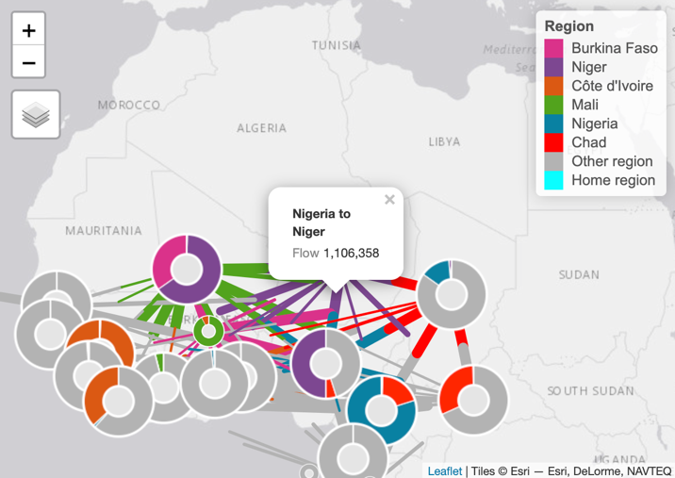

Fig1: *Migration flows between West and Central African countries on the Fig2: Migration flows between West and Central African countries on the number of refugees over the period 1961 to 2022 number of Asylum over the period 1961 to 2022*

|  |  |
| --- | --- |
| **Destination from Niger** | **Value** |
| MLI | 55470 |
| TCD | 5004 |
| NGA | 2896 |
| BFA | 269 |
| TGO | 49 |
| CIV | 35 |
| BEN | 31 |
| CMR | 15 |
| GIN | 10 |
| SEN | 7 |
| GAB | 6 |
| GHA | 5 |

|  |  |
| --- | --- |
| **Destination to Niger** | **Value** |
| NGA | 1106358 |
| MLI | 706239 |
| TCD | 18697 |
| GIN | 1500 |
| CAF | 861 |
| CIV | 644 |
| TGO | 204 |
| CMR | 201 |
| LBR | 52 |
| SLE | 27 |
| GHA | 14 |

1. **Internally displaced persons (IDP)**

The maps below present data from HDX ([The Humanitarian Data Exchange](https://data.humdata.org/group/ner)) on internally displaced persons (IDP) in Niger for three periods: 2017, 2019, and late September 2022. Between 2017 and 2019, internal displacements were primarily concentrated in the localities of Diffa, N’Guimini, Bosso, Maine-soroa, and Goudoumaria, situated near the borders with Nigeria and Chad, where armed conflicts involving Boko Haram were active. However, after 2020, the number of IDPs increased in the western regions, bordering Mali, and Burkina Faso, due to conflicts associated with terrorism. These three countries face recurrent terrorist attacks.

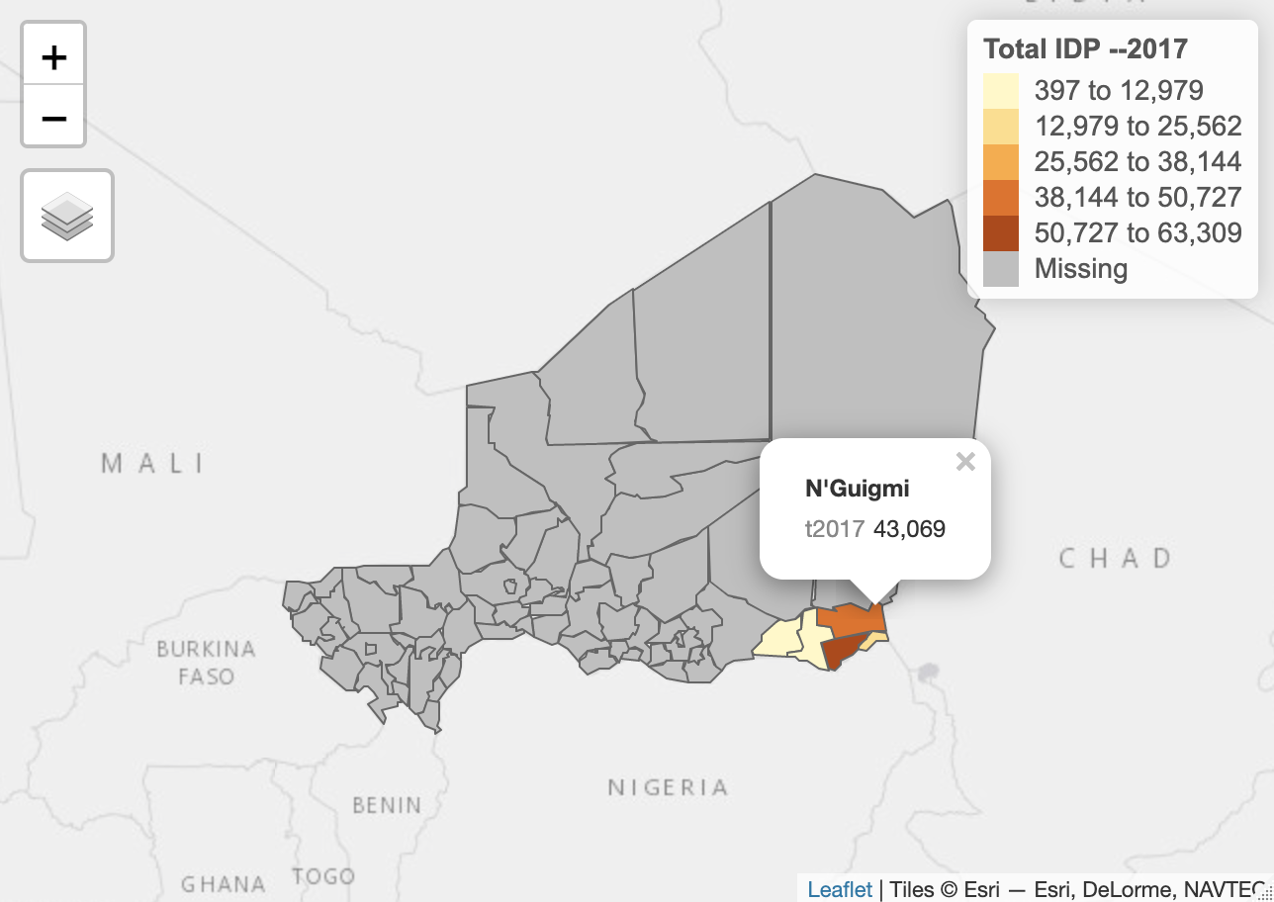

Fig3: IDP in 2017 Fig4: IDP in 2019 Fig5: IDP in 2022

The averages of internally displaced persons (IDP) over the period from 2017 to 2022 indicate higher values in the departments of Diffa with 65,067 displaced persons, Tchin-Taharade with 47,200 displaced persons, Tillabery with 44,316 displaced persons, and the city of Niamey with 40,241 displaced persons. However, the most significant variations are observed in the departments of Terra, Say, and Maine-soroa.

Furthermore, the figure illustrates that the number of internally displaced persons (IDP) continues to increase in certain localities. However, a decrease in the number of IDPs is observed in the localities of N’guimi and Tchin-Taharade during the period from 2017 to 2022.

1. **Refugees, return people.**

During the last quarter of 2019, four assessments were conducted at the four monitoring points for population flows and IDP sites in Niger. This page presents the findings from the latest assessment conducted on June 6, 2023. The data from the International Organization for Migration ([IOM](https://dtm.iom.int/datasets?f%5B0%5D=dataset_country%3A75)) provides an overview of the number of refugees, the number of people returning to their localities, and the number of individuals returning from Niger to other countries.

Refugee data reveals a distinct concentration within three specific departments, namely Groumdji (22,762 refugees), Madourounfa (11,900 refugees), and Diffa (21,679 refugees) in Niger. These three Nigerien departments are contiguous with the northern region of Nigeria, where Boko Haram attacks are frequent. Similarly, individuals returning to Niger to settle within the country are predominantly clustered in the Diffa department, numbering over 27,585 individuals. As for those choosing to return to their original localities, they are notably more observed in Madourounfa (15,231 individuals), Kollo (10,212 individuals), Madoua (9,324 individuals), and Diffa (9,297 individuals).

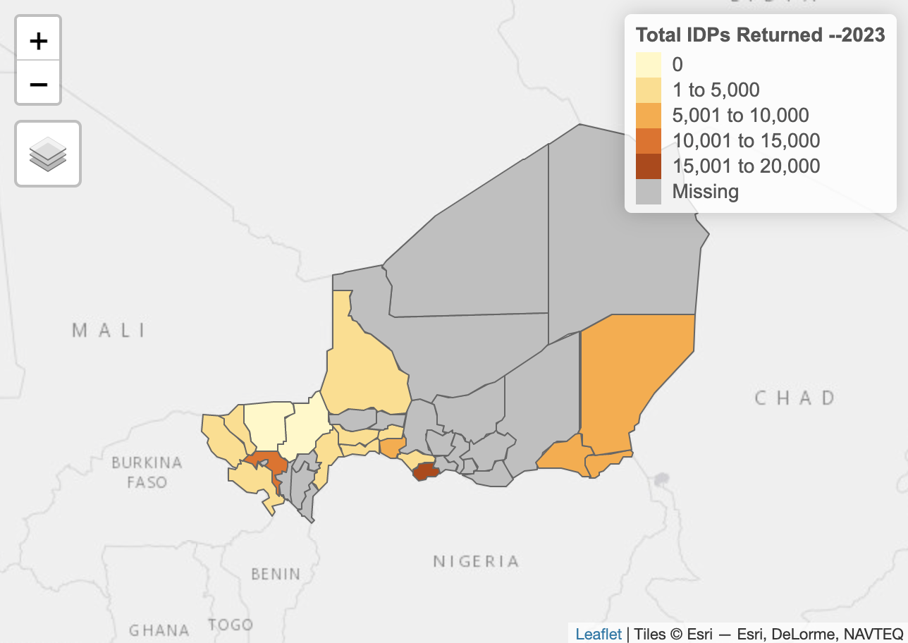

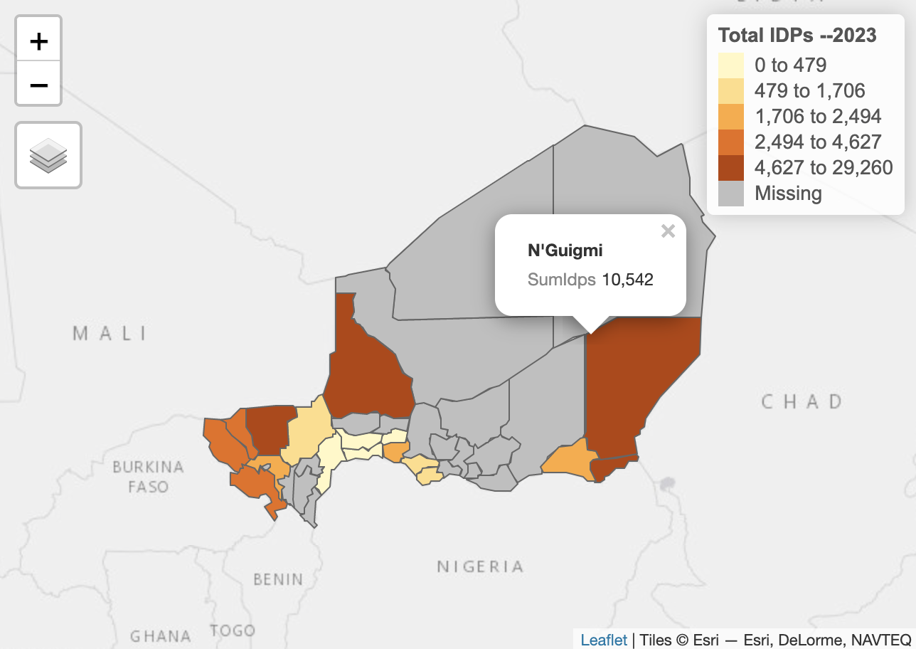

Utilizing an autocorrelation of the Morgan's index, it is observed that the departments of Diffa and N’guigmin are neighboring entities that exhibit closer values. These two departments alone account for 55% of the internally displaced persons.

