姓名：安雪娇
学号：10235501455

实验代码及结果：
mysql> -- 创建数据库（如果尚未创建）
mysql> CREATE DATABASE IF NOT EXISTS testdb;
Query OK, 1 row affected, 1 warning (0.00 sec)

mysql> USE testdb;
Database changed
mysql>
mysql> -- 创建 user 表
mysql> CREATE TABLE user (
-> id INT AUTO_INCREMENT PRIMARY KEY,
-> name VARCHAR(255) NOT NULL,
-> sex ENUM('Male', 'Female') NOT NULL,
-> age INT NOT NULL,
-> phone VARCHAR(20) NOT NULL UNIQUE
-> );
Query OK, 0 rows affected (0.01 sec)

mysql>
mysql> -- 插入初始数据
mysql> INSERT INTO user (name, sex, age, phone)
-> VALUES ('John Doe', 'Male', 25, '123-456-7890'),
-> ('Jane Smith', 'Female', 31, '987-654-3210'),
-> ('Bob Johnson', 'Male', 22, '555-123-4567');
Query OK, 3 rows affected (0.01 sec)
Records: 3 Duplicates: 0 Warnings: 0

mysql> SELECT * FROM user WHERE age BETWEEN 20 AND 30;
+----+-------------+------+-----+--------------+
| id | name | sex | age | phone |
+----+-------------+------+-----+--------------+
| 1 | John Doe | Male | 25 | 123-456-7890 |
| 3 | Bob Johnson | Male | 22 | 555-123-4567 |
+----+-------------+------+-----+--------------+
2 rows in set (0.00 sec)

mysql> INSERT INTO user (name, sex, age, phone) VALUES ('An Xuejiao', 'Female', 20, '000-111-2222'), ('An Xiaoming', 'Male', 28, '111-222-3333'), ('An Mei', 'Female', 24, '222-333-4444');
Query OK, 3 rows affected (0.00 sec)
Records: 3 Duplicates: 0 Warnings: 0

mysql> SELECT * FROM user WHERE name LIKE 'An%' AND age BETWEEN 20 AND 30 ORDER BY age DESC;
+----+-------------+--------+-----+--------------+
| id | name | sex | age | phone |
+----+-------------+--------+-----+--------------+
| 5 | An Xiaoming | Male | 28 | 111-222-3333 |
| 6 | An Mei | Female | 24 | 222-333-4444 |
| 4 | An Xuejiao | Female | 20 | 000-111-2222 |
+----+-------------+--------+-----+--------------+
3 rows in set (0.00 sec)

mysql> SELECT AVG(age) AS average_age FROM user;
+-------------+
| average_age |
+-------------+
| 25.0000 |
+-------------+
1 row in set (0.00 sec)

mysql> -- 创建 team 表
mysql> CREATE TABLE team (
-> id INT AUTO_INCREMENT PRIMARY KEY,
-> teamName VARCHAR(255) NOT NULL
-> );
Query OK, 0 rows affected (0.02 sec)

mysql>
mysql> -- 创建 score 表
mysql> CREATE TABLE score (
-> id INT AUTO_INCREMENT PRIMARY KEY,
-> teamid INT NOT NULL,
-> userid INT NOT NULL,
-> score INT DEFAULT 0,
-> FOREIGN KEY (teamid) REFERENCES team(id),
-> FOREIGN KEY (userid) REFERENCES user(id)
-> );
Query OK, 0 rows affected (0.02 sec)

mysql>
mysql> -- 插入团队和分数记录
mysql> INSERT INTO team (teamName) VALUES ('ECNU');
Query OK, 1 row affected (0.00 sec)

mysql>
mysql> -- 假设我们有一个用户ID为7（Young Li），年龄为19，属于"ECNU"队
mysql> INSERT INTO user (name, sex, age, phone) VALUES ('Young Li', 'Male', 19, '333-444-5555');
Query OK, 1 row affected (0.00 sec)

mysql>
mysql> -- 确认 Young Li 的实际 ID
mysql> SELECT id, name FROM user WHERE name = 'Young Li';
+----+----------+
| id | name |
+----+----------+
| 7 | Young Li |
+----+----------+
1 row in set (0.00 sec)

mysql>
mysql> -- 删除错误的分数记录（如果存在）
mysql> DELETE FROM score WHERE userid = 5;
Query OK, 0 rows affected (0.00 sec)

mysql>
mysql> -- 插入正确的分数记录（使用正确的 userid）
mysql> INSERT INTO score (teamid, userid, score)
-> VALUES ((SELECT id FROM team WHERE teamName = 'ECNU'), 7, 85);
Query OK, 1 row affected (0.01 sec)

mysql> SELECT u.*
-> FROM user u
-> JOIN score s ON u.id = s.userid
-> JOIN team t ON s.teamid = t.id
-> WHERE t.teamName = 'ECNU' AND u.age < 20;
+----+----------+------+-----+--------------+
| id | name | sex | age | phone |
+----+----------+------+-----+--------------+
| 7 | Young Li | Male | 19 | 333-444-5555 |
+----+----------+------+-----+--------------+
1 row in set (0.00 sec)

mysql> SELECT SUM(COALESCE(score, 0)) AS total_score
-> FROM score
-> JOIN team ON score.teamid = team.id
-> WHERE team.teamName = 'ECNU';
+-------------+
| total_score |
+-------------+
| 85 |
+-------------+
1 row in set (0.00 sec)

mysql> DELETE FROM user WHERE name = 'An Xuejiao';
Query OK, 1 row affected (0.01 sec)

mysql>
实验图片：
- 在新数据库中新建一张 user 表,插入几条数据,属性包含:唯一标识(id),姓名(name)性别(sex).年龄(age).联系方式(phone)，数据如下：
('John Doe', 'Male', 25, '123-456-7890')
('Jane Smith', 'Female', 31, '987-654-3210')
('Bob Johnson', 'Male', 22, '555-123-4567')
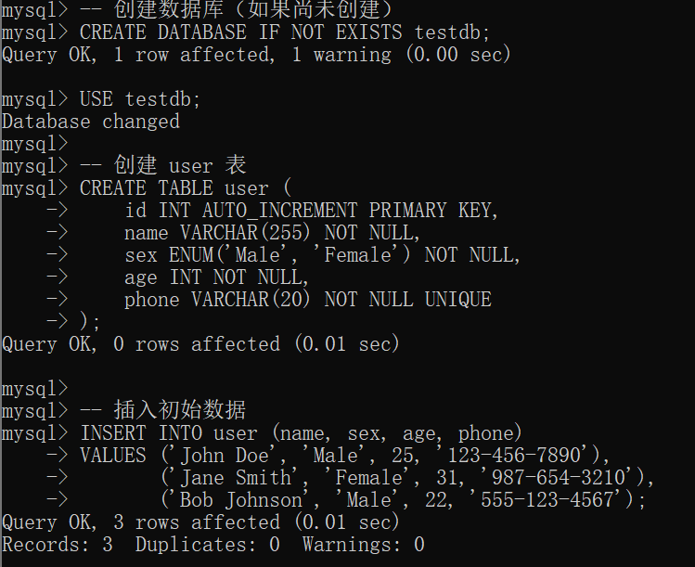
- 写出 SQL语句,查询 user 表中所有年龄在 20-30 范围内的用户
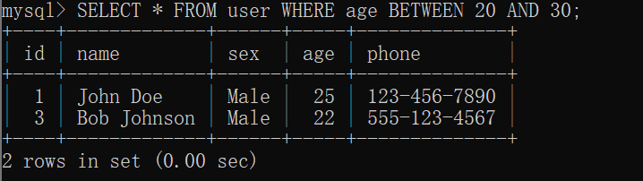
- 写出SQL语句，向user表中添加自己的个人信息，并添加几条和你姓名同姓的虚拟信息。
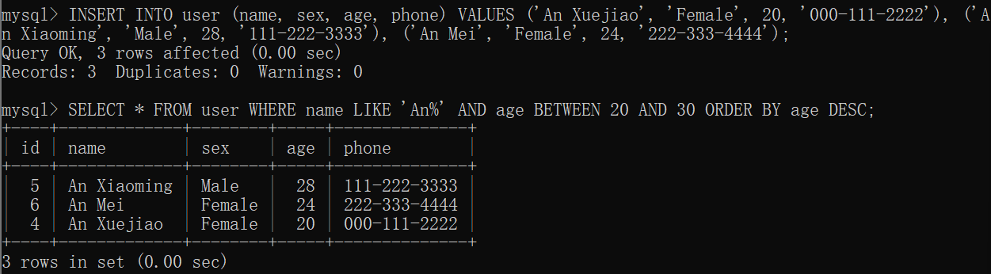
- 写出 SQL语句,查询 user 表中年龄在 20-30 范围内,名字包含“你的姓氏”的用户,并按照年龄从大到小排序输出

- 写出 SQL 语句,计算 user 表中所有用户的平均年龄
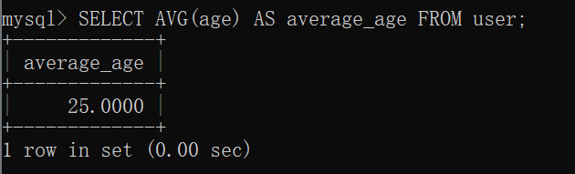
- 新建两张表team 表(id,teamName)和score 表(id,teamid,userid,score)。其中score 表中的 teamid 为指向 team表id 的外键，userid 为指向 user表id的外键
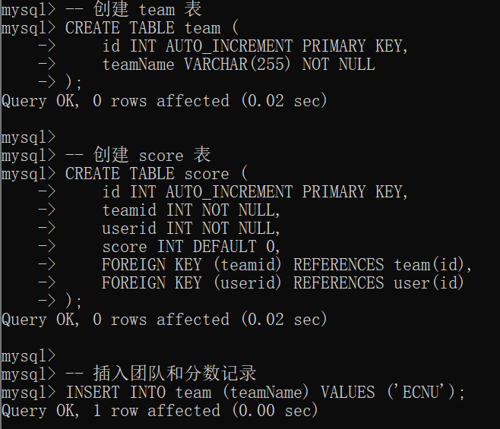
- 在team表中和score表中插入合适的记录，写出 SQL语句,查询 teamName 为“ECNU”的队伍中，年龄小于 20 的用户们，结果不得为空。
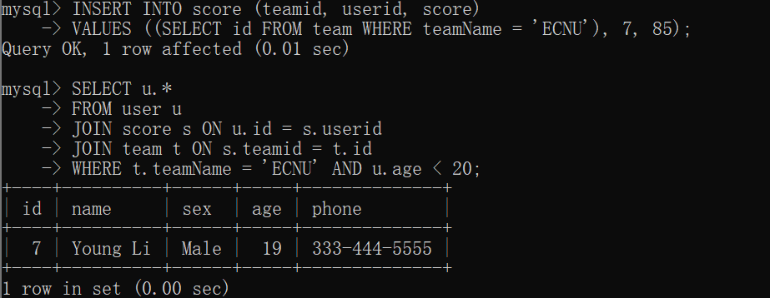
- 写出 SQL 语句,计算 teamName为“ECNU”的总分(假设 score 存在 null值,nul值默认为 0 加入计算)。
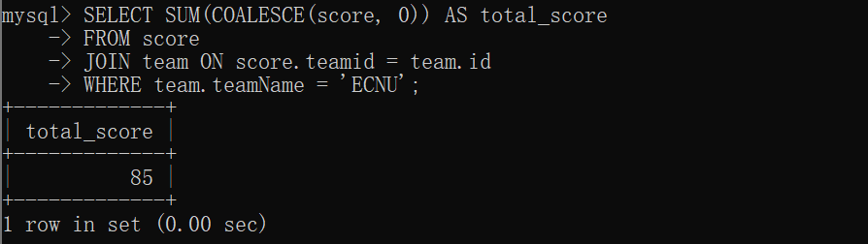
- 写出SQL语句，删除user表中个人信息的记录。
