To: ECOG314 Class

From: William Ampeh

Date: Wednesday, October 12, 2016

**R Studio Preview Version**

A “**preview**” version of RStudio is available for both Windows and Mac users. Similar the Mathematica and other software that makes use of “Notebooks”, the output from an “R Markdown code chunk” is displayed immediately after the code chunk instead of the console. This cool feature is just one of the many features which will be useful to the ECOG-314 class. Curious users can read about the additional features at <http://rmarkdown.rstudio.com/r_notebooks.html>.

**How to download, install and use RStudio Preview**

1 of 6: Point your browser to: <https://www.rstudio.com/products/rstudio/download/preview/>

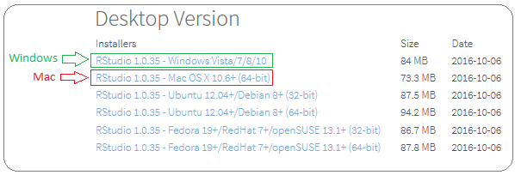2 of 6: Download and install the version that corresponds to the operating system of your computer. For example:

3 of 6: Click on the downloaded installation file to start the installation process. Then click on “Next” when the dialog box opens.

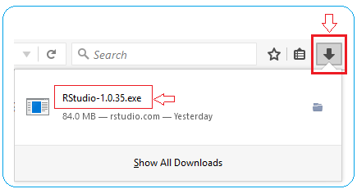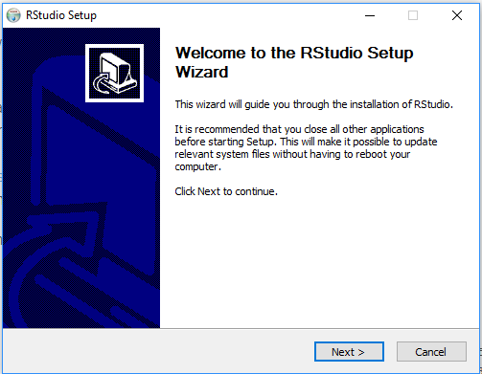

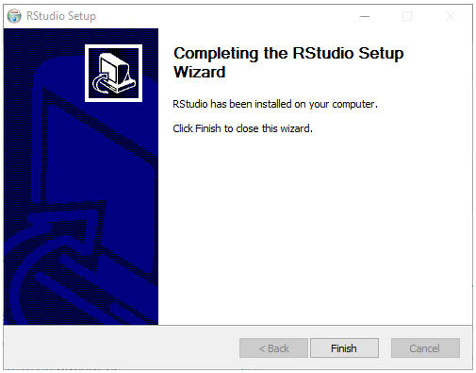4 of 6: Keep clicking on “Next” and finally “Finish” to complete the installation process.

5 of 6: Start RStudio

For Windows users, if you do not see the RStudio shortcut on your screen, click on:

“My Computer”, “C”-drive, “Program Files”, “RStudio”, “bin”, “rstudio.exe”

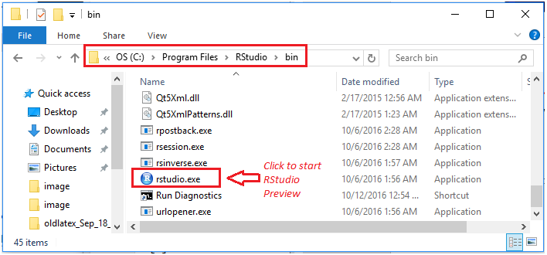 For example:

6 of 6: Open a lecture file, for example: ***lecture6Notes.rmd***

Then click on the “**Run Current Chunck**” (green arrow) shown below:

Note: Unlike our current RStudio session, the result is displayed just below the “code chuck” instead on the console (which has been minimized).

