White-Box State-Transition Governance for AI Agents

Candidate-First, Evidence-Bound Control of External Side Effects
Technical Research Note v0.2.2 — Public Release Candidate
Author: 万根
Affiliation: Independent Researcher
Correspondence: 593315006@qq.com
Date: October 2026

Abstract
AI agents are increasingly moving from text generation toward systems that can invoke tools, modify digital artifacts, interact with services, and initiate changes in external environments. Once an agent can produce side effects, governance cannot be reduced to the question of whether a tool call is syntactically valid or whether a subject has permission to invoke an operation. A second question becomes important: given the current state, available evidence, policy version, and proposed change, is this particular state transition eligible to proceed?
This technical note introduces White-Box State-Transition Governance, a candidate-first and evidence-bound reference model for agent-induced external state changes. The governed unit is not a generic tool invocation. It is the bound lineage formed by a Candidate Transition, its pre-state snapshot, supporting evidence, policy snapshot, governance decision, controlled execution boundary, observed outcome, and replayable lineage record. The term white-box is used narrowly: it does not claim access to an LLM's hidden reasoning or chain-of-thought. It refers only to the inspectability of this external governance lineage.
A minimal deterministic local reference implementation is used to evaluate the model. It does not import the protected engineering system that motivated this work, does not connect to networks, MCP, providers, shells, databases, filesystems, or real external tools, and uses a pure in-memory controlled executor with external_side_effects = false. Seven cases were declared in advance, covering admission, denial, insufficient evidence, escalation, failed execution after admission, replay without re-execution, and attempted direct-tool access. The reference implementation matched all predeclared fixed cases: expected decision agreement was 7/7, expected observation agreement was 7/7, and replay verification was 1/1. The implementation also passed 14 tests under Python 3.9 and 14 tests under Python 3.13.
These results are intentionally narrow. The result demonstrates conformance of this deterministic reference model to its declared protocol. It does not establish production safety, real-world generalization, kernel-level isolation, independent security certification, or governance of real external side effects. A larger protected engineering environment motivated parts of the problem formulation, but that system is not required to reproduce the claims of this note and is not treated as experimental evidence here.

Evidence-Status Vocabulary
This note uses three evidence levels throughout:
DEMONSTRATED_IN_REFERENCE_IMPLEMENTATION
Claims directly supported by the deterministic reference
implementation and its declared tests.

INTERNALLY_IMPLEMENTED_NOT_PUBLICLY_REPRODUCED
Protected engineering capabilities described only at a high
capability level. They are not evidence for the experiments
reported in this note.

RESEARCH_DIRECTION
Future work not claimed as implemented, reproduced, or
experimentally established in this release.

1. Introduction

1.1 From Tool Use to External State Change
Traditional language-model interaction can be simplified as:
User
↓
LLM
↓
Answer
Agentic systems introduce another boundary:
User
↓
Agent
↓
Tool
↓
External Environment
Once a tool can change an external object, a successful API call, shell command, database mutation, message send, configuration update, or workflow transition may alter a state outside the model itself.
Existing computer-security mechanisms already address important aspects of this problem. Access-control systems determine whether subjects may perform operations on protected objects. Runtime monitors enforce classes of security policies. Policy engines separate policy decisions from application-specific enforcement. Sandboxes constrain processes, files, network access, credentials, and other resources. These mechanisms remain necessary. [1–7]
This note focuses on a narrower semantic gap:
Permission to attempt an operation is not identical to qualification for a particular state change, and qualification is not identical to observed success.
Consider three statements:
The agent may call an operation.
The candidate state change is eligible to proceed.
The external state change was actually applied.
They describe different events.
The proposed model therefore separates:
Proposal
≠ Governance Admission
≠ Execution
≠ Observed Success
and, more specifically:
Candidate ≠ Commit
ALLOW ≠ APPLIED

1.2 Contributions
This note makes two public technical contributions.

- A candidate-first, evidence-bound semantic model for state-transition governance.
The model treats a candidate transition, pre-state snapshot, evidence binding, policy snapshot, decision, observation, and replayable lineage as one governed semantic unit.

- A deterministic reference demonstration and fixed-case property-verification protocol.
The implementation exercises the declared semantics without networking, real tools, or external side effects.

The experimental claims of this paper are limited to these two contributions.
A larger protected engineering environment involving runtime evidence, derived state, candidate handling, observation, and continuity-oriented review motivated the research problem. That environment is neither reproduced nor benchmarked in this note and is not required to verify the public claims.

1.3 What This Paper Does Not Claim
The work does not claim access to hidden LLM reasoning, chain-of-thought, or internal model cognition. It does not claim to replace access control, policy engines, sandboxes, capability security, or kernel-level execution boundaries.
It also does not claim that the complete protected engineering system has been publicly reproduced, that the reference implementation is production-ready, or that the method-evolution chain:
Episode → Pattern → Method → Operator
is part of this paper.

2. Problem Statement and Threat Boundary

2.1 The Governed Unit
The central abstraction of this note is:
Governed Unit
=
Candidate Transition
+ Pre-State Snapshot
+ Evidence Binding
+ Policy Snapshot
+ Governance Decision
+ Observation
+ Replayable Lineage
A tool invocation is an implementation event.
A governed transition is the semantic unit under evaluation.
This distinction matters because one tool call may have different governance meanings under different state versions, evidence, subjects, policy snapshots, or expected post-states.
For example, an operation named update_order is not sufficiently descriptive by itself. The governance meaning depends on questions such as:
Which order?
What is its current version?
What state is it currently in?
What post-state is proposed?
Which evidence supports the change?
Which policy version applies?
Who is requesting the transition?
What was actually observed after execution?

2.2 Threat Boundary
The reference implementation evaluates semantic governance properties, not operating-system security.
The implementation is:
local
deterministic
in-memory
side-effect-free
It does not connect to:
Network
MCP
Model providers
Shell
Database
Filesystem executor
External APIs
Physical devices
Production credentials
The controlled executor is explicitly configured such that:
external_side_effects = false
Accordingly, the experiments do not establish safety for real file writes, API calls, database changes, financial operations, physical actuators, or other production side effects.

2.3 Agent-Facing Boundary
The Agent Gateway accepts only candidate-transition submissions.
It does not intentionally expose:
tool handles
executor handles
shell handles
database clients
filesystem writers
network clients
A direct-tool request made through the public reference API is rejected and produces an audit record.
This demonstrates an API-level architectural property of the reference implementation. It does not establish protection against arbitrary malicious Python code executing with the same process authority.

2.4 Why This Boundary Matters
A semantic governance layer that can simply be bypassed is only advisory.
Runtime-enforcement research has long distinguished the expression of a policy from the mechanism that mediates execution. Schneider's execution-monitoring model formalized classes of enforceable security policies, while modern systems such as OpenShell place trusted enforcement outside the untrusted agent workload. [3,11] OpenShell's documented architecture separates a trusted supervisor from the sandboxed agent workload and mediates filesystem, process, network, and credential behavior.
The present implementation does not reproduce such a hard execution boundary. Its scope is the semantic model above that boundary.

3. White-Box Governance Lineage Model

3.1 Reference Governance Lineage

Figure 1. Reference Governance Lineage Demonstrated in the Reference Implementation
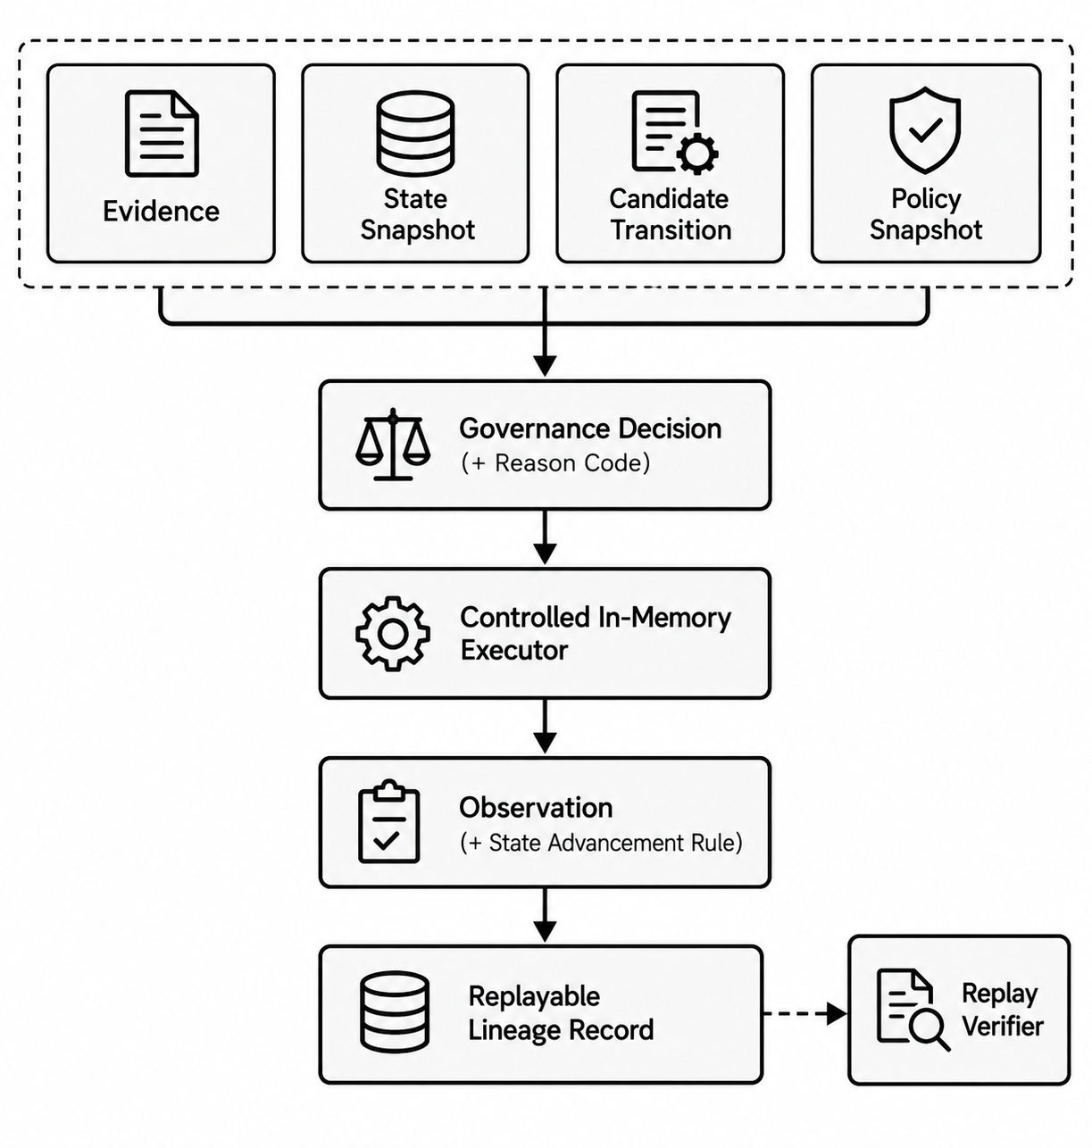
Figure 1 caption. This figure represents the reference model demonstrated by the current implementation. The executor is simulated and no real external side effect occurs.

3.2 Evidence
Evidence is information explicitly bound to the transition being governed.
The implementation fingerprints the evidence representation used for the decision. An idempotency replay is accepted only when the candidate, evidence, policy snapshot, and original state snapshot all match the first submission. A changed bound input is rejected rather than silently returning the earlier ALLOW record.
The reference implementation tests rejection when evidence is bound to the wrong object or version.
Evidence binding does not prove that the original evidence source is truthful. Trustworthiness of evidence sources is outside this paper's demonstrated claims.

3.3 State Snapshot
The State Snapshot represents the versioned pre-state against which the candidate is evaluated.
The state snapshot is fingerprinted.
A change in state identity or version changes the governance context.
The paper therefore distinguishes:
current state at decision time
from:
whatever state exists later

3.4 Candidate Transition
The agent does not submit an instruction semantically equivalent to:
execute_this_now()
Instead, it submits a candidate describing a proposed change.
A conceptual representation is:
candidate_transition:
subject: agent_007
object_id: object_123
pre_state_version: v4
operation: UPDATE
expected_post_state: v5
evidence_refs:
- evidence_001
risk_class: MEDIUM
candidate_fingerprint: <fingerprint>
The candidate exists before controlled execution.

3.5 Policy Snapshot
A governance decision is associated with a specific policy snapshot.
The implementation treats policy identity/version as part of the replay lineage.
If the policy snapshot changes, replay verification against the old lineage fails.
This prevents a decision made under one policy version from being silently represented as having been made under another.

3.6 Governance Decision and Reason Code
The reference implementation supports four decision classes:
Decision | Semantics
ALLOW | The candidate is eligible to be handed to the controlled executor
DENY | The candidate must not proceed
DEFER | Required evidence or conditions are currently insufficient
ESCALATE | Higher authority or human review is required
Every decision is accompanied by a reason code.
The decision does not represent an execution result.

3.7 Controlled Execution
Only an allowed candidate proceeds to the controlled executor.
In this reference implementation, the executor is purely in memory.
It is used to demonstrate the semantic distinction:
ALLOW
↓
execution attempt
↓
APPLIED, FAILED, or UNKNOWN
It is not presented as a sandbox, kernel security boundary, production actuator, or hardened enforcement system.

3.8 Observation
Observation reports the result of the controlled execution attempt.
The relevant states are:
APPLIED
FAILED
UNKNOWN
NOT_RUN
The model obeys the state-advancement rule:
if Observation == APPLIED:
simulated state advances
else:
simulated state does not advance
Therefore:
ALLOW → FAILED
is a valid outcome.
ALLOW means the attempt was admitted.
It does not mean the attempt succeeded.

3.9 Replayable Lineage Record
Every Lineage Record contains at least:
Candidate Transition + fingerprint
State Snapshot + fingerprint
Evidence + fingerprint
Policy Snapshot + fingerprint
Governance Decision
Reason Code
Controlled Execution boundary information
Observation
State After
Record Fingerprint
The Replay Verifier checks the original Candidate, State, Evidence, Policy, and Record Fingerprint.
Replay does not invoke the controlled executor again.
Thus:
Replay history
≠
Repeat side effect
Provenance standards such as PROV provide general structures for representing entities, activities, agents, derivations, and provenance relationships. The present model shares the goal of inspectable lineage but attaches that lineage to an ex-ante candidate-admission decision and a subsequent observation. PROV itself is a general provenance model rather than a candidate-transition admission mechanism. [6]

4. Governance Invariants
The reference model is organized around a small set of explicit semantic invariants.

4.1 Candidate Before Execution
No admitted candidate
→ no controlled execution

4.2 ALLOW Is Not APPLIED
ALLOW ≠ APPLIED
An admission decision and an observed execution outcome are different records.

4.3 Observation Controls Simulated State Advancement
APPLIED → advance simulated state
FAILED → do not advance
UNKNOWN → do not advance
NOT_RUN → do not advance

4.4 Non-Allow Decisions Do Not Execute
DENY → NOT_RUN
DEFER → NOT_RUN
ESCALATE → NOT_RUN

4.5 Replay Does Not Re-Execute
Replay
→ verify bound lineage
→ no second execution attempt

4.6 Binding Mismatches Fail Verification
A mismatch in required governance identity invalidates the expected lineage.
Examples tested by the reference implementation include:
wrong evidence object
wrong evidence version
policy snapshot drift
lineage record tampering

5. Reference Implementation

5.1 Implementation Scope
The reference implementation is intentionally small.
It is independent of the larger protected engineering system that motivated this line of research.
It does not import:
protected system source code
protected method libraries
historical internal logs
production keys
provider configuration
deployment topology
Its purpose is not to reproduce the protected system.
Its purpose is to reproduce the paper's narrow governance semantics.

5.2 Logical Components
The reference implementation contains the following logical path:
Agent Gateway
↓
Candidate Intake
↓
State / Evidence / Policy Validation
↓
Governance Decision
↓
Controlled In-Memory Executor
↓
Observation
↓
Lineage Recorder
↓
Replay Verifier
These are logical responsibilities and should not be interpreted as claims about production service decomposition.

5.3 Agent Gateway
The gateway receives Candidate Transitions.
The agent-facing interface does not expose the executor.
A request that attempts to directly call a tool through this interface is denied and audited.

5.4 Controlled Executor
The executor is deterministic and memory-only.
The implementation explicitly maintains:
external_side_effects = false
The executor can simulate:
successful application
execution failure
no execution
This is sufficient for testing the separation between governance admission and observation.

5.5 Fingerprint Binding
Fingerprints are used to bind:
Candidate Transition
State Snapshot
Evidence
Policy Snapshot
Lineage Record
The paper does not evaluate cryptographic attack resistance or claim that the fingerprint implementation forms a production trust root.
It evaluates only the integrity semantics exercised by the fixed tests.

5.6 Protected Engineering Context and Capability Boundary
The public-facing reference model was motivated by governance problems encountered in a larger protected engineering environment involving runtime evidence, derived state, candidate handling, observation, and continuity-oriented review.
That protected environment is not reproduced, benchmarked, or technically disclosed in this release. It is not required to execute, inspect, or validate the claims made by this paper.
Accordingly, the experimental claims in this note are limited to the reference demonstration and its declared protocol.

Figure 2. Protected Engineering Capability Context — Not Reproduced or Evaluated in This Release
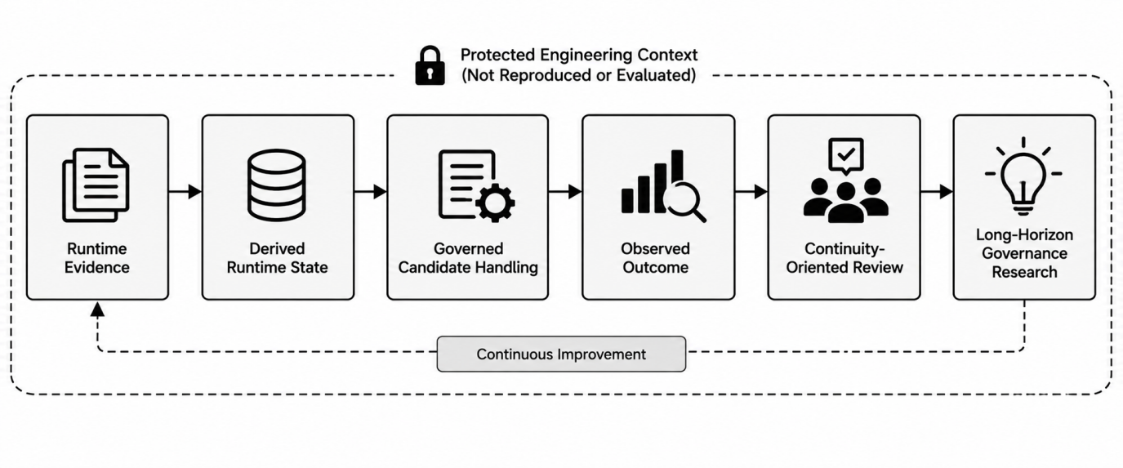
Figure 2 caption. This map is a high-level protected capability context. It does not disclose implementation architecture, algorithms, object schemas, relation computation, source code, internal state machines, method libraries, or operational records. It is not experimental evidence for this note.

5.7 Release Status
The implementation has been tested under:
Python 3.9 → 14 tests passed
Python 3.13 → 14 tests passed
At the time of this draft, the implementation remains local.
The reference implementation is prepared for controlled public release.
This note does not claim that a public GitHub repository is currently available.

6. Experimental Protocol and Semantic Ablation Design

6.1 Experimental Objective
The purpose of the experiment is not to estimate an empirical safety rate.
The question is:
Does the deterministic reference implementation conform to the governance semantics declared before execution?
The experimental protocol therefore uses fixed, predeclared cases.

6.2 Fixed Cases

Table 1. Predeclared Fixed Cases
ID | Input variation | Expected decision | Expected observation | Simulated effect
C1 | Valid evidence, state version, policy, and authorized subject | ALLOW | APPLIED | Yes
C2 | Subject not authorized by policy | DENY | NOT_RUN | No
C3 | Required evidence missing | DEFER | NOT_RUN | No
C4 | Higher-risk candidate requiring higher authority | ESCALATE | NOT_RUN | No
C5 | Candidate allowed, simulated execution fails | ALLOW | FAILED | No state advancement
C6 | Replay of same bound lineage | Verification succeeds | No new execution | No second effect
I1 | Agent attempts direct tool request through public API | DENY | NOT_RUN | No
C1 establishes the admitted success path.
C2 tests subject authorization.
C3 distinguishes insufficient evidence from denial.
C4 tests escalation without execution.
C5 tests the critical distinction:
ALLOW ≠ APPLIED
C6 tests replay without re-execution.
I1 tests the public API boundary.

6.3 Semantic Ablation Baseline
To distinguish the contribution of individual lineage bindings from the overall control flow, this note executes a deliberately reduced semantic baseline.
The executed reduced baseline removes:
evidence binding
state-version binding
observation-aware state advancement
replay-binding constraints
The purpose is not to compare against OPA, OpenShell, or another external product.
It asks a narrower question: if a semantic binding is removed from this same reference model, which declared property is no longer checked?
If a semantic binding is removed from this same reference model, which declared property can no longer be checked?
The four deterministic ablation cases were executed under Python 3.9 and Python 3.13. They show that omitting evidence-context binding accepts wrong-object or wrong-version evidence; omitting current-state-version binding accepts a stale candidate; omitting observation-aware advancement advances the simulated state after FAILED; and omitting bound-lineage replay leaves historical replay not checkable. These are within-model semantic-ablation results, not comparative safety results.

6.4 Integrity and Negative Tests

Table 2. Integrity and Negative Verification
Test | Modification | Expected result | Current status
Evidence Binding Mismatch | Evidence object or version does not match candidate context | DENY | Demonstrated
Policy Snapshot Drift | Replay uses changed policy snapshot/version | Replay Verification fails | Demonstrated
Record Tampering | Stored Lineage Record modified | Record Fingerprint validation fails | Demonstrated
Direct Tool Bypass | Agent requests direct tool invocation through public API | DENY → NOT_RUN | Demonstrated
Replay Without Re-execution | Valid record is replayed | Verify lineage; do not call executor again | Demonstrated
Idempotency Bound Input Conflict | Candidate, evidence, policy, or original state differs under the same idempotency key | DENY; no second effect | Demonstrated

7. Property Verification Results

7.1 Fixed-Case Results
The runner produced:
expected decision agreement = 7/7
expected observation agreement = 7/7
replay verification = 1/1
The same reference implementation passed:
Python 3.9 → 14/14 tests
Python 3.13 → 14/14 tests
The reference implementation matched all predeclared fixed cases.
The result demonstrates conformance of this deterministic reference model to its declared protocol.
These values are protocol-conformance counts, not estimated real-world safety percentages.

7.2 Governance Property Matrix

Table 3. Property Verification Matrix
Governance property | Reference implementation | Reduced ablation baseline | Supported conclusion
Candidate precedes controlled execution | PASS | NOT APPLICABLE: this binding was retained | Candidate/execution separation is demonstrated in the reference path
Wrong-object or wrong-version evidence does not support transition | PASS | FAIL: wrong evidence accepted without object/version check | Evidence-context binding has observable control semantics in the reference model
Policy drift invalidates historical replay | PASS | NOT CHECKABLE: no bound lineage replay verifier | Replay identity is bound to the policy snapshot in the reference model
Modified lineage record fails fingerprint validation | PASS | NOT CHECKABLE: no bound lineage record | Stored lineage integrity is checked in the reference model
ALLOW → FAILED does not advance state | PASS | FAIL: state advanced without checking FAILED | Admission is not conflated with successful application
Replay does not trigger a second execution | PASS | NOT CHECKABLE: replay semantics absent | Verification of history is separated from re-execution
Public API direct-tool request is rejected | PASS | NOT APPLICABLE: API boundary was retained | Agent-facing API does not expose the controlled execution path
Stale candidate state version is checked before execution | PASS | FAIL: stale candidate accepted without current-version check | State-version binding has observable control semantics in the reference model
The executed ablation establishes only this within-model result: each removed binding corresponds to a governance property that the reduced baseline no longer checks. It does not establish a comparative security result for any external product.

7.3 ALLOW Does Not Mean Success
C5 is a central result.
The candidate receives:
Decision = ALLOW
but the controlled executor returns:
Observation = FAILED
The simulated state does not advance.
Therefore:
ALLOW ≠ APPLIED
is not merely documentation; it is represented in the tested behavior.

7.4 DEFER Is Not DENY
C3 returns:
DEFER → NOT_RUN
The reference model therefore represents evidence insufficiency separately from a definitive negative authorization result.
This distinction matters because a candidate may be unresolved without being permanently prohibited.

7.5 ESCALATE Is Not Implicit Approval
C4 returns:
ESCALATE → NOT_RUN
Escalation is therefore represented as a governance outcome requiring a different authority path, not as an implicit success.

7.6 Replay Integrity
The replay verifier checks the identity of:
Candidate
State
Evidence
Policy
Lineage Record
A changed Policy Snapshot causes replay verification to fail.
Tampering with the Lineage Record causes Record Fingerprint verification to fail.
Replay itself does not invoke the controlled executor.

7.7 Interpretation Boundary
The fixed results demonstrate only what the declared protocol tests.
They do not demonstrate:
real external-tool security
generalization to unseen tasks
robustness against hostile same-process code
kernel-level bypass resistance
production performance
independent security certification
real business-state safety

8. Related Work
State-transition governance overlaps with several established research and engineering areas, but this note does not claim to replace them.

8.1 Authorization and Capability Security
Classical protection work established the importance of protected objects, controlled authority, mediation, least privilege, and capability-oriented access to resources. Dennis and Van Horn described protected and shared computational objects in multiprogrammed systems, while Saltzer and Schroeder articulated foundational information-protection principles such as least privilege and complete mediation. [1,2]
NIST's ABAC model determines authorization by evaluating subject, object, operation, and environmental attributes against policy. This means that using contextual state in an authorization decision is not, by itself, novel. The narrower distinction in this note is that a proposed state transition, its pre-state version, supporting evidence, later observation, and replay lineage are bound as one governance object. [5]

8.2 Runtime Policy Enforcement
Schneider's work on enforceable security policies formalized the class of policies enforceable through execution monitoring and security automata. [3]
Open Policy Agent is a general-purpose policy engine that receives structured input, evaluates it against policy and data, and deliberately separates policy decision-making from application-side enforcement. The present note therefore does not argue that policy engines are unable to inspect state or context. Its narrow distinction is the explicit lifecycle of the Candidate Transition through evidence binding, observation, and replay lineage. [7]

8.3 State-Machine and Workflow Modeling
State-transition systems and state machines are long-established tools for modeling reactive systems. Harel's Statecharts introduced hierarchy, concurrency, and communication as extensions to conventional state-transition diagrams. [4]
The contribution of the current note is therefore not the idea of representing state transitions. It is the governance binding around an agent-induced candidate transition: evidence, pre-state identity, policy snapshot, admission result, controlled execution, observation, and replay lineage.

8.4 Provenance and Auditability
W3C PROV-DM is a general conceptual model for describing provenance of entities, activities, agents, derivations, and responsibility. [6]
The present model uses provenance-like ideas but connects them specifically to an ex-ante governance decision and a later observed execution outcome.

8.5 Agent Runtime Enforcement and Privilege Control
AgentSpec defines a domain-specific language for triggers, predicates, and runtime enforcement mechanisms for LLM agents and was published in the ICSE 2026 Research Track. [8]
Progent focuses on programmable least-privilege policies over LLM-agent tool calls and deterministic privilege constraints. [9]
CaMeL separates trusted control flow from untrusted data flow and applies capabilities to prevent unauthorized information flows and prompt-injection-induced tool misuse. [10]
These works demonstrate that structured runtime control of agent behavior is an active research area. No experimental superiority over these systems is claimed here.

8.6 Sandboxing and External Enforcement
NVIDIA OpenShell is an execution-security system for autonomous agents. Its documented architecture separates the sandboxed agent workload from trusted supervisory components and applies policy to files, system calls, network connections, and credentials. [11]
The present reference implementation does not reproduce such OS- or kernel-level guarantees.
The conceptual relationship is therefore:
Execution / Resource Enforcement
+
Semantic State-Transition Governance
rather than substitution.

8.7 Precise Difference Summary

Table 4. Relationship to Adjacent Approaches
Category | Representative work and scope |  | Narrow distinction studied here
ABAC | NIST SP 800-162  Scope: Authorization using subject/object/action/environment attributes  Not claimed to replace: Enterprise access control |  | Candidate transition is bound to pre-state, evidence, observation, and lineage
Policy Engine | OPA  Scope: General structured policy decision  Not claimed to replace: Policy languages or PDP/PEP architecture |  | State, evidence, decision, observation, and replay form one governance lineage
Provenance | W3C PROV  Scope: Origin, derivation, responsibility, history  Not claimed to replace: General provenance models |  | Provenance-like records are tied to ex-ante admission and post-execution observation
State Machines | Statecharts  Scope: State-transition specification and reactive behavior  Not claimed to replace: State-machine formalisms |  | Governance semantics around an agent-induced candidate transition
Agent Runtime Enforcement | AgentSpec, Progent, CaMeL  Scope: Runtime constraints, tool privileges, injection defense  Not claimed to replace: Agent security frameworks |  | ALLOW ≠ APPLIED, evidence/state binding, and non-reexecuting lineage replay
Sandbox / Runtime Isolation | OpenShell  Scope: File/process/network/credential confinement  Not claimed to replace: Kernel, sandbox, or credential isolation |  | Semantic eligibility and traceability of a candidate state change

9. Limitations and Responsible Disclosure

9.1 Fixed Deterministic Case Set
The evaluation contains a small fixed case set.
The result:
7/7
does not mean:
100% real-world safety
universal correctness
generalization
adversarial robustness
It means only that the implementation matched all seven predeclared cases.

9.2 Simulated Executor
The controlled executor is purely in memory.
No conclusion can therefore be drawn about safe governance of:
real APIs
filesystems
shell commands
databases
networks
physical actuators
production workflows

9.3 API Boundary Is Not Process Isolation
The Agent Gateway rejects direct-tool requests made through the public API.
This does not prove protection from malicious same-process code with equivalent Python runtime authority.

9.4 No Hidden-Reasoning Claim
No LLM Chain-of-Thought is read, reconstructed, interpreted, or evaluated.
The term white-box refers only to the governance lineage of the external state transition.

9.5 No Comparative Product Benchmark
This release does not experimentally compare against:
OPA
NVIDIA OpenShell
AgentSpec
Progent
CaMeL
commercial policy engines
No superiority claim is made.

9.6 No Method-Evolution Chain
The following chain is out of scope:
Episode
→ Pattern
→ Skeleton
→ Method
→ Operator

9.7 No Unsupported Metadata
This note does not rely on fields such as:
unvalidated confidence scores
M17 or other undeployed method IDs
unpublished philosophical-rule mappings
unvalidated method promotion states

9.8 No Production or Certification Claim
The implementation is not claimed to be:
production-ready
independently security-certified
externally validated
kernel-enforced
hardware-isolated
a complete agent safety system

9.9 Evidence Trust Boundary
Evidence fingerprints and version binding establish consistency within the reference model.
They do not prove that the evidence source itself is honest or uncompromised.

9.10 Protected-System Boundary
The protected engineering context is not a substitute for public reproducibility, external validation, or comparative evidence.
It is presented only to explain the engineering motivation and scope of protected follow-on work.
The evidence categories in this note must therefore remain distinct:
DEMONSTRATED_IN_REFERENCE_IMPLEMENTATION
→ may support Results and Conclusion.

INTERNALLY_IMPLEMENTED_NOT_PUBLICLY_REPRODUCED
→ may describe engineering context only.

RESEARCH_DIRECTION
→ may appear only as future work or discussion.
A capability must not be promoted from one category to another without new evidence.

9.11 Public-Release Boundary
The reference implementation is prepared for controlled public release but is not described here as already available on GitHub.
Before publication, the release should freeze the exact:
source version
test receipts
manifest
file checksums
license
release tag
public disclosure boundary

10. Conclusion
This work establishes a minimal reference model prepared for controlled public release.
It demonstrates specified governance properties only within a deterministic, side-effect-free reference environment.
A larger protected engineering context motivates future integration, continuity, and long-horizon governance research, but those capabilities are not claimed, reproduced, or evaluated here.
The central semantic distinction is:
Proposal
≠ Admission
≠ Execution
≠ Observed Success
and therefore:
Candidate ≠ Commit
ALLOW ≠ APPLIED
The purpose of the model is not to solve agent safety in general. It provides a small, inspectable governance unit for asking a more precise question:
Under this state, this evidence, and this policy snapshot, was this proposed transition eligible to proceed, what happened after admission, and can that lineage later be verified without repeating the effect?
The reference implementation is prepared for controlled public release.
Collaboration inquiries concerning protected engineering capabilities may be directed to the corresponding author.

References
[1] J. B. Dennis and E. C. Van Horn, “Programming Semantics for Multiprogrammed Computations,” Communications of the ACM, vol. 9, no. 3, pp. 143–155, 1966. https://doi.org/10.1145/365230.365252.
[2] J. H. Saltzer and M. D. Schroeder, “The Protection of Information in Computer Systems,” Proceedings of the IEEE, vol. 63, no. 9, pp. 1278–1308, 1975. https://doi.org/10.1109/PROC.1975.9939.
[3] F. B. Schneider, “Enforceable Security Policies,” ACM Transactions on Information and System Security, vol. 3, no. 1, pp. 30–50, 2000. https://doi.org/10.1145/353323.353382.
[4] D. Harel, “Statecharts: A Visual Formalism for Complex Systems,” Science of Computer Programming, vol. 8, no. 3, pp. 231–274, 1987. https://doi.org/10.1016/0167-6423(87)90035-9.
[5] V. C. Hu et al., Guide to Attribute Based Access Control (ABAC) Definition and Considerations, NIST SP 800-162, 2014, updated 2019. https://doi.org/10.6028/NIST.SP.800-162.
[6] L. Moreau and P. Missier, eds., PROV-DM: The PROV Data Model, W3C Recommendation, 30 April 2013. https://www.w3.org/TR/prov-dm/.
[7] Open Policy Agent Project, Open Policy Agent Documentation, accessed October 2026. https://www.openpolicyagent.org/docs/latest/.
[8] H. Wang, C. M. Poskitt, and J. Sun, “AgentSpec: Customizable Runtime Enforcement for Safe and Reliable LLM Agents,” in ICSE ’26, 2026. https://doi.org/10.1145/3744916.3764546.
[9] T. Shi et al., “Progent: Securing AI Agents with Privilege Control,” arXiv:2504.11703, 2025. https://arxiv.org/abs/2504.11703.
[10] E. Debenedetti et al., “Defeating Prompt Injections by Design,” arXiv:2503.18813, 2025. https://doi.org/10.48550/arXiv.2503.18813.
[11] NVIDIA, OpenShell Architecture, accessed October 2026. https://docs.nvidia.com/openshell/about/architecture.

Appendix A. Lineage Record Schema
lineage_record:

candidate_transition:
value: <candidate transition>
fingerprint: <candidate fingerprint>

state_snapshot:
value: <pre-state snapshot>
fingerprint: <state fingerprint>

evidence:
value: <bound evidence>
fingerprint: <evidence fingerprint>

policy_snapshot:
value: <policy snapshot>
fingerprint: <policy fingerprint>

governance:
decision: ALLOW | DENY | DEFER | ESCALATE
reason_code: <reason code>

controlled_execution:
agent_has_executor_handle: false
external_side_effects: false
attempted: true | false

observation:
status: APPLIED | FAILED | UNKNOWN | NOT_RUN

state_after:
value: <simulated state>

record_fingerprint:
value: <record fingerprint>
The schema reflects three tested semantic distinctions:
Agent proposal does not directly invoke execution.

ALLOW does not imply APPLIED.

Replay verification does not repeat execution.

Appendix B. Fixed Cases and Expected Outcomes
ID | Condition | Decision | Observation | State advances?
C1 | Valid bound transition | ALLOW | APPLIED | Yes
C2 | Unauthorized subject | DENY | NOT_RUN | No
C3 | Missing evidence | DEFER | NOT_RUN | No
C4 | Higher-risk transition | ESCALATE | NOT_RUN | No
C5 | Admitted transition, simulated execution fails | ALLOW | FAILED | No
C6 | Same bound lineage replayed | Verification succeeds | No new execution | No
I1 | Direct tool request | DENY | NOT_RUN | No

Appendix C. Claims-to-Evidence Matrix
Claim | Supporting evidence | Evidence status
Candidate submissions precede controlled execution | Reference path + C1/C5 | DEMONSTRATED_IN_REFERENCE_IMPLEMENTATION
Public Agent Gateway does not expose direct executor use | I1 | DEMONSTRATED_IN_REFERENCE_IMPLEMENTATION
Unauthorized subject does not execute | C2 | DEMONSTRATED_IN_REFERENCE_IMPLEMENTATION
Missing evidence leads to non-execution | C3 | DEMONSTRATED_IN_REFERENCE_IMPLEMENTATION
Higher-risk candidate can escalate without execution | C4 | DEMONSTRATED_IN_REFERENCE_IMPLEMENTATION
ALLOW does not imply state advancement | C5 | DEMONSTRATED_IN_REFERENCE_IMPLEMENTATION
Only APPLIED advances simulated state | C1 + C5 | DEMONSTRATED_IN_REFERENCE_IMPLEMENTATION
Replay does not cause a second effect | C6 | DEMONSTRATED_IN_REFERENCE_IMPLEMENTATION
Wrong evidence object/version is rejected | Negative test | DEMONSTRATED_IN_REFERENCE_IMPLEMENTATION
Policy drift invalidates replay | Negative test | DEMONSTRATED_IN_REFERENCE_IMPLEMENTATION
Record tampering is detected by record-fingerprint check | Negative test | DEMONSTRATED_IN_REFERENCE_IMPLEMENTATION
Results reproduce across Python 3.9 and 3.13 | 14 tests on each version | DEMONSTRATED_IN_REFERENCE_IMPLEMENTATION
Protected system contains broader runtime-governance capabilities | Capability-level engineering context only | INTERNALLY_IMPLEMENTED_NOT_PUBLICLY_REPRODUCED
Long-horizon governance integration | Future research | RESEARCH_DIRECTION
Episode→Pattern→Method→Operator evolution | Not evaluated in this note | RESEARCH_DIRECTION
Production external-side-effect safety | No supporting evidence | Excluded
Kernel-level bypass prevention | No supporting evidence | Excluded
Superiority over OPA/OpenShell/AgentSpec/etc. | No comparative experiment | Excluded
Changed bound input under same idempotency key is rejected | Negative subcases in replay test | DEMONSTRATED_IN_REFERENCE_IMPLEMENTATION

Appendix D. Unsupported Claims Excluded
The following statements are intentionally excluded from this paper:
- “The system proves safe AI agents.”
- “The system is production-ready.”
- “The system prevents all bypasses.”
- “The system governs real external side effects.”
- “The system outperforms policy engines.”
- “The system outperforms NVIDIA OpenShell.”
- “The system provides kernel- or hardware-level enforcement.”
- “The system exposes or explains LLM chain-of-thought.”
- “7/7 means a 100% real-world safety rate.”
- “The results prove generalization.”
- “The implementation has been independently security-certified.”
- “The protected engineering system has been publicly reproduced.”
- “The complete method-evolution chain is demonstrated by this paper.”
- “The semantic ablation baseline has already been experimentally validated.”
- “ALLOW proves that an external state change succeeded.”
- “Replay proves the original external effect by executing it again.”

Appendix E. Release Metadata
Item | Release status
Author | 万根
Affiliation | Independent Researcher
Release version | 0.2.2
Citation metadata | CITATION.cff
Code and paper license | LICENSE.md
Public contact channel | 593315006@qq.com
Public GitHub repository | Published separately with this release
Git tag | v0.2.2-reference-demo after contact-update freeze
Zenodo record and DOI | Not yet created
Release manifest and checksums | Generated in this release package
Protected-capability overview | Included without protected implementation detail
Patent and public-disclosure boundary | Requires independent legal review before publication

