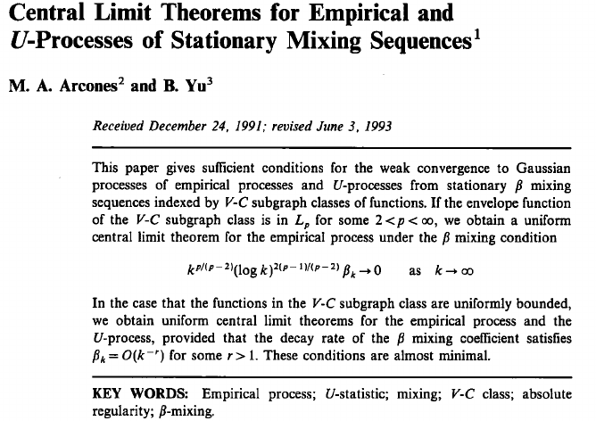

Convergene in probability

The sequence of random variables converges to the random variable in probability (notation in pr.) if
Proposition
(AS convergence vs convergence in pr 1) Almost sure convergence implies convergence in probability.
(AS convergence vs convergence in pr 2) Convergence in probability implies existence of a subsequence that converges almost surely to the same limit.

VC class of sets

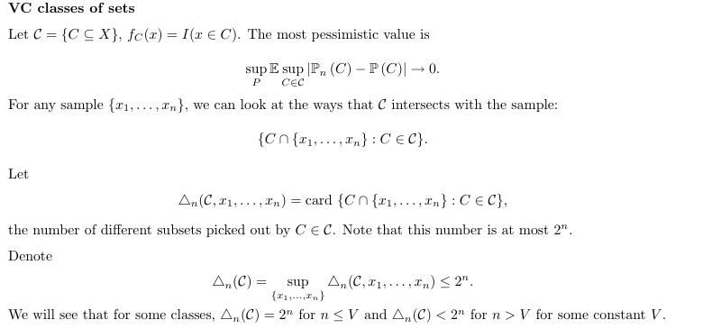
pick out: a class of subset C picked out a subset s of another set S, if there exists a set s' in the class such that the subset picked up is the intersection between the set and the
shatter
shatter
VC class, VC dimension
Sauer's lemma:

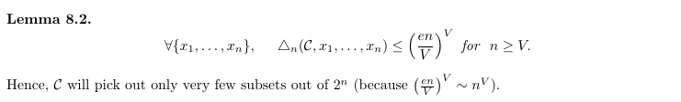
number of subsets picked out is bounded by number of subsets shattered.

Examples of VC class:

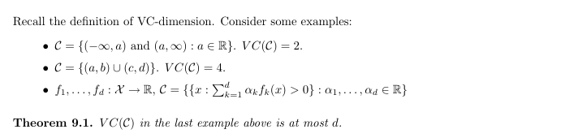

VC class operations:
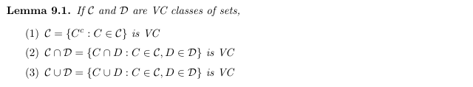
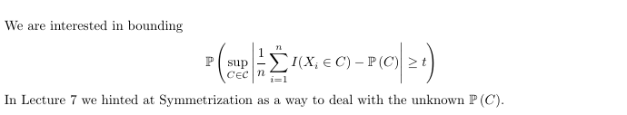
Hoeffding's inequality:

Let X1, ..., Xn be independent random variables. Assume that the Xi are almost surely bounded; that is:

We define the empirical mean of these variables

Theorem 2 of Hoeffding (1963) proves the inequalities

which are valid for positive values of t. Here E[X] is the expected value of X. The inequalities can be also stated in terms of the sum

of the random variables:

Note that the inequalities also hold when the Xi have been obtained using sampling without replacement; in this case the random variables are not independent anymore. A proof of this statement can be found in Hoeffding's paper. For slightly better bounds in the case of sampling without replacement, see for instance the paper by Serfling (1974).

