Pediatric Pneumonia Diagnosis: Integration of a Self-Assembled Digital Stethoscope with Raspberry Pi and 1D CNN Model
Sowrav Chowdhury
Department of Electrical and
Electronics Engineering,
University of Liberal Arts Bangladesh
688, Beribadh Road, Mohammadpur,
Dhaka, Bangladesh
sowrav.chowdhury.eee@ulab.edu.bd
Tammim Shahara Rafa
Department of Electrical and Electronics Engineering,
University of Liberal Arts Bangladesh, 688, Beribadh Road, Mohammadpur, Dhaka-1205, Bangladesh; tammim.shahara.eee@ulab.edu.bd
A. B. M. S. U. Doulah
Department of Electrical and Electronics Engineering,
University of Liberal Arts Bangladesh, 688, Beribadh Road, Mohammadpur, Dhaka-1205, Bangladesh; abul.sayeed@ulab.edu.bd
Mirza Rasheduzzaman
Department of Electrical and Electronics Engineering,
University of Liberal Arts Bangladesh, 688, Beribadh Road, Mohammadpur, Dhaka-1205, Bangladesh; mirza.rasheduzzaman@ulab.edu.bd

Globally, pneumonia is the leading infectious killer of children under five, accounting for 14% of all deaths. Approximately, three children die every hour from pneumonia in Bangladesh, which accounts for 24% of all childhood deaths- exceeding the global average of 24,000. These deaths are preventable with early detection of pneumonia, which is commonly done by radiologic imaging but is often not accessible to remote areas. Another diagnostic technique is through auscultation of lungs using a stethoscope, although it is subject to human errors, environmental noise and can be misdiagnosed. Hence, in our work a self-assembled digital stethoscope integrated with Raspberry-Pi, a pocket-size computer is used to analyze and predict pneumonia. In the study, a database was developed from 10 pneumonia-infected and 9 healthy subjects, collecting a total of 72 samples from multiple chest locations. The dataset was preprocessed and augmented through methods like noise addition, time stretching, and pitch shifting to simulate varied real-world scenarios. A 1D-Convolutional Neural Network (CNN) model was trained to identify patterns in the lung sounds indicative of pneumonia. The audio data was represented as feature vectors, including Mel-Frequency Cepstral Coefficients (MFCCs) and Zero Crossing Rate (ZCR). The CNN model comprised convolutional, pooling, and fully connected layers, with dropout layers to prevent overfitting and SoftMax activation in the output layer for probabilistic predictions. After rigorous training and testing, the model achieved an accuracy of around 86%, demonstrating its potential in early detection of pneumonia.
Keywords— Pediatric Pneumonia, Digital Stethoscope, Childhood Mortality, Machine Learning, Convolutional Neural Network

Introduction
Pneumonia remains one of the most formidable health challenges globally, particularly affecting children under five years. According to the World Health Organization (WHO), it is responsible for roughly 14% of all deaths in this age group, with a staggering 740,180 children losing their lives to pneumonia in 2019 alone. While the impact of pneumonia is felt worldwide, the burden is disproportionately high in regions like southern Asia and sub-Saharan Africa, where healthcare systems often struggle with limited resources [1]. In Bangladesh, the scenario is direr, approximately 2 to 3 children die every hour from pneumonia, leading to an annual death toll of 24,000. This accounts for 24% of all deaths among children under the age of five, a rate that exceeds the global average [2]. The continued prevalence of pneumonia as a major cause of child mortality underscores the critical need for more effective methods of diagnosis and treatment, particularly in areas where resources are scarce.
Traditional techniques for diagnosing pneumonia, which predominantly rely on clinical assessments and radiographic imaging, face multiple challenges. These include inaccuracy in diagnosis, limited access to necessary diagnostic tools in low-resource settings, and practical difficulties in their implementation. Moreover, the conventional method of listening to lung sounds through a stethoscope known as auscultation is inherently subjective and prone to variability between different listeners. This variability in interpretation can lead to inconsistent and unreliable diagnoses, complicating the management and treatment of pneumonia effectively [3], [4].
The advancement of digital stethoscope technology marks a significant leap forward in diagnosing respiratory diseases, offering capabilities to record and electronically amplify lung sounds for a more precise and comprehensive analysis than traditional methods. Despite their potential to transform diagnostics with objective evaluations, the widespread adoption of these devices is hindered by their high cost, averaging around US $500 per unit, making them prohibitive for many healthcare providers in developing countries [5]. Moreover, their effectiveness and reliability in pediatric medicine remain under investigation, necessitating further research and validation [6]. In response to these challenges, a study [7] has explored the feasibility of self-assembled digital stethoscopes by modifying three low-cost conventional stethoscopes to assess whether the data collected is robust enough to support the development of a ML model, aiming to make this technology more accessible and validate its efficacy in clinical settings.
In response to the urgent need for effective pneumonia diagnosis in resource-constrained settings, our research introduces a pioneering, cost-effective solution by integration of a self-assembled digital stethoscope with Raspberry Pi 4. This approach utilizes the computational power of the Raspberry Pi 4 for on-site lung sound data processing, essential for prompt and accurate diagnosis. Central to our method is the application of 1D CNN model to this digital stethoscope system, aiming to reduce the subjective variability that undermines traditional auscultation. Motivated by the scarcity of accessible diagnostic tools in under-resourced areas, our model, validated with data from 19 pediatric subjects (10 with pneumonia and 9 healthy), underwent comprehensive processing steps including amplification, filtration, normalization, and expert validation, enhanced by advanced data augmentation to refine the ML model's precision. The success of our system in diagnosing pneumonia not only confirms its efficacy but also its scalability and viability as a solution in settings lacking in resources.

Literature Review
The emergence of digital stethoscopes marks a significant advancement in the field of respiratory sound analysis. These modern devices enhance clinicians' ability to record, store, and analyze lung sounds, addressing critical limitations inherent in traditional stethoscopes, such as background noise interference and subtle sounds of crackles and wheezes present while inhalation and exhalation. The integration of digital stethoscopes with advanced signal processing techniques, like empirical mode decomposition (EMD) and discrete wavelet transforms (DWT), has refined lung sound data quality and improved disease classification accuracy. In a study by Naqvi and Choudhry [8] exemplify this progress, showcasing the potential of these technologies in clinical applications.
The early use of ML techniques has shown promise in identifying single lung disorders from lung sound analysis of adventitious sounds, as highlighted in studies by Rabe [9] and others. This approach to lung sound analysis, particularly through electronic auscultation, provides a non-invasive and cost-effective alternative to traditional imaging diagnostics. In this realm, the research contributions of Reichert et al. [10] and Bellos et al. [11] are particularly noteworthy. They underscore the potential of ML in this domain, while also acknowledging the challenges it faces, such as model overfitting and the need for extensive, well-labeled datasets.
Further enriching this field in recent times is the integration of Artificial Intelligence (AI) algorithms with digital stethoscope technology, a development explored in the works of Aziz et al. [12] and Shaikh et al. [13]. This synergy signifies a major stride in respiratory disease diagnosis, exemplified by the capacity of AI to detect pathological pediatric breath sounds accurately. It also leads to the development of economical diagnostic systems like the "Stetho-phone," which are particularly beneficial for healthcare in remote areas. Such integration is crucial for creating accessible and reliable healthcare solutions.
Adding to these developments, a recent study utilized real-world lung sounds from outpatient clinics for its machine learning model, achieving impressive results. The model demonstrated over 80% accuracy in internal validation and more than 90% accuracy in distinguishing normal from wheezing sounds. What's particularly significant is that the model outperformed non-pediatrician physicians in three out of four diagnostic tasks [14]. This achievement illustrates the potential of ML not only in matching but surpassing the diagnostic capabilities of traditional medical practices. This represents a transformative shift in the approach to pediatric respiratory diagnostics, indicating a future where AI and ML are integral to medical diagnostics and patient care. Despite these advancements, challenges remain, such as device-dependent performance variations in AI algorithms, highlighted by Aziz et al. [12] and Shen et al. [15]. Addressing these limitations, standardizing methodologies, and safely integrating AI into clinical practice are pivotal for advancing the field. Additionally, the subjective nature of adventitious sounds like coughs, as discussed by Khan and Ahmed [16], adds complexity to the detection of pneumonia and other lung illnesses.
According to the study [17], researchers propose a stacked ensemble learning approach for pediatric pneumonia classification, utilizing deep learning-based characteristics with a focus on dimensionality reduction through the Xception model's global average pooling layer. The approach incorporates a variety of classifiers, achieving an accuracy of 98.3% on a publicly available dataset. Concurrently, another study [18] delves into the challenges of diagnosing pediatric pneumonia using chest X-ray images, proposing a computer-aided diagnosis (CAD) model that enhances accuracy and performance through ensemble learning and deep CNN architectures with channel attention. While this research emphasizes the efficacy of X-ray images and a stacking classifier, our study diverges by focusing on lung auscultations as a diagnostic tool for pediatric pneumonia, especially in remote areas where radiographic imaging may not be accessible, highlighting a complementary pathway to traditional imaging techniques.
The rest of the manuscript is organized as following, Section III-provides a foundation by detailing the development of the digital stethoscope, data collection protocols, and raw data processing techniques. Section IV- elaborates on the machine learning algorithm employed, specifically the application of a 1D CNN model. The results of the study are thoroughly discussed in Section V, which leads into Section VI, where a detailed discussion on the implications, limitations, and significance of the findings is presented. The document concludes with Section VII and Section VIII, outlining future research directions and summarizing the key conclusions drawn from the study.

Materials and Methodology

Digital Stethoscope Development
A key focus of this study, is to develop an advanced digital stethoscope is designed to fulfill several critical functions: reliably capturing, storing, and preprocessing lung auscultations. Building upon foundational work detailed in a prior research in [7], the authors of this paper embarked on the development of a digital stethoscope system. This initial effort not only laid the groundwork but also analyzed the viability of the proposed system for supporting the subsequent construction of a ML model. The construction process of this digital stethoscope entailed a thoughtful amalgamation of components, notably pairing an MDF-747 stethoscope with a BOYA-M1-Pro electret condenser microphone. This intricate assembly procedure involved precise modifications such as carefully cutting the stethoscope tube and securely housing the microphone within it, ensuring optimal functionality and durability. Subsequently, the microphone was seamlessly integrated with a Raspberry Pi, a credit to the adaptability of modern technology, facilitated by a 3.5mm to USB adapter. The resulting system represents a convergence of traditional medical instrumentation with cutting-edge computational capabilities, symbolizing a significant leap forward in the field of digital healthcare. For a comprehensive understanding of this assembly process, Figure 1 provides an illustrative guide, offering a clear visualization of each step involved in setting up this innovative digital stethoscope system.
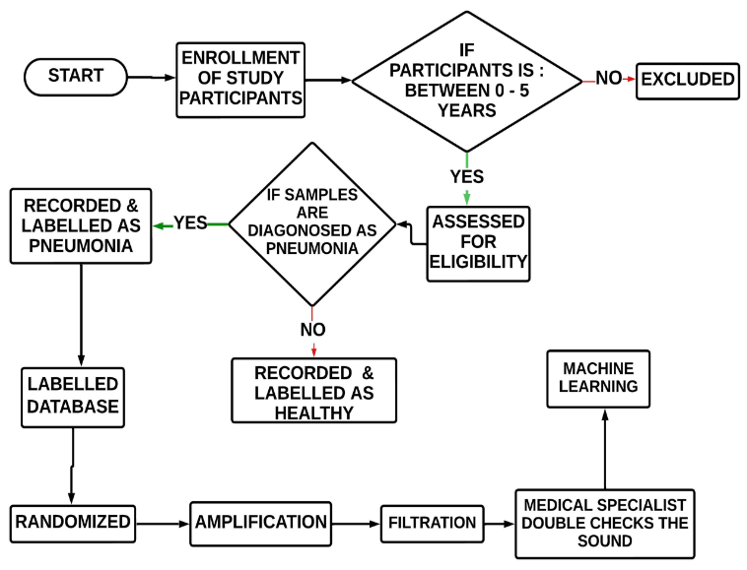
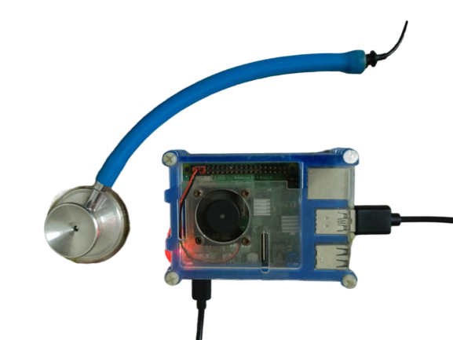
Fig. 1. Digital Stethoscope connection with microphone and Raspberry Pi

Data Collection
The core of our study involved precise data collection process, utilizing a self-assembled digital stethoscope. The device was vital for obtaining detailed lung sounds from a cohort of toddlers aged 0 to 5 years. In the study, incorporated
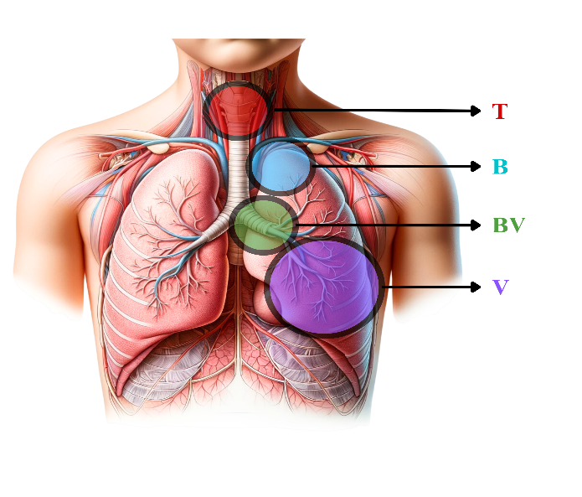
auscultations were at various key anatomical locations on each toddler. These locations are crucial for gathering a broad spectrum of lung sounds. Figure 2, shows the locations where data was collected. To ensure the well-being and comfort of our young participants, each auscultation session was intentionally brief, lasting just 2-3 minutes.
Fig. 2. Regions where data were collected from the subjects. T is tracheal, B is bronchial, BV is bronchovesicular, and V is vesicular.
The data thus collected culminated in a dataset comprising auscultation recordings from 19 toddlers, including 9 pneumonia-infected and 10 healthy subjects. However, the challenges of working with such a young demographic were evident as we had to exclude data from 3 subjects due to excessive environmental noise interference, therefore a total of 35 healthy and 37 pneumonia-infected auscultation samples were collected. The recordings were captured in WAV format at a high-fidelity sample rate of 44,100 Hz. This technical choice was strategic, as WAV files are renowned for preserving the original sound quality, a critical factor in ensuring the accuracy of our subsequent analysis. Each data samples were also verified, validated and doubled-checked by medical professional for accurate labelling.

Raw Data Processing
In our study, the raw data was processed using a specialized Thinklabs Phonocardiography software tailored for physiological sound processing. This phase commenced with meticulous filtering of the recordings, focusing on lung sound-relevant frequencies within a passband ranging from 280 Hz to 2300 Hz. Attention to detail extended to the transition regions to ensure a smooth frequency response curve and prevent signal distortion. Subsequently, we normalized the audio signals to a standardized range of -1 to 1 dB, ensuring uniform signal amplitudes across all recordings. Figure 3, illustrates our data collection, raw data processing and labelling process.
Fig. 3. Flowchart for Data Collection, Preprocessing and Labelling

Machine Learning
In the research, we have adopted a 1D Convolutional Neural Network (CNN) architecture, equipping it with the ability to identify distinct patterns and features extracted from respiratory audio data. The effectiveness of our model is intrinsically linked to the quality of the dataset used for both training and evaluation. We have rigorously preprocessed and augmented this dataset, encompassing a comprehensive range of respiratory conditions and healthy samples. Our model's architecture incorporates dropout layers to mitigate overfitting, while the final output layer utilizes SoftMax activation to provide probabilistic predictions for each class.
The data augmentation was crucial considering due to the dataset's relatively modest size. We employ three primary data augmentation techniques: random noise introduction, temporal stretching, and pitch shifting. These methods empower our model to handle variations in recording conditions and respiratory patterns, thereby bolstering its adaptability to real-world scenarios.
Feature extraction plays a pivotal role in our preprocessing pipeline, wherein we extract pertinent characteristics from audio data. Asuite of audio features were employed, including Mel-Frequency Cepstral Coefficients (MFCCs), Zero Crossing Rate (ZCR), Chromagram, Root Mean Square (RMS) Energy, and Mel Spectrogram. Collectively, these features furnish a multi-dimensional representation of respiratory sounds, endowing our machine learning model with the ability to discern variations and patterns indicative of distinct respiratory conditions.
The 1D CNN model comprises input layers for feature ingestion, multiple convolutional layers for feature extraction, max-pooling layers for spatial reduction, fully connected layers for decision-making, and an output layer for prediction. This architectural configuration enables our model to transform audio features into a concise representation amenable to classification, effectively capturing intricate patterns within the audio data. To ensure the effectiveness of model training and subsequent evaluation, we judiciously partition our dataset into distinct training (80%) and testing (20%) subsets. This partitioning strategy safeguards against data leakage and preserves the integrity of the evaluation process. Furthermore, we apply standard scaling, specifically z-score normalization, to our feature data as a preprocessing step. This standardization procedure serves to stabilize training, enhance model performance, and facilitate the efficient convergence of gradient-based optimization.
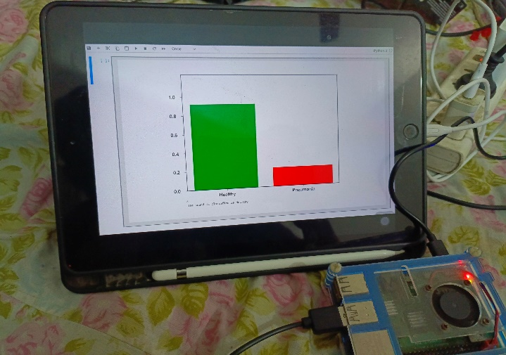
The 1D CNN undergoes categorical cross-entropy loss function, an appropriate choice for multi-class classification tasks. This loss function quantifies the degree of dissimilarity between predicted class probabilities and actual labels, guiding the model towards precise predictions. Our optimizer of choice is the Adam optimizer, renowned for its efficacy in gradient-based optimization. Furthermore, to prevent the issue of overfitting, we institute an early stopping mechanism. This
Fig. 4. iPad output of the prediction by the model
mechanism closely monitors the model's performance on a validation dataset during training and curtails training when early signs of overfitting emerge. After the model is trained an iPad is connected wirelessly to the Raspberry Pi using VNC server software. The trained model can now predict if a particular lung auscultation sample is healthy or not with the probability for each class. Figure 4 shows the representation of the iPad with the result.

Results
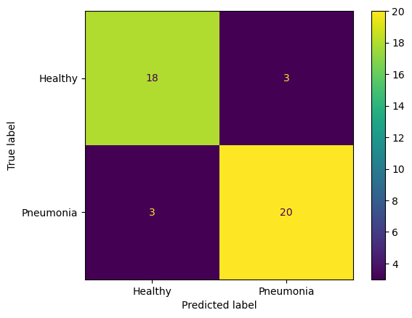
In this section, we provide a comprehensive evaluation of our specialized 1D CNN model's performance. We use a range of evaluative measures to assess its effectiveness. The confusion matrix in Figure 5, is a crucial tool for evaluating classification model performance. It provides a clear breakdown of the model's classifications compared to the true labels. In our case, we have 18 True Positives (TP) for the "Healthy" class, indicating that the model correctly identified
Fig. 5. Confusion Matrix
18 healthy instances. The "Pneumonia" class has 20 True Negatives (TN), indicating that the model correctly identified 20 instances of pneumonia. However, there were 3 False Positives (FP) when the model incorrectly labeled healthy instances as pneumonia, and 3 False Negatives (FN) when pneumonia cases were mislabeled as healthy. Evaluation metrics of the proposed method comprehend Accuracy, Precision, Recall, and F1 Score as shown in eqn. (1) – (4).
Accuracy: This measures the overall correctness of the model and is calculated as,
$\frac{TP+TN}{TP+TN+FP+FN}$…….………… (1)
$$\frac{18+20}{18+20+3+3}$$
The sum of TP and TN divided by the total number of instances. The accuracy of the model is 86.36%.
Precision for "Healthy": Precision assesses the proportion of positive identifications that were correct and is calculated as,
$\frac{TP }{TP+FP}$ …….……..…………. (2)
$\frac{TN }{TN+FN}$ ..….……………. …. (3)

For the "Healthy" class, the precision is ${18}/{18+3}$ ≈ 85.71%. Recall for "Pneumonia": Recall measures the proportion of actual positives that were correctly identified and is calculated as, For the "Pneumonia" class, the recall is ${20 }/{20+3}$ ≈ 86.96%.

F1 Score for "Healthy": The F1 Score is the harmonic mean of precision and recall, providing a balance between the two. It is calculated as,

$\frac{2 \left( Precision*Recall\right)}{Precision+Recall}$………………… . (4)

For the "Healthy" class, using the precision for "Healthy" and recall for "Pneumonia" (since we don't have recall for "Healthy", the F1 Score is approximately 86.31%.

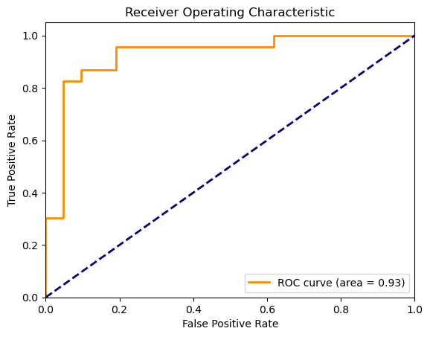
Receiver Operating Characteristics (ROC) Curve in Figure 6, is a fundamental tool for diagnostic test evaluation. The ROC curve illustrates the model's diagnostic ability, showing the trade-off between True Positive Rate (TPR) and False Positive Rate (FPR) at various thresholds. Our ROC curve exhibits rapid TPR increase with minimal FPR growth initially, indicating high sensitivity with low false positives. The area under the ROC curve, (AUC) is 0.93, signifying excellent discriminative ability.
Fig. 6. Receiver Operating Characteristics

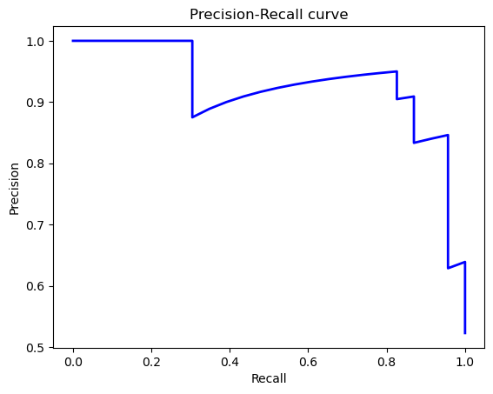
The Precision-Recall Curve, in Figure 7 evaluates the model's predictive performance across different thresholds. Notable aspects include the model's ability to maintain high precision even with increased recall. Precision remains above 0.7 for all levels of recall, demonstrating its value in maintaining precision while capturing more positive instances. This balance is crucial in medical applications like pneumonia detection.
Fig. 7. Precision-Recall Curve

Discussion
In this section, we discuss the results we achieved, the model's performance was thoroughly assessed using a variety of metrics derived from the confusion matrix, including accuracy, precision, recall, F1 score, and specificity. The accuracy of approximately 86.36% demonstrates the model's overall effectiveness in classifying the correct state of respiratory health.
The Confusion Matrix provides a detailed insight into the performance of our specialized 1D CNN for respiratory condition detection, with a specific focus on pneumonia. The model's overall accuracy of approximately 86.36% indicates its commendable ability to distinguish between "Healthy" and "Pneumonia" cases. However, a closer examination reveals that there is room for improvement in the classification of borderline cases, as evidenced by an equal number of false positives and false negatives. Achieving a balance between precision and recall is crucial in clinical applications, where misclassifications can have significant implications. Nonetheless, the precision of approximately 85.71% for the "Healthy" class and the recall of approximately 86.96% for the "Pneumonia" class highlight the model's potential for accurate diagnosis.
The ROC curve offers a visual representation of our model's diagnostic performance in pneumonia detection. The curve's rapid ascent, with a minimal increase in the FPR initially, underscores the model's ability to achieve high sensitivity while maintaining a low FPR. The curve's plateau near the top-left corner is indicative of consistently high TPR, which is advantageous in medical diagnostics, where missing a "Pneumonia" case can be critical. The AUC of 0.93 further affirms the model's excellent discriminative ability, making it a promising tool for clinicians. However, clinical validation is imperative to assess its real-world effectiveness.
The Precision-Recall curve provides a comprehensive assessment of our binary classifier's performance. It demonstrates that the model can maintain high precision even as recall increases, which is vital in medical applications such as pneumonia detection. The curve's consistent precision above 0.7 for all levels of recall suggests that the model can effectively balance precision and recall, ensuring accurate identification of positive cases without an undue increase in false positives. This balance underscores the model's robustness for supporting pneumonia diagnosis. However, further research involving diverse datasets and clinical scenarios is recommended to validate its performance comprehensively and assess its applicability in real-world healthcare settings.

Future Directions
In addressing the future trajectory of our project, it is essential to confront the current limitations head-on, particularly concerning the accuracy of our 1D CNN model. While our initial results are promising, achieving an accuracy that fully meets our aspirations remains a challenge. The key to unlocking higher levels of diagnostic precision lies in the expansion and diversification of our dataset. A more comprehensive dataset, characterized by a greater variety and balance of respiratory sounds, will enable the model to more accurately generalize across a wide array of patient demographics and conditions.

To this end, our primary focus will be on the systematic collection and incorporation of respiratory sound data from a broader and more diverse patient population. This effort will not only involve gathering a larger volume of data but also ensuring that the data accurately represents the spectrum of respiratory conditions, including various stages and severities of pediatric pneumonia. By achieving a dataset that mirrors the real-world diversity of patient cases, we anticipate a significant improvement in the model's ability to diagnose pneumonia with higher accuracy and reliability.

Furthermore, we recognize the importance of continuously exploring and evaluating advanced machine learning and deep learning architectures beyond the 1D CNN. Innovations in algorithmic approaches and model architectures may offer new avenues for enhancing the diagnostic capabilities of our system. Parallel to these technical advancements, we will undertake rigorous clinical validation studies to ensure that the enhancements in our model translate into tangible improvements in real-world healthcare settings.

Conclusions
Our project contributes to the ongoing efforts in pediatric healthcare by enhancing the diagnosis of pneumonia in children, especially within resource-limited settings. At its core, the initiative has been driven by two primary motivations. The first is the development of a state-of-the-art digital stethoscope, engineered to capture lung sounds with unprecedented clarity and precision. This device, by virtue of its innovative design and integration with Raspberry Pi technology, enables the rapid on-site analysis of lung sounds. This capability is crucial for identifying anomalies that are indicative of pneumonia and other respiratory conditions, thereby facilitating timely intervention.

The second motivation behind our work is to offer a diagnostic tool that is not only highly effective but also accessible and affordable. The integration of the digital stethoscope with Raspberry Pi technology embodies our commitment to creating a solution that leverages cutting-edge technology for the benefit of populations most in need, particularly in under-resourced areas. This approach aligns with our broader vision of democratizing access to quality healthcare and contributing to the global effort to reduce child mortality rates associated with respiratory diseases.

Through our research, we aim to bridge a critical gap in pediatric healthcare by providing a tool that enhances the early detection and accurate diagnosis of pneumonia. Recognizing the limitations of our current model, we are dedicated to pursuing a comprehensive research and development strategy. This strategy includes expanding our dataset, exploring new machine learning architectures, and conducting extensive clinical validation. Our ultimate goal is to deliver a diagnostic solution that not only meets but exceeds the expectations of healthcare providers worldwide, offering a new standard in the timely and accurate diagnosis of pediatric respiratory conditions.

References
- “Child mortality (under 5 years),” Jan. 28, 2022. https://www.who.int/news-room/fact-sheets/detail/levels-and-trends-in-child-under-5-mortality-in-2020
- icddr,b, "Childhood Pneumonia: Are we doing enough?," Press release, icddr,b, Dhaka, [Nov. 9, 2023]. Available: https://www.icddrb.org/quick-links/press-releases?id=180&task=view
- J. P. Metlay et al., “Diagnosis and Treatment of Adults with Community-acquired Pneumonia. An Official Clinical Practice Guideline of the American Thoracic Society and Infectious Diseases Society of America,” American Journal of Respiratory and Critical Care Medicine, vol. 200, no. 7, pp. e45–e67, Oct. 2019, doi: 10.1164/rccm.201908-1581st.
- M. D. Garber and R. A. Quinonez, “Chest Radiograph for Childhood Pneumonia: Good, but Not Good Enough,” Pediatrics, vol. 142, no. 3, Sep. 2018, doi: 10.1542/peds.2018-2025.
- M. Elhilali, “A Smart Stethoscope Puts AI in Medics’ Ears,” IEEE Spectrum, Aug. 18, 2022. https://spectrum.ieee.org/a-smart-stethoscope-puts-ai-in-medics-ears.
- A. Ramanathan et al., “Digital stethoscopes in paediatric medicine,” Acta Paediatrica, vol. 108, no. 5, pp. 814–822, Jan. 2019, doi: 10.1111/apa.14686.
- S. Chowdhury, A. B. M. S. U. Doulah and M. Rasheduzzaman, "Quality Assessment of Respiratory Sounds Extracted from Self-Assembled Digital Stethoscopes," 2022 International Conference on Advancement in Electrical and Electronic Engineering (ICAEEE), Gazipur, Bangladesh, 2022, pp. 1-6, doi: 10.1109/ICAEEE54957.2022.9836502.
- S. Z. H. Naqvi and M. A. Choudhry, “An Automated System for Classification of Chronic Obstructive Pulmonary Disease and Pneumonia Patients Using Lung Sound Analysis,” Sensors, vol. 20, no. 22, p. 6512, Nov. 2020, doi: 10.3390/s20226512.
- Rabe, F. Global Initiative for Chronic Obstructive Lung Disease. Global strategy for the diagnosis, management, and prevention of chronic obstructive pulmonary disease. GOLD executive summary. Am. J. Respir. Crit. Care Med. 2007, 176, 532–555.
- S. Reichert, R. Gass, C. Brandt, and E. Andrès, “Analysis of Respiratory Sounds: State of the Art,” Clinical medicine. Circulatory, respiratory and pulmonary medicine, vol. 2, p. CCRPM.S530, Jan. 2008, doi: 10.4137/ccrpm.s530.
- C. C. Bellos, A. Papadopoulos, R. Rosso, and D. I. Fotiadis, “Identification of COPD Patients’ Health Status Using an Intelligent System in the CHRONIOUS Wearable Platform,” IEEE Journal of Biomedical and Health Informatics, vol. 18, no. 3, pp. 731–738, May 2014, doi: 10.1109/jbhi.2013.2293172.
- S. Aziz, M. U. Khan, M. Shakeel, Z. Mushtaq, and A. Z. Khan, “An Automated System towards Diagnosis of Pneumonia using Pulmonary Auscultations,” 2019 13th International Conference on Mathematics, Actuarial Science, Computer Science and Statistics (MACS), Dec. 2019, Published, doi: 10.1109/MACS48846.2019.9024789.
- S. A. Fattah et al., "Stetho-phone: Low-cost digital stethoscope for remote personalized healthcare," 2017 IEEE Global Humanitarian Technology Conference (GHTC), San Jose, CA, USA, 2017, pp. 1-7, doi: 10.1109/GHTC.2017.8239325.
- J. S. Park, K. Kim, J. H. Kim, Y. J. Choi, K. Kim, and D. I. Suh, “A machine learning approach to the development and prospective evaluation of a pediatric lung sound classification model,” Scientific Reports, vol. 13, no. 1, Jan. 2023, doi: 10.1038/s41598-023-27399-5.
- F. Shen, J. Chao, and J. Zhao, “Forecasting exchange rate using deep belief networks and conjugate gradient method,” Neurocomputing, vol. 167, pp. 243–253, Nov. 2015, doi: 10.1016/j.neucom.2015.04.071.
- S.I. Khan, V. Ahmed. Khan et.al . “Study of Adventitious Lung Sounds of Paediatric Population using Artificial Neural Network Approach,” International Journal of Current Research and Review, 2017, Published, doi: 10.7324/ijcrr.2017.993745.
- J. Arun Prakash, C. Asswin, V. Ravi, V. Sowmya, and K. Soman, “Pediatric pneumonia diagnosis using stacked ensemble learning on multi-model deep CNN architectures,” Multimedia Tools and Applications, vol. 82, no. 14, pp. 21311–21351, Oct. 2022, doi: 10.1007/s11042-022-13844-6.
- A. P. J. et al., “Transfer learning approach for pediatric pneumonia diagnosis using channel attention deep CNN architectures,” Engineering Applications of Artificial Intelligence, vol. 123, p. 106416, Aug. 2023, doi: 10.1016/j.engappai.2023.106416

