Name: Wan Ahmad Zainie bin Wan Mohamad
ID: ME131135
MET1413 – Assignment #2 – 2013/14 Semester 2
(a) and (b) Run the ZF equalization and MMSE equalization program.
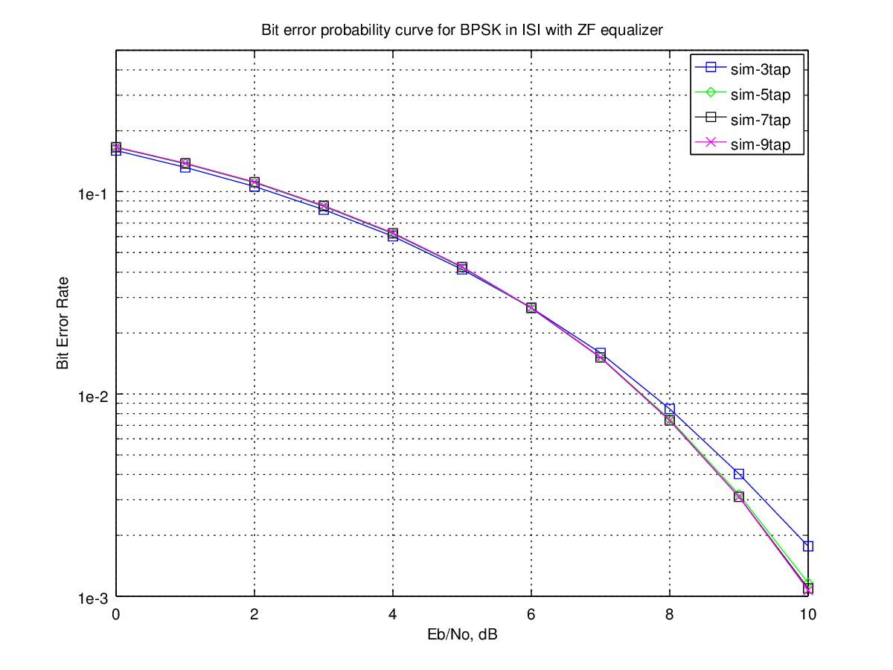
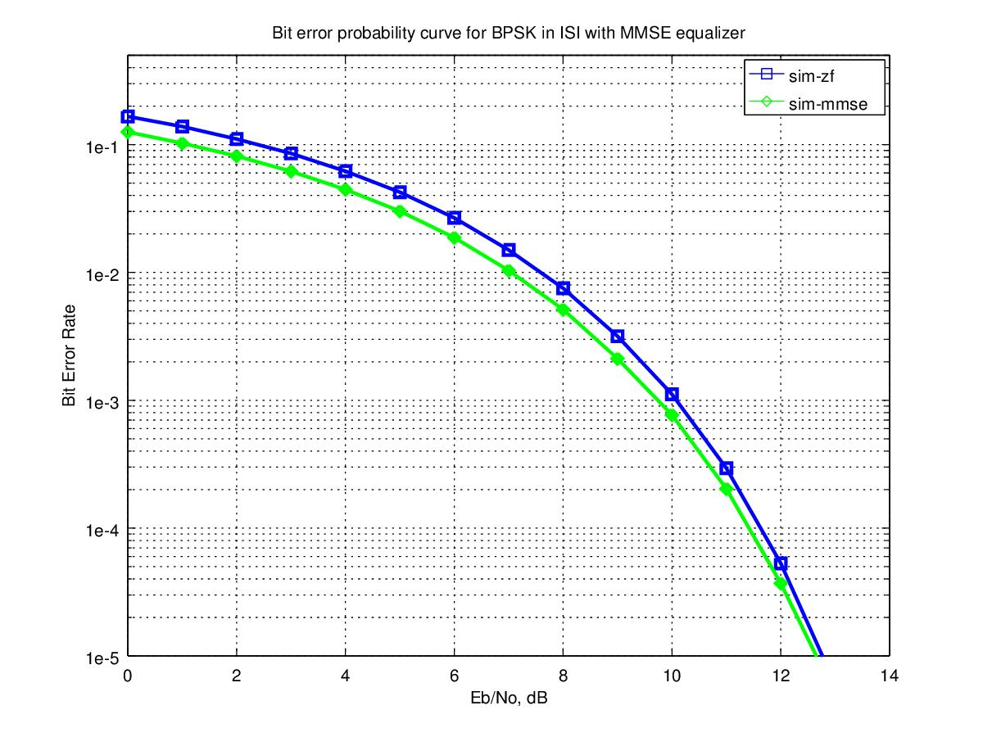
(c) Analyze critically the digital transmission system.

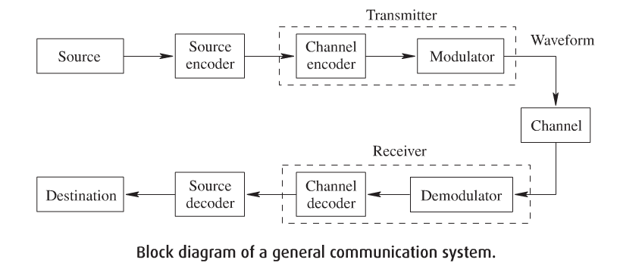
Figure 1: Block diagram of a general digital communication system.

The scripts for this assignment attempt to simulate effect of using different channel equalizer on the BER for BPSK in ISI channel. The ISI channel is assumed to be a fixed 3-tap channel.

Below are the steps taken by the scripts, against the block diagram in Figure 1:-
→ Source: Generate random binary sequence of 0's and 1's.
→ Source encoder: NONE.
→ Channel encoder: NONE.
→ Modulator: BPSK modulation; bit 0 represented as -1 and bit 1 as 0.
→ Channel:
→ At the transmitter, convolving the symbols with a fixed 3-tap fading channel.
→ Add White Gaussian Noise.
→ At the receiver, compute the ZF and MMES equalization filter.
→ Demodulator: Demodulation and conversion to bits.
→ Channel decoder: NONE.
→ Source decoder: NONE.
→ Destination: Counting the number of bit errors.

(d) Determine the effects of the noise and fading channel.

In communication systems, noise is an error or undesired random disturbance of a useful information signal in a communication channel. A noisy channel will have a low SNR.

On the other hand, fading is deviation of the attenuation (gradual loss in intensity) affecting a signal over a certain propagation media. Fading can cause poor performance because it can result in a loss of signal power without reducing the power of noise.

(e) Identify the effect of higher modulation level.

Using a higher modulation level will increase the transmit power, which in turn will increase the bit rate. The challenge is to keep the same bit error rate.

(f) Differentiate the ZF and MMSE equalization.

Zero Forcing Equalizer is a linear equalization algorithm used in communication systems, which inverts the frequency response of the channel. It applies the inverse of the channel to the received signal, to restore the signal before the channel. The name Zero Forcing corresponds to bringing down the ISI to zero in a noise free case. This will be useful when ISI is significant compared to noise.

The ZF algorithm is ideal when the channel is noiseless. However, when the channel is noisy, the ZF algorithm will amplify the noise greatly where the channel has small magnitude in the attempt to invert the channel completely. Employing the MMSE algorithm prevents the noise component from being amplified. The MMSE algorithm can be used to estimate the channel effect with varying decoding matrix in accordance with SNR.

(g) Discuss critically both the equalization techniques.

Objective of ZF equalization is to find a set of filter coefficients c[k] which can make h[k]*c[k]=δ[k].

Objective of MMSE equalization is to find a set of coefficients c[k] which minimize the error between the desired signal s[k] and the equalized signal c[k]*y[k] for each sample time k.

Details of calculations are implemented in the scripts.

(h) Compare their performance and identify the enhancement achievement.

In using the ZF equalizer, increasing the equalizer tap length from 3 to 5 shows a reasonable performance improvement. However, such improvement is not seen for the equalizer tap length more than 5.

From the 2nd plot, there is around 0.5 dB gain when using MMSE equalizer, against using ZF equalizer.

REFERENCES:-
- http://www.dsplog.com/2009/11/29/ber-bpsk-isi-channel-zero-forcing-equalization/
- http://www.dsplog.com/2010/01/24/ber-bpsk-isi-channel-mmse-equalization/
- http://en.wikipedia.org/wiki/Fading
- Performance of MMSE/ZF Equalization in Power Line Communication Systems
- Comparison of various detection algorithms in a MIMO wireless communication receiver
- Design of a Digital Communication System
- Comparison of BER Performance in OFDM Using Different Equalization Techniques
- Performance analysis of BPSK system with ZF & MMSE equalization
- Zero Forcing and Minimum Mean-Square-Error Equalization for Multiuser Detection in Code-Division Multiple-Access Channels
- Reduction in Bit Error Rate from Various Equalization Techniques for MIMO Technology

