Bidii Quality Builders Management System
Unit Code: BCS 3106 – Software Engineering
Project Title: Bidii Quality Builders Management System
Group 5
Group Members:
- Tyra Cheptoo Kiprotich: BSCNRB388224
- Ali Hassan Mohamed: BSCNRB493124
- Enock Wekesa Wanami: BSCNRB490224
Submission Date: 23 October 2025
GitHub Repository: https://github.com/wanami1/bidii-quality-builders-system.git

1.0 Project Objective
The goal of this project is to design and implement a computerized management system for Bidii Quality Builders, a construction and property-improvement company.
The system automates key operations such as recording customer details, preparing and sending estimates, scheduling jobs, managing workers and materials, generating invoices, and producing dashboards using Matplotlib. The system will be implemented with Python (Django framework) following secure coding principles.

2.0 Project Plan
The project will span six weeks, following SDLC phases of planning, analysis, design, implementation, testing, and deployment.

2.1 Work Breakdown Structure (WBS)

WBS ID | TASK DESCRIPTION | DURATION (DAYS)
1.0 | Project Planning and Requirement Analysis | 3
1.1 | Define objectives and scope | 2
1.2 | Gather user requirements | 3
2.0 | System Design | 5
2.1 | Create class diagram and data model | 3
2.2 | Develop UI wireframes | 2
3.0 | Implementation (Django) | 5
3.1 | Configure Django project & models | 4
3.2 | Develop views and templates | 4
3.3 | Integrate Matplotlib dashboard | 2
4.0 | Testing | 4
4.1 | Unit testing & bug fixing | 3
4.2 | Integration testing & validation | 1
5.0 | Deployment and Documentation | 3

2.2 Gantt Chart
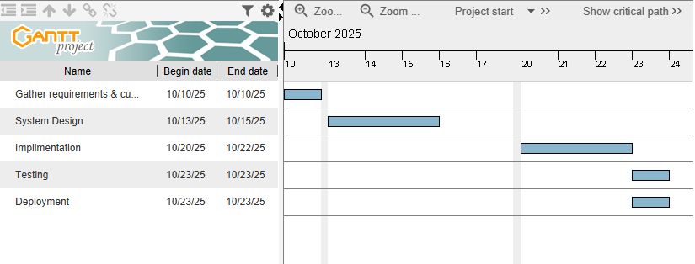

3.0 System Modeling
The system is modeled using UML class diagrams to illustrate major entities and their relationships.
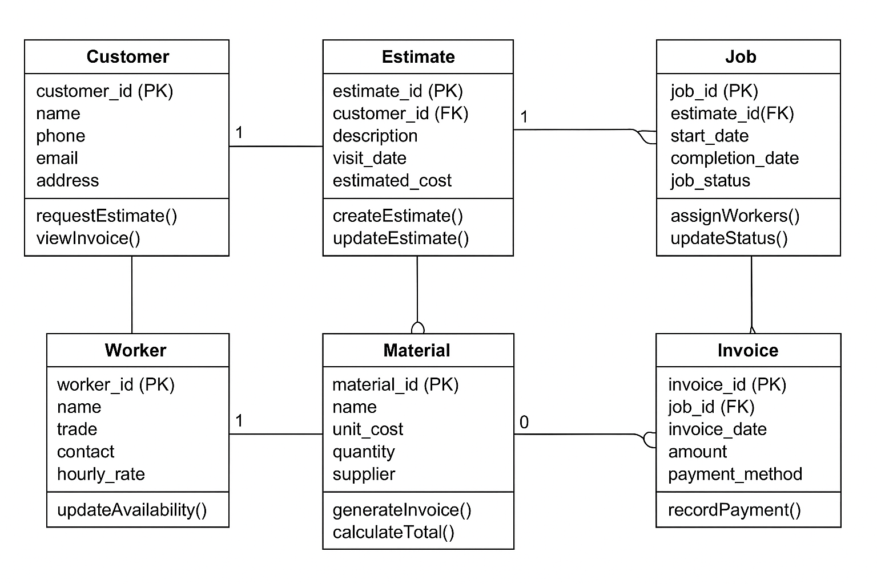

4.0 Actors and Key Use Cases
Actors:
• Customer
• Proprietor (Admin)
• Supplier
• Worker
Key Use Cases:
1. Request Estimate – Customer submits request; proprietor visits site and prepares cost estimate.
2. Approve Estimate and Schedule Job – Customer accepts estimate; proprietor schedules start date and orders materials.
3. Complete Job and Invoice – Job is completed; invoice generated and sent to customer.

5.0 Development Tools and Environment
Tool/Component | Version/Description
Programming Language | Python 3.11
Framework | Django 4.x
Database | SQLite (dev) / PostgreSQL (prod)
Visualization | Matplotlib
IDE | Visual Studio Code
Version Control | Git & GitHub
Operating System | Windows 10

6.0 References
1. Sommerville, I. (2015). Software Engineering (10th Ed.). Pearson Education.
2. Django Software Foundation (2025). Django Documentation. https://docs.djangoproject.com/
3. Python Software Foundation (2025). Python Documentation. https://docs.python.org/
4. Matplotlib Developers (2025). Matplotlib Documentation. https://matplotlib.org/

