
MINISTRY OF EDUCATION, CULTURE AND RESEARCH
OF THE REPUBLIC OF MOLDOVA
Technical University of Moldova
Faculty of Computers, Informatics and Microelectronics
Department of Software Engineering and Automation

Ion Moroșanu FAF-242

Report
Laboratory Work no. 2
Cryptography and Security

Checked by:
Zaica Maia
FCIM, UTM

Chișinău – 2026
TABLE OF CONTENTS
INTRODUCTION 3
Purpose of the work 3
Theoretical notes 3
1 THE INTERCEPTED CRYPTOGRAM 4
2 FREQUENCY ANALYSIS 5
3 BREAKING THE CIPHER STEP BY STEP 7
3.1 Step 1: V → e, W → t 7
3.2 Step 2: Q → h 8
3.3 Step 3: T → a, G → n, O → d 9
3.4 Step 4: N → o, C → f 10
3.5 Step 5: X → i 10
3.6 Step 6: I → r, F → y 11
3.7 Step 7: H → c, P → s 12
3.8 Step 8: U → p, R → w 13
3.9 Step 9: J → g, Z → m 14
3.10 Step 10: S → l, D → u 15
3.11 Step 11: A → b, K → v 16
3.12 Step 12: Y → x, B → q 17
3.13 Step 13: L → k, E → j 18
3.14 Step 14: M → z 18
4 THE RESULT 19
CONCLUSIONS 21
REFERENCES 22

INTRODUCTION

Purpose of the work
The purpose of the second laboratory work is to study the frequency analysis attack on monoalphabetic substitution ciphers and to use it to break an intercepted cryptogram. The cryptogram of variant 15 is known to be an English text encrypted with a monoalphabetic cipher in which only the letters were replaced; spaces, digits and punctuation were left unchanged [1].
The following tasks were set for the work:
a) to count the frequency of every letter in the cryptogram and to compare it with the frequency of the letters in English;
b) to recover the plaintext step by step, using the frequencies, common words and word patterns of English;
c) to reconstruct the key of the cipher and to describe the whole process in the same way as the example in the laboratory guide.

Theoretical notes
In a monoalphabetic substitution cipher every letter of the plaintext is always replaced by the same letter of the ciphertext. The key is a permutation of the alphabet, so there are 26! keys, about 4·10^26, and trying all of them is impossible. The weakness of the cipher is that the substitution does not change how often each letter is used. If the text is long enough and its language is known, the most frequent letters of the ciphertext correspond to the most frequent letters of that language [1].
In English the most frequent letters are E (12.70%), T (9.06%), A (8.17%), O (7.51%), I (6.97%), N (6.75%), S (6.33%), H (6.09%) and R (5.99%), while J, Q, X and Z are below 0.2%. Frequencies alone rarely give the whole key, so other properties of the language are used as well: the most common words (the, and, of, to, in), the fact that only a and I are one-letter words, the frequent digraphs TH, HE, AN, IN, ER and the patterns of longer words that appear once a few letters are known [1].
The work was done with the frequency analysis tool of the Crypto Corner site recommended in the guide [2]. The cryptogram is pasted into the Intercept box, and the button Find Frequencies counts the letters and lists them in decreasing order of frequency under the frequencies of English. Under every ciphertext letter there is a box for the guessed plaintext letter, and the button Make Substitutions shows the text with the guessed letters in lower case and the unknown letters still in upper case. The same convention is used in this report.

1 THE INTERCEPTED CRYPTOGRAM
The cryptogram of variant 15 contains 3165 letters. Its full text, as given in the laboratory guide, is shown below.
WQV WVSVJITUQ ztov hifuwnjituqf rqtw xw xp wnotf. Ptzdvs C. A. Znipvpvgw "Rqtw
qtwq Jno rindjqw!" xg 1844. Wqv gvyw fvti qxp strfvi tgouinznwxngts tjvgw,
Citghxp N. E. Pzxwq, udasxpqvo t hnzzvihxts hnovvgwxwsvo Wqv Pvhivw
Hniivpungoxgj Knhtadstif; Totuwvo cni Dpv wn Znipv'pVsvhwin-Ztjgvwxh Wvsvjituq,
xg rqnpv uivcthv qv ovhstivo wqtw "pvhivhf xghniivpungovghv, xp cti wqv znpw
xzuniwtgw hngpxovitwxng." Wqxp rtpuinkxovo af t pduvi-vghxuqvizvgw.Tp wqv znpw
vyhxwxgj xgkvgwxng nc wqv cxipw qtsc nc wqv hvgwdif, wqvwvsvjituq pwxiivo tp
zdhq xgwvivpw xg xwp otf tp Pudwgxl oxo xg xwp. Wqvjivtw tgo rxovsf cvsw gvvo
cni pvhivhf trtlvgvo wqv stwvgw xgwvivpw xghxuqvip wqtw pn ztgf uvnusv pvvz wn
qtkv, tgo lxgosvo t gvr xgwvivpw xgztgf nwqvip. Onmvgp nc uvipngp twwvzuwvo wn
oivtz du wqvxi nrgdgaivtltasv hxuqvip. Wqvxi hngwixadwxngp vgixhqvo xw rxwq
onmvgp nc gvrhxuqvi pfpwvzp.Tp adpxgvppzvg tgo wqv udasxh dpvo wqv wvsvjituq
zniv tgo zniv,wqvf cndgo wqtw wqvxi cvtip tandw sthl nc uixkthf rviv
vytjjvitwvo. Wqvhsvilp ovtsw xzuvipngtssf rxwq wqv zvpptjvp. Wqv wvsvjituq
hnzutgxvpivpuvhwvo wqvxi hngcxovgwxtsxwf. Tgo hnzzvihxts hnovp sxlv Pzxwq'p,
rqxhqivusthvo rniop tgo uqitpvp af pxgjsv hnovrniop ni hnov-gdzavip wn hdw
wvsvjituq wnssp, tccniovo pdccxhxvgw pvhdixwf cni znpwadpxgvpp witgpthwxngp af
pxzusf uivhsdoxgj tg tw-pxjqw hnzuivqvgpxng ncwqv zvtgxgj. Wqv ainlvip tgo
witovip pnng ivtsxmvo wqtw wqv ztxgtoktgwtjv nc wqvpv hnovp rtp wqvxi
vhngnzf.Jnkvigzvgw zxgxpwixvp dpvo wqv wvsvjituq, wnn. Tw cxipw wqvf zdpwqtkv
vghnovo rxwq wqvxi gnzvghstwnip. Adw tswqndjq pvhivhf rtputitzndgw cni wqvz,
wqvf sxlvo wqv wvsvjituqxh vhngnzf nc t stijv hnov—vpuvhxtssf tp wqvf
wvsvjituqvo zniv tgo zniv. Pn rqvg wqv wxzv tiixkvown hnzuxsv t gvr gnzvghstwni,
wqvf tatgongvo wqtw cniz, hnuxvo wqvhnzzvihxts cniz, tgo uinodhvo t cdss-csvojvo
hnov. Wqv gnzvghstwnipqto qto wqvxi 1,- ni 2,000 hnov-gdzavip xg zxyvo niovi,
adw wqv rtitgo cnivxjg zxgxpwixvp atslvo tw wqv vyuvgpv nc oitrxgj du t
50,000-vgwif hnov xg wrn utiwp, tgo wqvf qto gn uincvppxngts hifuwtgtsfpwp
wnrtig wqvz nc wqv otgjvi nc wqv ngv-utiw cniztw. Wqvf ivsxvo cni pvhdixwfdung
pztss voxwxngp, axj ptcvp, vywvgpxkv svyxhng (stijv hnovp tiv qtioviwn aivtl
wqtg pztss ngvp, nwqvi wqxgjp avxgj vbdts), tgopduvivghxuqvizvgw, ivwtxgxgj
hnovgdzavip wn cthxsxwtwv wqxp xgpwvto ncprxwhqxgj wn hnovrniop. Wqxp vknsdwxng
rtp vppvgwxtssf hnzusvwv af wqv1860p. Wqv stijv, ngv-utiw hnov qto ivusthvo wqv
pztss, wrn-utiwgnzvghstwni xg qxjq-svkvs zxsxwtif tgo oxusnztwxh
hifuwnjituqf.Zvtgrqxsv, wqv wvsvjituq, tdwqni nc wqxp ovkvsnuzvgw, rtp
hivtwxgjpnzvwqxgj gvr xg rti—pxjgts hnzzdgxhtwxngp, ni knsdzxgndp hnzztgotgo
ivhnggtxpptghv zvpptjvp. Nc hndipv pdhq zvpptjvp qto vyxpwvoavcniv, rxwq
wnihqvp, uxjvngp, tgo hndixvip, adw xg pn itivcxvo t cniz wqtwwqvf rviv gnw vkvg
htssvo "pxjgts hnzzdgxhtwxngp." Wqv wvsvjituqvgtasvo hnzztgovip, cni wqv cxipw
wxzv xg qxpwnif, wn vyviw xgpwtgwtgvndptgo hngwxgdndp hngwins nkvi jivtw ztppvp
nc zvg puivto nkvi stijvtivtp.Wqvpv wthwxhts zvpptjvp ivbdxivo uinwvhwxng:
wvsvjituq rxivp hndso avwtuuvo. Gvxwqvi wqv nso gnzvghstwni gni wqv gvr hnov
rndso on. Wqvfrviv wnn vtpf wn htuwdiv xg hnzatw, wnn qtio wn ivxppdv bdxhlsf
tgocivbdvgwsf wn wqv gdzvindp tgo rxovpuivto wvsvjituq unpwp. Pxjgtsnccxhvip
wdigvo trtf cinz wqvz. Wqvf snnlvo xgpwvto wn wqtw gvjsvhwvohqxso nc
hifuwnjituqf, wqv hxuqvi. Hxuqvip hndso av uixgwvo hqvtusf ng tpxgjsv pqvvw nc
utuvi tgo oxpwixadwvo rxwq vtpv. Pvhivhf rtp atpvo dungktixtasv lvfp, pn htuwdiv
nc wqv jvgvits pfpwvz tgo vkvg nc ngv nc wqvlvfp rndso gnw hnzuinzxpv tss tg
tizf'p pvhivw zvpptjvp. Pnsdwxngprndso av uivkvgwvo af ituxo lvf hqtgjvp.
Hxuqvip rviv xovts cni atwwsv-mngv zvpptjvp, tgo wqv cxipw nc wqv znovig rtip,
wqv Tzvixhtg Hxkxs Rti,dpvo wqvz cni edpw wqtw. Wqdp rtp anig t gvr jvgiv xg
hifuwnjituqf: wqvcxvso hxuqvi.

2 FREQUENCY ANALYSIS
The first step of the attack is to count how many times every letter appears in the cryptogram. The cryptogram was pasted into the tool and the button Find Frequencies was pressed (Figure 2.1). The tool shows the frequencies of English in the upper table and the frequencies of the cryptogram, in decreasing order, in the lower table, together with an empty substitution box under every letter.
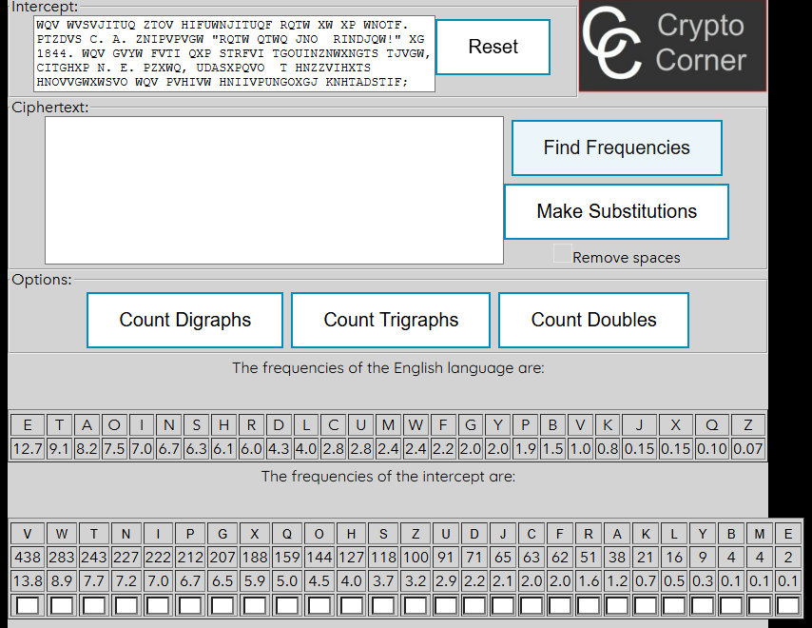
Figure 2.1 – The frequencies of English and of the cryptogram in the tool
Table 2.1 lists the number of occurrences of every letter in alphabetical order, and Table 2.2 lists the same letters in decreasing order of frequency, with their share of all the letters.
Table 2.1 – The frequency of the letters in the cryptogram, in alphabetical order
Letter | A | B | C | D | E | F | G | H | I | J | K | L | M
Count | 38 | 4 | 63 | 71 | 2 | 62 | 207 | 127 | 222 | 65 | 21 | 16 | 4
Letter | N | O | P | Q | R | S | T | U | V | W | X | Y | Z
Count | 227 | 144 | 212 | 159 | 51 | 118 | 243 | 91 | 438 | 283 | 188 | 9 | 100
Table 2.2 – The frequency of the letters in the cryptogram, in decreasing order
Letter | V | W | T | N | I | P | G | X | Q | O | H | S | Z
Count | 438 | 283 | 243 | 227 | 222 | 212 | 207 | 188 | 159 | 144 | 127 | 118 | 100
% | 13.8 | 8.9 | 7.7 | 7.2 | 7.0 | 6.7 | 6.5 | 5.9 | 5.0 | 4.5 | 4.0 | 3.7 | 3.2
Letter | U | D | J | C | F | R | A | K | L | Y | B | M | E
Count | 91 | 71 | 65 | 63 | 62 | 51 | 38 | 21 | 16 | 9 | 4 | 4 | 2
% | 2.9 | 2.2 | 2.1 | 2.0 | 2.0 | 1.6 | 1.2 | 0.7 | 0.5 | 0.3 | 0.1 | 0.1 | 0.1
The two profiles are very similar. The most frequent letter, V, has 13.8% against 12.70% for E in English, and the next letter, W, has 8.9% against 9.06% for T. At the other end, the letters Y, B, M, E appear only 9, 4, 4, 2 times and should correspond to the rarest English letters J, Q, X and Z. The middle of the list is too even to be matched letter by letter, so after the first two letters the attack continues with words.

3 BREAKING THE CIPHER STEP BY STEP
Each step below gives the reasoning, the substitutions entered in the tool and the beginning of the text after the button Make Substitutions was pressed. Letters already decrypted are in lower case and letters still unknown are in upper case. All the counts refer to the whole cryptogram.

3.1 Step 1: V → e, W → t
The most frequent letter of the cryptogram is V (438 occurrences, 13.8%), followed by W (283, 8.9%). Comparing them with the frequencies of English, we assume that they are the two most frequent English letters: V → e and W → t.
The text now begins:
tQe teSeJITUQ ZTOe HIFUtNJITUQF RQTt Xt XP tNOTF. PTZDeS C. A. ZNIPePeGt
"RQTt QTtQ JNO RINDJQt!" XG 1844. tQe GeYt FeTI QXP STRFeI ...
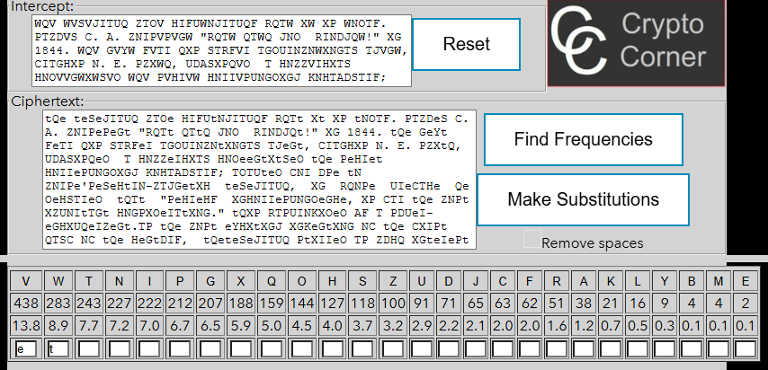
Figure 3.1 – The tool after step 1 (V → e, W → t)

3.2 Step 2: Q → h
After the first substitution the word “tQe” appears 36 times. The most common three-letter word in English is “the”, so Q → h.
A fragment of the text after the substitution, around the word “the”:
the teSeJITUh ZTOe HIFUtNJITUhF RhTt Xt XP tNOTF. PTZDeS C. A. ZNIPePeGt
"RhTt hTth JNO RINDJht!" XG 1844. the GeYt FeTI hXP STRFeI ...
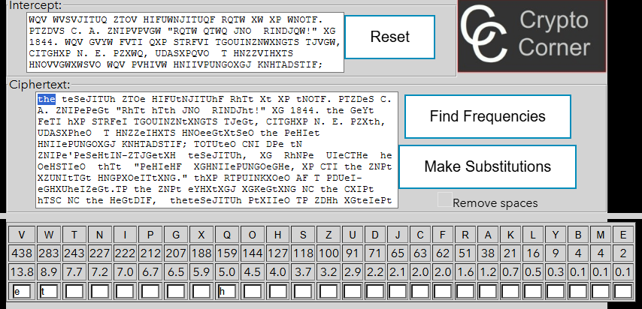
Figure 3.2 – The tool after step 2 (Q → h)

3.3 Step 3: T → a, G → n, O → d
The one-letter word “T” appears 9 times. Only “a” and “I” are one-letter words in English, and T is the third most frequent letter of the cryptogram (7.7%, close to 8.17% for A), so T → a. Then the word “aGO”, which appears 16 times, can only be “and”, so G → n and O → d.
A fragment of the text after the substitution, around the word “and”:
... XnteIePt Xn XtP daF aP PUDtnXL dXd Xn XtP. theJIeat and RXdeSF CeSt
need CNI PeHIeHF aRaLened the Satent XnteIePt XnHXUheIP that PN ZanF ...
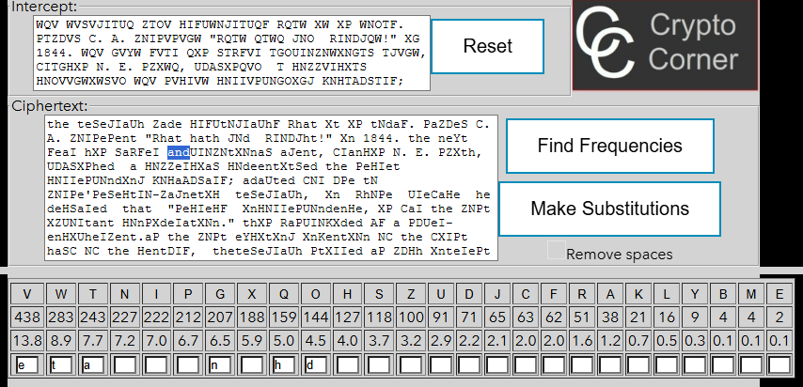
Figure 3.3 – The tool after step 3 (T → a, G → n, O → d)

3.4 Step 4: N → o, C → f
The two-letter word “tN” appears 11 times and fits only “to”, so N → o. After that the word “oC”, which appears 19 times, can only be “of”, so C → f.
A fragment of the text after the substitution, around the word “of”:
... PDUeI-enHXUheIZent.aP the ZoPt eYHXtXnJ XnKentXon of the fXIPt haSf of
the HentDIF, theteSeJIaUh PtXIIed aP ZDHh XnteIePt Xn XtP daF aP ...
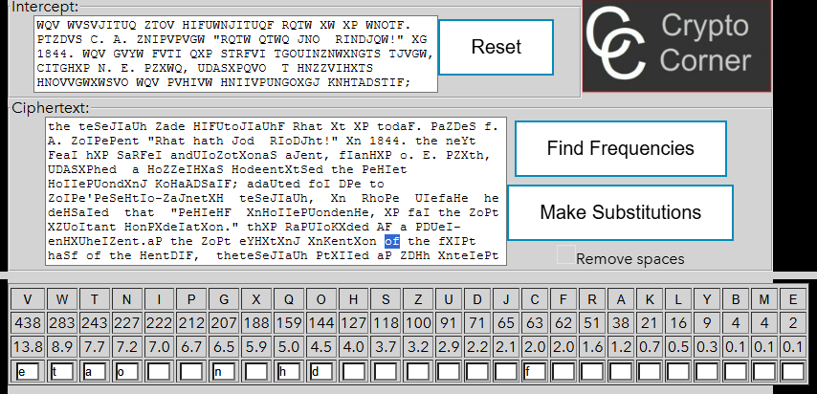
Figure 3.4 – The tool after step 4 (N → o, C → f)

3.5 Step 5: X → i
The word “Xn” appears 12 times. The only English word that fits is “in”, so X → i.
A fragment of the text after the substitution, around the word “in”:
... PaZDeS f. A. ZoIPePent "Rhat hath Jod RIoDJht!" in 1844. the neYt FeaI
hiP SaRFeI andUIoZotionaS aJent, fIanHiP o. E. PZith, UDASiPhed a ...
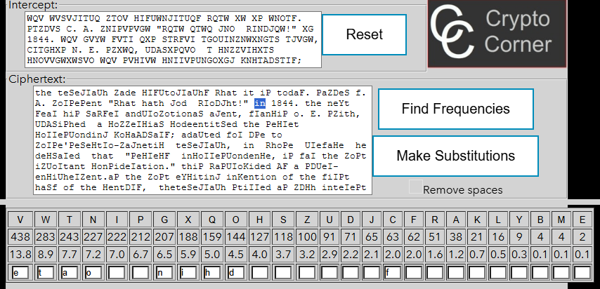
Figure 3.5 – The tool after step 5 (X → i)

3.6 Step 6: I → r, F → y
We notice that the word “theiI” (appears 7 times) is most probably “their”, so I → r; and the word “theF” (appears 8 times) is most probably “they”, so F → y.
A fragment of the text after the substitution, around the word “their”:
... otherP. doMenP of UerPonP atteZUted to dreaZ DU their oRnDnAreaLaASe
HiUherP. their HontriADtionP enriHhed it Rith doMenP of neRHiUher ...
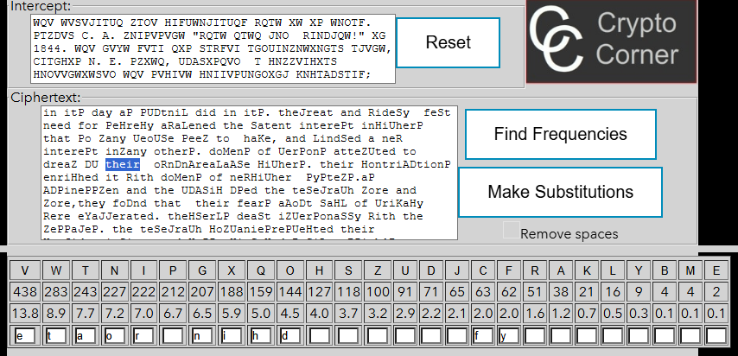
Figure 3.6 – The tool after step 6 (I → r, F → y)

3.7 Step 7: H → c, P → s
We notice that the word “Hode” (appears 7 times) is most probably “code”, so H → c; and the word “interePt” (appears 3 times) is most probably “interest”, so P → s.
A fragment of the text after the substitution, around the word “code”:
... RhichreUSaced Rords and Uhrases Ay sinJSe codeRords or code-nDZAers to
cDt teSeJraUh toSSs, afforded sDfficient secDrity for ZostADsiness ...
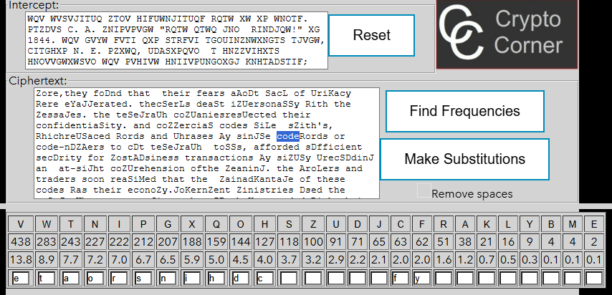
Figure 3.7 – The tool after step 7 (H → c, P → s)

3.8 Step 8: U → p, R → w
We notice that the word “ciUhers” (appears 3 times) is most probably “ciphers”, so U → p; and the word “Rith” (appears 5 times) is most probably “with”, so R → w.
A fragment of the text after the substitution, around the word “ciphers”:
... persons atteZpted to dreaZ Dp their ownDnAreaLaASe ciphers. their
contriADtions enriched it with doMens of newcipher systeZs.as ADsinessZen
...
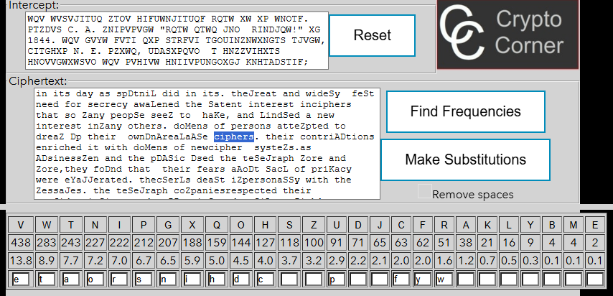
Figure 3.8 – The tool after step 8 (U → p, R → w)

3.9 Step 9: J → g, Z → m
We notice that the word “cryptoJraphy” (appears 4 times) is most probably “cryptography”, so J → g; and the word “Zore” (appears 4 times) is most probably “more”, so Z → m.
A fragment of the text after the substitution, around the word “cryptography”:
the teSegraph made cryptography what it is today. samDeS f. A. morsesent
"what hath god wroDght!" in 1844. the neYt year his Sawyer ...
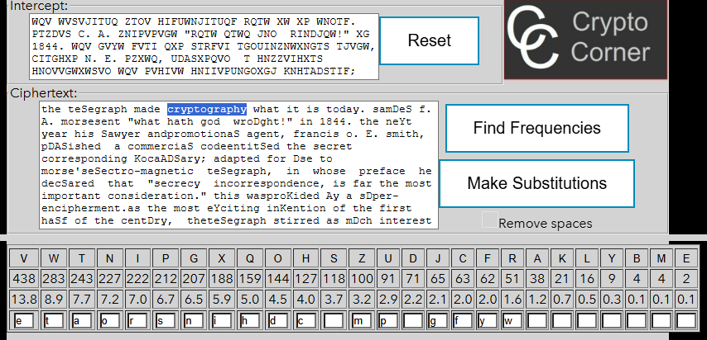
Figure 3.9 – The tool after step 9 (J → g, Z → m)

3.10 Step 10: S → l, D → u
We notice that the word “teSegraph” (appears 9 times) is most probably “telegraph”, so S → l; and the word “commDnications” (appears 2 times) is most probably “communications”, so D → u.
A fragment of the text after the substitution, around the word “telegraph”:
the telegraph made cryptography what it is today. samuel f. A. morsesent
"what hath god wrought!" in 1844. the neYt year his lawyer ...
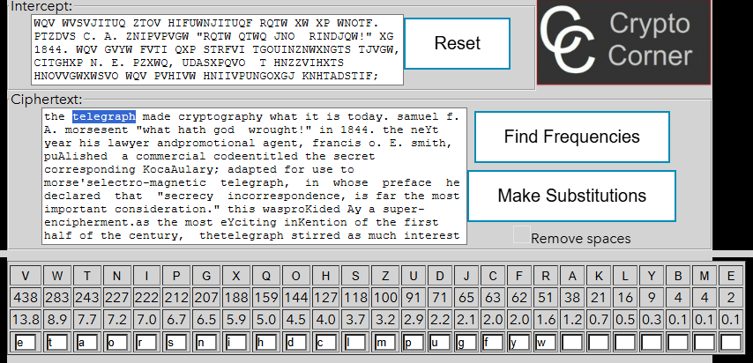
Figure 3.10 – The tool after step 10 (S → l, D → u)

3.11 Step 11: A → b, K → v
We notice that the word “numAers” (appears 2 times) is most probably “numbers”, so A → b; and the word “eKen” (appears 2 times) is most probably “even”, so K → v.
A fragment of the text after the substitution, around the word “numbers”:
... words and phrases by single codewords or code-numbers to cut telegraph
tolls, afforded sufficient security for mostbusiness transactions by ...
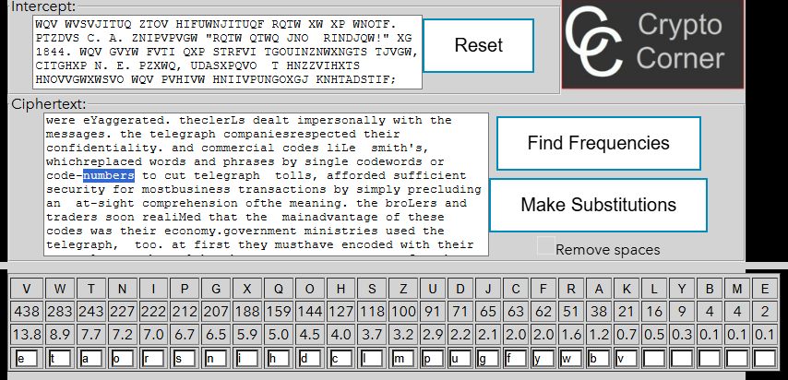
Figure 3.11 – The tool after step 11 (A → b, K → v)

3.12 Step 12: Y → x, B → q
We notice that the word “miYed” is most probably “mixed”, so Y → x; and the word “eBual” is most probably “equal”, so B → q.
A fragment of the text after the substitution, around the word “mixed”:
... nomenclatorshad had their 1,- or 2,000 code-numbers in mixed order,
but the warand foreign ministries balLed at the expense of drawing up a
...
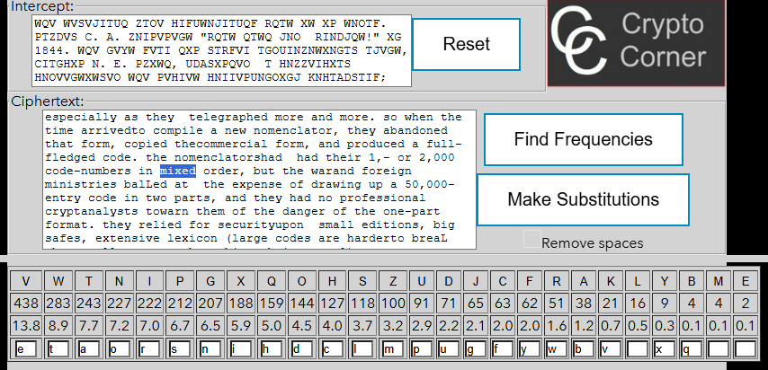
Figure 3.12 – The tool after step 12 (Y → x, B → q)

3.13 Step 13: L → k, E → j
We notice that the word “quicLly” is most probably “quickly”, so L → k; and the word “Eust” is most probably “just”, so E → j.
A fragment of the text after the substitution, around the word “quickly”:
... easy to capture in combat, too hard to reissue quickly andfrequently
to the numerous and widespread telegraph posts. signalofficers turned ...
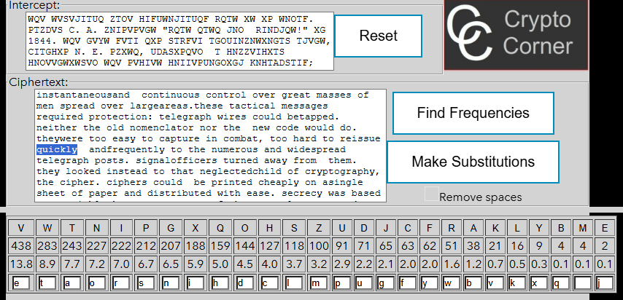
Figure 3.13 – The tool after step 13 (L → k, E → j)

3.14 Step 14: M → z
We notice that the word “doMens” (appears 2 times) is most probably “dozens”, so M → z.
A fragment of the text after the substitution, around the word “dozens”:
... have, and kindled a new interest inmany others. dozens of persons
attempted to dream up their ownunbreakable ciphers. their contributions
...
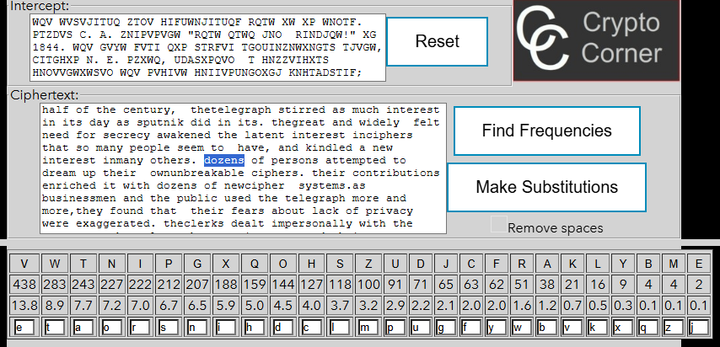
Figure 3.14 – The tool after step 14 (M → z)

4 THE RESULT
After 14 steps all 26 letters were found, and the tool shows a readable English text with no upper-case letters left. The decrypted message is the following.
THE TELEGRAPH made cryptography what it is today. Samuel F. B. Morsesent "What hath God wrought!" in 1844. The next year his lawyer andpromotional agent, Francis O. J. Smith, published a commercial codeentitled The Secret Corresponding Vocabulary; Adapted for Use to Morse'sElectro-Magnetic Telegraph, in whose preface he declared that "secrecy incorrespondence, is far the most important consideration." This wasprovided by a super-encipherment.As the most exciting invention of the first half of the century, thetelegraph stirred as much interest in its day as Sputnik did in its. Thegreat and widely felt need for secrecy awakened the latent interest inciphers that so many people seem to have, and kindled a new interest inmany others. Dozens of persons attempted to dream up their ownunbreakable ciphers. Their contributions enriched it with dozens of newcipher systems.As businessmen and the public used the telegraph more and more,they found that their fears about lack of privacy were exaggerated. Theclerks dealt impersonally with the messages. The telegraph companiesrespected their confidentiality. And commercial codes like Smith's, whichreplaced words and phrases by single codewords or code-numbers to cut telegraph tolls, afforded sufficient security for mostbusiness transactions by simply precluding an at-sight comprehension ofthe meaning.
The brokers and traders soon realized that the mainadvantage of these codes was their economy.Government ministries used the telegraph, too. At first they musthave encoded with their nomenclators. But although secrecy wasparamount for them, they liked the telegraphic economy of a large code—especially as they telegraphed more and more. So when the time arrivedto compile a new nomenclator, they abandoned that form, copied thecommercial form, and produced a full-fledged code. The nomenclatorshad had their 1,- or 2,000 code-numbers in mixed order, but the warand foreign ministries balked at the expense of drawing up a 50,000-entry code in two parts, and they had no professional cryptanalysts towarn them of the danger of the one-part format. They relied for securityupon small editions, big safes, extensive lexicon (large codes are harderto break than small ones, other things being equal), andsuperencipherment, retaining codenumbers to facilitate this instead ofswitching to codewords. This evolution was essentially complete by the1860s. The large, one-part code had replaced the small, two-partnomenclator in high-level military and diplomatic cryptography.Meanwhile, the telegraph, author of this development, was creatingsomething new in war—signal communications, or voluminous commandand reconnaissance messages.
Of course such messages had existedbefore, with torches, pigeons, and couriers, but in so rarefied a form thatthey were not even called "signal communications." The telegraphenabled commanders, for the first time in history, to exert instantaneousand continuous control over great masses of men spread over largeareas.These tactical messages required protection: telegraph wires could betapped. Neither the old nomenclator nor the new code would do. Theywere too easy to capture in combat, too hard to reissue quickly andfrequently to the numerous and widespread telegraph posts. Signalofficers turned away from them. They looked instead to that neglectedchild of cryptography, the cipher. Ciphers could be printed cheaply on asingle sheet of paper and distributed with ease. Secrecy was based uponvariable keys, so capture of the general system and even of one of thekeys would not compromise all an army's secret messages. Solutionswould be prevented by rapid key changes. Ciphers were ideal for battle-zone messages, and the first of the modern wars, the American Civil War,used them for just that. Thus was born a new genre in cryptography: thefield cipher.
Some words are joined without a space, for example morsesent. These spaces are missing in the cryptogram of the guide as well, so they are not errors of the decryption. The text is an excerpt from the book The Codebreakers by David Kahn [3], from the part about the influence of the telegraph on cryptography.
The key is obtained by writing, for every plaintext letter, the ciphertext letter that was found for it (Table 4.1).
Table 4.1 – The reconstructed alphabet of the cipher
Plain | a | b | c | d | e | f | g | h | i | j | k | l | m
Cipher | T | A | H | O | V | C | J | Q | X | E | L | S | Z
Plain | n | o | p | q | r | s | t | u | v | w | x | y | z
Cipher | G | N | U | B | I | P | W | D | K | R | Y | F | M
The key has no simple structure such as a shift or a keyword, so it is a random permutation of the alphabet. It was still found without trying a single key, only from the statistics of the language.

CONCLUSIONS
The work showed that a monoalphabetic substitution cipher can be broken without knowing anything about the key. The cipher has 26! possible keys, but it keeps the frequency of every letter, and a cryptogram of more than three thousand letters reproduces the frequency profile of English very closely. The two most frequent letters, V and W, matched E and T at once.
Frequencies alone were not enough for the rest of the alphabet, because the middle of the frequency list is too even. The decisive information came from the language itself: the word the gave H, the one-letter word gave A, and the words and, to, of and in gave N, D, O, F and I. From that point every new letter made longer words readable, and each of them revealed one or two more letters. The rarest letters, J, Q, X and Z, were found last, each from a single long word.
The tool only counts letters and replaces them; every decision about which letter to try was made by reasoning about English words. In this sense the attack confirms the remark of the guide that the process needs a human analyst. The result also explains why monoalphabetic ciphers are not used today: any long message encrypted with one of them can be read after a few minutes of counting.

REFERENCES
1. ZGUREANU, A. Lucrarea de laborator nr. 2. Criptanaliza cifrurilor monoalfabetice. Faculty of Computers, Informatics and Microelectronics, Technical University of Moldova, 2022.
2. Crypto Corner. Frequency Analysis: Breaking the Code [online]. Available: https://crypto.interactive-maths.com/frequency-analysis-breaking-the-code.html
3. KAHN, D. The Codebreakers: The Story of Secret Writing. New York: Macmillan, 1967.

