**表结构设计**

产品表（Products）

| **列名** | **数据类型** | **约束条件** |
| --- | --- | --- |
| product_id | INT | PRIMARY KEY, AUTO_INCREMENT |
| name | VARCHAR(255) | NOT NULL |
| price | DECIMAL(10,2) | NOT NULL |
| description | TEXT |  |
| manufacturer_id | INT | FOREIGN KEY REFERENCES Manufacturers(manufacturer_id) ON DELETE SET NULL |

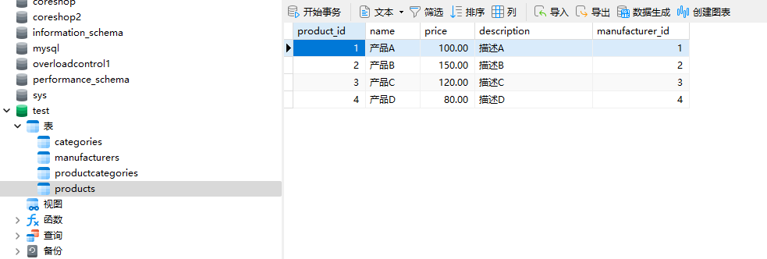

分类表（Categories）

| **列名** | **数据类型** | **约束条件** |
| --- | --- | --- |
| category_id | INT | PRIMARY KEY, AUTO_INCREMENT |
| name | VARCHAR(255) | NOT NULL |
| parent_id | INT | FOREIGN KEY REFERENCES Categories(category_id) ON DELETE CASCADE, NULLABLE |

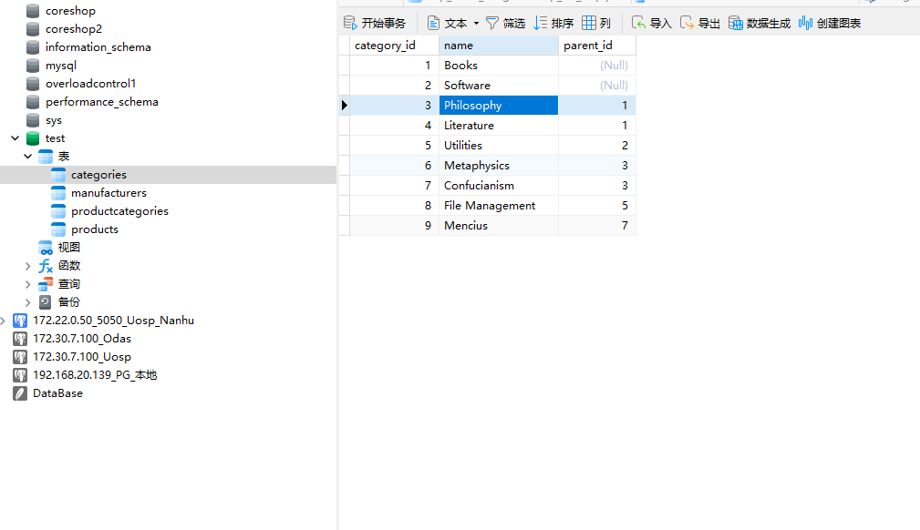

制造商表（Manufacturers）

| **列名** | **数据类型** | **约束条件** |
| --- | --- | --- |
| manufacturer_id | INT | PRIMARY KEY, AUTO_INCREMENT |
| name | VARCHAR(255) | NOT NULL |
| logo | VARCHAR(255) |  |

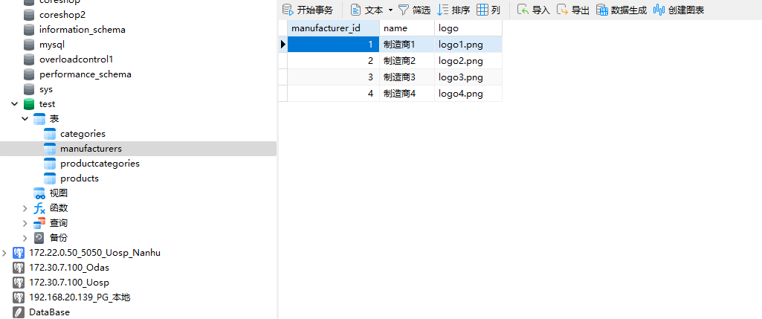

产品-分类关联表（ProductCategories）

| **列名** | **数据类型** | **约束条件** |
| --- | --- | --- |
| product_id | INT | FOREIGN KEY REFERENCES Products(product_id) ON DELETE CASCADE, PRIMARY KEY (product_id, category_id) |
| category_id | INT | FOREIGN KEY REFERENCES Categories(category_id) ON DELETE CASCADE, PRIMARY KEY (product_id, category_id) |

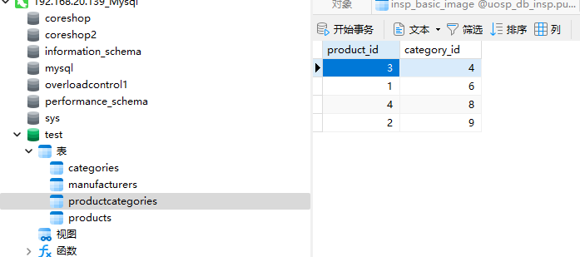

**SQL查询**

递归查询所有多层级分类商品

WITH RECURSIVE CategoryHierarchy AS (

SELECT

category_id,

name,

parent_id,

CAST(name AS CHAR(255)) AS full_path

FROM

Categories

WHERE

parent_id IS NULL

UNION ALL

SELECT

c.category_id,

c.name,

c.parent_id,

CONCAT(ch.full_path, ' - ', c.name) AS full_path

FROM

Categories c

INNER JOIN

CategoryHierarchy ch ON c.parent_id = ch.category_id

)

SELECT

ch.full_path AS category_path,

p.name AS product_name,

p.price,

p.description,

m.name AS manufacturer_name,

m.logo

FROM

CategoryHierarchy ch

INNER JOIN

ProductCategories pc ON ch.category_id = pc.category_id

INNER JOIN

Products p ON pc.product_id = p.product_id

INNER JOIN

Manufacturers m ON p.manufacturer_id = m.manufacturer_id

ORDER BY

ch.full_path, p.name;

