

STUDYHIVE, A GROUP BASED ONLINE LEARNING PLATFORM WITH PERSONALISED CONTENT RECOMMENDATION

MASENO UNIVERSITY

SCHOOL OF COMPUTING AND INFORMATICS

DEPARTMENT OF COMPUTER SCIENCE

**UNIT CODE:** CCS 403

**UNIT NAME:** COMPUTER SCIENCE PROJECT 1

**REGISTRATION NUMBER:** CCS/00009/020

**NAME:** SIMIYU GIDEON WANDABI

A project proposal submitted to the department of computer science in the school of computing and informatics, Maseno university in partial fulfilment of the requirements for the award of bachelor degree in computer science.

**DECLARATION**

This project is my original work and has not been presented before any other examination body in another university.

Signature: ………………………………

Date: ………………………………

SIMIYU GIDEON WANDABI

CCS/00009/020

This project has been submitted for examination with my approval as the university supervisor.

Signature: ………………………………

Date: ………………………………

DR. JAMES OBUHUMA

MASENO, KENYA

# **ACKNOWLEDGEMENT**

I take this opportunity to express my gratitude to all who contributed to the successful completion of this project. This would not have been possible without the guidance and support of many key individuals. I want to thank Dr. James Obuhuma, my project supervisor for his expert guidance and support throughout all the stages of writing this project proposal. I would also like to thank the Maseno faculty of computing and informatics for providing conducive environment. I also take this opportunity to express my gratitude to our lecturers who have been instrumental in approval of this project and their support thought the development of this project.

# **ABSTRACT**

This project is an innovative web-based platform tailored to the needs of students. This project caters to the educational requirements of users by offering personalized content recommendations within their chosen fields of study. Users can register, specify their interests, and subsequently receive a curated stream of articles, videos, and images that align with their academic pursuits. The project’s functionality extends beyond content recommendation, as it fosters connections among like-minded individuals through a real-time chat system. Additionally, it allows users to curate and share educational content they believe their followers would find valuable.

This project is underpinned by a robust recommendation engine powered by machine learning, which enhances the platform's safety by filtering offensive content and detecting potential fake contributions. The project encompasses system deployment, maintenance, and updates, ensuring its continuous improvement and efficiency. As it strives to create a dynamic and enriching online environment for students, the project presents a modern approach to education, emphasizing personalization, community, and technology.

The project is characterized by user authentication, content recommendations, and system security features, meeting the fundamental user and system requirements necessary for a safe, engaging, and personalized educational experience. It envisions a modern educational landscape where students can explore, connect, and recommend educational content that aligns with their unique areas of study

Table Of Contents

**DECLARATION** i

**ACKNOWLEDGEMENT** ii

**ABSTRACT** iii

**LIST OF TABLES** vi

**LIST OF FIGURES** vii

**ACRONYMS AND ABBREVIATIONS** viii

**CHAPTER 1** 1

**INTRODUCTION** 1

**1.1 Background of the study** 1

**1.2 Problem Statement** 1

**1.3 Research Objectives** 2

***1.3.1 General Objective*** 2

***1.3.2 Specific Objectives*** 2

**1.4 Research Questions** 2

**1.5 Justifications** 2

**1.6 Scope of the study** 3

**1.7 Significance of the study** 3

**1.8 Assumptions and Limitations** 3

***1.8.1 Assumptions*** 3

***1.8.2 Limitations*** 4

**1.9 Summary** 4

**CHAPTER 2** 5

**LITERATURE REVIEW** 5

**2.1 Introduction** 5

**2.2 Coursera** 5

**2.3 YouTube** 6

**2.4 Udemy** 7

**2.5 edX** 8

**2.6 LinkedIn Learning** 9

**2.7 The Research Gap** 10

**2.8 Summary** 12

**CHAPTER 3** 13

**SYSTEM ANALYSIS AND DESIGN** 13

**3.1 Introduction** 13

**3.2 Methodology** 13

***3.2.1 Data Collection Tools and Techniques*** 13

***3.2.2 Data Analysis Tools and Techniques*** 15

**3.3 System Analysis** 15

***3.3.1 User and System Requirements*** 15

***3.3.2 Functional Requirements*** 16

***3.3.3 Nonfunctional Requirements*** 16

**3.4 System Design** 16

***3.4.1 System Architecture*** 17

***3.4.2 Use Case Diagram*** 17

***3.4.4 Data Flow Diagrams*** 19

***3.4.5 Class Diagram*** 21

***3.4.6 Entity Relationship Diagram*** 22

**3.5 Work Plan** 22

**REFERENCES** 24

**APPENDIX** 25

# **LIST OF TABLES**

Table 2.1 The Research Gap ………………………………………………………… 10

Table 3.1 The work Plan ……………………………………………………………. 22

# **LIST OF FIGURES**

Figure 3.1 System Architecture ……………………....……………………………………. 17

Figure 3.2 Use Case Diagram ……………………………..……………………………….. 17

Figure 3.3 Context Diagram ………………………………….……………………………. 18

Figure 3.4 DFD Level 1 …………………………...……………………………………….. 19

Figure 3.4 DFD Level 2 ………………………………………………………..…………………………………….. 20

Figure 3.4 DFD Level 3 ……………………………………………………..……………………………………….. 21

Figure 3.4 Class Diagram …………………………………………………………………. 21

Figure 3.4 ER Diagram ………………………….………………………………………… 22

# **ACRONYMS AND ABBREVIATIONS**

DFD – Data Flow Diagram

ER – Entity Relationship

DR – Doctor

UI – User Interface

# **CHAPTER 1**

# **INTRODUCTION**

## **1.1 Background of the study**

In the age of digital information abundance, students find themselves navigating an ever-expanding sea of online educational content. While the internet offers an unparalleled wealth of knowledge, it presents a unique challenge – the ability to sift through this vast ocean of information to discover content that is not only relevant but also tailored to individual preferences and academic pursuits.

Traditional search engines, while undeniably powerful, fall short when it comes to delivering the personalized educational experience that modern learners need. This deficiency in personalization leads to a frustrating and time-consuming quest for content, causing students to expend valuable study time inefficiently.

The advent of online learning, accelerated by global events, has further underscored the need for effective digital learning environments. In the transition from physical classrooms to virtual ones, students often miss out on the rich interactions, group-based learning, and shared educational experiences that were once a staple of their academic journey. The absence of a supportive and engaging online learning community has a profound impact on their motivation, sense of belonging, and overall academic growth.

This project emerges as a solution to these pressing challenges. By leveraging cutting-edge technology, it aims to provide students with a dynamic and enriching online platform that redefines the way they access and engage with educational content. Through personalized content recommendations, real-time communication, and the cultivation of a collaborative learning ecosystem, the project aspires to empower students in their quest for knowledge and create a thriving online community where learning knows no bounds.

## **1.2 Problem Statement**

In the modern digital age, students are flooded with a very large volume of online content across different educational domains. However, the real challenge lies not in the amount of content but in its relevance and the ability for people to easily find things.

Students often struggle to find educational content custom-designed to their particular interests and school-related needs. Plain search engines, while powerful, don't provide the personalized experience necessary for effective learning. This lack of personalization results in students spending too much time sifting through unrelated content, leading to frustration and a decrease in productivity.

Moreover, the isolation that can come with online learning further compounds this issue. Students miss the valuable interactions and group-based learning opportunities that they would usually experience in a physical classroom. The absence of a supportive and engaging online learning community interferes with their motivation and academic growth.

## **1.3 Research Objectives**

### ***1.3.1 General Objective***

To create an integrated online platform that fosters a dynamic and secure learning community

### ***1.3.2 Specific Objectives***

1. To provide learners with a platform that recommends study materials based on their personal preferences.
2. To develop a chat service that allows learners to communicate with each other and share resources.
3. To Implement advanced content moderation algorithms to ensure a safe and respectful online environment.

## **1.4 Research Questions**

1. How can content recommendations be personalized based on individual user preferences and areas of study in the context of online education?
2. What are the key features contributing to the successful implementation of a real-time chat service for facilitating communication and resource sharing among learners in an online educational platform?
3. What machine learning models and algorithms can be employed to identify and mitigate fake content and instances of harassment, ensuring a secure and respectful online learning environment for users?

## **1.5 Justifications**

The project aims to revolutionize online education by leveraging advanced technology to provide students with a dynamic and enriching learning platform. By offering personalized content recommendations based on individual interests and areas of study, it streamlines the content discovery process, ensuring that learners access materials directly relevant to their learning objectives. Additionally, this project recognizes the isolation that can accompany online learning and seeks to create a vibrant online community through real-time communication and resource sharing features. This collaborative environment addresses the need for interactions and group-based learning, fostering motivation and academic growth.

Furthermore, the project places a strong emphasis on user safety and content quality. It acknowledges the prevalence of fake content and online harassment and aims to safeguard users through the implementation of advanced algorithms that detect and mitigate such issues. This commitment to a secure and respectful online learning environment ensures that users can engage confidently in a community built on trust and mutual respect.

In essence, the project is driven by the conviction that education is a transformative force, and it seeks to empower learners in their pursuit of knowledge and personal development. By addressing the challenges of information overload, personalization, online learning isolation, and content safety, The project is going to reshape the digital learning landscape, fostering engaged and informed learners who are prepared to thrive in the 21st century.

## **1.6 Scope of the study**

The project's scope encompasses the development of a specialized online learning and collaboration platform tailored for learners. It will include a content recommendation engine to provide links to personalized content suggestions, such as articles, videos, and educational resources, aligning with individual user preferences and academic interests. Additionally, the platform will feature robust real-time communication capabilities, enabling live chats and seamless resource sharing. Users will have the ability to create user profiles highlighting their academic pursuits, fostering a sense of community and knowledge exchange. The project will incorporate content moderation algorithms to ensure a secure online environment by detecting and filtering offensive content and harassment, prioritizing user safety within the context of their academic curriculum.

## **1.7 Significance of the study**

The project significantly improves the learning process by offering personalized content recommendations. This feature not only saves valuable study time but also ensures that students engage with materials directly relevant to their academic pursuits, leading to increased learning efficiency.

The platform fosters collaboration and knowledge exchange among peers through real-time communication features. This is especially crucial in the context of remote and online learning, as it recreates the collaborative atmosphere of physical classrooms, enriching the overall learning experience.

The project sets a standard for online safety by implementing advanced content moderation and safety measures. By proactively identifying and filtering offensive content and harassment, it creates a secure and respectful online environment, ensuring that users can engage confidently.

The project offers a global platform for learners, transcending geographical boundaries. It opens up opportunities for cross-cultural interactions and the exchange of diverse perspectives.

## **1.8 Assumptions and Limitations**

### ***1.8.1 Assumptions***

1. There will be sufficient educational content available for recommendation. To address this, "The project" will employ the google programmable search API.
2. The project assumes that, despite implementing advanced content moderation, there may be instances where offensive or inappropriate content is not identified promptly. To address this, the platform will empower users to report any such content promptly.
3. The project assumes that users are comfortable sharing their preferences and study habits. To address privacy concerns, the platform will implement robust data protection measures, obtain user consent for data usage, and adhere to relevant data privacy regulations.

### ***1.8.2 Limitations***

1. The project is limited by the availability of academic content for recommendation. Content for emerging or specialized subjects may be limited, impacting the personalization of recommendations in those areas.
2. Some users may face technological barriers such as lack of devices, slow or no internet connections, which could limit their access to certain platform features.

## **1.9 Summary**

This chapter sets the stage by explaining the problems students face when trying to find the right online educational material. It emphasizes how personalized recommendations are important and how online learning can sometimes make students feel isolated. Study Hive aims to solve these problems by giving students personalized content suggestions, real-time chat, and keeping the platform safe. This chapter is important because it shows that Study Hive is committed to making learning more efficient, encouraging collaboration, and ensuring a safe online environment, making it a game-changer in education.

# **CHAPTER 2**

# **LITERATURE REVIEW**

## **2.1 Introduction**

This chapter dives into the literature of three modern systems similar to this project. Fields explored for each system are it’s description, features, and it’s limitations. The systems have been explored in this order: Coursera, YouTube, Udemy, edX, LinkedIn Learning.

## **2.2 Coursera**

Coursera is a global online learning platform that offers anyone, anywhere, access to online courses and degrees from leading universities and companies. It was founded in 2012 by Andrew Ng, Daphne Koller, and Jeff Dean, three Stanford professors. Coursera now has over 100 million users and offers over 4,000 courses from over 200 universities and companies (Mazumder, 2019).

**Features of Coursera**

1. **Wide variety of content:** Coursera offers a wide variety of courses on a wide range of topics, including business, computer science, engineering, humanities, social sciences, and more.
2. **High-quality instruction:** Coursera courses are taught by world-renowned professors and experts in their field.
3. **Flexible learning:** Coursera courses are self-paced, so students can learn at their own convenience.
4. **Affordable:** Coursera courses are typically very affordable, and many courses are offered for free. Students can also purchase verified certificates of completion for a fee.
5. **Accessible:** Coursera courses are accessible on a variety of devices, including computers, smartphones, and tablets.

**Advantages of Coursera**

1. **Access to high-quality education:** Coursera provides students with access to high-quality education from top universities around the world. This is an opportunity that many students would not otherwise have.
2. **Flexibility:** Coursera courses are self-paced, so students can learn at their own convenience. This is especially beneficial for students who have busy schedules or who need to work while they are studying.
3. **Affordability:** Coursera courses are typically very affordable, and many courses are offered for free. This makes Coursera a great option for students who are on a budget.
4. **Diversity of content:** Coursera offers a wide variety of courses on a wide range of topics. This allows students to explore different subjects and to develop new skills.

**Limitations of Coursera**

1. **Quality of content:** The quality of content on Coursera can vary widely. Some courses are excellent, while others are not. It is important for students to read reviews of courses before enrolling.
2. **Distraction:** Coursera can be a distraction for students. It is important for students to set aside specific times to take Coursera courses and to avoid using Coursera during study sessions.
3. **Copyright:** Some courses on Coursera are copyrighted. It is important for students to be aware of copyright laws and to avoid using copyrighted materials without permission.

## **2.3 YouTube**

YouTube is a video-sharing platform that allows users to watch, upload, and share videos. It was founded in 2005 by three former PayPal employees: Chad Hurley, Steve Chen, and Jawed Karim. YouTube was acquired by Google in 2006 for $1.65 billion (Yang, Li, & Chen, 2022).

YouTube is one of the most popular websites in the world, with over 2 billion active users. It is available in over 100 countries and supports over 80 languages. YouTube offers a wide variety of content, including music videos, movie trailers, TV shows, educational videos, and more.

**Features of YouTube**

1. **Video sharing:** YouTube allows users to upload and share videos with others. Videos can be public, private, or unlisted. Public videos can be viewed by anyone on YouTube, while private videos can only be viewed by the uploader and people they invite. Unlisted videos can only be viewed by people who have the link to the video (Yang, Li, & Chen, 2022).
2. **Video watching:** YouTube allows users to watch videos on a variety of devices, including computers, smartphones, tablets, and smart TVs. YouTube also offers a variety of playback options, such as slow motion, fast motion, and repeat (García-Ruiz, López-Herrera, & Ruiz-Puente, 2020).
3. **Video editing:** YouTube offers a variety of video editing tools, such as trimming, cropping, and adding music. Users can also create playlists to organize their videos (García-Ruiz, López-Herrera, & Ruiz-Puente, 2020).
4. **Comments and likes:** YouTube users can comment on and like videos. This allows users to interact with each other and share their thoughts on the videos they watch (Clark & Mayer, 2019).
5. **Subscriptions:** YouTube users can subscribe to other users' channels to receive notifications when they upload new videos (Özdemir, Aydemir, & Yılmaz, 2018).

**Advantages of YouTube**

1. **Access to a wide variety of content:** YouTube offers a wide variety of educational content, including video lectures, tutorials, and demonstrations. This allows students to learn about a variety of topics at their own pace (Yang, Li, & Chen, 2022).
2. **Engaging and interactive:** YouTube videos can be engaging and interactive, which can help students to learn more effectively. For example, students can leave comments and ask questions on YouTube videos. They can also create their own videos to share what they have learned (Özdemir, Aydemir, & Yılmaz, 2018).
3. **Affordable:** YouTube is a free service, so it is an affordable option for students (Yang, Li, & Chen, 2022).
4. **Accessible:** YouTube is accessible on a variety of devices, so students can learn anywhere, anytime (Yang, Li, & Chen, 2022).

**Limitations of YouTube**

1. **Quality of content:** The quality of content on YouTube can vary widely. Some videos are accurate and informative, while others are not. It is important for students to evaluate the quality of the videos they watch before using them for learning (Wang, Chen, & Li, 2021).
2. **Distraction:** YouTube can be a distraction for students. It is important for students to set aside specific times to watch YouTube videos and to avoid using YouTube during study sessions (Wang, Chen, & Li, 2021).
3. **Copyright:** Some videos on YouTube are copyrighted. It is important for students to be aware of copyright laws and to avoid using copyrighted videos without permission (Wang, Chen, & Li, 2021).

## **2.4 Udemy**

Udemy is an online learning and teaching marketplace where users can create and take courses on a variety of topics. Udemy was founded in 2010 by Eren Bali and Gagan Biyani. It is headquartered in San Francisco, California.

Udemy offers a wide variety of courses, including business, programming, design, photography, and more. Courses are taught by instructors who are experts in their field. Udemy offers a variety of course formats, including video lectures, articles, and quizzes (Dhanu & Dwivedi, 2021).

**Features of Udemy**

1. **Course creation:** Udemy allows users to create and sell their own courses. Instructors can set their own prices and choose how to deliver their courses (Dhanu & Dwivedi, 2021).
2. **Course taking:** Udemy users can take courses on a variety of topics. Courses can be accessed on a variety of devices, including computers, smartphones, and tablets (Dhanu & Dwivedi, 2021).
3. **Offline learning:** Udemy users can download courses for offline learning. This allows users to learn even when they don't have an internet connection (Dhanu & Dwivedi, 2021).
4. **Certificates:** Udemy users can earn certificates of completion for the courses they take. Certificates can be shared on social media or used to apply for jobs (Dhanu & Dwivedi, 2021).

**Advantages of Udemy**

1. **Access to a wide variety of content:** Udemy offers a wide variety of courses on a variety of topics. This allows students to learn about a variety of topics at their own pace (Dhanu & Dwivedi, 2021).
2. **Self-paced learning:** Udemy courses are self-paced, so students can learn at their own pace. They can also pause and rewind videos as needed (Dhanu & Dwivedi, 2021).
3. **Affordable:** Udemy courses are typically very affordable. Students can also purchase courses in a bundle to save even more money (Dhanu & Dwivedi, 2021).
4. **Accessible:** Udemy courses are accessible on a variety of devices, so students can learn anywhere, anytime (Dhanu & Dwivedi, 2021).
5. **Qualified instructors:** Udemy courses are taught by instructors who are experts in their field. This ensures that students are receiving high-quality instruction (Dhanu & Dwivedi, 2021).

**Limitations of Udemy**

1. **Quality of content:** The quality of content on Udemy can vary widely. Some courses are high quality, while others are not. It is important for students to read reviews of courses before enrolling (Dhanu & Dwivedi, 2021).
2. **Distraction:** Udemy can be a distraction for students. It is important for students to set aside specific times to take Udemy courses and to avoid using Udemy during study sessions (Dhanu & Dwivedi, 2021).
3. **Copyright:** Some courses on Udemy are copyrighted. It is important for students to be aware of copyright laws and to avoid using copyrighted materials without permission (Dhanu & Dwivedi, 2021).

## **2.5 edX**

edX is a non-profit online learning platform founded in 2012 by Harvard University and Massachusetts Institute of Technology (MIT) (Zhang, W., & Zhao, 2015). edX offers online courses from over 160 universities and institutions around the world, including Harvard, MIT, Berkeley, Stanford, and Oxford. Courses cover a wide range of topics, including computer science, business, engineering, humanities, and social sciences (Zhang, W., & Zhao, 2015).

**Features of edX** (Zhang, W., & Zhao, 2015)**:**

1. **High-quality courses:** edX courses are taught by world-renowned professors and experts in their field. Courses are designed to be rigorous and engaging, and students can learn at their own pace.
2. **Variety of content:** edX offers a wide variety of courses on a wide range of topics. This allows students to learn about a variety of subjects and to develop new skills.
3. **Affordable:** edX courses are typically very affordable, and many courses are offered for free. Students can also purchase verified certificates of completion for a fee.
4. **Accessible:** edX courses are accessible on a variety of devices, including computers, smartphones, and tablets. This allows students to learn anywhere, anytime.

**Advantages of edX**

According to (Zhang, W., & Zhao, 2015) advantages of edX include:

1. **Access to high-quality education:** edX provides students with access to high-quality education from top universities around the world. This is an opportunity that many students would not otherwise have.
2. **Flexibility:** edX courses are self-paced, so students can learn at their own convenience. This is especially beneficial for students who have busy schedules or who need to work while they are studying.
3. **Affordability:** edX courses are typically very affordable, and many courses are offered for free. This makes edX a great option for students who are on a budget.
4. **Diversity of content:** edX offers a wide variety of courses on a wide range of topics. This allows students to explore different subjects and to develop new skills.

**Limitations of edX**

1. **Quality of content:** The quality of content on edX can vary widely. Some courses are excellent, while others are not. It is important for students to read reviews of courses before enrolling.
2. **Distraction:** edX can be a distraction for students. It is important for students to set aside specific times to take edX courses and to avoid using edX during study sessions.
3. **Copyright:** Some courses on edX are copyrighted. It is important for students to be aware of copyright laws and to avoid using copyrighted materials without permission.

## **2.6 LinkedIn Learning**

LinkedIn Learning is an online learning platform that offers video courses on a wide range of topics, including business, technology, design, and more. It is a subscription service, but there is a free trial available (Kennedy,2019).

**Features**

1. **Comprehensive library of courses:** LinkedIn Learning has over 17,000 courses available, with new courses being added all the time.
2. **Expert instructors:** The courses are taught by industry experts who share their knowledge and insights.
3. **Interactive learning:** Many of the courses include interactive elements, such as quizzes, exercises, and projects.
4. **Personalized learning recommendations:** LinkedIn Learning uses machine learning to recommend courses to you based on your interests and skills.
5. **Social learning features:** LinkedIn Learning allows you to connect with other learners and instructors, and to share your progress and insights.

**Advantages**

1. **Convenience:** LinkedIn Learning is an online platform, so you can learn at your own pace and on your own time.
2. **Variety:** LinkedIn Learning offers a wide range of courses on a variety of topics, so you can learn new skills or expand your knowledge base.
3. **Quality:** The courses on LinkedIn Learning are taught by industry experts and are of high quality.
4. **Affordability:** LinkedIn Learning is a subscription service, but the monthly fee is reasonable.

**Limitations**

1. **Cost:** LinkedIn Learning is a subscription service, so there is a monthly fee.
2. **Quality of some courses:** Some of the courses on LinkedIn Learning may not be of the same quality as others.
3. **Lack of interaction with instructors:** While LinkedIn Learning does have social learning features, it is not possible to interact with instructors in real time.

## **2.7 The Research Gap**

Table 1: The research gap

|  |  |  |  |
| --- | --- | --- | --- |
| **Existing System** | **Brief Description** | **Key Features** | **Gap** |
| Coursera  (Mazumder, 2019). | An online learning platform that offers a wide array of courses, specializations, and degree programs across various disciplines | 1. Wide variety of content 2. High-quality instruction 3. Flexible learning 4. Affordable 5. Accessible | Coursera is focuses on structured courses and may not provide the same level of content variety and community interaction as this project will provide.  Although affordable , some courses need a paid subscription |
| YouTube  (Yang, Li, & Chen, 2022),  (García-Ruiz, López-Herrera, & Ruiz-Puente, 2020). | YouTube is a video-sharing platform that allows users to watch, upload, and share videos | 1. Video sharing 2. Video watching 3. Video editing 4. Comments and likes 5. Subscriptions | The quality of content on youtude depends on the content creator.  Since youtube does not primarily focus on educational content , it may ecome a distraction to some learners. |
| Udemy  (Dhanu & Dwivedi, 2021) | An online learning platform that allows instructors to create and publish courses for learners. | 1. Course creation 2. Course taking 3. Offline learning 4. Certificates | While this project will be free to use, udemy requires paid subscription for some of the courses. Also, quality of learning largely depends on the tutor. |
| edX  (Zhang, W., & Zhao, 2015) | A non-profit online learning platform founded in 2012 by Harvard University and Massachusetts Institute of Technology | 1. High-quality courses 2. Variety of content 3. Affordable 4. Accessible | Some courses on edX are copyrighted. Edx does not offer good social feature as this project will , to facilitate group learning. |
| LinkedIn Learning  (Kennedy,2019) | LinkedIn Learning is an online learning platform that offers video courses on a wide range of topics, including business, technology, design, and more. It is a subscription service, but there is a free trial available. | 1. Comprehensive library of courses 2. Expert instructors 3. Interactive learning, 4. Personalized learning recommendations 5. Social learning features | LinkedIn Learning is a subscription service, so there is a monthly fee. Some of the courses on LinkedIn Learning may not be of the same quality as others. |

While platforms like Coursera, edX, Udemy, YouTube, and LinkedIn Learning offer a wealth of educational content, they collectively fall short in addressing the critical challenge of personalization and relevance for modern learners. These platforms do not provide a highly personalized and curated learning experience that caters to individual interests and academic needs. As a result, students continue to struggle with the overwhelming volume of content and the time-consuming process of sifting through unrelated material. The absence of tailored content recommendations often leads to frustration and decreased productivity.

Moreover, the existing platforms do not effectively bridge the gap in online learning by recreating the valuable interactions, group-based learning opportunities, and the supportive and engaging online learning community that are typical in physical classrooms. The isolation and lack of a vibrant online learning community negatively impact student motivation and academic growth, which is not adequately addressed by these platforms.

In essence, the research gap lies in the absence of a comprehensive and dynamic online learning environment like Study Hive that not only offers personalized content recommendations but also fosters meaningful interactions, group-based learning, and content quality assurance, addressing the challenges outlined in the problem statement.

This research gap signifies the need for a platform like Study Hive that goes beyond traditional online learning platforms to offer a transformative educational experience in line with the challenges faced by modern learners.Top of Form

Bottom of Form

## **2.8 Summary**

This chapter provides a comprehensive comparative analysis of online learning platforms similar to this project, including Coursera, edX, Udemy, YouTube, and LinkedIn Learning, with a focus on how these platforms address the challenges outlined in the problem statement. The analysis reveals that while these platforms offer diverse educational content, they collectively fall short in delivering a highly personalized, relevant, and curated learning experience. Moreover, they do not adequately bridge the gap in online learning by recreating the essential interactions, group-based learning, and a supportive online learning community typically found in physical classrooms. This analysis underscores the research gap and the need for Study Hive, a dynamic and transformative online learning environment aiming to provide a highly personalized, engaging, and supportive educational experience for modern learners

# **CHAPTER 3**

# **SYSTEM ANALYSIS AND DESIGN**

## **3.1 Introduction**

This chapter explains how the research was done, what tools and methods were used to collect data, and how the system was analyzed. It also lists the requirements for the system, both functional and non-functional, as well as the design of the system. This chapter is important because it lays the foundation for the development of StudyHive and makes sure that it meets the needs of the users.

## **3.2 Methodology**

The Agile methodology is the chosen approach for the development of this project. Agile methodology is well-known for it’s flexibility, iterative nature, and emphasis on delivering working increments. These characteristics align with the project's goal to implement and test the system in smaller, functional units, ensuring that each unit meets the specific requirements.

### ***3.2.1 Data Collection Tools and Techniques***

*1.Questionnaire*

Questionnaires are structured sets of questions designed to collect specific information from respondents. In the context of this project, questionnaires will help gather valuable feedback and requirements from target users.

**Preparation:**

The preparation began by defining the objectives of the questionnaire. It was crucial to have a clear understanding of what information to be collected and how it would contribute to the development of this project.

The questions were crafted to be clear, concise, directly related to the project's objectives unbiased and avoided any leading language.

To maintain a logical flow, the questions were organized in a structured manner. Starting with general inquiries and progressing to more specific ones, I incorporated a mix of question types, including multiple-choice, open-ended, and rating scale questions.

**Administration:**

The target audience for the questionnaire was chosen from people who could provide valuable insights. The questionnaire was then designed in a google form and participants could access the questionnaire online through email , fill it out in person or during interviews.

Clear instructions were provided to the participants, explaining how to complete the questionnaire. Respondents were assured of the confidentiality of their responses.

As respondents complete the questionnaire, their responses was systematically collected and recorded in google sheets.

The completed questionnaire, along with any relevant instructions and additional materials, has been attached as an appendix to the research report.

*2. Observation*

As part of the data collection process for the project, I undertook an observation activity aimed at gaining insights into how users engage with educational content platforms similar to this project. This activity involved the direct exploration of various platforms, both as an active user and as an observer of user interactions.

**Methodology and Preparation:**

* **Platform Selection:** To ensure the relevance of the observation, I carefully selected a diverse range of educational content platforms that shared key similarities with this project in terms of content delivery, personalization, and user interaction features.
* **Direct Engagement:** I actively engaged with these selected platforms as a regular user, interacting with their content, exploring their features, and experiencing the platforms from a user's perspective. This hands-on engagement allowed me to gain a deep understanding of their functionality.
* **Observation of User Interactions:** In addition to my active participation, I observed and documented the behaviors and interactions of other users on these platforms. This included noting ho w they engaged with content, their preferences, and their utilization of features such as recommendations and user interaction tools.
* **Note-taking:** Throughout the observation process, I maintained detailed notes and records of my experiences and observations. These notes encompassed user behaviors, the effectiveness of content recommendations, and the impact of user interaction features.

**Results and Insights:**

The results of this observation activity provided a wealth of insights into user behaviors and platform dynamics. Several key findings emerged from this observational study:

1. **Content Engagement Patterns:** The observations revealed distinct patterns in how users engaged with different types of educational content, shedding light on their preferences for articles, videos, interactive materials, and more.
2. **Recommendation Effectiveness:** By observing how users interacted with recommended content, I gained insights into the strengths and weaknesses of recommendation algorithms in guiding user choices.
3. **User Interaction Styles:** The observations highlighted the varied ways in which users engaged with each other, including through real-time chat, forums, and collaborative projects.

### ***3.2.2 Data Analysis Tools and Techniques***

The data collected was subjected to rigorous analysis using statistical tools. This process will involve the utilization of google sheets for data cleaning, organization, and descriptive analysis.This includes summarizing questionnaire responses and observational data, calculating frequencies, percentages, and central tendencies, and identifying outliers.

***Representation of Findings***

To make the findings accessible and visually comprehensible, various analytical tools and techniques will be used to represent the data. These include:

* **Pie Charts:** Pie chart was employed to illustrate the distribution of responses for categorical variables. For instance, they can depict the distribution of content preferences among users.

All pie charts have been attached as appendix to this report.

## **3.3 System Analysis**

The primary objective of this project is to create a dynamic and enriching online environment for students to explore, interact, and recommend meaningful content within their chosen areas of study. This platform serves as a bridge between educational content and students, fostering discovery within their niches while facilitating connections and interactions between like-minded individuals.

### ***3.3.1 User and System Requirements***

1. User Authentication and Authorization
   1. The system should allow users to create new accounts
   2. The system should allow existing users to login to access content
2. View and review recommended content
   1. The system should allow authenticated user access to recommendations.
   2. The system should allow users to review recommended content.

2.3 The system should allow users to view recommended content for their friends.

1. Profile management

3.1 System shall provide users with the ability to create and customize their profiles.

3.2 System should allow users to deactivate or delete their profiles.

1. Create and Share content
   1. The system should provide users with an interface to upload their content
   2. The system should allow other users to view user uploaded content
2. Create and join real time chat
   1. The system should allow user to create and join study rooms.
   2. The system should provide a user friendly interface to simulate group discussions

### ***3.3.2 Functional Requirements***

1. ***User Registration***

Users must be able to register by providing their name, email address, and a secure password.

1. **Personalized Content Recommendations**

The system must analyze user interests and provide content recommendations on the user's dashboard.

Users should be able to mark content as liked or disliked to improve recommendations.

1. **Content Curation and Sharing**

Users should be able to create content, add descriptions, and share it with their followers.

The system must provide tools for users to organize and categorize their shared content.

1. **Real-time Interaction**

Real-time chat functionality should allow users to message each other privately or within groups.

Discussion forums should support topic creation and threaded discussions.

Collaborative project spaces should allow users to collaborate on educational projects.

1. **Content Filtering and Safety**

The system must scan text and media content for offensive or inappropriate material and prevent it from being shared or displayed.

### ***3.3.3 Nonfunctional Requirements***

1. ***User Interface***

The user interface must be intuitive, responsive, and visually appealing to enhance the user experience.

1. **Data Security**

User data, including personal information and content, must be securely stored and transmitted using encryption.

1. **Content Accuracy**

Content recommendations must be accurate and relevant to the user's interests.

1. **Real-time Chat Responsiveness**

Real-time chat features should provide low-latency communication to ensure quick and efficient user interactions.

## **3.4 System Design**

### ***3.4.1 System Architecture***

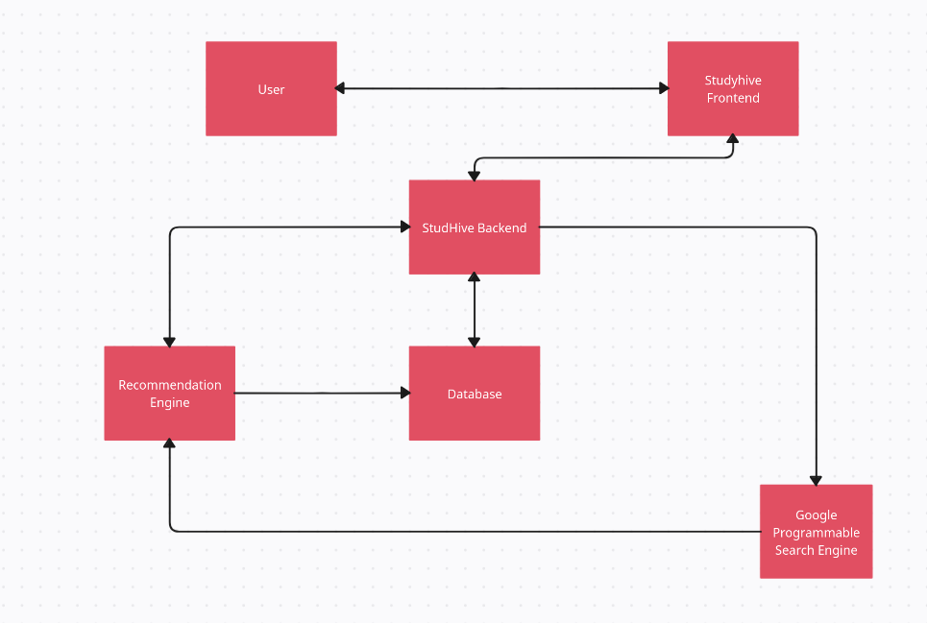

Figure 3.1: system architecture

### ***3.4.2 Use Case Diagram***

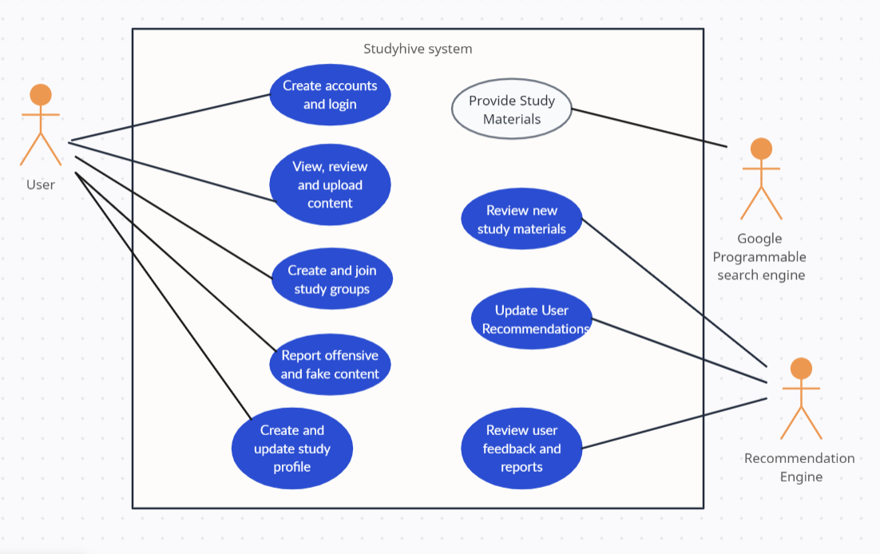

Figure 3.2 : Use case diagram

***3.4.3 Context Diagram***

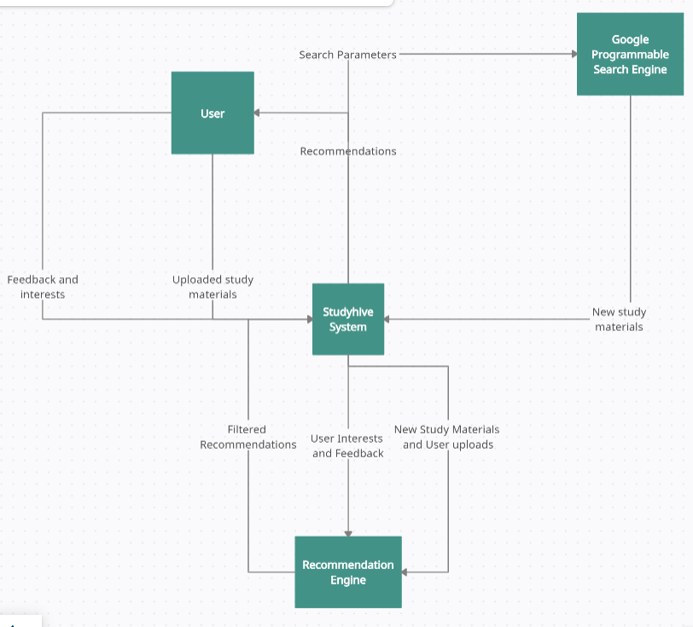

Figure 3.3 : Context Diagram

### ***3.4.4 Data Flow Diagrams***

*1. DFD LEVEL 1*

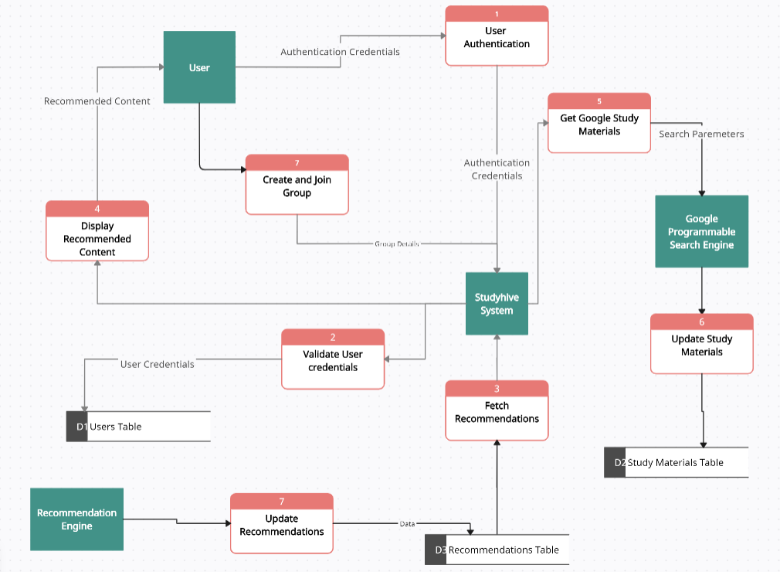

Figure 3.4 : DFD LEVEL 1

*2.DFD LEVEL 2*

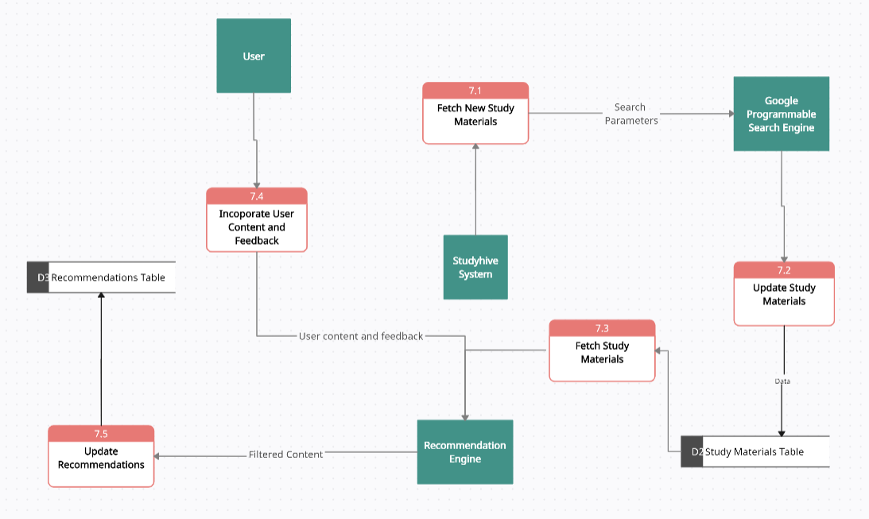

Figure 3.5 : DFD LEVEL 2

*3.DFD LEVEL 3*

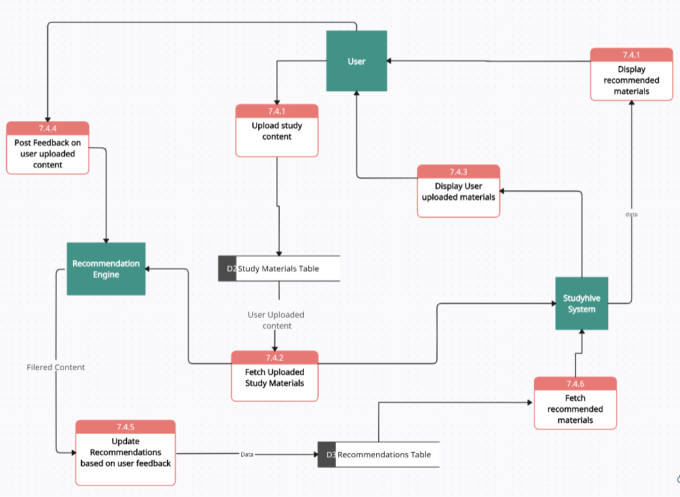

Figure 3.6 : DFD LEVEL 3

### ***3.4.5 Class Diagram***

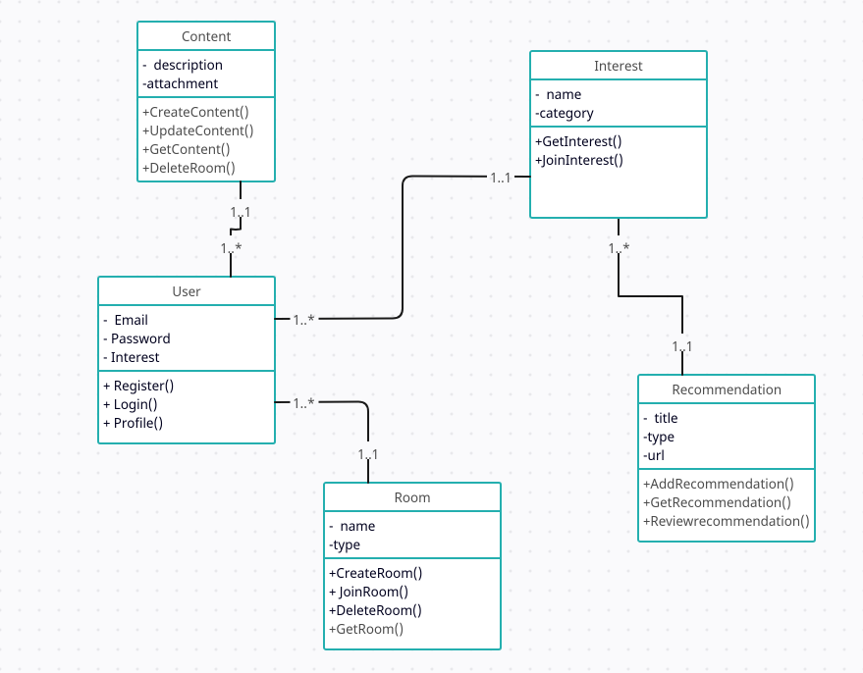

Figure 3.7: class diagram

### ***3.4.6 Entity Relationship Diagram***

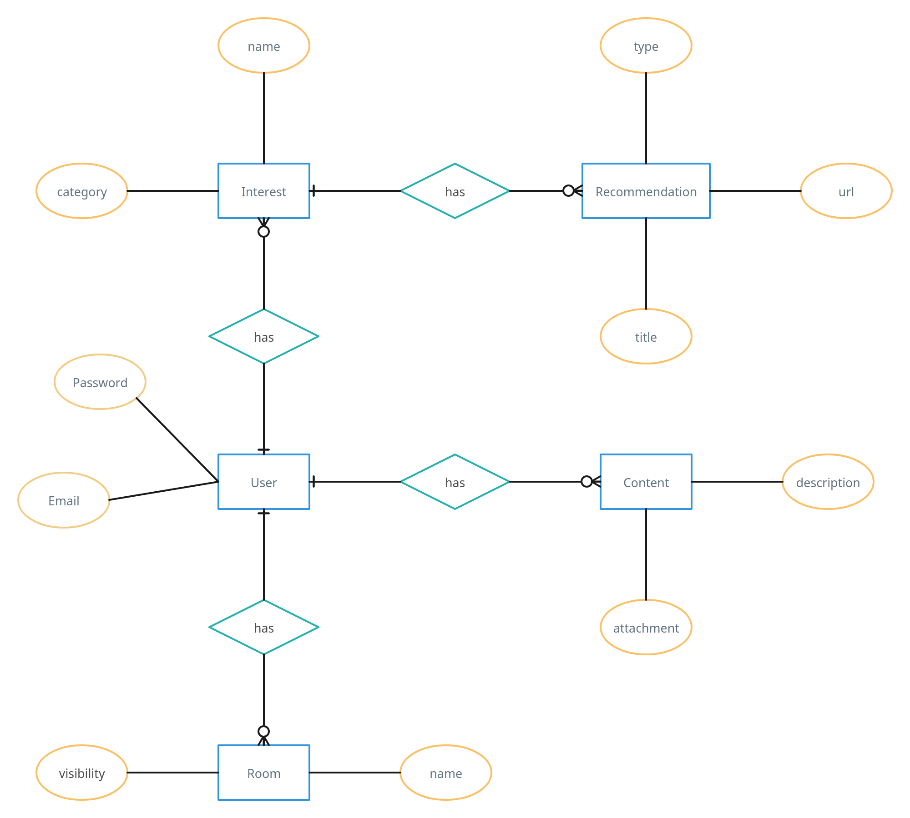

Figure 3.8 : ER DIAGRAM

## **3.5 Work Plan**

The work plan for the project is structured to ensure a systematic and efficient development process. Here is how the development process was broken down:

|  |  |  |
| --- | --- | --- |
|  | **Duration** | **Work plan** |
| 1 | September 1st - September 14th | Define the project scope and objectives.  Create Project plan. |
| 2 | September 15th - October 12th | Literature Review  Gathering System and User Requirements |
| 3 | October 13th - November 14th | System Analysis and Design |
| 4 | November 15th - December 31st | System Backend development |
| 5 | January 1st - February 13th | Recommendation engine development |
| 6 | February 14th - March 3th | System Frontend development |
| 7 | March 4th - March 18th | Unit testing  Integration testing  System testing |
| 8 | March 19th – April 1st | Maintenance and updates  System Documentation |

Table 3.1 The work plan

# **3.6 Project Budget**

**For the development of this project , most tools used were open-source. There were a few tools that required payment for example, the hosting site and google programmable search engine.**

**The budget has been attached as appendix viii.**

# **CHAPTER 4**

# **SYSTEM CODE GENERATION AND TESTING**

The process of generating the system code involved a two-phase approach that comprised both the backend and the frontend. Each phase involved a step-by-step coding process that followed the system's functional requirements. The backend phase entailed developing the server-side of the system, which included building the application logic, database design, and data storage. On the other hand, the frontend phase focused on creating the user interface of the system, which involved developing the layout, design, and functionality of the system's user-facing components. Overall, each coding phase was an essential step towards creating a functional and efficient system that met the user's needs.

## **Backend**

### **User Authentication and Authorization**

User registration included, user account creation, user login and profile viewing. Authentication is essential for securing the platform and ensuring that users can access their accounts securely. Implementing authentication involves validating user credentials and providing access tokens for authenticated users.

In the provided code snippet in appendix ix, the backend functionality for user registration is implemented using Django's custom user model (`CustomUser`) and a custom user manager (`CustomUserManager`).

**1. Custom User Model and Manager**:

* The `CustomUser` model extends Django's `AbstractBaseUser` and `PermissionsMixin`, providing custom fields such as `uid`, `email`, `username`, `password_reset`, `image`, `private`, `created_at`, `is_active`, and `is_staff`.
* The `CustomUserManager` class extends Django's `BaseUserManager` and overrides the `create_superuser` method to create a superuser with the specified email and password.

**2. Serializer and View Logic:**

* The `Profile` view handles both GET and POST requests.
* During a POST request, it checks for the type of action requested (`profile` or `password`).
* For profile updates, it validates the email and image fields if provided, then saves the user instance.
* For password updates, it validates the old password, new password, and password confirmation, then sets the new password for the user instance.
* Upon successful profile or password updates, it redirects the user to the profile page with appropriate success messages.

**3. Views for Registration and Login:**

* The `Register` view handles GET and POST requests for user registration.
* It validates the submitted form fields (email, username, password), checks for existing users with the same email, and creates a new user instance if validations pass.
* The `Login` view handles GET and POST requests for user authentication.
* It retrieves the submitted email and password, checks for matching credentials in the database, and logs in the user if authentication succeeds.

Overall, the backend logic ensures secure user registration, profile management, and authentication within the Studyhive system, contributing to a seamless user experience.

### **Personalized Content Recommendations**

The provided code snippet demonstrates the backend logic for generating recommendations based on user interests and reviews. This functionality utilizes collaborative filtering techniques to suggest relevant recommendations to users.

**1. Data Retrieval and Pre-processing:**

* User reviews are retrieved from the `UserReview` model, including reviews from the user and their connections.
* If the user has no reviews, recommendations based on the interests of their connections are considered.
* The data is then combined and pre-processed to create a user profile with features representing likes and dislikes.

**2. Collaborative Filtering:**

* Collaborative filtering is applied using the `NearestNeighbors` algorithm from the scikit-learn library.
* The algorithm identifies the k-nearest neighbors (users with similar preferences) based on the cosine similarity of user profiles.

**3. Recommendation Generation:**

* Once the nearest neighbours are identified, recommendations liked by these neighbours are retrieved.
* These recommendations are then filtered and returned as the final set of recommendations for the user.

**4. Implementation Considerations:**

* The number of nearest neighbours (`k_neighbors`) considered for recommendation is determined based on the length of the user profile.
* The logic handles cases where the user has no reviews or connections, ensuring that recommendations are still provided based on the interests of connections.

The recommendation logic provides a personalized experience for users by suggesting relevant content based on their preferences and the preferences of users with similar interests. This enhances user engagement and satisfaction within the Studyhive platform.

### **Content Curation and Sharing**

### **Real-time Interaction**

### **4.2.5 Content Filtering and safety**

## **Backend**

### **4.2.1 User Registration**

### **4.2.2 Personalized Content Recommendations**

### **4.2.3 Content Curation and Sharing**

### **4.2.4 Real-time Interaction**

### **4.2.5 Content Filtering and safety**

# **R****EFERENCES**

Dhanu, B., & Dwivedi, Y. K. (2021). Udemy: A review of the online learning platform and its impact on student learning. International Journal of Educational Technology in Higher Education, 18(1), 1-13.

García-Ruiz, R., López-Herrera, A. G., & Ruiz-Puente, C. (2020). The use of YouTube for teaching and learning in higher education: A systematic review of the literature. Educational Technology Research and Development, 68(4), 2473-2509.

Kennedy, M. R. (2019). LinkedIn learning product review. Journal of the Canadian Health Libraries Association/Journal de l'Association des bibliothèques de la santé du Canada

Mazumder, S. (2019). Online learning platforms: A systematic review of the literature. International Journal of Educational Technology in Higher Education, 16(1), 1-11.

Ozdemir, İ., Aydemir, N., & Yılmaz, E. (2018). The role of YouTube in student engagement and learning. Educational Technology Research and Development, 66(4), 1525-1545.

Wang, X., Chen, Y., & Li, H. (2021). The impact of YouTube on student learning: A meta-analysis. Computers & Education, 163, 104099.

Yang, Y., Li, H., & Chen, Y. (2022). YouTube as a learning platform: A systematic review of the literature. Journal of Computer Assisted Learning, 38(1), 3-28.

Zhang, W., & Zhao, S. (2015). The impact of online learning platforms on student learning: A meta-analysis. Educational Technology Research and Development, 63(4), 525-540.

# **APPENDIX**

*The Agile Methodology*

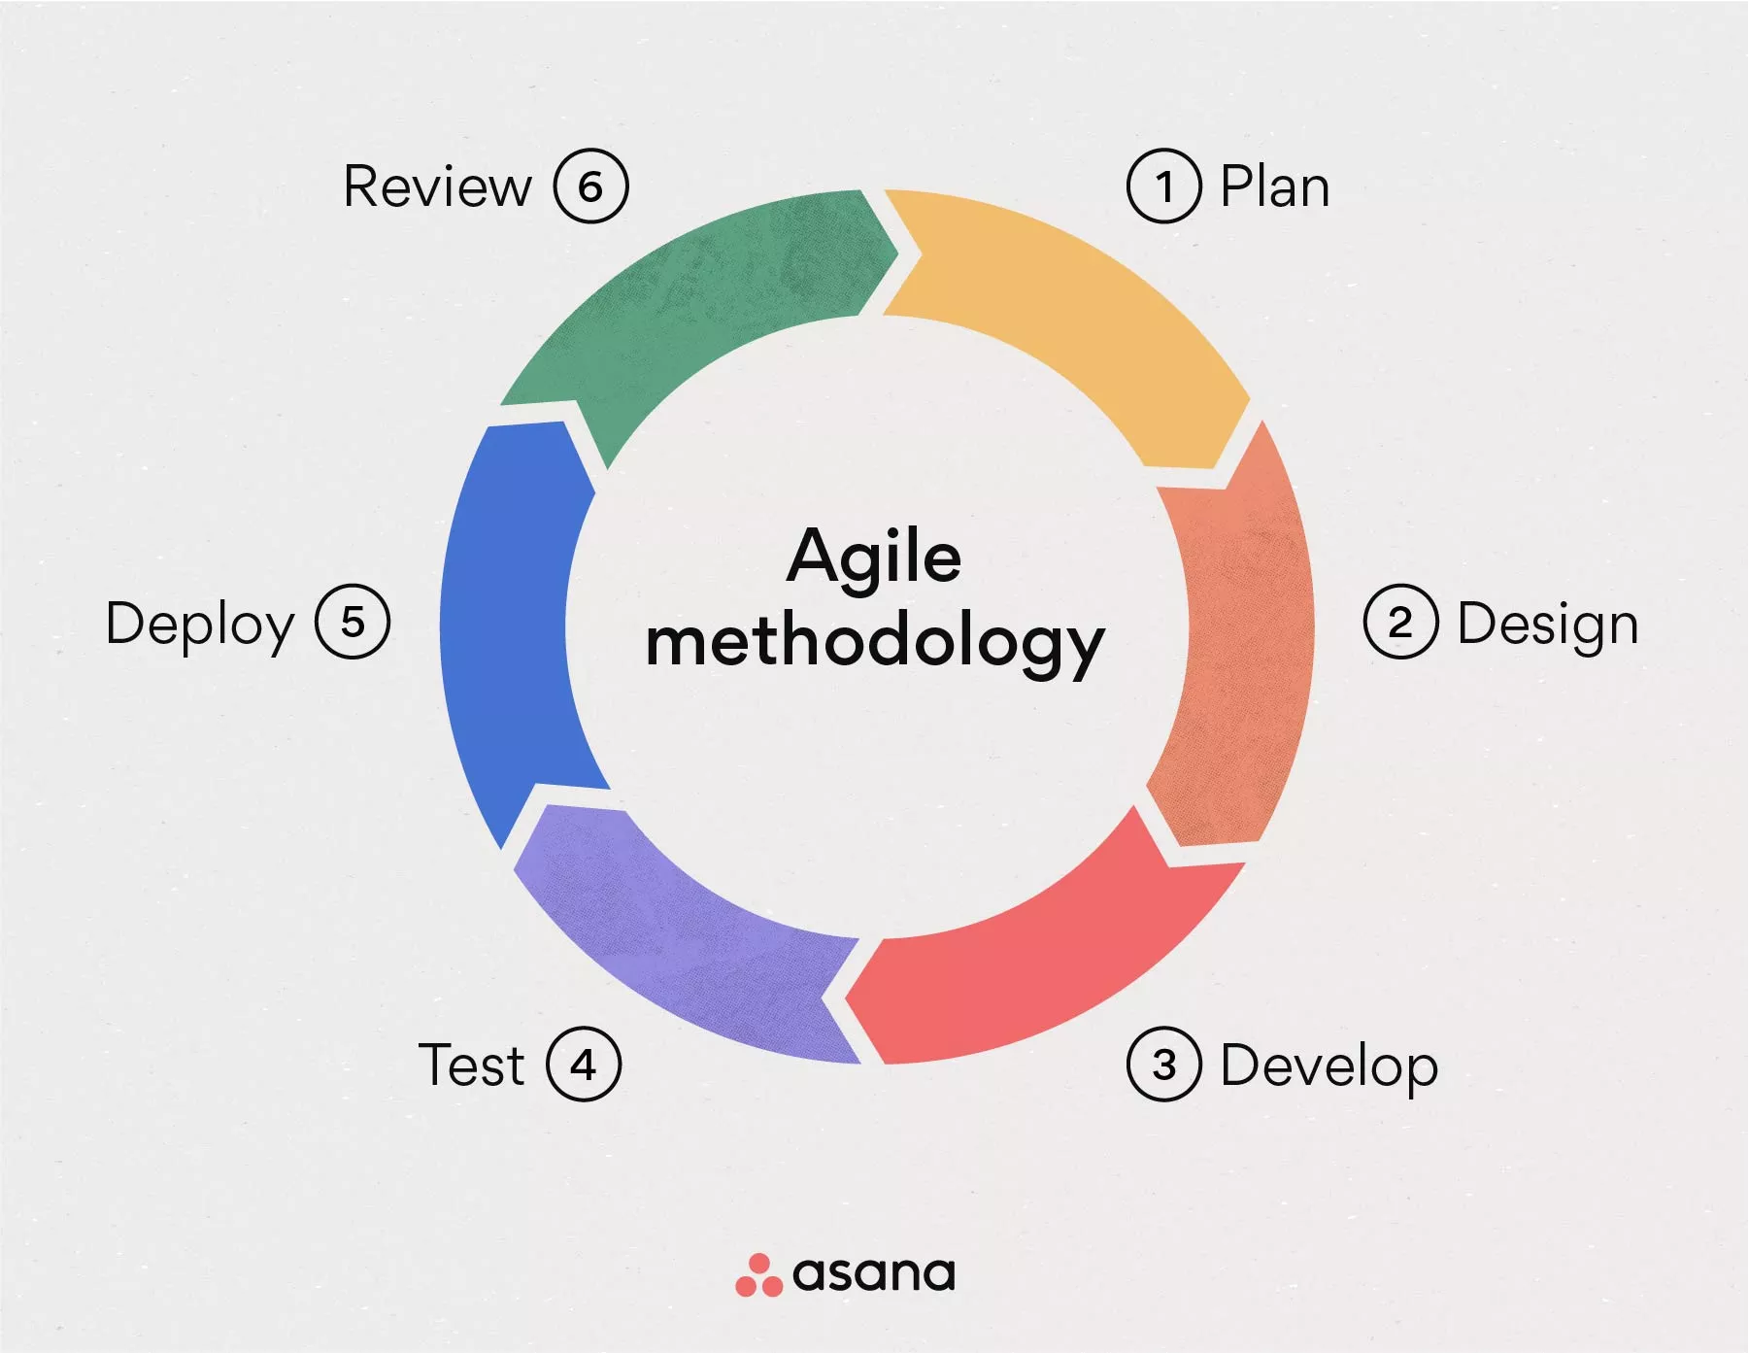

*Questinnaire used*

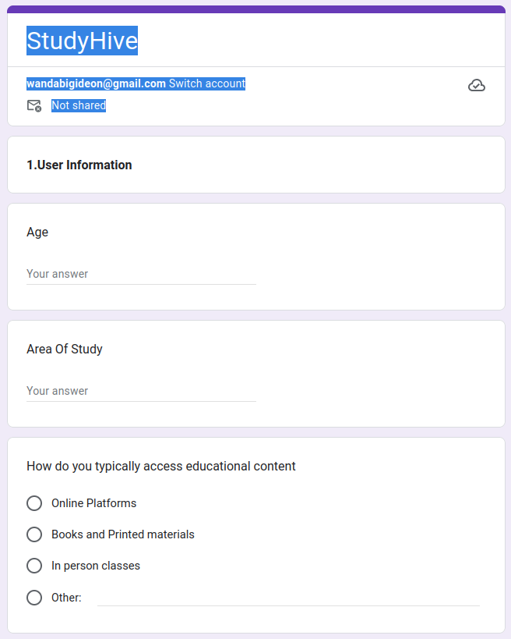appendix i

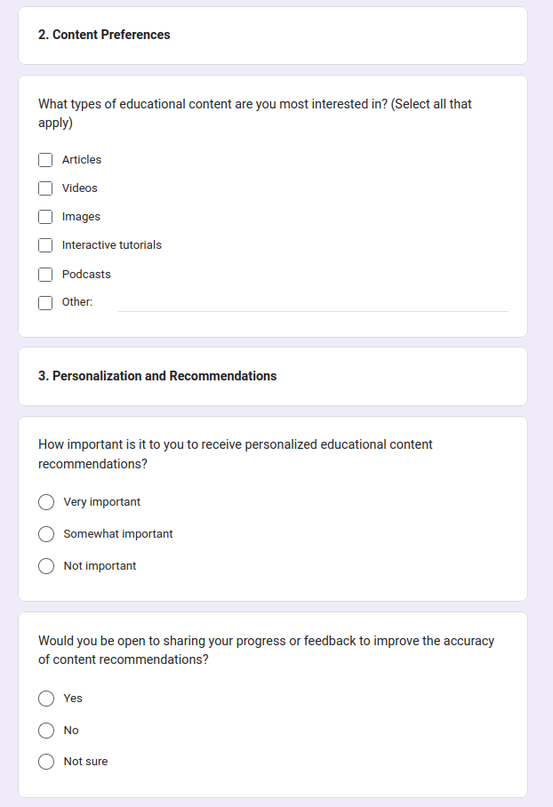appendix ii

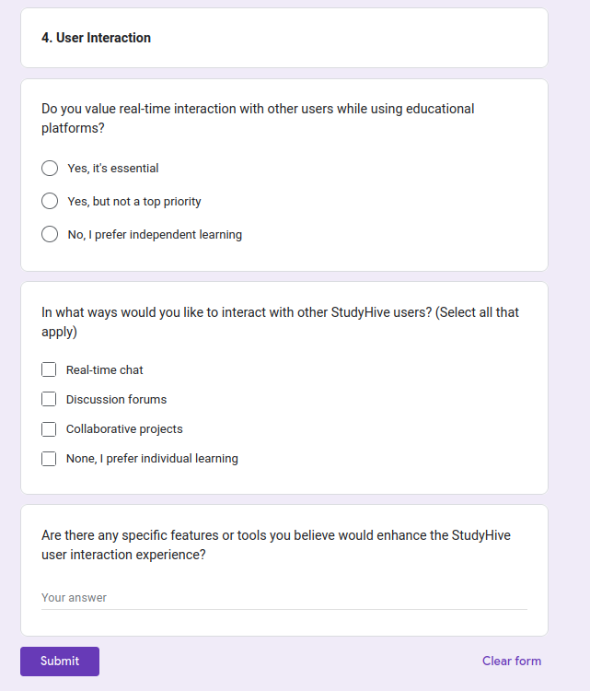appendix iii

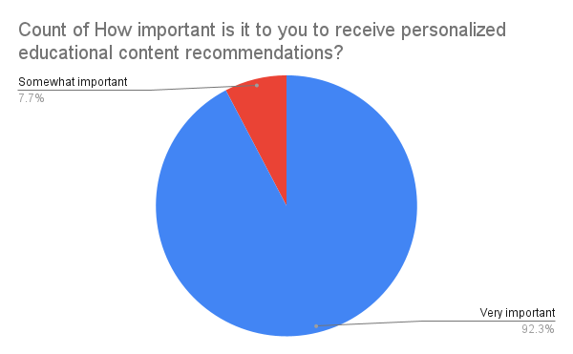

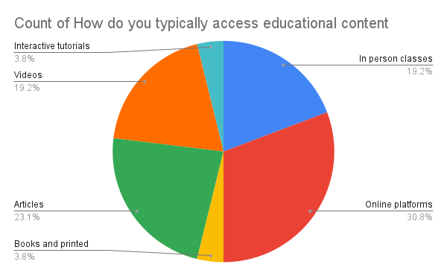appendix iv

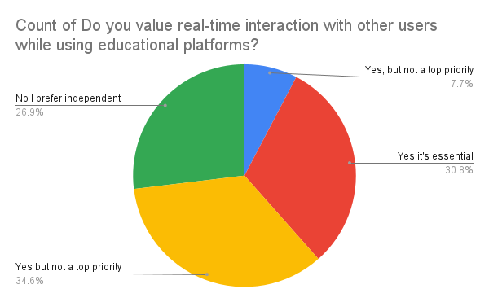appendix v

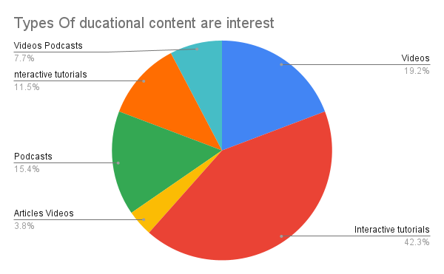appendix vi

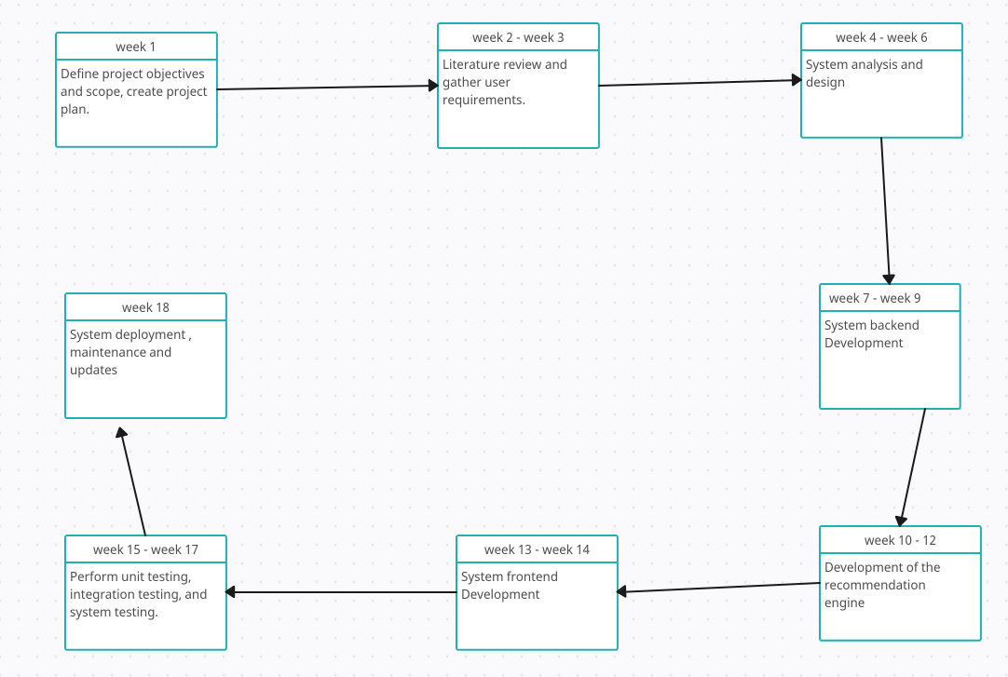appendix vii

appendix viii : Project budget

|  |  |  |
| --- | --- | --- |
| Product | Unit Price | Total Price |
| Google Programmable Search Engine | $5 per thousand queries | $50 |
| PythonAnywhere Hosting Site | $15 per month | $60 |
| Heroku Hosting site | $0.035/hour | $25.5 |