[进入计算机->属性->高级系统设置->环境变量中设置Path变量](http://jingyan.baidu.com/album/1709ad807a33af4635c4f06d.html?picindex=5" \t "https://jingyan.baidu.com/article/_self)

[[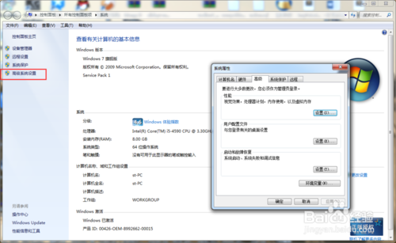](http://jingyan.baidu.com/album/1709ad807a33af4635c4f06d.html?picindex=4)](http://jingyan.baidu.com/album/1709ad807a33af4635c4f06d.html?picindex=5" \t "https://jingyan.baidu.com/article/_self)

[配置path值为php具体存放的位置，之后就可以在cmd命令行中执行php程序了](http://jingyan.baidu.com/album/1709ad807a33af4635c4f06d.html?picindex=5" \t "https://jingyan.baidu.com/article/_self)

[[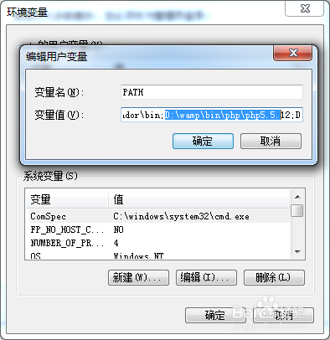](http://jingyan.baidu.com/album/1709ad807a33af4635c4f06d.html?picindex=5)](http://jingyan.baidu.com/album/1709ad807a33af4635c4f06d.html?picindex=5" \t "https://jingyan.baidu.com/article/_self)

也就是第一个用户变量