NWSS Dataset Description

The description of the data lists the attributes in the NWSS digital dataset and their values. Further information on the survey can be found in the documents containing guidance, plans and the data collection protocol.

The following datasets are available for GIS users:

Polygons: FC_S_NWSS (base map and polygon level attributes)
Tables: FC_S_NWSS_CANOPY_STRUCTURES
FC_S_NWSS_HABITAT_COMPONENTS
FC_S_NWSS_HERBIVORE_IMPACT
FC_S_NWSS_SPECIES_STRUCTURES
FC_S_NWSS_OTHER_TRAITS
FC_S_NWSS_INVASIVES

The following datasets are available on the FCS Internal Browser:

- NWSS Map
- NWSS Nativeness
- NWSS Habitat; relating to all habitat components
- NWSS Canopy Cover
- NWSS Semi-naturalness
- NWSS Canopy Structures; relating to the each structure component and each species-structure component
- NWSS Canopy Maturity; relating to each species-structure component
- NWSS Other Traits; relating to additional characteristics components
- NWSS Herbivore Impact; relating to identified herbivores.
- NWSS Invasives
- NWSS Data Availability

Dataset description

The minimum polygon size is 0.5ha.

Below there are lists of the attributes in each dataset:
1.1 Polygon attributes

The NWSS polygons contain: a unique polygon ID which is used to relate to the other NWSS tables and identifies each polygon: SCPTDATA_I

TYPE: describes the type of NWSS polygon which relates to the attributes that are collected, the type of habitat to expect, or to the main outcomes of the survey. | DESCRIPTION
Native woodland | >50% native species in the canopy
Nearly-native woodland | ≥40% ≤50% native species in the canopy
Open land habitat | <20% canopy cover, usually 100% surrounded by woodland and adjoining a native woodland
PAWS | A woodland area wholly or partially identified in the Ancient Semi-natural Woodland Inventory as ancient semi-natural but currently not semi-natural.

CANOPY_PCT: % assessment of the area covered by tree/shrubs | DESCRIPTION
0 to 100% in 10% classes.  *A minimum of 20% canopy is required to define woodland, so the 10% and 20% bands are skewed to allow for this. | 0% is used for zero presence  10% describes >0 to 19%*  20% describes 20% to 24%*  30% describes 25% to 34%  40% describes 35% to 44%  50% describes 45% to 54%  60% describes 55% to 64%  70% describes 65% to 74%  80% describes 75% to 84%  90% describes 85% to 99%  100% describes 100%

NATIVE_PCT: % share of native species in the total canopy | DESCRIPTION
0 to 100% in 5% classes.  * A minimum of 40% native species in the canopy are required to define a native or nearly native woodland, so the 30% and 40% bands are skewed to allow for this. | 0% is used for zero presence  5% describes >0% to 7%  10% describes 8% to 12%  15% describes 13% to 17%  20% describes 18% to 22%  25% describes 23% to 27%  30% describes 28% to 32%  35% describes 33% to 39%*  40% describes 40% to 42%*  45% describes 43% to 47%  50% describes 48% to 52%  55% describes 53% to 57%  60% describes 58% to 62%  65% describes 63% to 67%  70% describes 68% to 72%  75% describes 73% to 77%  80% describes 78% to 82%  85% describes 83% to 87%  90% describes 88% to 92%  95% describes 93% to 99%  100% describes 100%
DOM_HABITA: Woodland is defined both by priority woodland type and NVC woodland community. Open Land habitat is defined by BAP type. | DESCRIPTION (full descriptions are in Appendix 3 of the NWSS protocol)
- Priority woodland types are the UK Biodiversity Action Plan (UKBAP) priority woodland habitats  - NVCs are the National Vegetation Classifications (or are classed as unidentifiable). The National Vegetation Classification and is the standard classification used for describing vegetation in GB (Rodwell 1991).  (or are classed as unidentifiable).  - BAPs are the UKBAP broad habitat types. | Woodland habitat types [priority woodland types]:  - Native pinewood  - Upland birchwood  - Upland mixed ashwood  - Upland oakwood  - Wet woodland  - Lowland mixed deciduous woodland  Woodland habitat types [NVC types]:  - Juniper scrub  - Montane willow scrub  - Hawthorn scrub  - Blackthorn scrub  Woodland habitat types [other types]:  - Unidentifiable type  - Clear fell  - Non native  Open land habitat types [BAP types]:  - Acid grassland  - Agriculture and horticulture  - Bog  - Boundary and linear features  - Bracken  - Built up areas and gardens  - Calcareous grassland  - Dwarf shrub heath  - Exotic trees (<20% canopy; ER to Veteran)  - Fen, marsh and swamp  - Improved grassland  - Inland rock  - Montane habitats  - Native trees (<20% canopy; ER to Veteran)  - Neutral grassland  - Rivers and streams  - Scrub of exotic species (>20% canopy e.g. rhododendron, snowberry)  - Scrub of native species (>20% canopy; gorse, broom, bramble but not juniper, hawthorn and blackthorn which are NVC woodland communities)  - Standing open water and canals  - Visible regeneration of exotic species (≤1 metre height & ≥600 stems/ha)  - Visible regeneration of native species (≤1 metre height & ≥600 stems/ha)

DOM_HB_PCT: describes the % of the polygon covered by each NVC/priority woodland class. | DESCRIPTION
0 to 100% in 5% classes.  The % estimate for a NVC/HAP combination must include all unmappable open ground (all discrete open areas <0.5ha in area). It is NOT just an estimate of the area with canopy >20%.  A minority (0%) woodland component exists where a small unmappable (<0.5ha) NVC woodland community/priority woodland type occurs within a larger mappable polygon that is a different NVC/priority woodland type. A minority NVC/priority woodland can occur as a single small “patch” (<0.5ha), or multiple small patches each <0.5ha but which together may cover an area >0.5ha. To qualify as a minority each discrete unmappable NVC/priority woodland type must occupy <3% overall of the larger mappable “surveyed” polygon within which it occurs. | 0% describes “present <3%”  5% describes >3% to 7%  10% describes 8% to 12%  15% describes 13% to 17%  20% describes 18% to 22%  25% describes 23% to 27%  30% describes 28% to 32%  35% describes 33% to 37%  40% describes 38% to 42%  45% describes 43% to 47%  50% describes 48% to 52%  55% describes 53% to 57%  60% describes 58% to 62%  65% describes 63% to 67%  70% describes 68% to 72%  75% describes 73% to 77%  80% describes 78% to 82%  85% describes 83% to 87%  90% describes 88% to 92%  95% describes 93% to 99%  100% describes 100%

PAWS_SURVY: have polygons have been surveyed as a PAWS? | DESCRIPTION
- Yes  - No | PAWS are plantations on ancient semi-natural sites shown to exist on the ancient semi-natural woodland inventory.  This explains why some polygons are not native or nearly-native woodland, or open land habitat but are in the NWSS data. Native, nearly-native woodlands and open land habitat can be PAWS too.

MATURITY of the woodland based on the structural classes recorded. | DESCRIPTION
- Regenerating | - dominated by established and visible regeneration structures.
- Young | - dominated by pole immature
- Mature | - dominated by mature and veteran structures
- Mixed | - no dominant structure.
- Shrub | - dominated by shrubs.

DOM_STRUCT: identifies the largest structural classes recorded. | DESCRIPTION
- Veteran (V)  - Mature (M)  - Pole immature (PI)  - Shrub (S)  - Established regeneration (ER)  - Visible regeneration (VR) | - Veteran is any tree that meets both the minimum Diameter at Breast Height [DBH] threshold for its species and displays at least 3 of the listed growth & decay attributes.  - Mature reproductive trees where growth has begun to significantly slow down & > than the maturity threshold for the species (20cm, 30cm, 35cm or 15cm; 23cm & 26cm in stressed environments)  - PI stage/thicket trees ≥7cm DBH & < the maturity threshold for the species (20cm, 30cm, 35cm or 15cm; 23cm & 26cm in stressed environments), usually above 5m height but not yet mature.  - Shrubs are woody plants often (but not always) branching abundantly from the base, >1m tall and usually <5m tall , and depending on species should be treated as defined in one of the following two categories;  shrubs that are to be considered as part of the canopy are: juniper, blackthorn, dog rose, eared willow, montane willows, dwarf birch, guelder rose. Shrubs that do not count as part of the canopy cover estimate and are recorded as a proportion of the polygon are; gorse, broom, bramble, Japanese knotweed, rhododendron ponticum, snowberry  .  - ER is >1m height and <7cm DBH [up to and including large sapling but not ‘pole stage’]; Usually <5m height but again DBH overrides height in determining this class.  - VR are trees above predominant field layer height but < 1m tall and still susceptible to browsing damage; may range significantly in height up to maximum for class depending on height of field layer & browsing intensity.

STRUCT_NUM: is the number of structures recorded in the polygon | DESCRIPTION
- 0  - 1  - 2  - 3  - 4  - 5  - 6 | The number of different structures recorded in the polygon; as a combination of Veteran, Mature, Pole Immature, Shrub, Established Regeneration or Visible Regeneration.

OTHR_TRAITS: are there any other attributes recorded? | DESCRIPTION
- Yes  - No | Yes – there are other characteristics recorded – to view the characteristics relate the polygons to the NWSS_characteristics table.  No – there are no characteristics to view.

SEMINT_PCT: how much of the polygon has semi-natural characteristics? | DESCRIPTION
0 to 100% in 10% classes. | 0% is used for zero presence  10% describes 1 to 14%  20% describes 15% to 24%  30% describes 25% to 34%  40% describes 35% to 44%  50% describes 45% to 54%  60% describes 55% to 64%  70% describes 65% to 74%  80% describes 75% to 84%  90% describes 85% to 99%  100% describes 100%

HERBIVORE: the overall impact of herbivores on a woodland polygon. | DESCRIPTION
Unbrowsed
Light to moderately browsed
Moderate to heavy browsing, not heavily grazed
Heavy browsing and grazing under a full canopy
Heavy browsing and grazing under a fragmented canopy
Heavily browsed and grazed (frag canopy, poaching, bark stripping) or heavily poached (full canopy)

ER_NAT_PCT | DESCRIPTION
The ratio of the established regeneration in the polygon that is native species. Note this is calculated only when established regeneration in more than a minority component e.g. >0% in data (<3% of canopy cover of species) | 0 to 100%

INVASV_PCT | DESCRIPTION
The percent of the polygon affected by invasive species; rhododendron, Japanese knotweed, snowberry, giant hogweed, Himalayan balsam, and other herbaceous invasive exotics. | 0% describes “present <3%”  5% describes >3% to 7%  10% describes 8% to 12%  15% describes 13% to 17%  20% describes 18% to 22%  25% describes 23% to 27%  30% describes 28% to 32%  35% describes 33% to 37%  40% describes 38% to 42%  45% describes 43% to 47%  50% describes 48% to 52%  55% describes 53% to 57%  60% describes 58% to 62%  65% describes 63% to 67%  70% describes 68% to 72%  75% describes 73% to 77%  80% describes 78% to 82%  85% describes 83% to 87%  90% describes 88% to 92%  95% describes 93% to 99%  100% describes 100%

HECTARES: of the whole polygon. | DESCRIPTION
number of hectares to two decimal place.

  - Related tables’ attributes

Tables are always related using the unique polygon id “SCPTDATA_ID”.

FC_S_NWSS_CANOPY_STRUCTURES
Attributes | Description
- STRUCT_PCT  - STRUCTURE | % area of the canopy having a structure class  Veteran, Mature, Pole immature, Shrub, Established regeneration, or Visible regeneration

The areas of woodland are subdivided by priority woodland type and NVC community and these are the defining characteristic of the native woodland map.

FC_S_NWSS_HABITAT_COMPONENTS
Attributes | Description
- HABITA_PCT  - HAP_BAP  - NVC  - LANDSCAPE | % of the polygon covered by each NVC/priority woodland class.  - Woodland is defined both by priority woodland type (see polygon information above) and NVC woodland community (listed below). Open land habitat is defined by BAP type.  - W1 Salix cinerea - Galium palustre  - W2 Salix cinerea - Betula pubescens - Phragmites australis  - W3 Salix pentandra –Carex rostrata  - W4 Betula pubescens –Molina caerulea  - W5 Alnus glutinosa-Carex paniculata  - W6 Alnus glutinosa – Urtica dioica  - W7 Alnus glutinosa - Fraxinus excelsior woodland  - W8 Fraxinus excelsior - Acer campestre – Mercurialis perennis  - W9 Fraxinus excelsior – Sorbus aucuparia– Mercurialis perennis  - W10 Quercus robur – Pteridium aquilinum-Rubus fructicosus  - W11 Quercus petraea – Betula pubescens – Oxalis acteosella  - W16 Quercus spp. – Betula spp. – Deschamsia flexuosa  - W17 Quercus petraea – Betula pubescens – Dicranum majus  - W18 Pinus sylvestris – Hylocomium splendens  - W19 Juniperus communis ssp. communis-Oxalis acetosella  - W20 Salix lapponum – Luzula sylvatica  - W21 Crataegus monogyna – Hedera helix  - W22 Prunus spinosa – Rubus fructicosus  - WLz Oak/ Birch woodland with field layer dominated by Luzula Sylvatica  - WPc Lichen rich pinus sylvestris woodland  - Wh Hypericum pulchrum- melampyrum pratense ride community  - WN not identifiable as distinct NVC type  - Non native (non-native mosaic with native woodland)  The landscape feature is the type of micro-feature where the minority component is found; this is only indicated where a component is 0% (<3% of polygon area):  - Hilltop/Plateau/Terrace  - Hillslope  - Valley bottom  - Gorge  - Slope flush  - Valley bottom flush  - Cliff/Crag/Scree/Block litter  - Freshwater margins (non-gorge)

FC_S_NWSS_HERBIVORE_IMPACT
Attributes | Description
- IMPACT_PCT  - HERBIVORE | % of the polygon affected by each type of herbivore damage present.  The type of herbivore impact from the following list:  - Deer damage  - Livestock damage  - Rabbit or hare damage

FC_S_NWSS_SPECIES_STRUCTURES
Attributes | Description
- SP_STR_PCT  - SPECIES  - STRUCTURE  - STOCKING  - ESTIMT_HA | % area of the canopy having this structure class  Tree or shrub species (see Appendix 1) for a list of species) .* next to a name is a native species and a + sign is for a shrub not tree species  Structure of this species within the canopy (Veteran, Mature, Pole immature, Shrub, Established regeneration, Visible regeneration)  Stocking density of the species-structure within the canopy, as stems per hectare. In the following classes:  - <100 stems/ha  - 100 <600 stems/ha  - 600 <1100 stems/ha  - 1100 <2500 stems/ha  - 2500 stems/ha  The area estimated from the canopy cover of the species within the polygon.  This estimated area is calculated from the percent cover in the polygon (rather than canopy) for visible regeneration and for the following species: gorse, broom, rhododendron ponticum, Japanese knotweed, snowberry and bramble.

FC_S_NWSS_OTHER_TRAITS
Attributes | Description
- TRAIR_PCT  - OTHR_TRAIT  (some of these are also listed under herbivore impact when appropriate) | % of the polygon affected by each characteristic listed  Additional key characteristics within the polygon:  - Exotic trees  - Exotic regeneration  - Not site native trees  - Other herbaceous invasive exotics  - Recently cleared invasive exotics  - Pheasant management damage  - Drainage  - Windthrow  - Bracken  - Erosion  - Machinery  - Vandalism  - Dumping  - Disease/pests  - Pollution  - Die-back  - Muirburn/fire  - Casual felling  - House building  - Other built development  - Road  - Quarry  - Power line  - Giant hogweed  - Himalayan balsam  - Green cover [PAWS only]  - Enrichment  - Deer damage  - Livestock damage  - Rabbit or hare damage  - Grey squirrel damage  - Recreational impact  - Other management impacts  - Temporary felling (PAWS only)  - Permanently felled (PAWS only)  - Temp natural woodland loss (PAWS only)  - Mapping error - not woodland (PAWS only)  - Access issue

FC_S_NWSS_INVASIVES
Attributes | Description
- SP_STR_PCT  - SPECIES  - STRUCTURE  - STOCKING | % area of the POLYGON affected by the invasive species.  Giant hogweed  Himalayan balsam  Snowberry+  Rhododendron ponticum +  Japanese knotweed +  Other herbaceous invasive exotics  Structure of this species within the canopy (Shrub or Visible Regeneration) or null if the information not available.  Stocking density of the species-structure within the canopy, as stems per hectare. In the following classes:  - <100 stems/ha  - 100 <600 stems/ha  - 600 <1100 stems/ha  - 1100 <2500 stems/ha  - > 2500 stems/ha  - null

  - Pinewood zone

The pinewood zone is an area in Scotland where Pinus sylvestris is a native species; outside of this zone it is believed that pine is not native. The zone used in the NWSS is based on the work by McVean and Ratcliffe (1962) and Forest Research; for the purposes of the NWSS a 1km buffer was added. Any polygon intersecting the pine zone has Scots pine as native and any polygon not intersecting the pine zone it is not-native. This is available as a layer in for download or on the internal browser.
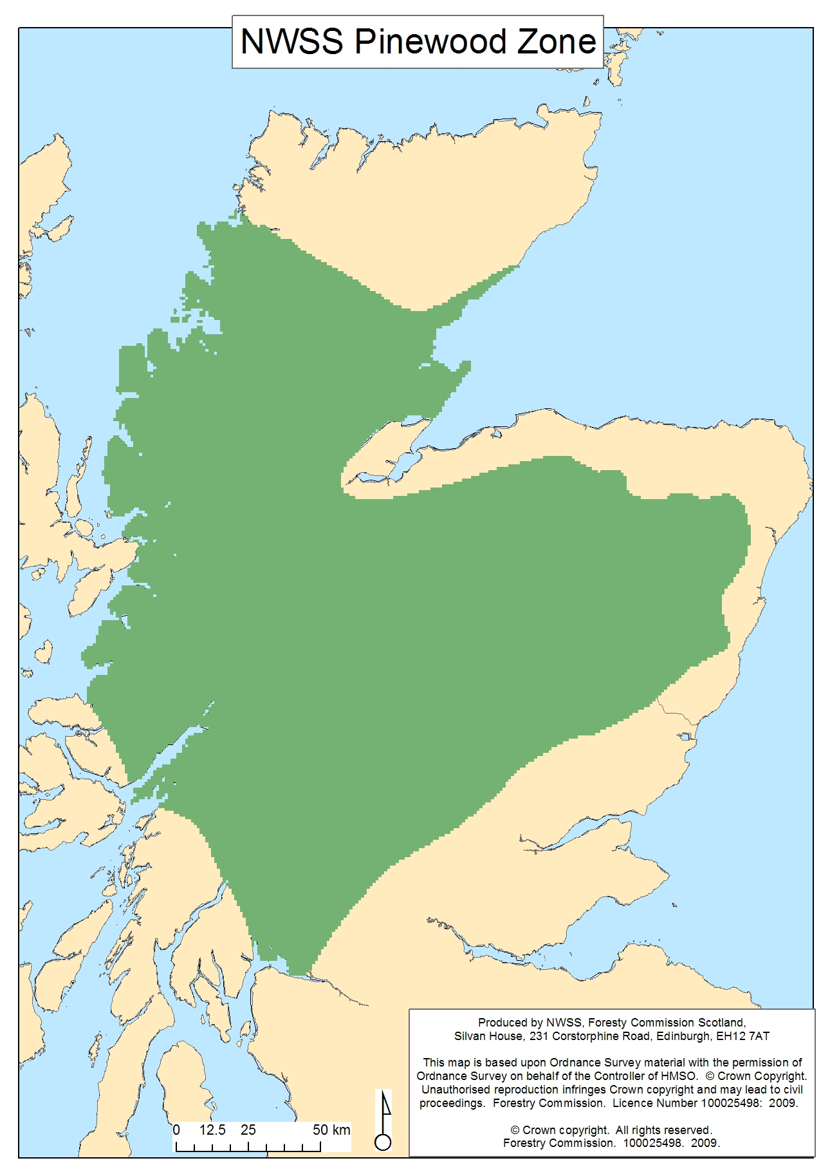
1.4 Species

Shrub species that are to be considered as part of the canopy:

Juniper (both spp)* +
Blackthorn* +
Dog rose* +
Eared willow* +
Montane willows* +
Dwarf birch* +
Guelder rose* +

Shrub species that do not count as part of the total canopy cover estimate and are recorded as a proportion of the polygon:
Gorse* +
Broom* +
Bramble* +
Japanese knotweed +
Rhododendron ponticum +
Snowberry +

(* = native species: + = shrubs)

Note: The total calculated area on all the species-structure components (with the shrubs in mind that are % of polygon and not % of canopy) may be >100% due to the different canopy layers.

* native species
+ shrub species

SPECIES LIST 1 order by species English name – as seen in datasets:
Arran whitebeam *
Ash *
Aspen *
Austrian pine
Beech
Birch *
Bird cherry *
Bishop pine
Blackthorn *+
Bramble *+
Broom *+
Coast redwood
Common alder*
Corsican pine
Crab apple
Dog rose *+
Douglas fir
Downy birch *
Dwarf birch *+
Dwarf juniper *+
Eared willow *+
Elder *
English elm
European larch
Field maple
Gean wild cherry *
Geulder rose *+
Goat willow*
Gorse *+
Grand fir
Grey alder
Grey willow *
Hawthorn *
Hazel *
Holly *
Hornbeam
Horse chestnut
Hybrid larch
Intermediate oak *
Japanese cedar
Japanese knotweed +
Japanese larch
Lawsons cypress
Leyland cypress
Lime all
Lodgepole pine
London plane
Maritime pine
Montane willow all *+
Noble fir
Non-native willow
Norway maple
Norway spruce
Nothofagus all
Omorika spruce
Other native willows *
Other non-native trees/shrubs
Other oak
Other pines
Other whitebeam
Pedunculate oak *
Poplar
Radiata pine
Red oak
Rhododendron ponticum +
Rock whitebeam *
Rowan *
Scots pine *
Sessile oak *
Shrubs - preferentially browsed +
Silver birch *
Silver fir
Sitka spruce
Smooth-leaved elm
Snowberry+
Sweet chestnut
Sycamore
Upright juniper * +
Walnut
Wellingtonia
Western hemlock
Western red cedar
Wild service tree
Wych elm *
Yew *

Shrubs – preferentially browsed:
Applies to the following species only and is only to be recorded where the listed species are accessible to browsers. (Record as ‘shrub’ size class).
- blaeberry
- bramble
- greater wood rush
- ferns (other than bracken)
- ivy
- honeysuckle
- bog myrtle

Native Willows

Species;
Salix caprea Goat Willow
S. cinerea Grey Willow
S. aurita Eared Willow

Willows [all montaine]* +
S. reticulata Net-leaved Willow
S. herbacea Dwarf Willow
S. arbuscula Mountain Willow
S. myrsinites Whortle-leaved Willow

S. lanata Woolly Willow
S. lapponum Downy Willow
S. repens Creeping Willow

Willow [other native]*
S. myrsinifolia Dark-leaved Willow
S. pentandra Bay Willow
S. purpurea Purple Willow
S. phylicifolia Tea-leaved Willow

