**Numerical Analysis – Fall 2021**

Assignment #2

Issued: Sept. 25, 2021 Due: Oct. 17, 2021

**Problem 1：**



**Problem 2：**

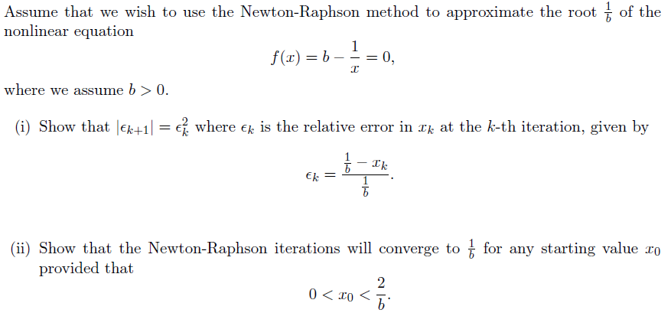

**Problem 3：**

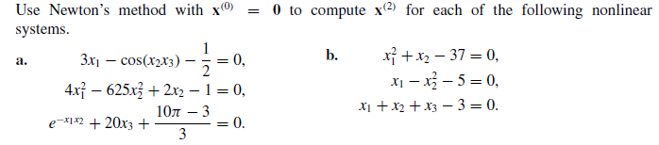

**Problem 4：**

