**Numerical Analysis – Fall 2021**

Assignment #4

Issued: Oct. 18, 2021 Due: Nov.1, 2021

**Please upload to the ‘hw4’ directory if you submit your homework in time.**

**Problem 1:**

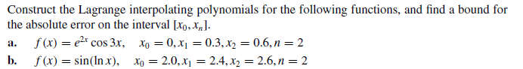

**Problem 2:**



**Problem 3:**

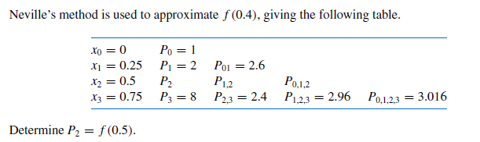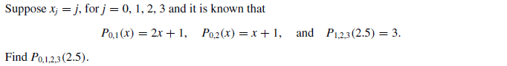

**Problem 4:**

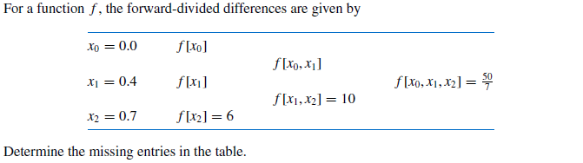

**Problem 5:**

