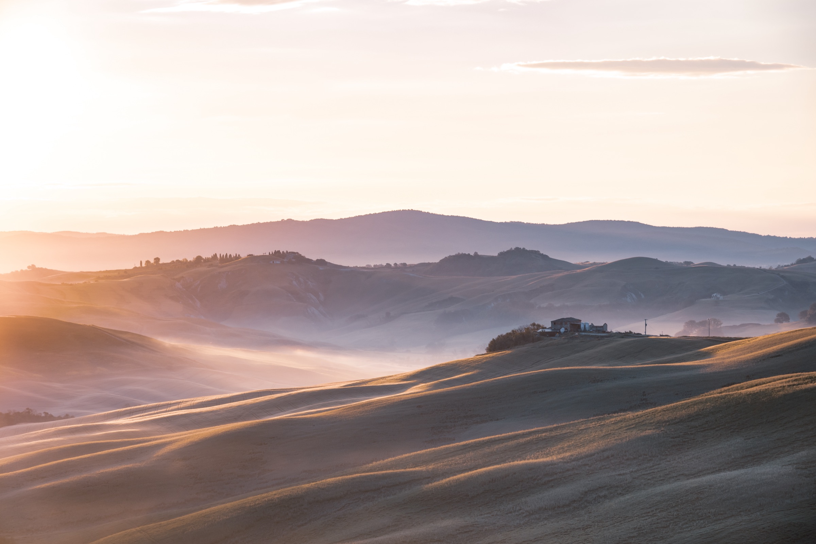
An Invitation to
Italy
FLORENCE • TUSCANY • ROME

PREPARED FOR  Jennifer Harlow Ingram  & Riley Criswell  27 October — 5 November 2026 · 9 nights | PREPARED BY  Wilson Schubert  Smartflyer · Virtuoso  wilson.schubert@smartflyer.com

— Trip at a glance
Nine nights, day by day.
 | DATE | WHERE | SUMMARY | INCLUDED
01 | TUE 27 Oct | FCO → Florence | Arrival at Rome Fiumicino; scenic 3.5-hour private transfer north to Florence. Check in at Hotel Calzaiuoli. Evening free. | Transfer
02 | WED 28 Oct | Florence | Half-day private Food & History tour on foot — Piazza della Repubblica, the Duomo, Mercato Centrale, and reserved entry to the David. Afternoon free. | Guide · David · Breakfast
03 | THU 29 Oct | Florence | Open day in Florence. | Breakfast
04 | FRI 30 Oct | Florence | Open day in Florence. | Breakfast
05 | SAT 31 Oct | Florence → Tuscany | Private transfer south with a truffle hunt and lunch en route. Check in at Castello di Vicarello. | Transfer · Truffle hunt · Lunch · Breakfast
06 | SUN 01 Nov | Tuscany | Open day at Castello di Vicarello. | Breakfast
07 | MON 02 Nov | Tuscany → Rome | Private cooking class with lunch, then a visit to a Brunello winery, before continuing on to Rome that afternoon. Check in at Umiltà 36. | Transfer · Cooking class · Lunch · Brunello · Breakfast
08 | TUE 03 Nov | Rome | Half-day private guided tour of Ancient Rome — Colosseum, Roman Forum, Circus Maximus, all reserved admissions included. Afternoon free. | Guide · Admissions · Breakfast
09 | WED 04 Nov | Rome | Open day in Rome. | Breakfast
10 | THU 05 Nov | Rome → FCO | One last Roman breakfast; private transfer to Fiumicino in time for your onward flight. | Transfer · Breakfast

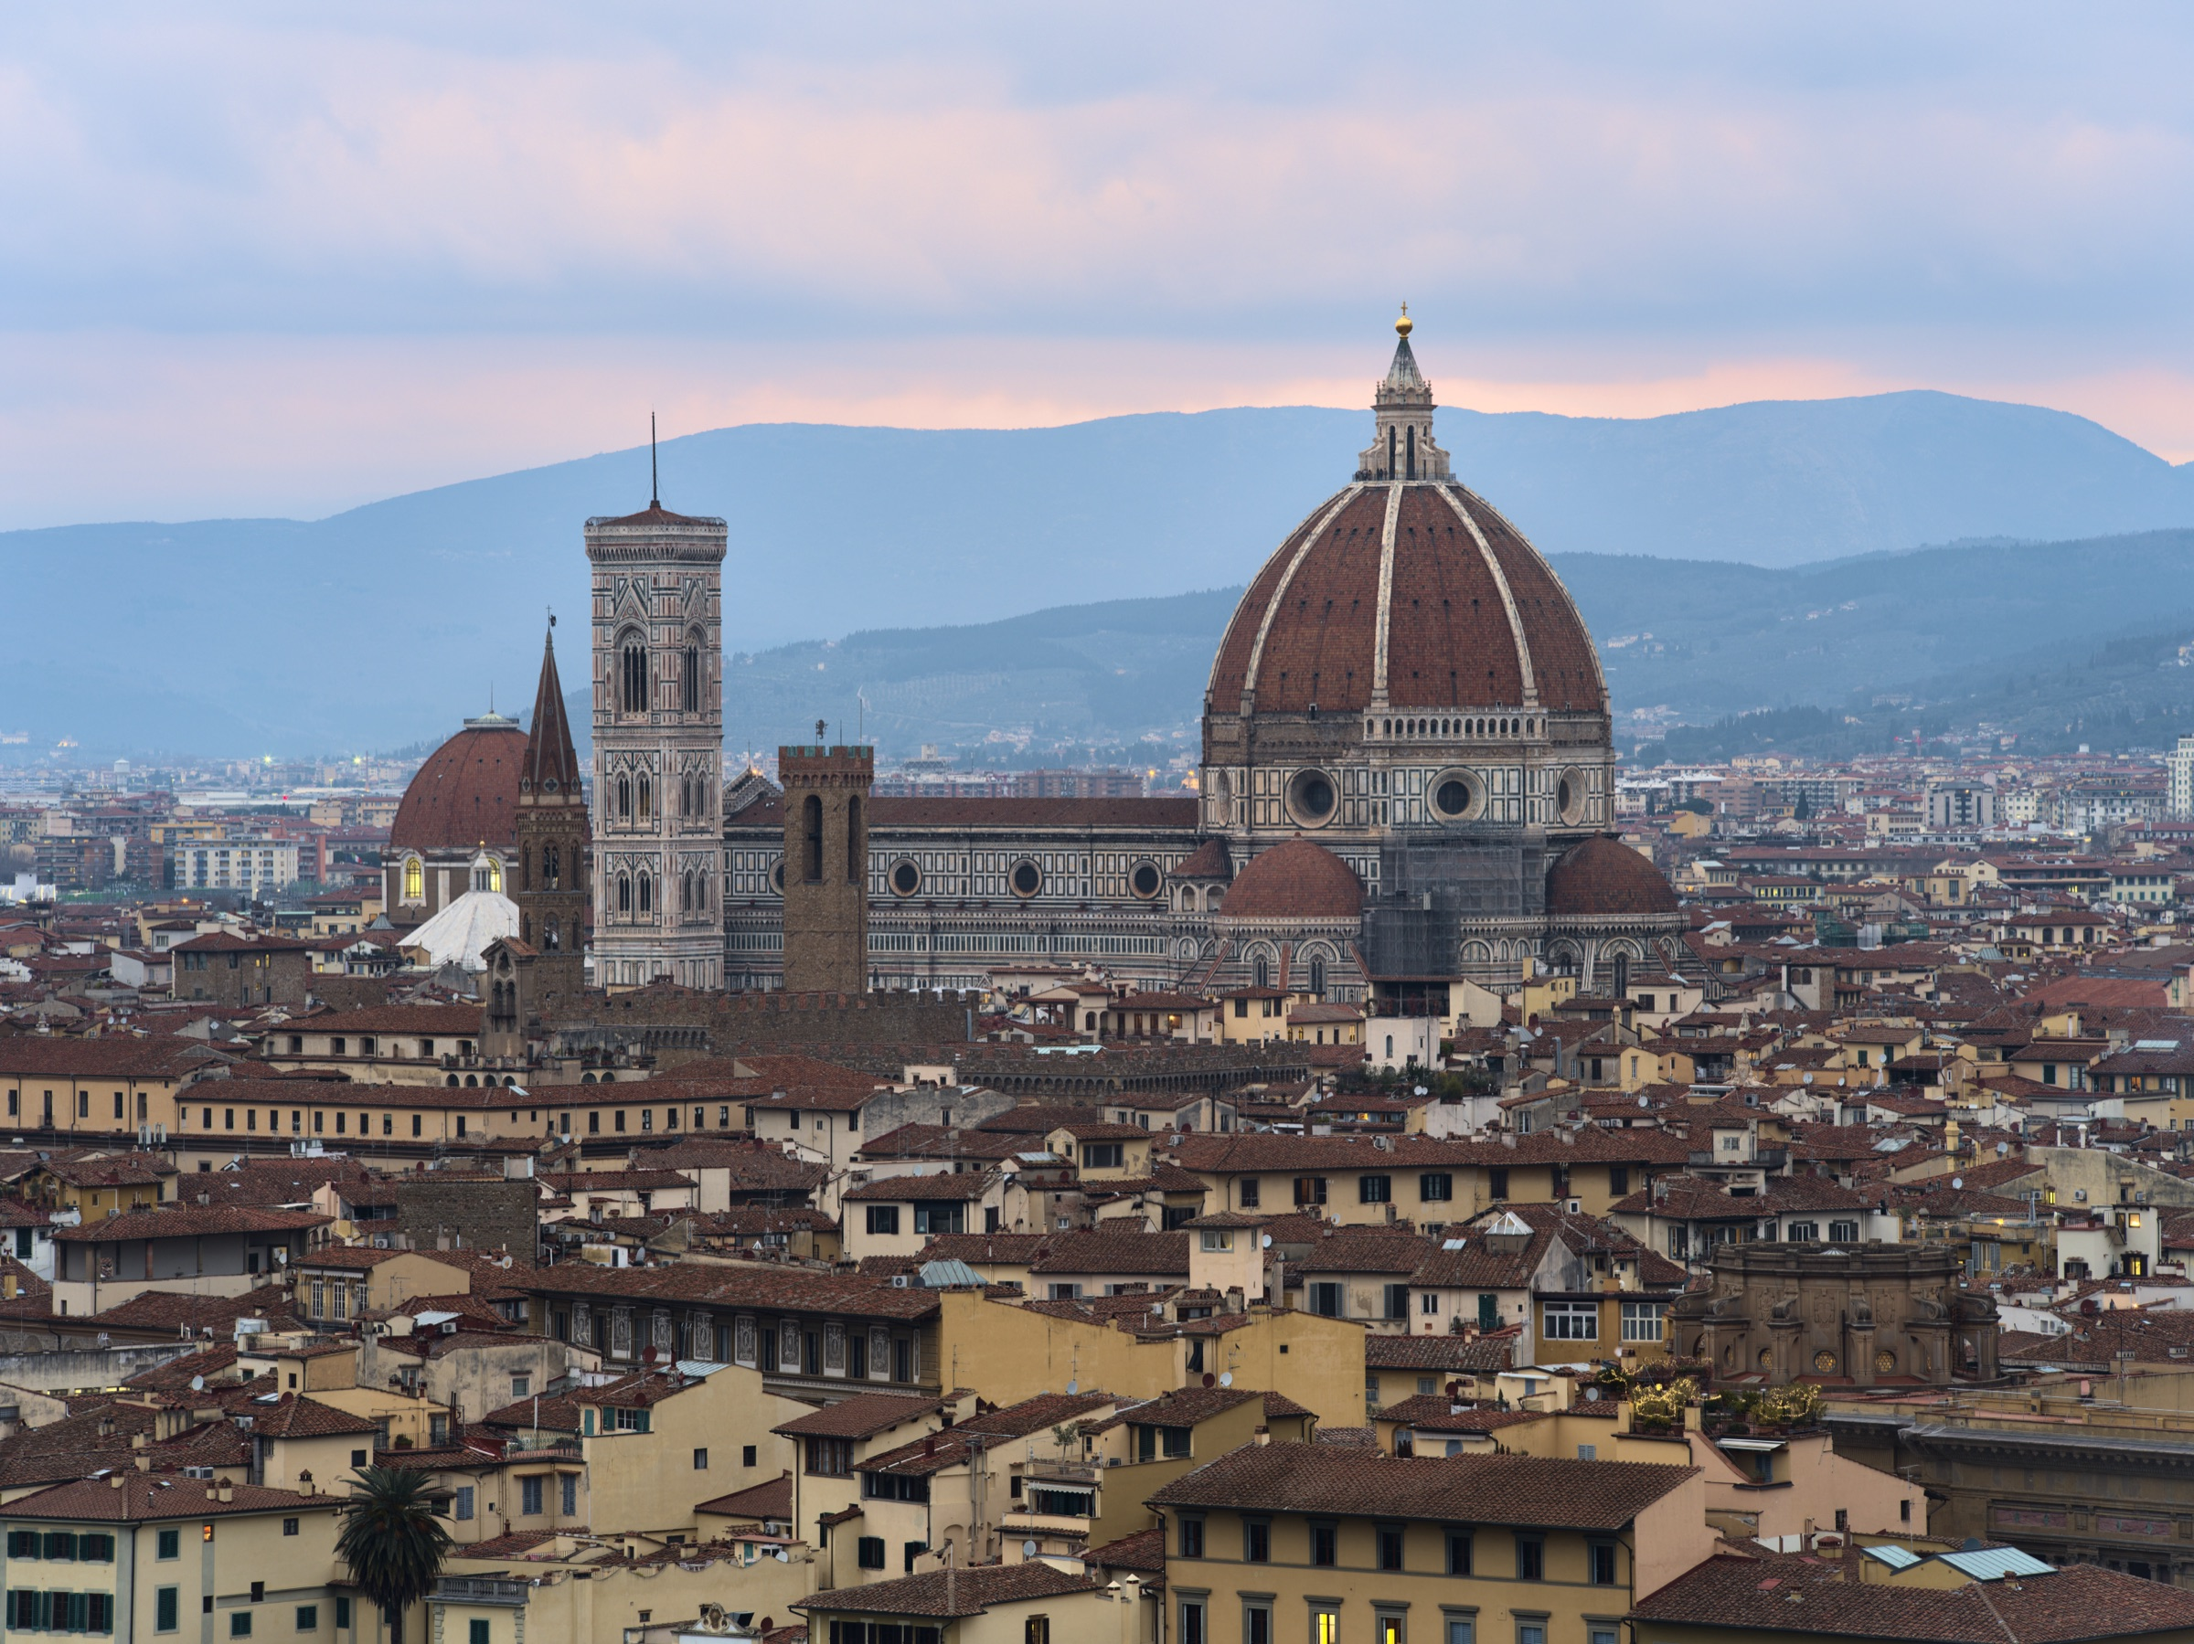
PART I
Florence
FOUR NIGHTS • HOTEL CALZAIUOLI

— Day by day
Four days in Florence.
Hotel Calzaiuoli · Bargello View Room

TUESDAY  27  OCTOBER  Florence | Slow Arrival, Tuscan Dusk  Touch down at Rome Fiumicino, where your English-speaking driver will be waiting at arrivals. Settle into a Mercedes sedan for the scenic three-and-a-half-hour drive north into Tuscany.  Check in to Hotel Calzaiuoli, your home for the next four nights — a refined four-star tucked between the Duomo and Piazza della Signoria. The evening is yours to wander.  ● PRIVATE FCO TRANSFER

WEDNESDAY  28  OCTOBER  Florence | David, the Duomo, and a Glass of Chianti by Noon  Meet your private licensed guide in the lobby for a half-day on foot through the city that birthed the Renaissance. Begin at Piazza della Repubblica, once the site of the Roman forum, then cross to Piazza del Duomo — its Gothic bell-tower, Romanesque baptistery, and the great cathedral itself.  Continue to the Mercato Centrale to sample Tuscany: focaccia, prosciutto and pecorino, a glass of Chianti — and, if the spirit moves you, the local lampredotto. Cap the morning at the Accademia with reserved entry to stand before Michelangelo's David. The afternoon is yours.  ● PRIVATE GUIDE · DAVID RESERVED ENTRY

THU / FRI  29 · 30  OCTOBER  Florence | Two Days Without an Itinerary  By design: nothing on the schedule. The most common note I get back from clients is that the unscheduled days are the ones they remember. Florence in late October rewards aimlessness — a second visit to the David, a long lunch you didn't book, the Brancacci frescoes when the school groups thin out at three.  ● OPEN DAYS

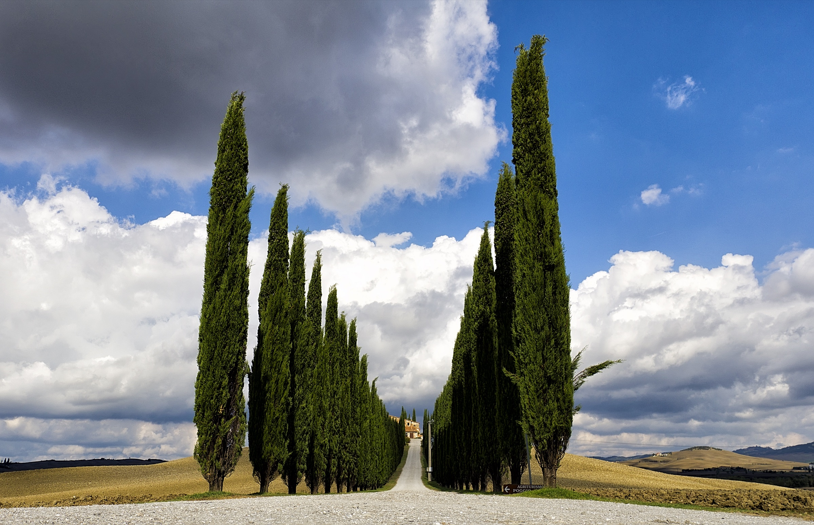
PART II
Tuscany
TWO NIGHTS • CASTELLO DI VICARELLO

— Day by day
Three days in the Maremma.
Castello di Vicarello · Suite Levante

SATURDAY  31  OCTOBER  Florence → Tuscany | A Morning Truffle Hunt  A morning truffle hunt in the Tuscan woods, followed by a leisurely truffle lunch at a nearby trattoria.  Continue on to Castello di Vicarello, a thousand-year-old hilltop estate in the Maremma. Your Suite Levante looks out over olive groves and cypress hills.  ● TRUFFLE HUNT · PRIVATE TRANSFER

SUNDAY  01  NOVEMBER  Tuscany | A Day That Belongs to the Castle  The reason people come back to Vicarello. This is the day the trip stops being a trip. No driver, no guide, no schedule.  If you want a half-day excursion — a Brunello tasting, a horseback ride through the estate, a long lunch in the garden — all can be arranged at the hotel.  ● OPEN DAY

MONDAY  02  NOVEMBER  Tuscany → Rome | Cooking, Brunello, Onward to Rome  A private cooking class with lunch, followed by a visit to a Brunello winery, before continuing on to Rome that afternoon. Check in at Umiltà 36.  ● COOKING CLASS · BRUNELLO TASTING · TRANSFER

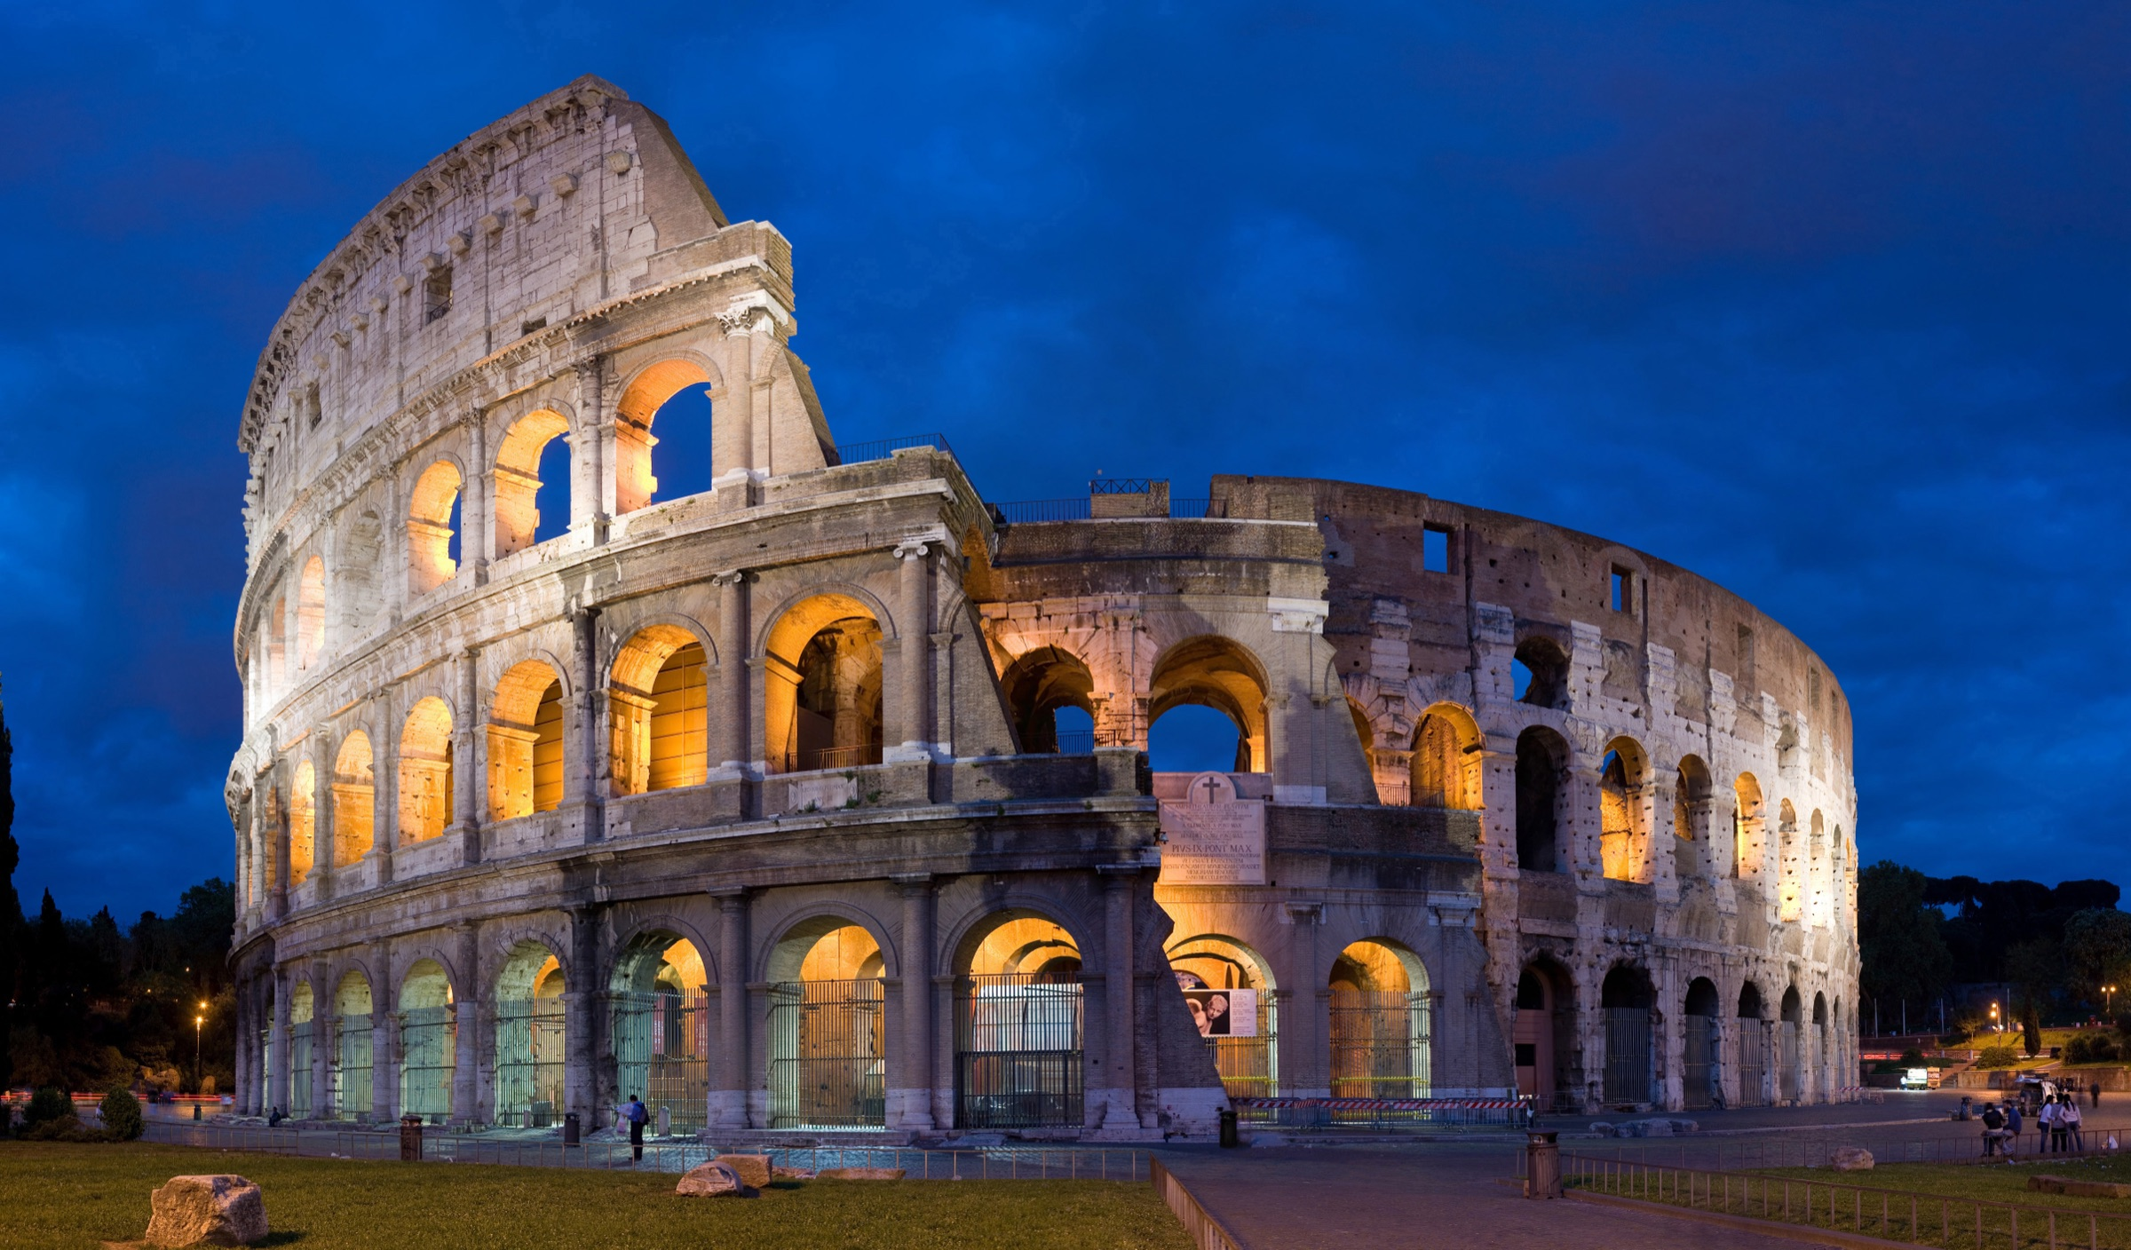
PART III
Rome
THREE NIGHTS • UMILTÀ 36

— Day by day
Three days in the Eternal City.
Umiltà 36 · Superior Room

TUESDAY  03  NOVEMBER  Rome | The Colosseum Before the Crowds  Meet your private licensed guide at the Arch of Constantine for a half-day in the city's deepest layer. Begin inside the Colosseum, walking the arena where Rome stage-managed its empire; continue through the Roman Forum, once the social, political, and commercial heart of the world; and finish at the Circus Maximus, the vast chariot-racing valley still etched into the city's grain.  All reserved entries are included. The afternoon is yours — a long lunch in Monti, a walk to the Pantheon, an evening passeggiata through Trastevere.  ● PRIVATE GUIDE · RESERVED ADMISSIONS

WEDNESDAY  04  NOVEMBER  Rome | Rome, on Your Terms  A second day in Rome, because one is never enough. The Vatican Museums, Galleria Borghese, a long afternoon at a neighborhood trattoria — the day is yours.  ● OPEN DAY

THURSDAY  05  NOVEMBER  Rome → FCO | Arrivederci  One last Roman breakfast. Your driver will meet you in the lobby for the fifty-minute transfer to Fiumicino in time for your onward flight.  ● PRIVATE FCO TRANSFER

— Where you stay
Three properties, each chosen for a reason.

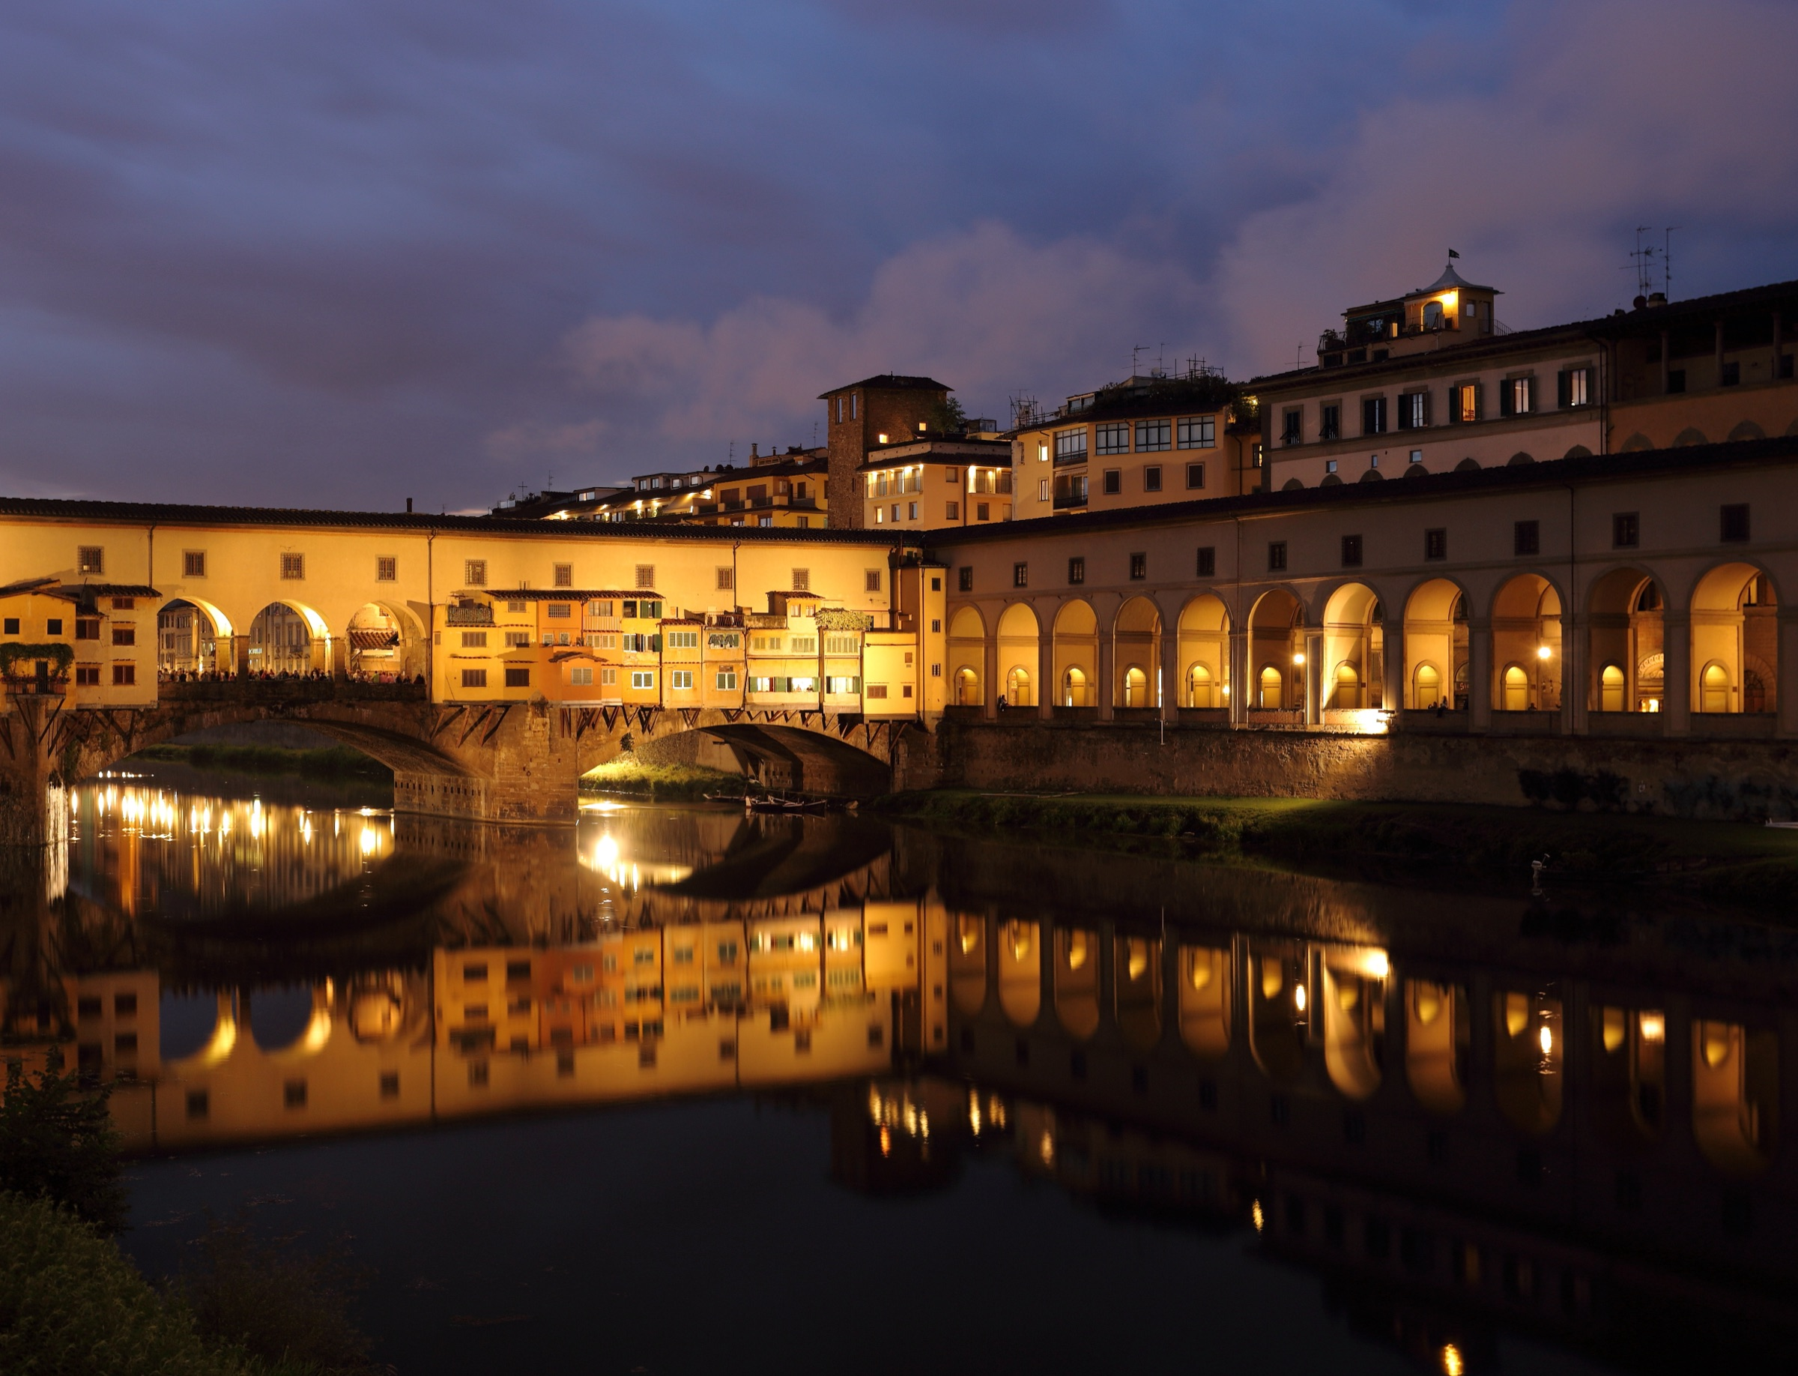 | PART I · FOUR NIGHTS  Hotel Calzaiuoli  FLORENCE · HISTORIC CENTER  A refined four-star tucked between the Duomo and Piazza della Signoria — the heart of historic Florence. Your Bargello View room with daily breakfast.  Room upgrade · Daily breakfast · Early check-in / late check-out*  27 — 31 OCTOBER · BARGELLO VIEW ROOM

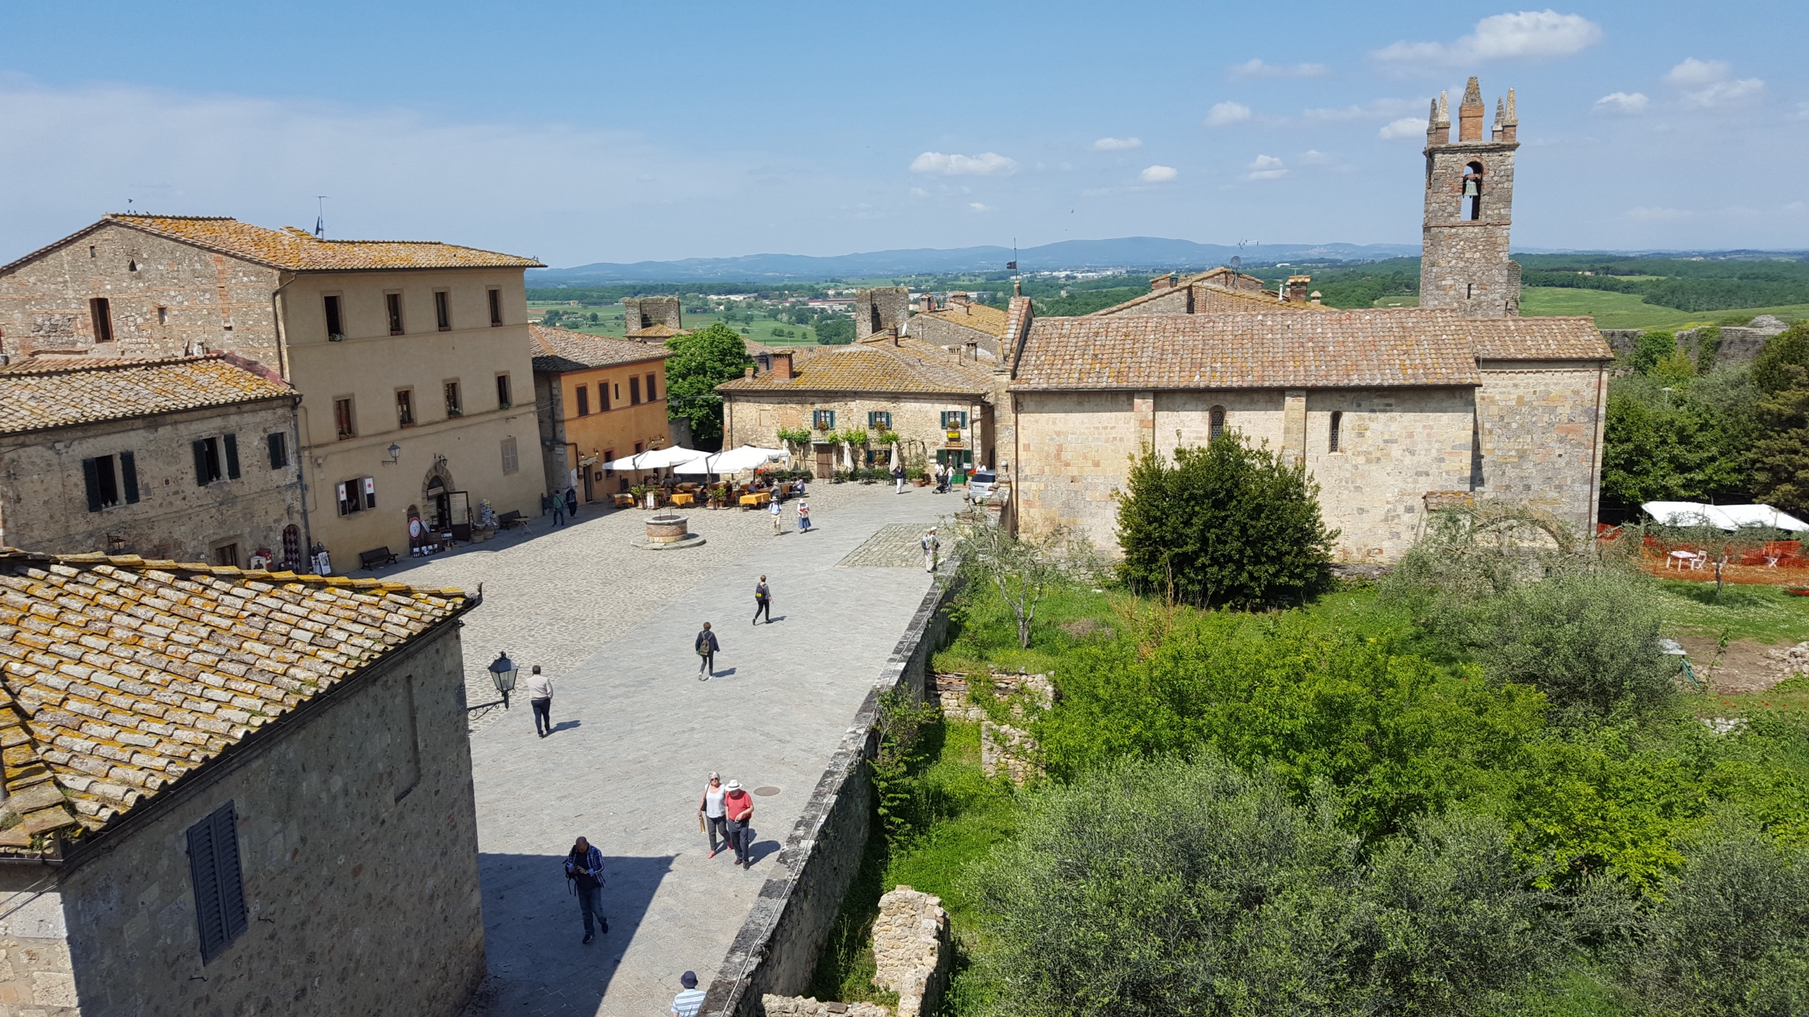 | PART II · TWO NIGHTS  Castello di Vicarello  MAREMMA, TUSCANY · VIRTUOSO  A thousand-year-old hilltop estate where the day's only obligation is dinner. Suite Levante — recently renovated, with a king bed and a magnificent green-marble bathroom — looks out over olive groves and cypress hills. The infinity pool faces the Maremma.  Upgrade on arrival · Daily breakfast for two · $100 USD resort credit · Early check-in / late check-out*  31 OCTOBER — 2 NOVEMBER · SUITE LEVANTE

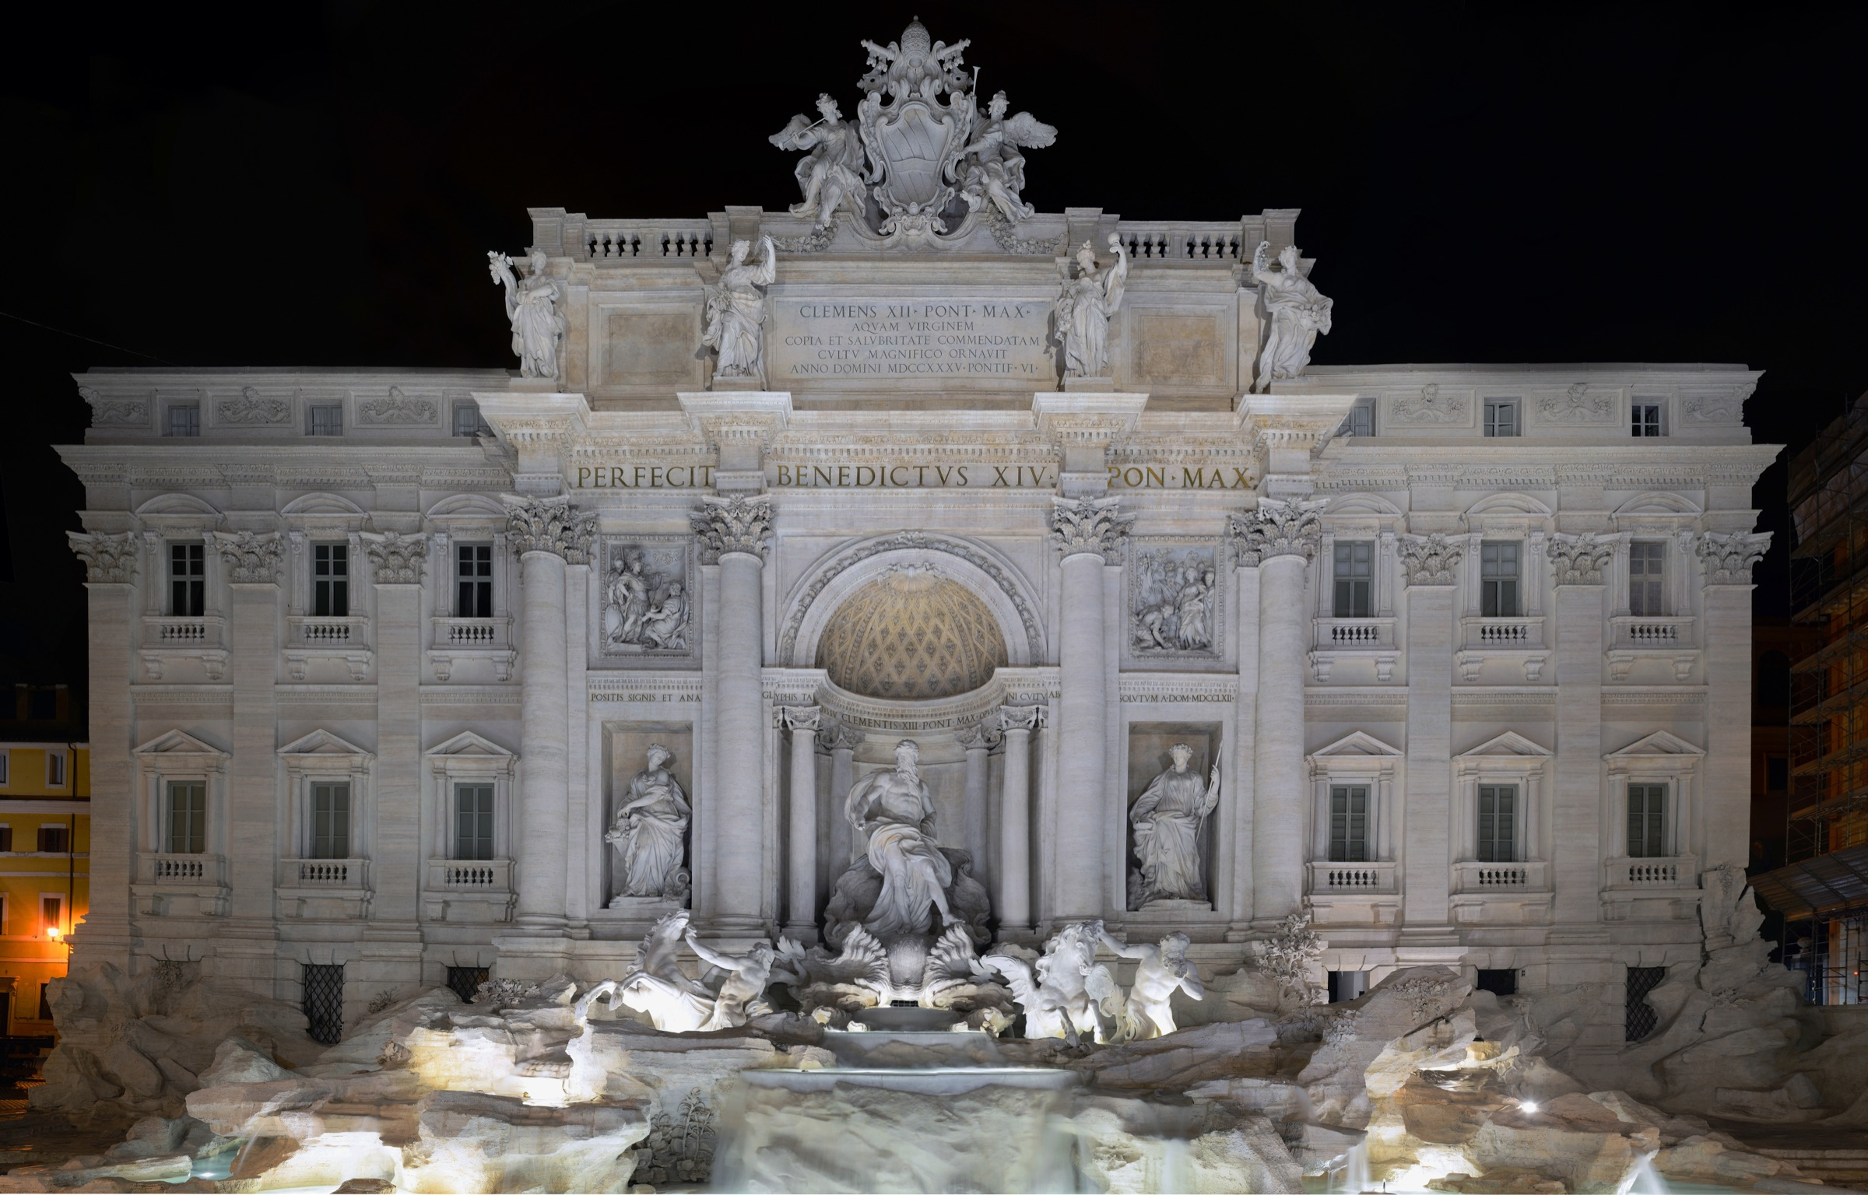 | PART III · THREE NIGHTS  Umiltà 36  ROME · BEHIND THE TREVI  A refined boutique five-star tucked on a quiet lane between the Trevi Fountain and the Spanish Steps. Superior Room with daily breakfast.  Escort to room · Daily breakfast · Early check-in / late check-out*  2 — 5 NOVEMBER · SUPERIOR ROOM

*Subject to availability.

— Your inclusions
Door to door, fully arranged.

INCLUDED  Accommodations  — Four nights at Hotel Calzaiuoli, Florence — Bargello View room with daily breakfast  — Two nights at Castello di Vicarello, Tuscany — Suite Levante with daily breakfast  — Three nights at Umiltà 36, Rome — Superior Room with daily breakfast  Private Transfers  — Airport pickup, FCO → Florence (Mercedes sedan, English-speaking driver)  — Florence → Castello di Vicarello, with truffle hunt and truffle lunch en route  — Castello di Vicarello → Rome, with cooking class, lunch, and Brunello winery en route  — Rome → FCO departure transfer | PRIVATE EXPERIENCES & AMENITIES  Private Experiences  — Half-day private Food & History tour of Florence with licensed guide and reserved entry to the Accademia (David)  — Truffle hunt followed by a truffle lunch  — Private cooking class and lunch in Tuscany  — Private guided tour and tasting at a Brunello winery  — Half-day private guided tour of Ancient Rome — Colosseum, Roman Forum, Circus Maximus, all admissions included  VIP Amenities  — Hotel Calzaiuoli: room upgrade and early check-in / late check-out (subject to availability)  — Castello di Vicarello (Virtuoso): upgrade on arrival, daily breakfast for two, $100 USD resort credit, early check-in / late check-out  — Umiltà 36: escort to room, early check-in / late check-out (subject to availability)

TOTAL FOR TWO TRAVELERS · FULLY ARRANGED | USD 12,972

