Email Spam Detector

Report

Summary:
I have successfully implemented the two machine learning techniques required for the assignment. This report captures how each of the models performed on the given data set. I have also gone through some references on the web and formulated a third model which I believe is the best of them all.

Naïve classifier:
This classifier uses a spam blacklist of words to label the given input message. The blacklist is a large set of words gathered after going through the internet. Given a data frame of input, the classifier joins the subject and message columns and checks if any regex in the blacklist of words is in the given input. This process is done per row so that, each entry gets a label.
The performance of this classifier is very bad as it was able to successfully predict with less than 50% accuracy. Hence, I had to choose another way of classifying the mails.
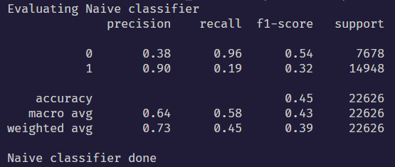
Accuracy = 0.45 = 45%

Multinomial Naïve Bayes’ classifier:
In this method, the input is fed directly to a sklearn’s MultinomialNB object. That will then train and predict appropriately for various inputs.

This is an advanced technique but some preprocessing of input is required. The changes I made to the input are:
- Combined the subject and message columns to get the feature column
- These features undergo a transformation from TfidfVectorizer which is inbuilt from sklearn’s feature_extraction library. The class converts the input text into numeric values from which advanced models will learn.
After the transformation, the model is trained and predictions are done. Now the accuracy is very high. This can be easily used for commercial applications.
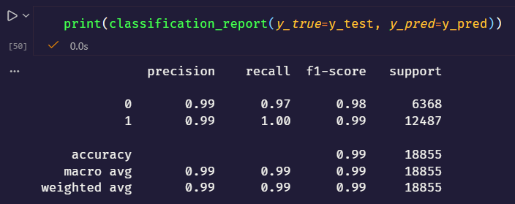
Accuracy = 0.99 = 99%

Logistic Regression classifier:
The third method which I used consists of logistic regression. It uses a decision boundary to classify and it is a linear method of classification. The same transformed data in multinomial NB is used here too for the training and predictions.

This result is almost similar to the result of Multinomial NB. The precision, recall and f1 score of logistic regression is much better than those of multinomial NB. Hence, I choose to go with this as the best model for classifying mails into spam vs ham.
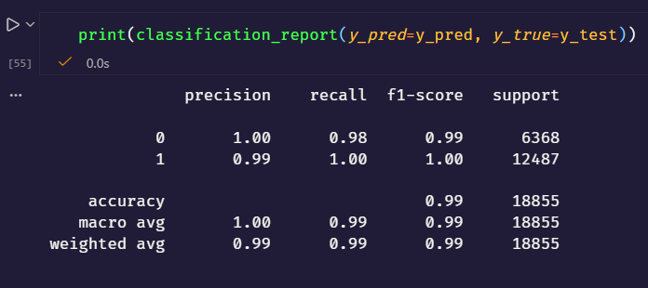
Accuracy = 0.99 = 99%

