Midterm Project Report: Simulated E-Wallet and Rewards System for E-Commerce

1. ER Model
The Entity-Relationship (ER) Model for our e-wallet system consists of the following major entities:
- Users (Customers, Merchants, Admins, Support Staff)
- Accounts (Each user can have multiple accounts)
- Transactions (Top-ups, Purchases, Withdrawals, Refunds, Reward Redemptions)
- Merchants (Sellers registered on the platform)
- Products (Items listed for sale by merchants)
- Orders (Customer purchases)
- Order_Items (Many-to-Many relationship between Orders and Products)
- Reward Points (Earned and redeemed by accounts)
- Refunds (Processed for canceled transactions)
- Logs (Records user activities)
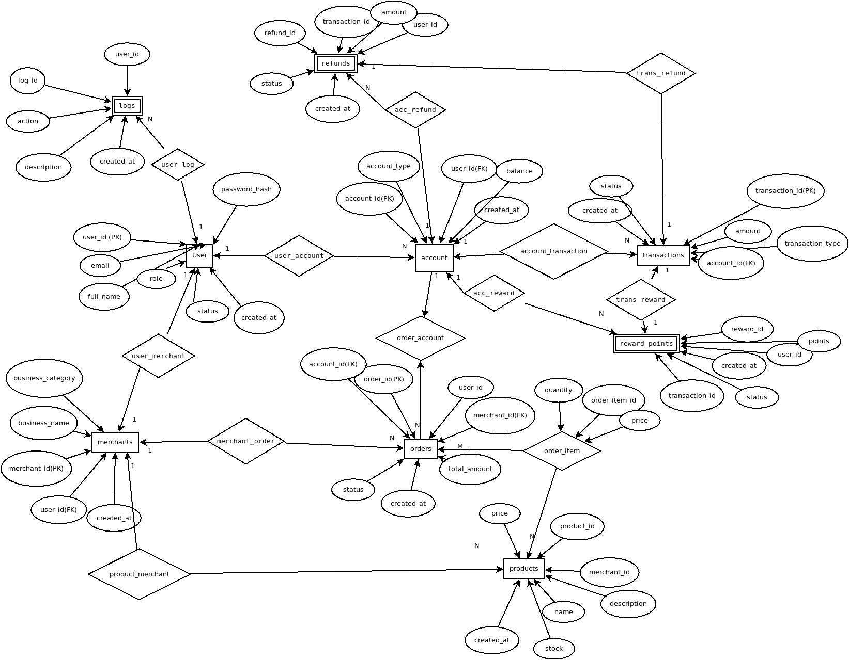

2. All tables and relational model
CREATE TABLE Users (
user_id SERIAL PRIMARY KEY,
full_name VARCHAR(255) NOT NULL,
email VARCHAR(255) UNIQUE NOT NULL,
password_hash VARCHAR(255) NOT NULL,
role ENUM('customer', 'admin', 'merchant', 'support') NOT NULL,
status ENUM('active', 'blocked') DEFAULT 'active',
created_at TIMESTAMP DEFAULT now()
);

CREATE TABLE Accounts (
account_id SERIAL PRIMARY KEY,
user_id INT NOT NULL,
account_type ENUM('wallet', 'merchant') NOT NULL,
balance DECIMAL(10,2) DEFAULT 0.00,
created_at TIMESTAMP DEFAULT now(),
FOREIGN KEY (user_id) REFERENCES Users(user_id) ON DELETE CASCADE
);

CREATE TABLE Transactions (
transaction_id SERIAL PRIMARY KEY,
account_id INT NOT NULL,
transaction_type ENUM('top-up', 'purchase', 'withdrawal', 'refund', 'reward_redemption') NOT NULL,
amount DECIMAL(10,2) NOT NULL,
status ENUM('pending', 'completed', 'failed', 'reversed') DEFAULT 'pending',
created_at TIMESTAMP DEFAULT now(),
FOREIGN KEY (account_id) REFERENCES Accounts(account_id) ON DELETE CASCADE
);

CREATE TABLE Merchants (
merchant_id SERIAL PRIMARY KEY,
user_id INT UNIQUE NOT NULL,
business_name VARCHAR(255) NOT NULL,
business_category VARCHAR(255),
created_at TIMESTAMP DEFAULT now(),
FOREIGN KEY (user_id) REFERENCES Users(user_id) ON DELETE CASCADE
);

CREATE TABLE Products (
product_id SERIAL PRIMARY KEY,
merchant_id INT NOT NULL,
name VARCHAR(255) NOT NULL,
description TEXT,
price DECIMAL(10,2) NOT NULL,
stock INT NOT NULL,
created_at TIMESTAMP DEFAULT now(),
FOREIGN KEY (merchant_id) REFERENCES Merchants(merchant_id) ON DELETE CASCADE
);

CREATE TABLE Orders (
order_id SERIAL PRIMARY KEY,
account_id INT NOT NULL,
merchant_id INT NOT NULL,
total_amount DECIMAL(10,2) NOT NULL,
status ENUM('pending', 'completed', 'canceled', 'refunded') DEFAULT 'pending',
created_at TIMESTAMP DEFAULT now(),
FOREIGN KEY (account_id) REFERENCES Accounts(account_id) ON DELETE CASCADE,
FOREIGN KEY (merchant_id) REFERENCES Merchants(merchant_id) ON DELETE CASCADE
);

CREATE TABLE Order_Items (
order_item_id SERIAL PRIMARY KEY,
order_id INT NOT NULL,
product_id INT NOT NULL,
quantity INT NOT NULL,
price DECIMAL(10,2) NOT NULL,
FOREIGN KEY (order_id) REFERENCES Orders(order_id) ON DELETE CASCADE,
FOREIGN KEY (product_id) REFERENCES Products(product_id) ON DELETE CASCADE
);

CREATE TABLE Reward_Points (
reward_id SERIAL PRIMARY KEY,
account_id INT NOT NULL,
points INT NOT NULL,
transaction_id INT,
status ENUM('earned', 'redeemed', 'expired') DEFAULT 'earned',
created_at TIMESTAMP DEFAULT now(),
FOREIGN KEY (account_id) REFERENCES Accounts(account_id) ON DELETE CASCADE,
FOREIGN KEY (transaction_id) REFERENCES Transactions(transaction_id) ON DELETE SET NULL
);

CREATE TABLE Refunds (
refund_id SERIAL PRIMARY KEY,
transaction_id INT NOT NULL,
account_id INT NOT NULL,
amount DECIMAL(10,2) NOT NULL,
status ENUM('pending', 'completed', 'rejected') DEFAULT 'pending',
created_at TIMESTAMP DEFAULT now(),
FOREIGN KEY (transaction_id) REFERENCES Transactions(transaction_id) ON DELETE CASCADE,
FOREIGN KEY (account_id) REFERENCES Accounts(account_id) ON DELETE CASCADE
);

CREATE TABLE Logs (
log_id SERIAL PRIMARY KEY,
user_id INT,
action VARCHAR(255) NOT NULL,
description TEXT,
created_at TIMESTAMP DEFAULT now(),
FOREIGN KEY (user_id) REFERENCES Users(user_id) ON DELETE SET NULL
);

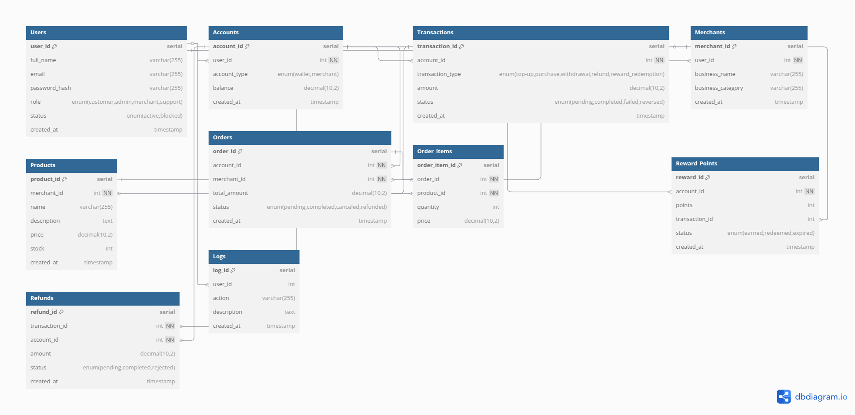

3. Sample Data

Users Table
INSERT INTO Users (full_name, email, password_hash, role, status) VALUES
('Alice Johnson', 'alice@example.com', 'hashed_password1', 'customer', 'active'),
('Bob Merchant', 'bob@store.com', 'hashed_password2', 'merchant', 'active');

Accounts Table
INSERT INTO Accounts (user_id, account_type, balance) VALUES
(1, 'wallet', 500.00),
(2, 'merchant', 0.00);

Transactions Table
INSERT INTO Transactions (account_id, transaction_type, amount, status) VALUES
(1, 'top-up', 500.00, 'completed'),
(1, 'purchase', 200.00, 'completed');

4. Functions Implementation

Function 1: Reward Points Calculation for Purchases
CREATE OR REPLACE FUNCTION grant_reward_points()
RETURNS TRIGGER AS $$
BEGIN
IF NEW.transaction_type = 'purchase' THEN
INSERT INTO Reward_Points (account_id, points, transaction_id, status)
VALUES (NEW.account_id, FLOOR(NEW.amount / 100) * 5, NEW.transaction_id, 'earned');
END IF;
RETURN NEW;
END;
$$ LANGUAGE plpgsql;

CREATE TRIGGER trigger_grant_rewards
AFTER INSERT ON Transactions
FOR EACH ROW
EXECUTE FUNCTION grant_reward_points();

Function 2: Cashback Redemption
CREATE OR REPLACE FUNCTION redeem_rewards(accountId INT, pointsToRedeem INT)
RETURNS VOID AS $$
DECLARE cashbackAmount DECIMAL(10,2);
BEGIN
cashbackAmount := pointsToRedeem / 10;
UPDATE Accounts
SET balance = balance + cashbackAmount
WHERE account_id = accountId;
END;
$$ LANGUAGE plpgsql;

Function 3: Merchant Withdrawals
CREATE OR REPLACE FUNCTION process_withdrawal(merchantAccountId INT, amount DECIMAL(10,2))
RETURNS VOID AS $$
BEGIN
UPDATE Accounts
SET balance = balance - amount
WHERE account_id = merchantAccountId;
END;
$$ LANGUAGE plpgsql;

5. Screenshots of Function Execution
(Insert screenshots of reward points being credited, cashback redemption, and merchant withdrawal)
reward points before transaction reward points after transaction
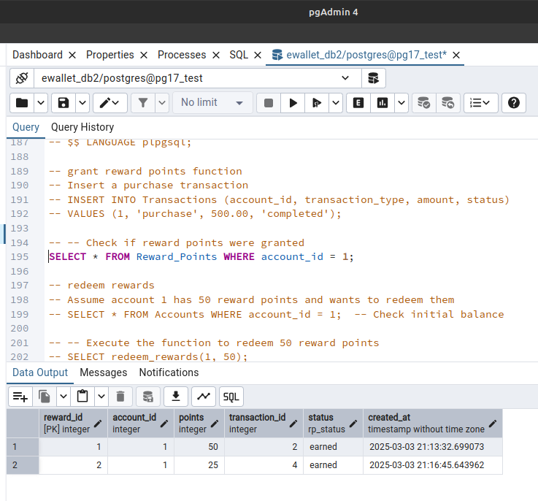
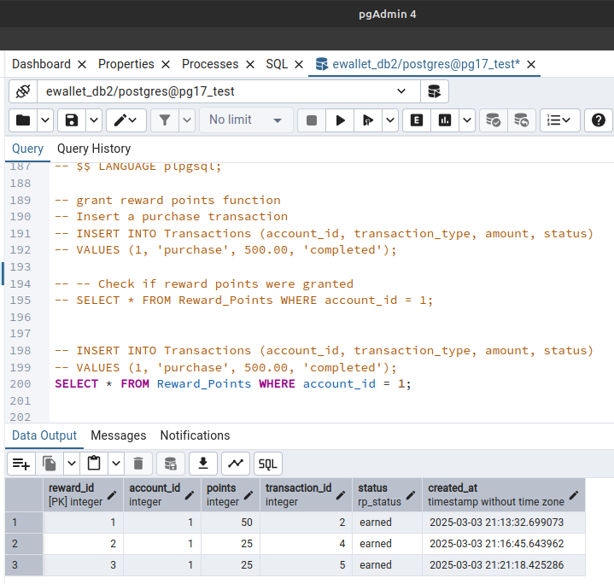

1. The first function is a trigger which executes automatically when a transaction is made. It grants reward points to user in the transaction. From the above output, it is clear that after a transaction, a reward is granted.

accounts before redeeming rewards accounts after redeeming rewards
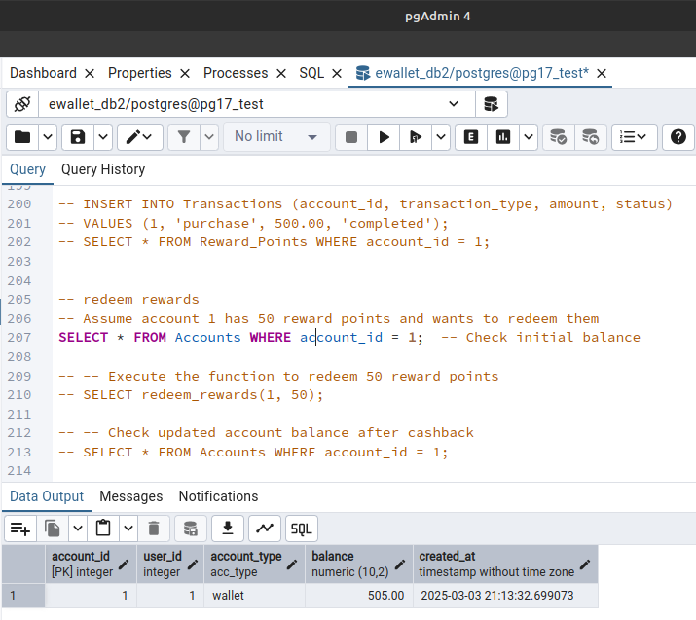
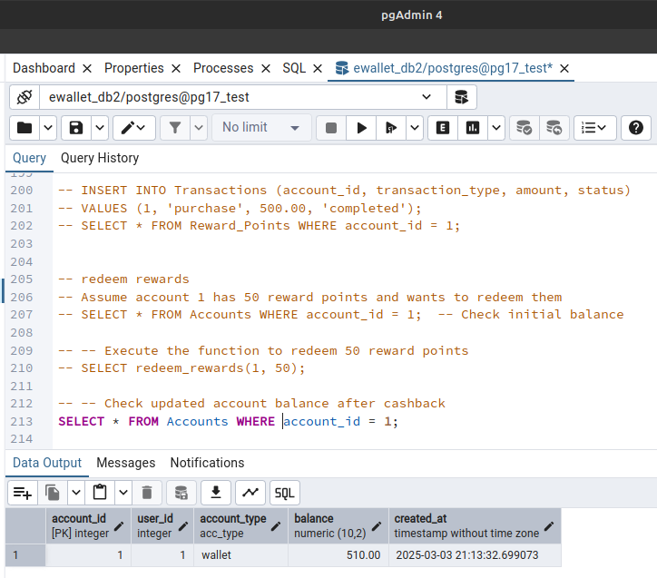

2. The second function is redeem rewards function. Here it makes a user to redeem the corresponding reward points obtained for his transactions. From the outputs, it is clear that a reward of 5 units is granted to user with id = 1.

accounts before withdrawal accounts after withdrawal
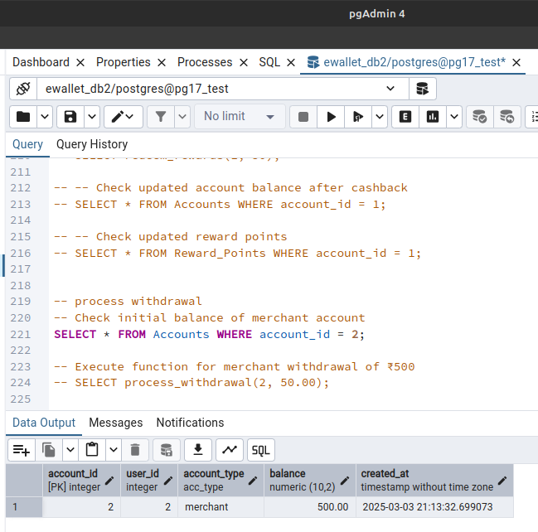
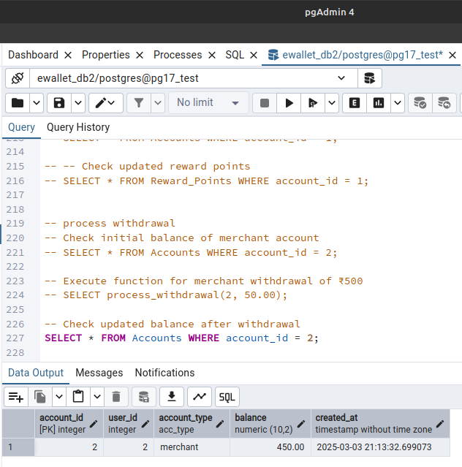

3. The third function is process withdrawal function. This is the core part of a withdrawal. i.e, it decreases the balance of the withdrawing user’s account by the requested amount. From the outputs, it is clear that 50 units is deducted from the account with id = 2.

6. Conclusion
This midterm report presents the ER model, relational model, database schema, constraints, sample data, and stored functions required for the simulated e-wallet and rewards system. The reward points automation, cashback redemption, and merchant withdrawal functions ensure smooth financial operations within the platform. The screenshots provided validate the proper execution of the implemented functions.
Future Improvements:
- Implementing stored procedures for batch processing.
- Improving performance with indexing strategies.
- Adding many more functions.
- Ensuring logging is done properly and implement a more general rewards scheme.

Project team:
Bhogaraju Shanmukha Sri Krishna (112201013)
Gajula Sri Siva Sai Shashank (112201014)
Ponnavolu Chakradhar Reddy (112201022)

