**Nikita Churilov**

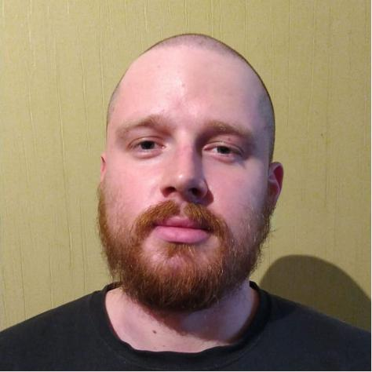

**Personal information**

Address: 31 Novgorodskaya str., apt. 108, Moscow, 127572, Russia Telephone: mobile: +79151360739

Email: getingjagare@gmail.com

Telegram: https://t.me/getingjagare

GitHub: <https://github.com/GetingJagare>

Date of birth: 28th September 1991

Nationality: Russian

Marital status: single

**Objective**

I am looking for a backend- or frontend-developer position to apply current abilities and to develop other ones.

**Education**

Moscow State University of the Printing Arts

**Work experience**

**Km2b Corporation**, New York, U.S.A.

March 2021 – December 2022

Position: Frontend-Developer (part-time)

* Implementing interface of KMS (Knowledge Management System), output of different statistics charts, creating of interactive functionality.
* Stack: VanillaJS (ES6+) + jQuery, D3.js, CSS (SCSS), Webpack, Docker Compose

**OptDecor,** Moscow, Russia

September 2019 — April 2020,

Position: PHP programmer

* Developing new functionality in an online store
* Implementing new frontend features
* Covering some logic with unit tests
* Stack: PHP7, MariaDB, Yii2, ElasticSearch, VanillaJS

**JustCall**, Moscow, Russia,

June 2018 — March 2019

Position: Web developer

* Developing new features and supporting some online stores
* Tuning remote server
* Stack: PHP5, Laravel5, Vue.js, Apache, Nginx

**Rustex**, Moscow, Russia,

August 2016 — April 2018

Position: Junior web developer

* Developing backend and frontend functionality on some commercial and non-commercial sites
* Connecting online payment and delivery services
* Stack: Javascript + jQuery, PHP5, CMS Drupal

**Personal qualities**

Eager to learn

Ability to work both in a team and as an individual Honest

Open-minded

**Special skills**

Native Russian

Good reading and translating ability in English

Basic knowledge of German

Hobbies: history, foreign languages

**References**

Available upon request