Wanderson De Castro

BCIT – A01062023

Mark bacchus

FINAL PROJECT

COMP 1630 – RELATIONAL DATABASE & SQL

PROJECT CONTENT

PROJECT DESCRIPTION 3

Part A - Database and Tables 4

Q.1 4

Q.2 5

Q.3 6

Q.4 8

Q.5 10

Q.6 12

Part B - SQL Statements 13

Q.1 13

Q.2 14

Q.3 15

Q.4 16

Q.5 17

Q.6 18

Q.7 19

Q.8 20

Q.9 21

Q.10 22

Part C - INSERT, UPDATE, DELETE and VIEWS Statements 23

Q.1 23

Q.2 24

Q.3 24

Q.4 25

Q.5 25

Q.6 26

Q.7 27

Q.8 28

Q.9 29

Q.10 30

Part D - Stored Procedures and Triggers 31

Q.1 31

Q.2 32

Q.3 33

Q.4 34

Q.5 35

Q.6 36

Q.7 37

Q.8 38

Q.9 39

SCRIP COPY – ALL QUESTIONS SCRIPTS 40

BULK INSERT SCRIPT 68

# **PROJECT DESCRIPTION**

**•Final Project for COMP 1630.**

**•This project will have instructions to how create, edit, manipulee and insert most of the principal’s commands of SQL SERVER.**

**•You can follow all steps to learn each command and execute.**

**•At the very end you will see all scripts to execute.**

**•The Bulk insert script will need to be inserted separate from the main script.**

**•After done all questions you will be able to create a DATABASE and edit following the requirements of what you will need.**

**•This project has only proposed for COMP 1630 and do not can be apply for a real company in your real script. You should create you own DATABASE following your company rules.**

**•This project also can be used to show in resume for interview in a company to show what you are able to do.**

# **Part A - Database and Tables**

## **Q.1**

1. Create a database called **Cus_Orders**.

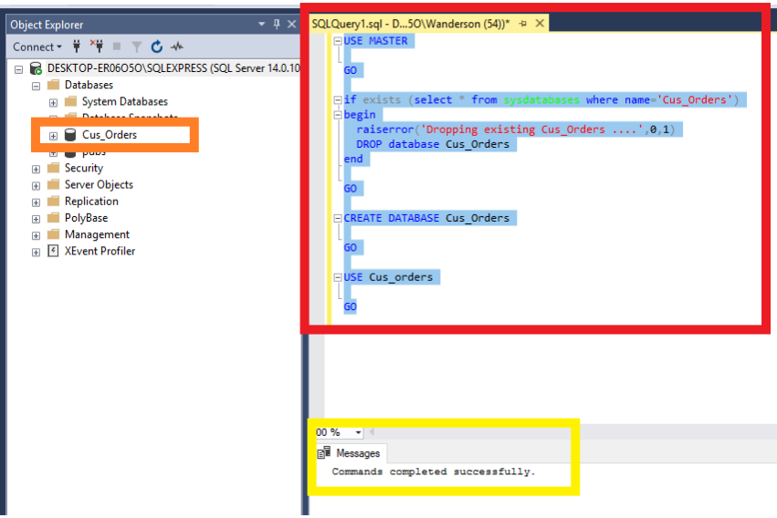

•THIS IS THE PROCESS TO CREATE A DATABASE CALLED Cus_Orders

•RED – SCRIPT THAT WAS INSERTED

•YELLOW – MESSAGE PRODUCED

•ORANGE – AFTER REFRESH YOU CAN SEE THAT THE DATABASE WAS CREATED

## **Q.2**

1. Create a user defined data types for all similar Primary Key attribute columns (e.g. order_id, product_id,title_id**),** to ensure the same data type, length and null ability. See pages 12/13 for specifications.

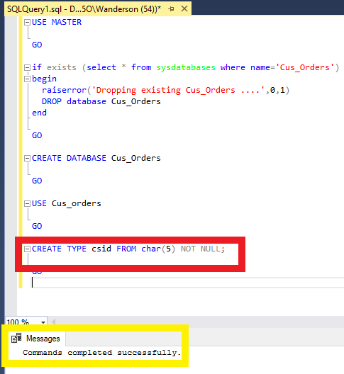

•THIS SCRIPT WAS USED TO CREATE A UNIQUE SPECIFICATION FOR THIS TYPE.

•RED – SCRIPT THAT WAS INSERTED

•YELLOW – MESSAGE PRODUCED

## **Q.3**

1. Create the following tables (see column information on pages 12 and 13 ):

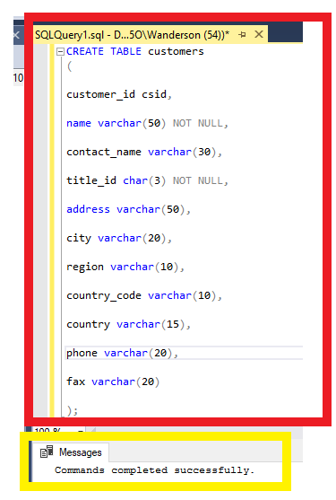

•FOR CREATE A TABLE I USED THIS SCRIPT, YOU HAVE TO USE THIS SCRIPT FOR EACH TABLE AND CHANGING THE TABLE NAME AND COLUMNS NAME AND SPECIFICATIONS.

•RED – SCRIPT THAT WAS INSERTED

•YELLOW – MESSAGE PRODUCED

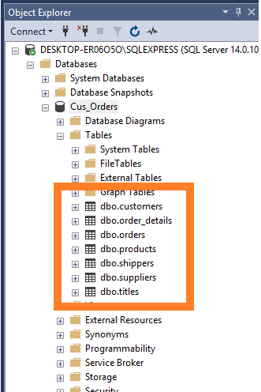

•ORANGE – AFTER REFRESH YOU CAN SEE THAT THE TABLES WERE CREATED.

GO TO “Databases > Cus_Orders > Tables”

## **Q.4**

1. Set the **primary** **keys** and **foreign** **keys** for the tables.

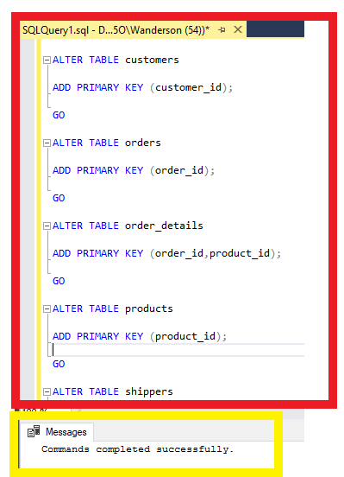

•FOR CREATE PRIMARY KEYS YOU SHOULD USE THIS SCRIPT WITH THE INFORMATION THAT YOU WANT.

ATER TABLE – TO CHOOSE TABLE THAT WILL BE USED.

ADD PRIMARY KEY – TO INSERT PRIMARY KEY (COLUMN NAME);

•RED – SCRIPT THAT WAS INSERTED

•YELLOW – MESSAGE PRODUCED

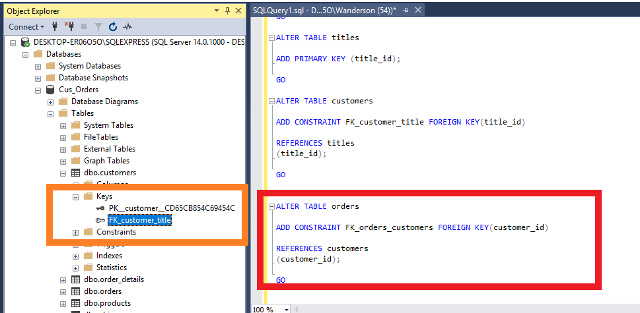

•FOR ADD FOREIGN KEYS YOU SHOULD USE THIS SCRIPT.

ATER TABLE – TO CHOOSE TABLE THAT WILL BE USED.

ADD CONSTRAINT “CONSTRAINT NAME” – WILL ADD A CONSTRAINT TO THIS TABLE WITH THE NAME THAT YOU CHOOSED.

FOREIGN KEY (COLUMN NAME) – WILL TRANSFORM THIS COLUMN IN A FOREIGN KEY.

REFERENCES “TABLE THAT FOREIGN IS PRIMARY”

(COLUMN THAT IN THIS TABLE IS PRIMARY KEY);

•RED – SCRIPT THAT WAS INSERTED

•ORANGE – AFTER REFRESH YOU CAN SEE THAT THE PRIMARY AND FOREIGN WERE CREATED.

OPEN TABLE > KEYS

## **Q.5**

1. Set the **constraints** as follows:

**customers** **table** - country should default to Canada]

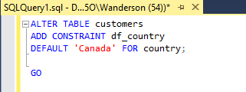

•USE THIS SCRIPT TO CREATE A CONSTRAINT WITH A DEFAULT VALUE.

DEFAULT ‘NAME’

FOR “COLUMN”

**orders** **table** - required_date should default to today’s date plus ten days

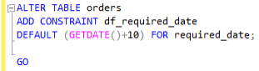

•USE THIS SCRIPT TO CREAT A CONSTRAINT WITH YOUR RULE.

•IN THIS CASE WE USED “GETDATE()” THAT WILL TAKE THE ATUAL DATE

AND “+10” THAT WILL USE TO ADD 10 DAYS.

**order details table** - quantity must be greater than or equal to 1

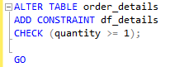

**products table** - reorder_level must be greater than or equal to 1

- quantity_in_stock value must not be greater than 150

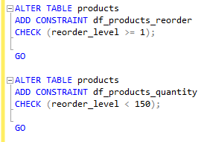

•IN THIS SCRIP WE SHOULD USE “CHECK” TO DETERMINE IF THIS VALUE IT IS TRUE AND IF WILL BE ABLE TO USE.

•HOW YOU CAN SEE FOR “GREATER OR EQUAL THAN 1” WE USE THE SIGNAL “>=”

AND FOR THAT ONE THAT CAN’T BE GREATER THAN 150 WE USE ”<”.

**suppliers table** - province should default to BC

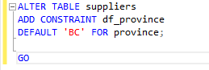

## **Q.6**

1. Load the data into your created tables using the following files:

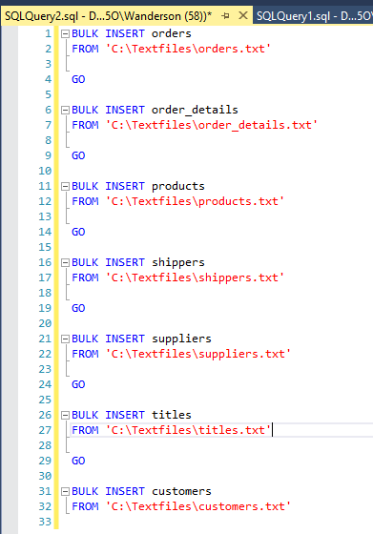

•FOR IMPORT DATA FROM SOMEWHERE FROM YOU COMPUTER OR DATACENTER WE CAN USE THE FUNCTION “BULK INSERT”

BULK INSERT “table name”

FROM “Where they are in your storage”

•THE VALUE PRODUCED FOR THIS CASE WILL BE NUBER OF ROLLS AFFECTED THAT WILL BE DIFFERENT FOR EACH INSERT.

# **Part B - SQL Statements**

## **Q.1**

1. List the customer id, name, city, and country from the customer table. Order the result set by the **customer id**. The query should produce the result set listed below.

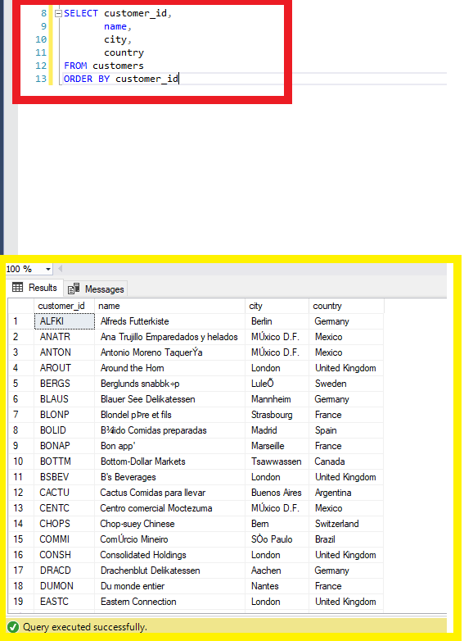

•RED – SCRIPT THAT WAS INSERTED

•YELLOW – MESSAGE PRODUCED

•ON THE SCRIPT YOU SHOULD SELECT COLUMNS THAT YOU WANT, FROM THE TABER THAT THEY ARE AND USE “ORDER BY” TO ORDER FOLLOWING WHAT YOU NEED.

## **Q.2**

1. Add a new column called **active** to the customers table using the ALTER statement. The only valid values are 1 or 0. The default should be **1**.

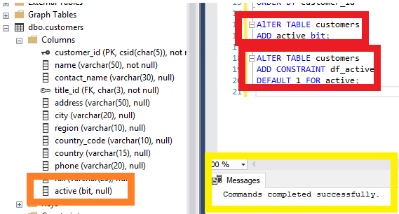

•RED – SCRIPT THAT WAS INSERTED

•YELLOW – MESSAGE PRODUCED

•ORANGE – AFTER REFRESH YOU CAN SEE THAT THE DATABASE WAS CREATED

•IN THIS CASE I USED AGAIN O ALTER TO ADD A COLUMN TO A CUSTOMERS TABLE ALSO I CHOOSED TYPE “bit” THAT HAS VALUE BETWEEN 0-1 AS WAS ASKED.

•USING ALTER AGAIN I CHANGED DEFAULT VALUE FOR 1 TO COLUMN active.

## **Q.3**

1. List all the orders where the order date is between **January 1** and **December 31, 200**1. Display the order id, order date, and a new shipped date calculated by adding 7 days to the shipped date from the orders table, the product name from the product table, the customer name from the customer table, and the cost of the order. Format the date order date and the shipped date as **MON DD YYYY**. Use the formula (quantity * unit_price) to calculate the cost of the order. The query should produce the result set listed below.

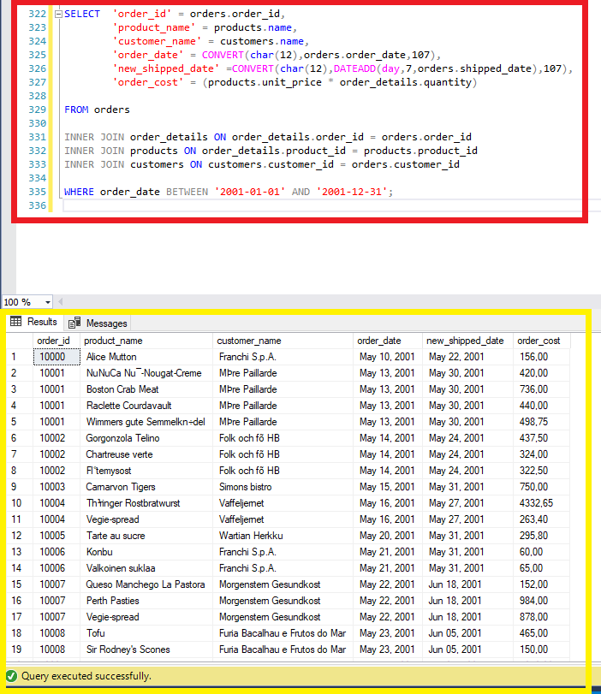

•RED – SCRIPT THAT WAS INSERTED

•YELLOW – MESSAGE PRODUCED

•THIS VIEW IT’S MORE COMPLEX BECAUSE YOU WILL NEED USE INNER JOIN TO TAKE VALUES FROM ANOTHER TABLES. BUT THE PROCESS IT’S ALMOST THE SAME , NAME THE COLUMN HOW YOU NEED AND USE BEFORE THE COLUMN NAME THE NAME FROM TABLE WHERE IT CAME FROM AS “TABLE.COLUMN_NAME”.

•TO ADD 7 DAYS TO SHIPPED_DATE I USED “DATEADD(day,number of days, column) AND TO CONVERT TO MON DD YYYY I USED DATE TYPE 107.

## **Q.4**

1. List all the orders that have **not** been shipped. Display the customer id, name and phone number from the customers table, and the order id and order date from the orders table. Order the result set by the customer name. The query should produce the result set listed below.

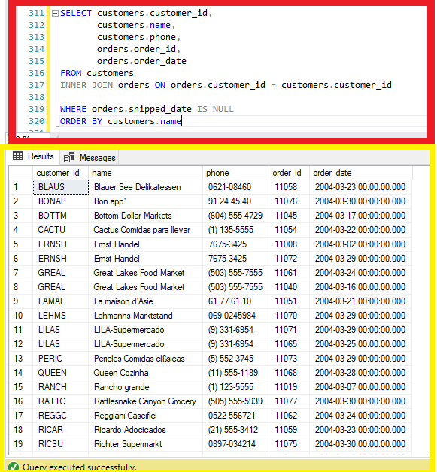

•RED – SCRIPT THAT WAS INSERTED

•YELLOW – MESSAGE PRODUCED

•THIS CASE IS VERY SIMILAR AS SHOWED ON QUESTION NUMBER 3, BUT IN THIS CASE AT THE END I USED TO ORDER BY A ESPECIFIC COLUMN.

## **Q.5**

1. List all the customers where the region is **NULL**. Display the customer id, name, and city from the customers table, and the title description from the titles table. The query should produce the result set listed below.

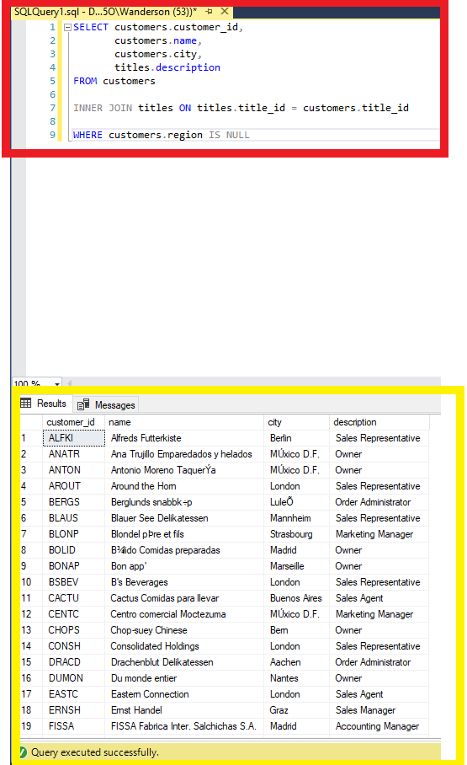

•RED – SCRIPT THAT WAS INSERTED

•YELLOW – MESSAGE PRODUCED

•IN THIS CASE I USED WHERE TO SELECT ALL REGIONS THAT ARE NULL.

## **Q.6**

1. List the products where the reorder level is **higher than** the quantity in stock. Display the supplier name from the suppliers table, the product name, reorder level, and quantity in stock from the products table. Order the result set by the supplier name. The query should produce the result set listed below.

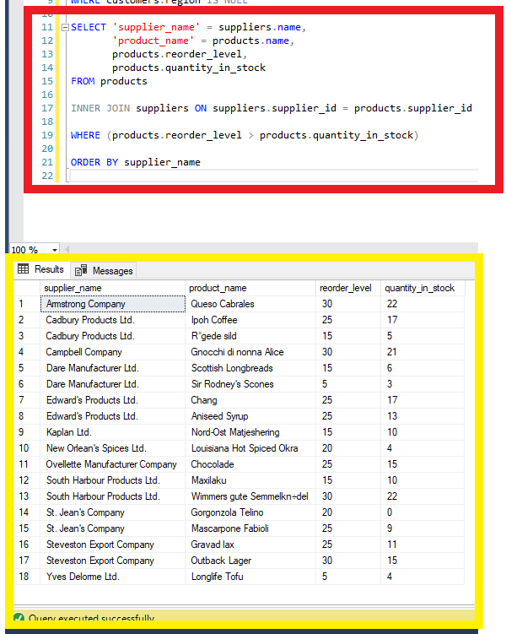

•RED – SCRIPT THAT WAS INSERTED

•YELLOW – MESSAGE PRODUCED

•THIS CASE AFTER SELECTED ALL COLUMNS THAT I WANT AND WHERE THEY ARE FROM, I DID ONE INNER JOIN TO GET MY SUPPLIER_ID AND ON WHERE I USED “>” BETWEEN COLUMNS THAT I WANT FOR SHOW ONLY VALUES THAT ONE IS GREATER THAN OTHER.

## **Q.7**

1. Calculate the length in years from **January 1, 2008** and when an order was shipped where the shipped date is **not null**. Display the order id, and the shipped date from the orders table, the customer name, and the contact name from the customers table, and the length in years for each order. Display the shipped date in the format MMM DD YYYY. Order the result set by order id and the calculated years. The query should produce the result set listed below.

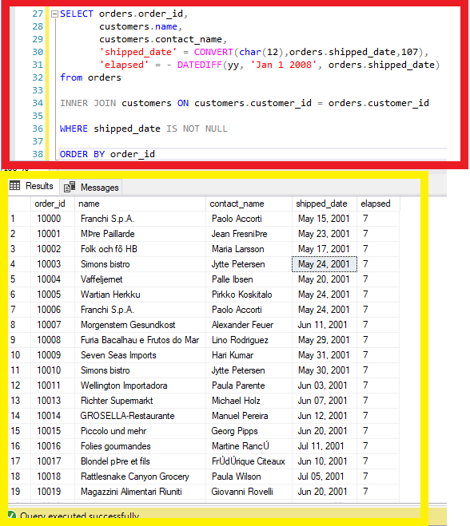

•RED – SCRIPT THAT WAS INSERTED

•YELLOW – MESSAGE PRODUCED

•IN THIS QUESTION WAS USED “CONVERT” TO SHOW DATE RESULTS ON FORMAT THAT WAS ASKED AND “DATEDIFF” TO GET THE DIFERENCE BETWEEN TIME THAT I WANTED.

## **Q.8**

1. List number of customers with names beginning with each letter of the alphabet. Ignore customers whose name begins with the letter **S**. Do not display the letter and count unless **at least two** customer’s names begin with the letter. The query should produce the result set listed below.

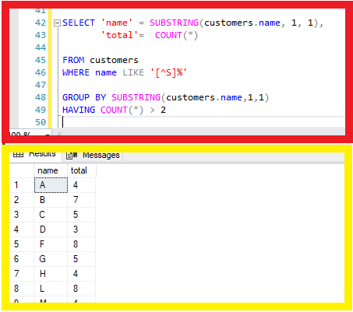

•RED – SCRIPT THAT WAS INSERTED

•YELLOW – MESSAGE PRODUCED

•THIS QUESTION I USED “SUBSTRING” TO USE JUST THE FIRST LETTER OF NAMES AND

“COUNT” TO COUNT THEM.

•ON WHERE I USED “LIKE” AND “[^S]%” TO NOT SHOW LETTERS S.

• “GROUP BY” TO SHOW THEM IN GROUPS.

•AND TO SHOW THAT ONES THAT HAVE JUST MORE THAN 2 I USED HAVING.

## **Q.9**

1. List the order details where the quantity is **greater than 100**. Display the order id and quantity from the order_details table, the product id and reorder level from the products table, and the supplier id from the suppliers table. Order the result set by the order id. The query should produce the result set listed below.

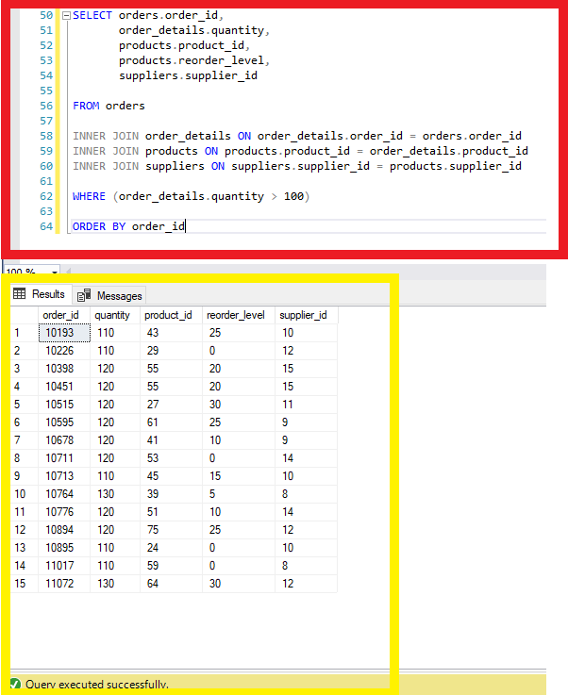

•RED – SCRIPT THAT WAS INSERTED

•YELLOW – MESSAGE PRODUCED

•THIS QUESTION I SLECTED THE COLUMNS AND MADE HIS RESPCTIVES INNER JOINS AND TO SHOW ONLY QUANTITY GREATER THAN 100 I USED WHERE WITH “>”.

## **Q.10**

1. List the products which contain **tofu** or **chef** in their name. Display the product id, product name, quantity per unit and unit price from the products table. Order the result set by product name. The query should produce the result set listed below.

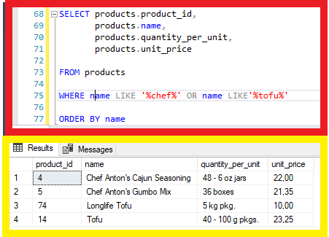

•RED – SCRIPT THAT WAS INSERTED

•YELLOW – MESSAGE PRODUCED

•FOR THIS QUESTION I SELECTED COLUMNS AND TO SHOW ONLY THAT NAMES WHERE HAVE “CHEF” OR “TOFU” I USED “WHERE” WITH “LIKE” CONDITION AND “%LOOKFOR%” SO THE SISTEM WILL LOOK JUST FOR NAMES THAT HAVE “LOOKFOR”.

# **Part C - INSERT, UPDATE, DELETE and VIEWS Statements**

## **Q.1**

1. Create an **employee** table with the following columns:

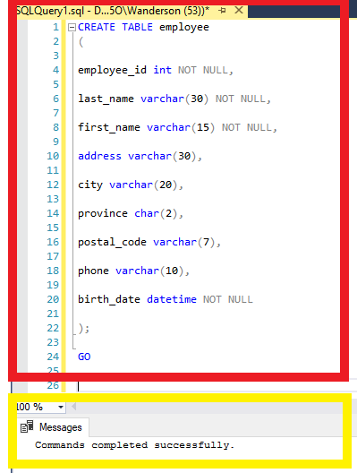

•RED – SCRIPT THAT WAS INSERTED

•YELLOW – MESSAGE PRODUCED

• SAME AS USED ON PART A WE USE “CREATE TABLE” FOLLOWING FOR THE COLUMNS.

## **Q.2**

1. The **primary key** for the employee table should be the employee id.

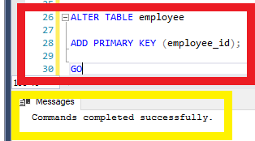

•RED – SCRIPT THAT WAS INSERTED

•YELLOW – MESSAGE PRODUCED

## **Q.3**

1. Load the data into the employee table using the employee.txt file; **9** rows. In addition, **create the relationship** to enforce referential integrity between the employee and orders tables.

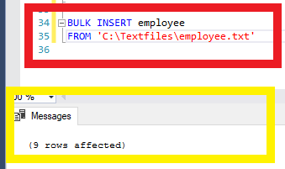

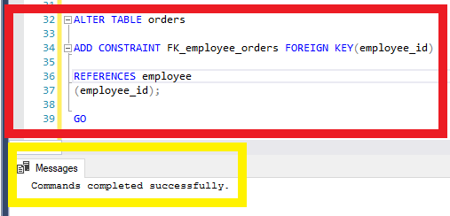

•RED – SCRIPT THAT WAS INSERTED

•YELLOW – MESSAGE PRODUCE

## **Q.4**

1. Using the INSERT statement, add the shipper **Quick Express** to the shippers table.

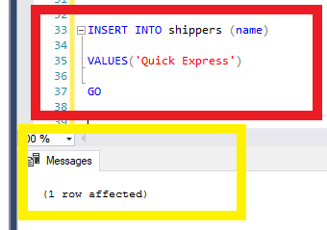

•RED – SCRIPT THAT WAS INSERTED

•YELLOW – MESSAGE PRODUCED

•HERE WE ARE USING “INSERT INTO” TO INSERT SOME VALUE AT THE “TABLE”

FOLLOWING BY “VALUE” THAT YOU MUST INSERT THE VALUE.

## **Q.5**

1. Using the UPDATE statement, increate the unit price in the products table of all rows with a current unit price between **$5.00** and **$10.00** by **5%**; 12 rows affected.

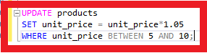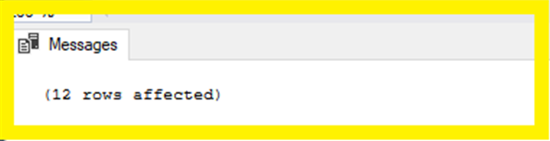

•RED – SCRIPT THAT WAS INSERTED

•YELLOW – MESSAGE PRODUCED

•FOR “UPDATE” WE CAN SET SOME RULE AS YOU CAN SEE.

## **Q.6**

1. Using the UPDATE statement, change the fax value to **Unknown** for all rows in the customers table where the current fax value is **NULL**; 22 rows affected.

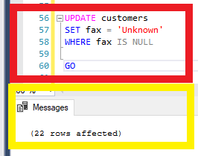

•RED – SCRIPT THAT WAS INSERTED

•YELLOW – MESSAGE PRODUCED

## **Q.7**

1. Create a view called **vw_order_cost** to list the cost of the orders. Display the order id and order_date from the orders table, the product id from the products table, the customer name from the customers tble, and the order cost. To calculate the cost of the orders, use the formula (order_details.quantity * products.unit_price). Run the view for the order ids between **10000** and **10200**. The view should produce the result set listed below.

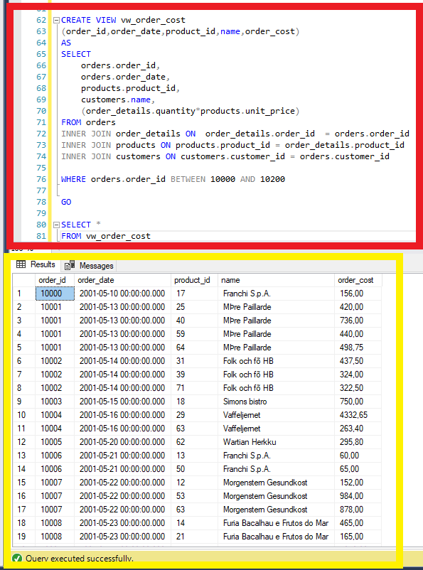

•RED – SCRIPT THAT WAS INSERTED

•YELLOW – MESSAGE PRODUCED

•CREATE A VIEW WILL HELP YOU TO EXECUTE JUST THIS VIEW COMAND TO SEE SOME CONTENT THAT WAS DEFINED BEFORE.

•AS YOU SEE ON IMAGE, WE CREATED A VIEW TO SEE ORDERS BETWEEN 10000 AND 10200,

SO, YOU CAN UPDATE THE DATA AND YOU CAN JUST EXECUTE THE VIEW TO SHOW RESULTS.

## **Q.8**

1. Create a view called **vw_list_employees** to list all the employees and all the columns in the employee table. Run the view for employee ids **5**, **7**, and **9**. Display the employee id, last name, first name, and birth date. Format the name as last name followed by a comma and a space followed by the first name. Format the birth date as **YYYY.MM.DD**. The view should produce the result set listed below.

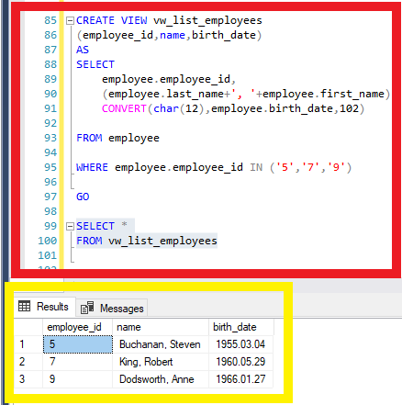

•RED – SCRIPT THAT WAS INSERTED

•YELLOW – MESSAGE PRODUCED

•THIS VIEW WAS CREATED FOR SEE EMPLOYEES WITH ID “5,7,9”.

## **Q.9**

1. Create a view called **vw_all_orders** to list all the orders. Display the order id and shipped date from the orders table, and the customer id, name, city, and country from the customers table. Run the view for orders shipped from **January 1, 2002** and **December 31, 2002**, formatting the shipped date as **MON DD YYYY**. Order the result set by customer name and country. The view should produce the result set listed below.

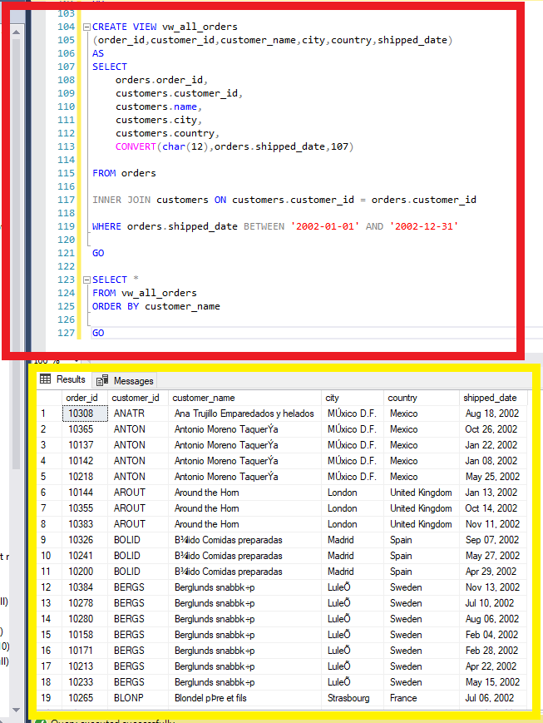

•RED – SCRIPT THAT WAS INSERTED

•YELLOW – MESSAGE PRODUCED

•THIS VIEW WAS CREATED TO SEE ORDERS THAT WAS SHIPPED BETWEEN THE DATE THAT WAS DETERMINED.

## **Q.10**

1. Create a view listing the suppliers and the items they have shipped. Display the supplier id and name from the suppliers table, and the product id and name from the products table. Run the view. The view should produce the result set listed below, *although not necessarily in the same order.*

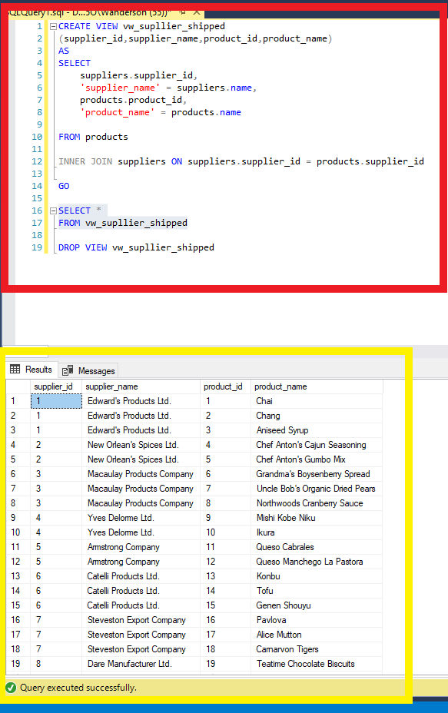

•RED – SCRIPT THAT WAS INSERTED

•YELLOW – MESSAGE PRODUCED

•VIEW CREATED TO SEE SUPPLIERS AND THE ITEMS THAT THEY HAVE SHIPPED.

# **Part D - Stored Procedures and Triggers**

# **Q.1**

1. Create a stored procedure called **sp_customer_city** displaying the customers living in a particular city. The **city** will be an **input parameter** for the stored procedure. Display the customer id, name, address, city and phone from the customers table. Run the stored procedure displaying customers living in **London**. The stored procedure should produce the result set listed below.

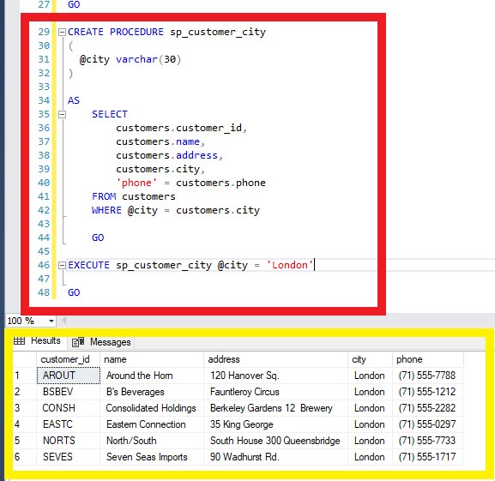

•RED – SCRIPT THAT WAS INSERTED

•YELLOW – MESSAGE PRODUCED

•”PROCEDURE” IS CREATE TO SHOW DETERMINED VALUE THAT YOU CAN INSERT WHEN EXECUTE.

•IN THIS CASE THE VALUE WILL BE CITY, SO EVERY TIME THAT YOU WILL EXECUTE THIS PROCEDURE YOU MUST DETERMINE THE CITY SO THE RESULTS WILL BE ONLY THE CUSTOMERS THAT LIVES IN THE CITY INSERTED.

## **Q.2**

1. Create a stored procedure called **sp_orders_by_dates** displaying the orders shipped between particular dates. The **start** and **end** date will be **input parameters** for the stored procedure. Display the order id, customer id, and shipped date from the orders table, the customer name from the customer table, and the shipper name from the shippers table. Run the stored procedure displaying orders from **January 1, 2003** to **June 30, 2003**. The stored procedure should produce the result set listed below.

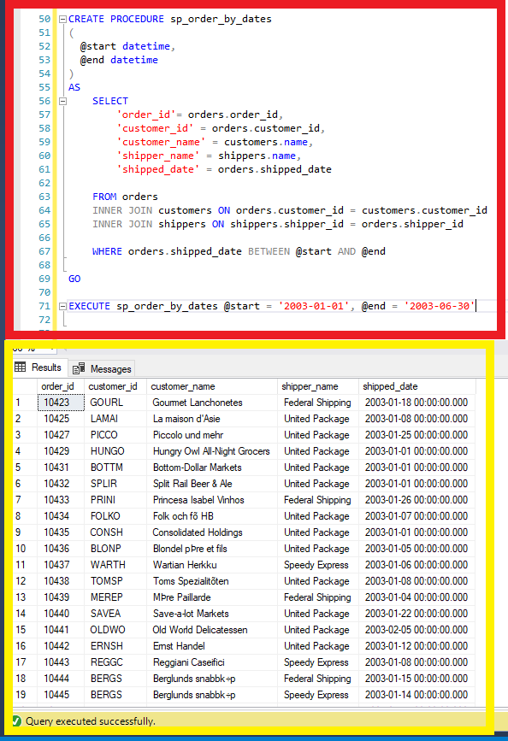

•RED – SCRIPT THAT WAS INSERTED

•YELLOW – MESSAGE PRODUCED

•THIS PROCEDURE YOU WILL FIND A ORDER BETWEEN SOME DATES SO YOU MUST DETERMINE WHEN EXECUTE THE START DATE END THE END DATE.

## **Q.3**

1. Create a stored procedure called **sp_product_listing** listing a specified product ordered during a specified month and year. The **product** and the **month** and **year** will be **input** **parameters** for the stored procedure. Display the product name, unit price, and quantity in stock from the products table, and the supplier name from the suppliers table. Run the stored procedure displaying a product name containing **Jack** and the month of the order date is **June** and the year is **2001**. The stored procedure should produce the result set listed below.

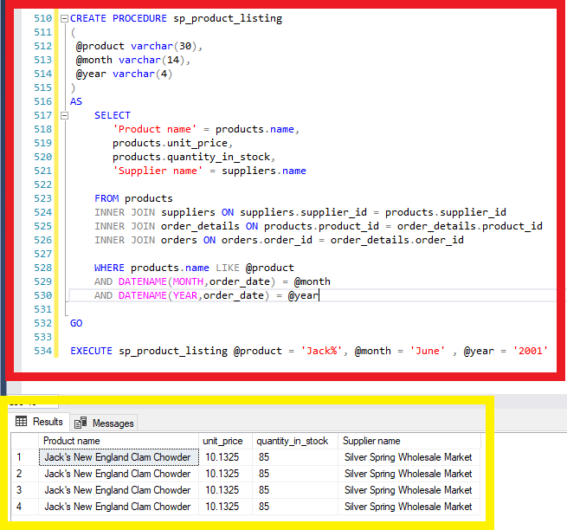

•RED – SCRIPT THAT WAS INSERTED

•YELLOW – MESSAGE PRODUCED

•THIS PROCEDURE WILL BE ABLE TO SHOW A PRODUCT LIST WITH ESPECIFIC NAME AND MONTH AND YEAR.

## **Q.4**

1. Create a **DELETE** trigger on the order_details table to display the information shown below when you issue the following statement:

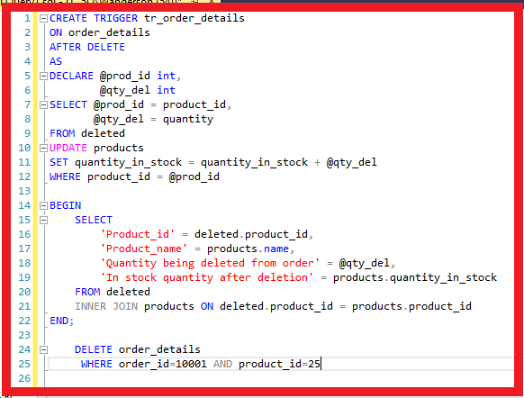

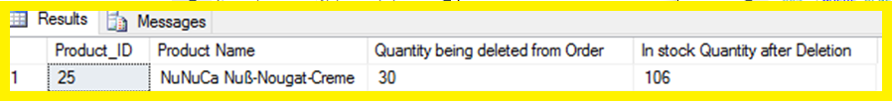

•RED – SCRIPT THAT WAS INSERTED

•YELLOW – MESSAGE PRODUCED

•”TRIGGER” IS AN AUTO EXECUTABLE COMMAND THAT WILL BE EXECUTED EVERY TIME THAT YOU DO SOMETHING THAT WAS DETERMINED, LIKE INSERT, DELETE, UPDATE.

•IN THIS CASE EVERY TIME THAT YOU DELETE SOME PRODUCT QUANTITY THIS WILL SHOW YOU THE QUANTITY DELETED AND QUANTITY IN STOCK AFTER DELETE.

## **Q.5**

1. Create an **INSERT** and **UPDATE** trigger called **tr_check_qty** on the order_details table to only allow orders of products that have a quantity in stock greater than or equal to the units ordered. Run the following query to verify your trigger.

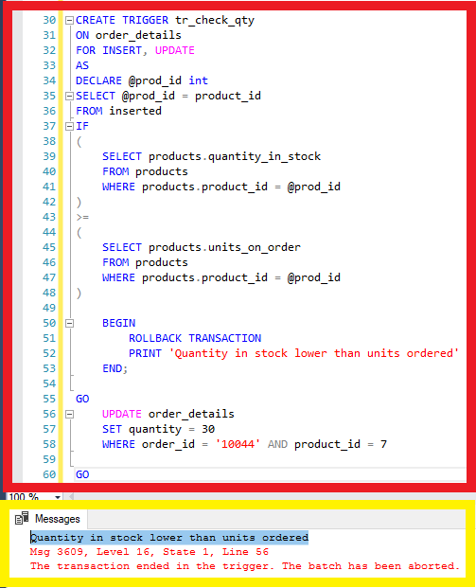

•RED – SCRIPT THAT WAS INSERTED

•YELLOW – MESSAGE PRODUCED

•THIS TRIGGER WAS CREATED TO INSERT AND UPDATE TABLE IF THE FOLLOWING RULES ARE ABLE TO EXECUTE. IN THIS CASE THE QUANTITY IN STOCK SHOULD BE GREATER OR EQUAL TO UNITS ON ORDER.

## **Q.6**

1. Create a stored procedure called **sp_del_inactive_cust** to **delete** customers that have no orders. The stored procedure should delete **1** row.

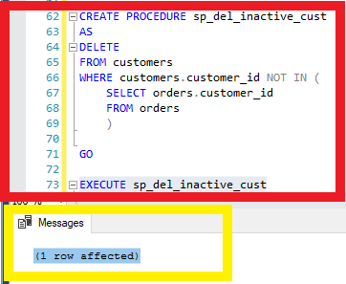

•RED – SCRIPT THAT WAS INSERTED

•YELLOW – MESSAGE PRODUCED

•THIS PROCEDURE INCLUDES A TRIGGER TO DELETE EVERY CUSTOMER THAT HAVE NO ORDERS.

## **Q.7**

1. Create a stored procedure called **sp_employee_information** to display the employee information for a particular employee. The **employee id** will be an **input** **parameter** for the stored procedure. Run the stored procedure displaying information for employee id of **5**. The stored procedure should produce the result set listed below.

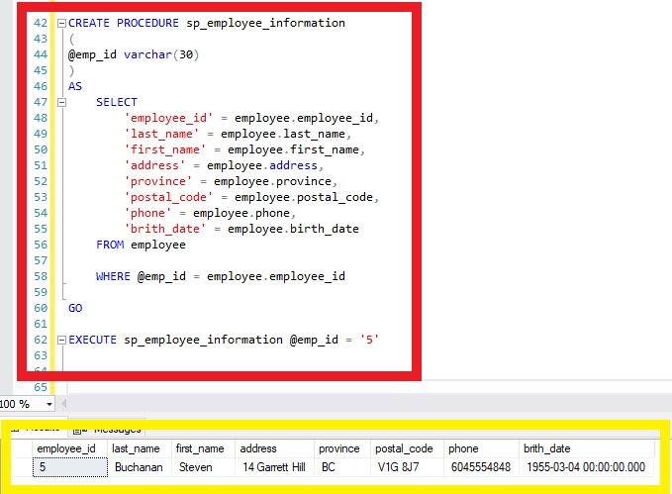

•RED – SCRIPT THAT WAS INSERTED

•YELLOW – MESSAGE PRODUCED

•THIS PROCEDURE WILL SHOW INFORMATION ABOUT A SPECIFIC EMPLOYEE ID.

## **Q.8**

1. Create a stored procedure called **sp_reorder_qty** to show when the reorder level subtracted from the quantity in stock is less than a specified value. The **unit** value will be an **input** **parameter** for the stored procedure. Display the product id, quantity in stock, and reorder level from the products table, and the supplier name, address, city, and province from the suppliers table. Run the stored procedure displaying the information for a value of **5**. The stored procedure should produce the result set listed below.

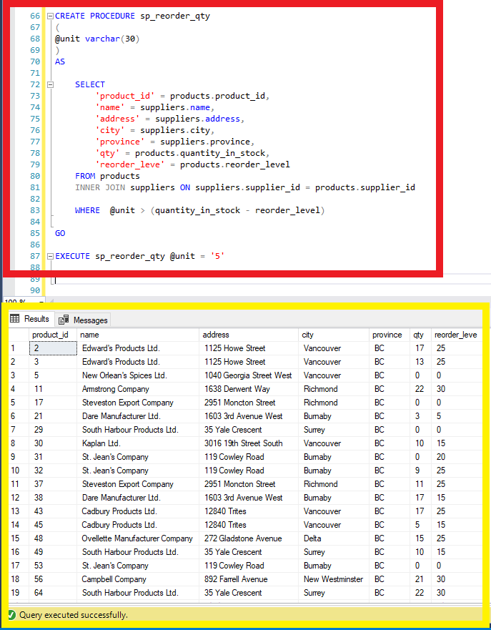

•RED – SCRIPT THAT WAS INSERTED

•YELLOW – MESSAGE PRODUCED

## **Q.9**

1. Create a stored procedure called **sp_unit_prices** for the product table where the **unit price** is **between particular values**. The **two unit prices** will be **input** **parameters** for the stored procedure. Display the product id, product name, alternate name, and unit price from the products table. Run the stored procedure to display products where the unit price is between **$5.00** and **$10.00**. The stored procedure should produce the result set listed below.

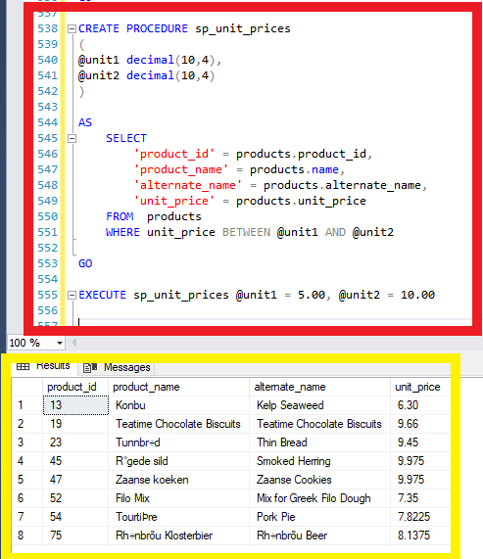

•RED – SCRIPT THAT WAS INSERTED

•YELLOW – MESSAGE PRODUCED

•THIS PROCEDURE WILL SHOW PRODUCTS BETWEEN THE PRICES THAT YOU CAN INPUT WHEN EXECUTED.

# **SCRIP COPY – ALL QUESTIONS SCRIPTS**

USE MASTER

GO

if exists (select * from sysdatabases where name='Cus_Orders')

begin

raiserror('Dropping existing Cus_Orders ....',0,1)

DROP database Cus_Orders

end

GO

-- 1)

CREATE DATABASE Cus_Orders

GO

--2)

USE Cus_orders

GO

CREATE TABLE customers

(

customer_id char(5) NOT NULL,

name varchar(50) NOT NULL,

contact_name varchar(30),

title_id char(3) NOT NULL,

address varchar(50),

city varchar(20),

region varchar(15),

country_code varchar(10),

country varchar(15),

phone varchar(20),

fax varchar(20)

);

GO

CREATE TABLE orders

(

order_id int NOT NULL,

customer_id char(5) NOT NULL,

employee_id int NOT NULL,

shipping_name varchar(50),

shipping_address varchar(50),

shipping_city varchar(20),

shipping_region varchar(15),

shipping_country_code varchar(10),

shipping_country varchar(15),

shipper_id int NOT NULL,

order_date datetime,

required_date datetime,

shipped_date datetime,

freight_charge money

);

GO

CREATE TABLE order_details

(

order_id int NOT NULL,

product_id int NOT NULL,

quantity int NOT NULL,

discount float NOT NULL

);

GO

CREATE TABLE products

(

product_id int NOT NULL,

supplier_id int NOT NULL,

name varchar(40) NOT NULL,

alternate_name varchar(40),

quantity_per_unit varchar(25),

unit_price money,

quantity_in_stock int,

units_on_order int,

reorder_level int,

);

GO

CREATE TABLE shippers

(

shipper_id int IDENTITY NOT NULL,

name varchar(20) NOT NULL

);

GO

CREATE TABLE suppliers

(

supplier_id int IDENTITY NOT NULL,

name varchar(40) NOT NULL,

address varchar(30),

city varchar(20),

province char(2)

);

GO

CREATE TABLE titles

(

title_id char(3) NOT NULL,

description varchar(35) NOT NULL,

);

-- 4)

GO

ALTER TABLE customers

ADD PRIMARY KEY (customer_id);

GO

ALTER TABLE orders

ADD PRIMARY KEY (order_id);

GO

ALTER TABLE order_details

ADD PRIMARY KEY (order_id,product_id);

GO

ALTER TABLE products

ADD PRIMARY KEY (product_id);

GO

ALTER TABLE shippers

ADD PRIMARY KEY (shipper_id);

GO

ALTER TABLE suppliers

ADD PRIMARY KEY (supplier_id);

GO

ALTER TABLE titles

ADD PRIMARY KEY (title_id);

GO

ALTER TABLE customers

ADD CONSTRAINT FK_customer_title FOREIGN KEY(title_id)

REFERENCES titles

(title_id);

GO

ALTER TABLE orders

ADD CONSTRAINT FK_orders_customers FOREIGN KEY(customer_id)

REFERENCES customers

(customer_id);

GO

ALTER TABLE orders

ADD CONSTRAINT FK_orders_shippers FOREIGN KEY(shipper_id)

REFERENCES shippers

(shipper_id);

GO

ALTER TABLE order_details

ADD CONSTRAINT FK_order_dt_orders FOREIGN KEY(order_id)

REFERENCES orders

(order_id);

GO

ALTER TABLE order_details

ADD CONSTRAINT FK_oder_dt_products FOREIGN KEY(product_id)

REFERENCES products

(product_id);

GO

ALTER TABLE products

ADD CONSTRAINT FK_products_suppliers FOREIGN KEY(supplier_id)

REFERENCES suppliers

(supplier_id);

GO

-- 5)

ALTER TABLE customers

ADD CONSTRAINT df_country

DEFAULT 'Canada' FOR country;

GO

ALTER TABLE orders

ADD CONSTRAINT df_required_date

DEFAULT DATEADD(day,10,GETDATE()) FOR required_date;

GO

ALTER TABLE order_details

ADD CONSTRAINT df_details

CHECK (quantity >= 1);

GO

ALTER TABLE products

ADD CONSTRAINT df_products_reorder

CHECK (reorder_level >= 1);

GO

ALTER TABLE products

ADD CONSTRAINT df_products_quantity

CHECK (reorder_level < 150);

GO

ALTER TABLE suppliers

ADD CONSTRAINT df_province

DEFAULT 'BC' FOR province;

GO

-- PART B 1)

SELECT customer_id,

name,

city,

country

FROM customers

ORDER BY customer_id

GO

-- 2)

AlTER TABLE customers

ADD active bit;

GO

ALTER TABLE customers

ADD CONSTRAINT df_active

DEFAULT 1 FOR active;

GO

-- 3)

SELECT 'order_id' = orders.order_id,

'product_name' = products.name,

'customer_name' = customers.name,

'order_date' = CONVERT(char(12),orders.order_date,107),

'new_shipped_date' =CONVERT(char(12),DATEADD(day,7,orders.shipped_date),107),

'order_cost' = (products.unit_price * order_details.quantity)

FROM orders

INNER JOIN order_details ON order_details.order_id = orders.order_id

INNER JOIN products ON order_details.product_id = products.product_id

INNER JOIN customers ON customers.customer_id = orders.customer_id

WHERE order_date BETWEEN '2001-01-01' AND '2001-12-31';

-- 4)

GO

SELECT customers.customer_id,

customers.name,

customers.phone,

orders.order_id,

orders.order_date

FROM customers

INNER JOIN orders ON orders.customer_id = customers.customer_id

WHERE orders.shipped_date IS NULL

ORDER BY customers.name

GO

-- 5)

SELECT customers.customer_id,

customers.name,

customers.city,

titles.description

FROM customers

INNER JOIN titles ON titles.title_id = customers.title_id

WHERE customers.region IS NULL

GO

-- 6)

SELECT 'supplier_name' = suppliers.name,

'product_name' = products.name,

products.reorder_level,

products.quantity_in_stock

FROM products

INNER JOIN suppliers ON suppliers.supplier_id = products.supplier_id

WHERE (products.reorder_level > products.quantity_in_stock)

ORDER BY supplier_name

GO

-- 7)

SELECT orders.order_id,

customers.name,

customers.contact_name,

'shipped_date' = CONVERT(char(12),orders.shipped_date,107),

'elapsed' = - DATEDIFF(yy, 'Jan 1 2008', orders.shipped_date)

from orders

INNER JOIN customers ON customers.customer_id = orders.customer_id

WHERE shipped_date IS NOT NULL

ORDER BY order_id

GO

-- 8)

SELECT 'name' = SUBSTRING(customers.name, 1, 1),

'total'= COUNT(*)

FROM customers

WHERE name LIKE '[^S]%'

GROUP BY SUBSTRING(customers.name,1,1)

HAVING COUNT(*) > 2

GO

-- 9)

SELECT orders.order_id,

order_details.quantity,

products.product_id,

products.reorder_level,

suppliers.supplier_id

FROM orders

INNER JOIN order_details ON order_details.order_id = orders.order_id

INNER JOIN products ON products.product_id = order_details.product_id

INNER JOIN suppliers ON suppliers.supplier_id = products.supplier_id

WHERE (order_details.quantity > 100)

ORDER BY order_id

GO

-- 10)

SELECT products.product_id,

products.name,

products.quantity_per_unit,

products.unit_price

FROM products

WHERE name LIKE '%chef%' OR name LIKE'%tofu%'

ORDER BY name

GO

-- PART C 1)

CREATE TABLE employee

(

employee_id int NOT NULL,

last_name varchar(30) NOT NULL,

first_name varchar(15) NOT NULL,

address varchar(30),

city varchar(20),

province char(2),

postal_code varchar(7),

phone varchar(10),

birth_date datetime NOT NULL

);

GO

-- 2)

ALTER TABLE employee

ADD PRIMARY KEY (employee_id);

GO

--BULK INSERT BEFORE 3)

ALTER TABLE orders

ADD CONSTRAINT FK_employee_orders FOREIGN KEY(employee_id)

REFERENCES employee

(employee_id);

GO

-- 4)

INSERT INTO shippers (name)

VALUES('Quick Express')

GO

-- 5)

UPDATE products

SET unit_price = unit_price*1.05

WHERE unit_price BETWEEN 5 AND 10;

GO

-- 6)

UPDATE customers

SET fax = 'Unknown'

WHERE fax IS NULL

GO

-- 7)

CREATE VIEW vw_order_cost

(order_id,order_date,product_id,name,order_cost)

AS

SELECT

orders.order_id,

orders.order_date,

products.product_id,

customers.name,

(order_details.quantity*products.unit_price)

FROM orders

INNER JOIN order_details ON order_details.order_id = orders.order_id

INNER JOIN products ON products.product_id = order_details.product_id

INNER JOIN customers ON customers.customer_id = orders.customer_id

WHERE orders.order_id BETWEEN 10000 AND 10200

GO

SELECT *

FROM vw_order_cost

GO

-- 8)

CREATE VIEW vw_list_employees

(employee_id,name,birth_date)

AS

SELECT

employee.employee_id,

(employee.last_name+', '+employee.first_name),

CONVERT(char(12),employee.birth_date,102)

FROM employee

WHERE employee.employee_id IN ('5','7','9')

GO

SELECT *

FROM vw_list_employees

GO

-- 9)

CREATE VIEW vw_all_orders

(order_id,customer_id,customer_name,city,country,shipped_date)

AS

SELECT

orders.order_id,

customers.customer_id,

customers.name,

customers.city,

customers.country,

CONVERT(char(12),orders.shipped_date,107)

FROM orders

INNER JOIN customers ON customers.customer_id = orders.customer_id

WHERE orders.shipped_date BETWEEN '2002-01-01' AND '2002-12-31'

GO

SELECT *

FROM vw_all_orders

ORDER BY customer_name

GO

-- 10)

CREATE VIEW vw_supllier_shipped

(supplier_id,supplier_name,product_id,product_name)

AS

SELECT

suppliers.supplier_id,

suppliers.name,

products.product_id,

products.name

FROM products

INNER JOIN suppliers ON suppliers.supplier_id = products.supplier_id

GO

SELECT *

FROM vw_supllier_shipped

GO

-- PART D 1)

CREATE PROCEDURE sp_customer_city

(

@city varchar(30)

)

AS

SELECT

customers.customer_id,

customers.name,

customers.address,

customers.city,

'phone' = customers.phone

FROM customers

WHERE @city = customers.city

GO

EXECUTE sp_customer_city @city = 'London'

GO

-- 2)

CREATE PROCEDURE sp_order_by_dates

(

@start datetime,

@end datetime

)

AS

SELECT

'order_id'= orders.order_id,

'customer_id' = orders.customer_id,

'customer_name' = customers.name,

'shipper_name' = shippers.name,

'shipped_date' = orders.shipped_date

FROM orders

INNER JOIN customers ON orders.customer_id = customers.customer_id

INNER JOIN shippers ON shippers.shipper_id = orders.shipper_id

WHERE orders.shipped_date BETWEEN @start AND @end

GO

EXECUTE sp_order_by_dates @start = '2003-01-01', @end = '2003-06-30'

GO

-- 3)

CREATE PROCEDURE sp_product_listing

(

@product varchar(30),

@month varchar(14),

@year varchar(4)

)

AS

SELECT

'Product name' = products.name,

products.unit_price,

products.quantity_in_stock,

'Supplier name' = suppliers.name

FROM products

INNER JOIN suppliers ON suppliers.supplier_id = products.supplier_id

INNER JOIN order_details ON products.product_id = order_details.product_id

INNER JOIN orders ON orders.order_id = order_details.order_id

WHERE products.name LIKE @product

AND DATENAME(MONTH,order_date) = @month

AND DATENAME(YEAR,order_date) = @year

GO

EXECUTE sp_product_listing @product = 'Jack%', @month = 'June' , @year = '2001'

GO

-- 4)

CREATE TRIGGER tr_order_details

ON order_details

AFTER DELETE

AS

DECLARE @prod_id int,

@qty_del int

SELECT @prod_id = product_id,

@qty_del = quantity

FROM deleted

UPDATE products

SET quantity_in_stock = quantity_in_stock + @qty_del

WHERE product_id = @prod_id

BEGIN

SELECT

'Product_id' = deleted.product_id,

'Product_name' = products.name,

'Quantity being deleted from order' = @qty_del,

'In stock quantity after deletion' = products.quantity_in_stock

FROM deleted

INNER JOIN products ON deleted.product_id = products.product_id

END;

GO

DELETE order_details

WHERE order_id=10001 AND product_id=25

GO

-- 5)

CREATE TRIGGER tr_check_qty

ON order_details

FOR INSERT, UPDATE

AS

DECLARE @prod_id int

SELECT @prod_id = product_id

FROM inserted

IF

(

SELECT products.quantity_in_stock

FROM products

WHERE products.product_id = @prod_id

)

>=

(

SELECT products.units_on_order

FROM products

WHERE products.product_id = @prod_id

)

BEGIN

ROLLBACK TRANSACTION

PRINT 'Quantity in stock lower than units ordered'

END;

GO

UPDATE order_details

SET quantity = 30

WHERE order_id = '10044' AND product_id = 7

GO

-- 6)

CREATE PROCEDURE sp_del_inactive_cust

AS

DELETE

FROM customers

WHERE customers.customer_id NOT IN (

SELECT orders.customer_id

FROM orders

)

GO

EXECUTE sp_del_inactive_cust

GO

-- 7)

CREATE PROCEDURE sp_employee_information

(

@emp_id varchar(30)

)

AS

SELECT

'employee_id' = employee.employee_id,

'last_name' = employee.last_name,

'first_name' = employee.first_name,

'address' = employee.address,

'province' = employee.province,

'postal_code' = employee.postal_code,

'phone' = employee.phone,

'brith_date' = employee.birth_date

FROM employee

WHERE @emp_id = employee.employee_id

GO

EXECUTE sp_employee_information @emp_id = '5'

GO

-- 8)

CREATE PROCEDURE sp_reorder_qty

(

@unit varchar(30)

)

AS

SELECT

'product_id' = products.product_id,

'name' = suppliers.name,

'address' = suppliers.address,

'city' = suppliers.city,

'province' = suppliers.province,

'qty' = products.quantity_in_stock,

'reorder_leve' = products.reorder_level

FROM products

INNER JOIN suppliers ON suppliers.supplier_id = products.supplier_id

WHERE @unit > (quantity_in_stock - reorder_level)

GO

EXECUTE sp_reorder_qty @unit = '5'

GO

-- 9)

CREATE PROCEDURE sp_unit_prices

(

@unit1 decimal(10,4),

@unit2 decimal(10,4)

)

AS

SELECT

'product_id' = products.product_id,

'product_name' = products.name,

'alternate_name' = products.alternate_name,

'unit_price' = products.unit_price

FROM products

WHERE unit_price BETWEEN @unit1 AND @unit2

GO

EXECUTE sp_unit_prices @unit1 = 5.00, @unit2 = 10.00

# BULK INSERT SCRIPT

BULK INSERT orders

FROM 'C:\Textfiles\orders.txt'

GO

BULK INSERT order_details

FROM 'C:\Textfiles\order_details.txt'

GO

BULK INSERT products

FROM 'C:\Textfiles\products.txt'

GO

BULK INSERT shippers

FROM 'C:\Textfiles\shippers.txt'

GO

BULK INSERT suppliers

FROM 'C:\Textfiles\suppliers.txt'

GO

BULK INSERT titles

FROM 'C:\Textfiles\titles.txt'

GO

BULK INSERT customers

FROM 'C:\Textfiles\customers.txt'

GO

BULK INSERT employee

FROM 'C:\Textfiles\employee.txt'