Marc Anderson’s Portfolio Website  
External Documentation

Table of Contents:  
Description of Site Pg1  
Colours Pg1  
Typography Pg1  
Branding Pg2

Description

This website acts as an information site about who I am as a computer programmer and as a point of contact for potential clients to get in contact with me.

Colours

I have used a mono-coloured theme on my website. Common colours (in hex values) include  
Main Background:#16DE01  
Some Text Color:#000000  
Darker Green:#3D8835  
Darkest Green:#0A6500  
Lighter Green:#4FEF3E  
Pale Green:#E3FFE5  
Contrasting red:#FC010E

Typography

Almost all text is styled with the CSS3 property: font-family: "Times New Roman", Times, serif;

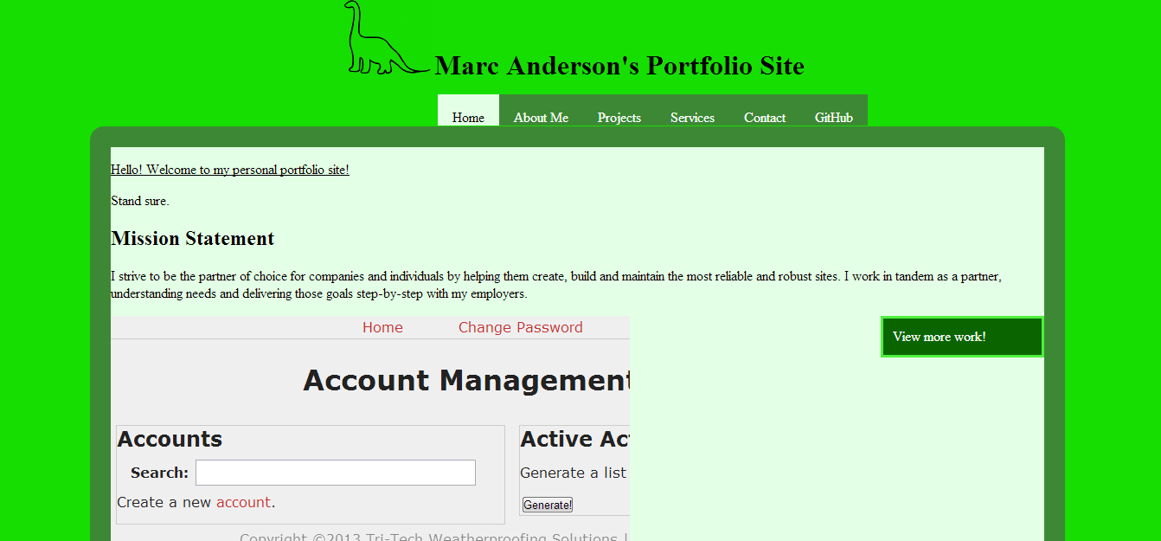

Branding  
(see previous for home page)

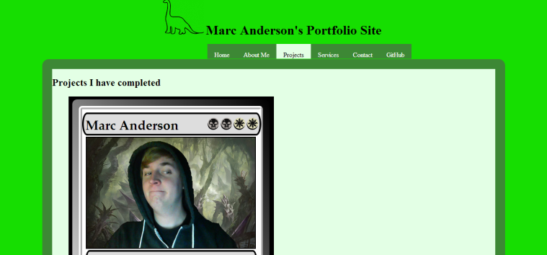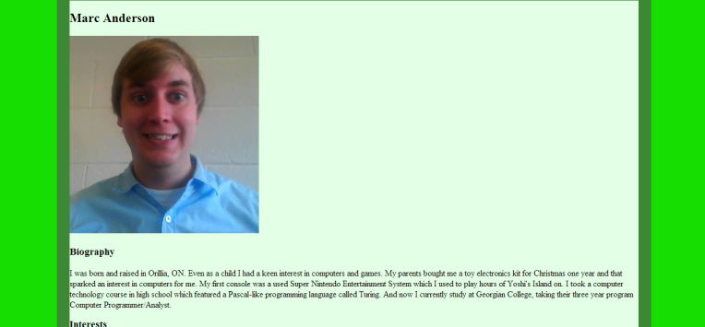About Projects

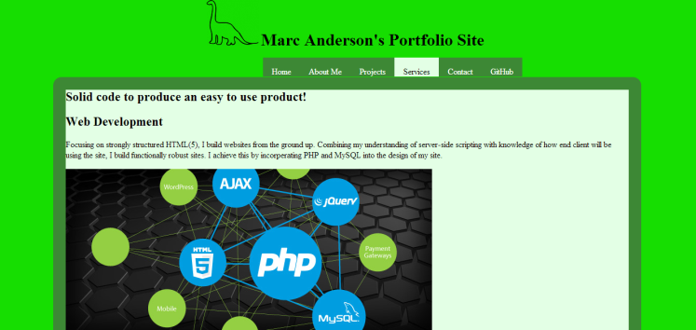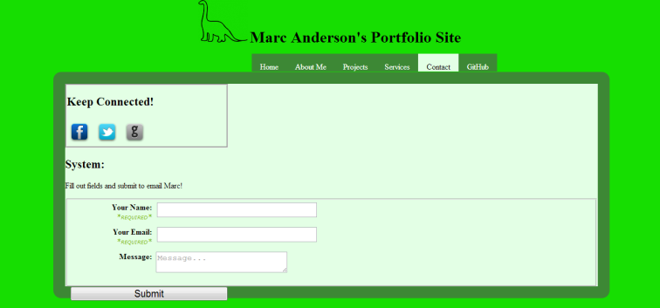Services Contact

Logo Colour Key