Marc Anderson’s Mobile Portfolio External Documentation

Table of Contents:  
Description of Site Pg1  
Nav Bar Section Pg1  
Colours Pg1  
Typography Pg1  
Branding Pg2

Description

This website builds upon my previous portfolio website and adds an additional mobile friendly version of the site to visitors. It acts as an information site about who I am as a computer programmer and as a point of contact for potential clients to get in contact with me.

Nav Bar Section

Desktop Nav Bar Image

Mobile Nav Bar Image

Colours

I have used a mono-coloured theme on my website. Common colours (in hex values) include  
Main Background:#16DE01  
Some Text Color:#000000  
Darker Green:#3D8835  
Darkest Green:#0A6500  
Lighter Green:#4FEF3E  
Pale Green:#E3FFE5  
Contrasting red:#FC010E

Typography

Almost all text is styled with the CSS3 property: font-family: "Times New Roman", Times, serif;

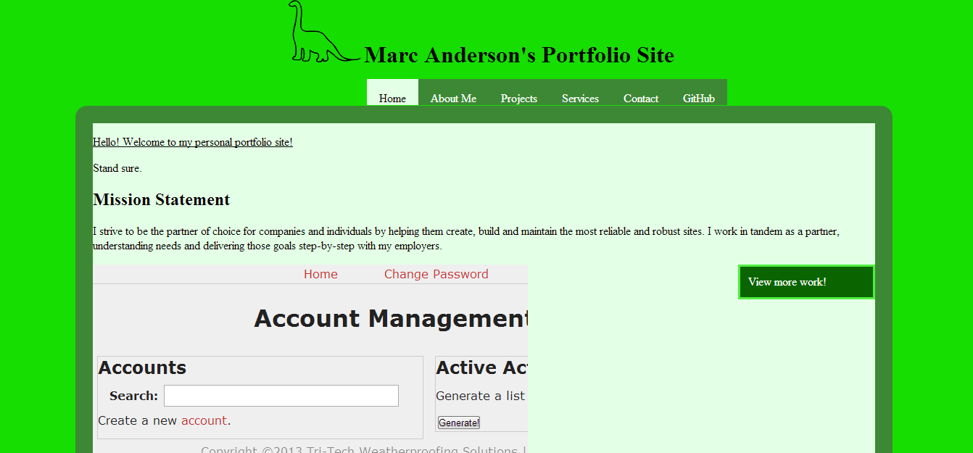

Branding  
(see previous for home page)

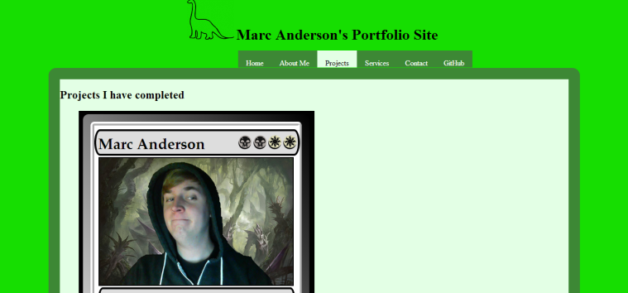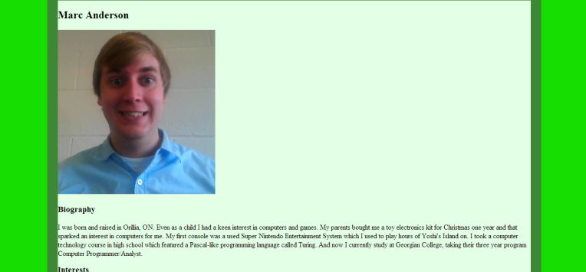About Projects

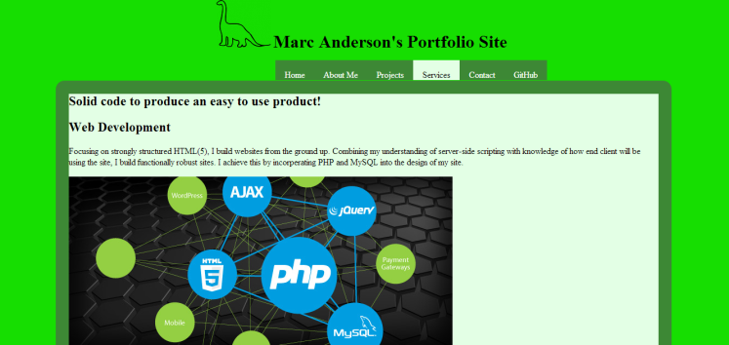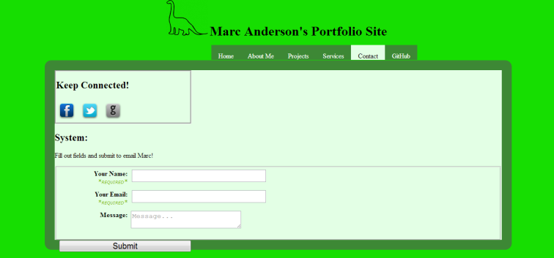Services Contact

Logo Colour Key