**Facebook widgets**

**Installation**

1. Copy **com.temenos.widgets.social.facebook** folder in your widgets folder (Ex: /{your project/templates })
2. Copy the content of **widget.xml** in your widget.xml file within your project

**How to use**

For all Facebook widgets you have to set up the settings within “Facebook SDK” (these are common for all Facebook widgets). See the image below.

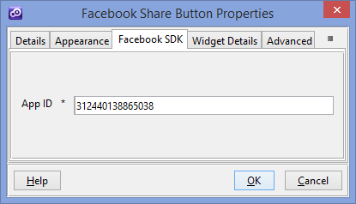

To obtain a valid app id you have to create a new application within your Facebook developer account ([**https://developers.facebook.com/apps**](https://developers.facebook.com/apps) **) .** A guid about “How to setup your application” you could find on this URL [**https://developers.facebook.com/docs/apps**](https://developers.facebook.com/docs/apps) **.**

1. **Facebook Share Button**

**Overview**

The Share button lets people add a personalized message to links before sharing on their timeline, in groups, or to their friends via a Facebook Message.

1. You will have to insert a new display Item of **Facebook Share Button** type in the **Presentation Editor**
2. Within Widget Details tab you have to set up the widget settings .

* **URL to share-** The absolute URL of the page that will be shared. Default value is the current URL.
* **Layout -** Selects one of the different layouts that are available for the button.

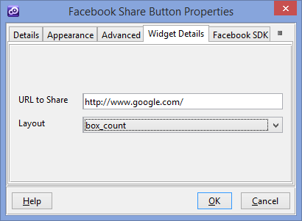

You could find more details on facebook website ( <https://developers.facebook.com/docs/plugins/share-button> )

1. **Facebook Like Button**

**Overview**

The Like button is the quickest way for people to share content with their friends. A single click on the Like button will 'like' pieces of content on the web and share them on Facebook. You can also display a Share button next to the Like button to let people add a personal message and customize who they share with.

1. You will have to insert a new display Item of **Facebook like Button** type in the **Presentation Editor**
2. Within Widget Details tab you have to set up the widget settings .

* **Action** – The verb to display on the button. Can be either "like" or "recommend"
* **Color Scheme** - The color scheme used by the widget for any text outside of the button itself.
* **URL to like** - The absolute URL of the page that will be liked. Default value is the current URL.
* **Kid directed site** - If your web site or online service, or a portion of your service, is directed to children under 13 you must enable this
* **Layout** - Selects one of the different layouts that are available for the plugin.
  + - * 1. **standard -**Minimum width: 225 pixels. Minimum increases by 40px if action is 'recommend' by and increases by 60px if send is 'true'.

Default width: 450 pixels. Height: 35 pixels (without photos) or 80 pixels (with photos).

* + - * 1. **box_count -** Minimum width: 55 pixels. Default width: 55 pixels. Height: 65 pixels.
        2. **button_count -** Minimum width: 90 pixels.Default width: 90 pixels. Height: 20 pixels.
        3. **button** **-** Minimum width: 47 pixels. Default width: 47 pixels. Height: 20 pixels.
* **Referrals** - A label for tracking referrals which must be less than 50 characters and can contain alphanumeric characters and some punctuation (currently +/=-.:_)
* **Include a share button** - Specifies whether to include a share button beside the Like button.
* **Show faces** - Specifies whether to display profile photos below the button (standard layout only). You must not enable this on child-directed sites.
* **Width** - The width of the plugin. The layout you choose affects the minimum and default widths you can use.

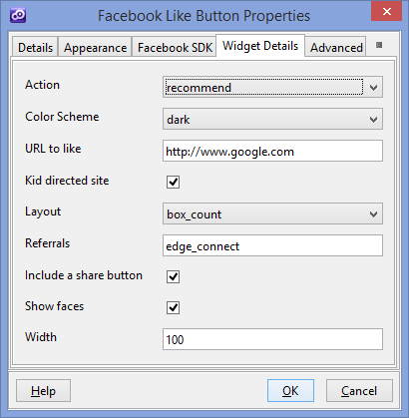

You could find more details on facebook website ( <https://developers.facebook.com/docs/plugins/like-button> )

1. **Facebook Send Button**

**Overview**

The Send button lets people privately send content on your site to one or more friends in a Facebook message, to an email address, or share it with a Facebook group.

1. You will have to insert a new display Item of **Facebook Send Button** type in the **Presentation Editor**
2. Within Widget Details tab you have to set up the widget settings .

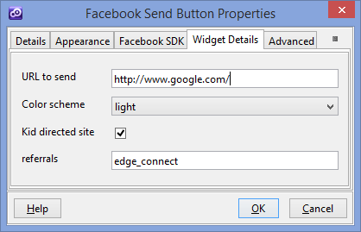

* **URL to send** - The absolute URL of the page that will be sent. Default value is the current URL.
* **Color Scheme** -The color scheme used by the widget for any text outside of the button itself.
* **Kid directed site** - If your web site or online service, or a portion of your service, is directed to children under 13 you must enable this
* **Referrals** - A label for tracking referrals which must be less than 50 characters and can contain alphanumeric characters and some punctuation (currently +/=-.:_)

You could find more details on facebook website ( <https://developers.facebook.com/docs/plugins/send-button> )

1. **Facebook embedded post**

**Overview**

Embedded Posts are a simple way to put public posts - by a Page or a person on Facebook - into the content of your web site or web page. Only public posts from Facebook Pages and profiles can be embedded.

1. You will have to insert a new display Item of **Facebook embedded post** type in the **Presentation Editor**
2. Within Widget Details tab you have to set up the widget settings .

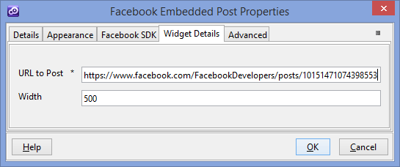

* **URL to Post** – The URL of a public post from Facebook Pages or Facebook User Profiles
* **Width** - The pixel width of the post (between 350 and 750)

You could find more details on facebook website ( <https://developers.facebook.com/docs/plugins/embedded-posts> )

1. **Facebook Follow Button**

**Overview**

The Follow button lets people subscribe to the public updates of others on Facebook.

1. You will have to insert a new display Item of **Facebook Follow Button** type in the **Presentation Editor**
2. Within Widget Details tab you have to set up the widget settings .

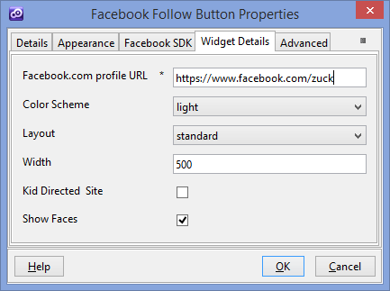

* **Profile URL** – The Facebook.com profile URL of the user to follow.
* **Color Scheme** -The color scheme used by the widget for any text outside of the button itself.
* **Layout** - Selects one of the different layouts that are available for the plugin.
  + - * 1. **standard -**Minimum width: 225 pixels. Minimum increases by 40px if action is 'recommend' by and increases by 60px if send is 'true'.

Default width: 450 pixels. Height: 35 pixels (without photos) or 80 pixels (with photos).

* + - * 1. **box_count -** Minimum width: 55 pixels. Default width: 55 pixels. Height: 65 pixels.
        2. **button_count -** Minimum width: 90 pixels.Default width: 90 pixels. Height: 20 pixels.
* **Width** - The width of the plugin. The layout you choose affects the minimum and default widths you can use
* **Kid directed site** - If your web site or online service, or a portion of your service, is directed to children under 13 you must enable this
* **Show Faces** - Specifies whether to display profile photos below the button (standard layout only). You must not enable this on child-directed sites.
* You could find more details on facebook website ( <https://developers.facebook.com/docs/plugins/follow-button> )

1. **Facebook Comments**

**Overview**

The Comments box lets people comment on content on your site using their Facebook profile and shows this activity to their friends in news feed. It also contains built-in moderation tools and special social relevance ranking.

1. You will have to insert a new display Item of **Facebook Comments** type in the **Presentation Editor**
2. Within Widget Details tab you have to set up the widget settings .

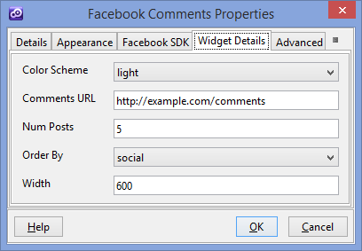

* **Color Scheme** -The color scheme used by the widget for any text outside of the button itself.
* **Comments URL** - The absolute URL that comments posted in the plugin will be permanently associated with. Stories on Facebook about comments posted in the plugin will link to this URL. Default is Current URL.
* **Num Posts** - The number of comments to show by default. The minimum value is 1. Default value is 10.
* **Order By** - The order to use when displaying comments .
* **Width** - The width of the widget. Either a pixel value or the literal 100% for fluid width. The mobile version of the Comments plugin ignores the width parameter, and instead has a fluid width of 100%.

You could find more details on facebook website ( <https://developers.facebook.com/docs/plugins/comments> )

1. **Facebook Activity Feed**

**Overview**

The Activity feed displays the most interesting, recent activity taking place on your site, using actions (such as likes) by your friends and other people..

1. You will have to insert a new display Item of **Facebook Activity Feed** type in the **Presentation Editor**
2. Within Widget Details tab you have to set up the widget settings .

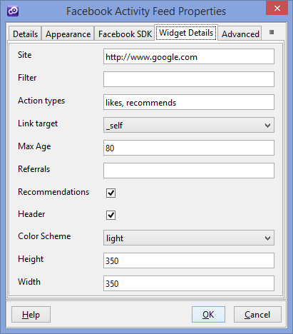

* **Site** – The domain for which to show activity. Default value is current domain.
* **Filter** - Allows you to filter which URLs are shown in the plugin. For example, if the site parameter is set to 'www.example.com' and the filter parameter was set to '/section1/section2' then only pages which matched 'http://www.example.com/section1/section2/*' would be included in the activity feed section of this widget.
* **Action types**- A comma-separated list of Open Graph action types to show in the feed. Default value is any action type.
* **Link target** - Determines what happens when people click on the links in the feed.
* **Max Age** - Limit the created time of articles that are shown in the feed. Valid values are 1-180, which represents the age in days to limit to. Default value 0 - no limit.
* **Referrals** - A label for tracking referrals which must be less than 50 characters and can contain alphanumeric characters and some punctuation (currently +/=-.:_).
* **Recommendations** - Specifies whether to always show recommendations (Articles liked by a high amount of people) in the bottom half of the feed.
* **Header** - Show the "Recent Activity" header above the feed
* **Color Scheme** -The color scheme used by the plugin. Can be "light" or "dark".
* **Height** - The height of the plugin in pixels. Default value is 300 .
* **Width** - The width of the plugin in pixels. Default value is 300.
* You could find more details on facebook website ( <https://developers.facebook.com/docs/plugins/activity> )

1. **Facebook Recommendations Feed**

**Overview**

The Recommendations feed displays the most recommended content on your site, using actions (such as likes) by your friends and other people. It is different from the Activity feed which displays recent actions on your site.

1. You will have to insert a new display Item of **Facebook Recommendations Feed** type in the **Presentation Editor**
2. Within Widget Details tab you have to set up the widget settings .

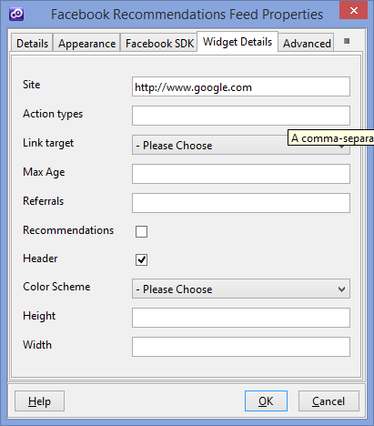

* **Site** – The domain for which to show activity. Default value is current domain.
* **Action types**- A comma-separated list of Open Graph action types to show in the feed. Default value is any action type.
* **Link target** - Determines what happens when people click on the links in the feed.
* **Max Age** - Limit the created time of articles that are shown in the feed. Valid values are 1-180, which represents the age in days to limit to. Default value 0 - no limit.
* **Referrals** - A label for tracking referrals which must be less than 50 characters and can contain alphanumeric characters and some punctuation (currently +/=-.:_).
* **Recommendations** - Specifies whether to always show recommendations (Articles liked by a high amount of people) in the bottom half of the feed.
* **Header** - Show the "Recent Activity" header above the feed
* **Color Scheme** -The color scheme used by the plugin. Can be "light" or "dark".
* **Height** - The height of the plugin in pixels. Default value is 300 .
* **Width** - The width of the plugin in pixels. Default value is 300.
* You could find more details on facebook website ( <https://developers.facebook.com/docs/plugins/recommendations> )

1. **Facebook Like Box**

**Overview**

The Like Box is a special version of the Like Button designed only for Facebook Pages. It allows admins to promote their Pages and embed a simple feed of content from a Page into other sites.

1. You will have to insert a new display Item of **Facebook Like Box** type in the **Presentation Editor**
2. Within Widget Details tab you have to set up the widget settings .

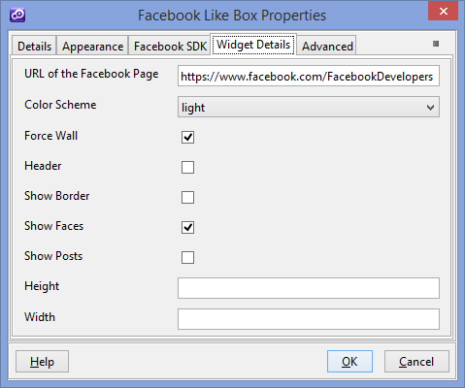

* **URL to the Facebook Page** - The absolute URL of the Facebook Page that will be liked. This is a required setting.
* **Color Scheme** -The color scheme used by the plugin. Can be "light" or "dark".
* **Force Wall** - For "place" Pages (Pages that have a physical location that can be used with check-ins), this specifies whether the stream contains posts by the Page or just check-ins from friends.
* **Header** - Specifies whether to display the Facebook header at the top of the widget.
* **Show Border** - Specifies whether or not to show a border around the widget
* **Show Faces** - Specifies whether to display profile photos of people who like the page.
* **Show Posts** - Specifies whether to display a stream of the latest posts by the Page.
* **Height** - The height of the widget in pixels. The default height varies based on number of faces to display, and whether the stream is displayed. With Show Posts checked and 10 photos displayed (via Show Faces) the default height is 556px. With Show Posts and Show Faces both unchecked, the default height is 63px.
* **Width** - The width of the widget in pixels. Minimum is 292. Default value is 300.

You could find more details on facebook website ( <https://developers.facebook.com/docs/plugins/like-box-for-pages> )

1. **Facebook Facepile**

**Overview**

The Facepile widget displays the Facebook profile photos of people who have connected with your Facebook page or app.

1. You will have to insert a new display Item of **Facebook Facepile** type in the **Presentation Editor**
2. Within Widget Details tab you have to set up the widget settings .

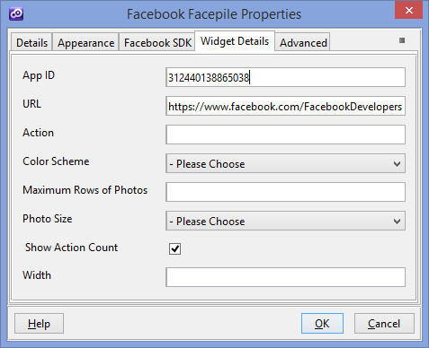

* **App ID**- Specify this if you want the widget to display users who have connected to your site using your Facebook Login widget. This should be similar with App ID from Facebook SDK tab.
* **URL** - Display photos of the people who have liked this absolute URL.
* **Action** - An Open Graph action type, such as like or customapp:run. Default value is "like"
* **Color Scheme** -The color scheme used by the plugin. Can be "light" or "dark".
* **Maximum Rows of Photos** - The maximum number of rows of faces to display. Note that if there are fewer faces to display than rows specified, the plugin will pick the next lowest number of rows. Default value is 1.
* **Photo Size** - Controls the size of the photos shown in the plugin.
* **Show Action Count** - Toggles the global count of actions on this URL.
* **Width** - The width of the plugin in pixels, minimum of 200.Default value is 300.

You could find more details on facebook website ( <https://developers.facebook.com/docs/plugins/facepile> )

1. **Facebook Publish Button**

**Overview**

This Publish Button is a special version of Share Button. Compared with the Share Button , this one , when is clicked will post automatically on Facebook wall without any intermediary modal dialog.

1. You will have to add a new custom button in your presentation. Within **Appereance** -> **Button tab** for ”Display Type” field you have to select “Facebook Publish Button “
2. Within Widget Details tab you have to set up the widget settings .

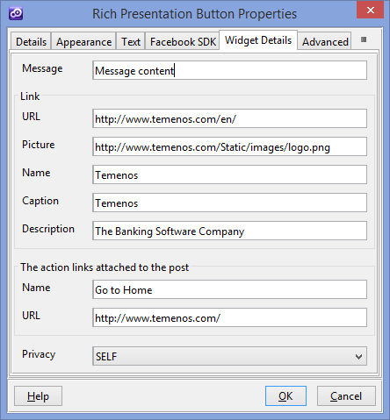

* **Message**- The main body of the post, otherwise called the status message.
* **URL** - The URL of a link to attach to the post
* **Picture** - Determines the preview image associated with the link.
* **Name** - Overwrites the title of the link preview.
* **Caption** - Overwrites the caption under the title in the link preview.
* **Description** - Overwrites the description in the link preview.
* **Action links Name** - The name or label of the action link.
* **Action link URL** - The URL of the action link itself.
* **Privacy**  - Determines the privacy settings of the post .

1. **Facebook Login Button**

**Overview**

Facebook Login is a personalized and secure way for people to sign in to your app . On the web, Facebook uses a variant of the OAuth2.0 protocol for confirming a person's identity (authentication) as well as control of what data they will share with your app (authorization) .

1. You will have to add a new custom button in your presentation. Within **Appereance** -> **Button tab** for ”Display Type” field you have to select “Facebook Login Button “
2. Within Widget Details tab you have to set up the widget settings .

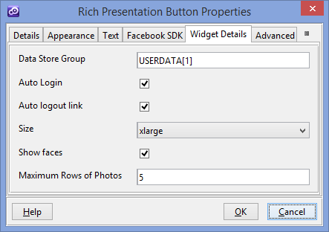

* **Data Store Group** - Data Group where to save user information after successful login. Within this data store group you should add any fields from these (id, birthday, email, first_name, last_name, picture )
* **Auto Login** - Login automatically on Page Load without any user action.
* **Auto logout link** - If enabled, the button will change to a logout button when the user is logged in.
* **Size** - Picks one of the size options for the button.
* **Show faces** - Determines whether a Facepile of logged-in friends is shown below the button. When this is enabled, a logged-in user will only see the Facepile, and no login or logout button.
* **Maximum Rows of Photos** - The maximum number of rows of profile photos in the Facepile when “Show faces” is checked. The actual number of rows shown may be shorter if there aren't enough faces to fill the number you specify.

You could find more details on facebook website ( <https://developers.facebook.com/docs/facebook-login/login-flow-for-web/v2.1> )