**MAKERERE UNIVERSITY**

**MASTER OF SCIENCE IN COMPUTER SCIENCE**

**CLOUD TECHNOLOGIES AND ARCHITECTURES**

**WENAREEBA INNOCENT**

**STUDENT NUMBER : 2100702315**

**REGISTRATION NUMBER :  2021/HD05/2315U**

**ASSIGNMENT ONE**

**CLOUD COMPUTING**

Cloud computing is the on-demand delivery of IT resources over the Internet with pay-as-you-go pricing. Instead of buying, owning, and maintaining physical data centers and servers, you can access technology services, such as computing power, storage, and databases, on an as-needed basis from a cloud provider like Amazon Web Services (AWS).

Organizations of every type, size, and industry are using the cloud for a wide variety of use cases, such as data backup, disaster recovery, email, virtual desktops, software development and testing, big data analytics, and customer-facing web applications. For example, healthcare companies are using the cloud to develop more personalized treatments for patients. Financial services companies are using the cloud to power real-time fraud detection and prevention. And video game makers are using the cloud to deliver online games to millions of players around the world.

There are a various technologies that are used when connecting and accessing resources , in this research we are going to describe how they work.

**GRID COMPUTING**

What is group computing?

Grid computing is a group of networked computers which work together as a virtual supercomputer to perform large tasks, such as analyzing huge sets of data or weather modeling. Through the cloud, you can assemble and use vast computer grids for specific time periods and purposes, paying, if necessary, only for what you use to save both the time and expense of purchasing and deploying the necessary resources yourself. Also, by splitting tasks over multiple machines, processing time is significantly reduced to increase efficiency and minimize wasted resources.

Unlike with parallel computing, grid computing projects typically have no time dependency associated with them. They use computers which are part of the grid only when idle and operators can perform tasks unrelated to the grid at any time. Security must be considered when using computer grids as controls on member nodes are usually very loose. Redundancy should also be built in as many computers may disconnect or fail during processing.

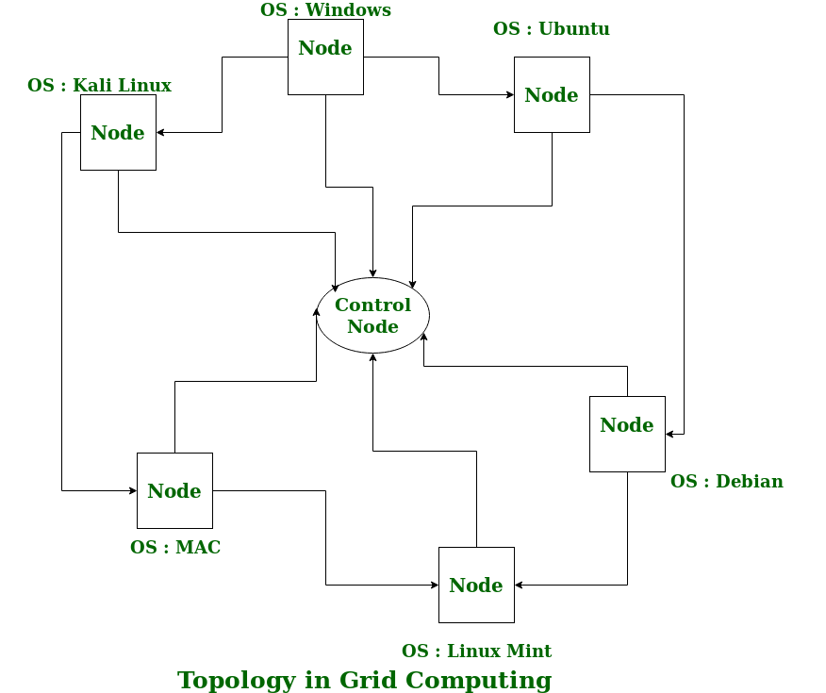

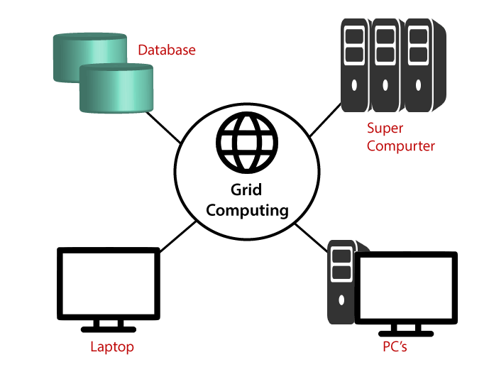

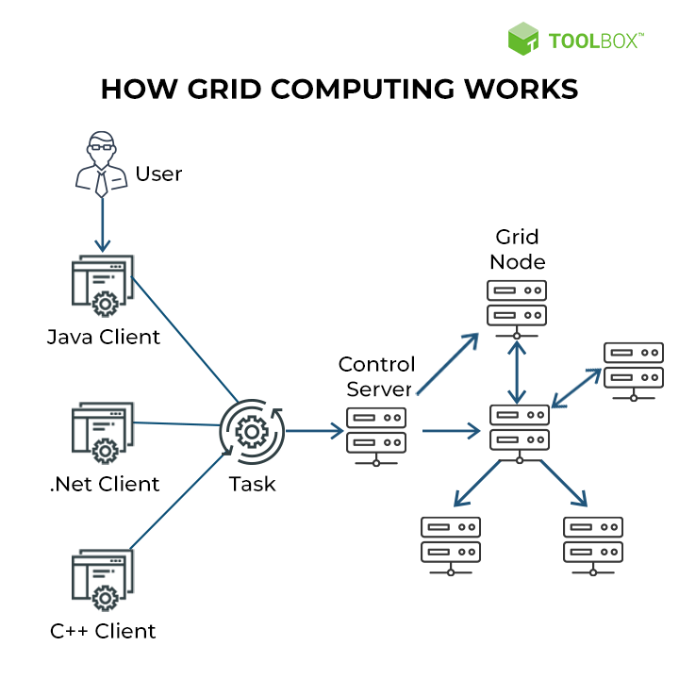

USES OF GRID COMPUTING

* Grid Computing plays an important role in performing a complex task that is impossible for a single computer to handle.
* Grid computing lowers the need for supercomputers, and two or more organizations can work together, taking advantage of supercomputers from Grid computing.
* Grid Computing is used in the movie industry due to its ability to do the task more efficiently and save time. Computers help add effects, but they also allow the film to be made quicker than usual using grid computing.
* Grid Computing finds another field of work in the gaming industries. With the increase in users more interested in online gaming, the traffic has increased, and this is where grid computing helps in processing faster and better.
* The amount of data that is handled by the government is huge. And handling so much data and then processing it becomes much easier with the use of grid computing. The application of grid computing to distribute data and process it in chunks makes it easier.

2) UTILITY COMPUTING

What is Utility computing? Utility computing is a model in which computing resources are provided to the customer based on specific demand. The service provider charges exactly for the services provided, instead of a flat rate. The foundational concept is that users or businesses pay the providers of utility computing for the amenities used – such as computing capabilities, storage space and applications services. The customer is thus, absolved from the responsibility of maintenance and management of the hardware. Consequently, the financial layout is minimal for the organization.

Utility computing is one of the most popular IT service models, primarily because of the flexibility and economy it provides. This model is based on that used by conventional utilities such as telephone services, electricity and gas. The principle behind utility computing is simple. The consumer has access to a virtually unlimited supply of computing solutions over the Internet or a virtual private network, which can be sourced and used whenever it's required. The back-end infrastructure and computing resources management and delivery is governed by the provider.

Utility computing solutions can include virtual servers, virtual storage, virtual software, backup and most IT solutions.

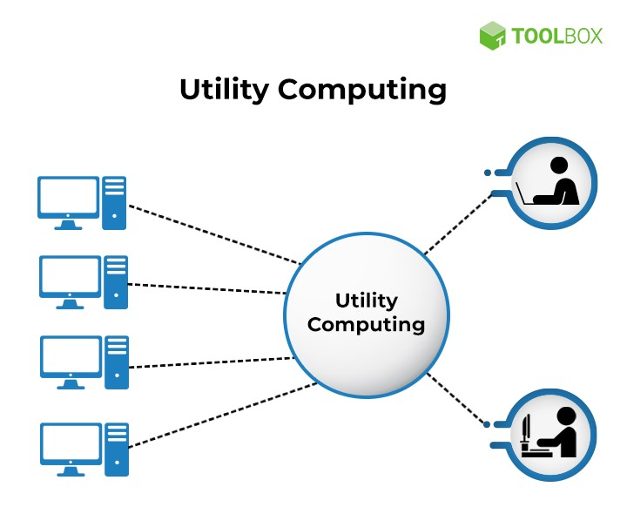

ADVANTAGES OF UTILITY COMPUTING

* For most clients, the biggest advantage of utility computing is convenience. The client doesn't have to buy all the hardware, software and licenses needed to do business Instead, the client relies on another party to provide these services. The burden of maintaining and administering the system falls to the utility computing company, allowing the client to concentrate on other tasks.

**COMPUTING ON DEMAND**

On-demand computing is a business computing model where computing resources are made available to the user when they are needed, rather than full time.

ADVANTAGES OF COMPUTING ON DEMAND

1) On-demand services allow you to pay only for what you need This is because they allow you to define your specific data storage and management needs and only get services that will cater to this need. You get a tailor-made solution that enables your business to run efficiently.

2)On-demand services also ensure that you will be able to scale up your data infrastructure as and when you need to.

3)Convenience, they allow a business to tailor their IT infrastructure in the cloud to correspond to their particular needs.

4)In essence, on-demand services allow a business to maintain its uniqueness even in the cloud. It also allows a business to have more control of their infrastructure and cloud computing solutions.

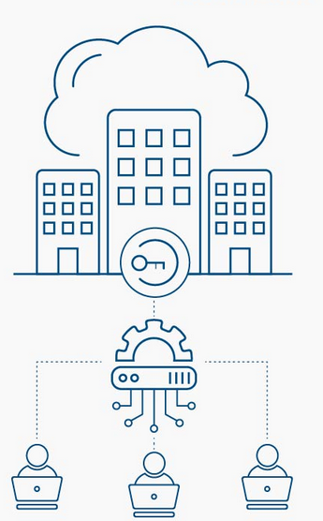

**SOFTWARE AS A SERVICE**

SaaS stands for software as a service, which means software is hosted by a third-party provider and delivered to customers over the internet as a service. While most SaaS products are aimed at business users, some products have proved popular with individual consumers, like note-taking app Evernote or personal finance tools

**ADVANTAGES OF SOFTWARE AS A SERVICE**

* It allows real time collaboration since it is provided over the internet
* Lower costs.
* Scalability and integration
* Easy to use
* It is easy to do new releases or upgrades of the service

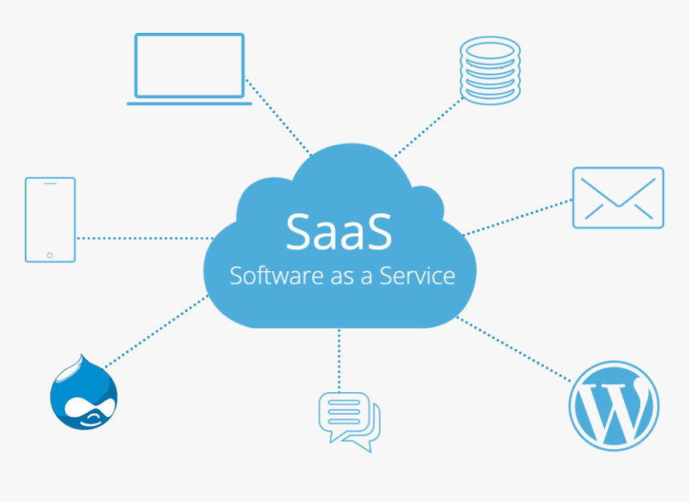

SERVICE ORIENTED ARCHITECTURE

Service-Oriented Architecture (SOA) is a style of software design where services are provided to the other components by application components, through a communication protocol over a network.

ADVANTAGES

* **Greater business agility; faster time to market**
* **Improved collaboration between business and IT**
* **Shared services**
* Increase operation efficiency

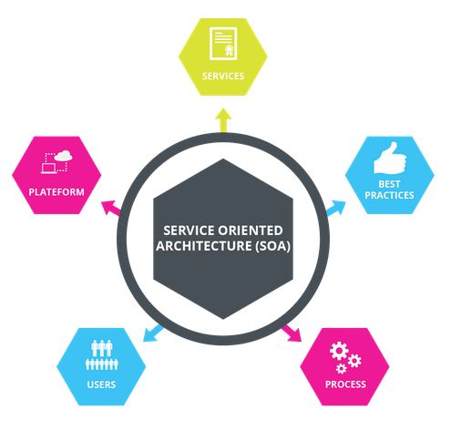

OUTSOURCING

Outsourcing is the practice of allowing an outside company to handle services that would normally be performed in-house. Customer service, human resources and distribution are all commonly outsourced departments. While outsourcing a computer doesn’t make much sense, some companies do allow an outside service provider to handle computer services or information technology services for its business. Outsourcing an IT or computer services department has both advantages and disadvantages.

ADVANTAGES OF OUTSOURCING

* Cost, the biggest advantage of outsourcing a computer department for your company is the cost. The human resource expense of hiring, training and maintaining an entire department for your company can be significant. Outsourcing these positions often saves you a large percentage of your overhead because you’re paying the fee to a company that already has the necessary processes in place.
* Labor focus, in addition to saving money, outsourcing can save time. Computer services require a specialized skill set and the time to execute the necessary tasks. If you and your staff don’t have the time or skills to perform these tasks, attempting to do them may take longer than necessary.

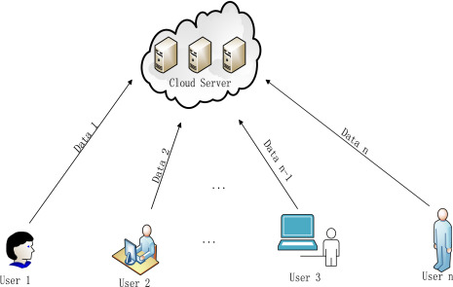

CLUSTER COMPUTING

is a collection of tightly or loosely connected computers that work together so that they act as a single entity? The connected computers execute operations all together thus creating the idea of a single system.

ADVANTAGES

* Cluster computing gives a relatively inexpensive, unconventional to the large server or mainframe computer solutions.
* It resolves the demand for content criticality and process services in a faster way.
* Many organizations and IT companies are implementing cluster computing to augment their scalability, availability, processing speed and resource management at economic prices.

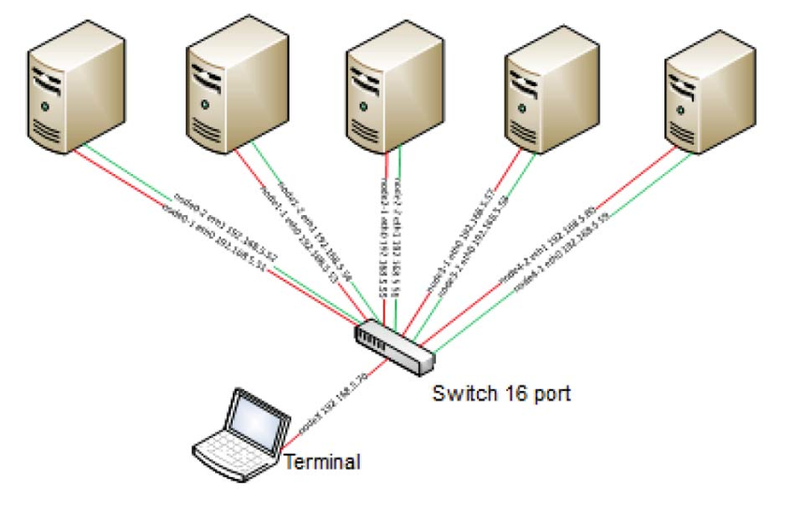

PEER TO PEER NETWORKS

In peer-to-peer (P2P) networking, **a group of computers are linked together with equal permissions and responsibilities for processing data**

**ADVANTAGES**

**1. Cost**

The overall cost of building and maintaining a peer-to-peer network is relatively inexpensive. The setup cost has been greatly reduced due to the fact that there is no central configuration. Moreover, for the windows server, there is no payment required for each of the users on the network. The payment should be done only once.

**2. Reliability**

Peer to Peer network is not dependent on a centralized system. Which means that the connected computers can function independently with each other. Even if one part of the network fails, it will not disrupt other parts. Only the user will not be able to access those files.

**3. Implementation**

It is generally easy to setup a peer-to-peer network requiring no advanced knowledge. Only a hub or a switch is needed for the connection. And also, since all the connected computers can manage themselves, there should be no much configurations. However, it needs some specialized software.

**4. Scalability**

P2P networking has one of the best scalability features. Even if there are extra clients added, the performance of the network will remain the same. Sometimes more users tend to share a single file. For this case, the network will increase the availability of bandwidth.

**5. Administration**

There is no need for any specialized network administrator since all the users are given the right to manage their own system. They can choose what type of files they are willing to share.

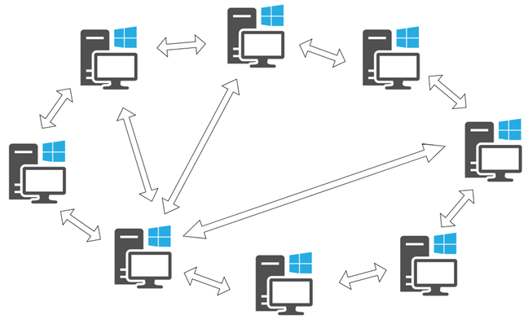

**DIAGRAM SHOWING RELATIONSHIP BETWEEN CLOUD COMPUTING AND OTHER TECHNOLOGIES**

