为该项目添加视频录制功能，记录测试视频

（1）添加ScreenRecorder.cs

点击NotepadTest->右键Add->New Item->ScreenRecorder.cs

ScreenRecorder.cs见该文件

（2）打开ScenarioEditor.cs，在测试方法：EditorEnterText()中，添加：

var screenRecorder = ScreenRecorder.CreateRecorder(@"D:\Improvement\PrepareForTestReportTeacher\NotepadTest\TestResults\screenRecorder.mp4");

screenRecorder.StartRecording(screenRecorder, 2);

…

_logger.Info("end recordering");

screenRecorder.EndRecording();

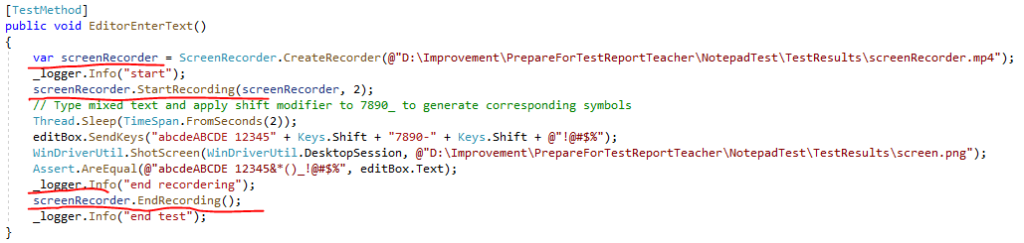

（3）在TestExplorer中运行测试：EditorEnterText,

