20-模型集成

2023-04-14

library(tidymodels)

## ── Attaching packages ────────────────────────────────────── tidymodels 1.1.0 ──

## ✔ broom 1.0.4 ✔ recipes 1.0.6  
## ✔ dials 1.2.0 ✔ rsample 1.1.1  
## ✔ dplyr 1.1.2 ✔ tibble 3.2.1  
## ✔ ggplot2 3.4.2 ✔ tidyr 1.3.0  
## ✔ infer 1.0.4 ✔ tune 1.1.1  
## ✔ modeldata 1.1.0 ✔ workflows 1.1.3  
## ✔ parsnip 1.1.0 ✔ workflowsets 1.0.1  
## ✔ purrr 1.0.1 ✔ yardstick 1.2.0

## ── Conflicts ───────────────────────────────────────── tidymodels_conflicts() ──  
## ✖ purrr::discard() masks scales::discard()  
## ✖ dplyr::filter() masks stats::filter()  
## ✖ dplyr::lag() masks stats::lag()  
## ✖ recipes::step() masks stats::step()  
## • Dig deeper into tidy modeling with R at https://www.tmwr.org

library(stacks)  
tidymodels_prefer()

library(finetune)  
  
library(rules)  
library(baguette)

concrete <-   
 concrete %>%   
 group_by(across(-compressive_strength)) %>%   
 summarize(compressive_strength = mean(compressive_strength),  
 .groups = "drop")  
nrow(concrete)

## [1] 992

#> [1] 992  
 set.seed(1501)  
concrete_split <- initial_split(concrete, strata = compressive_strength)  
concrete_train <- training(concrete_split)  
concrete_test <- testing(concrete_split)  
  
set.seed(1502)  
concrete_folds <-   
 vfold_cv(concrete_train, strata = compressive_strength)

normalized_rec <-   
 recipe(compressive_strength ~ ., data = concrete_train) %>%   
 step_normalize(all_predictors())   
  
poly_recipe <-   
 normalized_rec %>%   
 step_poly(all_predictors()) %>%   
 step_interact(~ all_predictors():all_predictors())  
  
linear_reg_spec <-   
 linear_reg(penalty = tune(), mixture = tune()) %>%   
 set_engine("glmnet")  
  
nnet_spec <-   
 mlp(hidden_units = tune(), penalty = tune(), epochs = tune()) %>%   
 set_engine("nnet", MaxNWts = 2600) %>%   
 set_mode("regression")  
  
mars_spec <-   
 mars(prod_degree = tune()) %>% #<- use GCV to choose terms  
 set_engine("earth") %>%   
 set_mode("regression")  
  
svm_r_spec <-   
 svm_rbf(cost = tune(), rbf_sigma = tune()) %>%   
 set_engine("kernlab") %>%   
 set_mode("regression")  
  
svm_p_spec <-   
 svm_poly(cost = tune(), degree = tune()) %>%   
 set_engine("kernlab") %>%   
 set_mode("regression")  
  
knn_spec <-   
 nearest_neighbor(neighbors = tune(), dist_power = tune(), weight_func = tune()) %>%   
 set_engine("kknn") %>%   
 set_mode("regression")  
  
cart_spec <-   
 decision_tree(cost_complexity = tune(), min_n = tune()) %>%   
 set_engine("rpart") %>%   
 set_mode("regression")  
  
bag_cart_spec <-   
 bag_tree() %>%   
 set_engine("rpart", times = 50L) %>%   
 set_mode("regression")  
  
rf_spec <-   
 rand_forest(mtry = tune(), min_n = tune(), trees = 1000) %>%   
 set_engine("ranger") %>%   
 set_mode("regression")  
  
xgb_spec <-   
 boost_tree(tree_depth = tune(), learn_rate = tune(), loss_reduction = tune(),   
 min_n = tune(), sample_size = tune(), trees = tune()) %>%   
 set_engine("xgboost") %>%   
 set_mode("regression")  
  
cubist_spec <-   
 cubist_rules(committees = tune(), neighbors = tune()) %>%   
 set_engine("Cubist")   
  
nnet_param <-   
 nnet_spec %>%   
 extract_parameter_set_dials() %>%   
 update(hidden_units = hidden_units(c(1, 27)))  
  
model_vars <-   
 workflow_variables(outcomes = compressive_strength,   
 predictors = everything())  
  
no_pre_proc <-   
 workflow_set(  
 preproc = list(simple = model_vars),   
 models = list(MARS = mars_spec, CART = cart_spec, CART_bagged = bag_cart_spec,  
 RF = rf_spec, boosting = xgb_spec, Cubist = cubist_spec)  
 )  
no_pre_proc

## # A workflow set/tibble: 6 × 4  
## wflow_id info option result   
## <chr> <list> <list> <list>   
## 1 simple_MARS <tibble [1 × 4]> <opts[0]> <list [0]>  
## 2 simple_CART <tibble [1 × 4]> <opts[0]> <list [0]>  
## 3 simple_CART_bagged <tibble [1 × 4]> <opts[0]> <list [0]>  
## 4 simple_RF <tibble [1 × 4]> <opts[0]> <list [0]>  
## 5 simple_boosting <tibble [1 × 4]> <opts[0]> <list [0]>  
## 6 simple_Cubist <tibble [1 × 4]> <opts[0]> <list [0]>

normalized <-   
 workflow_set(  
 preproc = list(normalized = normalized_rec),   
 models = list(SVM_radial = svm_r_spec, SVM_poly = svm_p_spec,   
 KNN = knn_spec, neural_network = nnet_spec)  
 )  
normalized

## # A workflow set/tibble: 4 × 4  
## wflow_id info option result   
## <chr> <list> <list> <list>   
## 1 normalized_SVM_radial <tibble [1 × 4]> <opts[0]> <list [0]>  
## 2 normalized_SVM_poly <tibble [1 × 4]> <opts[0]> <list [0]>  
## 3 normalized_KNN <tibble [1 × 4]> <opts[0]> <list [0]>  
## 4 normalized_neural_network <tibble [1 × 4]> <opts[0]> <list [0]>

with_features <-   
 workflow_set(  
 preproc = list(full_quad = poly_recipe),   
 models = list(linear_reg = linear_reg_spec, KNN = knn_spec)  
 )  
  
all_workflows <-   
 bind_rows(no_pre_proc, normalized, with_features) %>%   
 # Make the workflow ID's a little more simple:   
 mutate(wflow_id = gsub("(simple_)|(normalized_)", "", wflow_id))  
all_workflows

## # A workflow set/tibble: 12 × 4  
## wflow_id info option result   
## <chr> <list> <list> <list>   
## 1 MARS <tibble [1 × 4]> <opts[0]> <list [0]>  
## 2 CART <tibble [1 × 4]> <opts[0]> <list [0]>  
## 3 CART_bagged <tibble [1 × 4]> <opts[0]> <list [0]>  
## 4 RF <tibble [1 × 4]> <opts[0]> <list [0]>  
## 5 boosting <tibble [1 × 4]> <opts[0]> <list [0]>  
## 6 Cubist <tibble [1 × 4]> <opts[0]> <list [0]>  
## 7 SVM_radial <tibble [1 × 4]> <opts[0]> <list [0]>  
## 8 SVM_poly <tibble [1 × 4]> <opts[0]> <list [0]>  
## 9 KNN <tibble [1 × 4]> <opts[0]> <list [0]>  
## 10 neural_network <tibble [1 × 4]> <opts[0]> <list [0]>  
## 11 full_quad_linear_reg <tibble [1 × 4]> <opts[0]> <list [0]>  
## 12 full_quad_KNN <tibble [1 × 4]> <opts[0]> <list [0]>

library(parallel)  
cl.cores <- detectCores()  
makeCluster(getOption("cl.cores", 10))

## socket cluster with 10 nodes on host 'localhost'

#cl <- parallelly::makeClusterPSOCK(12, autoStop = TRUE)  
  
library(finetune)  
  
race_ctrl <-  
 control_race(  
 save_pred = TRUE,  
 parallel_over = "everything",  
 save_workflow = TRUE  
 )  
  
race_results <-  
 all_workflows %>%  
 workflow_map(  
 "tune_race_anova",  
 seed = 1503,  
 resamples = concrete_folds,  
 grid = 10,  
 control = race_ctrl  
 )

## ✖ The workflow requires packages that are not installed: 'kernlab'. Skipping this workflow.  
## ✖ The workflow requires packages that are not installed: 'kernlab'. Skipping this workflow.

## ✖ The workflow requires packages that are not installed: 'kknn'. Skipping this workflow.  
## ✖ The workflow requires packages that are not installed: 'kknn'. Skipping this workflow.

concrete_stack <-   
 stacks() %>%   
 add_candidates(race_results)

## Warning: ! Some elements of the supplied workflow set failed to evaluate with resamples.  
## ℹ The workflow with ID `SVM_radial`, `SVM_poly`, `KNN`, and `full_quad_KNN`  
## will be excluded from the data stack.

concrete_stack

## # A data stack with 8 model definitions and 18 candidate members:  
## # MARS: 1 model configuration  
## # CART: 1 model configuration  
## # CART_bagged: 1 model configuration  
## # RF: 1 model configuration  
## # boosting: 1 model configuration  
## # Cubist: 3 model configurations  
## # neural_network: 5 model configurations  
## # full_quad_linear_reg: 5 model configurations  
## # Outcome: compressive_strength (numeric)

set.seed(2001)  
ens <- blend_predictions(concrete_stack)

autoplot(ens)

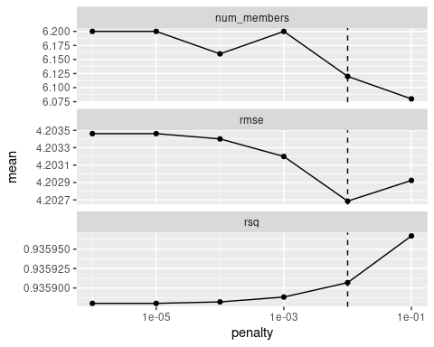

set.seed(2002)  
ens <- blend_predictions(concrete_stack, penalty = 10^seq(-2, -0.5, length = 20))  
autoplot(ens)

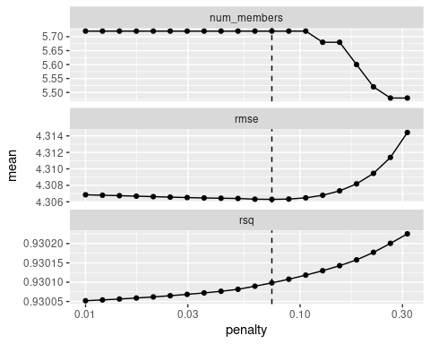

autoplot(ens, "weights") +  
 geom_text(aes(x = weight + 0.01, label = model), hjust = 0) +   
 theme(legend.position = "none") +  
 lims(x = c(-0.01, 0.8))

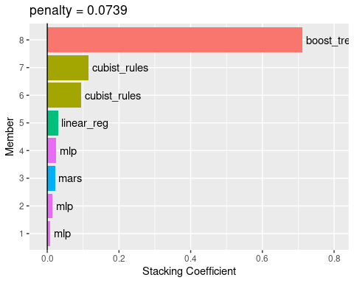

在测试集的评估指标

ens_fit <- ens %>% fit_members()  
reg_metrics <- metric_set(rmse, rsq)  
ens_test_pred <-  
 predict(ens_fit , concrete_test) %>%  
 bind_cols(concrete_test)  
  
ens_test_pred %>%  
 reg_metrics(compressive_strength, .pred)

## # A tibble: 2 × 3  
## .metric .estimator .estimate  
## <chr> <chr> <dbl>  
## 1 rmse standard 3.29   
## 2 rsq standard 0.957