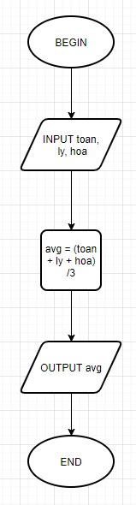BEGIN

INPUT toan, ly, hoa

avg = (toan + ly + hoa) / 3

OUTPUT = avg

End