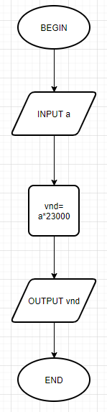BEGIN

INPUT a

vnd = a\*23000

OUTPUT = vnd

End