

Interim Assessment of the Thesis
for the Master’s Degree

Name Gao Li
Entrance Date 2015.09.01
Thesis Title Research and Application
of Plug-in Machine Based on Machine Vision
Discipline Mechanical Engineering
Supervisor Professor HuHong
Report Date 2016.03.11

- Does the thesis progress according to the research objectives and schedule as stated in the primary report?
According to the schedule stated in the primary report, I must have read some materials related to plug-in machine and image processing and have established the platform which is used to determine the image capturing and processing schemes already. In addition, the algorithm of image processing should be done, and some related software too. By now, I’ve already done all these above, and finished some research objectives ahead. For example, the software of motion control should be done from March to May in 2016. But it has been finished and now I am debugging the machine to find the bugs and determine the solution in the following research.
So, it’s obviously that I followed the research objectives and schedule in primary report. And I have finished the research contents on time.

- The completed work and its related outcomes

  - Structure design of the machine vision
In this machine, we can take pictures of mark points and component pins with only one CCD by rotating the mirror. From figure 1, we can see that a mirror with 45 degrees apart from horizontal plane in front of the lens and CCD. Above the mirror are the pins and below is the PCB board. When the mirror turns below, we can learn the position of mark points and holes on PCB board. And when it turns above, we can take pictures of component and figure out some related dates.
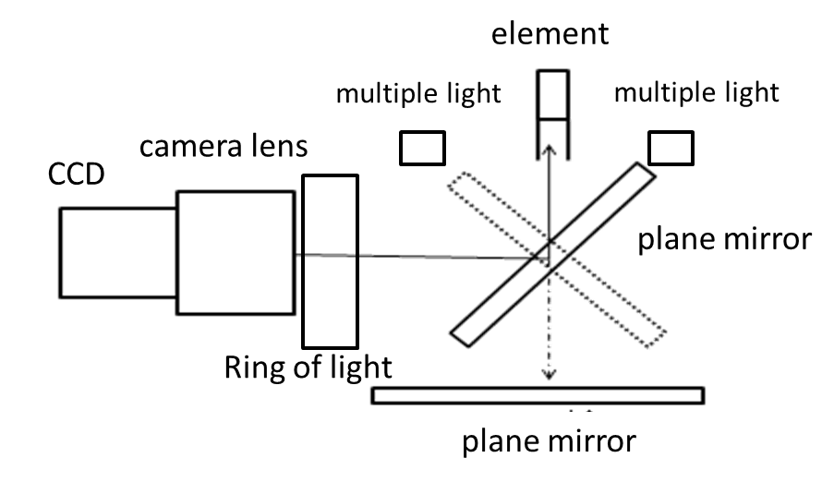
Fig.1. System schematic of image acquisition

The structure of the camera, lens, light source and a plane mirror are fixed on a bracket, which can move along the four plugs along the head, and the structure is shown in figure 2. Each camera has a lens and a light source, so they will cost thousands of dollars, and all the works of the machine are using one camera, saving a lot of money. Also, the plugin machines on the market use multiple cameras, and fixed on the one position, reflecting the superiority and innovation of the structure designed by me.
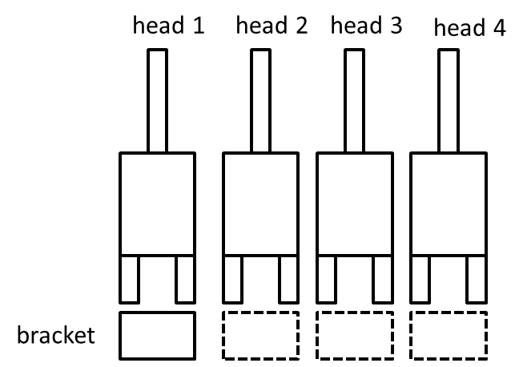
Fig.2. Structure of plug-in head

  - CCD Calibration
    - The calibration of pixel equivalent
This machine will make a camera into two virtual cameras. Pixel equivalent of the PCB plate and pin plane will be a slight deviation, so the need for calibration respectively on up pixel equivalent (PX _{up}, PY _{up}) and down pixel equivalent (PX _{down} ,PX _{down}) and calibration the calibration block are shown in the figure 3.
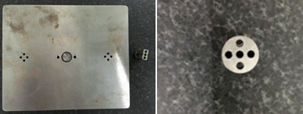
Fig.3.physical map of Calibration block

(1)The calibration of under pixel equivalent
When calibrating the under pixel equivalent calibration, firstly moving x and y, the bottom hole is now within the field of view through the image algorithm getting hole of the pixel coordinates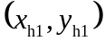, then respectively along the X, Y direction a (mm) and B (mm), at this time the coordinate of hole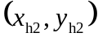, as shown in figure 4, X, Y direction of the pixel equivalent can expressed as:
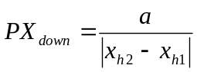
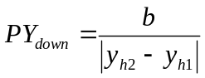
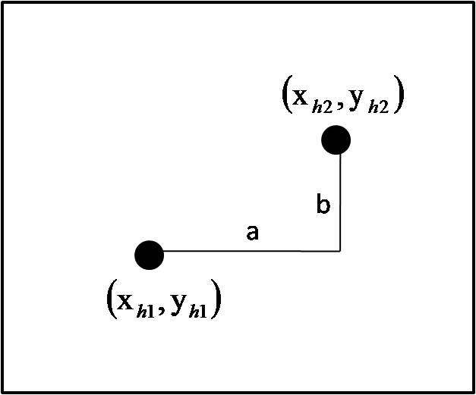
Fig.4.Hole position before and after camera movement

(2) The calibration of up pixel equivalent
When calibrating the up pixel equivalent calibration, as the camera is installed on the plug head, the mobile x, y and the imaging position of the calibration block in the field of view can not be changed. At this point, we use the X direction of two points as the difference and Y direction of two points for the difference between the pixel equivalent, as shown in the figure 5 respectively, taking up about four points 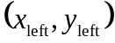, 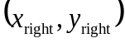,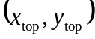 , 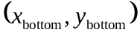, and the equivalent of the pixel equivalent can expressed as:
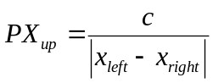
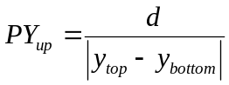
Here D and C are about two points of the actual distance (mm) and the actual distance between two points (mm).
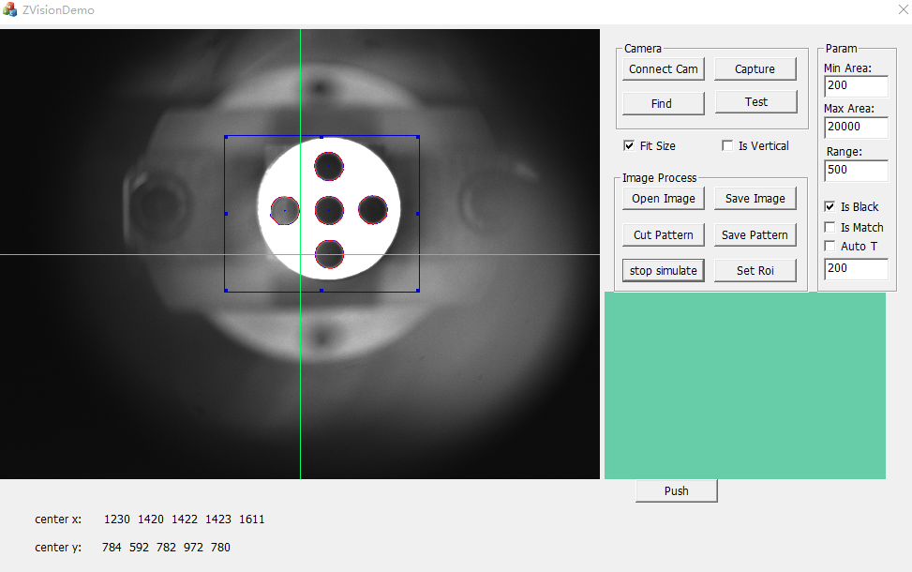
Fig.5.Image system to find the coordinates of the four points on the calibration block

    - The calibration of the mirror error
Since the top and bottom of the camera is rotated through a flat mirror, and the installation accuracy of the mirror cannot guarantee absolute high, we need to calibrate the rotation error of the mirror. A camera must virtually be made into two cameras. When shooting out of the picture, they may have error, so shot out of the picture above and below can not be directly compared, only shot out of the picture above for comparison and shot out of the picture below for comparison, that is to say plugin process simulating calibration process.
First, gas claws calibration block from the inner hole of the pull up rise to camera position, at this time calibration block can be inserted into the hole as a whole, then toward the mirror shoot below a hole, getting the coordinates of the center 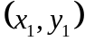 and then flipping mirror pat on the calibration block and getting the coordinates of the center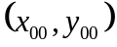, as shown in the figure 6.
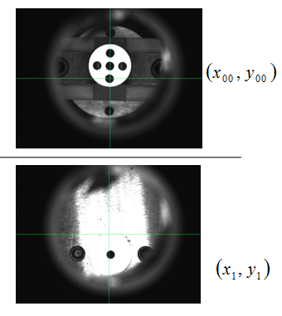
Fig.6.The coordinates of the superscript fixed block and the bottom hole are respectively taken by the camera.

As shown in Figure7, before the calibration, we must first determine the Z axis in the verticality of the position of the camera how, this can be the calibration blocks are respectively at four positions 0°, 90°, 180°, 270°respectively calculating the coordinate of center of the calibration block, 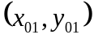, 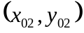, 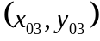 .If there is little difference in the coordinate of the center coordinates of the C0 and C2 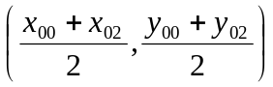and the center coordinates of C1 and C3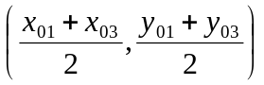, we can think the axis in position to take photographs of the axis of rotation is unchanged, and actual test results show that deviation in the X, Y direction is not more than 1 pixel, so axial coordinate 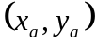can be approximated as:
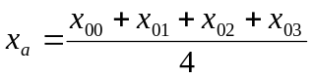
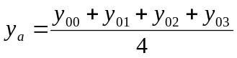
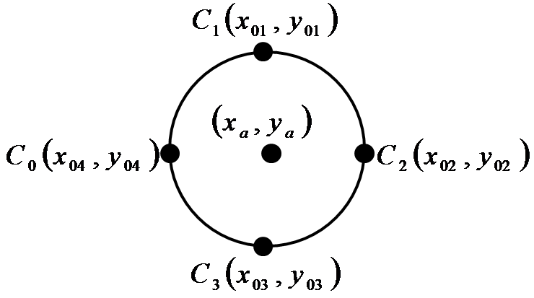
Fig.7. Calibration block rotation of the center coordinates of a week

When using the actual plugin, camera components pin gets the coordinates of the center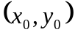, scratching component diagram is as shown in the figure 8, figure says axis coordinates, the coordinates of the center of the element and calibration position are in relation to the center of mass coordinates. We need to make the element center moved to the center of calibration, and the need of the moving distance is:
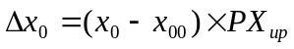
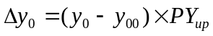
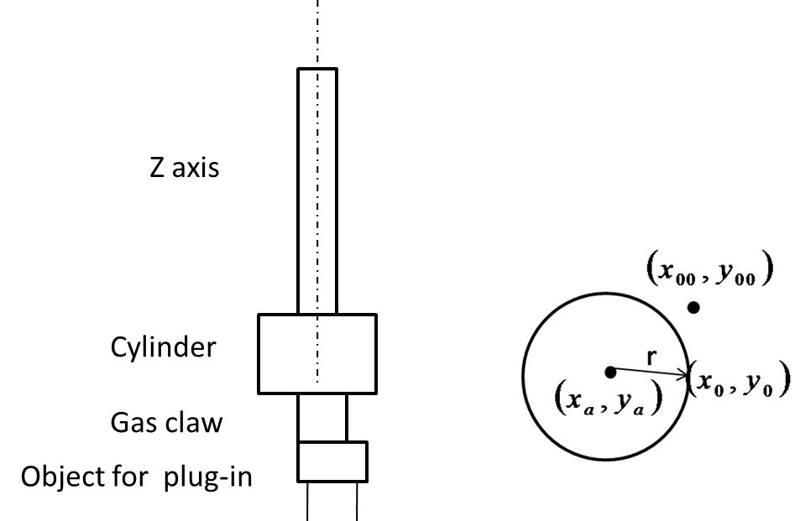
Fig.8.The relationship between the axis and the center of the element and the center of the calibration block

When studying the PCB board, and the coordinate recorded is a center and the center of the visual field of coincidence to be inserted when the mechanical coordinate, as shown in the figure 9. While the calibration shot hole beneath the time coordinate of the center of the hole and the center of the camera field of view does not coincide, so at this time x, y also supply a deviation:
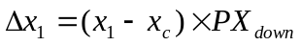
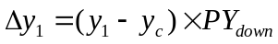
When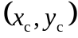 is the center of the field of view coordinates, the camera we chose is 5 million pixels of CMOS, so here is(1296,972).
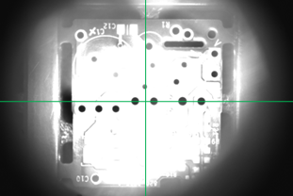
Fig.9. PCB plate hole coordinates

So the total error caused by the mirror turning is:
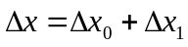
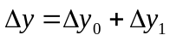
  - Related algorithms
    - Location algorithm of mark point
PCB board positioning of the machine is used to locate the mark point. The specific method is to insert a new PCB board, firstly using the camera to shoot the coordinates of the two diagonal mark points: 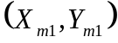,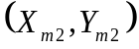. And then we shoot the coordinates of each position to be inserted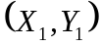，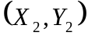，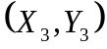……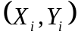.These numbers are written in step and saved. When starting plug-in, fixed PCB board firstly should be shot into two mark point coordinates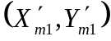,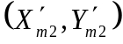.The transformation matrix between the standard board and the board to be inserted is provided:
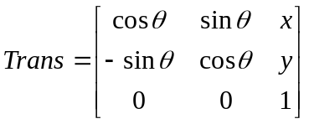
The relationship between any point on the standard board and the corresponding point on the panel is:
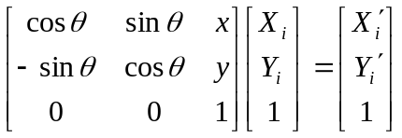
Then, according to the four coordinates ，，， ( as shown in figure 10), the coordinate transformation between the standard plate and the plate to be inserted is obtained.
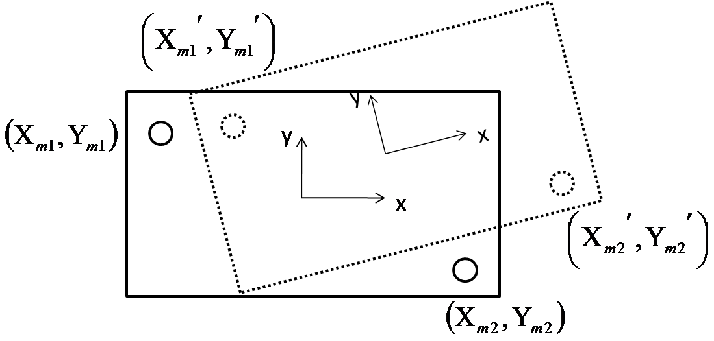
Fig.10.Standard plate and mark point coordinates to be inserted

Specific algorithms are as follows
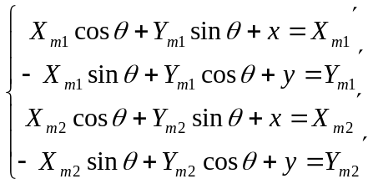
- Seek for 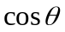
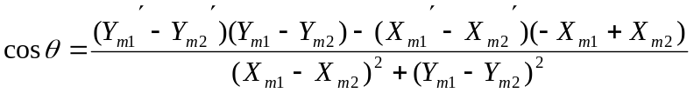
- Seek for 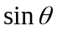
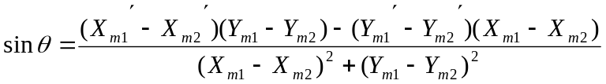
- Seek for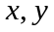
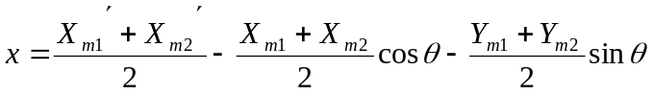
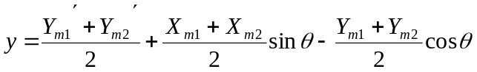
- Seek for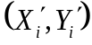
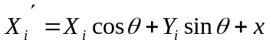
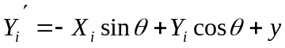
After getting four parameters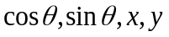, we can know the plane transformation matrix Trans between the two PCB boards, and get the coordinates of any position to be inserted on the parameters by step (4).
    - Compensation algorithm
After get the plane transformation matrix, we can know the coordinate of the center of the jack, but if we want the components accurately inserted into the inner hole we also need to know the rotation angle and after the rotation of the coordinates of the center in the X, Y direction deviation, so we need angle compensation and linear compensation before plug-in, the specific algorithm are as follows:
- angle compensation algorithm
After the component pin is shot, the angle of rotation can be expressed as:
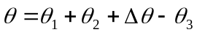
The angle is between the horizontal direction of the hole and the field of view when the camera was shot out of the standard PCB board. The included angle 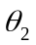 is between the standard PCB board and the PCB board to be inserted (as shown in figure 11). The angle 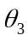 is the current coordinates when the camera takes pictures of the R axis (rotation axis) motor and feedback. When components can just insert PCB board hole, components increased to camera height, mirror to clap out pin and horizontal angle and the mirror down shot hole and horizontal angle is 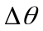 (as shown in figure 12). depends on the installation precision of the camera and mirror, if the camera and a flat mirror rotating shaft verticality of good words, the value theory should be zero, so before the visual part of the mechanical installation we need to open the camera shot as the standard block, adjust the camera position, make the best imaging effect and bring about by the camera installed at smaller error. Through multiple machine debugging and experiments, the value is within + 0.5 degrees to meet the accuracy requirements, so it can be ignored.
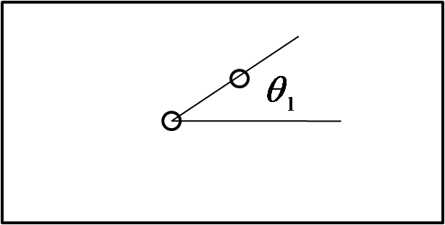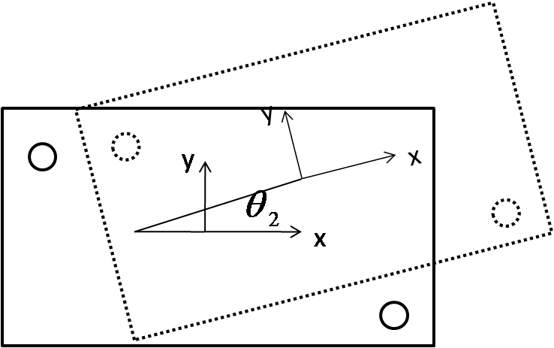
Fig.11. the angle of standard PCB plate hole and horizontal direction and the angle of standard PCB board and the PCB board to be inserted

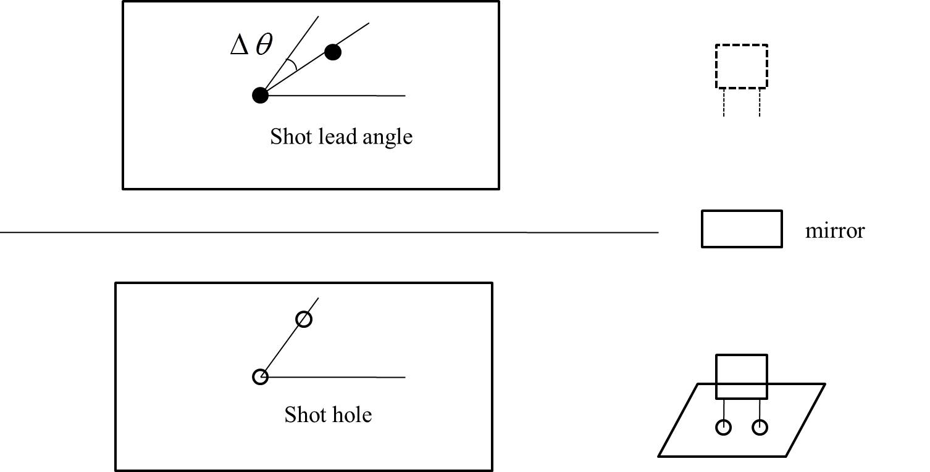
Fig.12. Pin and hole angle and components from the plug-in to the camera position
- linear compensation algorithm
Although we know the coordinate of the center of the jack, but even there is only one pin, plug-in head cannot go to this location or inserted into, because the shot hole toward the mirror and shot pin, when toward the mirror, we also need to know the deviation caused by the mirror flipping, specific method is shown above in mirror reversal error calibration. All errors are added after the components of the center and the coordinates of the center of the jack the basic coincidence, but also around the axis of rotation angle, so in X, Y direction will produce errors due to rotation, can be expressed as:
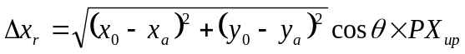
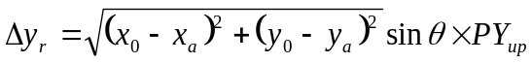
Here is the component center coordinates, and 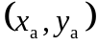 is axis center coordinates.
Total deviation is:
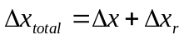
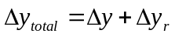
Among them, 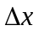，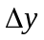are the turning error of the mirror.
- Z axis compensation algorithm
The Z axis is an elongated shaft of 8mm diameter, which can be moved up and down, and can be rotated. It's the journey from the camera position to the plug-in position, the distance is about 80mm, as shown in figure 13. From the perspective of mechanical processing, the processing precision of the slender shaft is difficult to be guaranteed, coupled with the installation error, so that the Z axis in the rotation will produce a larger deviation.
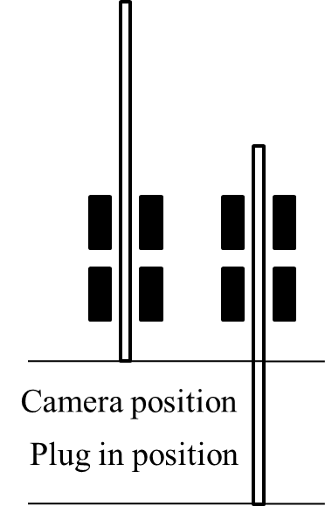
Fig.13. Z axis of the plug and camera position

The camera position is close to the bearing, and the error is only about 2 wire when the rotation table is rotated, which is basically consistent with the error of the camera when the camera is calibrated. While the Z axis down to the plug-in unit, so that the Z axis has been rotated, and then the table gets the error of about 20 wire. Since the height of the camera is in the plug-in position and camera position, so we cannot directly use the camera to shoot the rotation error of the position, at this time we can only choose to do manually on the deviation.
The same element are respectively inserted into 0°,90°,180°,270°. a location hole, manual in these positions, can be inserted into the components required to compensate for the deviation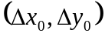，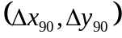，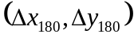，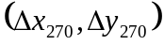,calibration gas claw is at 0° position grab calibration block, so original in 0° hole insertion is not necessary to compensate for the deviation, i.e. 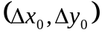=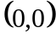, and in fact the manual of is 0, which validated prior compensation algorithm correctness.
The four position compensation value into the Cartesian coordinates and found the composition is an irregular quadrilateral, so we can't make it fitted round to compensate. Through many experiments, we find that the linear compensation can meet the requirements, specific methods are as follows:
Read the first step from the angle of the socket, if 
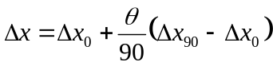
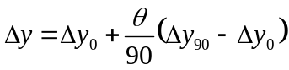
If 
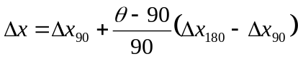
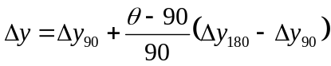
If 
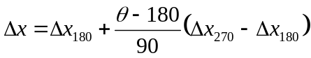
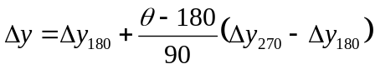
If 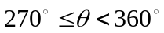
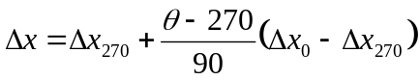
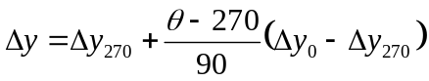
    - Algorithm of fitting a circle
This paper for circular characteristics takes least squares method of circle fitting, such as shot mark or hole in, firstly through the threshold segmentation and edge detection, edge feature point coordinates of the pixel, these points then use least squares method of circle fitting.
Set circle equation: 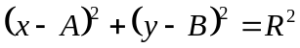
Spread out and as follow:
As 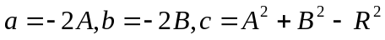
The equation can be expressed as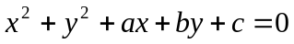
Here 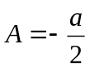，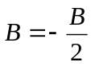，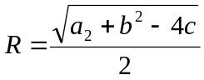
With a lot of edge points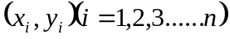, their coordinates to the center of the circle, then
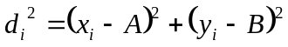
As 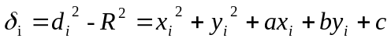,then
What we need to do next is to get the minimum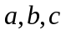. We use the partial derivative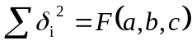, and then the partial derivative 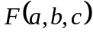is equal to 0, the obtained value can be obtained, which can be obtained by fitting the circle equation and its center coordinates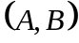. As shown in figure 14, mark point detection results.
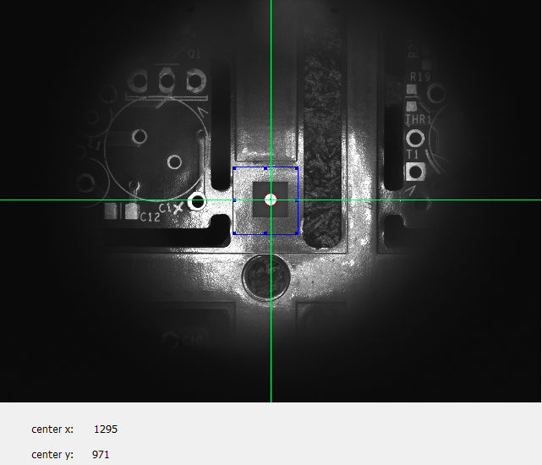
Fig.14. Image system to detect mark points
- The work to be completed and its schedule.
2016.03—2016.04 Debug the second batch of plug-in machines;
2016.05—2016.06 Improve the algorithm and optimize the PC software;
2016.07—2016.09 Read more materials and strengthen the theoretical knowledge of learning;
2016.10—2016.12 Write the graduate thesis and prepare for defending the thesis.

- The existing or expected difficulties and problems.

- The wear of mirror flipping
The mirror needs to flip over and over when plugging. So the rotation axis can be worn or loose after a long time. If the mirror is worn or loose, the coordinate from the image processing system will be not accurate and the machine cannot plug in perfectly. So, it’s really a big problem. Now we have a solution for this problem. We can use two fixed mirrors instead of one mirror flipping. However, in this way we need to consider how to change the mechanical structure and moving processes.
- Slow communication
The communication between the main machine and feeders is created with the serial port RS232. When the machine is running, we find that sometimes the communication is very slow. However, if we test the communication time separately, it will just take tens of milliseconds. I think the bug may be related to multi thread. So, we have two solutions. We can use I/O instead or send the communication code to thread in the form of message.

- The considerations on the possibility of completing the thesis on-time
I have been debugging the machine for nearly three month. So, I am very familiar with the mechanical structure and working principle of the machine and the PC software has almost already done. What I need to do next is improving the algorithm of image capturing and processing and optimizing the PC software to make the machine standardized. Also, I need to read more materials and strengthen the learning of theoretical knowledge. With the guide of teacher and the help of my colleagues and classmates, I believe that I can finish the graduated thesis on time.

