哈尔滨工业大学（深圳）
Harbin Institute of Technology, Shenzhen

Interim Assessment of the Thesis
for the Master’s Degree

Name Xu Jiangchang
Entrance Date 2015.09.01
Thesis Title Research on Automation System
of Precision Assembly for Coronary
Stent Gold Radiopaque Marker
Discipline Mechanical Engineering
Supervisor Professor HuHong
Report Date 2017.03.10

- Does the thesis progress according to the research objectives and schedule as stated in the primary report? (at least 100 words)
The main research combines machine vision, motion control and mechanical structure with process design to achieve the automation process of precision assembly that gold radionpaque material is assembled to the stent radionpaque hole. According to the schedule stated in the primary report, I must have read some materials about the automation system of precision assembly and image process and achieved the debugging and improvement about entire process and mechanical structure. In addition, the motor control and trajectory planning about motion control, pressure sensor control, the design of automatic control flow, the design of host software should be done. By now, I’ve already done all these above, and finished some research objectives ahead. For example, some algorithm of image processing should be done from March to May 2017, but it has been finished.
All in all, it’s obviously that I followed the research objectives and schedule in primary report. And I have finished the research contents on time.
.
- The completed work and its related outcomes (at least 1500 words) .
  - Mechanical structure design
The mechanical structure is mainly composed of horizontal movement mechanism, feeding mechanism, pick and place material mechanism, rotating mechanism, supporting mechanism, riveting mechanism and so on. Its structure as shown in Figure 2-1.
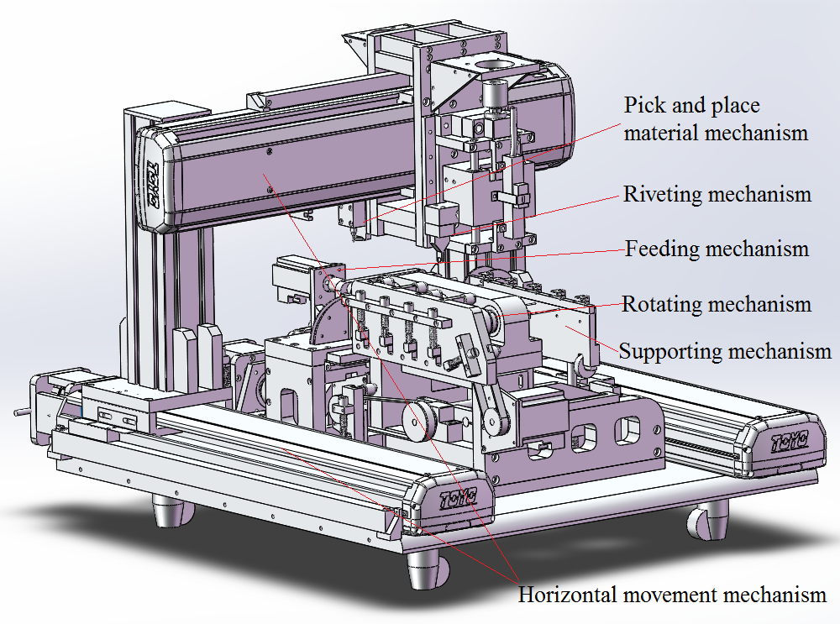
Figure 2-1 Mechanical structure diagram
  - Motion control system
The motion control system is a major part of the computer control system. it is mainly composed of the host computer, motion controller, motor server, running institution, position detection device, pressure detection device and so on. It as shown in Figure 2-2.
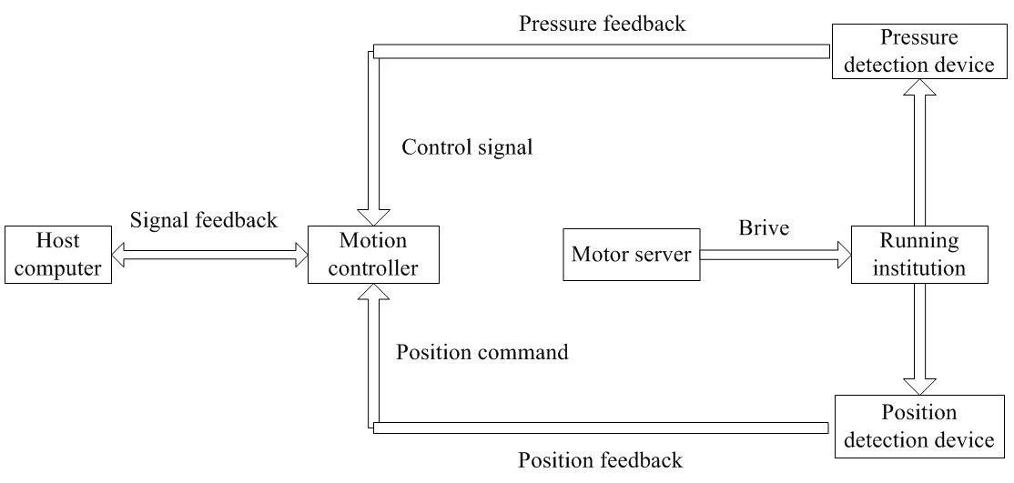
Figure 2-2 Composition of the motion control system
The motion control system is involves eight axes of movement, is controlled by Raytheon DMC3800 motion control card. Every axis drove by the Mitsubishi servo motor. Its need to complete reset movement, uniform speed movement and accelerate the closed-loop movement. X, Y need to complete interpolation movement, Z1, Z2, T axis need to complete movement about uniform acceleration up and down, G, HOLD axis need to complete uniform movement and R need to complete uniform rotation movement. Besides, through the board I / O, the small DC motor need to control the cover of the flip and electromagnet need to control the adsorption.
The positioning of servo motor is applied to motor driver position mode and motor speed and movement distance is controlled by command pulse. Take the movement of the X axis as an example, the servo motor rotation angle is proportional to the number of control pulses output from the command output. The number of pulses output by the motion control card is:
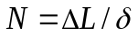 (2-1)
Where: 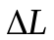- the displacement of the X axis (mm);
- the pulse equivalent of the X axis (per millimeter pulse: p / mm);
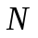-the number of pulses output by the motion control card.
X-axis ball screw pitch is 5mm, the drive set every 5000 pulse when motor rotate a week, so the labeling X-axis movement accuracy of 0.001mm. That is, each drive receives a pulse, the motor moves 0.001mm. By this method, calculate the number of pulses for per revolution as shown in Table 2-1.
Table 2-1 Number of pulses for per revolution of per axis
Axis No | X | Y | Z1 | Z2 | T | G | R | HOLD
Pulse/per revolution | 5000 | 5000 | 10000 | 10000 | 10000 | 7200 | 7200 | 14628.888

Through motion control card is combined with the control of the axis, plus pressure control and position feedback, vision system, the preparation of the upper control software to achieve the functions of rotation to find the front, taking material, discharge materials, pressure materials and so on about automation system of precision assembly for coronary stent gold radiopaque marker. Control system software, including the user interface, as shown 2-3, handle debugging, as shown 2-4, kinematic parameters settings, as shown 2-5, product parameters settings, as shown 2-6, I/O monitoring, as shown 2-7, pressure interface, as shown 2-8.
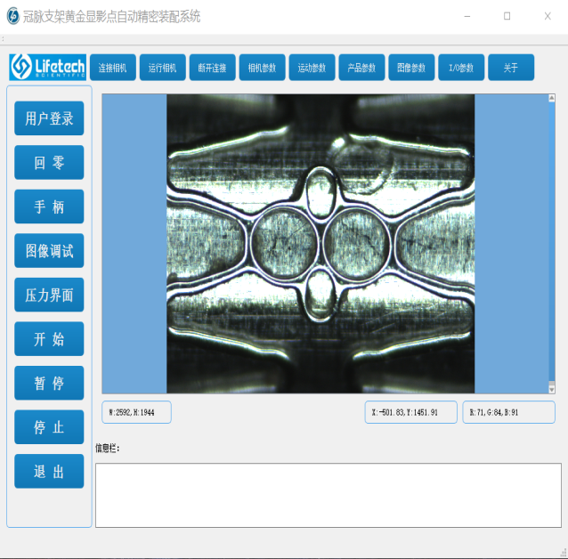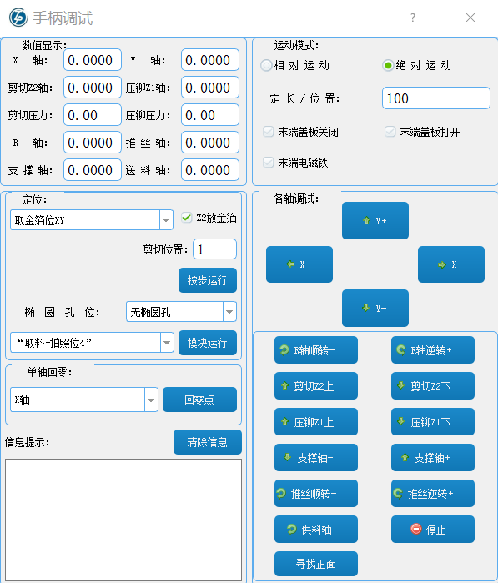
Figure 2-3 Operation Interface Figure 2-4 Handle Commissioning
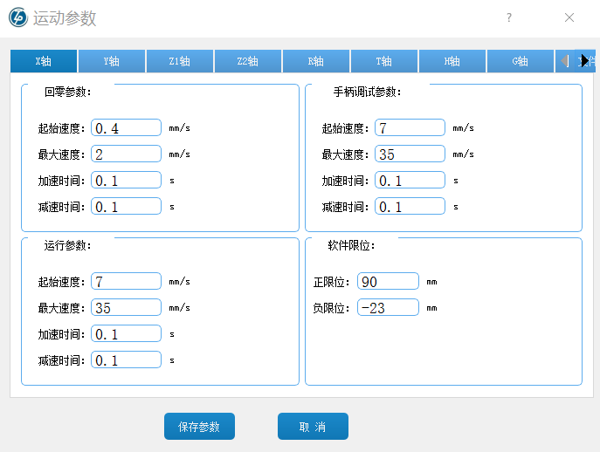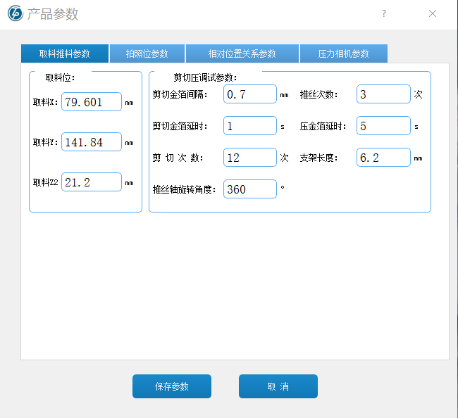
Figure 2-5 Kinematic parameters Figure 2-6 Product parameters
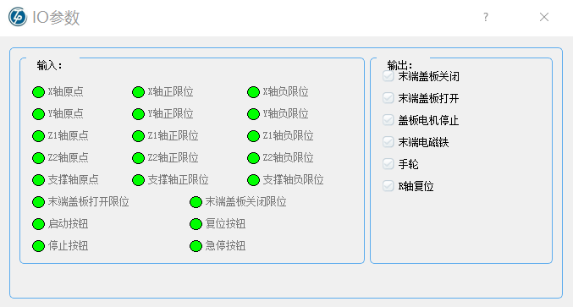
Figure 2-7 I / O monitoring
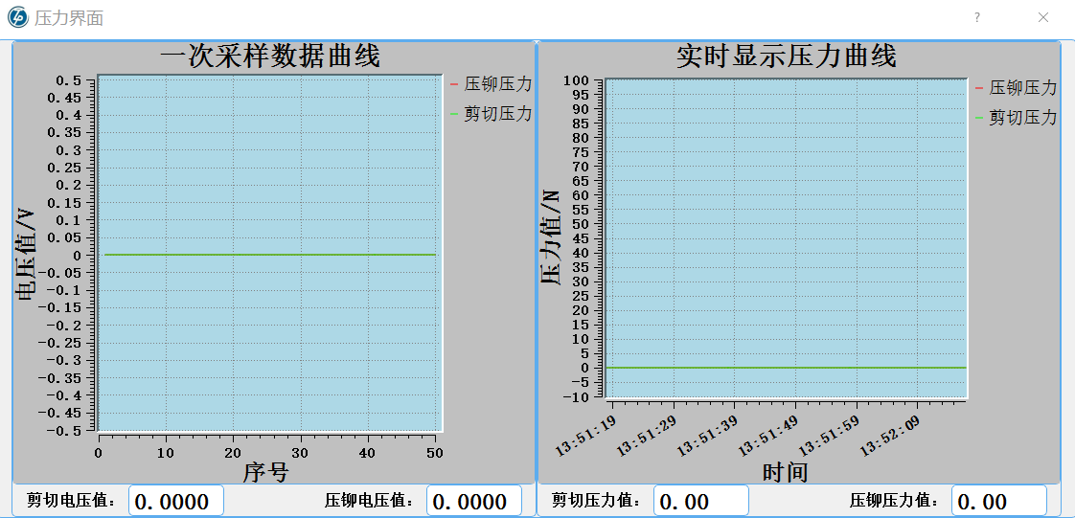
Figure 2-8 Pressure interface diagram
2.3 Machine vision
Machine vision, that is, image process of automation system of precision assembly for coronary stent gold radiopaque marker. Machine vision platform is composed by the CCD, lens, ring light source, rotating bracket, support institutions and so on. As the coronary stent is a turn shape, two ends of which have two micron ellipse radiopaque holes, but them are not the same as a line. So the machine vision structure is designed as shown in Figure2-9. The light source is provided by the ring light source and coronary stent is set on the support bar. Through the rotation mechanism to drive the support rod rotation, the camera can continuously grab the images.
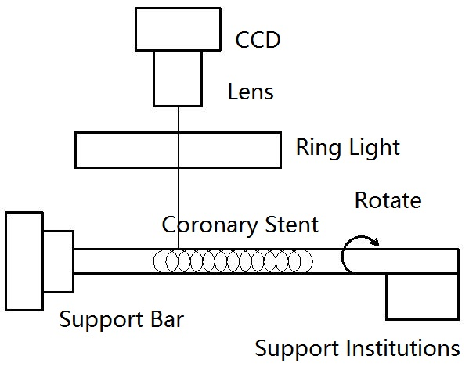
Figure2-9 Machine vision structure
2.3.1 The positioning of the elliptical front on the rotary axis
A more important link of automation system of precision assembly for coronary stent gold radiopaque marker is the positioning of the elliptical front on the coronary stent. As the coronary stent is set on a rotating support rod and the radiopaque hole is micron level, so it is difficult to ensure that the elliptical radiopaque hole is facing up, when operator put stent on the support bar. This time we need to use the machine vision to position the front of radiopaque hole on the coronary stent.
In order to more effectively carry out position detection about elliptical front, I use the method that combine algorithm of rough localization with algorithm of precise localization. First at all, Preparedness, collect each degree of the image about rotary coronary stent as a collection of samples, which is divided into a class by certain degree. The HOG feature and SVM classification were extracted from the samples to obtain training data. Then, rough localization, grab a frame of image and find the rotation angle by extracting its HOG to matches the sample results. Rotate support bar so that the elliptical hole appears in the camera field of view. At last, precise localization, In the analysis of the blob by dividing the ellipse in the HSV space, the Zernike moments subtract the sub pixel edge and then fit ellipse to find the elliptical center coordinates. Compare the deviation from the center of the image to calculate the angle to rotate back the front of the elliptical hole. The flow is shown in Figure 2-10.
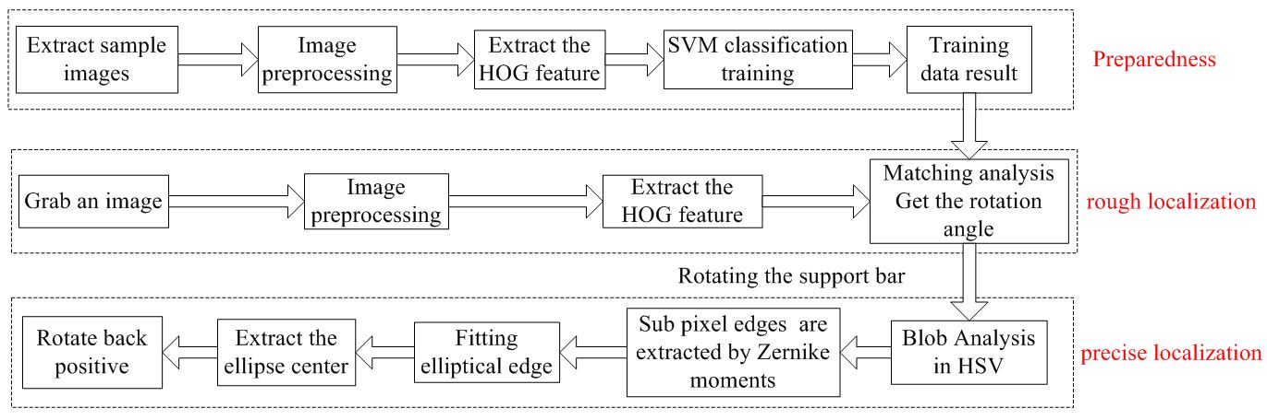
Figure 2-10 Flow about positioning of the elliptical front
- HOG feature extraction and SVM classification
The HOG feature is a feature descriptor that uses the gradient or edge direction density to represent the representation and shape of a local target of an image. Its specific implementation is: Firstly, each image is transformed into a grayscale image and normalized in size; Secondly, the size and direction of gradient are obtained for each pixel of the image; Thirdly, the image is divided into several small cell units Cell according to a certain method, and the gradient histogram in each Cell is calculated to obtain the local information of the identifier; Fourth, according to certain rules, a plurality of cells are composed of a block, and the gradient histogram in each block is counted and normalized to form the feature vector of each block; Finally, the feature vector of the block needed to finally combine the HOG feature description vector of the target image.
Support vector machine, also known as SVM, is based on the statistical theory of a machine learning method. It is a bit more prominent in solving linear classification problems, nonlinear problems and higher latitude recognition problems. Here SVM classification and identification is based in HOG feature.
With the ellipse long axis at the center of the picture width of 0 °, by sampling every 30 ° picture, as shown in Figure 2-11, we can find the coronary stent is symmetry based on the ellipse long axis and have some certain regular. Therefore, we use HOG feature + SVM classification and identification method, as shown in Table 2-2, will be divided into seven categories to learn.
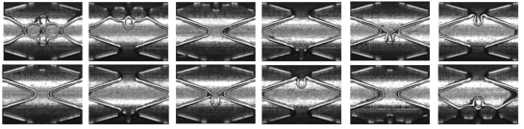
Figure 2-11 Sampling of coronary stents

Table 2-2 SVM Learning Classification Table
Group No | 0 | 1 | 2 | 3 | 4 | 5 | 6
Angle range (°) | 0-20U  340-360 | 21-60 | 61-90U  181-210 | 91-120U  211-240 | 121-150U  241-270 | 151-180U  271-300 | 301-339
Detect HOG feature images on the angle of 0,120,240 about coronary stent, as shown in Figure 2-12, 2-13, 2-14. As the number of image samples is limited, as shown in Table 2-3 data, collected 2879 images for classifying training, collected 360 for testing, the test results shown in the table. Through the results show that some of the categories of mistakes are relatively high, it needs to increase the training samples late and increase the number of test samples.
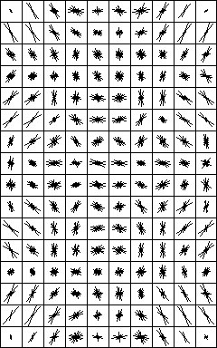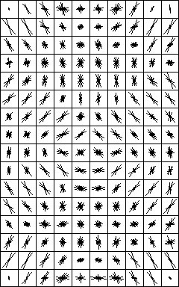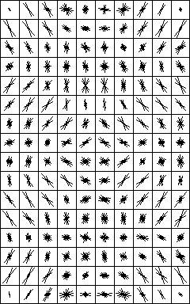
Figure 2-12 0 ° HOG Figure2-13 120 ° HOG Figure 2-14 240 ° HOG

Table 2-3 SVM Learning Statistics
Group No | 0 |  | 1 |  | 2 |  | 3 |  | 4 |  | 5 |  | 6 | Sum
Training No |  | 327 |  | 320 |  | 480 |  | 480 |  | 480 |  | 480 | 312 |  | 2879
Test No | 41 |  | 40 |  | 60 |  | 60 |  | 60 |  | 60 |  | 39 | 360
Fail | 0 |  | 0 |  | 0 |  | 4 |  | 2 |  | 1 |  | 0 | 7
Success | 1 |  | 1 |  | 1 |  | 0.9333 |  | 0.9667 |  | 0.9833 |  | 1 | 0.9806

- Blob analysis of HSV color space
HSV color model is composed of three attributes, which are hue, saturation, brightness. It is an inverted hexagonal cone, the bottom of which is the point of 0, whose color is black, and the color of the center point on the top of which is white. HSV hexagonal vertebral image as shown in Figure 2-15. H is defined as the hue, and its range is 0-360 degrees. 0 degrees is the red axis, green is 120 degrees, blue is 240 degrees; S defined as saturated Degrees, refers to the distance to the V axis, whose range is 0-1. When S is 0, it is only gray; V is defined as the brightness and its range is 0-1.
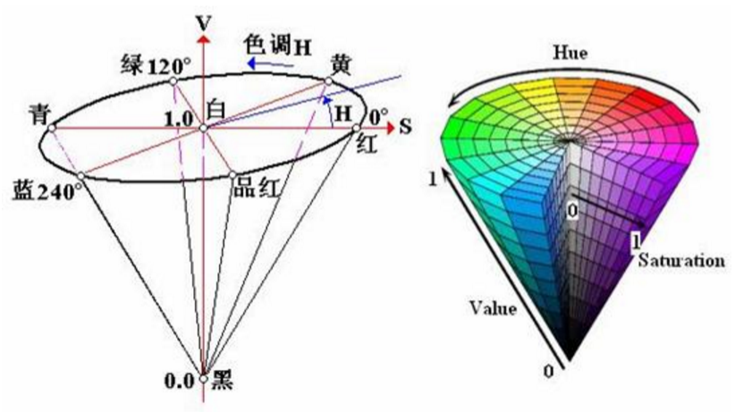
Figure 2-15 HSV model
Blob analysis is mainly threshold segmentation on the target area, the traditional threshold segmentation is usually in the gray image or RGB color interval for segmentation, but the effect is not good by using them. The threshold segmentation is performed by converting the RGB color interval to the HSV space, combining the morphological processing, adjusting the S, H, V range, and the area size and roundness of the region. The effect of the split by this method is shown in Figure 2-16, when the stent hole is in the position of the upper or lower position, it can be divided out.
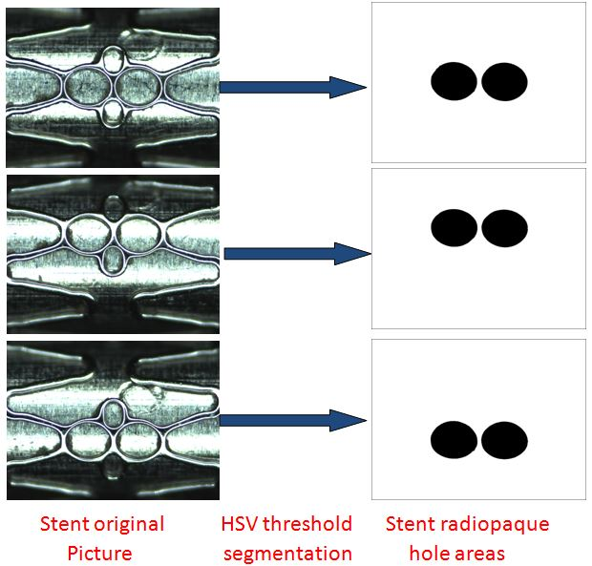
Figure 2-16 HSV threshold segmentation graph
- Sub pixel edge extraction of Zernike moments
The accuracy of Coronary stent radiopaque hole is the micron level, so the edge extraction requirements are relatively high. The extraction accuracy of pixel edge is relatively low, so extract the sub-pixel edge is asked to improve accuracy. Sub-pixel edge detection algorithm has quadratic polynomial fitting, Gaussian fitting, Zernike moment detection and so on. Zernike moments have a rotational invariance effect that will be better, but the traditional method is slower. Though using the fixed 7x7 template Zernike moment can have high speed and high precision, so use this method.
The n-th order Zernike moments of the two-dimensional continuous image are defined as:
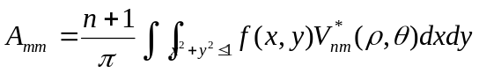 （2-2）
Where 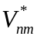is the conjugate retest of 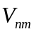, 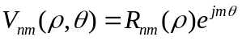，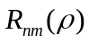defined as:
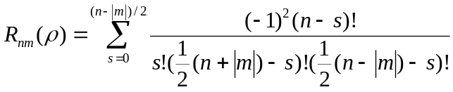 （2-3）
Assuming that the center of the unit circle is located on a certain pixel of the image, and the edge just passes through the circle, the ideal step edge model is established, as shown in Figure a of Figure 2-18. The step gray scale is k, the background gray scale is h, the shadow part of the gray value is h+k, the center of the vertical distance to the edge is l, the edge of the vertical line is and the angle between axes is x. Rotate the image clockwise to make the edges parallel to the axis. As shown in Figure 2-17, it can be seen that the phase angle of the Zernike moment is transformed and the amplitude is not transformed. So it has a rotating invariance. The two-dimensional ideal step edge model is shown in Figure c of Figure 2-17.
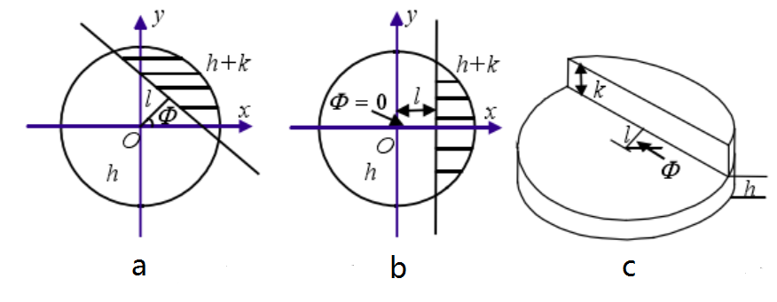
Figure 2-17 Zernike sub-pixel edge model
In the Zernike sub-pixel edge of the search, first select the three NxN template matrix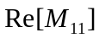,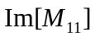 and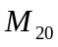, where the choice of 7X7, for their convolution obtained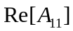,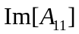 and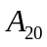, using the following formula:
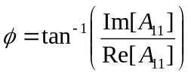 （2-4）
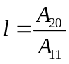 （2-5）
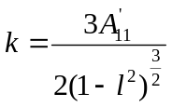 （2-6）
According to the three parameters of Zernike sub pixel edge algorithm, the sub pixel edge coordinate value is obtained by the following formula:
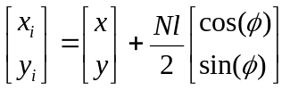 （2-7）
According to the above algorithm, do sub pixel edge for the region, which was being threshold segmentation in the HSV color space. As shown in Figure 2-18, the sub-pixel edge can be obtained better.
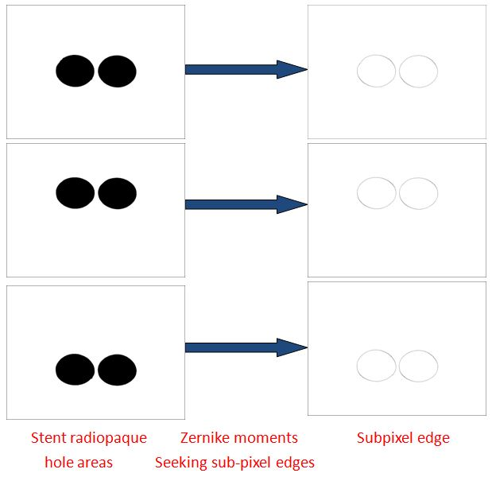
Figure 2-18 Defect detection process
(4) Elliptical edge fitting
After elliptical Zernike moments are extracted from the sub pixel edges of coronary stent, it is required elliptical fitting. The elliptic equation is expressed by the algebraic form of the conic curve equation, and the constant term is normalized to 1: 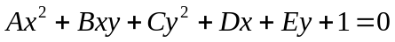. Also can use the geometric parameters of the plane coordinate system to represent the ellipse, the central position of the ellipse is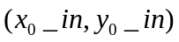, the radius of the long axis is a and the semi short axis is b, the inclination of the major axis is, as shown in Figure 2-19.
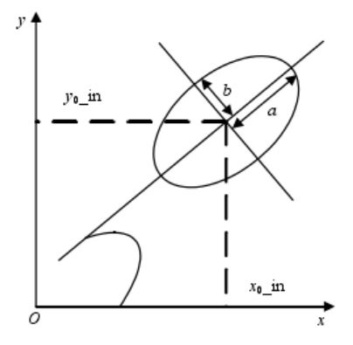
Figure 2-19 Ellipse model diagram
Let a number of discrete detection points can be expressed as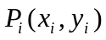,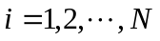where the objective function is:
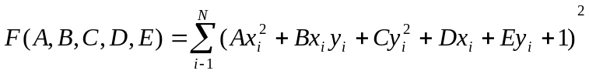 （2-8）
In order to minimize the formula (10), according to the extreme principle, the following equation exists:
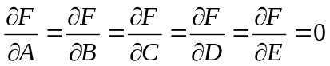 （2-9）
From this we can get a set of linear equations, calculate the ellipse of the various parameter values. As shown below
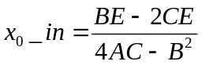 （2-10）
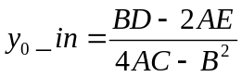 （2-11）
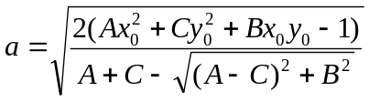 （2-12）
According to the above least squares theory, the sub pixel edges of coronary stent holes extracted by the Zernike moments can be elliptically fitted, the effect of fitted elliptical as shown in Figure 2-20. Through the fitting position of the ellipse on the coronary stent, can be found it is basically the same as the position on coronary stent hole, which meet the test requirements.
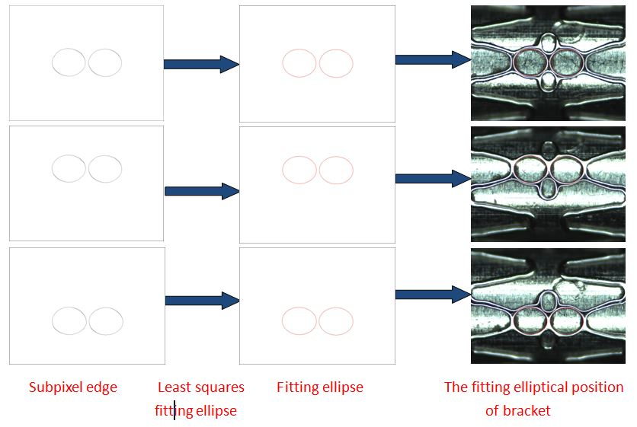
Figure 2-20 Defect detection process
2.3.3 Defect detection of feeding
By feeding process of automation system of precision assembly for coronary stent gold radiopaque marker, Consider the impact of the height of feeding, there will be phenomenon of feeding deviation. The gold is placed (Figure 2-21), the gold is slightly biased (Figure 2-22), the gold is out of the elliptical holes (Figure 2-23).When the gold out of the elliptical holes, it does not meet the requirements of feeding and can’t be pressed at riveting process, so it is asked to defect detection of feeding.
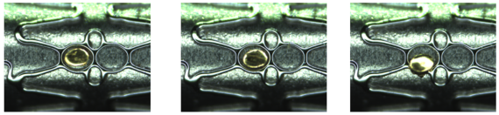
Figure 2-21 Position Putting Figure 2-22 Position Micro Offset Figure 2-23 Position Gap
Feeding defect algorithm is mainly used image difference method. Firstly, the ROI region is selected and the threshold is segmented by HSV color space to obtain the area of the gold. Then, the region adds the elliptical area before. Finally, the area and the total Of the area are difference, and compare the size of the area to judge.
Using the algorithm to process the image, as shown in Figure 2-24, by checking the area of the results region to determine whether there are defects. By testing 30 sets of samples, 2, 4, 8, 15, 16, 18, 2, 29 are defective groups, can be found when the area exceeds 2500 (unit: pixel), they are unqualified, as shown in Figure 2-25. So the final selection area is more than 2500 (unit: pixel) as the criterion for judging the defect.
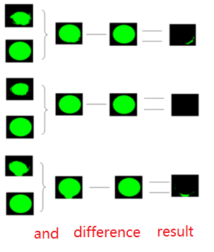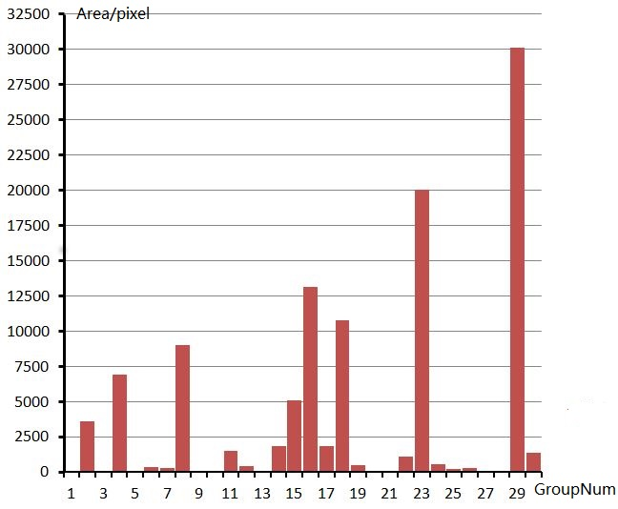
Figure 2-24 defect detection process Figure 2-25 defect detection group

- The work to be completed and its schedule.
- The work to be completed
Since June last year, the design work of this subject has been started, the work has been completed by schedule. In the mechanical structure improvement and process debugging has been basically completed. Through semi-automatic manual debugging, has been able to transfer the entire process system. In Control aspects, the axis of motion control, pressure control, automatic control process and the host software has been basically completed; In machine vision aspects, the discharge of defect detection has been completed, oval front positioning detection also have been completed, there are some content to be added and improved.
(2) Schedule
2017.3-2017.5 complete the rest of task about mechanical, motion control and machine vision.
2017.6—2017.7 Improve the image processing algorithms, optimize the host computer software, debugging machines;
2017.8-2017.9 Read more materials and strengthen the theoretical knowledge of learning;
2017.10-2017.12 Write the graduate thesis and prepare for defending the thesis.

- The existing or expected difficulties and problems.
In the mechanical structure and process, because this process is a new process, while the original mechanical structure exist some unreasonable, its automation process encountered more instability problems, for example take, put, and pressure the material is not good.
In terms of control, mainly in the control of the interpolation movement, because the whole motion control involves many axes, and some of the axes need to use the interpolation algorithm for co-movement, which gives control some trouble. And the actual control of the situation is complex, the movement may be chaotic, serious cases may occur collision. Pressure control will encounter a signal interference problem.
In the machine vision, exist lighting problems, because the use of the image to detect a certain degree of ideal, and the actual production of complex lighting, the resulting image may not be able to detect or detect the location is not accurate. Also the algorithm may be unstable.
- The considerations on the possibility of completing the thesis on-time (at least 100 words).
So far, the mechanical structure of the machine and the process has been basically transferred, the motion control system has also been completed; the most of algorithm about machine vision have been done; the PC software has been basically formed. Later also need to optimize the image processing algorithms and improve the function of the host computer software, but also continue to debug the machine. Also, I need to read more materials and strengthen the learning of theoretical knowledge. With the guide of teacher and the help of my colleagues and classmates, I believe that I can finish the graduated thesis on time.

