哈尔滨工业大学（深圳）
Harbin Institute of Technology, Shenzhen

Interim Assessment of the Thesis
for the Master’s Degree

Name: Ronghui Qian
Entrance Date: 2015.09
Thesis Title: Research on Quantification of
defects by lock-in infrared thermography
Discipline: Machinery & Electronics
Supervisor: Hong Hu
Report Date: 2017.03.15

- Does the thesis progress according to the research objectives and schedule as stated in the primary report? (at least 100 words)
The thesis progress does mainly according to the schedule as stated in the primary report. The main contents has been completed include theoretical analysis and simulation of Lock-in infrared thermography, the set-up of experiment system ,the extraction and reconstruction of signal and the quantification of defects.
There are still some works need to be complete. Frequency choice is the first big problem. And the estimate depth is not accuracy enough now which need to be improved. Finally, in order to get a better understanding of the heat conduction, it’s urge to establish the three-dimensional thermodynamic analysis.

- The completed work and its related outcomes (at least 1500 words).
- Theory research and simulation of infrared thermal wave
Lock-in thermography makes use of a modulated optical stimulation to heat the sample, thus producing a thermal wave which propagates through the thickness of test sample. As the thermal wave encounters a discontinuity it undergoes reflection because of the locally changed heat propagation parameters. The reflected wave interferes with the surface giving rise to a stationary oscillating temperature filed, which is remotely measured through its thermal infrared emission by the IR camera.
2.1.1 Theory of infrared thermal wave
The excitation harmonic heat flux is represented by a time vary sinusoidal equation n lock-in thermography, given by,
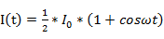 （2-1）
Thus, the temperature distribution in the plate can be calculated by equation (2-2):
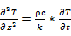 （2-2）
The front surface of the plate is heated by heat flow. As the front surface temperature of the plate is higher than the ambient temperature, convection and radiation will occur on the front and back surfaces. The boundary conditions at the surface of the plate can be obtained from equations (2-3) and (2-4).
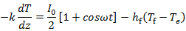
=Re (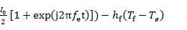
(z=0, t>0) （2-3）
where is the heat flux density, is the front surface temperature of the plate; is the heat transfer coefficient of the front surface of the plate; is the excitation load frequency; is the ambient temperature.
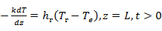 （2-4）
Where is the post-plate surface temperature; is the plate surface heat transfer coefficient;
The excitation heat flow can be divided into two parts, one for a constant heat flow of /2 and the other for the modulation heat flow. The constant heat flow causes the temperature of the plate steady increase, the other part generate a modulated heat wave.
（2-5）
Where is the temperature generated by the constant heat flow, and is the temperature generated by the modulation heat flow.
The solution of can be obtained by the following equations-given by,
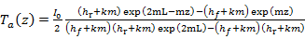 （2-6）
where 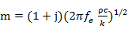.
Thus:
（2-7）
2.1.2 Simulation of the surface temperature distribution
In order to analyze the temperature distribution caused by periodic heat flow on the surface of the specimen, the finite element method is used to simulate the process. Figure 2.2 gives the structure of the specimens. Table 2-1 lists the material and the thermal properties of the hollowed out air. Table 2-2 gives the boundary conditions and parameters.
Tab.2-1 Thermal properties of materials
Materials Density/ Special heat/ Thermal conductivity/
(kg.) (J.) (W.)
A3钢 7830 469 47
空气 1.1774 1005.7 0.02064

Tab.2-2 Parameters of boundary conditions
Power/W Thermal coefficient Thermal coefficient Ambient temperature
hf/(kg.) hr/(kg.)/(J/kg/K) /
200 12.2 11.8 20
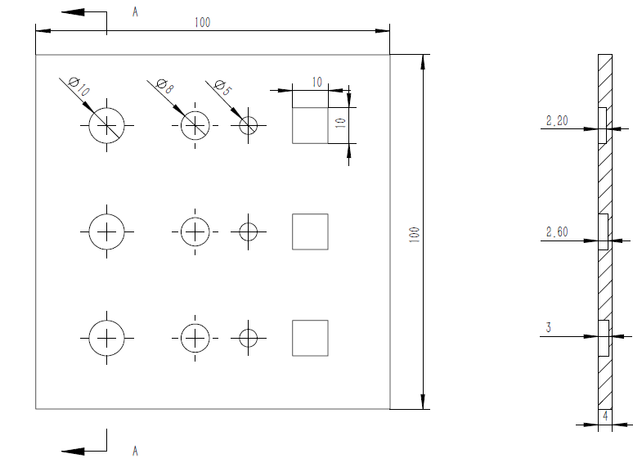
Figure 2.2 the structure of the specimens
Figure 2.3 (a) and (b) are the surface heat map at different loading frequency but the same load time. It’s evident to see that low frequency can detect defects at greater depth.
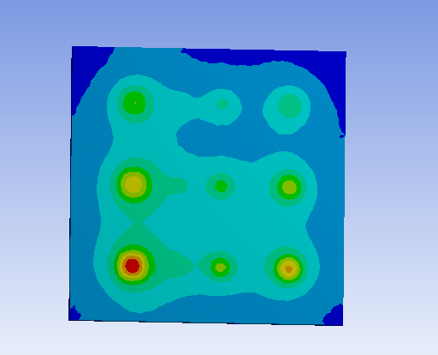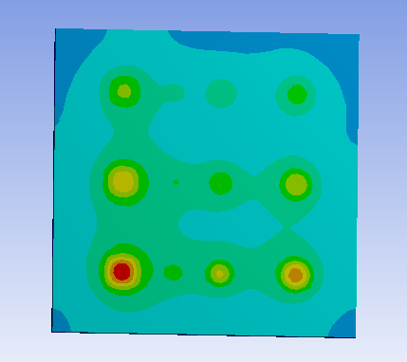
（a） （b）
图2.3 （a）w=3,t=15，（b）w=3,t=15, the surface heat map
- Construction of experimental platform and image processing system
In order to study the detection effect of infrared non-destructive testing and to obtain the defect size, depth and other quantitative information, we must establish infrared non-destructive testing system. The size and depth of the defect can be obtained by studying the surface temperature distribution of the measured object and the theory of the combined heat transfer.
    - Specimens and experimental systems
The experimental systems consists of the following components: (1) infrared camera; (2) thermal excitation system; (3) infrared image acquisition, processing and analysis system. As shown in Figure 2.4.
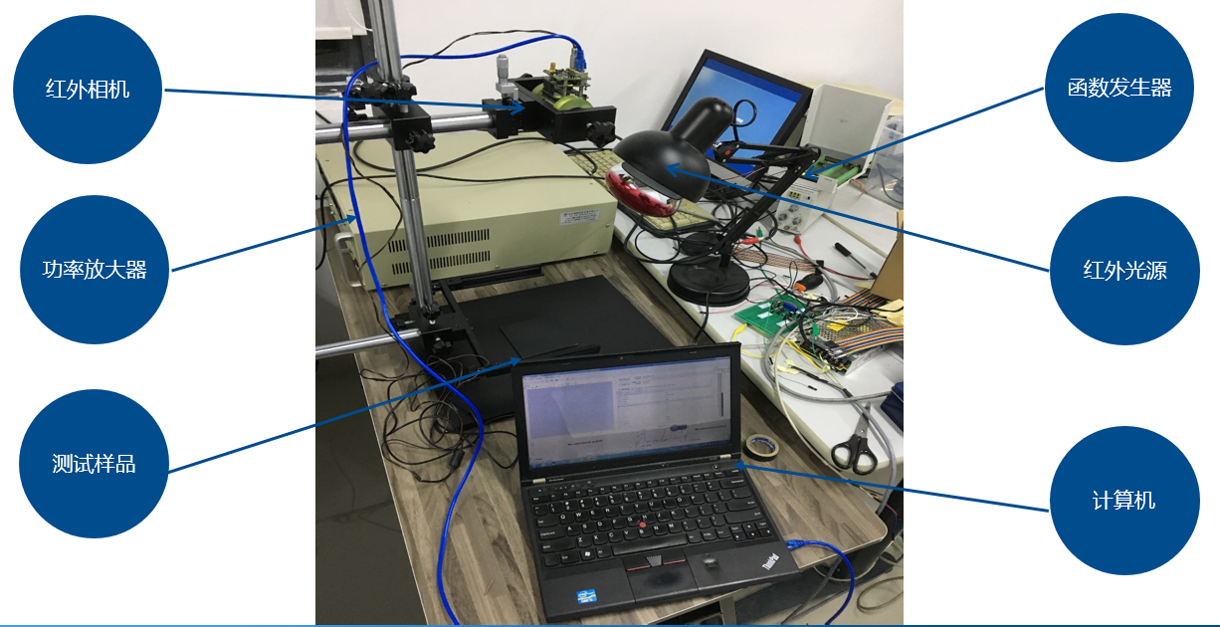
Figure 2.4. Photograph of experimental set-up
For generation of sine waves of a single frequency, a programmable function generator was used. Thermal waves was detected by Gobi-640. The sample was heated with a sinusoidal modulated heat wave from a 250W Philips infrared light source.
The specimens were selected as Q235 steel. The test sample structure is shown in Figure 2.2. Defect depth from left to right in order of 1.0, 1.4, 1.8mm. In thermography, temperature is interpreted from the radiation emitted from the surface under investigation. If the emissivity of the surface is very low, then the radiation emitted from this surface is very weak, which leads to the formation of an image with low SNR. It has been reported that thermographic measurement is not possible for surfaces having emissivity value lower than 20% of blackbody emissivity. Low emissivity surfaces also suffer from the problem of secondary reflection, due to the presence of surrounding bodies. The most common methodology to overcome the above mentioned emissivity problems is by applying a uniform black paint of high emissivity value, which not only increases the surface emissivity value but also reduces the secondary reflections, besides providing a uniformly emissive surface. Hence, the surface of the specimens facing the camera was black painted using a high emissivity (ε ∼ 0.98) black paint. The excitation frequency was selected 0.1Hz, the acquisition frame rate was 7fps. Some collected picture was shown in Figure 2.5.
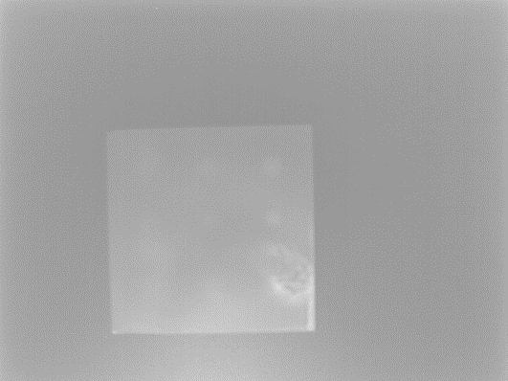
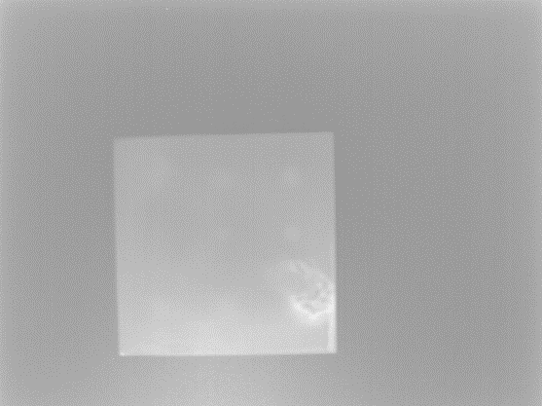
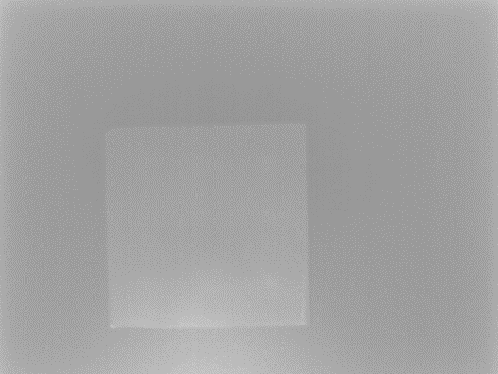
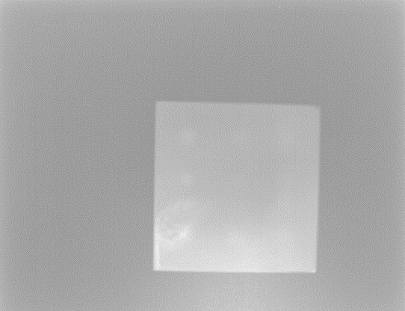
（a）T/4 （b）T/2

（c）3T/4 （d）T
Fig. 2.5 Infrared heat maps at different times
    - Thermal Wave signal processing algorithms
1）Image preprocessing
For the captured image sequence, since the camera field of view is relatively large, an irrelevant area appears in the image. In the pretreatment, we need to extract the region of interest first. Extract the region of interest not only can improve the processing speed, but also to avoid interference. Then, it’s known to us that the infrared image is strongly affected by background noise which cause by uneven heating, inconsistent emissivity of the material surface, absorption and scattering on the optical path and the stability of the infrared camera. So it’s necessary to remove noise.
- Extract the region of interest
The extraction of the region of interest is mainly composed of the following five parts:
1) grayscale the image and binarized by OUST;
2) Edge detection of images using Canny operator;
3) Hough transfer to find the edge information and obtain the slope of the line;
4) Rotate the image by affine transformation;
5) Rectangle the region of interest.
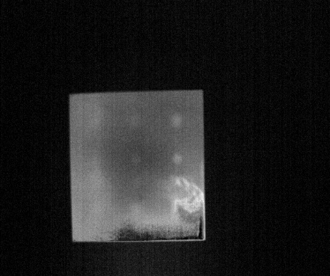
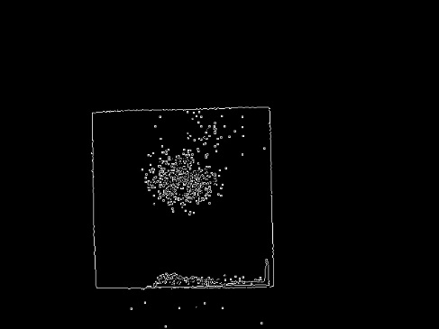
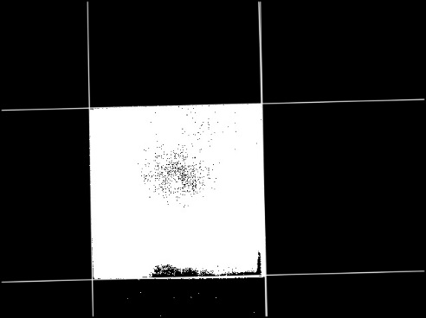
The result of the above algorithm is shown in Figure 2.6:

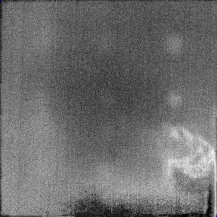

Fig. 2.6 Schematic diagram of the region of interest extraction
- Remove noises
As we know, the excitation frequency of light is generally low, while the frequency of noise is relative high. So in the image preprocessing stage, the Savitzky-Golay filtering algorithm is used to smooth the digital quantization value of the surface temperature signal and eliminate the influence of high frequency noise. The Savitzky-Golay filter is widely used to extract the relative width and height of visible light in the noise data line. Figure 2.7 shows the results of digital filtering smoothing using the Savitzky-Golay filter for the digital signal of the collected temperature signal.
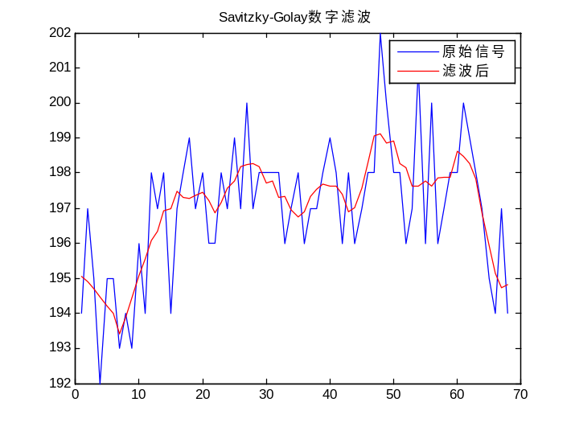
Fig. 2.7 Savitzky-Golay filter smoothing results
2) Signal processing algorithm
  - Four-point correlation method
Four-point correlation method was firstly proposed by Busse et al. in 1992. This method uses four equidistant surface temperature (thermal wave) data points S₁–S₄, the amplitude and phase of thermal wave signal are given by:
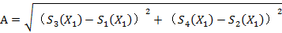 （2-8）
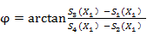 （2-9）
Through the four-point average algorithm for image sequence processing, the obtained phase and amplitude figures shows in Figure 2.8.
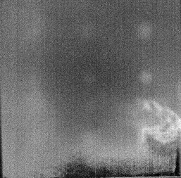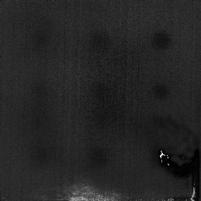
( a) Amplitude （b）Phase
Fig. 2.8 Four-point correlation method
  - Principal component analysis
Principal component analysis (PCA) is a statistical procedure that uses an orthogonal transformation to convert a set of observations of possibly correlated variables into a set of values of linearly uncorrelated variables called principal components. The number of principal components is less than or equal to the smaller of (number of original variables or number of observations). This transformation is defined in such a way that the first principal component has the largest possible variance (that is, accounts for as much of the variability in the data as possible), and each succeeding component in turn has the highest variance possible under the constraint that it is orthogonal to the preceding components. The resulting vectors are an uncorrelated orthogonal basis set. PCA is sensitive to the relative scaling of the original variables.
PCA transforms m * n-dimensional matrix A into s * n-dimensional (s <m) matrix , which can be multiplied by matrix to obtain, and establish m * m dimension matrix S as follows:
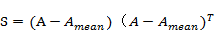 （2-10）
Singularity decomposition of S:
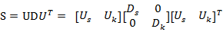 （2-11）
Where U is the eigenvector of matrix and D is the diagonal matrix.
After PCA transform, the original matrix is reduced from m dimension to s dimension, where s + k = m. is calculated by the s-dimensional principal component:
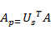 （2-12）
Using PCA to analysis the image sequence, the first four main elements are shown in Figure 2.10.
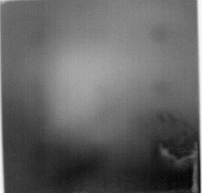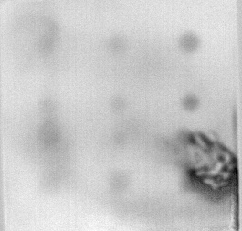
（a）First principal element （b）Second principal element
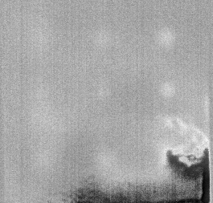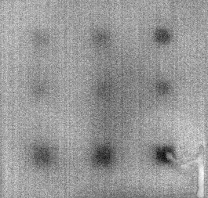
（c）Third principal element （d）Fourth principal element
Fig. 2.10 the first four main elements
  - Fourier transforms method
Fourier transform method is a powerful/popular tool to calculate the amplitude and phase angle of thermal wave signal harmonic components. This method is available prior to calculate the amplitude and phase of thermal wave signal on the off-line.
The Fourier transform of thermal images sequence is given in Eq. (7) at the modulated frequency which is called lock-in frequency:
（2-13）
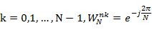
where F_{K}(x, y) are the Fourier transforms of thermal image sequence, F_{n}(x, y) is the thermal image sequence, N is the number of sample per lock-in period, and K is the digital frequency.
In order to extract thermal wave at the lock-in frequency, the digital frequency K is given in the following equation [9]:
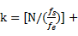1 （2-14）
where fs is the frame rate.
The amplitude and phase angle of thermal wave are obtained by,
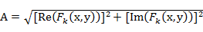 （2-15）
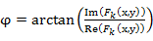 （2-16）
where A is the amplitude of thermal wave signal, φ is the phase angle of thermal wave signal.
The amplitude and phase diagrams obtained by FFT transform are shown in Figure 2.11.
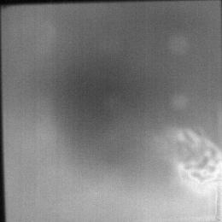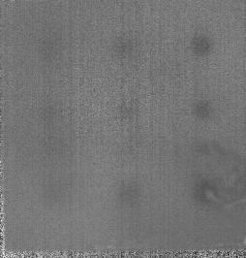
（a）Amplitude （b） Phase
Fig. 2.11 FFT transfer result
- Quantification of defects
In the nondestructive testing, qualitative determination of the existence of defects and quantitative analysis of defect characteristics is always the focus of the study. In the previous work, the realization of the identification of defects and relative position to determine. And for the smaller defects still have some problems, and thus it need to do further study to the size and the depth of the defect. This section combines some of the more popular machine learning algorithms to further study about the qualitative determination the depth and the area of defects.
2.3.1 Estimation of defects size
The amplitude and phase of the image are obtained by analyzing the sequence of the image. From the figure, the approximate position of the defect is determined. In order to analyze the exact location and defect size of the defect, this paper proposes a new way that it’s use the support vector machine to identify the damaged area in the image, so as to achieve the quantitative analysis of the defect area.
For the experimental samples, some positive and negative samples are used to train the SVM. Positive samples get from the damaged area and negative samples get from the lossless area. Select 200 positive samples of pixels, and 800 negative samples are our training data. For the choice of features, we choose the pixel sequence diagram. And support vector machine is used to determine and identify the defect. Since the choice of parameters of the support vector machine is mainly dependent on the empirical value, the manual participation and error adjustment process are required. In order to obtain the optimal parameters, it is proposed to use genetic algorithm to find parameters.
Genetic algorithm is a computational model for simulating the natural selection and genetic mechanism of Darwin's theory of biological evolution. It is a method to search the optimal solution by simulating the natural evolutionary process. Genetic manipulation is a method of simulating genetic inheritance of biological genes. In the genetic algorithm, the task of genetic operation after coding the initial population is to carry out the operation of the individual of the group according to their environmental fitness (fitness assessment), so as to realize the evolution process of the survival of the fittest. From the perspective of optimal search, genetic operations can solve the problem, from generation to generation, and approximate the optimal solution. Using the genetic algorithm, the optimal SVM parameters can be obtained.
Figure 2.11 (a) and (b) show the results obtained using the previous image sequence processing algorithm and the defect result obtained by SVM classification. The experimental results show that the intelligent algorithm can improve the recognition effect of the defect size, and the specific position and the relative size of the defect can be almost recognized.
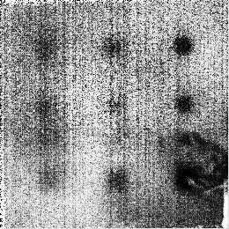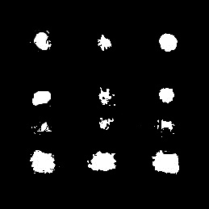
（a）FFT processing result (b) SVM recognition result
Fig. 2.11 FFT and SVM processing results
2.3.2 Estimation of defects depth
For the determination of the depth of the defect, the artificial neural network is used to predict the depth. The three-layer neural network is selected. The input network is the time-temperature value of each pixel. The 10 neurons are selected for the middle layer and the output is the depth of the defect. Using 800 data points for a total of 600 different areas of damage, four different depth defects of the damaged area of the 50 points.
Figure 2.11 for the excitation frequency of 0.1Hz experimental results for the depth of calculation, from the experimental results, the neural network calculation of the depth of the defect is generally consistent, there are some deviations, mainly in the lossless area and defect edge, due to surface characteristics and heating Uneven influence, resulting in lossless areas and edge determination is not very accurate.
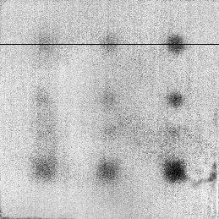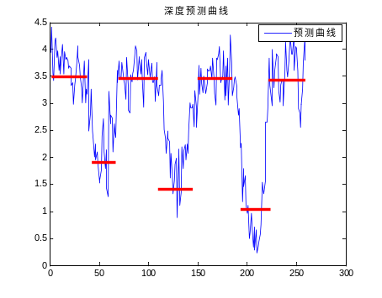
（a）Overall depth map （b）Actual depth versus planned depth
图2.11 Results of calculation for defect depth

- The work to be completed and its schedule.
The work to be completed and its schedule are the following:
2017.03—2017.04 Further study of depth estimation;
2017.05—2017.06 Optimize the experimental parameters(frequency, excitation time);
2017.07—2017.09 Do more experiments on different experimental materials and analysis the experimental results
2017.10—2017.12 Write the graduate thesis and prepare for defending the thesis.

- The existing or expected difficulties and problems.
(1) The choice of exaction frequency. In the experiment, the frequency range in 0.001Hz to 100Hz. But the frequency is very important to the experimental result. So it’s necessary to find an optional frequency. But how to choose the frequency has because the obstacle to our project. At present, I thought use some optimization algorithms to achieve the optimal frequency of choice;
(2) At present, I used ANN to predict the depth, but the result is not good enough. So I need the find the new method to estimate the depth. But now, I don’t have a good idea. The solution is read more literature to look for reliable depth estimation methods.
(3) For thermodynamic analysis, I only consider one-dimensional heat conduction. And I need to establish the three-dimensional thermodynamic analysis.

- The considerations on the possibility of completing the thesis on-time (at least 100 words).
Up to now, the experimental platform has been set up and the corresponding experimental analysis means have been roughly completed. And we are familiar with the infrared image sequence processing.
At present, the experimental data is being optimized and the experiment is applied. Late work is still very difficult. In the next days, I need to find the optional frequency to excite the light, to look better way to estimate the depth and establish the three-dimensional thermodynamic analysis.
Although the task is tough, but I believe in the mentor's guidance and my own efforts, the paper will be able to complete on time.

