哈尔滨工业大学（深圳）
Harbin Institute of Technology , Shenzhen

硕士学位论文
英文撰写格式范例
Template of Master’s Thesis Format in English

说明:规范中所引用的示例，只作为论文撰写格式的示范，并不代表论文研究内容的示范。

STATEMENT
The Template of Master’s Thesis Format in English shows the English written norm of Master’s Thesis .There’s not any research content involved.

硕士学位论文

******设计研究

STUDY ON********

*** ←(Name)

哈尔滨工业大学
2018年12月

国内图书分类号：**** | 学校代码： | 10213
国际图书分类号：***.** | 密级： | 公开

工学硕士学位论文

********设计研究

硕士研究生 | ： | ***
导 师 | ： | *** 教授
申请学位 | ： | 工学硕士
学科 | ： | *******
所 在 单 位 | ： | 哈尔滨工业大学（深圳）
答 辩 日 期 | ： | 2018年12月
授予学位单位 | ： | 哈尔滨工业大学

Classified Index: TN47
U.D.C: 621.38

A dissertation submitted in partial fulfillment of
the requirements for the academic degree of
Master of Engineering

STUDY ON******

Candidate： | ******
Supervisor： | Prof. ***
Academic Degree Applied for： | Master of Engineering
Speciality： | *******
Affiliation： | Harbin Institute of Technology, Shenzhen
Date of Defence： | December, 2018
Degree-Conferring-Institution： | Harbin Institute of Technology

摘 要
可测试性设计技术已经广泛地应用于集成电路测试领域以提高测试效率。在可测试设计技术中，扫描设计是最重要的实现手段。
… …

关键词：可测试性设计；***；***；****

（根据《关于使用英文撰写硕士学位论文的暂行规定》第二条，硕士学位论文用英文撰写时，需有不少于3000字的详细中文摘要。详细中文摘要的内容与学位论文的英文摘要可以不完全对应。）
Abstract
Design for testability (DFT) techniques have been widely applied in integrated circuits (ICs) design to facilitate the testing process.
……

Keywords: ***, ** **, ****, ****

Acknowledgement
I would like to give my greatest gratitude to my supervisor …….
Through these years, my families gave me endless love and supports. ……
I am very grateful to Professor ……
I give my appreciation to my friends ……

Contents
Page
Abstract II
Acknowledgement III
Nomenclature V
List of Tables VI
List of Figures VII
Chapter 1 Introduction 1
1.1 Background 1
1.1.1 Circuit testing 1
1.1.2 ****** 1
1.2 ****** 2
Chapter 2 Literature Review 3
2.1 ****** 3
2.1.1 ***** 3
2.1.2 ***** 3
2.2 ****** 4
2.3 Summary 4
Chapter 3 Security Analysis of ****** 5
3.1 ***** 5
3.2 ***** 5
3.3 ****** 5
3.3.1 ***** 5
3.3.2 ****** 5
3.4 Summary 6
Chapter 4 ******* 7
4.1 ***** 7
4.4 Summary 7
Conclusions 8
References 9
Author’s Publications 10
哈尔滨工业大学学位论文原创性声明和使用权限 11

Nomenclature
AES | Advanced Encryption Standard
ATPG | Automatic Test Pattern Generation
BC | Byte-Changing
BIST | Built-In Self-Test
CUT | Circuit Under Test
DES | Data Encryption Standard
DFF | D Type Flip-Flop
DFT | Design-for-Testability

List of Tables
Table Page
Table 3-1 Performance of various secure scan designs 6
……

List of Figures
Figure Page
Figure 1.1 Structure of a typical scan chain 1
……

Introduction

Background

Circuit testing
It is unavoidable that some faults should appear during an integrated circuit (IC) manufacturing.
……

******
To facilitate IC testing, design-for-testability (DFT) technique was proposed to add some specific design structure to improve the testability of CUT^{[1, 2]}.
……
Figure 1.1 shows a structure of a typical scan chain design.
……
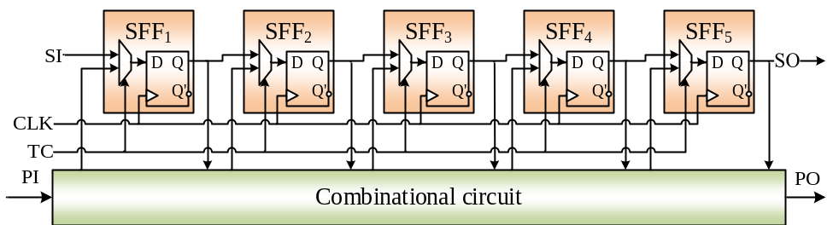
Figure 1.1 Structure of a typical scan chain
……
      - Normal scan-based testing
As presented in Figure 1.3, the signal TC is set as ‘0’, i.e., the CUT is switched from normal mode to testing mode.
……
      - Scan-based attack flow
Scan-based attacks can be implemented in 4 steps.
- Feed a specific plaintext into crypto module.
- Run the encryption procedure until the sensitive information is included in the scan chain.
- Scan out the sensitive information.
- Repeat the above steps until enough information obtained to retrieve the cipher key.
…….

******

Literature Review
In this chapter, the related work on scan-based side-channel attacks and related countermeasures are reviewed and their advantages and disadvantages are discussed.

******
The attacks on a chip with intent to steal sensitive data can be classified into invasive and non-invasive attacks.
……

*****
The work in [4] proposed to perform scan-based attack towards DES chip in three steps.
……

*****
Take the Figure 2.1 as a simple example. Supposing a is an input plaintext and 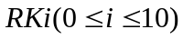are the 11 round keys. Then the round function result f_{i} can be calculated as:
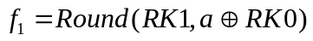 (2.1)
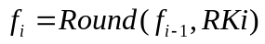 (2.2)
      - Attacks against AES
To deduce the cipher key, we need to find the round keys at first. Obviously, f₁ will be the best choice to get start because it is only related with RK0 and RK1 as we can see from Formula-(2.2). Also, there are pieces of facts to be noted before these round keys can be deciphered.
- f₁ is affected by two round keys, RK0 and RK1.
- For a 128-bit RK0, it is impractical to perform exhaustive examination on each possible RK0.
- The exact relationship between scan out data with values in register R is unknown.
In order to reduce the complexity of solving Fact 1, authors in [3] try to eliminate RK1 from output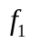. Let a₁ and a₂ be two plaintexts, e₁, e₂ stand for Mixcolumn output of a₁ and a₂,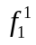 and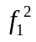 are corresponding round function outputs. Then, we can get:
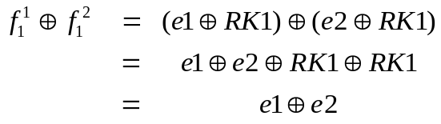 (2.3)
The value of 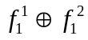 dependents on RK0, a₁ and a₂.
……

******
…….

Summary
Various scan-based attack scenarios have been proposed to use the scan design to crack the cipher key. ……

Security Analysis of ******
In this chapter, the problem that whether scan-based attacks rely on a certain testing order is discussed. …….

*****
…….

*****
In this section, ……

******
This section first outlines ……

*****
An attack against the countermeasure in is proposed with the following four steps:
      - Identify the length of sub chain
…….

******
Recall that the number of scan cells of the chip is n, the minimum number of the sub chains is p and the attacker wants to determine the length of the sub chain is l.
…….
The following procedure illustrates how the value of sub chain length l can be identified by constructing and analyzing multiple excerpts.
  - Set the external control signals and select a sub chain sc.
  - Collect the bit stream scanned out from the scan out pin.
  - ……
Step b) shows how to generate an excerpt. When t consecutive bits of the same value appear in the output from a sub chain, the attacker should invert the external control signal to halt the operation of the current sub chain.
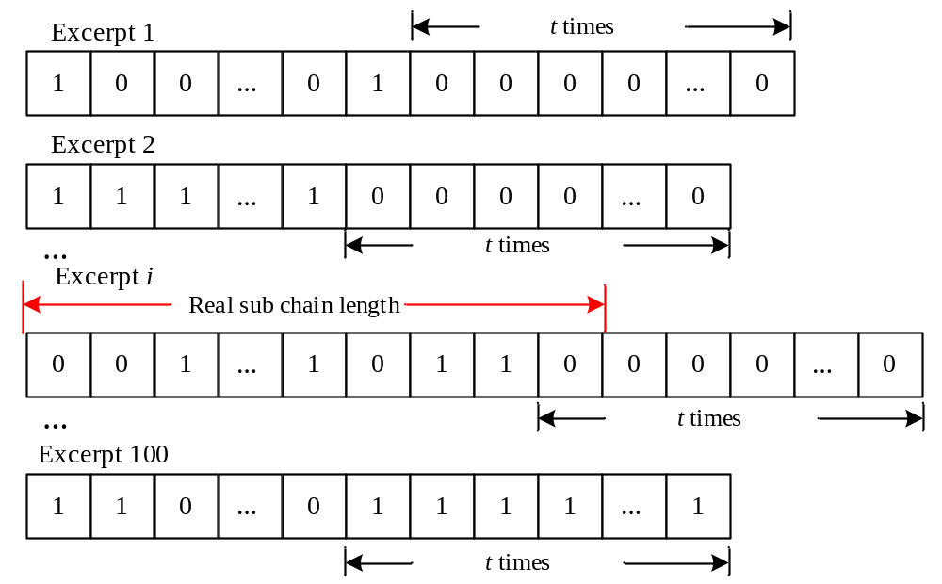
Figure 3.2 Identify the length of scan chain in ROS design
This section is concluded by a brief discussion on how to set the values for parameters t and q. t should be set to be larger than n/p to avoid cases like t consecutive 1’s or 0’s in the output response.
……..
Table 3-1 Performance of various secure scan designs
Design | ΔA(%) | Security | Testability | Other
BK | Low | High | Normal | Limited applying scenarios
BSO-128 | Normal | High | Normal | 128 clocks before testing
MKR | Normal | High | Secret key cannot be tested | NO online testing
Mode reset | High | Low | Normal | NA
TSC | High | Low | Normal | More clocks before testing
ROS | Low | Low | Normal | More clocks before testing
SDSFF | Normal | High | Compromised | NA

Summary
……..

*******
In this chapter, …….

*****
…….
…….

4.4 Summary
…….

ConclusionS
Scan design has been used as a side channel to leak the secret information of the CUT.
……
The main contribution of this dissertation can be concluded into the following three main parts.
- This work analyzes ………
- …….
- ……
However, the proposed secure scan designs based on obfuscating scan output adopts lock and key scheme. Hence, its security depends most on the security of the key. …….

References
- Bushnell M, Agrawal V. Essentials of Electronic Testing for Digital, Memory and Mixed-Signal VLSI Circuits[M]. Springer, US, 2002: 4-54
- Nagle H, Roy S, Hawkins C, et al. Design for Testability and Built-In Self Test: A Review[J]. Industrial Electronics, IEEE Transactions on, 1989, 36(2):129-140.
- Yang B, Wu. K, Karri R. Secure Scan: A Design-for-Test Architecture for Crypto Chip[J]. Computer-Aided Design of Integrated Circuits and Systems, IEEE Transaction on, 2006, 25: 2287-2293.
- Saeed S, Ali S, Sinanoglu O, et al. Test-Mode-Only Scan Attack and Countermeasure for Contemporary Scan Architectures[C]// International Test Conference (ITC), IEEE, 2014: 20-23.

Author’s Publications
- Luo Y, Cui A. Secure Scan Design Against Scan-Based Side-Channel Attacks[C]// International Symposium on Circuits and Systems (ISCAS), IEEE. 2016. under review. EI.
- Luo Y, Cui A, Li H. et al. Security Analysis and Vulnerability Exploration of Current Secure Scan Designs[C]// Asia and South Pacific Design Automation Conference (ASP-DAC), IEEE/ACM, 2016, Accepted. EI.
- Yu T, Cui A, Luo Y, et al. A New Decompressor on Parallel Scan Design for Reduction of Test Data[C]// 16th Chinese Fault-Tolerant Computing (CFTC), CFTC, 2015, Accepted.
- Cui A, Luo Y, Chang C. A New Secure Design Against Scan-Based Side-Channel Attacks[J]. Information Forensics and Security, IEEE Transaction on, To be submitted. SCI.

哈尔滨工业大学学位论文原创性声明和使用权限

学位论文原创性声明

本人郑重声明：此处所提交的学位论文《抗扫描旁路攻击的安全扫描链设计研究》，是本人在导师指导下，在哈尔滨工业大学攻读学位期间独立进行研究工作所取得的成果，且学位论文中除已标注引用文献的部分外不包含他人完成或已发表的研究成果。对本学位论文的研究工作做出重要贡献的个人和集体，均已在文中以明确方式注明。

作者签名： 日期： 年 月 日

学位论文使用权限

学位论文是研究生在哈尔滨工业大学攻读学位期间完成的成果，知识产权归属哈尔滨工业大学。学位论文的使用权限如下：
（1）学校可以采用影印、缩印或其他复制手段保存研究生上交的学位论文，并向国家图书馆报送学位论文；（2）学校可以将学位论文部分或全部内容编入有关数据库进行检索和提供相应阅览服务；（3）研究生毕业后发表与此学位论文研究成果相关的学术论文和其他成果时，应征得导师同意，且第一署名单位为哈尔滨工业大学。
保密论文在保密期内遵守有关保密规定，解密后适用于此使用权限规定。
本人知悉学位论文的使用权限，并将遵守有关规定。

作者签名： 日期： 年 月 日

导师签名： 日期： 年 月 日

