Assembling Defect Detection of Atomizer Based on Machine Vision

Jiankun Wang and Hong Hu | Long Chen and Caiying He
Department of Mechatronic Engineering | Technology Center
Harbin Institute of Technology Shenzhen Graduate School | Shenzhen Colibri Technologies Co. Ltd
Shenzhen, 518055, China | Shenzhen, Guangdong Province, China
honghu@hit.edu.cn | longchen@colibri.com.cn

Abstract - The atomizer is assembled in an automated assembly line, which inevitably creates assembly defects. In this paper, we use machine vision technology to detect assembly defects in atomizer. We propose two algorithms: image processing algorithm and deep learning algorithm based on convolutional neural network. For the image processing algorithm, we set the ROI for detection according to the position of different assembly defects, and design the corresponding image processing detection algorithm. For the deep learning algorithm, we adopted the MobileNet model and proposed a new training program to improve the accuracy of the detection. At the end of this paper, we evaluate the performance of the two algorithms, analyze and compare the advantages and disadvantages of the two algorithms.

Index Terms - Atomizer; Assembly defect detection; Machine vision; CNN

I. Introduction
In industrial automation production, in order to ensure the quality of the product, it is necessary to perform defect detection on the product to eliminate defective products. In practical applications, machine vision is often used for defect detection, which increases the automation of production and reduces labor costs. At present, there are two types of algorithms for machine vision, one is digital image processing algorithm, and the other is deep learning algorithm based on convolutional neural network.
Jiancheng [1] uses the distance measurement method to measure the position of the part to detect whether the syringe is assembled correctly. Jing et al. [2] used the modified Hausdorff distance matching algorithm to detect the position of the part. Ardhy et al. [3] preprocessed the image using an adaptive Gaussian threshold method, and then performed a differential operation on the standard image and the image to be detected to detect whether the PCB board is defective.
In recent years, deep learning technology has made remarkable achievements in the field of image recognition. Image recognition algorithms based on convolutional neural networks have been successfully applied in many fields. In the field of industrial defect detection, some scholars have also begun to use convolutional neural networks for defect detection and classification.
Je-Kang Park et al. designed a simple CNN network structure to detect surface defects of different items. Wu Tong [4] used the X-ray imaging system to collect images of the products and label them, extract the feature of the parts using a convolutional neural network, and then train the deep learning model. Use the model to categorize the internal parts of the assembly to detect missing parts.
The research object of this paper is the atomizer. The assembly process of the atomizer requires several processes. Failure of the gripping of components can result in missing parts. The vibration of the machine, assembly accuracy, etc. may cause the assembly position of the parts to be inaccurate. Combined with the actual situation of production, the assembly defects of the atomizer can be divided into four types: missing workpiece, missing cotton core, missing metal sheet and abnormal wire position. Defect samples are shown in Fig. 1.
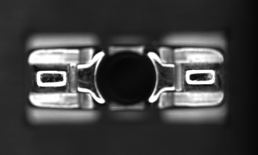  workpiece missing | 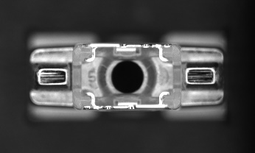  cotton core missing
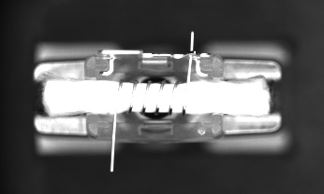  metal sheet missing | 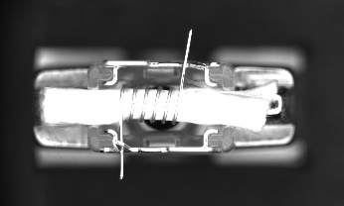  wire abnormality
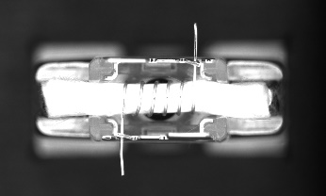
normal
Fig. 1. Images of atomizer assembly defects samples
At present, there is no research on the detection of atomizer assembly defects. Two algorithms for detecting atomizer assembly defects are proposed in this paper. One is the image processing detection algorithm, and the other is the deep learning detection algorithm based on convolutional neural network.
II. Image Processing Algorithm
A. Detection Target Location and ROI Setting
The first step of detection is to locate the target. Since the relative position of the assembly and fixture is known, we can locate the fixture position first, and then set the corresponding ROI according to the position of the defect in the assembly. The specific steps are as follows:
Step-1: Separate the foreground and background. The image has distinct foreground and background, and can be segmented by image binarization to get the fixture and assembly area. Because the background of the image is black, we use fixed threshold binary segmentation. The formula is as follows:

B. References
Number citations consecutively in square brackets [1]. Punctuation follows the bracket [2]. Refer simply to the reference number, as in [3]. Use “Ref. [3]” or “Reference [3]” at the beginning of a sentence: “Reference [3] was the first …”
Number footnotes separately in superscripts. Place the actual footnote at the bottom of the column in which it was cited. Do not put footnotes in the reference list. Use letters for table footnotes (see Table I). IEEE Transactions no longer use a journal prefix before the volume number. For example, use “IEEE Trans. Magn., vol. 25,” not “vol. MAG-25.”
Give all authors’ names; use “et al.” if there are six authors or more [4]. Papers that have not been published, even if they have been submitted for publication, should be cited as “unpublished” [4]. Papers that have been accepted for publication should be cited as “in press” [5]. In a paper title, capitalize the first word and all other words except for conjunctions, prepositions less than seven letters, and prepositional phrases.
For papers published in translated journals, first give the English citation, then the original foreign-language one [6].
C. Abbreviations and Acronyms
Define abbreviations and acronyms the first time they are used in the text, even if they have been defined in the abstract. Abbreviations such as IEEE, SI, MKS, CGS, ac, dc, and rms do not have to be defined. Do not use abbreviations in the title unless they are unavoidable.
D. Equations
Number equations consecutively with equation numbers in parentheses flush with the right margin, as in (1). To make your equations more compact, you may use the solidus (/) and the exp function, etc. Italicize Roman symbols for quantities and variables, but not Greek symbols. Use an en dash (–) rather than a hyphen for a minus sign. Use parentheses to avoid ambiguities in denominators. Punctuate equations with commas or periods when they are part of a sentence, as in

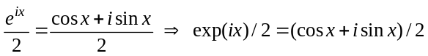. (1)

Symbols in your equation should be defined before the equation appears or immediately following. Cite equations using “(1),” not Eq. (1)” or “equation (1),” except at the beginning of a sentence: “Equation (1) is …”

E. Other Recommendations
The Roman numerals used to number the section headings are optional. Do not number Acknowledgement and References and begin Subheadings with letters. Use two spaces after periods (full stops). Hyphenate complex modifiers: “zero-field-cooled magnetization.” Avoid dangling participles, such as, “Using (1), the potential was calculated.” Write instead, “The potential was calculated using (1),” or “Using (1), we calculated the potential.”
Use a zero before decimal points: “0.25,” not “.25.” Use “cm³,” not “cc.” Do not mix complete spellings and abbreviations of units: “Wb/m²” or “webers per square meter,” not “webers/m².” Spell units when they appear in text: “…a few henries,” not “…a few H.” If your native language is not English, try to get a native English-speaking colleague to proofread your paper. Do not add page numbers.
III. Units
Use either SI (MKS) or CGS as primary units. (SI units are encouraged.) English units may be used as secondary units (in parentheses). An exception would be the use of English units as identifiers in trade, such as “3.5-inch disk drive.”
Avoid combining SI and CGS units, such as current in amperes and magnetic field in oersteds. This often leads to confusion because equations do not balance dimensionally. If you must use mixed units, clearly state the units for each quantity that you use in an equation.
IV. Some Common Mistakes
The word “data” is plural, not singular. In American English, periods and commas are within quotation marks, like “this period.” A parenthetical statement at the end of a sentence is punctuated outside of the closing parenthesis (like this). (A parenthetical sentence is punctuated within the parentheses.) A graph within a graph is an “inset,” not an “insert.” The word alternatively is preferred to the word “alternately” (unless you mean something that alternates). Do not use the word “essentially” to mean “approximately” or “effectively.” Be aware of the different meanings of the homophones “affect” and “effect,” “complement” and “compliment,” “discreet” and “discrete,” “principal” and “principle.” Do not confuse “imply” and “infer.” The prefix “non” is not a word; it should be joined to the word it modifies, usually without a hyphen. There is no period after the “et” in the Latin abbreviation “et al.” The abbreviation “i.e.” means “that is,” and the abbreviation “e.g.” means “for example.” An excellent style manual for science writers is [7].
Acknowledgment
The preferred spelling of the word “acknowledgment” in America is without an “e” after the “g.” Try to avoid the stilted expression, “One of us (R. B. G.) thanks …” Instead, try “R.B.G. thanks …” Put sponsor acknowledgments in the unnumbered footnote on the first page.
References
- M. King, B. Zhu, and S. Tang, “Optimal path planning,” Mobile Robots, vol. 8, no. 2, pp. 520-531, March 2001.
- H. Simpson, Dumb Robots, 3rd ed., Springfield: UOS Press, 2004, pp.6-9.
- M. King and B. Zhu, “Gaming strategies,” in Path Planning to the West, vol. II, S. Tang and M. King, Eds. Xian: Jiaoda Press, 1998, pp. 158-176.
- B. Simpson, et al, “Title of paper goes here if known,” unpublished.
- J.-G. Lu, “Title of paper with only the first word capitalized,” J. Name Stand. Abbrev., in press.
- Y. Yorozu, M. Hirano, K. Oka, and Y. Tagawa, “Electron spectroscopy studies on magneto-optical media and plastic substrate interface,” IEEE Translated J. Magn. Japan, vol. 2, pp. 740-741, August 1987 [Digest 9th Annual Conf. Magnetics Japan, p. 301, 1982].
- M. Young, The Technical Writer’s Handbook, Mill Valley, CA: University Science, 1989.

