Supplementary Material 1: Comparison-Structure Routing Specification
TRACE-CU used a two-stage comparison-routing process. LLM-assisted contextual analysis first generated a candidate comparison-structure label from the PubMed abstract. The prespecified hierarchical rules below were subsequently applied to route assignment and ambiguity resolution and did not replace the upstream contextual-recognition step.
1. Explicit comparator check. If the abstract reported one therapeutic strategy without an explicit concurrent comparator, the evaluation was assigned to `Single-arm therapeutic evaluation`.
2. Multi-arm pair check. If the study contained three or more treatment arms, cohorts, or strategies and the abstract explicitly reported a treatment-pair comparison, the evaluation was assigned to `Pairwise comparison within a multi-arm trial`.
3. Population-boundary check. If the evaluation was not assigned to the multi-arm pairwise route and the reported result was independently attributable to an explicitly defined subgroup or population boundary, it was assigned to `Population-specific therapeutic comparison`.
4. Standard pairwise check. If two therapeutic strategies were explicitly compared and the evaluation did not meet the preceding criteria, it was assigned to `Pairwise therapeutic comparison`.
5. Insufficient-structure check. If the abstract did not provide sufficient information to determine a clinically interpretable comparison boundary, the structure was marked `Unresolved` and routed to manual review. An unresolved record was not converted into a verified CU slot.
This precedence rule prevented duplicate primary labels. For example, a subgroup comparison reported within a three-arm trial was assigned to the multi-arm pairwise route, while the subgroup definition remained part of the population context. A subgroup-specific result from a two-arm study could be assigned to the population-specific route when it represented an independently reported therapeutic evaluation.
The primary route label was an operational processing label. It did not replace the original study-design or phase metadata.
Dose, administration-frequency, treatment-sequence, schedule, and factorial comparisons were processed by the general comparison-analysis module according to source-supported contextual relationships in the abstract. A CU was instantiated only when the comparison was explicitly reported and was mapped to the existing pairwise or multi-arm route according to the reported treatment structure; unreported or merely theoretically possible contrasts were not generated.
Table 1. Four comparison structures and CU-slot rules
Primary comparison structure | Required source-supported conditions | Comparator status | Comparison-slot rule | Prohibited automatic action
Pairwise therapeutic comparison | Two explicitly contrasted therapeutic strategies, one shared outcome context, and a source-supported treatment pair | Required | Create one comparison slot for each explicitly reported treatment pair | Do not infer a comparison merely because two treatments occur in the same abstract
Single-arm therapeutic evaluation | One therapeutic strategy evaluated without an explicit concurrent comparator | Not applicable | Create one comparison slot for each independently interpretable single-strategy evaluation | Do not create a historical, registry-derived, or model-inferred comparator
Population-specific therapeutic comparison | An explicitly defined subgroup or population boundary with an independently attributable treatment evaluation and result | Conditional | Create a population-bounded comparison slot only when treatment and outcome evidence are independently attributable | Do not create a CU from a subgroup label alone or infer an unreported biomarker population
Pairwise comparison within a multi-arm trial | A study with three or more reported arms, cohorts, or strategies and an explicitly reported treatment-pair comparison | Required for each pairwise slot | Create an independent slot for every explicitly reported treatment pair; a shared comparator may be reused | Do not enumerate all mathematically possible treatment pairs
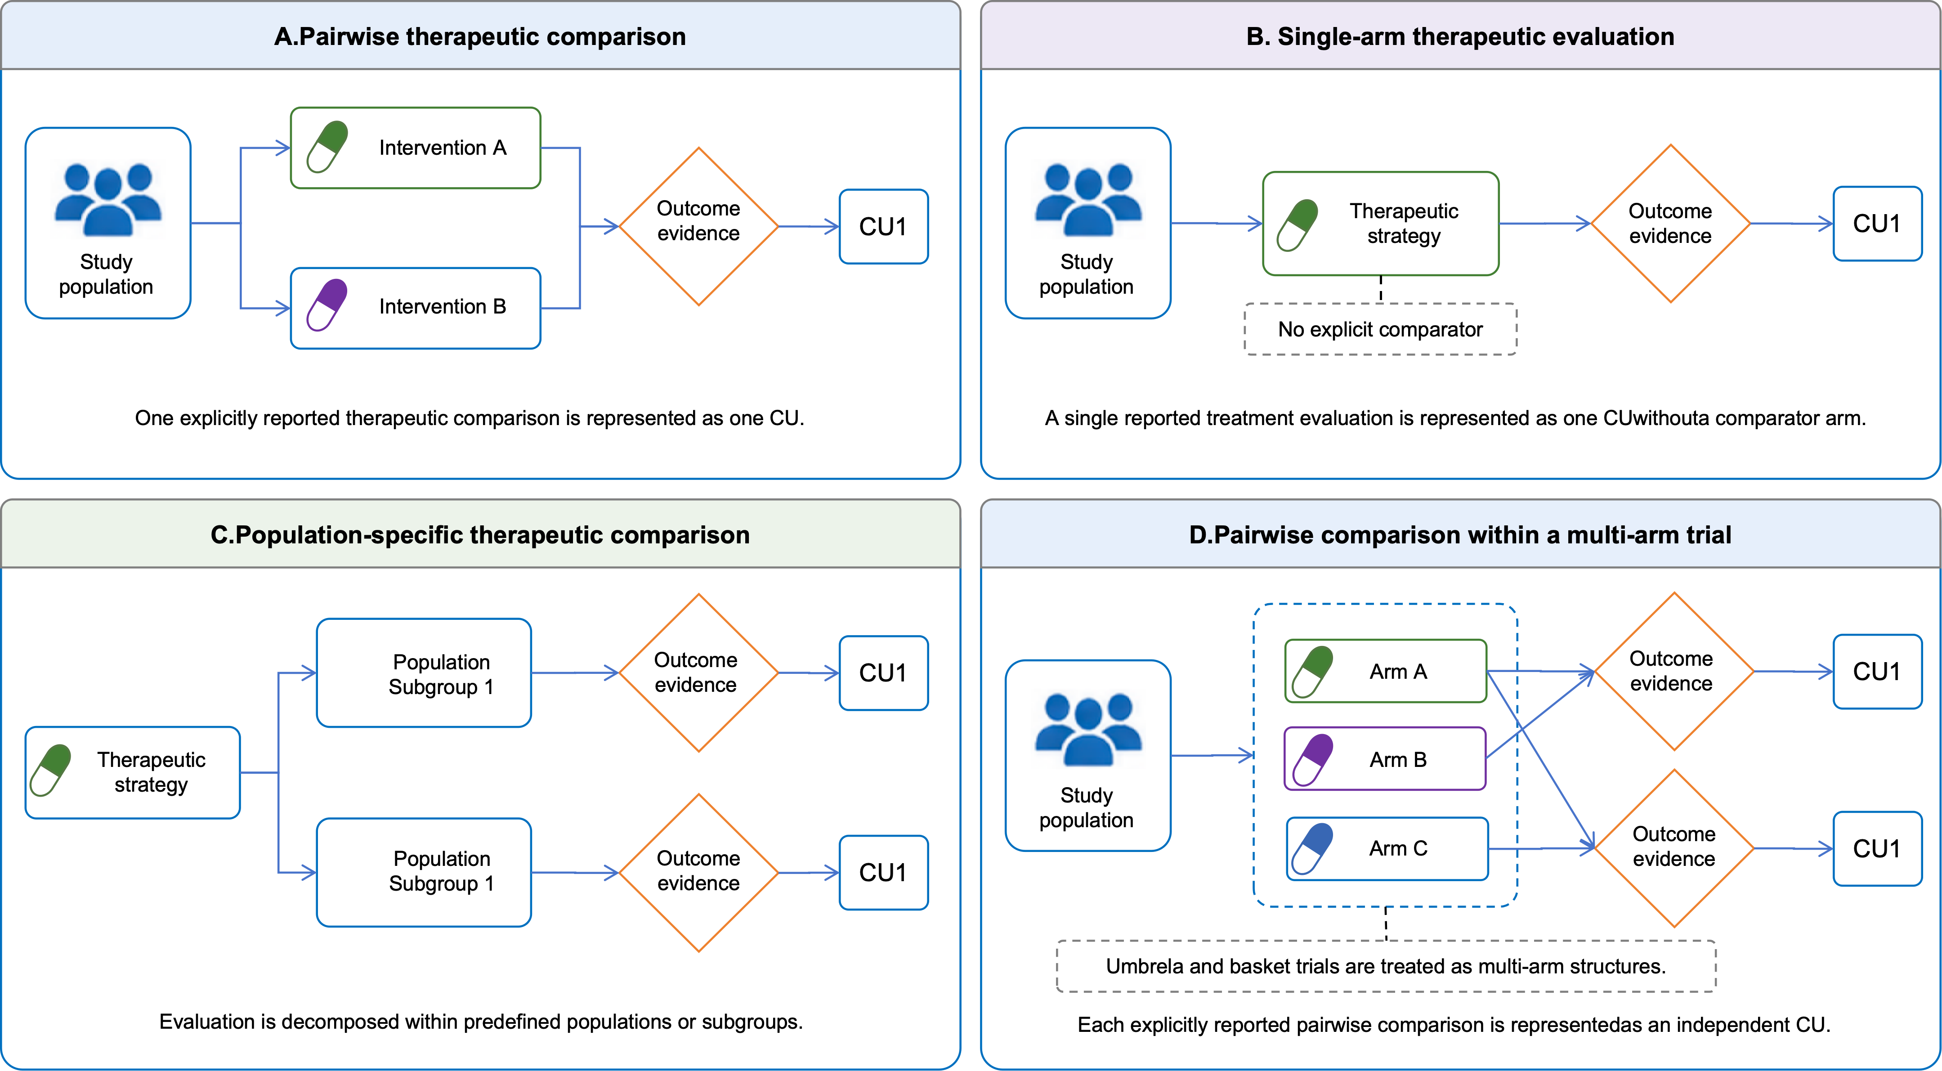
Figure 1. Four comparison-structure templates used for CU-slot decomposition. The templates distinguish pairwise therapeutic comparisons, single-arm evaluations, population-specific comparisons, and pairwise contrasts within multi-arm trials.
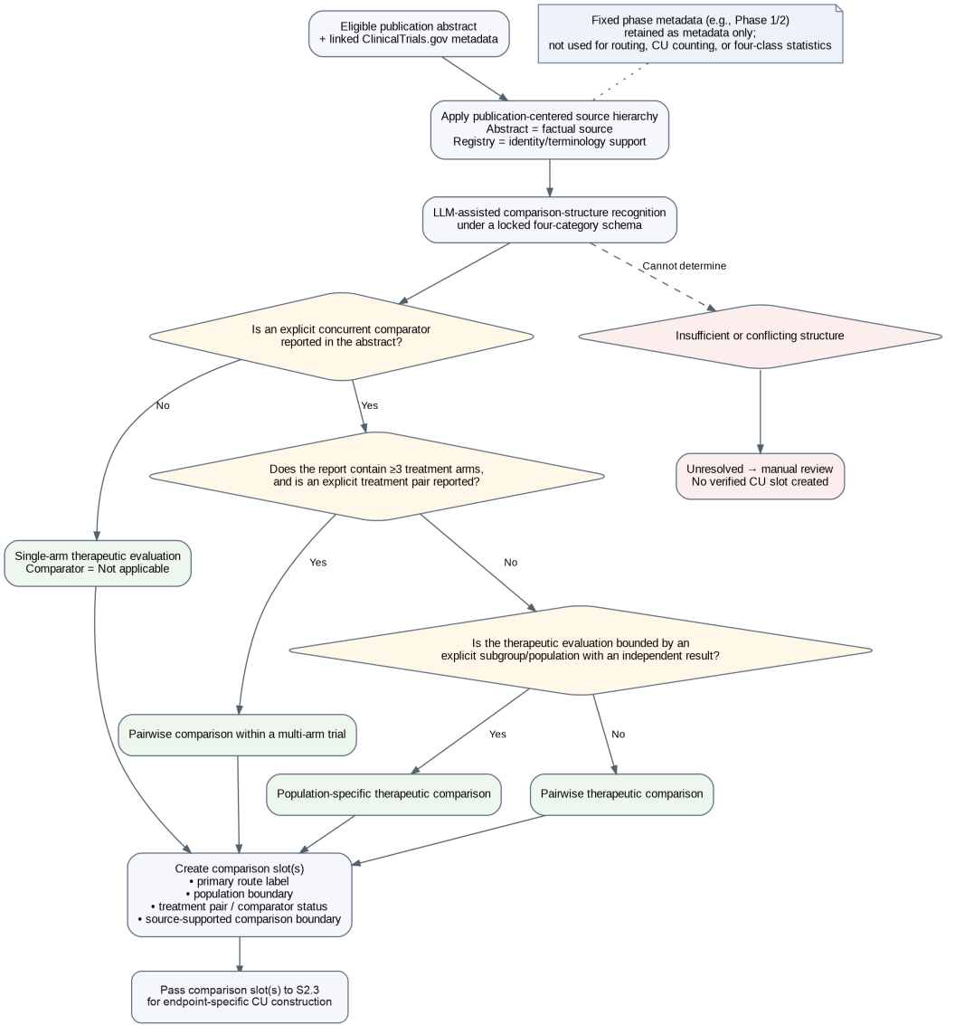
Figure 2. Route-identification workflow. The publication-centered workflow assigns a primary comparison route before CU-level field extraction.

