Deploying Groundwork Agent for Tomcat

Supported Tomcat Versions: 5.5, 6.0

Pre-requisite :

- Tomcat 5.5/6.0 installed and running.
- Groundwork Monitor 6.2.x installed and running.

Step : 1
Copy gwos_tomcat.properties to <TOMCAT_INSTALL_DIRECTORY>/conf/ folder.

Step : 2
Stop Tomcat server if running. Add the following jmx and classpath settings in <TOMCAT_INSTALL_DIRECTORY>/setclasspath.sh(on the top, after the copyright info)

CLASSPATH="$CLASSPATH""$CATALINA_HOME"/conf
CATALINA_OPTS="-Dcom.sun.management.jmxremote -Dcom.sun.management.jmxremote.port=9012 -Dcom.sun.management.jmxremote.ssl=false -Dcom.sun.management.jmxremote.authenticate=false"

Step : 3
Modify the gwos-tomcat properties file and update the target <GROUNDWORK_SERVER_HOSTNAME> in the nagios settings section.Make sure the nagios_encryption and nagios_password settings match groundwork server bronx.cfg file. Only XOR and DES encryption are supported. Also no encryption is supported. nagios_password is required if XOR or DES encryption is selected.

Step : 4
Download the gwos-tomcat-monitoringAgent.war(located on the folder /usr/local/groundwork/apache2/htdocs/java-agents/) file from groundwork server. Copy the war file to <TOMCAT_INSTALL_DIRECTORY>/server/default/deploy/ folder

Step: 5
In the groundwork server, discover the tomcat host and add the tomcat services by importing the service-profile-tomcat.xml. Commit the configuration in monarch.

Step : 6
Start Tomcat Server. You should see the “GWOS MBean Collector started successfully” message in the gwosCollector.log

Exporting the profiles to Groundwork server.
By default, agent ships with connectionPool, threadPool, webApp modules for providers which can be used for out of box tomcat installation. To monitor components for your environment, you need to generate environment based custom configuration files. To generate the custom files, after step 5 above, visit the http://<tomcat server>:8080/gwos-tomcat-monitoringAgent/index.html and click the button, “Auto Discover My Tomcat Components” (This depends on the object.name.filter property in the gwos_tomcat.properties file. This property will narrow down the autodiscovery search. If not sure, leave the default value). Then select the list of services from the discovered list(by default, default components are pre selected) and then click “Next” button. Now, enter the groundwork server name, username and password and click export.This will generate gwos_jboss.properties file in the /tmp folder of your tomcat server and exports the profiles to the Groundwork Server.

For more information please visit www.groundworkopensource.com .

UI Screen shots

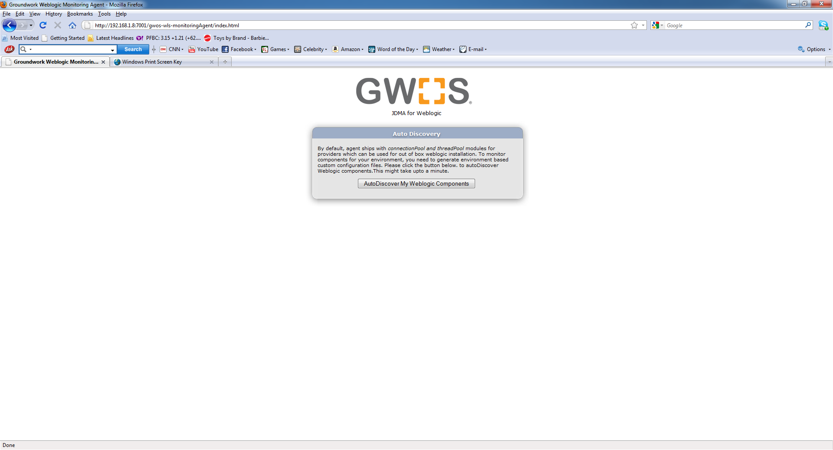

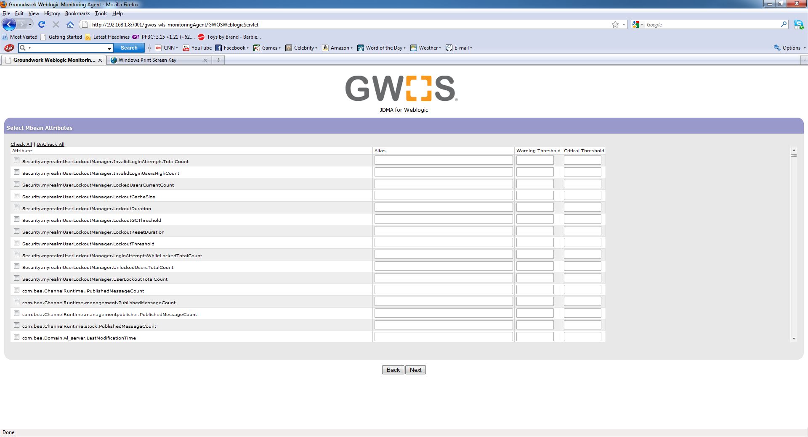

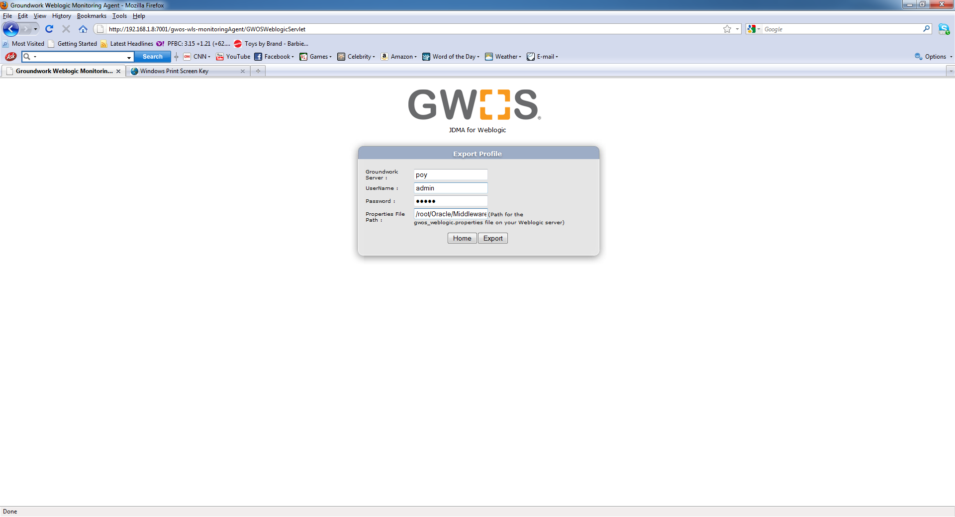

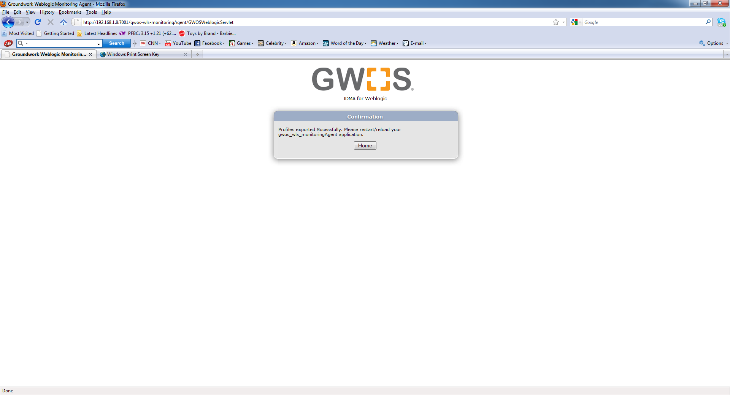

For more information please visit www.groundworkopensource.com .

Note : Currently agent doesnot support jmx password authentication or SSL.

