Deploying Groundwork Agent forWeblogic

Supported Weblogic Versions: 10.3.2 and above

Pre-requisite :

- Weblogic 10.3.2 or above installed and running.
- Groundwork Monitor 6.3 installed and running.
- Valid groundwork user account.

Step : 1
Modify bronx.cfg on the groundwork server. Uncomment the nagios_encryption and nagios_password properties. Specify any value for the nagios_password property and specify nagios_encryption to 1 or 2. Only XOR and DES encryption are supported. Also no encryption is supported. nagios_password is required if XOR or DES encryption is selected. Restart Nagios.

Step : 2
Copy gwos_weblogic.properties to appserver classpath. On a default installation of weblogic <WEBLOGIC_INSTALL_DIRECTORY>/wlserver_10.3/samples/server/examples/build/serverclasses folder.

Step : 3
Modify the gwos-jboss properties file and update the target <GROUNDWORK_SERVER_HOSTNAME> in the nagios settings section. Make sure the nagios_encryption and nagios_password settings match groundwork server bronx.cfg file. If you are familiar with the JMX object names and want to narrow your auto discovery search you can modify object.name.filter or just leave default if not sure. Also check the other weblogic admin settings properties like username, password, protocol, port etc and change appropriate to your environment.

Step : 4

Download the gwos-wls-monitoringAgent.war file(located on the folder /usr/local/groundwork/apache2/htdocs/java-agents/) from groundwork server. Deploy the war file to<WEBLOGIC_INSTALL_DIRECTORY>/wlserver_10.3/samples/domains/wl_server/autodeploy/ folder

Step: 5
Point the browser to the url http://<weblogic server>: 7001/gwos-wls-monitoringAgent/index.html and click the "Auto Discover My Weblogic components".

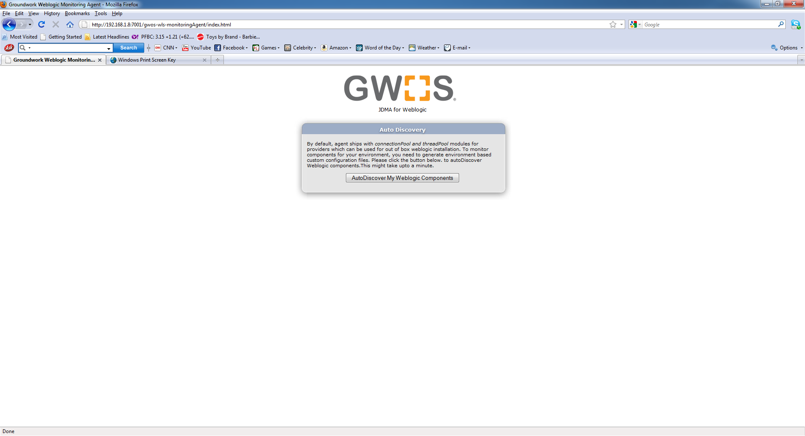

Step: 6
Select the mbean attributes from the list. Provide an alias, warning and critical values. Agent communicates to groundwork server with alias only. Define a value that is understandable and unique if the default alias is too long. Click Next.
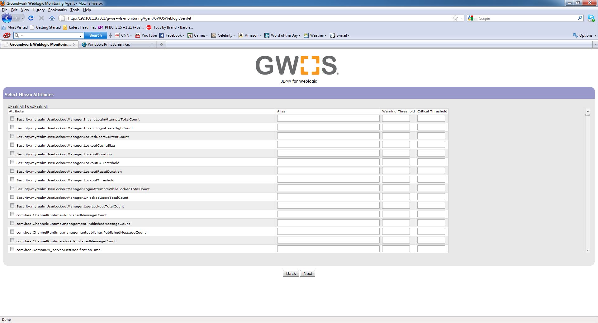

Step: 7
Fillout the groundwork server name and login details. Specify the classpath to copy the new properties file. Here <WEBLOGIC_INSTALL_DIRECTORY>/wlserver_10.3/samples/server/examples/build/serverclasses. Click Export. The old gwos_properties file is backed up with the name gwos_weblogic.properties_old.backup.

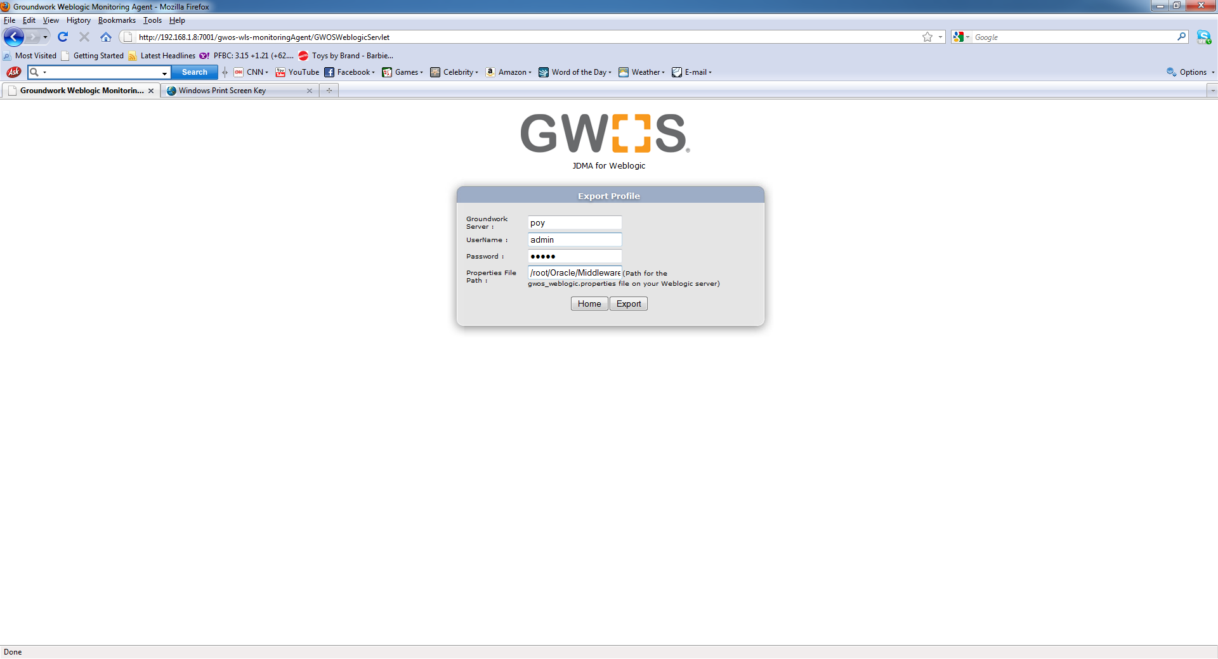

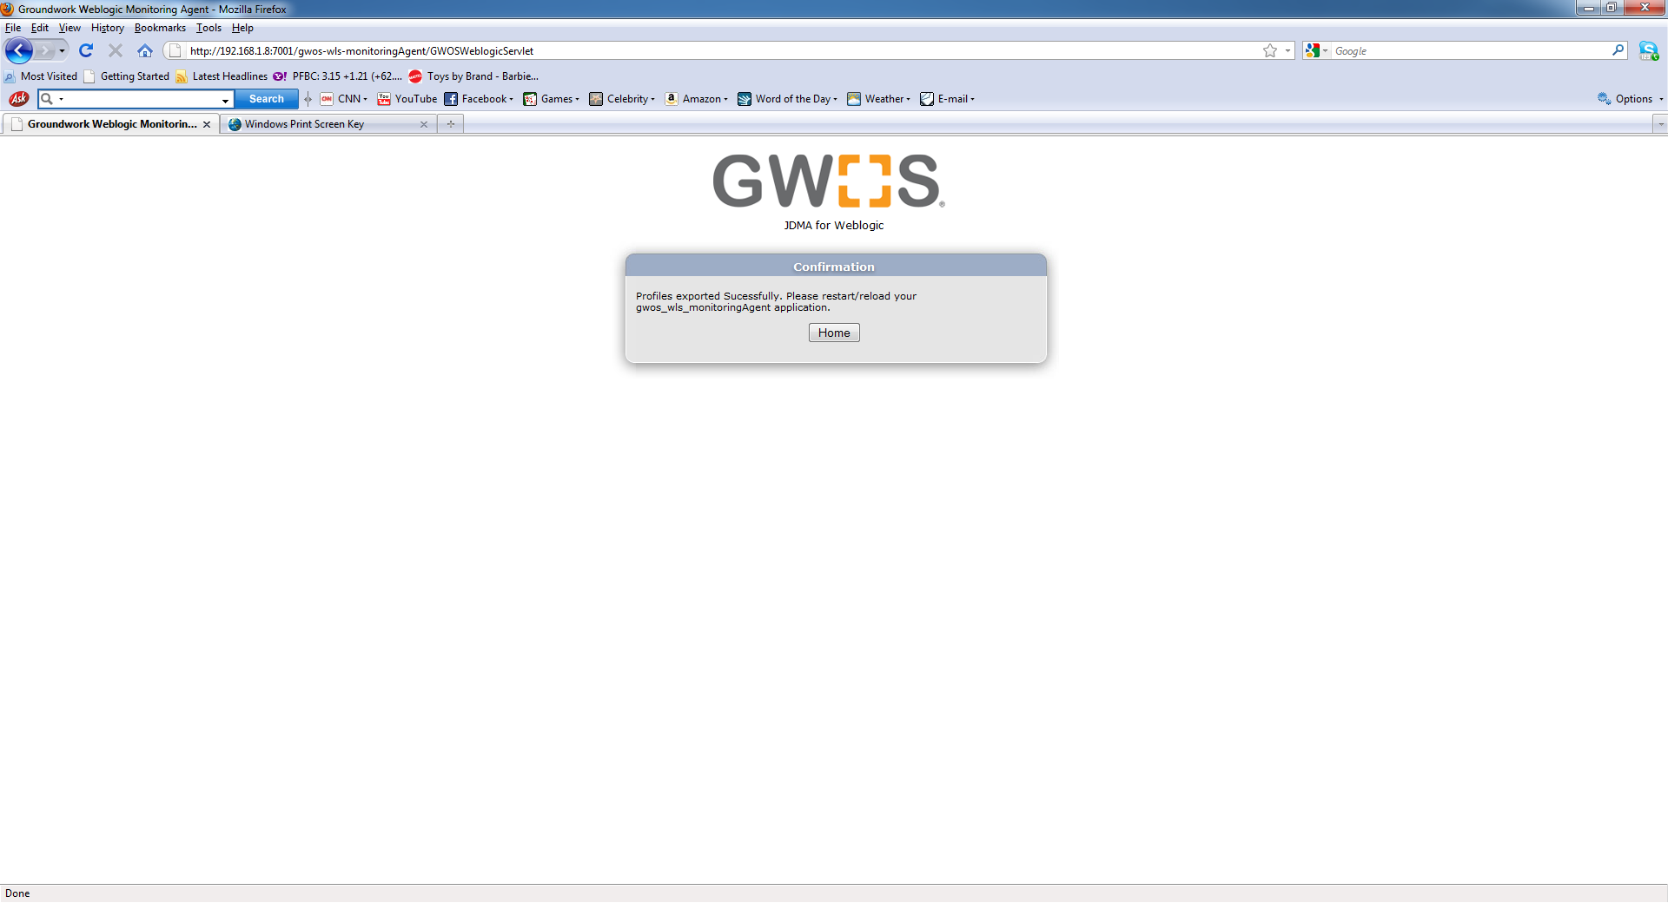

Step: 8
On your groundwork server login as an administrator and go to Configuration and import the service-profile-weblogic.xml. If you have exported multiple weblogic profiles, you would see multiple profile names like service-profile-weblogic_1.xml, service-profile-weblogic_2.xml. Higher the suffix, latest is the export. Now, Create or assign these services to a host and do commit.

Step : 9
On your weblogic server, touch the <WEBLOGIC_INSTALL_DIRECTORY>/wlserver_10.3/samples/domains/wl_server/autodeploy/gwos-wls-monitoringAgent.war using the touch command. This will reload/ restart the applicationYou should see the "GWOS MBean Collector started successfully" message in the gwosCollector.log. Also you will see the passive check results in the nagios.log on your groundwrok server.

