Deploying Groundwork Agent for JBoss

Supported JBoss Versions: 4.2.3GA, 5.1GA

Pre-requisite :

- JBoss 4.2.3GA/5.1GA installed and running.
- Groundwork Monitor 6.2.x installed and running.

Step : 1
Copy gwos_jboss.properties to <JBOSS_INSTALL_DIRECTORY>/server/default/data/ folder.

Step : 2
- Stop Jboss Server if running.
- Add the following line in the <JBOSS_INSTALL_DIRECTORY>/bin/run.sh before “# Display our environment” comment.
#GWOS
JBOSS_CLASSPATH="$JBOSS_CLASSPATH:$JBOSS_HOME/server/default/data/"

Step : 3
Modify the gwos-jboss properties file and update the target <GROUNDWORK_SERVER_HOSTNAME> in the nagios settings section. Make sure the nagios_encryption and nagios_password settings match groundwork server bronx.cfg file. Only XOR and DES encryption are supported. Also no encryption is supported. nagios_password is required if XOR or DES encryption is selected.

Step : 4
Download the gwos-jboss-monitoringAgent.war file(located on the folder /usr/local/groundwork/apache2/htdocs/java-agents/) from groundwork server. Copy the war file to <JBOSS_INSTALL_DIRECTORY>/server/default/deploy/ folder

Step: 5
In the groundwork server, discover the jboss host and add the jboss services by importing the service-profile-jboss.xml. Commit the configuration in monarch.

Step : 6
Start Jboss Server. You should see the “GWOS MBean Collector started successfully” message in the gwosCollector.log

Exporting the profiles to Groundwork server.
By default, agent ships with connectionPool, threadPool, webApp modules for providers which can be used for out of box jboss installation. To monitor components for your environment, you need to generate environment based custom configuration files. To generate the custom files, after step 5 above, visit the http://<jboss server>:8080/gwos-jboss-monitoringAgent/index.html and click the button, “AutoDiscover My Jboss Components” (This depends on the object.name.filter property in the gwos_jboss.properties file. This property will narrow down the autodiscovery search. If not sure, leave the default value). Then select the list of services from the discovered list and then click “Next” button. Now, enter the groundwork server name, username, password properties file path and click export.The old gwos_properties file is backed up with the name gwos_jboss.properties_old.backup. This exports the profiles to the Groundwork Server

For more information please visit www.groundworkopensource.com .

UI ScreenShots

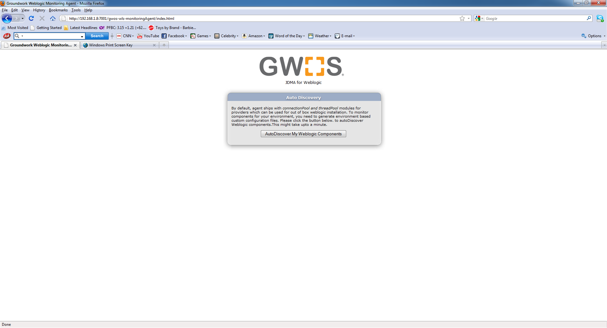

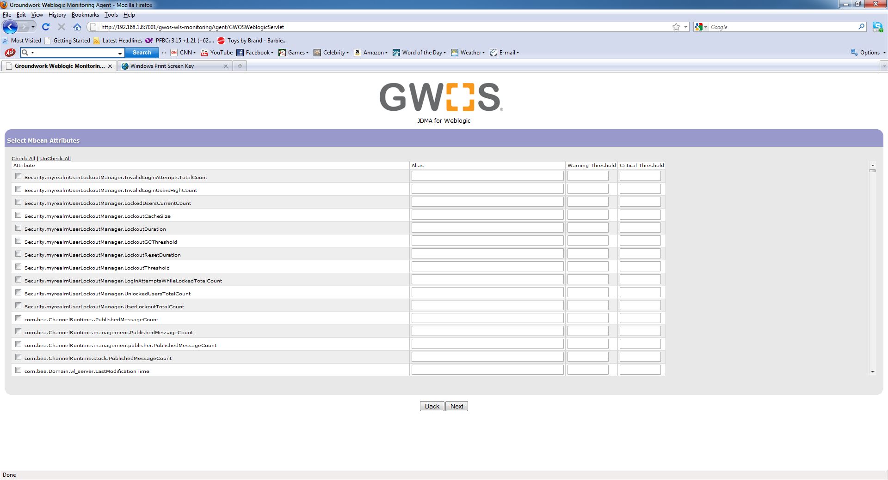

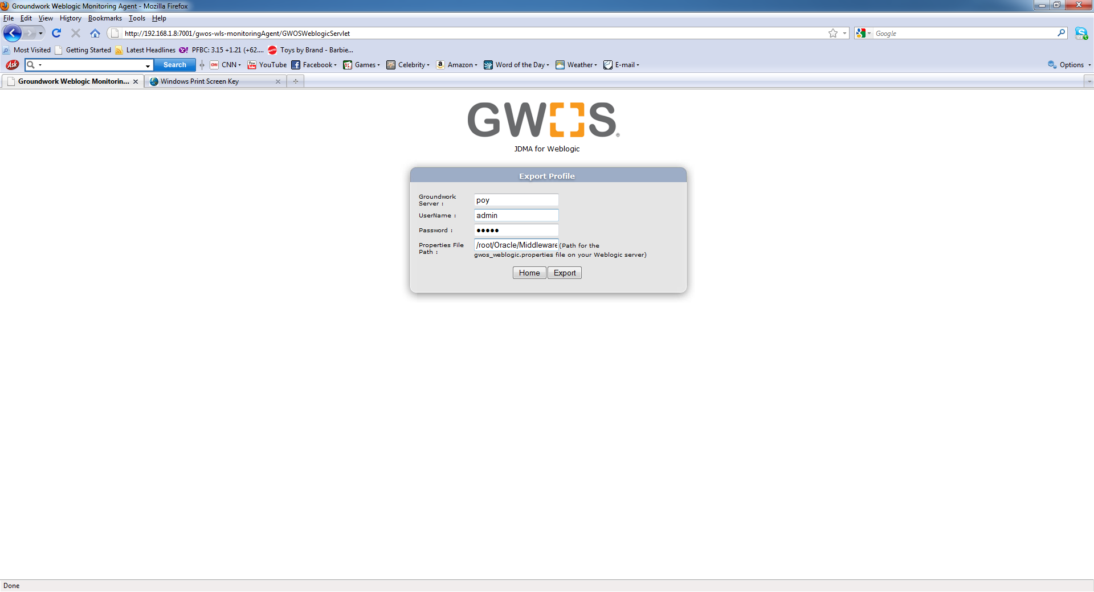

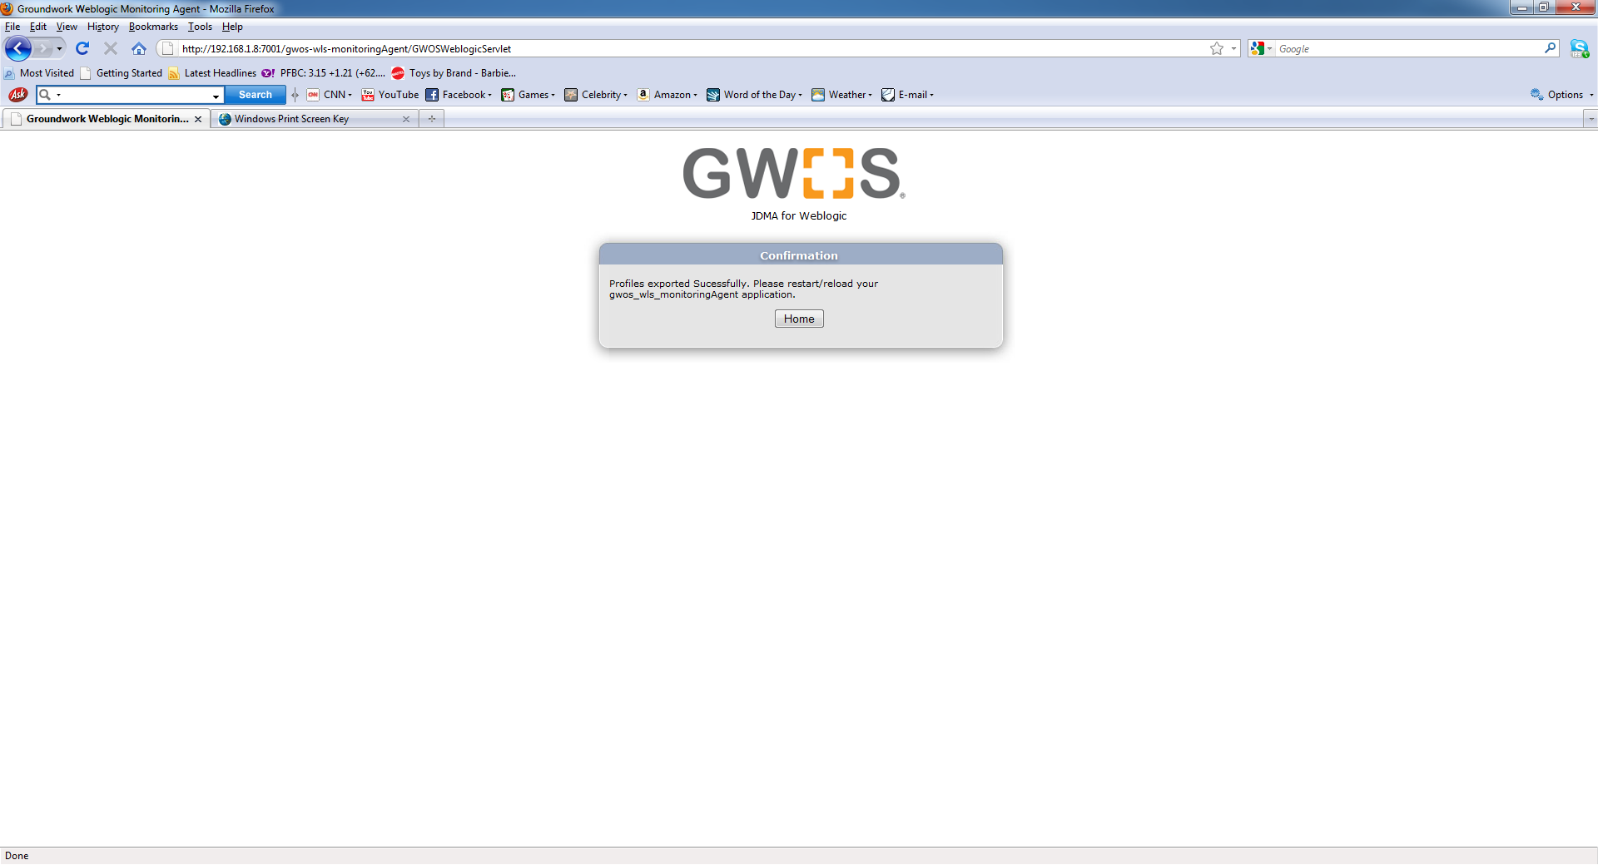

Note : Currently agent doesnot support jmx password authentication or SSL.

