GroundWork Monitor Cloud Connector For Eucalyptus

Release: 20100702 (v1.0)

Introduction
The GroundWork Monitor Cloud Connector Eucalyptus is an add-on software solution for GroundWork Monitor Enterprise Edition. It provides the ability to monitor Eucalyptus and Ubuntu Enterprise Cloud-based private clouds alongside traditional datacenter infrastructure. Your feedback and suggestions for improving this solution are very welcome via the GroundWork Support portal.

How it Works
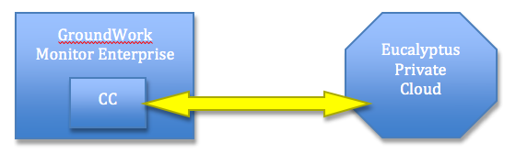

The Cloud Connector to Eucalyptus extends your existing Enterprise installation with additional components:
- A “Cloud” tab within the user interface to configure the cloud monitoring settings.
- A cloud synchronization module that periodically synchronizes the monitoring system with the current configuration of the cloud.
- Additional profiles for monitoring cloud capacity, and a basic up-down availability monitoring profile for cloud instances.
- Low-level utilities such as the EC2 command-line tools (ec2-api-tool-1.3-46266) used to access the cloud infrastructure. See these web pages for more information:
http://docs.amazonwebservices.com/AWSEC2/latest/CommandLineReference/
http://docs.amazonwebservices.com/AWSEC2/latest/CommandLineReference/index.html?command-reference.html

Basic Operation
The cloud synchronization script runs periodically (every 15 minutes, by default) to update the monitoring system with the current status and configuration of all clouds (multiple Eucalyptus clouds may be monitored.) Security credentials and certificates are used to access the cloud infrastructure. During each synchronization run, the monitoring system is automatically updated to reflect the current state of the running cloud, as follows:

- Each instance running in the cloud is configured as a host on the monitoring system.
- If the instance image matches an available monitoring profile, that profile is automatically applied to the host.
- A host group is created for each applied machine-instance profile, grouping similar instances together in the GroundWork Monitor interface.
- A host group is created for each availability zone in the cloud, and each instance running in the zone is added to the group.
- Each availability zone is configured as a virtual host, with the instances as subordinate children. This ensures properly conditioned alarms in the event of the failure of an entire availability zone.
- The overall cloud capacity is monitored, showing the number of instances that may be created of different sizes.

An example of the user view when monitoring a cloud is shown below:

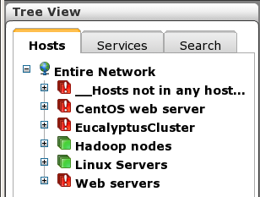
EucalyptusCluster = availability zone
Hadoop nodes = Instance type grouping (based on image)
Web Servers = Instance type grouping (based on image)

Each availability zone is also configured as a virtual host, with performance (available capacity) and availability (ping) service monitoring drawn from the parent region service endpoint (for EC2) or Cloud Controller (for Eucalyptus):

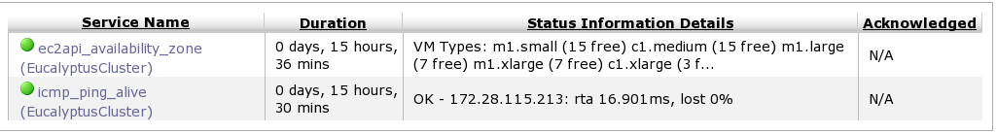
Performance data is automatically graphed for these services:

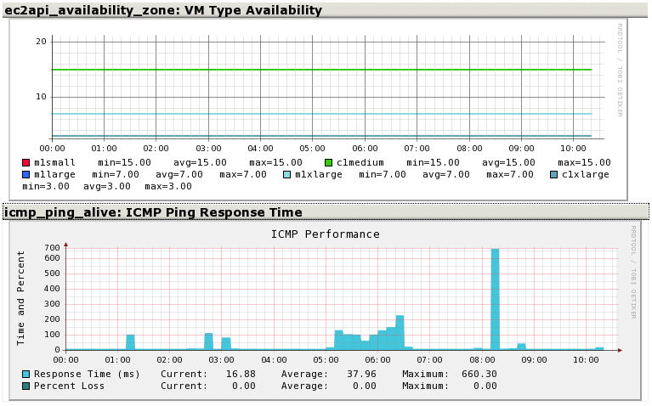

Configuring Cloud Monitoring
The “Cloud” top-level menu item is available to the GroundWork Monitor administrator and provides the following features:

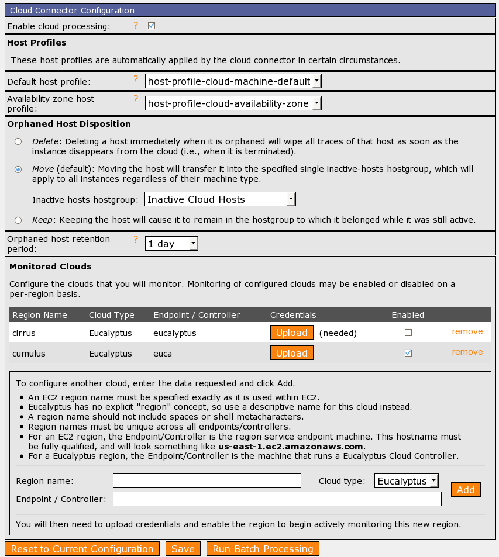

The fields in the configuration screen should be adjusted as follows:

Feature | Purpose
Enable cloud processing | Global switch for all cloud monitoring. Unchecking this box disables all cloud related operations. This is recommended when making manual configuration changes using Monarch.
Default host profile | The host profile to apply to new instances if no other monitoring profile applies. This rarely needs to be changed.
Availability zone host profile | The profile to apply for availability zone monitoring. This rarely needs to be changed.
Orphaned Host Disposition | Determines what to do when an instance is terminated.  - Keep – do nothing. Terminated instances will continue to be monitored (and likely be down)  - Move – keep the system configured but move it to a special host group. This preserves any availability information associated with the host. After the retention period, they will be removed.  - Delete – permanently remove it from the monitoring system.
Monitored Clouds | Each cloud to be monitored must be configured in this section. The parameters to provide are:  - Region name – A name for the cloud, e.g. the location or purpose of the cloud.  - Cloud type – This is Eucalyptus for Eucalyptus and UEC clouds.  - Endpoint/Controller – The fully qualified hostname or IP address of the Cloud Controller in your Eucalyptus installation.  - Credentials – Access keys for probing the cloud for information about its zones and instances.  - Enabled – Selection to enable or disable monitoring of individual regions.

To enable monitoring of each cloud, the access credentials for the cloud must be provided. This is performed by uploading the euca2-admin-x509.zip file specific to your installation, via the Upload button in the previous screen. That leads to the following screen, in which you can choose and upload the credentials file:

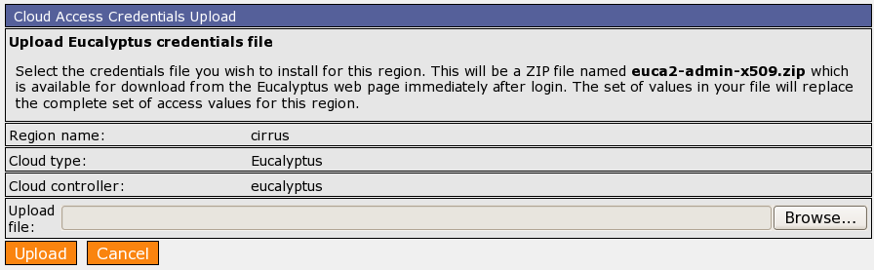

Operating Instructions
By default, each availability zone will be monitored using ping, and each instance will be monitored by checking its SSH port. More complex monitoring is configured by creating host profiles that match the names of EMIs (Eucalyptus Machine Images, used to create cloud machine instances) in your Eucalyptus cloud.

For example, to automatically monitor Hadoop nodes using Hadoop specific checks, perform the following steps, starting on your Eucalyptus Cloud Controller machine. (The “eucalyptus” word on the “source” command is the Region name for the cloud you are interested in.)

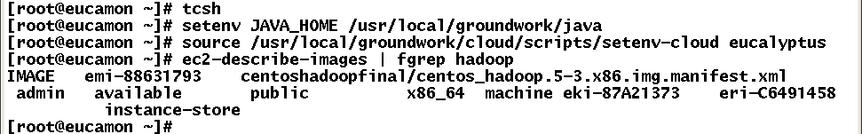
The EMI identifier for our Hadoop stack in this example is emi-88631793.

Create a host profile with the special name format: cloud-machine-emi-xxxx:

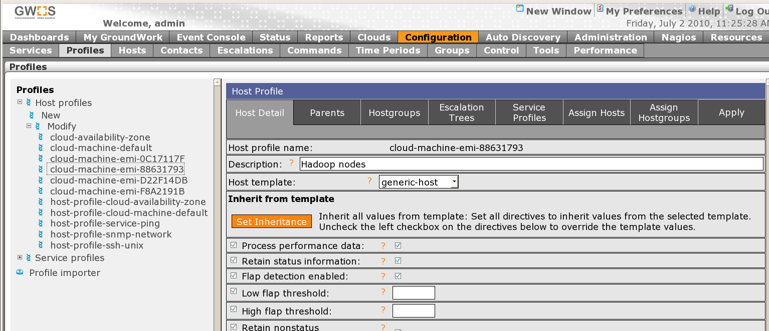
Set the Description field to be a short description of this instance type – it is displayed as a group in the status viewer.

Assign service profiles to this host profile, where multiple software components are present in the image (e.g., a webserver, tomcat, or database). Multiple service profiles can be assigned.

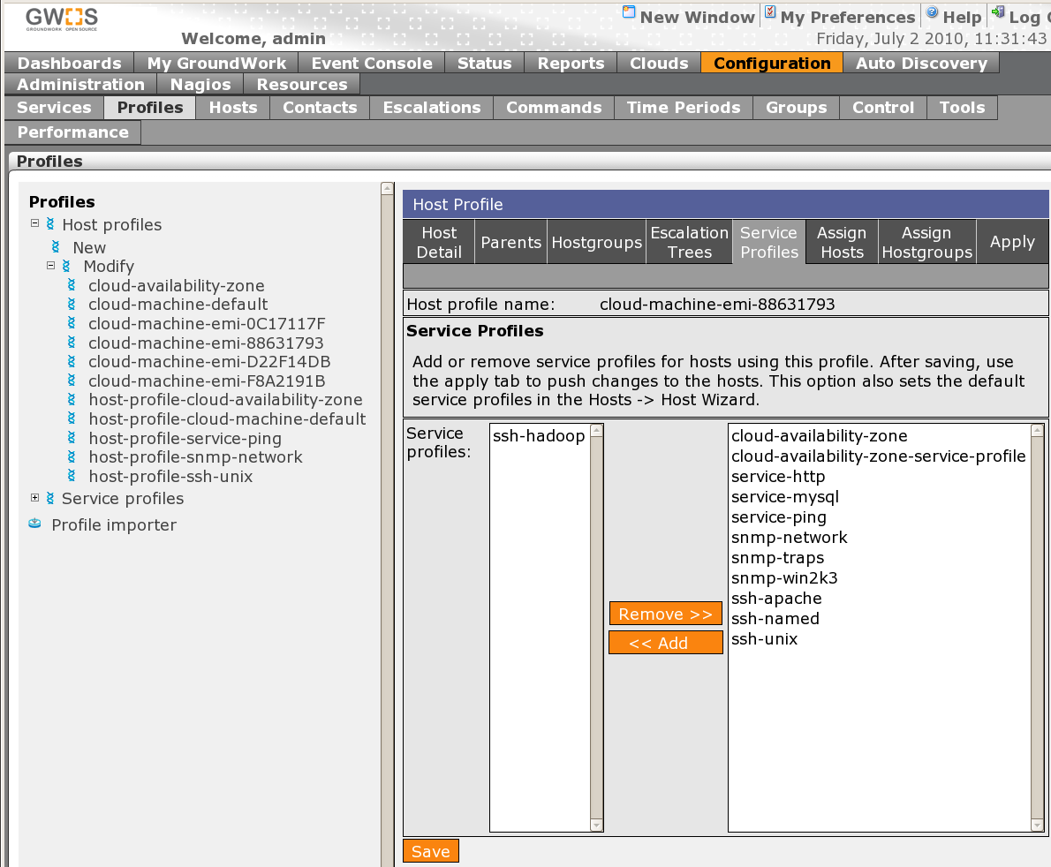

Hints and Tips
Manual changes to the monitoring configuration for cloud infrastructure will be reset each time the synchronization script is run. Modify the cloud monitoring behavior by creating new host profiles. Non-cloud host groups, hosts, and services are not affected by the Cloud Connector and can be manually administered.

Monitoring data can be collected using an agent or agentless approaches. For private cloud installations, the following approaches are recommended:

- Agent monitoring. Existing agents (NSClient++, GDMA, NRPE) can be included in EMI images to avoid manual agent distribution. Use of a configuration management tool such as Puppet or RightScale is recommended for larger deployments. Appropriate ports must be explicitly opened in the security group in most cases.
- Agentless monitoring. Active monitoring via SSH is a convenient way to collect data given that TCP port 22 is generally available. This approach requires the plugins to be located in ~nagios/libexec and the ~nagios/.ssh/.authorized_keys file to be updated in each EMI. For larger installations, a configuration management tool is recommended.
- GroundWork Monitor + Cloud Connector can monitor private clouds from outside or within the cloud itself. When running in a private cloud, the extra large instance size is recommended.

Known Issues and Limitations
- It is recommended that automatic cloud synchronization be disabled when making manual configuration changes in GroundWork Monitor.
- RPM packaging is not standard on Ubuntu-based systems, though it can be handled via the “alien” package converter.
- A large DHCP pool is recommended – if the IP address of an instance changes during its lifetime, the system address may be out-of-sync with the cloud state.
- Crontab scheduling of the background cloud configuration script cannot be modified via the user interface at this time.
- Cloud health dashboards must be manually created at this time.
- The orphaned host retention period function is not yet complete. Either select "Delete" as the Orphaned Host Disposition setting in the Cloud Configuration screen, or manually manage the eventual deletion of terminated instances.
- Host groups are created from scratch each time the cron job runs. As a result, instances that don't show up in the ec2-describe-instances command (perhaps because they have been deleted) will not show up in any of the host groups that the cloud_config.pl script recreates. This results in orphaned hosts that show up in the Status application in a meta host group called "__Hosts not in any host groups".
- EC2 support has been disabled in this release.
- EC2 API tools will fail, and the monitoring of EC2 regions will return bad results, if the system time on the monitoring server is too far off from Internet time. Use NTP or some similar mechanism to keep the time on your monitoring system properly synchronized.
- The handling of regions assumes their names are unique across all monitored clouds.

Installation Instructions
GroundWork Monitor Enterprise Edition 6.1.1 or higher is required. The cloud connector is installed using the following steps:

On RedHat, CentOS, and SuSE:
Install the supplied RPM directly:

rpm -Uvh groundwork-cloud-connector-xxx.rpm

On Ubuntu:
First make sure that “alien” is installed on your machine, then use it to install the supplied RPM:

apt-get install alien
alien -c -k -i groundwork-cloud-connector-xxx.rpm

Installation of the RPM will restart part of GroundWork Monitor to have it pick up changes. Once GroundWork Monitor restarts, the Cloud Connector is available for setup. On either type of system, log into GroundWork Monitor as an administrator and take the following steps:

- Create a hostgroup named "Inactive Cloud Hosts", or an other name you would like to use to contain cloud instances that have terminated.

- Import the provided host and service profiles:

host profile: host-profile-cloud-availability-zone.xml
host profile: host-profile-cloud-machine-default.xml
service profile: service-profile-cloud-availability-zone.xml
service profile: service-profile-ssh-hadoop.xml

- If you wish to monitor particular services associated with your cloud machines, the easiest way to do so is to create host profiles named after instances:

cloud-machine-ami-xxxxxx (for an EC2 cloud instance)
cloud-machine-emi-xxxxxx (for a Eucalyptus cloud instance)

These host profiles will be used by matching "ami-xxxxxx" or "emi-xxxxxx" against the image used for an instance, and the profile will be applied to each new instance of that machine. Also, a host group will be created for these instances, with a name based on the Description field for that host profile.

- Do the following for each "cloud" you will monitor. A Eucalyptus cloud here refers to a particular machine which is running the Eucalyptus Cloud Controller. It will be treated by our monitoring as though it were an EC2 region. An EC2 cloud here refers to an EC2 region.

Navigate to the Clouds -> Cloud Configuration screen. Adjust the options as needed for your site. Add the cloud regions you wish to monitor. Note that region names in the monitoring system are not allowed to contain spaces or shell metacharacters. You will probably want to follow the same principle when you name your regions within Eucalyptus.

Obtain the euca2-admin-x509.zip file that can be generated from the Eucalyptus system admin scripts via the Eucalyptus web page download facility. Using the Cloud Configuration screen, upload this file as the credentials for that region.

Once the credentials are uploaded, enable the individual cloud, in the list of Monitored Clouds in the Cloud Configuration screen.

Finally, also make sure the cloud processing as a whole is enabled. This selection is made at the top of the Cloud Configuration screen.

File layout guide
The following directories are used to hold files related to the Cloud Connector:
Path | Content
/usr/local/groundwork/cloud/ | Cloud Connector base location
.../config/ | Configuration state managed by the UI
.../credentials/ | Credentials, keys, and eucarc
.../doc/ | Installation and developer notes
.../ec2-api-tools-1.3-46266/ | EC2 command-line tools
.../info/ | Build timestamp
.../logs/ | Cloud Connector sync script logs
.../perl/ | Perl extensions for the Cloud Connector
.../scripts/ | Connector and wrapper scripts
.../var/ | Lock file to block concurrent syncs

