

GroundWork Monitor
Ganglia Integration Module
System Administrator Guide

Revision 6.0.1
May 10, 2013

Prepared by: | GroundWork Open Source, Inc.  201 Spear Street, Suite 1650  San Francisco, CA 94105

Contents
1 Overview 3
2 Installation 4
2.1 GroundWork Monitor 4
2.2 Fresh Installation of the Ganglia Integration Module 4
2.3 Upgrading from a Previous Release of the Ganglia Integration Module 7
2.3.1 Upgrading to a MySQL-based GroundWork Monitor Release 7
2.3.2 Upgrading from a MySQL- to a PostgreSQL-based GroundWork Monitor Release 9
3 Detailed Description 14
3.1 Check Ganglia and Nagios 14
3.2 Performance Considerations 17
3.3 ganglia Database 18
3.3.1 ganglia Database (PostgreSQL version) 18
3.3.1.1 PostgreSQL public.cluster Table 18
3.3.1.2 PostgreSQL public.clusterhost Table 19
3.3.1.3 PostgreSQL public.host Table 19
3.3.1.4 PostgreSQL public.hostinstance Table 19
3.3.1.5 PostgreSQL public.location Table 20
3.3.1.6 PostgreSQL public.metric Table 20
3.3.1.7 PostgreSQL public.metricinstance Table 20
3.3.1.8 PostgreSQL public.metricvalue Table 21
3.3.2 ganglia Database (MySQL version) 21
3.3.2.1 MySQL cluster Table 21
3.3.2.2 MySQL clusterhost Table 21
3.3.2.3 MySQL host Table 22
3.3.2.4 MySQL hostinstance Table 22
3.3.2.5 MySQL location Table 22
3.3.2.6 MySQL metric Table 23
3.3.2.7 MySQL metricinstance Table 23
3.3.2.8 MySQL metricvalue Table 23
3.4 Ganglia Web Interface 24
3.4.1 Threshold Configuration 24
3.4.2 Access to Ganglia Web Servers 24
3.5 Auto-Import 25
4 Administration 27
4.1 Ganglia-Related Configuration 27
4.1.1 Check Ganglia Configuration 27
4.1.2 Ganglia Threshold Administration Configuration 30
4.1.3 Ganglia Web Server Viewing Configuration 31
4.1.4 Ganglia Portal Access Permissions 32
4.2 Ganglia Database Administration 33
4.2.1 Defining Thresholds 33
4.2.2 Validating the Configuration 38
4.2.3 Finding and Deleting Hosts 38
4.3 Auto-Import Configuration 40
Appendix A: Revision History 44

Overview
This document describes the system administrator tasks required to install and administer the software which integrates GroundWork Monitor with Ganglia, referred to as the Ganglia Integration Module. This software allows information gathered by the Ganglia monitoring system to be processed by a GroundWork Monitor system.
Ganglia is an agent-based, cluster-oriented monitoring system. It is useful for large installations with many similar hosts. It is efficient and scalable, and can collect and graph many different metrics. Ganglia, however, does not include threshold values for these metrics, or notifications when these thresholds are violated. Nor does it include reporting. These functions are part of GroundWork Monitor, via the Nagios® monitoring system and GroundWork's user interfaces and databases. This integration module brings these projects together by allowing GroundWork Monitor operator views, dashboards, reports, notifications, and configuration tools to be applied to Ganglia data.
The Ganglia Integration Module has the following features.
- A “collector” gathers information for each host running the Ganglia gmond agent, and relays that information to a GroundWork Monitor host. For each monitored host, selected metrics are compared against warning and critical thresholds. If the thresholds are exceeded for a configured duration, a service alert is generated.
- A web interface called the Ganglia Configuration Administration tool is provided. This interface allows the administrator to:
  - Define Ganglia metrics to monitor (i.e., select a subset of the metrics that Ganglia is collecting, for purposes of watching for extreme values).
  - Define warning, critical, and duration thresholds for the watched metrics.
  - Assign watched-metric thresholds globally (to all Ganglia clusters), to specific Ganglia clusters, or to specific hosts.
  - View the current metric state of certain metrics monitored by the Ganglia interface, for particular hosts.
  - Conveniently access the web pages provided by Ganglia itself.
- An import script that automatically defines the Ganglia hosts to the GroundWork Monitor system is also included. The Monarch Nagios configuration database is updated by the import script, and Monarch procedures are called to automatically commit the changes to Nagios.
The integration module package consists of the following main components:
- Check Ganglia daemon, check_ganglia.pl. This module reads a set of Ganglia gmetad and/or gmond XML streams and extracts the metrics for each host. It compares these metrics to the defined watched-metric thresholds to determine if a metric is in violation of its associated thresholds. It then sends passive service check results to the Nagios command pipe. The daemon also updates the ganglia database.
- ganglia PostgreSQL database. (MySQL is also supported, for legacy systems.) This database contains:
  - The default, per-cluster, and per-host watched-metric thresholds.
  - The current metric measurements for each host.
- Ganglia configuration administration CGI programs, presented as portal applications within GroundWork Monitor Enterprise Edition. The standard security mechanisms available to similar portal applications (e.g., limiting access to only certain Roles) are also available for these portal pages.
- Auto-import script. This script, autoimport.pl, queries the ganglia PostgreSQL (or MySQL) database for hosts reported by the check ganglia daemon. It then queries the monarch database for hosts defined in Nagios, and finds Ganglia hosts that are not in Nagios, which it adds to the monarch database. It applies a default ganglia profile to such new hosts, and optionally commits the changes to Nagios.
The detailed design of the system is described below.

Installation
The following software prerequisites are required to install the Ganglia Integration Module.
- GroundWork Monitor Enterprise Edition version 6.4.0 or later.
- Ganglia Version 3.0.x or later monitoring your infrastructure. Note: it is not necessary to install gmond or gmetad on the GroundWork server, but if you do not, you must ensure that the GroundWork server can access the XML feed on at least one gmond or gmetad instance.
The Ganglia Integration Module is supplied as a set of RPM packages:
- groundwork-ganglia-integration
- groundwork-autoimport
Multiple RPMs are used to provide appropriate granularity for upgrades as this software and the base product both evolve. Currently, RPMs are provided for the Red Hat Enterprise Linux 5 64-bit platform.
Certain customer-specific extensions may be supplied to those customers as separate RPMs:
- groundwork-ganglia-customername
- groundwork-autoimport-customername
The check_ganglia.pl script which is at the heart of this software runs continually under control of the GroundWork Monitor gwservices service. To enable us to automatically install all the software in its intended locations without having it disrupt system operation before it is properly configured, the daemon script looks for the enable_processing setting in its configuration file. If the option is turned off, as it is in the default installed configuration file, the script will just emit a log message saying that processing is not enabled, and it will then sleep for a very long time.
To install, you will need to perform the following steps:
- Set up GroundWork Monitor Enterprise Edition.
- Set up Ganglia, and in particular make sure you understand where the gmond and/or gmetad XML feeds are accessible.
- Install the required Ganglia Integration RPM.
- Optionally install the Autoimport RPM.
- Configure and start the software.
The rest of this chapter contains basic instructions for performing these steps.

GroundWork Monitor
Install GroundWork Monitor according to the standard product installation procedures. If you are upgrading from GWMEE 6.5.0 or earlier to GWMEE 6.6.1 or later, and you had the Ganglia Integration Module already installed on the original system, you must read Section 2.3.2, Upgrading from a MySQL- to a PostgreSQL-based GroundWork Monitor Release, on page 9 before you begin the upgrade. For this type of upgrade, some adjustments are necessary, and installation/upgrade of the new Ganglia Integration Module is slightly intertwined with the installation of the base GroundWork Monitor product.

Fresh Installation of the Ganglia Integration Module
All the Ganglia Integration RPMs get installed on your top-level GroundWork Monitor system, which is where the check_ganglia.pl script will run.
Note: Installation of the RPMs will restart both of the apache and gwservices components of GroundWork Monitor. This will disrupt existing, running sessions where users are accessing GroundWork Monitor. Thus, you may wish to wait until a convenient period of low use to perform these steps.
Install the RPMs for your platform. Here we specify them as individual rpm commands, but you may combine them on a single rpm command if you wish. The groundwork-ganglia-customername and/or groundwork-autoimport-customername RPMs will only be installed at particular customer sites.
rpm -Uvh groundwork-ganglia-integration-release-build.platform.rpm
rpm -Uvh groundwork-ganglia-customername-release-build.platform.rpm
rpm -Uvh groundwork-autoimport-release-build.platform.rpm
rpm -Uvh groundwork-autoimport-customername-release-build.platform.rpm
where platform is i386 for a 32-bit platform, x86_64 for a 64-bit platform, or noarch for either platform.
Once the software is installed, take the following steps:
- Create the ganglia database. This is a destructive operation (it will wipe out any previous database named ganglia). Creating the database is not done automatically during RPM installation because we cannot assume where you want to have this database reside.
  - For a PostgreSQL-based GroundWork Monitor release (6.6.0 or later), use the following commands, to first create the database itself and then to create the tables and other objects within it:
cd /usr/local/groundwork/core/databases/postgresql
/usr/local/groundwork/postgresql/bin/psql -h host -U postgres < create-ganglia-db.sql
/usr/local/groundwork/postgresql/bin/psql -h host -U ganglia < ganglia-db.sql
where, if you are just connecting to PostgreSQL running on the same machine, the -h host option can be either specified as -h localhost or omitted entirely. Note that two different database users (postgres and ganglia) are used in these two commands. The postgres user must be specified on the first command so you have permission to create the ganglia database itself. The ganglia user is used on the second command as a simple way both to log in as that user and to default the database you connect to as the ganglia database.
If this is a completely fresh install of the Ganglia Integration Module, not part of an upgrade from a previous release, you must also load the database with a small amount of seed data. (In an upgrade situation, this data will be migrated from the prior release, so you must not execute these commands in that case.)
cd /usr/local/groundwork/core/databases/postgresql
/usr/local/groundwork/postgresql/bin/psql -h host -U ganglia < ganglia-seed.sql
Each psql command will prompt you for the corresponding database password; these will generally be different for the two users. See the create-ganglia-db.sql script for the initial password for the ganglia user; later, you can use ordinary PostgreSQL facilities to change this as you wish:
alter role ganglia with password 'foobar';
If you do change the password, keep track if it, as the new value will be needed in several of the configuration files for the Ganglia Integration Module.
  - For a MySQL-based GroundWork Monitor release, use:
/usr/local/groundwork/mysql/bin/mysql options \
< /usr/local/groundwork/core/databases/ganglia_db_create.sql
where the options are whatever you need to access the proper MySQL instance as the administrative user, such as:
mysql -h host -u root -p < ganglia_db_create.sql
Note: If you don't have a password for the MySQL root account (definitely not a recommended setup!), just type Return at the password prompt.
- Set up the /usr/local/groundwork/config/check_ganglia.conf config file (Section 4.1.1, Check Ganglia Configuration, on page 27). In particular:
  - Check that the GANGLIA_GMOND_PORT and GANGLIA_GMETAD_PORT definitions match the port numbers in use at your site.
  - Define the hosts and ports at which Ganglia XML streams should be accessed to obtain metric data (<ganglia_hosts> section).
  - List the names of the particular Ganglia clusters you wish to monitor (ganglia_cluster lines).
  - Adjust the database-access parameters (ganglia_dbtype through ganglia_dbpass) to fit your local site.
  - Set enable_processing = yes (this parameter appears at the top of the file) once all the other setup in this file is ready.
- Set up the /usr/local/groundwork/config/GangliaConfigAdmin.conf config file (Section 4.1.2, Ganglia Threshold Administration Configuration, on page 30). In particular, adjust the database-access parameters (ganglia_dbtype through ganglia_dbpass) to fit your local site.
- Set up the /usr/local/groundwork/config/GangliaWebServers.conf config file (Section 4.1.3, Ganglia Web Server Viewing Configuration, on page 31). In particular, define the hosts and URLs at which your Ganglia Web Server pages are available for viewing (<ganglia_web_servers> section). Also, if you wish, choose a default Ganglia web server to display (see the comments in the configuration file.)
- Set up the /usr/local/groundwork/config/autoimport.conf config file (Section 4.3, Auto-Import Configuration, on page 40). In particular:
  - Check the commit_changes value to make sure it will reflect your local usage of auto-import.
  - Check the process_wg_hostgroups value to make sure it reflects your local usage. Almost all customers will set this to no.
  - Check the custom_hostgroup_package and custom_hostgroup_package_options values to make sure they reflect your local usage. Most customers will set the custom_hostgroup_package to an empty string; this option must be set properly even if process_wg_hostgroups is set to no.
  - Adjust the database-access parameters (ganglia_dbtype through ganglia_dbpass, and possibly cacti_dbtype through cacti_dbpass) to fit your local site.
  - Check the process_cacti_hosts value to make sure it reflects your local usage.
- Create various objects within Monarch that will be needed by auto-import. See Section 4.3, Auto-Import Configuration, on page 40 for details.
- Possibly set up a nagios-user cron job for auto-import. (See Section 4.3, Auto-Import Configuration, on page 40 for information on how the autoimport.pl script is run.)
- Kill the check_ganglia.pl daemon so it restarts (under control of gwservices) using the modified configuration file. Finding the right process to kill is a bit complicated because of the manner in which Perl is installed in GroundWork Monitor. You can either restart all of gwservices:
service groundwork restart gwservices
or target just the check_ganglia.pl daemon. This command will do the trick (or complain with a usage message if the daemon is not running):
kill `ps -w -w --no-headers -C .perl.bin -o pid,args | fgrep check_ganglia.pl | awk '{print $1}'`
Note that all of the configuration files above (check_ganglia.conf, GangliaConfigAdmin.conf, GangliaWebServers.conf, and autoimport.conf) have definite controlled ownership (nagios:nagios) and permissions (600). These settings are not optional; the configuration files are checked for access rights each time the associated program runs, and each program will not run if access to the configuration file is not restricted.
At this point, all of the components are installed and ready to begin collecting data and monitoring your infrastructure. Please read the main body of this document to learn how to get the database populated with your Ganglia-monitored hosts, import them into GroundWork Monitor, set up the thresholds on the metrics, and start getting results.
You may also want to modify the default access controls set up for the Ganglia Integration Module's UI pages. See Section 4.1.4, Ganglia Portal Access Permissions, on page 32 for details.

Upgrading from a Previous Release of the Ganglia Integration Module
Read through the entire applicable subsection before beginning. Some steps must be taken manually on the old system to capture configuration data there and transfer it to the new system.

Upgrading to a MySQL-based GroundWork Monitor Release
For a MySQL-to-MySQL upgrade, the ganglia database schema for this release is compatible with that from the Ganglia Integration Module version 4.X.X and 5.X.X releases. The configuration files are largely compatible with prior releases, but the configuration variable names used for database access credentials have been normalized to be more consistent with the naming conventions we have used for similar credentials elsewhere within GroundWork Monitor.
The basic upgrade strategy is multi-step, and is subject to the caveats listed below:
- Save your old database and configuration files in a safe place.
- Run the Fresh Installation procedure in the previous section. The “rpm -Uvh ...” commands given there will upgrade your existing installation if it is on the same machine, or install for the first time if it is on a new machine.
- Put back your old database and settings from the old configuration files as needed.
The following caveats apply:
- You may create the ganglia database as noted under Fresh Installation, but you will then replace its content with that of the old database, to restore the metric thresholds you previously configured.
  - To back up your old database before upgrading the Ganglia Integration Module, run a copy of mysqldump that knows where your ganglia database is located. For instance, on a GroundWork Monitor 5.1.3 system with the database on the same machine, the command would be:
/usr/bin/mysqldump -u root -p ganglia > /tmp/gangla-db.dump
On a GroundWork Monitor 6.4 system with the database on the same machine, the commands would be:
cd /usr/local/groundwork/mysql/bin
./mysqldump -u root -p ganglia > /tmp/gangla-db.dump
  - To restore the database dump on the upgraded system, after moving it to the /tmp directory on your GWMEE 6.4 or GWMEE 6.5 system, use the following commands:
cd /usr/local/groundwork/mysql/bin
./mysql -h host -u root -p ganglia < /tmp/ganglia-db.dump
- The gangliaconfig.conf file from very old releases is no longer used.
- Attributes of the check_cacti.conf and GangliaConfigAdmin.conf files must be as established by the new release for the ownership (nagios:nagios) and permissions (600) on these files.
- The /usr/local/groundwork/etc/check_ganglia.conf file in much older releases has been moved. Its new location is listed above, in the Fresh Installation section.
- When you install the new RPMs, your existing check_ganglia.conf will remain untouched, and a new copy will appear as the /usr/local/groundwork/config/check_ganglia.conf.rpmnew file. You may compare the two files to see what has changed in the new version.
- Certain parameters in the check_ganglia.conf file may no longer be relevant in the upgraded environment. In particular:
  - custom_metrics_package should be set to "" if you will not be using a customer-specific package (groundwork-ganglia-customername RPM) to process metric data.
  - Database-access parameters should be re-examined, because you may be running the ganglia database on new hardware in conjunction with an upgrade to the GWMEE 6.5 release.
  - As of the Ganglia Integration Module 6.0.0 release, the names of the database-access configuration variables have been modified. The old options:
dBHost
dBName
dBUser
dBPass
have been replaced by similar new options:
ganglia_dbtype
ganglia_dbhost
ganglia_dbname
ganglia_dbuser
ganglia_dbpass
Note that the ganglia_dbtype option is new, and for this type of upgrade its value must be set to "mysql" (including those enclosing quotes).
- The /usr/local/groundwork/etc/GangliaConfigAdmin.conf file in much older releases has been moved. Its new location is listed above, in the Fresh Installation section.
- When you install the new RPMs, your existing GangliaConfigAdmin.conf will remain untouched, and a new copy will appear as the /usr/local/groundwork/config/GangliaConfigAdmin.conf.rpmnew file. You may compare the two files to see what has changed in the new version.
- Certain parameters in the GangliaConfigAdmin.conf file may have changed in the upgraded environment. In particular:
  - Database-access parameters should be re-examined, because you may be running the ganglia database on new hardware in conjunction with an upgrade to the GWMEE 6.5 release.
  - As of the Ganglia Integration Module 6.0.0 release, the names of the database-access configuration variables have been modified. The old options:
DatabaseHost
DatabaseName
DatabaseUser
DatabasePass
have been replaced by similar new options:
ganglia_dbtype
ganglia_dbhost
ganglia_dbname
ganglia_dbuser
ganglia_dbpass
Note that the ganglia_dbtype option is new, and for this type of upgrade its value must be set to "mysql" (including those enclosing quotes).
- The GangliaWebServers.conf file was new with the Ganglia Integration Module 5.0.0 release. Its form and usage have not changed in the Ganglia Integration Module 6.0.0 release. If you are upgrading from a release prior to 5.0.0, the content of this file must be configured from scratch.
- When you install the new RPMs, your existing autoimport.conf file will remain untouched, and a new copy will appear as the /usr/local/groundwork/config/autoimport.conf.rpmnew file. You may compare the two files to see what has changed in the new version.
- Certain parameters in the autoimport.conf file may have changed in the upgraded environment. In particular:
  - As of the Auto-Import 2.0.0 release, logging now pays more attention to the configured debug level. For this reason, you probably want to set the debug_level to 5 (log statistical data) to capture operational statistics in the log file.
  - As of the Auto-Import 2.0.0 release, the standard logfile path has changed. It is now:
# Where to put all the log messages from autoimport processing.
logfile = "/usr/local/groundwork/nagios/var/log/autoimport.log"
(Note that the RPM installation will create a symlink to this path in the /usr/local/groundwork/logs/ directory, for convenient access.)
  - You may wish to revisit your settings for the custom_hostgroup_package and custom_hostgroup_package_options options, if you have process_wg_hostgroups enabled and there are any recent changes to the packages you have available for assigning hostgroups to hosts.
  - Database-access parameters should be re-examined, because you may be running the ganglia and cacti databases on new hardware in conjunction with an upgrade to the GWMEE 6.5 release.
  - As of the Auto-Import 3.0.0 release, the names of the database-access configuration variables have been modified. The old options:
ganglia_database
ganglia_host
ganglia_dbuser
ganglia_dbpwd
and:
cacti_database
cacti_host
cacti_dbuser
cacti_dbpwd
have been replaced by similar new options:
ganglia_dbtype
ganglia_dbname
ganglia_dbhost
ganglia_dbuser
ganglia_dbpass
and:
cacti_dbtype
cacti_dbname
cacti_dbhost
cacti_dbuser
cacti_dbpass
Note that the ganglia_dbtype and cacti_dbtype options are new, and for this type of upgrade their values must be set to "mysql" (including those enclosing quotes).

Upgrading from a MySQL- to a PostgreSQL-based GroundWork Monitor Release
For a MySQL-to-PostgreSQL upgrade, the ganglia database schema for this release has necessarily changed from that used with the Ganglia Integration Module version 4.X.X and 5.X.X releases. The basic structure mirrors the MySQL version, but the field types have been modified to work as expected with the new database engine, and new sequence objects have been added to support the auto-increment behavior of the primary ID columns in the tables. The configuration files are largely compatible with prior releases, but the configuration variable names used for database access credentials have been normalized to be more consistent with the naming conventions we have used for similar credentials elsewhere within GroundWork Monitor.
The basic upgrade strategy is multi-step, and is carried out in conjunction with the upgrade of the GroundWork Monitor release. It involves stopping the monitoring of the Ganglia data stream only for as long as it takes to copy the data between MySQL and PostgreSQL databases, through the end of the upgrade.
- If the machine that will run a PostgreSQL-based release of GroundWork Monitor is the same machine as the initial MySQL-based machine:
- Upgrade the Ganglia Integration Module on the MySQL system, as described in the previous subsection (Section 2.3.1). That will install scripts which will be needed during the remainder of this process.
- At this point, the upgraded software should be working on the MySQL system.
    - Exercise the Web UI (the Ganglia > Ganglia Thresholds tab, and the Ganglia > Ganglia Views tab).
    - Check the log file for the Check Ganglia plugin for errors (/usr/local/groundwork/logs/check_ganglia.log).
    - Run an autoimport (see Section 4.3, Auto-Import Configuration, on page 40).
    - Check the log file for the auto-import for errors (/usr/local/groundwork/logs/autoimport.log).
- If the Ganglia Integration Module isn’t working, diagnose and fix the problem before you proceed.
- Run the following script to check for duplicate rows that will prevent applying unique constraints to the ganglia database:
cd /usr/local/groundwork/ganglia/scripts
/usr/local/groundwork/mysql/bin/mysql -u root -p -v -v -v < mysql_ganglia_show_duplicates.sql
If there are any duplicate rows, they will be displayed as tables in the output of this script. You will need to eliminate all such duplicates before you can proceed, generally by some manual work at the database level. Some degree of detailed investigation may be needed to choose which of the alternate rows in each set should be deleted and which should be kept. When you have all duplicates dealt with, the script should run with:
Empty set (0.00 sec)
as the result for all of the queries in the script.
- Once the mysql_ganglia_show_duplicates.sql script shows no duplicate rows, run the following script to apply various unique constraints to the existing MySQL database. Doing this now in the MySQL database will prevent any trouble when the data is migrated to the PostgreSQL database, where these constraints will already be in place.
cd /usr/local/groundwork/ganglia/scripts
/usr/local/groundwork/mysql/bin/mysql -u root -p < mysql_ganglia_unique_constraints.sql
If you see any errors when running this script, you will need to dig in and figure out what the problem is, before you proceed with the rest of the upgrade. All of the unique constraints listed in this script should be present before upgrading to PostgreSQL. Note that the following SQL command may be of help when investigating problems in this area:
show index from table;
- Run the first portion of the standard upgrade to the new GroundWork Monitor release, through the “Install Cleanup Scripts” step in this section of the install instructions:
https://kb.groundworkopensource.com/display/SUPPORT/Installing+or+Upgrading+to+GroundWork+Monitor+6.7.0#InstallingorUpgradingtoGroundWorkMonitor6.7.0-InstallCleanupScripts
Stop before you run the “Cleanup of MySQL Databases” step. At this point, you will have the standard cleanup scripts installed, but you will need to run an alternate cleanup script instead.
- If the machine that will run a PostgreSQL-based release of GroundWork Monitor is not the same machine as the initial MySQL-based machine:
- Install the Ganglia Integration Module as a fresh install on the new GroundWork Monitor machine, following the procedure outlined in Section 2.2, Fresh Installation of the Ganglia Integration Module, on page 4, with one exception noted below. This will get the software in place and an empty ganglia database established. During this installation, compare the Ganglia Integration Module configuration files on the old and new machines, and copy over any customized values as needed. The file paths on the new machine will be:
/usr/local/groundwork/config/autoimport.conf
/usr/local/groundwork/config/check_ganglia.conf
/usr/local/groundwork/config/GangliaConfigAdmin.conf
/usr/local/groundwork/config/GangliaWebServers.conf
The paths on the old machine may be slightly different if you are starting from a very old release of the Ganglia Integration Module; see Section 2.3.1, Upgrading to a MySQL-based GroundWork Monitor Release, on page 7 for details if this is an issue for you.
- The exception mentioned above is that, when you edit the check_ganglia.conf file, you should leave the enable_processing option set to no for now.
- Copy one script from the new machine back to the old (MySQL-based) machine:
cd /usr/local/groundwork/ganglia/scripts
scp -p mysql_ganglia_unique_constraints.sql root@oldmachine:/tmp
- Back on the old machine, run the script, in order to apply various unique constraints to the existing MySQL database. The primary reason to do this now in the MySQL database is to verify that there won’t be any trouble when the data is migrated to the PostgreSQL database, where these constraints will already be in place.
cd /usr/local/groundwork/mysql/bin
./mysql -u root -p ganglia < /tmp/mysql_ganglia_unique_constraints.sql
If you see any errors when running this script, you will need to dig in and figure out what the problem is, before you proceed with the rest of the upgrade. All of the unique constraints listed in this script should be present before upgrading to PostgreSQL. Note that the following SQL command may be of help when investigating problems in this area:
show index from table;
- In this step, you will clean up the old databases.
  - If you are migrating to GWMEE 6.7.0 or earlier, then in the “Cleanup of MySQL Databases” step, you will need to run a modified version of the master_migration_to_pg.pl script, installed from the Ganglia Integration Module. Instead of this command:
/usr/local/groundwork/core/migration/postgresql/master_migration_to_pg.pl -c
you will run this command instead:
/usr/local/groundwork/ganglia/scripts/master_migration_to_pg.pl.6.7.0_extended -c
The alternative command will recognize how to deal with the ganglia database.
  - For upgrades to GWMEE releases later than 6.7.0, the special modifications should have been already folded into the standard script for the new release, so you can run the standard version shown in the GWMEE installation/upgrade instructions.
- Continue with the installation process for the GWMEE upgrade, through the “Final Pre-Upgrade Backup” step in this section of the install instructions:
https://kb.groundworkopensource.com/display/SUPPORT/Installing+or+Upgrading+to+GroundWork+Monitor+6.7.0#InstallingorUpgradingtoGroundWorkMonitor6.7.0-FinalPreUpgradeBackup
Stop before you run the “MySQL to PostgreSQL Data Migration” step. At this point, you will have the PostgreSQL database software installed, as either a local or remote database.
- If the machine that will run a PostgreSQL-based release of GroundWork Monitor is the same machine as the initial MySQL-based machine:
- In this step, you will briefly disable the Ganglia data feed, so it does not interfere with any of the database-data copying. This will, of course, cause the monitored devices to eventually go into alarm state, when Nagios detects that no data has come in for awhile. You should be prepared for that, and disable notifications beforehand if needed.
- Disable the data feed by setting the enable_processing option in the check_ganglia.conf file to no, and killing the running copy of the check_ganglia.pl script so it will pick up the new configuration and go to sleep (essentially forever) when it is automatically restarted.
- Create the PostgreSQL copy of the ganglia database, and its tables and other associated objects.
cd /usr/local/groundwork/core/databases/postgresql
/usr/local/groundwork/postgresql/bin/psql -U postgres < create-ganglia-db.sql
/usr/local/groundwork/postgresql/bin/psql -U ganglia < ganglia-db.sql
Note that two different database users (postgres and ganglia) are used in these two commands. The postgres user must be specified on the first command so you have permission to create the ganglia database itself. The ganglia user is used on the second command as a simple way both to log in as that user and to default the database you connect to as the ganglia database.
Each psql command will prompt you for the corresponding database password; these will generally be different for the two users. See the create-ganglia-db.sql script for the initial password for the ganglia user; later, you can use ordinary PostgreSQL facilities to change this as you wish:
alter role ganglia with password 'foobar';
If you do change the password, keep track if it, as the new value will be needed in several of the configuration files for the Ganglia Integration Module.
- You will next move back to the main installation procedure for upgrading your copy of GroundWork Monitor. However, in the next step you will carry out,”MySQL to PostgreSQL Data Migration”:
https://kb.groundworkopensource.com/display/SUPPORT/Installing+or+Upgrading+to+GroundWork+Monitor+6.7.0#InstallingorUpgradingtoGroundWorkMonitor6.7.0-MySQLtoPostgreSQLDataMigration
you must take special care when you run the master migration script.
  - If you are migrating to GWMEE 6.7.0 or earlier, then the standard master_migration_to_pg.pl script provided as part of the GWMEE upgrade must be ignored, and you must run an altered version instead, as shown here. The modified version knows where to find the database access credentials for the old ganglia database, and how to copy its data into the new database.
service groundwork stop gwservices
/usr/local/groundwork/ganglia/scripts/master_migration_to_pg.pl.6.7.0_extended -m
  - For upgrades to GWMEE releases later than 6.7.0, the special modifications should have been already folded into the standard script for the new release, so you can run the standard version shown in the GWMEE installation/upgrade instructions.
- After migrating the data in all databases from MySQL to PostgreSQL, return back to the procedure here before continuing the GWMEE installation. Save aside the configuration files that you have previously customized, so you can restore them after the GWMEE installation is completed.
cd /usr/local/groundwork/config
cp -p autoimport.conf /usr/local/groundwork/ganglia/backups
cp -p GangliaConfigAdmin.conf /usr/local/groundwork/ganglia/backups
cp -p GangliaWebServers.conf /usr/local/groundwork/ganglia/backups
cp -p check_ganglia.conf /usr/local/groundwork/ganglia/backups
If you have any customer-specific packages related to the Ganglia Integration Module installed, you will need to back up their configuration files as well. For example:
cp -p Site_Code_Name.conf /usr/local/groundwork/ganglia/backups
- Go back to the standard installation process for the GWMEE upgrade, starting wih the “Upgrade of GWMEE Components” step. Run through that step, and stop before the “Final Steps” section. When editing the httpd.conf file to bring back any prior customized settings, it is not necessary to install the Ganglia-related changes, as they will be re-applied automatically in the following step, when you re-install the packages.
- Most of the files from the Ganglia Integration Module that were previously installed are now lost, so you will need to re-install them. The --force option is necessary here because the system knows that these RPMs were previously installed, and it will ordinarily reject a request to install the same version of a package. As before, the groundwork-ganglia-customername and/or groundwork-autoimport-customername RPMs will only be installed at particular customer sites.
rpm -Uvh --force groundwork-ganglia-integration-release-build.platform.rpm
rpm -Uvh --force groundwork-ganglia-customername-release-build.platform.rpm
rpm -Uvh --force groundwork-autoimport-release-build.platform.rpm
rpm -Uvh --force groundwork-autoimport-customername-release-build.platform.rpm
- Restore the configuration files you backed up above:
cd /usr/local/groundwork/ganglia/backups
cp -p GangliaConfigAdmin.conf /usr/local/groundwork/config
cp -p GangliaWebServers.conf /usr/local/groundwork/config
cp -p autoimport.conf /usr/local/groundwork/config
cp -p check_ganglia.conf /usr/local/groundwork/config
If you have any customer-specific packages related to the Ganglia Integration Module installed, you will need to restore those configuration files as well. For example:
cp -p Site_Code_Name.conf /usr/local/groundwork/config
- Edit the database-access credentials in the restored files to reflect the new PostgreSQL-based setup:
cd /usr/local/groundwork/config
vim GangliaConfigAdmin.conf
vim autoimport.conf
vim check_ganglia.conf
At a minimum, you will need to change the ganglia_dbtype and cacti_dbtype values from "mysql" to "postgresql", but you should check the other parameters as well. You should be using the ordinary ganglia user, not the administrative postgres user, to access the ganglia database. See the sample files in this document (Section 4.1.1, Check Ganglia Configuration, on page 27; Section 4.1.2, Ganglia Threshold Administration Configuration, on page 30; Section 4.3, Auto-Import Configuration, on page 40) for examples.
- Make sure the Ganglia data feed is enabled on the new GroundWork Monitor system, by setting the enable_processing option in the check_ganglia.conf file to yes and killing the running check_ganglia.pl process so it will pick up the new configuration when it is automatically restarted.
- Go back to the main install procedure for the GWMEE upgrade, and continue with the “Final Steps”. Be sure to bounce the entire system as the first step, as described in those instructions. If you disabled notifications in Step 6a above, re-enable them before running the Commit operation listed in the “Final Steps”.

Detailed Description
The operation of the Ganglia Integration Module is described in the following sections.

Check Ganglia and Nagios
The following diagram illustrates the system operation.
Ganglia data for an entire grid or cluster can be queried from the gmond or gmetad agents. The agents output their data in a standard XML stream format, documented in the Ganglia manuals. You can inspect this stream by entering the command “telnet <ganglia host> <port #>” where <ganglia host> is the host name or IP address of the host executing the Ganglia gmond or gmetad agent and <port #> is the TCP port where gmond or gmetad is configured to attach. Typically, this is 8649 for a host running gmond and 8651 for a host running gmetad.
cluster
host
gmetad / gmond
Ganglia configuration administration
node metrics (XML)
node
metric
data
passive service
check results
<Cluster Name=A>
<Host Name=Host1>
<Metric Name=cpu Value=20% />
<Metric Name=disk Value=500MB />
</Host>
<Host Name=Host2>
<Metric Name=cpu Value=20% />
host ganglia service
Nagios

ganglia database
* current metric state
* thresholds
* host configurations

host ganglia service
host ganglia service
cluster
host
cluster
host
cluster
host
cluster
host
status.log
nagios.log
status feeder
event feeder
Status
Viewer
Event
Console

GWCollageDB
* current node states

status
data
log
messages
event
data
host/service
status data
Nagios
event log
messages
host/service
status info
Nagios user interface
out-of-band alerts
service
status
service
status
node, CPU
utilization
RRD files
check_ganglia daemon

The check_ganglia daemon reads this XML stream to find the metrics for each host. The XML stream describes the cluster-host-metric hierarchy. Be aware that the XML data envelopes do differ between the gmond and gmetad streams. The check_ganglia daemon is capable of interpreting both. In general, if you are running gmetad, you will use that XML data stream.
The check_ganglia daemon is implemented as the check_ganglia.pl script. This is not a Nagios plugin, despite its resident directory and the similar-looking filename. It is not launched as an active check by the Nagios scheduler. Instead, it runs under the supervise director program, which will restart programs under its control. The supervise program is itself run as part of the GroundWork Monitor gwservices component.
The check_ganglia daemon polls every 5 minutes by default, maintaining the current status states and metric values in memory. When it starts, check_ganglia.pl first reads the last state and metric values from the ganglia MySQL database. This initial read of the data allows the daemon to detect state transitions even on the first polling cycle. At the beginning of each polling cycle, the thresholds are read anew from the ganglia database, to pick up any recent changes. After each poll, the daemon compares the last values with the thresholds and sets the state of each metric to either OK, WARNING, or CRITICAL. It then sends these results to Nagios by writing to the Nagios command pipe, located in /usr/local/groundwork/nagios/var/nagios.cmd, or wherever the configuration file specifies. check_ganglia.pl then updates the ganglia database with the latest state and metric values.
The check_ganglia.pl script prints operational statistics in its log file at the end of each polling cycle. The log file can be most easily found through the /usr/local/groundwork/logs/check_ganglia.log symlink.
check_ganglia.pl provides for several types of alerting options — value duration, special metrics, and custom metrics.
- To ensure alerts are generated only for consistent problems rather than transient ones, a duration threshold can be specified for each metric. A metric must have exceeded its Warning or Critical threshold continuously (insofar as the periodic check_ganglia polling cycles can see) for more than the Duration threshold in order for that state to be set.
For example, if a critical CPU threshold is set for 95% and the duration threshold is 1 hour, the first time the CPU measurement is greater than 95% will NOT set the state to CRITICAL. Each successive poll for the next 1 hour must show the CPU usage greater than 95% before it is set to CRITICAL. A metric is reset to an OK state when a single poll measurement is less than the configured state-recognition threshold.
- Derived metrics are those metrics that do not originate from Ganglia, but are calculated using multiple Ganglia metrics. This feature enables alert thresholds for certain types of conditions to be set more easily.
An example of one such derived metric is swap_free_percent. An out-of-the-box Ganglia install gathers metrics for swap_total and swap_free, but not for swap_free_percent. It is not uncommon for clusters and compute grids to contain systems that have varying swap configurations. A derived metric like swap_free_percent could prove useful when applying universal thresholds to all machines or to subsets of machines on the grid. Clearly, setting thresholds on a per host basis using the standard Ganglia metrics is tedious in this case. The check_ganglia daemon makes this process considerably less painful by actually computing, storing, and alerting on these derived metrics.
As currently written and included in this module, check_ganglia supports four derived metrics:
  - mem_cached_percent
  - mem_free_percent
  - swap_free_percent
  - time_since_last_update
This set can be expanded further by the administrator, though all derived metrics must be directly coded into the check_ganglia.pl script. If you do decide to create more special metrics, please contribute your modifications back to GroundWork for folding into future releases.
- Boottime metric. When check_ganglia notices that a monitored machine's Ganglia boottime metric has changed since the last time the machine's state was checked, a temporary WARNING service state will be generated starting with that polling cycle of that host. The duration of this pulsed state is configured at a global level to reflect site preferences. This state will appear in the Console messages so the operators are able to sense when machines get rebooted even if they are otherwise in an OK state when each state-data polling cycle occurs. The pulse duration allows such conditions to be noticed even when operators are distracted or out of the room for some period.
- Custom metrics. Some customers have specialized needs beyond those which can be handled by the metrics listed above. Certain internal interfaces have been designed to enable call-outs to a external Perl module which can contain arbitrary extensions. Typically, an external module like this is used to adapt to the peculiar environment at the customer site in a manner which is not appropriate for a general product to support. The APIs for these module calls are not currently documented.
Processing of derived, boottime, and custom metrics is controlled via options in the check_ganglia.conf configuration file rather than through the threshold-configuration GUI. See Section 4.1.1, Check Ganglia Configuration, on page 27 for details.
There are also several options for defining how Nagios integrates with check_ganglia. The Nagios system may be set up to have a single service that represents all Ganglia-related metrics for that host, or a separate service for each metric. These options are described below.
The Nagios service detail screen for a single service, named, for example, “ganglia”, would look like this:
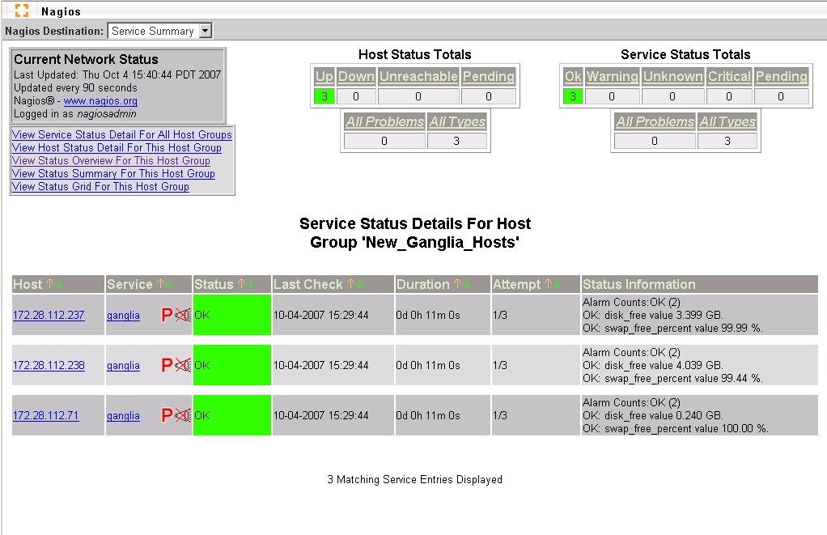
In this case, if any metric comprising the “ganglia” service for a host goes into the WARNING or CRITICAL state, the service will go into that state. If there are multiple metrics in alert, the state of the service is set to the highest severity. The service text will show the metrics that are in the WARNING or CRITICAL state with the last measurements. The consolidate_metrics_service_output_detail option in the check_ganglia.conf configuration file controls the level of detail that is displayed in the service output text.
In the above example, a low level of detail is shown — if OK, no metric measurements are shown and if non-OK, only the non-OK metrics and measurements are shown. If the high detail setting is chosen, the state and last value for every metric is shown. A standard, non-GroundWork Nagios configuration will only show 64 characters on the service output text. On a GroundWork Monitor implementation of Nagios, this field has been expanded to 2048 characters to accommodate this option.
The second option is to define a separate service for each metric. In this case, each Ganglia metric is defined as a service under the host, for example, “ganglia_cpu_wio”, “ganglia_cpu_sys”, “ganglia_load_1”, etc. The check_ganglia.pl script will send separate passive service results to Nagios for each metric in this case.
When choosing whether to consolidate, or to “roll” or “unroll” the Ganglia service checks in Nagios, note that there is a significant performance impact with unrolling the ganglia checks into multiple Nagios service checks. The next section details this further. Rolling all Ganglia checks into a single Nagios service check allows for simpler configuration and navigation, especially for large data centers. In contrast, using multiple service checks provides for greater granularity during alerting and reporting.

Performance Considerations
A number of factors influence the performance of the system. The primary driver is the number of Ganglia hosts that need to be monitored by the Nagios system. A corollary to this is the total number of services that the Nagios system needs to support. In testing various configurations, GroundWork has noticed the following potential bottlenecks in Nagios.
- A large number of services will cause Nagios to take a long time to verify or commit. GroundWork has observed this when the number of services is greater than 20,000.
- The Nagios command pipe, nagios.cmd, can only read and buffer a limited number of passive service check results at one time. If the internal buffer becomes full and Nagios stops reading the pipe, check_ganglia will delay while writing to this pipe. This can be partially remedied by setting a non-default value for the “External command buffer slots” option in Page 2 of the “Configuration → Control → Nagios main configuration” settings. The default value built into Nagios is 4096; a value of 16000 is more suitable for a very large site.
- Historically, there are other issues with the Nagios handling of a large volume of passive service checks that are outside the scope of this document; customers with a support contract can contact GroundWork for details and a workaround.
- Nagios can only process a limited number of state changes at any one time. State transitions from OK to CRITICAL appear to be especially problematic. Nagios 3.x will not process any other host or service checks when it is verifying a host alert. Depending on the host check command, the number of retries, and the retry interval, this can significantly delay Nagios updates when the number of down hosts is large.
Care must be taken so that passive check result messages do not overload the Nagios command pipe, causing a condition where the number of queued messages keeps increasing. In this case, Nagios may fall behind and never catch up. check_ganglia has several features that attempt to avoid this condition. The intent of these features is to minimize the number of service check results that are sent from check_ganglia to the Nagios command pipe for each poll, and to optimize the writing of results that do get sent to the command pipe.
- Passive service checks can be sent on every poll or only when a state has changed. This behavior is controlled by a pair of options in the config file:
send_updates_even_when_state_is_persistent
suppress_most_updates_for_persistent_non_okay_states
If the first of these options is disabled, either the state is OK or the second option is enabled, and the state has not changed, a passive service check will not be sent. The maximum_service_non_update_time parameter can be set so a service can be guaranteed an update within a defined time interval, even when the first and second options are set as described. This allows a periodic passive check to be submitted into Nagios even when the underlying state has not changed. Setting this latter option to less than the Nagios freshness check thresholds will ensure that results are submitted in time to avoid a false positive alarm, and still limit the latency to detect an error condition that prevents the host or service from sending data to Nagios.
- As stated in the previous section, you can consolidate the metrics into a single service or have a separate service for each metric. Using multiple metrics increases the overall services count and has a tendency to add additional delay into the Nagios verify and startup operations. In addition, multiple metrics also cause more passive results to be written to the Nagios command pipe and thus cause more service state changes to be processed.
- If the send_after_each_service option is set to “yes”, the daemon will write the passive service check results after each service state is processed. If it is set to “no”, it will write all service results at one time. We have found that the write time to the Nagios command pipe is minimized if this is set to “no”.
- A throttle parameter called throttle_state_change_threshold can be set to limit the number of state changes that are sent to Nagios at any one time. If this threshold is reached, check_ganglia will break the current batch of state change messages into smaller batches, insert each batch into the Nagios command pipe, wait the number of seconds specified in the throttle_state_change_threshold_wait parameter, and then transmit the next batch. This continues until all messages have been sent.
- The send_to_foundation option can be set to send the service check results directly to the Foundation database, avoiding Nagios altogether. Foundation can process state changes more quickly than Nagios, so this can be an option if the operator is using only the GroundWork-specific user interface components (Status Viewer and Event Console). Of course, this will render the Nagios web pages and notification engine unusable for Ganglia service checks, as they will be out of sync with the service checks data stream. Special setup for Nagios would be needed in this case so that Nagios would not feel starved for input on these services.
All of these options and several other operating parameters are documented in the check_ganglia.conf configuration file installed by the RPM. The initial settings in this file represent a good starting point and should be checked and adjusted as needed. Before you change values in this file, you may wish to first make a backup copy, to make it easy to refer to the original settings.

ganglia Database
The ganglia database contains the following tables:
- cluster – clusters monitored.
- clusterhost – relates clusters to hosts. Populated by configuration, and used for host thresholds.
- host – hosts monitored.
- hostinstance – relates hosts to clusters. Populated by check_ganglia. Has all the hosts Ganglia knows about.
- location – locations reference. Used only in limited ways — reserved for future use.
- metric – holds abstract metric definitions and default thresholds, to be copied as initial values when these metrics are applied during configuration to specific clusters or hosts.
- metricinstance – last metric state and value reported by check_ganglia.
- metricvalue – stores the actual metric thresholds to be applied, whether they are at the global default level, the cluster level, or the host level.
The metricvalue table should have been named metricthreshold, to better reflect its actual content. This situation will be corrected in a future update to this package.

ganglia Database (PostgreSQL version)
Each table's field structure is described below, along with basic data about its indexes and foreign keys. Not shown here is detail about the associated sequence objects that implement auto-incrementing of the respective ID columns when new rows are added to these tables.

PostgreSQL public.cluster Table
+-------------+----------+-------------------------------------------------------------+
| Column | Type | Modifiers |
+-------------+----------+-------------------------------------------------------------+
| clusterid | integer | not null default nextval('cluster_clusterid_seq'::regclass) |
| name | text | not null |
| description | text | |
| regex | smallint | |
+-------------+----------+-------------------------------------------------------------+
Indexes:
"cluster_pkey" PRIMARY KEY, btree (clusterid)
"cluster_name_key" UNIQUE CONSTRAINT, btree (name)
Referenced by:
TABLE "clusterhost" CONSTRAINT "clusterhost_clusterfk" FOREIGN KEY (clusterid) REFERENCES cluster(clusterid) ON UPDATE RESTRICT ON DELETE RESTRICT
TABLE "hostinstance" CONSTRAINT "hostinstance_clusterfk" FOREIGN KEY (clusterid) REFERENCES cluster(clusterid) ON UPDATE RESTRICT ON DELETE RESTRICT
TABLE "metricvalue" CONSTRAINT "metricvalue_clusterfk" FOREIGN KEY (clusterid) REFERENCES cluster(clusterid) ON UPDATE RESTRICT ON DELETE RESTRICT

PostgreSQL public.clusterhost Table
+---------------+---------+---------------------------------------------------------------------+
| Column | Type | Modifiers |
+---------------+---------+---------------------------------------------------------------------+
| clusterhostid | integer | not null default nextval('clusterhost_clusterhostid_seq'::regclass) |
| clusterid | integer | not null |
| hostid | integer | not null |
+---------------+---------+---------------------------------------------------------------------+
Indexes:
"clusterhost_pkey" PRIMARY KEY, btree (clusterhostid)
"clusterhost_hostid_clusterid_key" UNIQUE CONSTRAINT, btree (hostid, clusterid)
"clusterhost_clusterhost_clusterfk" btree (clusterid)
"clusterhost_clusterhost_hostfk" btree (hostid)
Foreign-key constraints:
"clusterhost_clusterfk" FOREIGN KEY (clusterid) REFERENCES cluster(clusterid) ON UPDATE RESTRICT ON DELETE RESTRICT
"clusterhost_hostfk" FOREIGN KEY (hostid) REFERENCES host(hostid) ON UPDATE RESTRICT ON DELETE RESTRICT

PostgreSQL public.host Table
+-------------+-----------------------+-------------------------------------------------------+
| Column | Type | Modifiers |
+-------------+-----------------------+-------------------------------------------------------+
| hostid | integer | not null default nextval('host_hostid_seq'::regclass) |
| name | text | not null |
| ipaddress | character varying(45) | |
| description | text | |
| regex | smallint | |
+-------------+-----------------------+-------------------------------------------------------+
Indexes:
"host_pkey" PRIMARY KEY, btree (hostid)
"host_name_key" UNIQUE CONSTRAINT, btree (name)
Referenced by:
TABLE "clusterhost" CONSTRAINT "clusterhost_hostfk" FOREIGN KEY (hostid) REFERENCES host(hostid) ON UPDATE RESTRICT ON DELETE RESTRICT
TABLE "hostinstance" CONSTRAINT "hostinstance_hostfk" FOREIGN KEY (hostid) REFERENCES host(hostid) ON UPDATE RESTRICT ON DELETE RESTRICT
TABLE "metricvalue" CONSTRAINT "metricvalue_hostfk" FOREIGN KEY (hostid) REFERENCES host(hostid) ON UPDATE RESTRICT ON DELETE RESTRICT

PostgreSQL public.hostinstance Table
+----------------+---------+-----------------------------------------------------------------------+
| Column | Type | Modifiers |
+----------------+---------+-----------------------------------------------------------------------+
| hostinstanceid | integer | not null default nextval('hostinstance_hostinstanceid_seq'::regclass) |
| clusterid | integer | not null |
| hostid | integer | not null |
| locationid | integer | not null |
+----------------+---------+-----------------------------------------------------------------------+
Indexes:
"hostinstance_pkey" PRIMARY KEY, btree (hostinstanceid)
"hostinstance_hostid_clusterid_key" UNIQUE CONSTRAINT, btree (hostid, clusterid)
"hostinstance_hostinstance_clusterfk" btree (clusterid)
"hostinstance_hostinstance_hostfk" btree (hostid)
"hostinstance_hostinstance_locationfk" btree (locationid)
Foreign-key constraints:
"hostinstance_clusterfk" FOREIGN KEY (clusterid) REFERENCES cluster(clusterid) ON UPDATE RESTRICT ON DELETE RESTRICT
"hostinstance_hostfk" FOREIGN KEY (hostid) REFERENCES host(hostid) ON UPDATE RESTRICT ON DELETE RESTRICT
"hostinstance_locationfk" FOREIGN KEY (locationid) REFERENCES location(locationid) ON UPDATE RESTRICT ON DELETE RESTRICT
Referenced by:
TABLE "metricinstance" CONSTRAINT "metricinstance_hostinstancefk" FOREIGN KEY (hostinstanceid) REFERENCES hostinstance(hostinstanceid) ON UPDATE RESTRICT ON DELETE RESTRICT

PostgreSQL public.location Table
+-------------+----------+---------------------------------------------------------------+
| Column | Type | Modifiers |
+-------------+----------+---------------------------------------------------------------+
| locationid | integer | not null default nextval('location_locationid_seq'::regclass) |
| name | text | not null |
| description | text | |
| regex | smallint | |
+-------------+----------+---------------------------------------------------------------+
Indexes:
"location_pkey" PRIMARY KEY, btree (locationid)
"location_name_key" UNIQUE CONSTRAINT, btree (name)
Referenced by:
TABLE "hostinstance" CONSTRAINT "hostinstance_locationfk" FOREIGN KEY (locationid) REFERENCES location(locationid) ON UPDATE RESTRICT ON DELETE RESTRICT
TABLE "metricvalue" CONSTRAINT "metricvalue_locationfk" FOREIGN KEY (locationid) REFERENCES location(locationid) ON UPDATE RESTRICT ON DELETE RESTRICT

PostgreSQL public.metric Table
+-------------+-----------------------+-----------------------------------------------------------+
| Column | Type | Modifiers |
+-------------+-----------------------+-----------------------------------------------------------+
| metricid | integer | not null default nextval('metric_metricid_seq'::regclass) |
| name | text | not null |
| description | text | |
| units | character varying(45) | |
| critical | numeric(64,10) | |
| warning | numeric(64,10) | |
| duration | numeric(64,10) | |
+-------------+-----------------------+-----------------------------------------------------------+
Indexes:
"metric_pkey" PRIMARY KEY, btree (metricid)
"metric_name_key" UNIQUE CONSTRAINT, btree (name)
Referenced by:
TABLE "metricinstance" CONSTRAINT "metricinstance_metricfk" FOREIGN KEY (metricid) REFERENCES metric(metricid) ON UPDATE RESTRICT ON DELETE RESTRICT
TABLE "metricvalue" CONSTRAINT "metricvalue_metricfk" FOREIGN KEY (metricid) REFERENCES metric(metricid) ON UPDATE RESTRICT ON DELETE RESTRICT

PostgreSQL public.metricinstance Table
+---------------------+---------+---------------------------------------------------------------------------+
| Column | Type | Modifiers |
+---------------------+---------+---------------------------------------------------------------------------+
| metricinstanceid | integer | not null default nextval('metricinstance_metricinstanceid_seq'::regclass) |
| hostinstanceid | integer | not null |
| metricid | integer | not null |
| description | text | |
| laststate | text | |
| lastupdatetime | integer | not null |
| laststatechangetime | integer | not null |
| lastvalue | text | |
+---------------------+---------+---------------------------------------------------------------------------+
Indexes:
"metricinstance_pkey" PRIMARY KEY, btree (metricinstanceid)
"metricinstance_hostinstanceid_metricid_key" UNIQUE CONSTRAINT, btree (hostinstanceid, metricid)
"metricinstance_metricinstance_hostinstancefk" btree (hostinstanceid)
"metricinstance_metricinstance_metricfk" btree (metricid)
Foreign-key constraints:
"metricinstance_hostinstancefk" FOREIGN KEY (hostinstanceid) REFERENCES hostinstance(hostinstanceid) ON UPDATE RESTRICT ON DELETE RESTRICT
"metricinstance_metricfk" FOREIGN KEY (metricid) REFERENCES metric(metricid) ON UPDATE RESTRICT ON DELETE RESTRICT

PostgreSQL public.metricvalue Table
+---------------+----------------+---------------------------------------------------------------------+
| Column | Type | Modifiers |
+---------------+----------------+---------------------------------------------------------------------+
| metricvalueid | integer | not null default nextval('metricvalue_metricvalueid_seq'::regclass) |
| clusterid | integer | not null |
| hostid | integer | not null |
| locationid | integer | not null |
| metricid | integer | not null |
| description | text | |
| critical | numeric(64,10) | |
| warning | numeric(64,10) | |
| duration | numeric(64,10) | |
+---------------+----------------+---------------------------------------------------------------------+
Indexes:
"metricvalue_pkey" PRIMARY KEY, btree (metricvalueid)
"metricvalue_hostid_clusterid_metricid_key" UNIQUE CONSTRAINT, btree (hostid, clusterid, metricid)
"metricvalue_metricvalue_clusterfk" btree (clusterid)
"metricvalue_metricvalue_hostfk" btree (hostid)
"metricvalue_metricvalue_locationfk" btree (locationid)
"metricvalue_metricvalue_metricfk" btree (metricid)
Foreign-key constraints:
"metricvalue_clusterfk" FOREIGN KEY (clusterid) REFERENCES cluster(clusterid) ON UPDATE RESTRICT ON DELETE RESTRICT
"metricvalue_hostfk" FOREIGN KEY (hostid) REFERENCES host(hostid) ON UPDATE RESTRICT ON DELETE RESTRICT
"metricvalue_locationfk" FOREIGN KEY (locationid) REFERENCES location(locationid) ON UPDATE RESTRICT ON DELETE RESTRICT
"metricvalue_metricfk" FOREIGN KEY (metricid) REFERENCES metric(metricid) ON UPDATE RESTRICT ON DELETE RESTRICT

ganglia Database (MySQL version)
Each table's field structure is described below, along with basic data about its indexes.

MySQL cluster Table
+-------------+------------------+------+-----+---------+----------------+
| Field | Type | Null | Key | Default | Extra |
+-------------+------------------+------+-----+---------+----------------+
| ClusterID | int(11) unsigned | NO | PRI | NULL | auto_increment |
| Name | text | NO | | | |
| Description | text | YES | | NULL | |
| Regex | tinyint(1) | YES | | NULL | |
+-------------+------------------+------+-----+---------+----------------+

+---------+------------+----------+--------------+-------------+-----------+
| Table | Non_unique | Key_name | Seq_in_index | Column_name | Collation |
+---------+------------+----------+--------------+-------------+-----------+
| cluster | 0 | PRIMARY | 1 | ClusterID | A |
+---------+------------+----------+--------------+-------------+-----------+

MySQL clusterhost Table
+---------------+------------------+------+-----+---------+----------------+
| Field | Type | Null | Key | Default | Extra |
+---------------+------------------+------+-----+---------+----------------+
| ClusterHostID | int(11) unsigned | NO | PRI | NULL | auto_increment |
| ClusterID | int(11) unsigned | NO | MUL | | |
| HostID | int(11) unsigned | NO | MUL | | |
+---------------+------------------+------+-----+---------+----------------+

+-------------+------------+-----------------------+--------------+---------------+-----------+
| Table | Non_unique | Key_name | Seq_in_index | Column_name | Collation |
+-------------+------------+-----------------------+--------------+---------------+-----------+
| clusterhost | 0 | PRIMARY | 1 | ClusterHostID | A |
| clusterhost | 1 | ClusterHost_ClusterFK | 1 | ClusterID | A |
| clusterhost | 1 | ClusterHost_HostFK | 1 | HostID | A |
+-------------+------------+-----------------------+--------------+---------------+-----------+

MySQL host Table
+-------------+------------------+------+-----+---------+----------------+
| Field | Type | Null | Key | Default | Extra |
+-------------+------------------+------+-----+---------+----------------+
| HostID | int(11) unsigned | NO | PRI | NULL | auto_increment |
| Name | text | NO | | | |
| IPAddress | varchar(45) | YES | | NULL | |
| Description | text | YES | | NULL | |
| Regex | tinyint(1) | YES | | NULL | |
+-------------+------------------+------+-----+---------+----------------+

+-------+------------+----------+--------------+-------------+-----------+
| Table | Non_unique | Key_name | Seq_in_index | Column_name | Collation |
+-------+------------+----------+--------------+-------------+-----------+
| host | 0 | PRIMARY | 1 | HostID | A |
+-------+------------+----------+--------------+-------------+-----------+

MySQL hostinstance Table
+----------------+------------------+------+-----+---------+----------------+
| Field | Type | Null | Key | Default | Extra |
+----------------+------------------+------+-----+---------+----------------+
| HostInstanceID | int(11) unsigned | NO | PRI | NULL | auto_increment |
| ClusterID | int(11) unsigned | NO | MUL | | |
| HostID | int(11) unsigned | NO | MUL | | |
| LocationID | int(11) unsigned | NO | MUL | | |
+----------------+------------------+------+-----+---------+----------------+

+--------------+------------+-------------------------+--------------+----------------+-----------+
| Table | Non_unique | Key_name | Seq_in_index | Column_name | Collation |
+--------------+------------+-------------------------+--------------+----------------+-----------+
| hostinstance | 0 | PRIMARY | 1 | HostInstanceID | A |
| hostinstance | 1 | HostInstance_ClusterFK | 1 | ClusterID | A |
| hostinstance | 1 | HostInstance_HostFK | 1 | HostID | A |
| hostinstance | 1 | HostInstance_LocationFK | 1 | LocationID | A |
+--------------+------------+-------------------------+--------------+----------------+-----------+

MySQL location Table
+-------------+------------------+------+-----+---------+----------------+
| Field | Type | Null | Key | Default | Extra |
+-------------+------------------+------+-----+---------+----------------+
| LocationID | int(11) unsigned | NO | PRI | NULL | auto_increment |
| Name | text | NO | | | |
| Description | text | YES | | NULL | |
| Regex | tinyint(1) | YES | | NULL | |
+-------------+------------------+------+-----+---------+----------------+

+----------+------------+----------+--------------+-------------+-----------+
| Table | Non_unique | Key_name | Seq_in_index | Column_name | Collation |
+----------+------------+----------+--------------+-------------+-----------+
| location | 0 | PRIMARY | 1 | LocationID | A |
+----------+------------+----------+--------------+-------------+-----------+

MySQL metric Table
+-------------+------------------+------+-----+---------+----------------+
| Field | Type | Null | Key | Default | Extra |
+-------------+------------------+------+-----+---------+----------------+
| MetricID | int(11) unsigned | NO | PRI | NULL | auto_increment |
| Name | text | NO | | | |
| Description | text | YES | | NULL | |
| Units | varchar(45) | YES | | NULL | |
| Critical | decimal(64,10) | YES | | NULL | |
| Warning | decimal(64,10) | YES | | NULL | |
| Duration | decimal(64,10) | YES | | NULL | |
+-------------+------------------+------+-----+---------+----------------+

+--------+------------+----------+--------------+-------------+-----------+
| Table | Non_unique | Key_name | Seq_in_index | Column_name | Collation |
+--------+------------+----------+--------------+-------------+-----------+
| metric | 0 | PRIMARY | 1 | MetricID | A |
+--------+------------+----------+--------------+-------------+-----------+

MySQL metricinstance Table
+---------------------+------------------+------+-----+---------+----------------+
| Field | Type | Null | Key | Default | Extra |
+---------------------+------------------+------+-----+---------+----------------+
| MetricInstanceID | int(11) unsigned | NO | PRI | NULL | auto_increment |
| HostInstanceID | int(11) unsigned | NO | MUL | | |
| MetricID | int(11) unsigned | NO | MUL | | |
| Description | text | YES | | NULL | |
| LastState | text | YES | | NULL | |
| LastUpdateTime | int(11) unsigned | NO | | | |
| LastStateChangeTime | int(11) unsigned | NO | | | |
| LastValue | text | YES | | NULL | |
+---------------------+------------------+------+-----+---------+----------------+

+----------------+------------+-------------------------------+--------------+------------------+-----------+
| Table | Non_unique | Key_name | Seq_in_index | Column_name | Collation |
+----------------+------------+-------------------------------+--------------+------------------+-----------+
| metricinstance | 0 | PRIMARY | 1 | MetricInstanceID | A |
| metricinstance | 1 | MetricInstance_HostInstanceFK | 1 | HostInstanceID | A |
| metricinstance | 1 | MetricInstance_MetricFK | 1 | MetricID | A |
+----------------+------------+-------------------------------+--------------+------------------+-----------+

MySQL metricvalue Table
+---------------+------------------+------+-----+---------+----------------+
| Field | Type | Null | Key | Default | Extra |
+---------------+------------------+------+-----+---------+----------------+
| MetricValueID | int(11) unsigned | NO | PRI | NULL | auto_increment |
| ClusterID | int(11) unsigned | NO | MUL | | |
| HostID | int(11) unsigned | NO | MUL | | |
| LocationID | int(11) unsigned | NO | MUL | | |
| MetricID | int(11) unsigned | NO | MUL | | |
| Description | text | YES | | NULL | |
| Critical | decimal(64,10) | YES | | NULL | |
| Warning | decimal(64,10) | YES | | NULL | |
| Duration | decimal(64,10) | YES | | NULL | |
+---------------+------------------+------+-----+---------+----------------+

+-------------+------------+------------------------+--------------+---------------+-----------+
| Table | Non_unique | Key_name | Seq_in_index | Column_name | Collation |
+-------------+------------+------------------------+--------------+---------------+-----------+
| metricvalue | 0 | PRIMARY | 1 | MetricValueID | A |
| metricvalue | 1 | MetricValue_ClusterFK | 1 | ClusterID | A |
| metricvalue | 1 | MetricValue_HostFK | 1 | HostID | A |
| metricvalue | 1 | MetricValue_LocationFK | 1 | LocationID | A |
| metricvalue | 1 | MetricValue_MetricFK | 1 | MetricID | A |
+-------------+------------+------------------------+--------------+---------------+-----------+

Ganglia Web Interface
The Ganglia web interface consists of two parts.

Threshold Configuration
Configuration of thresholds within the ganglia database is controlled by the GangliaConfigAdmin.cgi CGI Perl script. Settings for this script are defined in the GangliaConfigAdmin.conf file (see Section 4.1.2, Ganglia Threshold Administration Configuration, on page 30). The following functions are available in this interface.
- Define the Ganglia metrics to be monitored, by adding the metric names to the database. Each configured name must exactly match the corresponding Ganglia metric name.
- Define the clusters to be monitored, by adding the cluster names to the database. This setup should match the set of ganglia_cluster definitions you specify separately in the check_ganglia.conf file.
- Define hosts to be monitored. Hosts are automatically added to the ganglia database by check_ganglia. This allows you to modify a host’s settings by selecting from a list of existing hosts. check_ganglia will also put the host’s configuration information in the host description field.
- Define the Warning, Critical, and Duration thresholds for each metric.
  - You must define metric thresholds for the “Default” cluster. These are global, default settings which will apply if there are no other settings defined at the cluster or host level.
  - You may define metric thresholds for a specific cluster. These settings will override the default cluster settings. These settings are overridden by host metric thresholds, if they exist.
  - You may define metric thresholds for a specific host. These settings will override the default or specific cluster settings.
  - Be sure to specify threshold values that make sense for the metric. In some cases, you may want the metric value to normally be above a certain level, and to alert you when it falls below the thresholds you specify. In this case, simply set the Warning threshold higher than the Critical threshold, and this setup will properly analyze the state.
- You may also delete clusters, hosts, or metrics from the ganglia database. Note that this will not affect Monarch or Nagios, until and unless autoimport.pl is run.

Access to Ganglia Web Servers
The Ganglia Integration Module provides a simple way to access the web interface provided by Ganglia itself, without exiting the GroundWork Monitor environment. The Ganglia Views tab presents a list of Ganglia web servers, whose hostnames and access URLs are configured in the GangliaWebServers.conf file (see Section 4.1.3, Ganglia Web Server Viewing Configuration, on page 31). The GangliaWebServers.cgi script uses this configuration data to present a screen with links to the Ganglia servers; web pages from those servers are presented in a frame beneath these links.

Auto-Import
The majority of Ganglia implementations are large. One of the big advantages of Ganglia is its ability to monitor a large infrastructure. Integrating it with Nagios has therefore traditionally been difficult, because of the extremely tedious process of creating all those host and service definitions. One of the great things about GroundWork Monitor, though, is that we can import host definitions and automatically assign service profiles. The auto-import script does that, both for Ganglia and for Cacti, though of course here we are dealing only with Ganglia. You can run the auto-import script as a regularly scheduled (cron) job on the GroundWork server, or as needed, manually.
The auto-import process is shown in the following diagram.
The auto-import script optionally reads the ganglia database to find the current hosts that are in the Ganglia XML stream, and optionally reads the cacti database to find the current hosts known to Cacti. It also queries the monarch database to determine the hosts currently defined in the Nagios system. For hosts in Ganglia but not in Nagios, the script will add the new host to Monarch using the hostname and IP address determined from the Ganglia XML, and matching that stored in the ganglia database. A default host profile must be specified in the autoimport.conf configuration file. This host profile, which defines the services to be applied to a host, is then applied to each imported host. This host profile must be pre-defined in Monarch. You can easily create this profile via the Monarch GUI. Note that the default host profile must have a one-to-one correspondence with the type of service checks set in the check_ganglia configuration — a single service check for all Ganglia metrics, or a separate service check definition for each metric. The auto-import script will also optionally assign the host to a default “New_Ganglia_Hosts” hostgroup. This host group must also be pre-defined.
reconciles monarch, ganglia, and cacti databases;
updates monarch database; syncs with GWCollageDB;
adds Ganglia hosts with ganglia service;
adds Cacti hosts with a Cacti profile
service
status
tracking
creates Nagios
configuration files and
re-loads Nagios
(commits changes)
Auto-Import
host ganglia service
Nagios
host ganglia service
host ganglia service
host ganglia service
monarch database
* Nagios configuration
display
control
display
control

ganglia database
* current metric state
* thresholds
* host configurations

Ganglia configuration
administration
Cacti configuration
administration

cacti database
* current metric state
* thresholds
* host configurations

GWCollageDB database
* Grid configuration

If a host known to Ganglia is to be deleted from Nagios with Monarch, it must also be deleted from the ganglia database using the Ganglia Threshold Configuration web interface. If not, the host will be added back to Monarch the next time auto-import executes.
If a host is in Monarch, but is no longer in the Ganglia database, the host is optionally assigned by auto-import to a “deleted hosts” host group. Collecting all such hosts together in one place this way allows you to manually delete hosts more easily by reviewing the hosts in this host group.
Certain special features are configurable in the autoimport.conf file (see Section 4.3, Auto-Import Configuration, on page 40). These include:
- Assignment of hosts to custom non-default hostgroups, with the assigned hostgroup for each host derived from the host name (and possibly external data, not part of auto-import itself).
- Application of non-default host profiles named after the Ganglia clusters in which the hosts reside, instead of using a single default host profile for all hosts. (This can simplify administration, for instance, if cluster boundaries correspond to functional or machine-type groupings.)
- Selection of whether Ganglia hosts or Cacti hosts (or both) are to be auto-imported. A site would choose to ignore importing from Cacti, for instance, if no Cacti monitoring were configured.

Administration
The administration tasks for the Ganglia Integration Module are described in this section.

Ganglia-Related Configuration

Check Ganglia Configuration
The following parameters control the options in the check_ganglia.pl script (see Section 3.1, Check Ganglia and Nagios, on page 14). These are found in the check_ganglia.conf file, and represent a common starting point. To configure the check_ganglia.pl script, simply edit this file in /usr/local/groundwork/config/, and restart gwservices.
# Configuration file for the check_ganglia.pl script.

#######################################################
#
# General Program Execution Options
#
#######################################################

# Process Ganglia XML streams? If not, just sleep forever.
# This option is turned off (the value "no", but without quotes) in the default
# configuration file simply so the script can be safely installed before it is
# locally configured. To get the software to run, it must be turned on here
# (the value "yes", but without quotes) once the rest of the setup is correct
# for your site.
enable_processing = no

# Auto-flush the logging output.
# no = normal processing, for efficiency
# yes = autoflush the log output on every single write, for debugging mysterious failures
autoflush_log_output = no

# Global Debug Level Flag; No debug = 0, Statistics = 5, Normal debug = 6,
# Detail debug = 7 (gmond XML and metric attribute parsing)
# More precisely, specify one of the following numbers:
# NONE = 0; turn off all debug info
# FATAL = 1; the application is about to die
# ERROR = 2; the application has found a serious problem, but will attempt to recover
# WARNING = 3; the application has found an anomaly, but will try to handle it
# NOTICE = 4; the application wants to inform you of a significant event
# STATS = 5; the application wants to log statistical data for later analysis
# INFO = 6; the application wants to log a potentially interesting event
# DEBUG = 7; the application wants to log detailed debugging data
debug_level = 5

# Send to Nagios?
# [yes/no]
send_to_nagios = yes

# Send updates to the database and Nagios even when the state does not change?
# (If not, update in any case on the next iteration after maximum_service_non_update_time.)
# [yes/no]
send_updates_even_when_state_is_persistent = no

# Avoid sending updates to the database and Nagios when the state is not changing?
# (Even if so, send them in any case on the next iteration after maximum_service_non_update_time.)
# [yes/no]
suppress_most_updates_for_persistent_non_okay_states = yes

# Absolute pathname of the Nagios command pipe.
nagios_cmd_pipe = "/usr/local/groundwork/nagios/var/spool/nagios.cmd"

# Consolidate metric results?
# no = send individual metric results
# yes = send all metric results as a single service
consolidate_metrics = yes

# Service name used for consolidated metrics.
consolidate_metrics_service_name = "ganglia"

# Detail for metric service output.
# [yes/no]; yes = show more detail, no = low detail
consolidate_metrics_service_output_detail = yes

# How to group writes of service results to Nagios.
# no = send all results in a single write
# yes = send to Nagios after each service result
send_after_each_service = no

# How to select the part of a hostname to report out, if the host is not an IP address.
# This pattern must include exactly one part enclosed in parentheses.
# If you don't want any hostname stripping, set this pattern to "".
# For example, to strip the full domain, and only use an unqualified name, use:
# short_hostname_pattern = "(\S+?)\."
short_hostname_pattern = ""

# What external package to call to process custom metrics.
# Set to an empty string if you have no such external package.
# If you don't know what these are, set this to "".
custom_metrics_package = ""

# Output a warning if the host has rebooted since the last reporting cycle?
output_reboot_warning = yes

# Set to the number of seconds to continue to report a reboot warning, if $output_reboot_warning is set.
# Anything shorter than the value for cycle_time (below) is effectively equal to zero.
# Simple arithmetic (e.g., 5*60) is allowed in this expression.
output_reboot_warning_duration = 10*60

# Output the mem_free_percent calculated metric?
output_mem_free_percent = no

# Output the mem_cached_percent calculated metric?
output_mem_cached_percent = no

# Output the swap_free_percent calculated metric?
output_swap_free_percent = yes

# Output the time since Ganglia received an update for each host?
output_time_since_last_update = yes

#######################################################
#
# Performance Throttling Parameters
#
#######################################################

# Time interval for each ganglia poll, in seconds.
# Standard period is 5 minutes.
# Simple arithmetic (e.g., 5*60) is allowed in this expression.
cycle_time = 5*60

# Maximum time interval in seconds between service checks sent to Nagios.
# That is, we will always send a service check result to Nagios on the next
# iteration after this time period has elapsed.
# Simple arithmetic (e.g., 15*60) is allowed in this expression.
maximum_service_non_update_time = 10*60

# Maximum number of state changes that will be sent for each write to Nagios.
# If the number of outstanding state changes is greater than this, check_ganglia
# will wait for throttle_state_change_threshold_wait seconds before sending the
# remaining messages.
throttle_state_change_threshold = 500

# When throttle_state_change_threshold is exceeded, time in seconds to wait
# before sending the remaining state change message buffer.
# Simple arithmetic (e.g., 2*60) is allowed in this expression.
throttle_state_change_threshold_wait = 6

# The number of slots to pre-allocate for queueing Nagios service messages
# before they are sent to the command pipe. This number should be a little
# more than the total number of hosts in your grid.
initial_bulk_messages_size = 15000

# The number of slots to pre-allocate for queueing metric-instance update rows before
# they are sent to the database. This number should be a little more than the total
# number of metrics you expect to process in each cycle. Bear in mind that you will
# typically have configured at least several metrics to be thresholded per host.
initial_metric_values_size = 100000

# The maximum number of metric value rows you want to have updated in one database
# statement. For efficient updates, it should be at least several thousand.
max_bulk_update_rows = 5000

# The maximum time in seconds to wait for any single write to the output command pipe
# to complete.
max_command_pipe_wait_time = 3*60

# The maximum size in bytes for any single write operation to the output command pipe.
# The value chosen here must be no larger than PIPE_BUF (getconf -a | fgrep PIPE_BUF)
# on your platform, unless you have an absolute guarantee that no other process will
# ever write to the command pipe.
max_command_pipe_write_size = 4096

# Send a check_ganglia service check result at the end of each polling cycle?
# [yes/no]
send_check_ganglia_service_check = yes

#######################################################
#
# Ganglia Parameters
#
#######################################################

# Where to talk to the Ganglia gmond to fetch node-state data.
# Default gmond port is 8649.
GANGLIA_GMOND_PORT = 8649

# Where to talk to the Ganglia gmetad to fetch node-state data.
# Default gmetad port is 8651.
GANGLIA_GMETAD_PORT = 8651

# List of Ganglia gmond or gmetad hosts to query.
# For convenience, to disable a given entry you need only comment out
# its port definition, not the entire <host ...></host> block.
# You may also refer to symbols defined above, like $GANGLIA_GMOND_PORT,
# to document your choices.
<ganglia_hosts>

<host localhost>
port = $GANGLIA_GMOND_PORT
</host>
<host mygmetadhost>
# port = $GANGLIA_GMETAD_PORT
</host>
<host 192.168.1.99>
# port = 8648
</host>

</ganglia_hosts>

# Clusters to monitor.
# Define as many as you need, on separate lines; enclose each value in "double quotes".
# If you define some ganglia_cluster values here, only the clusters listed will be monitored.
# If you don't define any ganglia_cluster values, then all clusters will be monitored.
# Examples:
# ganglia_cluster = "GroundWork Cluster 002"
# ganglia_cluster = "GroundWork Compute Farm"
ganglia_cluster = "GroundWork Cluster 001"

# Ganglia thresholds database connection parameters.
# ganglia_dbtype can be either "mysql" or "postgresql".
ganglia_dbtype = "postgresql"
ganglia_dbhost = "localhost"
ganglia_dbname = "ganglia"
ganglia_dbuser = "ganglia"
ganglia_dbpass = "gwrk"

#######################################################
#
# Foundation Options (used if send_to_foundation=yes)
#
#######################################################

# Send host/service status updates to Foundation?
# [yes/no]
send_to_foundation = no

# This monitoring server name; used as update content (message source).
this_server = "localhost"

# Where to connect to Foundation to send the updates.
# Usual foundation_port is 4913.
foundation_host = "localhost"
foundation_port = 4913

Ganglia Threshold Administration Configuration
The following parameters control the options in the GangliaConfigAdmin.cgi script (see Section 3.4.1, Threshold Configuration, on page 24). These are found in the GangliaConfigAdmin.conf file. You will need to adjust the database-access parameters in this file to match your local site. To configure this user interface, simply edit this file in /usr/local/groundwork/config/.
# Configuration file for the GangliaConfigAdmin.cgi script.

#######################################################
#
# General Program Execution Options
#
#######################################################

# Global Debug Level Flag.
# 0 = no debug output
# 1 = Normal debug output
debug_level = 0

# The max number of hosts to process in one DELETE statement. (This just puts a limit on
# a single statement; repeated statements will still be used to process longer lists.)
max_delete_hosts = 1000

# Ganglia thresholds database connection parameters.
# ganglia_dbtype can be either "mysql" or "postgresql".
ganglia_dbtype = "postgresql"
ganglia_dbhost = "localhost"
ganglia_dbname = "ganglia"
ganglia_dbuser = "ganglia"
ganglia_dbpass = "gwrk"

Ganglia Web Server Viewing Configuration
The following parameters control the options in the GangliaWebServers.cgi script (see Section 3.4.2, Access to Ganglia Web Servers, on page 24). These are found in the GangliaWebServers.conf file. You will need to adjust the set of Ganglia web server hosts and their respective URLs to specify the ones you want to make available through the GroundWork Monitor UI. To configure this user interface, simply edit this file in /usr/local/groundwork/config/.
Most likely, you will want to choose one entry as the default Ganglia Web Server, so it shows up automatically when this screen is first displayed. Use the default specification for that, as described in the configuration file comments.
# Configuration file for the GangliaWebServers.cgi script.

#######################################################
#
# General Program Execution Options
#
#######################################################

# Global Debug Level Flag.
# 0 = no debug output
# 1 = Normal debug output
debug_level = 0

# List of Ganglia web servers to allow access to.
#
# For convenience, to disable a given entry you need only comment out
# its url definition, not the entire <host ...></host> block.
#
# If exactly one entry with an active url definition has "default = true" as
# part of its entry, then that entry's Ganglia web server page will appear
# automatically when the screen is first opened. Otherwise, the screen's
# enclosed frame will initially be blank, and the user will need to manually
# select a link for an initial Ganglia web server page to appear.
#
<ganglia_web_servers>

<host work>
url = "http://work/ganglia/"
</host>
<host geco-15-4>
url = "http://geco-15-4/ganglia/"
default = true
</host>
<host mygmetadhost>
# url = "http://mygmetadhost/ganglia/"
</host>
<host 192.168.1.99>
# url = "http://192.168.1.99/ganglia/"
default = false
</host>

</ganglia_web_servers>

Ganglia Portal Access Permissions
The GroundWork 6.4.0 environment uses the JBoss authentication/authorization facilities for controlling access to the elements within the top-level Ganglia tab within GroundWork Monitor, just as it does for other facilities within the base product. By default, a fresh installation allows access only to users with the GWAdmin role. However, it may be helpful to allow operators (who are not GroundWork Monitor administrators) access to the Ganglia → Ganglia Views page, for quick access to the data the Ganglia web servers can present, while still preventing them from accessing the Ganglia → Ganglia Thresholds page.
The Ganglia Integration Module makes the following objects accessible to an administrator under the Administration tab, for modifying access permissions as needed in the local environment.
- Portal Management → Portal Objects → groundwork-monitor → ganglia-integration
- Portal Management → Portal Objects → groundwork-monitor → ganglia-integration → ganglia-thresholds
- Portal Management → Portal Objects → groundwork-monitor → ganglia-integration → ganglia-views
The following additional objects are provided by the Ganglia Integration Module. Do not change the settings on these objects without first consulting with GroundWork Support.
- Portal Management → Portlet Instances → GWGangliaThresholdsInstance
- Portal Management → Portlet Instances → GWGangliaViewsInstance
- Portal Management → Portlet Definitions → Ganglia Metric Threshold Configuration Portlet
- Portal Management → Portlet Definitions → Ganglia Web Server Views Portlet
The steps needed to modify any of these objects are beyond the scope of this document. For details, see the PORTAL ADMINISTRATION section of the Bookshelf within GroundWork Monitor.

Ganglia Database Administration

Defining Thresholds
To set up monitoring of Ganglia metrics via thresholds, you will need to:
- define them, and
- apply them to the clusters, hosts, and metrics that Ganglia is now collecting for you.
The minimal steps required are:
- Add a metric name for each metric you want to monitor. If special (derived, boot time, or custom) metrics are defined and enabled, you have to add them as well if you want them to be monitored.
- Select the Default cluster, which contains the global default threshold settings.
- Add the metric names you want to monitor to the Default cluster, and define the Warning, Critical, and Duration thresholds for them.
You can also create more specific thresholds which apply to individual clusters and hosts.
- Add specific clusters.
- Select the cluster, and add the metrics for which you want to override the Default cluster settings for this specific cluster.
- Define the Warning, Critical, and Duration thresholds for each cluster-level override of the global settings.
- Optionally, add or select specific hosts.
- Select the cluster in which this host is defined (i.e., set the Threshold Cluster for the host) and update the host.
- Add the metrics for which you want to override the Default and specific-cluster settings.
- Define the Warning, Critical, and Duration thresholds for each host-level override of the global and cluster-level settings.
Some things to remember:
- The metric names have to match those from Ganglia exactly. It's a good idea to have the Ganglia web interface up while you work on the thresholds, so you can see the precise format of the metrics and define the thresholds in ways that make sense. Accessing GroundWork Monitor through several windows in the same browser is supported in current GWMEE releases. So if you want, you can access the Ganglia Web Server pages through the Ganglia → Ganglia Views screen.
- Warning thresholds and critical thresholds can be high or low, so make sure you see the metric values and alert on them properly. If the warning threshold is less than or equal to the critical threshold, you will get an alarm when the value rises. If the warning threshold is greater than the critical threshold, you will get an alarm when the value falls.
- The units of measure are important for thresholds. For example, the disk_free metric is in gigabytes by default. If you want an alarm when you have 500 megabytes left, set the threshold to 0.5.
- Duration thresholds are specified in seconds.
The remainder of this section walks through setting up thresholds on a few metrics to get you started. There is also help in the form of tool tips and a help page, but It's probably a good idea to read this section first and make sure you understand how to set up thresholds before just diving in. Once you are familiar with the tasks involved, the tool tips will serve to remind you of what to do and how to use the more advanced features.
The initial screen of the Ganglia threshold-configuration web interface is shown below.
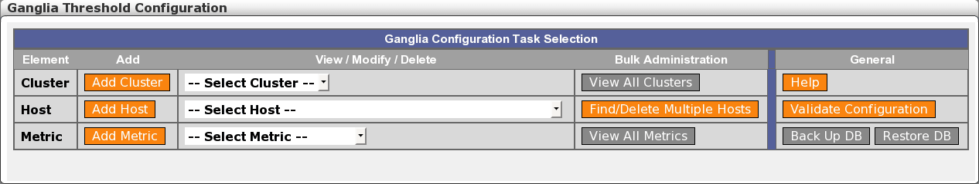Your first task is to set up metrics. To define a new metric, select the “Add Metric” button. This will present the following screen.
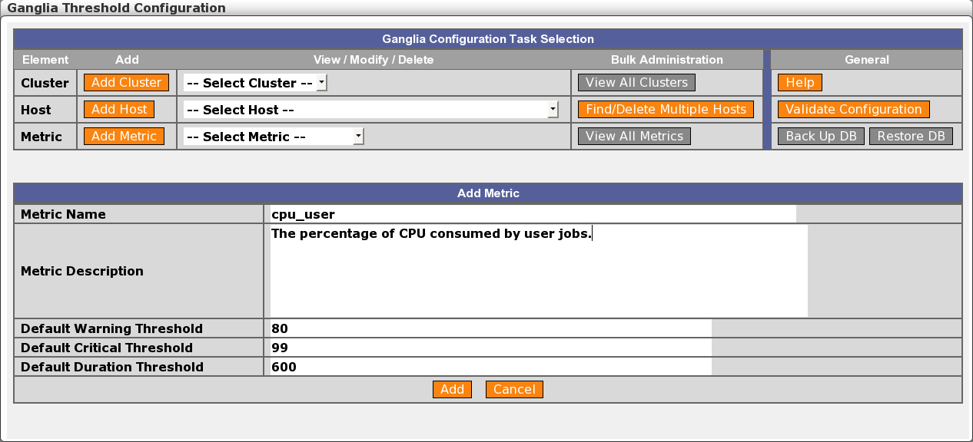Enter the metric name, exactly as defined in Ganglia. The example here is cpu_user, a common metric. A free text field is available for the metric description. Also define the default Warning, Critical, and Duration threshold values that will be filled in when this metric is applied to a cluster or host, and click the Add button. After a metric is added, it will appear in the metric drop-down lists.
Once you have at least one metric, it can be applied to a cluster or host. You will probably want to set up several metrics before you proceed to this step.
First, the metric must be applied to the “Default” cluster so that a global default threshold exists for any host. To do this, select the “Default” cluster from the cluster drop down list under View/Modify/Delete. The following page is presented:
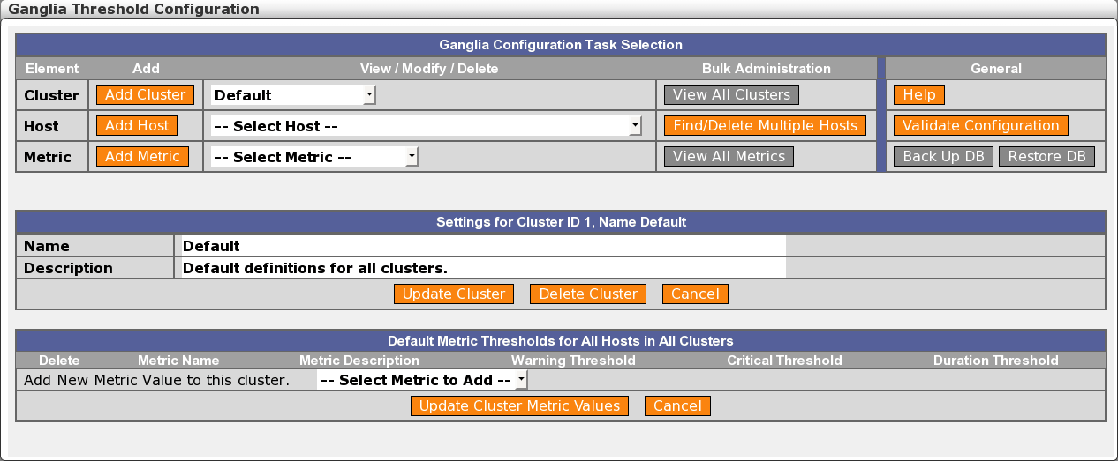By selecting a metric from the “Add New Metric Value to this cluster” drop down, one of the metrics you have defined will be added to the list. If desired, update the metric description, or the Warning, Critical, or Duration thresholds. Continue until all the metrics you wish to monitor are defined and applied to the Default cluster.
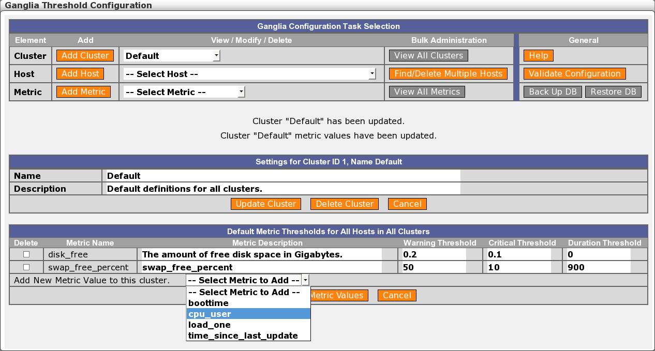To delete metrics from a cluster, select their Delete checkboxes, then click the “Update Cluster Metric Values” button.
You can also delete definitions for this entire cluster by clicking the “Delete Cluster” button. DO NOT DO THIS for the Default cluster!
After defining the Default cluster, you may click the “Add Cluster” button to define a new cluster, then repeat this process to define metric thresholds for that cluster. Note that if you don’t define a metric for this cluster, it will still be monitored using the thresholds defined and applied to the Default cluster. Those global settings are shown as read-only copies above the per-cluster metric thresholds, as shown in the figure below. This gives you a complete picture of all the thresholds that will be applied to hosts in the cluster, all in one screen. The Source field is a link to the screen where these default settings are established, so these global values can be quickly accessed and adjusted if needed. Only define metric thresholds in a specific cluster if you want to override the settings in the Default cluster. If you do define per-cluster thresholds for some metrics, the display of the corresponding Default cluster thresholds for those metrics will be suppressed, as they will no longer apply to this particular cluster.
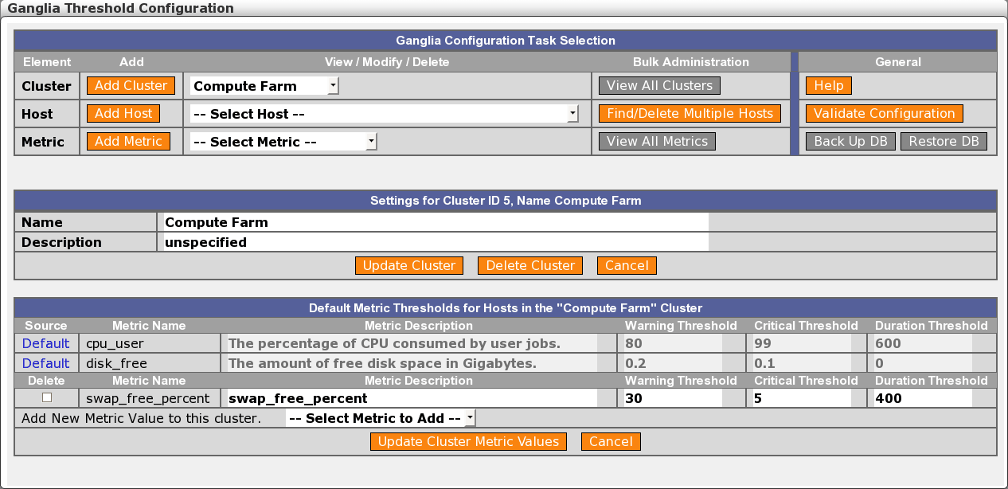Generally speaking, you will want to stop at this stage and not go further to define per-host metric thresholds. That's because treating hosts in a grid as individual objects adds complexity to the setup and extra administrative burden to maintain it. Uniformity of monitoring across groups of similar hosts makes the configuration much easier to understand. However, if you do have hosts with particular characteristics that should be monitored in a special way, you can proceed to the next step and set up metric thresholds at the host level.
You may manually define hosts to the ganglia database by selecting “Add Host”, but note that hosts are automatically added to the database by check_ganglia. It is much easier to allow check_ganglia to execute at least once, then select the existing host from the “Modify Host Metric Values” drop-down list and modify its metric settings. You can also use the Find/Delete Multiple Hosts function to generate a list, from which you can click the host name link to reach the particular host's screen. When you select an existing host with one of these methods, the following page appears.
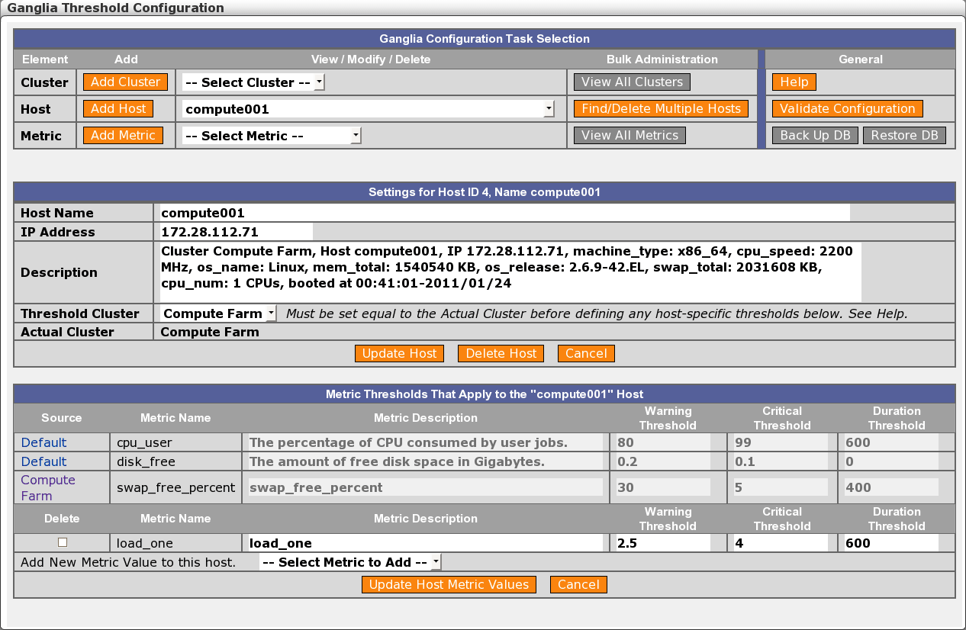To define per-host metric thresholds, first select the Cluster that this host belongs to in the “Threshold Cluster” field, and click the “Update Host” button to add the host to that cluster in the database. This step is necessary since the database is not populated with this information by check_ganglia.
As on the cluster page, you may add metrics and thresholds to this host. These values will override any thresholds for the same metrics specified at the cluster level, as well as the Default-cluster thresholds for those metrics if no cluster-level thresholds are defined. Note that if you don’t define a metric for this host, it will still be monitored if it is defined in the Default cluster or this specific cluster. Only define metrics for a host if you want to override the setting in the specific cluster or the Default cluster. The screen for this host shows all the thresholds that apply to this host if the corresponding metrics are sensed by Ganglia, with the source of each threshold clearly identified.
Once you have your thresholds defined, you will begin to receive passive service check results for the services on these hosts in Nagios. You next need to define these hosts and services in Nagios so that you can set up the displays and notifications. The easiest way to do this is with the Auto-Import function, described in a later section.

Validating the Configuration
Certain combinations of settings make little sense, but can be hard to spot when the user interface is presenting only a small portion of the setup in any single screen. To help with this, the threshold configuration UI provides an automated mechanism for digging out certain types of misconfiguration and making them very evident. This facility can be accessed via the “Validate Configuration” button in the top section of the screen.
In the present release, validation runs just one type of sanity check, namely, looking for hosts that belong to more than one cluster, according to the ganglia database. This could cause confusion as to what cluster-level metric thresholds should be applied, so it is a situation to be avoided. If any such hosts are found, they are listed on-screen:
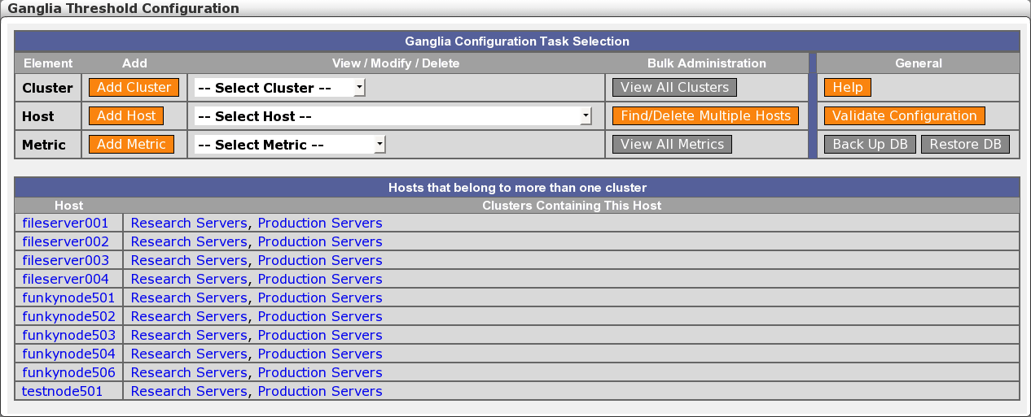The host and cluster names are links to the respective pages for those hosts and clusters within the threshold configuration UI, so you can jump immediately to those areas to investigate and make adjustments.

Finding and Deleting Hosts
The threshold configuration tool is designed to make bulk administration of metric thresholds easy. But another aspect of bulk administration comes into play at other times — namely, when you need to find certain hosts, or delete groups of hosts. This is important, for instance, when you take a complete cluster permanently out of service.
Identifying individual hosts or groups of similar hosts can be done via the “Find/Delete Multiple Hosts” capability, accessed via a button in the top section of the screen. It brings up a search template:
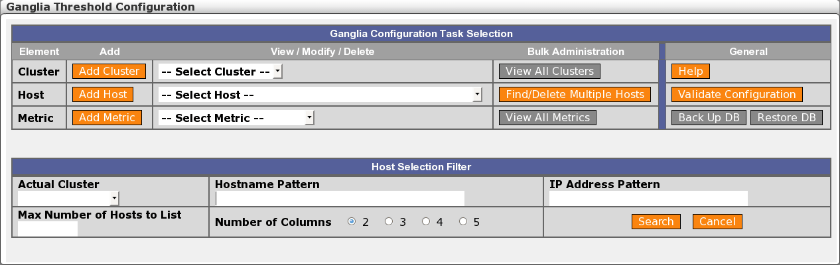
You can specify a number of criteria to search on, either singly or in combination. If you wave the mouse pointer over the respective heading for each search criterion, a pop-up tooltip will appear that describes acceptable values. (The tooltip will remain steady for you to read its content until either some other tooltip appears, or you click somewhere in the screen to dismiss it.)
The search results look like this:
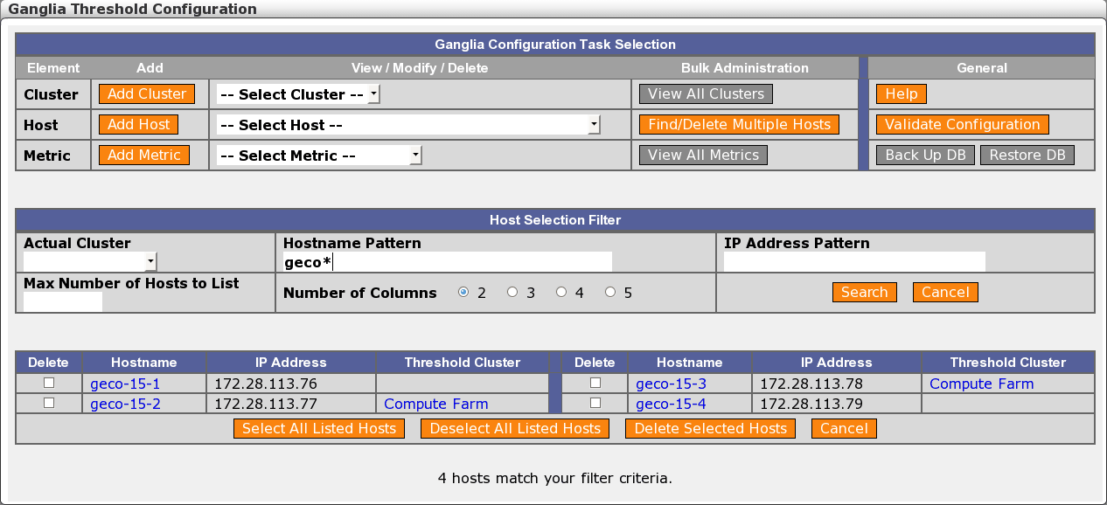Here we see four hosts that matched our specified hostname pattern. Each of their names is a link to the respective host page within the threshold configuration tool. We also see that two of these hosts (geco-15-2 and geco-15-3) have a Threshold Cluster set, which is a strong indication that host-level metric thresholds are set for these hosts. These cluster names are also links to the respective cluster pages.
Once you have identified an interesting group of hosts this way, you can easily select some or all of them and delete them in bulk from the ganglia database. This is a maintenance step you would typically need to take before running auto-import, so the synchronization of the Monarch and Nagios views of the infrastructure with the Ganglia view will properly reflect the permanent removal of these hosts from your data center.

Auto-Import Configuration
There are several parameters that control the options in the auto-import script (see Section 3.5, Auto-Import, on page 25). These are found in the autoimport.conf file, stored in the /usr/local/groundwork/config directory. To configure auto-import, simply edit this file, and create associated objects within Monarch (see below). If the import runs under cron, you may wish to kick it off once by hand to ensure the results are what you expect, and that you did not make a mistake editing the file that would prevent the import from functioning. If you are running the import manually, then you will do this anyway.
As always, be sure to make a backup of your monarch database before running any kind of bulk update such as this import script. If it fails for any reason, you should take care not to lose any data.
We present below a listing of the initial configuration file. You should review this file and modify it to meet your needs, then set up the required services, profiles, and host groups in the Monarch GUI. In particular:
- Depending on your configuration of process_ganglia_hosts and process_cacti_hosts, create and customize services named according to your choices in the autoimport.conf file for:
- ganglia_svc_name
- cacti_svc_name
If you are creating these services from scratch, the following setup is appropriate:
  - Check command:
check_msg
  - Command line:
check_msg!3!"You actively checked a passive service, check your configuration"
- If the assign_deleted_hosts_to_hostgroup option is enabled, create a hostgroup named _DELETED_HOSTS (or whatever name you have chosen for the deleted_hostgroup option).
- If the assign_new_hosts_to_hostgroup option is enabled, create hostgroups named according to your choices for:
- new_ganglia_hosts_hostgroup
- new_cacti_hosts_hostgroup
depending on whether you have process_ganglia_hosts and/or process_cacti_hosts enabled. (In contrast, hostgroups assigned under the process_wg_hostgroups option will be created automatically as needed during auto-import processing.)
- If the assign_host_profiles_by_ganglia_clusters option is enabled, create and customize host profiles named after the Ganglia clusters in which your hosts reside.
- Depending on your configuration of process_ganglia_hosts and process_cacti_hosts, create and customize host and service profiles named according to your choices for:
- default_host_profile_ganglia
- default_service_profile_ganglia
- default_host_profile_cacti
- default_service_profile_cacti
If you enabled assign_host_profiles_by_ganglia_clusters but failed to create a host profile named after a particular Ganglia cluster in which a host is found, these Ganglia-related profiles will be used as a fallback.
You will probably want to assign the service you named as ganglia_svc_name to the default_service_profile_ganglia service profile, and the service you named as the cacti_svc_name to the default_service_profile_cacti service profile.
Then simply run the script from the command line:
/usr/local/groundwork/nagios/libexec/autoimport.pl
Look in the configured logfile (see below) to see whether any errors occurred, and to examine the operational statistics for each run.
If the script ran without errors, and you did not enable the commit_changes option, just open the Monarch (Configuration) GUI, review and adjust the imported hosts, and commit the changes. It's probably a good idea not to enable that option the first time you run the import, just so you can be sure of the results before you go live with the new setup.
You may also want to know which hosts are not being monitored by Ganglia, either because they are being monitored some other way, by Nagios, perhaps, or because they have dropped out of the Ganglia data stream. By default, these hosts will be placed in a new host group you created (e.g., _DELETED_HOSTS). Do not worry, the autoimport script will not actually delete the hosts it moves there. That is up to you to do on review.
Once you are done importing your hosts and committing your changes, you will be monitoring with Ganglia thresholds under Nagios in GroundWork Monitor. Congratulations!
# Configuration file for the autoimport.pl script.

#######################################################
#
# General Program Execution Options
#
#######################################################

# Global Debug Level (controls the output of messages in the logfile)
# NONE = 0; turn off all debug info
# FATAL = 1; the application is about to die
# ERROR = 2; the application has found a serious problem, but will attempt to recover
# WARNING = 3; the application has found an anomaly, but will try to handle it
# NOTICE = 4; the application wants to inform you of a significant event
# STATS = 5; the application wants to log statistical data for later analysis
# INFO = 6; the application wants to log a potentially interesting event
# DEBUG = 7; the application wants to log detailed debugging data
debug_level = 5

# Where to put all the log messages from autoimport processing.
logfile = "/usr/local/groundwork/nagios/var/log/autoimport.log"

# Whether or not to commit a new configuration to Nagios.
# Changes will be committed to the Monarch database regardless.
# [yes/no]
commit_changes = yes

# When defining a monarch host, use the host name instead of the IP address?
# [yes/no]
define_monarch_host_using_dns = yes

# Whether to process WesternGeco-style hostgroups.
# [yes/no]
process_wg_hostgroups = yes

# Whether to use hostgroup_program to classify hosts according to their function.
# If "no", use custom_hostgroup_package instead.
# Used only if process_wg_hostgroups = yes.
# [yes/no]
use_hostgroup_program = no

# A program to classify hosts into hostgroups according to their function.
# Used only if process_wg_hostgroups = yes and use_hostgroup_program = yes.
# The value specified can include initial options beyond just the program name;
# the hostname to be classified will be appended to this full command string.
hostgroup_program = "/usr/local/groundwork/jobs/westerngeco/bin/hosttype -c"

# What Perl package to call to classify hosts into hostgroups according to their function.
# Used only if process_wg_hostgroups = yes and use_hostgroup_program = no.
# For efficiency, the use of a package, if available, is preferred over an external program.
# Set this to an empty string if you have no such package.
custom_hostgroup_package = "WesternGecoHostgroupName"

# What options to initialize the custom_hostgroup_package with.
custom_hostgroup_package_options = "-c"

# Where to find the Nagios log file.
nagioslogfile = "/usr/local/groundwork/nagios/var/nagios.log"

# Ganglia service name to search for in Nagios log file. Hosts with this service will be matched.
ganglia_svc_name = "ganglia"

# Cacti service name to search for in Nagios log file. Hosts with this service will be matched.
cacti_svc_name = "cacti"

# Assign deleted hosts to the deleted_hostgroup specified below?
# [yes/no]
assign_deleted_hosts_to_hostgroup = yes

# The name of the hostgroup to which deleted hosts will be assigned.
# This hostgroup must already exist in the Monarch database.
deleted_hostgroup = "_DELETED_HOSTS"

# Assign new hosts to the single fixed new hostgroup for the type of node discovered,
# as specified below (new_ganglia_hosts_hostgroup or new_cacti_hosts_hostgroup)?
# [yes/no]
assign_new_hosts_to_hostgroup = no

# Names of hostgroups for newly discovered hosts.
# Used only if assign_new_hosts_to_hostgroup = yes.
new_ganglia_hosts_hostgroup = "New_Ganglia_Hosts"
new_cacti_hosts_hostgroup = "New_Cacti_Hosts"

# For newly discovered Ganglia hosts, assign host profiles named by the Ganglia clusters
# in which the hosts reside? "yes" is only possible if get_ganglia_host_from_ganglia_db
# (below) is "yes".
# If "no", just use the single fixed default_host_profile_ganglia specified below.
# If "yes", the default_host_profile_ganglia host profile will still be used if we find
# no host profile named after a given Ganglia cluster.
# [yes/no]
assign_host_profiles_by_ganglia_clusters = yes

# Note: For newly discovered Cacti hosts, assuming you only use Cacti for network devices,
# using a single host profile (default_host_profile_cacti, specified below) makes sense.
# Within Cacti, you don't have something akin to "Host Groups", though you do have a 'tree'
# structure defined in the database for navigating the devices. If we did want to allow
# alternate host profiles for Cacti devices, then the name of the branch of the tree the
# device is attached to would be the logical candidate. We leave that sort of thing for
# possible future development.

# Default Monarch host and service profiles to be applied to newly discovered hosts.
default_host_profile_ganglia = "ganglia_host"
default_service_profile_ganglia = "Ganglia Hosts"
default_service_profile_ganglia_id = ""
default_host_profile_cacti = "cacti_host"
default_service_profile_cacti = "Cacti Hosts"
default_service_profile_cacti_id = ""

# Process ganglia hosts?
# [yes/no]
process_ganglia_hosts = yes

# Read the Nagios log to pick up the list of Ganglia hosts from service check messages?
# [yes/no]
get_ganglia_host_from_nagios_log = no

# Get the list of ganglia hosts from the Ganglia database?
# Only effective if get_ganglia_host_from_nagios_log = no.
# [yes/no]
get_ganglia_host_from_ganglia_db = yes

# How to access the Ganglia database.
# ganglia_dbtype can be either "mysql" or "postgresql".
ganglia_dbtype = "postgresql"
ganglia_dbname = "ganglia"
ganglia_dbhost = "localhost"
ganglia_dbuser = "ganglia"
ganglia_dbpass = "gwrk"

# Process cacti hosts?
# [yes/no]
process_cacti_hosts = no

# How to access the Cacti database.
# cacti_dbtype can be either "mysql" or "postgresql".
cacti_dbtype = "postgresql"
cacti_dbname = "cacti"
cacti_dbhost = "localhost"
cacti_dbuser = "cacti"
cacti_dbpass = "cactipasswd"

# How to access the Monarch database.
monarch_user_acct = "super_user"

Revision History
This manual is expected to be a living document. Future versions may include detail and experience which is not available during the initial development.
The following versions of this document have been issued to date.
Version | Date | Description of Changes
2.0 | October 3, 2007 | First public release.
3.0 | --- | Interim internal release.
4.0.5 | February 6, 2008 | Draft-in-progress of changes to reflect repackaging as RPMs.
5.0.0 | February 28, 2011 | Revised to reflect installation and running in the GroundWork Monitor Enterprise Edition 6.4 environment. Also edited operational instructions for clarity and to describe new functionality.
5.1.0 | March 24, 2011 | Extended to:  - Document the default view in the Ganglia Web Server Views screen.  - Document additional manual steps needed during initial setup.  - Highlight special features briefly mentioned in configuration files.  - Provide critical cross-references within this document, for fast access to related info.
6.0.0 | November 16, 2012 | Software ported to support using a PostgreSQL database, and documentation upgraded to match. Special cross-database upgrade procedures are documented as well. This allows operation with GroundWork Monitor Enterprise Edition 6.6.1 and later releases.
6.0.1 | May 10, 2013 | No change to the doc, except to upgrade the version number and release date. The code was changed to prevent recognition of external entity references while parsing XML streams. This requires an updated libxml2 library, as will be available in the GWMEE 7.0.0 release.

- Because of the significant system loading it imposes, the separate-service model is not supported in the current release of the Ganglia Integration Module (GWMON-5461).
- A variety of performance improvements in the GroundWork and Nagios processing of Commit operations have been made since this original observation. Testing with a current release of the product is in order.
- That was true for Nagios 2. We need to verify the claim for Nagios 3.
- Inasmuch as hosts known to Ganglia will be automatically added back to the ganglia database when check_ganglia runs, it only makes sense to delete hosts after you have either removed them from service or when you stop monitoring the cluster in which they reside. Note that other Ganglia nodes in the cluster will hang on to knowledge about a host for some time after it has gone missing (see, for example, the host_dmax and cleanup_threshold parameters in gmond.conf files).
- The name of this hostgroup is configurable in the autoimport.conf file.
- The standard name of this hostgroup is _DELETED_HOSTS. It is likewise configurable, and whatever the choice of name, this hostgroup must also be pre-defined in Monarch.
- Accessing GroundWork Monitor through several windows in the same browser is supported in current GWMEE releases. So if you want, you can access the Ganglia Web Server pages through the Ganglia → Ganglia Views screen.
- Well, it kind of is, but in a different place. That's where the Actual Cluster displayed in the screen comes from. This distinction and the extra manual step involved will be reviewed in a future release.

