Deploying Groundwork Agent for JBoss AS 7

Supported JBoss Versions: 7.1.x, 7.2

Pre-requisite :

- JBoss 7.1.1 or higher installed and running.
- Groundwork Monitor 7.1.0. or higher installed and running.

Step : 1

Stop JBoss Server if running.

Create a new jboss module to add the provided JDMA config file gwos-jbossas7.xml in the jboss classpath:

mkdir -p <JBOSS_INSTALL_DIRECTORY>/modules/com/groundwork/jdma/jbossas7/main

Create a new module.xml file in

<JBOSS_INSTALL_DIRECTORY>/modules/com/groundwork/jdma/jbossas7/main/module.xml

with the following content and save the file with the name module.xml:

<?xml version="1.0" encoding="UTF-8"?>
<module xmlns="urn:jboss:module:1.1" name="com.groundwork.jdma.jbossas7">
<resources>
<resource-root path="."/>
</resources>
</module>

This is where the agent picks up the gwos-jbossas7.xml file.

Step : 2

Edit <JBOSS_INSTALL_DIRECTORY>/standalone/configuration/standalone.xml:

The JMX subsystem should look like:

<subsystem xmlns="urn:jboss:domain:jmx:1.1">
<show-model value="true"/>
<remoting-connector use-management-endpoint="false" />
</subsystem>

Make sure that you enable the following system property in standalone.xml:

“org.apache.tomcat.util.ENABLE_MODELER”

by adding to the system-properties section so that JBoss will make the “jboss-web:type=Manager” access available to remote JMX clients. If your configuration already has properties defined, just add this property.

<system-properties>
<property name="org.apache.tomcat.util.ENABLE_MODELER" value="true"/>
</system-properties>

To enable JMX Authentication, see instructions at end of this document
If you are not using JMX Authentication, leave the JBoss Username and Password fields empty.

Step : 3
Download the gwos-jbossas7-monitoringAgent.war file from the Groundwork server, located in this folder:

/usr/local/groundwork/apache2/htdocs/java-agents/

Copy the war file to the folder:

<JBOSS_INSTALL_DIRECTORY>/standalone/deployments/

Step: 4
In the Monarch configuration on the Groundwork server, discover the JBoss host and add the JBoss services by importing the service-profile-jbossas7.xml. Commit the configuration in Monarch.

Step : 5
Start JBoss Server.

Touch the dodeploy file to instruct JBoss to deploy the app:

touch <JBOSS_INSTALL_DIRECTORY>/standalone/deployments/ gwos-jbossas7-monitoringAgent.war.dodeploy

You should see the “GWOS MBean Collector started successfully” message in the JBoss console output and /usr/local/groundwork/jpp/standalone/log/framework.log

Step 6: Selecting your JMX Metrics with the UI

To select the JMX metrics that you want to monitor for your environment, you will need to discover and select those metrics. To get started, navigate the browser to:

http://<tomcat server>:8080/gwos-jbossas7-monitoringAgent/index.html

and follow the User Interface Usage section below to select the JMX Metrics you want to monitor.

If you have apache as a web proxy, then add the following ProxyPass to your apache httpd.conf and restart apache.

ProxyPass /gwos-jbossas7-monitoringAgent/ http://localhost:8080/gwos-jbossas7-monitoringAgent/

User Interface Usage

Initial Landing Page

Navigate to and choose “Start new Configuration”:

http://localhost:8080/gwos-jbossas7-monitoringAgent/

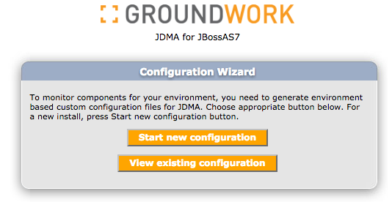

Setup JBoss Connection on Nagios Connection
After entering parameters, press “Test Connection” to test your JMX connection. If it passes, press “Start Discovery” …

This example is a JMX configuration without JMX Authentication. Note that we leave the JBoss User Name and JBoss Password empty:

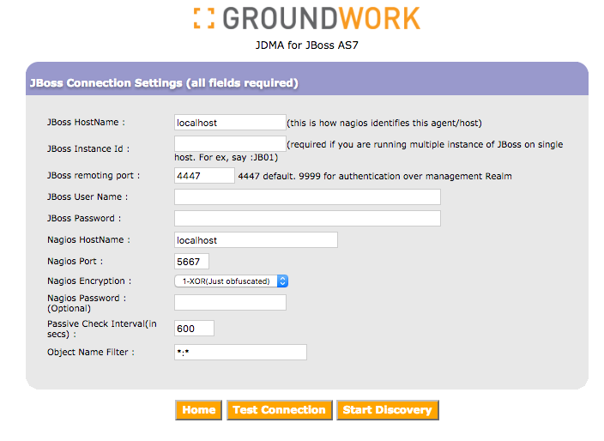

This example is a JMX configuration with JMX Authentication. Note that we enter fields into the JBoss User Name and JBoss Password fields. Also note that the remoting port is changed to 9999:

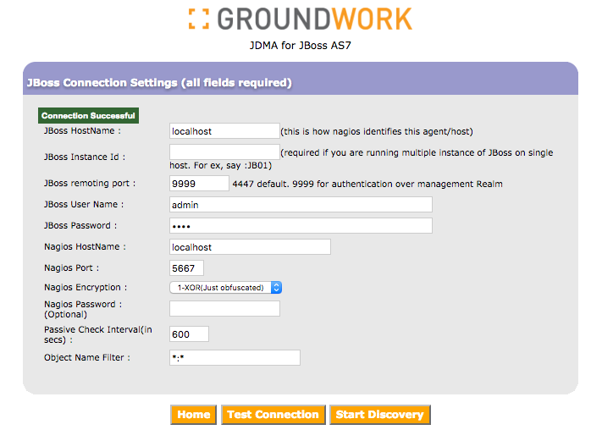

Select and configure JMX

Select the JMX Properties you want to monitor

Use the Filter to search for JMX metrics by prefix. You can limit the JMX metrics displayed by enter a filter prefix. You can further limit the metrics displayed by editing the gwos_jbossas7.xml file, and setting the object.name.filter property in the gwos_tomcat.xml file. This property will narrow down the autodiscovery search. If not sure, leave the default value to *:*.

To select the list of services from the discovered list, simply click on the metric in the left hand side of the UI. The selected metrics will show up in the right hand side panel.

When all metrics are selected, click the “Next” button to continue:

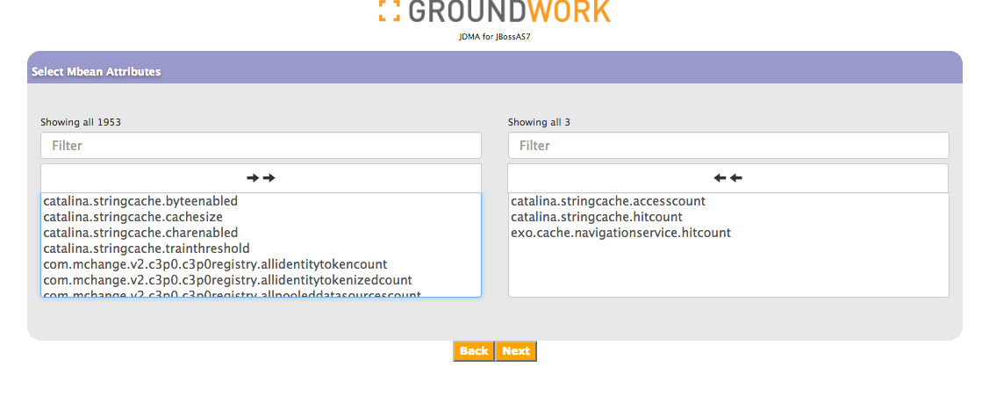

Choose warning levels and threshold values. Enter -1 for none. Press Next to continue, parameters are not yet saved:

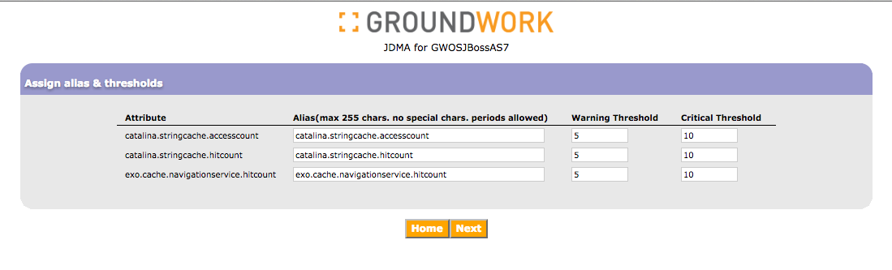

Setup Tomcat Connection on Nagios Connection

Enter the hostname of your Groundwork Server, and then enter the API credentials to access that server. The “Properties File Path” field should contain the full path to the directory where you copied the gwos-tomcat.xml file in Step 1. Do not include the file name. The default location for the Properties File Path is sufficient for monitoring the Groundwork server:

/usr/local/groundwork/jpp/modules/com/groundwork/jdma/jbossas7/main/

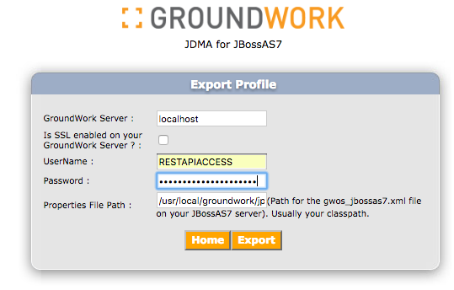
Press Export to save. You are ready to start monitoring once JBoss is restarted:

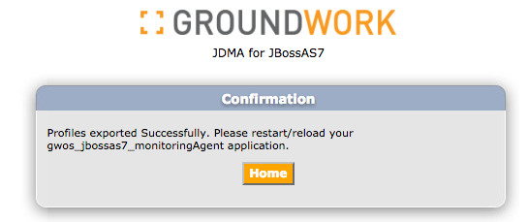

To view your configuration from the home page press “View Existing Configuration”:

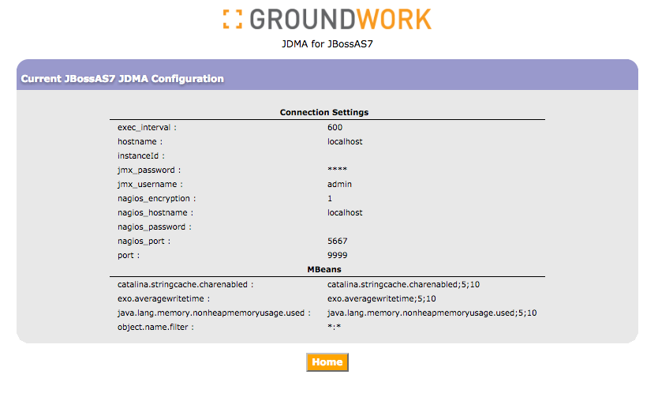

JMX Authentication

Add a Management User

To enable JMX Authentication, you’ll need to first add a Management User to JBoss. Skip this section if you already have a Management user configured in JBoss.

From the command line:

cd <JBOSS_INSTALL_DIRECTORY>/bin
./add-user.sh

And follow the prompts. Here is a sample interaction:

What type of user do you wish to add?
a) Management User (mgmt-users.properties)
b) Application User (application-users.properties)
(a): a

Enter the details of the new user to add.
Realm (ManagementRealm) :
Username (admin) : admin
Password :
Re-enter Password :
The username 'admin' is easy to guess
Are you sure you want to add user 'admin' yes/no? yes
About to add user 'admin' for realm 'ManagementRealm'
Is this correct yes/no? yes
Added user 'admin' to file '/usr/local/groundwork/jpp/standalone/configuration/mgmt-users.properties'
Added user 'admin' to file '/usr/local/groundwork/jpp/domain/configuration/mgmt-users.properties'

Enable the Management Realm for JMX

Ensure that the management realm is turned on for JMX.
Edit <JBOSS_INSTALL_DIRECTORY>/standalone/configuration/standalone.xml

Note that we are now setting the remoting-connector-use-management-endpoint to TRUE

The JMX subsystem inside our JBoss configuration file should look :

<subsystem xmlns="urn:jboss:domain:jmx:1.1">
<show-model value="true"/>
<remoting-connector use-management-endpoint="true"/>
</subsystem>

While in the standalone.xml, review the management security realms section. Ensure that
- There is a security realm named ManagementRealm
- Ensure that there is NOT a default-user for your ManagementRealm:

<management>
<security-realms>
<security-realm name="ManagementRealm">
<authentication>
<!—REMOVE THIS: <local default-user="$local"/> -->
<properties path="mgmt-users.properties" relative-to="jboss.server.config.dir"/>
</authentication>
</security-realm>

After making these changes, save the standalone.xml file.

JMX and SSL

Not supported.
For more information please visit www.groundworkopensource.com .

https://kb.groundworkopensource.com/display/GWENG/Using+JMX+with+JConsole

