Deploying Groundwork Agent for Tomcat

Supported Tomcat Versions: 5.5, 6.0,7.0

Pre-requisite :

- Tomcat 5.5/6.0/7.0 installed and running.
- Groundwork Monitor 7.x installed and running.

Step : 1

Create a new directory <TOMCAT_INSTALL_DIRECTORY>/gwos/
Copy gwos_tomcat.xml to <TOMCAT_INSTALL_DIRECTORY>/gwos/ folder.

Step : 2

Stop Tomcat server if running.
Add the following JMX and classpath settings to this file:

<TOMCAT_INSTALL_DIRECTORY>/setclasspath.sh

(1) For the classpath, add this line near the top of the file, after the copyright info:

CLASSPATH="$CLASSPATH""$CATALINA_HOME"/gwos

(2) To turn on JMX, add this line immediately after the CLASSPATH line:

CATALINA_OPTS="-Dcom.sun.management.jmxremote -Dcom.sun.management.jmxremote.port=9012 -Dcom.sun.management.jmxremote.ssl=false -Dcom.sun.management.jmxremote.authenticate=false"

To enable JMX Authentication, see instructions at end of this document
If you are not using JMX Authentication, leave the Tomcat Username and Password fields empty.

Step : 3

Modify the gwos-tomcat.xml file and update the target <GROUNDWORK_SERVER_HOSTNAME> in the nagios settings section.

Make sure the nagios_encryption and nagios_password settings match groundwork server bronx.cfg file. Only XOR and DES encryption are supported. Also no encryption is supported.

nagios_password is required if XOR or DES encryption is selected.

Step : 4
Download the gwos-tomcat-monitoringAgent.war from the Groundwork server, located in this folder:

/usr/local/groundwork/apache2/htdocs/java-agents/

Copy the war file to <TOMCAT_INSTALL_DIRECTORY>/webapps/

Step: 5

In the groundwork server, configure Monarch to discover the tomcat host and add the tomcat services by importing the service-profile-tomcat.xml. Commit the configuration in monarch.

Step: 6

Start Tomcat Server. You should see the “GWOS MBean Collector started successfully” message in the <TOMCAT_INSTALL_DIRECTORY>/logs/gwosCollector.log

Step 7: Selecting your JMX Metrics with the UI

To select the JMX metrics that you want to monitor for your environment, you will need to discover and select those metrics. To get started, navigate the browser to:

http://<tomcat server>:8080/gwos-tomcat-monitoringAgent/index.html

and follow the User Interface Usage section below to select the JMX Metrics you want to monitor…

User Interface Usage

Initial Landing Page

Navigate to and choose “Start new Configuration”:

http://localhost:8080/gwos-tomcat-monitoringAgent/

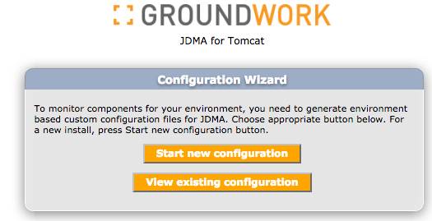

Setup Tomcat Connection on Nagios Connection
After entering parameters, press “Test Connection” to test your JMX connection. If it passes, press “Start Discovery” …

This example is a JMX configuration without JMX Authentication. Note that we leave the Tomcat User Name and Tomcat Password empty:

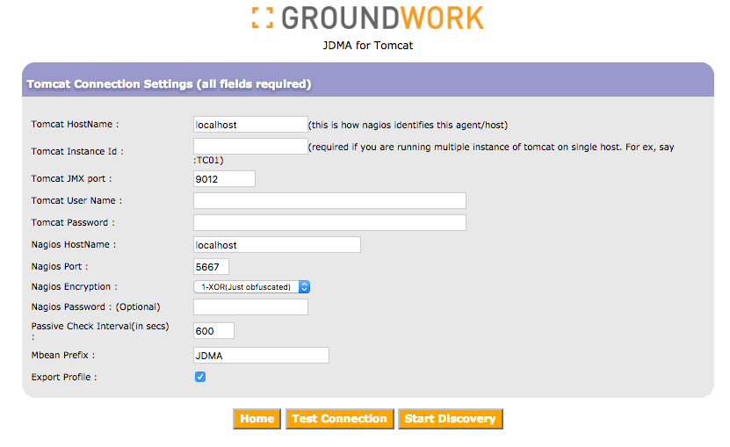

This example is a JMX configuration with JMX Authentication. Note that we enter fields into the Tomcat User Name and Tomcat Password fields

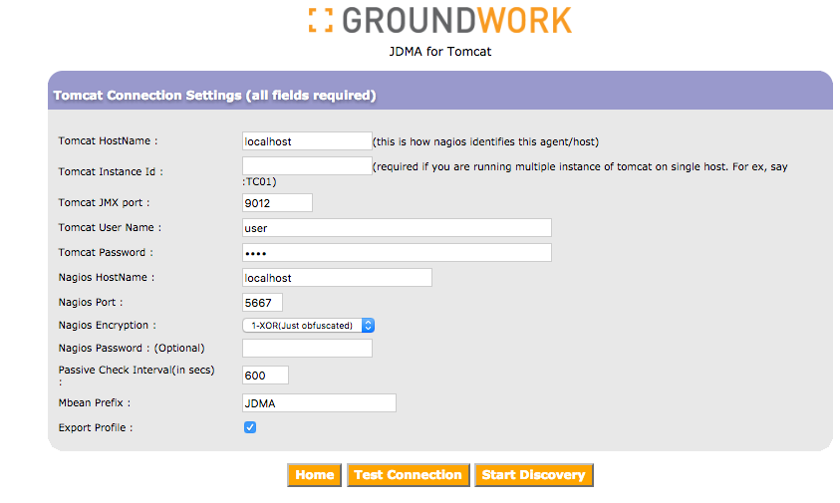

Select and configure JMX

Select the JMX Properties you want to monitor.

Use the Filter to search for JMX metrics by prefix. You can limit the JMX metrics displayed by enter a filter prefix. You can further limit the metrics displayed by editing the gwos_tomcat.xml file, and setting the object.name.filter property in the gwos_tomcat.xml file. This property will narrow down the autodiscovery search. If not sure, leave the default value to *:*.

To select the list of services from the discovered list, simply click on the metric in the left hand side of the UI. The selected metrics will show up in the right hand side panel.

When all metrics are selected, click the “Next” button to continue:

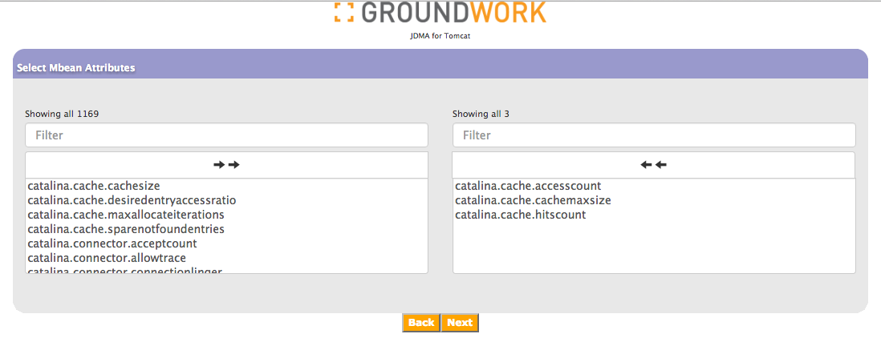

Choose warning levels and threshold values. Enter -1 for none. Press Next to continue, parameters are not yet saved:

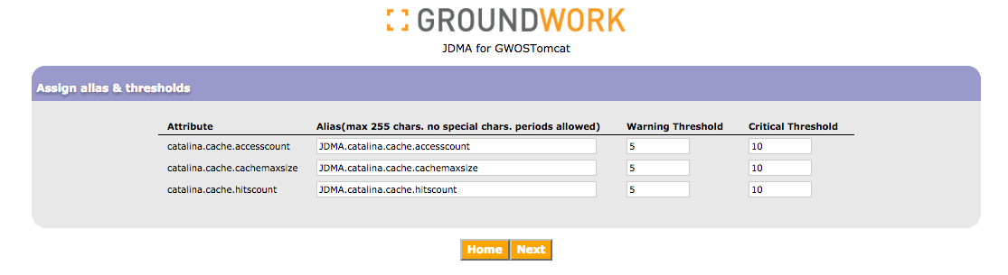

Setup Tomcat Connection on Nagios Connection

Enter the hostname of your Groundwork Server, and then enter the API credentials to access that server. The “Properties File Path” field should contain the full path to the directory where you copied the gwos-tomcat.xml file in Step 1. Do not include the file name:

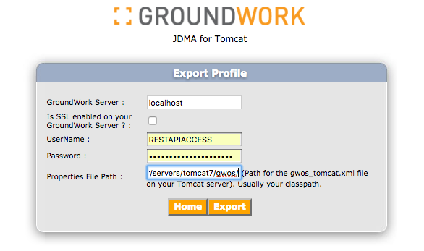

Press Export to save. You are ready to start monitoring once Tomcat is restarted:

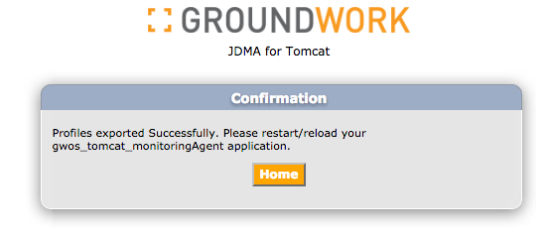

To view your configuration from the home page press “View Existing Configuration”:

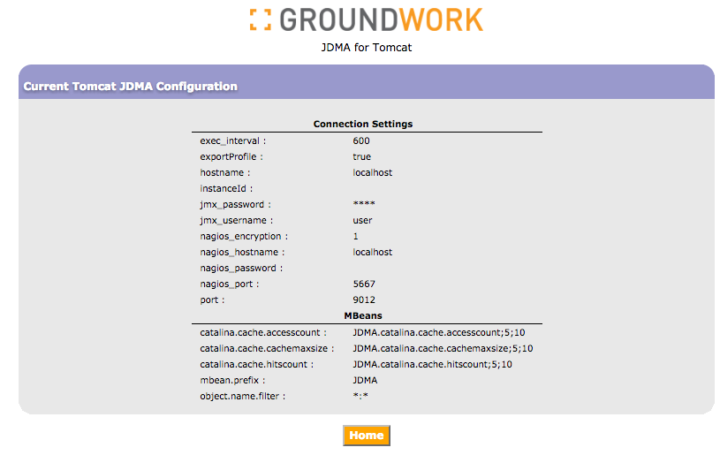

JMX Authentication

To enable JMX Authentication, add three additional properties to CATALINA_OPTS in setclasspath.sh:

Dcom.sun.management.jmxremote.authenticate=true
-Dcom.sun.management.jmxremote.password.file=../conf/jmxremote.password
-Dcom.sun.management.jmxremote.access.file=../conf/jmxremote.access

And create a new conf/jxmremote.password per Tomcat instructions where users are listed with usernames and passwords space separated. Here we have two users, admin and user, with their respective passwords:

admin adminpassword
user userpassword

You will also need a conf/jmxremote.access file, with entries for each user granting read or readwrite access. JDMA only needs read (readonly) access:

admin readwrite
user readonly

Ensure that these files are properly secured on your Linux file system:

chmod 600 conf/jmxremote.password
chmod 600 conf/jmxremote.access

JMX and SSL
The Tomcat server that is being monitored needs to be started with JMX + SSL enabled. Ensure these system properties are set and that a Java keystore is properly configured:

-Dcom.sun.management.jmxremote
-Dcom.sun.management.jmxremote.port=9012
-Dcom.sun.management.jmxremote.authenticate=true
-Dcom.sun.management.jmxremote.ssl=true
-Dcom.sun.management.jmxremote.password.file=../conf/jmxremote.password
-Dcom.sun.management.jmxremote.access.file=../conf/jmxremote.access
-Djavax.net.ssl.keyStore=/path-to-keystore/keystore.dat
-Djavax.net.ssl.keyStorePassword=yourPassword

The JVM running the Tomcat JDMA Agent will require a public key stored in a Trust Store. Ensure that the JVM (Tomcat) containing the Tomcat JDMA Agent starts up with these 2 system properties:

-Djavax.net.ssl.trustStore=/path-to-trust/truststore.dat
-Djavax.net.ssl.trustStorePassword=yourPassword

For more information please visit www.groundworkopensource.com .

