Design Documentation:
Foundation Action Service Overview

Document History
Date | Change | Author
October 17, 2007 | Initial draft | Gary Lee
October 18, 2007 | Added new tables and return value structure | Gary Lee
October 24, 2007 | Updated ApplicationAction table | Gary Lee
October 25, 2007 | Updated ActionReturn data structure | Gary Lee
November 1, 2007 | Added Sample Code | Gary Lee

Table of Contents

1. Terms and Definitions 3
2. Overview 4
3. Actions 4
4. Action Triggers 4
5. Action Return Values 5
6. Action Service Database Tables 5
6.1. ActionType Table 5
6.2. Action Table 5
6.3. ApplicationAction Table 6
6.4. ActionProperty Table 6
6.5. ActionParameter Table 7
7. Sequence Diagrams 8
7.1. Action Web Service Call Sequence 8
8. Available Actions 8
9. Future Items 8
10. Sample Code Web Service Java API 9
10.1. Retrieve Actions By Application Type 9
10.2. Perform actions 9

Terms and Definitions
Term | Definition
Action | Customizable operation which is performed as a result of an explicit call or internal event.
Action Service | Foundation business service responsible for managing configured actions and executing actions as a result of an action trigger.
Action Trigger | Event that occurs and causes an action or actions to be performed.

Overview
The Foundation Action Service provides the ability for clients to define and configure specific operations to be performed as a result of an explicit call executing the action or internal events which occur within the Foundation platform. For the 5.2.0 release, we will only be supporting the ability for clients to make a web service call to perform specified custom actions.

In order to facilitate the Action Service implementation we will be leveraging the FoundationMessage implementation that is currently being used to process incoming feeder messages. Specifically, we will be leveraging the XML message structure validation, parsing and packaging into a FoundationMessage.

Actions
Actions are a set of predefined operations which occur as a result of an Action Trigger. Professional services and third-parties should be able to define and configure custom actions that are performed. As metioned, in the 5.2.0 release, we will only support the ability for clients to explicitly call a web service method to perform a custom action or actions.

There are 3 types of actions that we will support:

- URL Post - This action provides the ability send a http post request
- Script - This action will run a custom shell script with the appropriate parameters.
- Custom Java Class - This action will instantiate and call a predefined java interface that will execute an action

All actions are executed synchronously and will provide a return value which indicates the status of action execution and potentially any custom data being returned for the execution of the custom action.

Action Triggers
An action trigger is an event which occurs within Foundation that causes the Action Service to perform configured actions related to the event which occurred. The following is a list of potential action triggers:

- Explicit Web Service Call - For example, the Console application will make a predefined web service call that passes the appropriate log message information and the action to execute.
- Internal Foundation Event - Within Foundation events such as host / service status changes, new log message, etc may trigger action or actions that need to occur as a result of the internal event. For example, suppose a host state changes to critical and a IT help ticket needs to be automatically created or a network administrator needs to be notified. Users would be able to configure these actions to be triggered based the event change.
- Scheduled Event - There are times where actions need to be performed on a regular time-interval basis. These scheduled events would trigger the configured actions to be performed. For example, lets say a SLA report needs to be generated weekly and emailed to particular persons. The users would be able to configure a scheduled event and associate the report generation and email action to be performed for the scheduled event.

For the 5.2.0 release, a basic structure will be put in place and we will only support the explicit web service trigger. Internal Foundation events and schedule events will be supported in future releases.

Action Return Values
Depending on the action that is being performed there are cases where clients that performed the action or actions need to know the status of the actions performed and potentially some information that may be returned from the action. For example, if an action's purpose is to create a help ticket in an external help desk system, the help ticket # that was created may need to be returned from the action. In order to support potentially any data return from the execution of the action, we will wrap the return value in a data structure along with the completion status of the action.

The following is the definition of the ActionReturn data structure being returned for each action that is performed.

ActionReturn Data Structure

Field | Data Type | Description
ActionId | int | Action id related to the return value.
ReturnCode | String | Action specific return code. This may be a http status code like 200 or 0, 1 for a shell script
ReturnValue | String | Action specific data being returned. This may be any information the action deems necessary to return.

Action Service Database Tables
The following section describe the database tables that will be created in order to support the Action Service functionality:

ActionType Table
The ActionType table contains all available action types. There are currently three types of actions, URL, SCRIPT, and JAVA.

Column | Data Type | Description
ActionTypeID | int | Primary key identifier for action type
Name | varchar(256) | Unique name of action. This should be human readable b/c it will be displayed in user interface.
ClassName | varchar(256) | Name of action implementation class

Action Table

The Action table stores all configured actions and the data related to them.

Column | Data Type | Description
ActionID | int | Primary key identifier for action
ActionTypeID | int | Foreign key to ActionType table which indicates the of action to be performed (URL, Script, Java)
Name | varchar(256) | Unique name of action. This should be human readable b/c it will be displayed in user interface.
Description | varchar(512) | Short description of action
Timeout | int | Timeout in seconds for which the action should be performed. If the action is not completed by the timeout indicated it will be stopped. A value <= 0 will indicate to never timeout.

ApplicationAction Table
The ApplicationAction table contains the associations between actions and applications. Each action is related to one or more application type.

Column | Data Type | Description
ApplicationTypeID | int | Application type identifier foreign key. This column along with with ActionID column make a composite primary key for the table.
ActionID | int | Action identifier foreign key. This column along with the ApplicationTypeID column make a composite primary key for the table.

ActionProperty Table
The ActionProperty table contains all configuration properties for the specified action. For example, a row for URL would exist of a URL action which identifies the URL of the http request sent when performing the action.

Column | Data Type | Description
ActionPropertyID | int | Primary key identifier for action property
ActionID | int | Foreign key to Action table indicating which action this property is related.
Name | varchar(128) | Name identifier of action property
Value | text | Value of property. Note that all values are strings. It will be up to to the implementation of the action to convert to appropriate data types, if necessary.

ActionParameter Table
The ActionParameter table contains all action parameter values for the action. These values will be passed to the action. For example, if the action is of URL type the parameter values for the action will be passed in the query string.

Column | Data Type | Description
ActionParameterID | int | Primary key identifier for action parameter
ActionID | int | Foreign key to Action table indicating which action this parameter is related.
Name | varchar(128) | Name identifier of action parameter
Value | text | Value of parameter. Note that all values are strings. It will be up to to the implementation of the action to convert to appropriate data types, if necessary. In the future, we may provide ability to assign parameter values at run-time.

Sequence Diagrams

Action Web Service Call Sequence
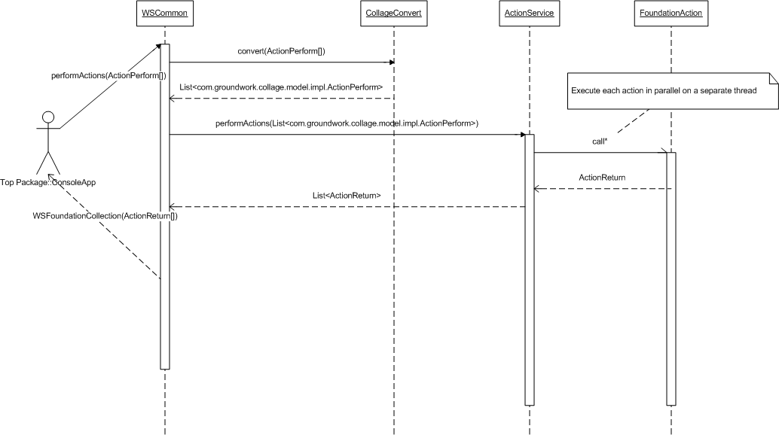

Available Actions
The following is a list of actions that will be provided with Foundation:

- Nagios Acknowledge - This action runs a shell script that notifies Nagios of log messages acknowledgment.
- Accept Log Message - This is a java action that changes the identified log messages to an ACCEPTED operation status. This action excepts a parameter with the name "LogMessageIds" and a comma-separated list of log message ids as its value.
- Close Log Message - This is a java action that changes the identified log messages to an CLOSED operation status. This action excepts a parameter with the name "LogMessageIds" and a comma-separated list of log message ids as its value.
- Notify Log Message - This is a java action that changes the identified log messages to an NOTIFIED operation status. This action excepts a parameter with the name "LogMessageIds" and a comma-separated list of log message ids as its value.
- Open Log Message - This is a java action that changes the identified log messages to an OPENED operation status. This action excepts a parameter with the name "LogMessageIds" and a comma-separated list of log message ids as its value.

Future Items
- In the future, we will need the ability for users to define and configure action trigger logic. For example, lets say a customer would like perform actions when a particular host reaches a particular state, they should be able to define the logic which produces the event and triggers the action or actions to be performed.

Sample Code Web Service Java API

Retrieve Actions By Application Type
WSCommonServiceLocator locator = new WSCommonServiceLocator();

locator.setEndpointAddress("wscommon", "http://localhost:8080/foundation-webapp/services/wscommon");

WSCommon wsCommon = locator.getcommon();

// Retrieve all actions for the NAGIOS application type and include SYSTEM actions, also
WSFoundationCollection col = wsCommon.getActionsByApplicationType("NAGIOS", true);

Action[] actions = col.getAction();

Perform actions
The following code shows the code to perform specified actions:

WSCommonServiceLocator locator = new WSCommonServiceLocator();

locator.setEndpointAddress("wscommon", "http://localhost:8080/foundation-webapp/services/wscommon");

WSCommon wsCommon = locator.getcommon();

// Construct ActionPeform array - Perform action id: 1 & 3
// Action ID: 3 expects the parameter, LogMessageIds, which is a comma delimited list of
// log message ids to perform the action on.
ActionPerform[] actionPerforms = new ActionPerform[2];
StringProperty[] parameters = new StringProperty[1];
parameters[0] = new StringProperty("LogMessageIds", "1,2,3");

actionPerforms[0] = new ActionPerform(3, parameters);
actionPerforms[1] = new ActionPerform(1, null);

// Perform the actions - An ActionReturn instance will be returned for each action performed.
WSFoundationCollection col = wsCommon.performActions(actionPerforms);

ActionReturn[] actionReturns = col.getActionReturn();

