Specification for Foundation Message Dispatcher for
GroundWork Professional

Document History
Date | Change | Author
March 16, 2007 | Initial draft | Gary Lee

Table of Contents
Terms and Definitions 3
Introduction 4
High-level Architecture 4
Security 5
Message Durability 5
Scalability / Reliability 6
Performance 6
Foundation Message Dispatcher Configuration 6
Foundation Message Format 6
Message Processing Flow 7
Foundation Message Dispatcher Configuration 8
Notes: 8
Tasks: 8
Questions: 8
Long-Term Goals 8
Resources 8

Terms and Definitions
Term | Definition
FMD | Foundation Message Dispatcher – Software component responsible for reading incoming message from JMS Queue and appropriately dispatching them.

Introduction
The following document is a design specification for the Foundation Message Dispatcher (FMD). The FMD will replace the current Foundation mechanism for processing incoming feeder messages. The FMD will be developed as part of the Andros A2 cycle. The following list describes the overall objectives for FMD:

- Increase feeder message throughput and decrease processing time by increasing the amount of messages that are processed in parallel. In order to process messages in parallel, the FMD must coordinate message execution to insure the execution does not collide. For example, a HOST_STATUS message could result in a device create. If multiple HOST_STATUS messages come in at the same time then we could get
- Injection of a durable JMS message queue to decrease the potential of messages being lost because of system failure.
- The FMD should be event driven and ultimately extend the JMS MessageListener interface. We need to investigate Joram's implementation. The goal will be not to take up system resources with polling when no messages are on the queue.

High-level Architecture
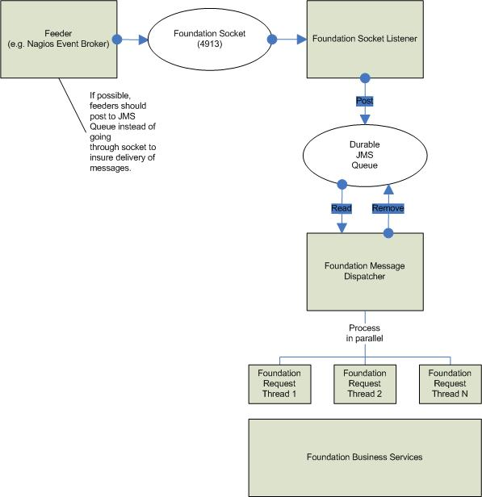

Security

TBD

Message Durability
In order to help insure incoming message are not lost we will be using a durable JMS queue to store all incoming

Scalability / Reliability
Since message state will be managed in the FMD, we may need to replicate this state among multiple servers if we have multiple processes reading the message queue. Another possible solution is to distribute the message execution among multiple servers and have the JMS queue replicated for fail-over.

One of the first steps is to capture the message throughput for the Joram MOM implementation, specifically with a durable, transacted queue. As well as understand all incoming messages currently supported in our solution. If there are a set of incoming messages that are atomic and no coordination is needed, a separate queue and FMD can be used to process the messages. Also if there is a subset of messages that are isolated from other messages, they can be coordinated with another instance of the FMD. Potentially, this instance or instances of the FMD could be deployed on a separate server in order to get better performance.

Performance

We need to insure that any performance degradation is nominal. There may be a traded off in performance when using a durable, transacted JMS queue and getting the parallel processing of the messages. We will need to capture these metrics early on in the development.

Foundation Message Dispatcher Configuration

In order for the FMD to properly coordinate messages it needs to be aware of message fields that identify the entities for which the message is related. The FMD configuration will define the message's key fields and use them to coordinate incoming messages. If a message is currently being processed for a specified key then it will be queued and executed once the related message is completed.

Also, we will allow for multiple instances of the FMD to be configured and potentially run on separate boxes. Each FMD instance should be configured so each is aware of the incoming messages that it can process.. Note that each FMD instance will have its own Foundation Socket Listener which justs reads a socket and writes the message to a queue.

Long term the FMD should be configured to post specified messages onto other queues or topics for interested parties (e.g. external system, auditing, monitoring, etc).

Foundation Message Format
For the Andros A2 release, we will try to keep message format as it is in the A1 release. Message structure will only change if needed to help facilitate the FMD with coordination of message execution.

All message field names should be consistent between messages. For example, the “Identification” in the HOST_STATUS message defines the device identification. This field would be a key indicating if any other messages come in with the same device identification then they will be queued until the first message is complete. Therefore, the “Identification” shield should be used by all messages to identify the device.

Message Processing Flow
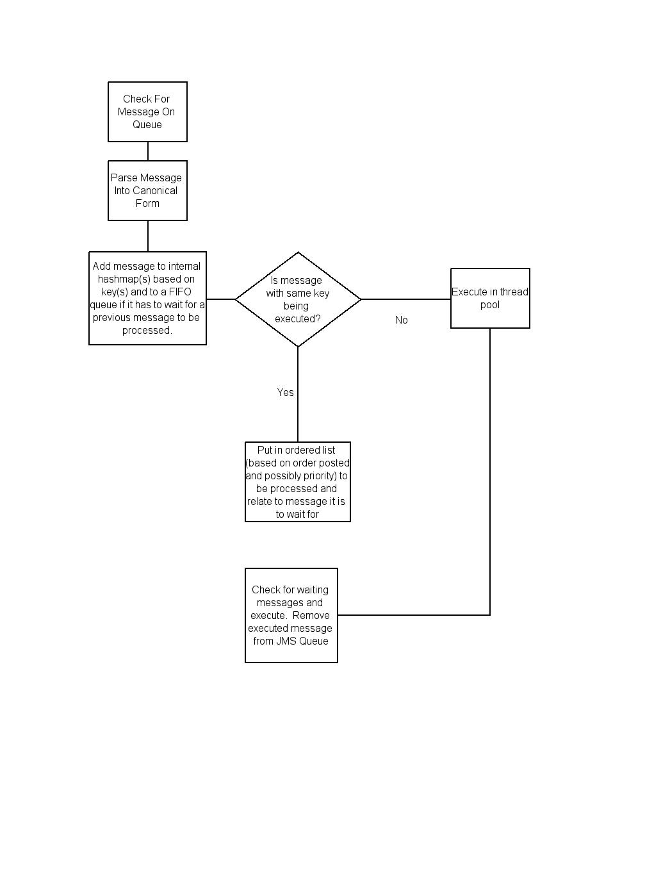

Foundation Message Dispatcher Configuration
The FMD configuration is part of the foundation.properties configuration file. Below is a list of all the FMD configuration properties.

#######################################
# Foundation Dispatcher Configuration
#######################################

# Maximum number of messages placed on message queue. Once this limit is reached the
# dispatcher will stop reading messages from the JMS queue until it is caught up
fmd.message.queue.max=500

# Coordinate all incoming messages on the following attributes
fmd.msgkeys.HOST_STATUS=Host,Device
fmd.msgkeys.SERVICE_STATUS=Host,Device,ServiceDescription
fmd.msgkeys.NAGIOS_LOG=Device
fmd.msgkeys.COLLAGE_LOG=Device
fmd.msgkeys.GENERICLOG=Device
fmd.msgkeys.SYSTEM_CONFIG=Host,Device
fmd.msgkeys.SNMPTRAP=Device
fmd.msgkeys.SYSLOG=Device
fmd.msgkeys.SYSTEMADMIN=Host,HostId,Device,DeviceId,HostGroup,HostGroupId,ServiceDescription,ServiceId

# If any of the attributes listed appear in the message then all messages of the same type
# with the same attribute value will be executed serially
fmd.msgserialkeys.NAGIOS_LOG=consolidation
fmd.msgserialkeys.GENERICLOG=consolidation
fmd.msgserialkeys.COLLAGE_LOG=consolidation
fmd.msgserialkeys.SYSTEMADMIN=Host,HostId,Device,DeviceId,HostGroup,HostGroupId,ServiceDescription,ServiceId
fmd.msgserialkeys.SYSLOG=consolidation
fmd.msgserialkeys.SNMPTRAP=consolidation

# Foundation Message Dispatcher Request Executor Pool Configuration
# Note: fmd.executor.max.pool.size should be equal or more than with the max number of db connections
# in the database connection pool (db.properties)
fmd.executor.core.pool.size = 10
fmd.executor.max.pool.size = 100
fmd.executor.queue.size = 1000

# Keep Thread Alive In Seconds
fmd.executor.keep.alive = 60

Notes:

- Message Consolidation – FMD should consolidate duplicate messages, but not perform application logic such as log message consolidation. Any data scrubbing or message filtering behavior should be accomplished through FMD configuration and should never perform application like business logic.
- We are going to keep the Foundation socket for client who cannot post directly to the JMS Queue (i.e. perl feeders, etc)
- Do not forget about bulk processing. Currently, the message parser considers a discrete message as being everything within a beginning tag and matching end tag. <SYSTEM_CONFIG ><HOST ../></SYSTEMCONFIG>
Also, Changed HostName attribute to Host for message coordination
- Need to throttle messages placed on JMS Queue if messages accumulating in the queue. Ideally, all messages would be on queue in order to insure durability.

Tasks:

- Capture Joram limitations with durable / transacted message processing.
- Define / Implement FMD XML configuration format
- Define incoming XML message format which will best facilitate FMD functionality
- Update feeders to post message to JMS Queue and new message format.

Questions:

- If execution of message fails should we retry?
- Do we need authentication for posting to JMS Queue? ANS: Plan for it in the design
- Do we support a message priority? If so, we need to define the algorithm.
- Should the FMD contain logic to queue, batch and consolidate similar incoming messages? Batch execution can be set up by a timeout, # of messages, or both.
- Should we look into open source message routing solutions (e.g. Mule

Long-Term Goals
- Add monitoring of Incoming Foundation Messages

Foundation Message Changes:
All these changes need to be reflected in the feeders.

- SYSTEM_CONFIG – Changed HostName attribute to Host in Bulk Messages
- TurboNocEvent – Changed HostName to Host
- NAGIOS_LOG – Changed HostName to Host and Identification to Device
- HostStatus – Changed Identification to Device
- ServiceStatus – Changed Identification to Device

Resources

Performance Metrics

All performance metrics will be captured on Utah (.228)

JMS Queue Read / Write

- Read and write 1000, 5000, 10000 messages to durable JMS Queue
  - Capture time to write and read messages simultaneously
  - Capture memory usage
- Process 1000, 5000, 10000 incoming messages per minute
  - Breakdown each message batch into host status, service status, log messages
  - Capture time to process individual messages as well as overall time to process entire batch
  - Determine message throughput and point will Foundation cannot catch up with incoming messages with current configuration.
  - Capture memory usage
- Process 1000, 2000, 5000 Host Create messages in one batch
  - Capture time to process individual messages as well as overall time to process entire batch

