

Network Management Suite (NMS) 2.0
Installation Guide

Table of Contents
NMS 2.0 Installation - Overview 4
Installation Scenarios 4
Upgrade from NMS 1.0 4
NMS 1.0 Uninstall 5
Backup GroundWork Monitor 5.1.x 5
Backup Cacti, NeDi, Ntop, and Guava 5
Backup Packages 6
Remove NMS 1.0 6
Temporarily Replace the Weathermap Directory 6
Upgrade to GroundWork Monitor 5.2.x 7
Install NMS 2.0 7
Post-NMS 2.0 Install 7
Restoring Cron Job Customizations 7
Cleaning Up After an Upgrade 7
Standard Installation: Installing NMS on a GroundWork Monitor 5.2.x server 7
Location of NMS 2.0 RPMs 8
Installation Sequence 8
Install NMS 2.0 RPMs 8
enterprise.properties File 9
Standard Installation 9
Custom Installation 9
Deployment 10
Running deploy.pl 10
Enable NMS Packages 14
Verify the List of Packages 14
Enabling the NMS 2.0 Packages in GroundWork Monitor 15
Components and Roles 16
Cacti Configuration 16
Validate Access to Packages 18
Installation in a Distributed Environment 19
DNS 19
Verifying Correct DNS Configuration 19
Deployment 19
Installation Steps 19
Example: Running Cacti on a Server Other Than the Main Server 19

NMS 2.0 Installation - Overview
GroundWork Network Management Suite (NMS) is made up of from one to four modules (depending upon your company’s requirements). The modules are:
- Network Discovery Module (NeDi)
- Traffic Graphing Module (Cacti)
- Network Map Module (PHP Weathermap)
- Protocol Analysis Module (Ntop)

Installation Scenarios
NMS 2.0 can be installed on an individual host or in a distributed environment.
The NMS 2.0 Installation Guide discusses the following installation scenarios:
- Upgrade from NMS 1.0 – When NMS 1.0 has been installed with GroundWork Monitor 5.1.x, you must first uninstall NMS 1.0, then upgrade to GroundWork Monitor 5.2.x, and then proceed with a fresh installation of NMS 2.0. Refer to “Upgrade from NMS 1.0” on page 4.
- Standard Installation – For a fresh installation of NMS 2.0 and GWM 5.2.x, including installation of all four NMS modules, refer to “Standard Installation: Installing NMS on a GroundWork Monitor 5.2.x server” on page 8.
- Custom Installation – For a fresh installation of NMS 2.0 and GWM 5.2.x with installation of from one to three of the four NMS modules, follow the instructions in “Standard Installation: Installing NMS on a GroundWork Monitor 5.2.x server” on page 8. In addition, edit the enterprise.properties file as described in the section on the “enterprise.properties File”.
- Installation in a Distributed Environment – For installation on one or more servers in addition to the GroundWork Monitor server, refer to “Installation in a Distributed Environment” on page 20.

Upgrade from NMS 1.0
WARNING: NMS 1.0 must be uninstalled prior to installation of NMS 2.0 due to the integration with the Guava portal, an integral component of GroundWork Monitor. The RPM removal of NMS 1.0 results in incomplete removal of Guava packages data, which leaves inconsistent references that cause failure on login to Guava.
NMS 1.0 is not compatible with the GroundWork Monitor 5.2.x platform. Therefore, after making appropriate backups, you must uninstall NMS 1.0 before beginning an installation of GroundWork Monitor 5.2.x and NMS 2.0.

NMS 1.0 Uninstall
The complete NMS 1.0 uninstall described here permits a clean installation of GroundWork Monitor Professional 5.2.x, followed by the installation of NMS 2.0 and subsequent configuration.
NOTE: The NMS 1.0 uninstall steps will not remove NMS 1.0 data. The NMS 1.0 data will upgraded by the NMS 2.0 deploy procedure.
You must uninstall NMS 1.0 whether installed:
- Locally in a single server configuration
- Remotely on a separate server with SSO for portal access.
WARNING: Uninstall NMS 1.0 only after making appropriate backups of the configuration files, data collection files, and databases.
Follow these steps on both the GroundWork Pro server and on the remote server, if NMS 1.0 is installed there.

Backup GroundWork Monitor 5.1.x
Create backups of GroundWork Monitor 5.1.x in accordance with the GroundWork Monitor 5.2.x upgrade procedure documented in the GroundWork Monitor Pro 5.2.x Install Guide.

Backup Cacti, NeDi, Ntop, and Guava
After creating backups of GroundWork Monitor 5.1.x, create backups of Cacti, NeDi, Ntop, Guava files and databases, as follows:
- Disable cron job for Cacti and NeDi by commenting out the appropriate lines in /etc/crontab and in local nagios, cactiuser, and, possibly, nobody user according to the way the customer is set up:
crontab –u <user> -e
- Make a backup of the crontabs for all users, that is:
  - /etc/crontab
  - /var/spool/cron/*
- Stop Ntop and verify that Ntop, NeDi and Cacti threads are all inactive, with the following command:
ps –ef | grep [<user>|<process>]
- For Guava, Cacti and NeDi, execute:
Mysqldump <database> > /usr/local/backups/<database>.sql
- For Weathermap, Ntop, Cacti, and NeDi:
  - Make TAR backups of the install directories and the init.d files.
  - Backup the entire /etc/init.d directory.
NOTE: The backup of Weathermap is critical to the NMS install.

Backup Packages
- To backup packages, make a TAR backup of the guava/packages subdirectory:
tar –cf /usr/local/backup/guava-packages /usr/local/groundwork/guava/packages
- Log in to Groundwork Monitor Professional as an administrator and open the roles one by one.
- Make a note of the roles that include the NMS packages, so that you can re-associate them when you are done with the upgrade.
- Open the packages tab and uninstall each of the NMS packages including the SVCactigraphs view package. When doing this make sure you do not have any windows open with an SVCactiGraph view active as this interferes with the package removal. Likewise do not keep files open in vi session or the like.
- Log out of GroundWork Monitor.
- Find the database, user, and password information for the following packages:
  - Cacti: /usr/local/groundwork/cacti/include/config.php
  - NeDi: /usr/local/groundwork/nedi/nedi.conf
  - Ntop: Refer to your notes from the installation. Typically the user is “admin” and the password is “admin”.

Remove NMS 1.0
Get the exact NMS package names using the command:
rpm –qa | grep nms
To remove the NMS 1.0 packages execute:
rpm –e <package name> <package name>
NOTE: Only program files will be removed. NMS 1.0 data will not be removed and will be upgraded by the deploy procedure for NMS 2.0.

Temporarily Replace the Weathermap Directory
To supply reference files for the NMS 2.0 installation, put the TAR backup in place by executing a TAR extract from your backup into the original location at:
/usr/local/groundwork/weathermap

Upgrade to GroundWork Monitor 5.2.x
Proceed with the upgrade to 5.2.x on the GroundWork Monitor server, and also apply any patches available at the time, according to published instructions.

Install NMS 2.0
Proceed with the installation of NMS 2.0:
- Follow the Standard Installation instructions in this document (refer to “Standard Installation: Installing NMS on a GroundWork Monitor 5.2.x server”, page 8). Pay attention to the issues around existing databases and files.
- Complete the items discussed in the “Post-NMS 2.0 Install” section that follows.

Post-NMS 2.0 Install

Restoring Cron Job Customizations
After installation, restore any customizations in the cron entries that were created for the packages, unless the NMS 2.0 installation has made the customizations unnecessary.

Cleaning Up After an Upgrade
If you are performing an upgrade on a single server or a set of servers, when you have satisfactorily validated the NMS 2.0 installation as complete, you should clear away any remnants of the NMS 1.0 install (i.e. partially empty directories). These directories are confusing and contain nothing needed for operation:
/usr/local/groundwork/cacti
/usr/local/groundwork/ntop
/usr/local/groundwork/cactid
/usr/local/groundwork/nedi
/usr/local/groundwork/weathermap
It is good practice to archive and then remove the 5.1.3 backup files made in the course of the upgrade/installation once you are sure all is in working order.

Standard Installation: Installing NMS on a GroundWork Monitor 5.2.x server
The following section describes a fresh installation of NMS 2.0 with GroundWork Monitor 5.2.x. The standard (or default) installation is a local installation: GroundWork Monitor, NMS components, and the database all reside on the same host.
A local installation does not require the host to be listed in the DNS (Domain Name Service).
NOTE: Prior to a fresh installation of NMS 2.0, verify that GroundWork Monitor 5.2.x is installed, configured, and running.

Location of NMS 2.0 RPMs
The NMS 2.0 tar.gz file containing the NMS 2.0 RPMs is located on GroundWork Connect:
www.groundworkconnect.com/downloads

Installation Sequence
The installation proceeds in the following order:
- Install NMS 2.0 RPMs.
- Edit the enterprise.properties file (if necessary).
- Run the deployment script.
- In GroundWork Monitor, enable the NMS packages and configure Cacti.
- If upgrading from NMS 1.0, complete upgrade steps.

Install NMS 2.0 RPMs
- Copy the NMS 2.0 RPMs to the GroundWork Monitor 5.2.x Installation.
- Execute the following command to install the RPMs:
rpm -Uhv groundwork-nms-*
The following figure displays the output after installing the NMS 2.0 RPMs for a standard (complete) installation.
INSTALLING ALL RPMS:
====================
[root@giant RPMS]# ls -al
total 46180
drwxr-xr-x 2 root root 4096 May 1 15:09 .
drwxr-xr-x 3 root root 4096 May 1 15:09 ..
-rw-r--r-- 1 root root 2169623 May 1 15:09 groundwork-nms-cacti-2.0.0-2999.noarch.rpm
-rw-r--r-- 1 root root 36207004 May 1 15:09 groundwork-nms-core-2.0.0-2999.i386.rpm
-rw-r--r-- 1 root root 2285572 May 1 15:09 groundwork-nms-nedi-2.0.0-2999.noarch.rpm
-rw-r--r-- 1 root root 4269331 May 1 15:09 groundwork-nms-ntop-2.0.0-2999.noarch.rpm
-rw-r--r-- 1 root root 2269682 May 1 15:09 groundwork-nms-weathermap-2.0.0-2999.noarch.rpm
[root@giant RPMS]# rpm -Uhv groundwork-nms-*
Preparing... ########################################### [100%]
1:groundwork-nms-core ########################################### [ 20%]
2:groundwork-nms-cacti ########################################### [ 40%]
3:groundwork-nms-nedi ########################################### [ 60%]
4:groundwork-nms-ntop ########################################### [ 80%]
5:groundwork-nms-weatherm########################################### [100%] [root@giant RPMS]#

enterprise.properties File
The enterprise.properties file describes every running component in a GroundWork Monitor system. The file is found at:
usr/local/groundwork/enterprise/config/enterprise.properties
The enterprise.properties file contains two sections pertaining to each component:
- Properties section – Configures the NMS server
- Application section - Configures the NMS application for the specific component.

Standard Installation
By default, the enterprise.properties file is configured for the installation of all four NMS modules on a local machine.

Custom Installation
If you install from one to three of the modules (rather than the complete set of four modules) or you install in a distributed environment, you must configure enterprise.properties.
NOTE: You must configure enterprise.properties before running deploy.pl.
To configure enterprise.properties, you must comment out the sections specific to the modules you are not installing.
For example, the following shows the section of the enterprise.properties file that is specific to the NeDi Guava Package. If you are not installing NeDi, you must comment out this section.
# NeDi Application Guava Package
application.nedi-pkg.nedi_pkg_main.host=%LOCAL_HOSTNAME
application.nedi-pkg.nedi_pkg_main.nedi=$nms.nedi.nedi_main
The following shows the section of the enterprise.properties file that is specific to the NeDi service. If you are not installing NeDi, you must comment out this section.
###########################
## [nms.nedi] Properties ##
###########################

# All of the properties of the
# nedi instances.

nms.nedi.nedi_main.host=%LOCAL_HOSTNAME
nms.nedi.nedi_main.database=$system.database.mysql_main
nms.nedi.nedi_main.httpd=$nms.httpd.httpd_main
nms.nedi.nedi_main.database_name=nedi
nms.nedi.nedi_main.database_user=nediuser
nms.nedi.nedi_main.database_password=nediuser

Deployment
The deploy procedure includes deployment "profiles". Presently, there are two profile types supported:
- Local – default profile
- Distributed
You specify a profile on the command line with -p, as in:
./deploy.pl -p local -a
The local profile is the default. You do not need to specify it in the command line. The local profile is for a standard installation where all of the components (including the database) are on the same, local host. Cookies are resolved using the short host name instead of the FQDN.

Running deploy.pl
NOTE: Before running deploy.pl, you must configure enterprise.properties as necessary.
- Navigate to the enterprise deployment directory:
cd /usr/local/groundwork/enterprise/bin
- Run the enterprise deployment script with the -a (install all) option:
./deploy.pl –a
NOTE: At the completion of the deployment script, restart the GroundWork httpd server.
The following figure displays typical output after running deploy.pl.
DEPLOYING FOR ALL COMPONENTS:
=============================
[root@giant RPMS]# cd /usr/local/groundwork/enterprise/bin
[root@giant bin]# ./deploy.pl -a
=============================================================================
= deploy.pl -- deploy local configuration =
= Copyright (C) 2008 Groundwork Open Source, Inc. =
=============================================================================
Loading Configuration File: '/usr/local/groundwork/enterprise/config/enterprise.properties'
Deploying All Local Components
Deploying Component: [system.database.mysql_parent]
No Deployment Executor for this Component.
Deploying Component: [system.bronx.bronx_parent]
No Deployment Executor for this Component.
Deploying Component: [system.foundation.foundation_parent]
No Deployment Executor for this Component.
Deploying Component: [application.gwm.gwm_parent]
No Deployment Executor for this Component.
Deploying Component: [nms.httpd.httpd_parent]
Deploying to Local Host: giant.groundwork.groundworkopensource.com ()
Deploying Httpd Instance [httpd_parent]
{
httpd_host = giant.groundwork.groundworkopensource.com
httpd_port = 81
http_auth_login:host = giant.groundwork.groundworkopensource.com
http_auth_login:port = 80
httpd_auth_domain = groundwork.groundworkopensource.com
}
Setting Listener Port.
Setting Server Name.
Setting authorization ticketing information.
Copying init.d script.
Setting permissions.
Starting nms-httpd
Done.
Deploying Component: [nms.cacti.cacti_parent]
Deploying to Local Host: giant.groundwork.groundworkopensource.com ()
Deploying Cacti Instance [cacti_parent]
{
db_host = giant.groundwork.groundworkopensource.com
db_type = mysql
db_port = 3306
db_root_user = root
db_root_password = [hidden]
database_name = cacti
database_user = cactiuser
database_password = [hidden]
httpd_host = giant.groundwork.groundworkopensource.com
httpd_port = 81
}
Building new database.
Creating database user permissions and settings.
Patching plugin database.
Patching files.
Patching PHP files.
Patching Perl files.
Patching configuration files.
Setting permissions.
Adding entry to crontab.
Done.
Deploying Component: [nms.nedi.nedi_parent]
Deploying to Local Host: giant.groundwork.groundworkopensource.com ()
Deploying NeDi Instance [nedi_parent]
{
db_host = giant.groundwork.groundworkopensource.com
db_type = mysql
db_port = 3306
db_root_user = root
db_root_password = [hidden]
database_name = nedi
database_user = nediuser
database_password = [hidden]
httpd_host = giant.groundwork.groundworkopensource.com
httpd_port = 81
}
Patching files.
Patching Perl files.
Patching PHP files.
Patching other.def.
Copying database settings to nedi.conf.
Cleaning old database and user.
Initializing NeDi Database.
Building new database and user.
Setting permissions.
Adding entry to crontab.
Done.
Deploying Component: [nms.ntop.ntop_parent]
Deploying to Local Host: giant.groundwork.groundworkopensource.com ()
Deploying ntop Instance [ntop_parent]
{
ntop_port = 82
}
Patching files.
Setting permissions.
Starting nms-ntop
Done.
Deploying Component: [nms.weathermap.weathermap_parent]
Deploying to Local Host: giant.groundwork.groundworkopensource.com ()
Deploying Weathermap Instance [weathermap_parent]
{
host = giant.groundwork.groundworkopensource.com
}
Attaching to Cacti Instance.
Attaching to Cacti Instance.
Building Configuration File.
Done.
Deploying Component: [application.cacti-pkg.cacti_pkg_parent]
Deploying to Local Host: giant.groundwork.groundworkopensource.com ()
Deploying Cacti Instance [cacti_pkg_parent]
{
cacti:httpd:host = giant.groundwork.groundworkopensource.com
cacti:httpd:port = 81
cacti:database:host = giant.groundwork.groundworkopensource.com
cacti:database_name = cacti
cacti:database_user = cactiuser
cacti:database_pass = cactiuser
}
Cleaning previous Cacti Package.
Installing new Cacti Package.
Installing new Cacti plugins and supporting files.
Configuring for server location.
Configuring httpd server.
Creating directory structure if needed.
Modifying groundwork apache configuration file.
Creating httpd configuration file.
Adjusting permissions.
Patching guava.
Done. You will need to restart the Groundwork httpd server.
Deploying Component: [application.nms-automation.nms_automation_parent]
Deploying to Local Host: giant.groundwork.groundworkopensource.com ()
Deploying Cacti Instance [nms_automation_parent]
{
host = giant.groundwork.groundworkopensource.com
}
Installing NMS Automation Components.
Installing Scripts.
Installing Templates.
Done.
Deploying Component: [application.nedi-pkg.nedi_pkg_parent]
Deploying to Local Host: giant.groundwork.groundworkopensource.com ()
Deploying Nedi Instance [nedi_pkg_parent]
{
nedi:httpd:host = giant.groundwork.groundworkopensource.com
nedi:httpd:port = 81
}
Cleaning previous Nedi Package.
Installing new Nedi Package.
Configuring for server location.
Patching guava package.
Configuring httpd server.
Creating directory structure if needed.
Modifying groundwork apache configuration file.
Creating httpd configuration file.
Adjusting permissions.
Patching guava.
Done. You will need to restart the Groundwork httpd server.
Deploying Component: [application.ntop-pkg.ntop_pkg_parent]
Deploying to Local Host: giant.groundwork.groundworkopensource.com ()
Deploying Ntop Instance [ntop_pkg_parent]
{
ntop:host = giant.groundwork.groundworkopensource.com
ntop:port = 82
}
Cleaning previous Ntop Package.
Installing new Ntop Package.
Configuring for server location.
Patching guava package.
Done.
Deploying Component: [application.weathermap-editor-pkg.weathermap-editor_pkg_parent]
Deploying to Local Host: giant.groundwork.groundworkopensource.com ()
Deploying Weathermap Editor Instance [weathermap-editor_pkg_parent]
{
weathermap-editor:httpd:host = giant.groundwork.groundworkopensource.com
weathermap-editor:httpd:port = 81
}
Cleaning previous Weathermap Editor Package.
Installing new Weathermap Editor Package.
Configuring for server location.
Patching guava package.
Patching other files.
Configuring httpd server.
Creating directory structure if needed.
Modifying groundwork apache configuration file.
Creating httpd configuration file.
Adjusting permissions.
Patching guava.
Building Weathermap Editor Configuration File.
Done. You will need to restart the Groundwork httpd server.
=============================================================================

Enable NMS Packages
After installation you must enable the NMS packages within GroundWork Monitor.
NOTE: Cacti requires additional configuration steps as noted in “Cacti Configuration” on page 17.
NOTE: If you have removed NMS 1.0 prior to NMS 2.0 installation, refer to the notes you made for package association with roles.

Verify the List of Packages
- Log in to GroundWork Monitor 5.2.x.
- Click the Application Launcher and select Administration > Packages. The Packages Available in the System screen appears (Figure 1: NMS Packages Displayed in GWM).
- Review the Packages list in the left navigation bar. The following names appear in the left navigation bar (in no specific order):
  - Cacti
  - NeDi
  - Ntop
  - Status Viewer Cacti Graphs
  - Weathermap Editor
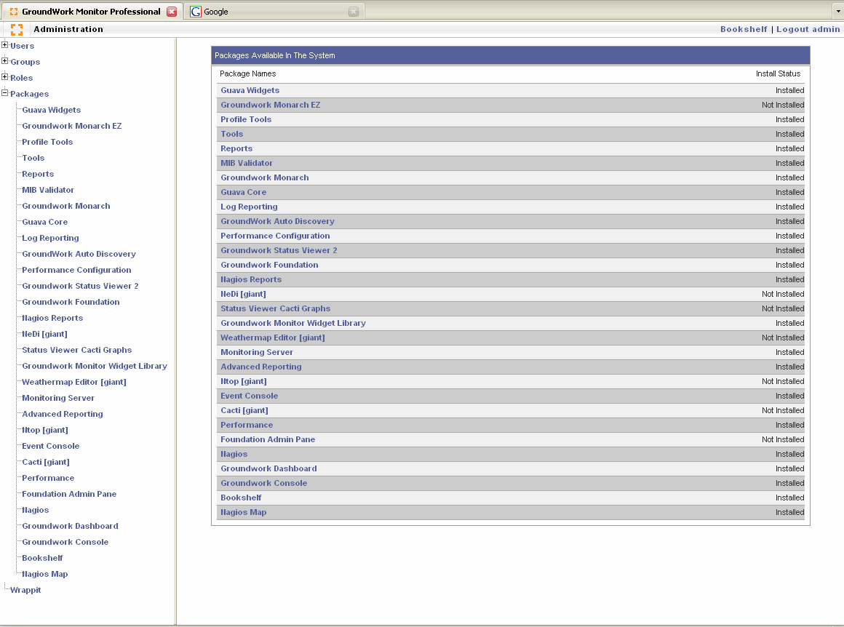
Figure 1: NMS Packages Displayed in GroundWork Monitor

Enabling the NMS 2.0 Packages in GroundWork Monitor
NOTE: The Packages may be enabled in any order.
- Click the Application Launcher and select Administration > Packages.
- On the Packages Available in The System screen, click the name of the package you want to enable. The Showing Package Information for <package_name> screen appears.
- Click Install This Package Now. The screen redisplays and the link “Uninstall this package” now appears.
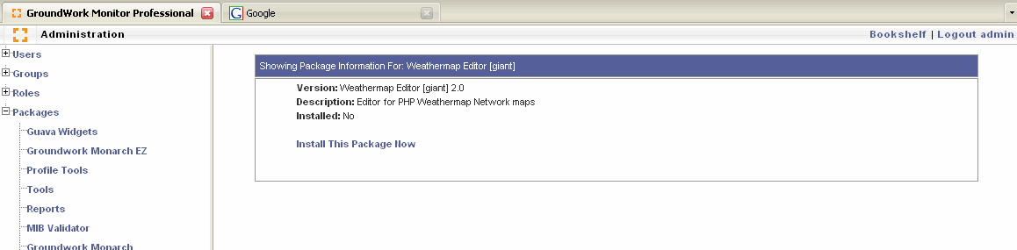
Figure 2: Package Information screen

Components and Roles
Within GroundWork Monitor, you must add each NMS component to the Role(s) to which you want to grant access to the component.
- Click the Application Launcher and select Administration > Roles.
- Select the Role to which you want to grant access. The Showing Role Information For: <Role> screen appears.
- At the bottom of the screen select the component from the Add View to this Role drop-down. Click Add View. When added successfully the screen displays:
Successfully added View Subscription
- Log out of GroundWork Monitor and log back in as a user with that role. The menu will now display the installed components for that user/role.

Cacti Configuration
The Cacti component requires specific configuration for NMS.
- Click the Application Launcher and select Cacti. Prior to configuration for NMS, the Cacti screen displays only two tabs at the top of the screen.
- On the Cacti screen at the bottom of the left navigation menu, select User Management. The User Management screen appears.
- Select the User Name you wish to configure. The User Name will be the same you have used to log into GroundWork Monitor.
- In the Realm Permissions section of the User Management screen, click the final five check boxes. Click Save. The Cacti screen now displays the thold and weathermap tabs.
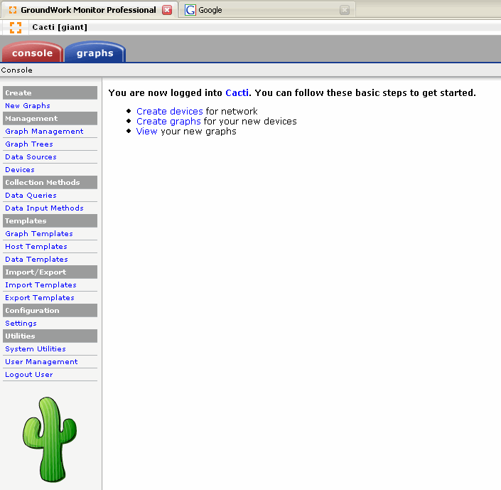
Figure 3: Cacti Screen displaying 2 tabs
- Select the Role to which you want to grant access. The Showing Role Information For: <Role> screen appears.
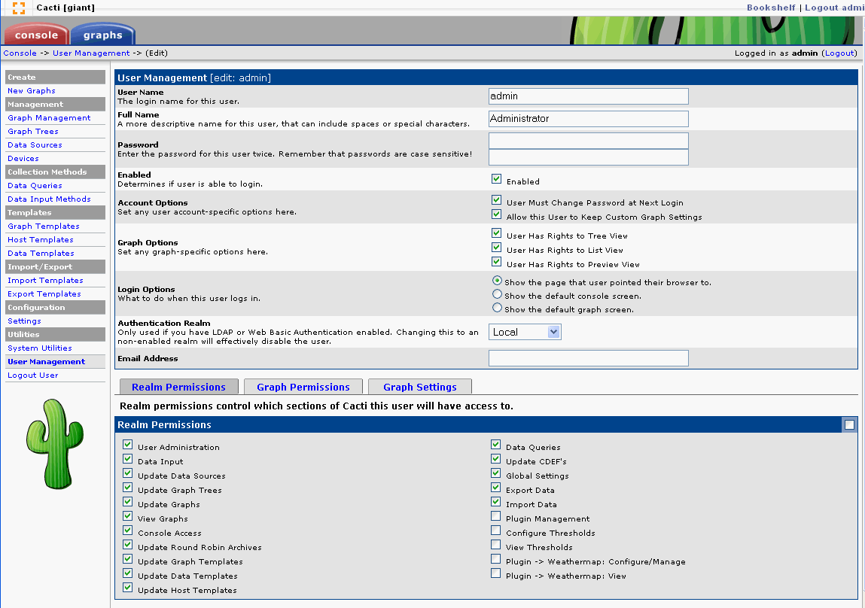
Figure 4: Cacti User Management

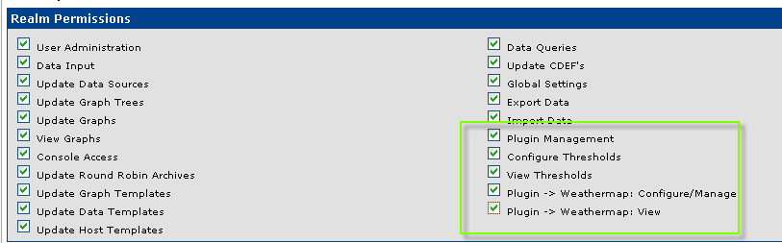
Figure 5: Cacti User Management Detail

Validate Access to Packages
After package and role configuration, validate for each role that you can access the packages:
- Log out of GroundWork Monitor.
- Log in again as each user type that uses a role affected by your entries.
- Validate for each role that you can access the packages.
- Return to the “Post-NMS 2.0 Install” section on page 7 and complete the following:
- Restore Cron Job Customizations
- Clean Up After the Upgrade

Installation in a Distributed Environment

DNS
For a distributed installation, you must run the deploy script with the –p distributed option. This option requires that you have DNS and that when you type ‘hostname’, it must return a fully-qualified domain name (FQDN) (for example: 'saturn.groundwork.groundworkopensource.com'), not just the short hostname (for example: 'saturn').

Verifying Correct DNS Configuration
To test whether your machine is correctly configured for DNS, when you execute the hostname command from the shell it should return the FQDN not just the short name.

Deployment
Use the distributed profile (-p distributed) to manage distributed installation issues such as resolving cookies by domain name or having your database reside on another host. The distributed profile manages these situations for you.
You specify the distributed profile on the command line with -p, as in:
./deploy.pl -p distributed -a

Installation Steps
The following steps are required when installing in a distributed environment:
- Edit enterprise.properties. Update the host name to indicate where the component will be running. NOTE: The host name must be specified as a fully-qualified domain name.
- Install the RPM for that module on both the GroundWork Monitor server and that host.
- Run the deployment script.
- In GroundWork Monitor, enable the NMS packages and configure Cacti.

Example: Running Cacti on a Server Other Than the Main Server
- For example, if running Cacti on a server other than the main server:
- Install Cacti on the main server.
- On the other host, install NMS core and the Cacti RPMs.
- Edit enterprise.properties to change the host property for Cacti to be the fully-qualified domain name where that component is being deployed.
- Place a copy of the enterprise.properties file on the main host and on the distributed host.
NOTE: You must have a copy of the enterprise.properties file on every host that is running NMS.
You must run deploy.pl both on the main and on each distributed host. Each host running an NMS module must have IDENTICAL enterprise.properties files.
NOTE You must edit enterprise.properties before running deploy.pl. However, you can edit and re-deploy at anytime without harm.

