Copyright 2004-2008 GroundWork Open Source, Inc. ("GroundWork"). All rights reserved. Use is subject to GroundWork commercial license terms. GroundWork products are released under the terms of the various public and commercial licenses. For information on licensing and open source elements please see http://www.groundworkopensource.com/products/pro-ipingredients.html. GroundWork, GroundWork Open Source, GroundWork Monitor Professional, GroundWork Monitor Open Source, GroundWork Community Edition, GroundWork Monitor Enterprise, GroundWork Foundation, GroundWork Status Viewer, Monarch, and GroundWork Guava are trademarks of GroundWork Open Source, Inc. Other trademarks, logos and service marks (each, a "Mark") used in GroundWork’s products, including Nagios, which is a registered trademark of Ethan Galstad, are the property of other third parties. These Marks may not be used without the prior written consent of GroundWork Open Source or the third party that owns the respective Mark.

GroundWork Network Management Suite Readme
The purpose of this document is to outline the Known Issues and Bug Fixes in Network Management Suite (NMS) 2.0. Product support is available through a GroundWork Subscription Agreement accessible online by logging into GroundWork Connect at http://www.groundworkconnect.com/.
Contents
SECTION 1 - KNOWN ISSUES
SECTION 2 - BUG FIXES
SECTION 1 - KNOWN ISSUES
This section includes a description of the known issues in this release of NMS.
- GroundWork Monitor Enterprise 5.2.1 with SP2 or later must be installed when deploying NMS 2.0.
- The Weathermap, Thold and Discovery Cacti plugins available at release time did not support the new features of the Cacti PIA (Plug-In Architecture) such as dynamic registration/installation/removal. As a result, even though the plug-ins are present and work correctly, the entries in the Plugin Management screen do not show any entries (unless you have installed new plugins that support the updated PIA).
- To resolve errors generated when email addresses are not set in Cacti, you must configure Cacti email settings on a number of screens as follows:
On the Cacti Settings (Alert/Thold) screen, set the following:
- Dead Hosts Notifications – Not checked
- Baseline Notifications – Not checked
- A number of Cacti settings should be configured as follows:
On the Cacti Settings (Misc) screen, disable discovery. This feature is generally not useful as it will try to add discovered devices automatically to your Cacti polling. To disable:
- Start Time for Polling – Verify the field is empty
- Poller Frequency - Set to Disabled.
On the Cacti Settings Poller screen:
- Enabled – Check
- Poller Type – spine
- Poller Interval – 5
- Cron Interval - 5
NOTE: For any installations other than a fresh installation: If you change the Poller or Cron Interval on this screen, you must remake any existing RRD files, because when a device is added and the graphs first specified, they are set according to the values defined here.
On the Cacti Settings (Paths) screen,
- All paths should display the message: OK: FILE FOUND
- Verify that each entry is truly the path and executable you need (for example, the “spine” executable).
On the Cacti Settings (General) screen:
- For normal operations, the Cacti Settings (General) screen should reflect the configuration in the following screen capture, which has minimal Cacti logging that is not going to the syslog.
- To debug, click in some of the detail boxes at the top, and save the settings. The Cacti log will receive more entries that are more helpful than running the poller by hand to the screen.
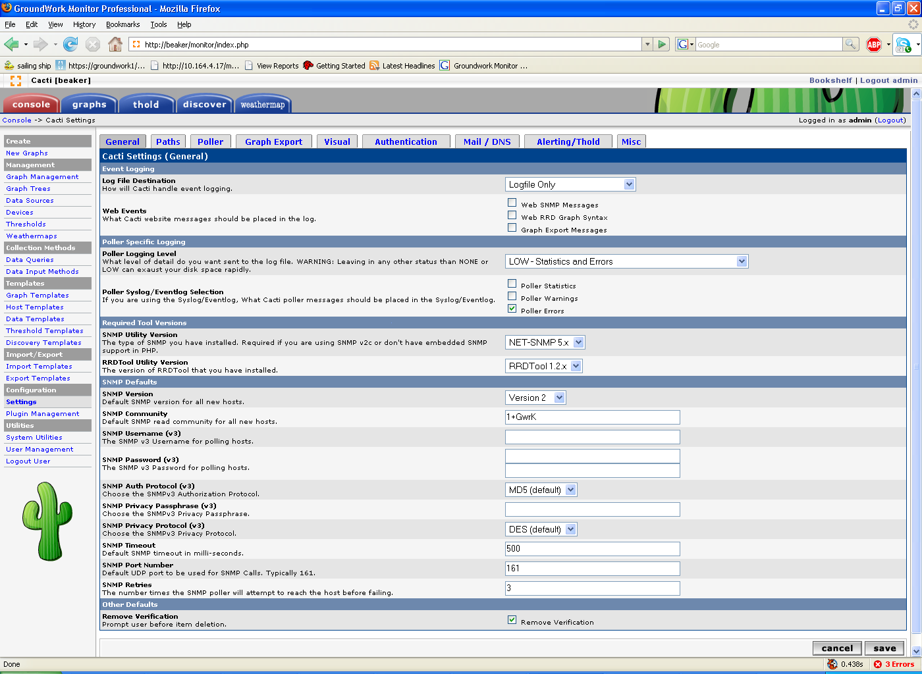
- When NMS 2.0 is first installed, Weathermap is not viewable until a weathermap is added and users are allowed to view it. On the Weathermap Management screen:
- Click Add to add a map for viewing and then click the user name “admin” in the map line to control which users are allowed to see each map.
SECTION 2 - BUG FIXES
This section includes a description of the externally reported bugs fixed in this release of Network Management Suite. If available, the SalesForce Case number (SFC) is listed along with a brief description.
- Provide informative error messages if NMS install fails – The deploy procedure now outputs errors on failure conditions.

- SFC 4268 - Weathermap viewer package missing from NMS integration 5.1.3 – Resolved.

- SFC 4461 - check_cacti plugin has lib statement that will not work when running nagios – Resolved.

- Ntop error message when starting daemon

- SFC 3138 - Missing libraries in install – Resolved.

- Fix overlib issues – Resolved.

