

NMS README for Distributed Installations V 1.3

Prepared by:
Version 1.1 Daniel Feinsmith (November 3, 2008)
Version 1.2 Richard Barry-Smith (November 3, 2008)
Version 1.3 Richard Barry-Smith (February 27, 2009)

- I. Applying the .nms configuration file

- For GroundWork Customers who have purchased the NMS distributed option, please be aware of the fact that you must download an .nms file from Jira (NMS-240).
This file must be place in to NMS installer’s config directory.

- II. “Edit this Menu” issue

- This issue arises when a user customizes their MySQL Server login parameters from the following screen. If the user does not perform any customizations (ex: entering a MySQL password, etc...), then this issue does not arise.

- 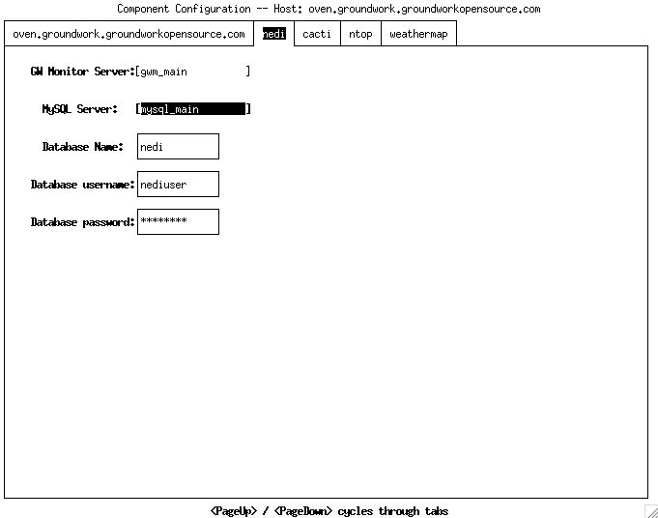

- When the user clicks on [mysql_main], it brings up the following drop-down list:

- 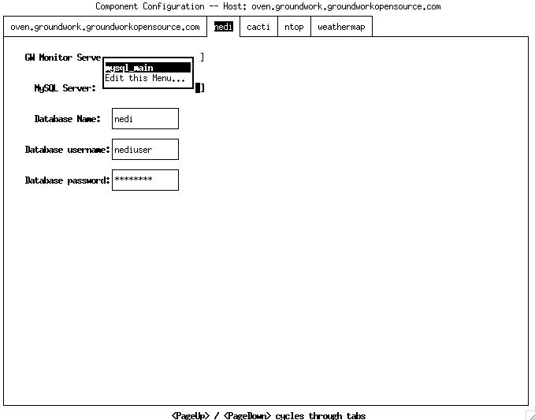

- The user then selects Edit this Menu... to enter into the next screen:

- 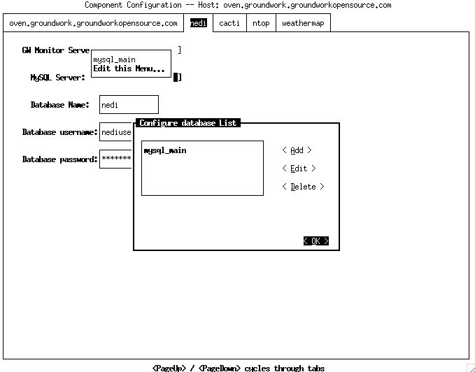

- From this screen, the user can add or edit his MySQL database parameters. When the user has completed editing from this interface and clicks on the < OK > button, he is returned to the previous screen:

- 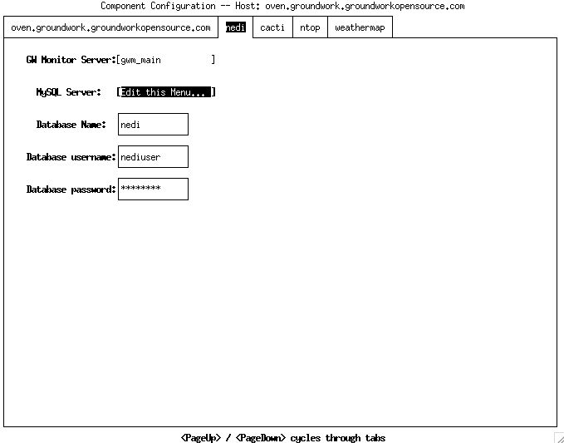

- As can be seen, the MySQL Server: now points to [Edit this Menu...] instead of [gwm_main]. If this is allowed to remain as shown on the screen shot above, the database parameters associated within the GW Monitor server in the enterprise.properties file will be corrupted. In order to rectify this, you need to click on [Edit this Menu...] which will bring up the drop down list as seen earlier before the edits took place:

- 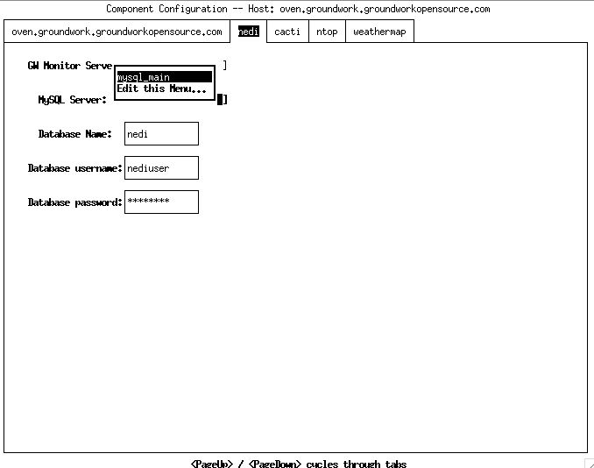

- ... and finally click on mysql_main. Once this screen looks as follows you will be safe to continue with your installation:

- III. Configuration Ordering Issue

- When using the installer in Distributed Custom mode, before defining any additional hosts (the Master Server host is the first one defined), you first must go in to configure the master server host, and otherwise it will assign the Master privileges to the first host that you configure. By “go into configure”, that you must click on the host, and enter “Configure Host”, which will lead you to the Component Configuration Screen. Once you have gone into that screen, you can click on
< Back >, and continue with adding other hosts.

- IV. Installer Exit Issue

- If the installer exits in error, you need to delete the enterprise.properties file it created, as it can be in a corrupted state, and if re-used on a foregoing re-start of the installer, can cause problems.

- V. Component Configuration required for each Host
- Similar to item #II, you must *always* go to the “Component Configuration” Screen for each Host, otherwise it will not correctly write the ‘.host’ property for that component.

- VI. “Write Config” can cause crash/corruption.

- Don’t “Write Config” file until you’ve configured each host. If you do, it could cause either corruption of the enterprise.properties file, crash of the installer, or both.

- VII. Placeholder Text

- The “This is a placeholder for lots of explanatory text” needs actual explanatory text.

