Copyright 2004-2009 GroundWork Open Source, Inc. ("GroundWork"). All rights reserved. Use is subject to GroundWork commercial license terms. GroundWork Monitor products are released under the terms of the various public and commercial licenses. For information on licensing and open source elements please see http://www.groundworkopensource.com/products/pro-ipingredients.html. GroundWork, GroundWork Open Source, GroundWork Monitor Professional, GroundWork Monitor Open Source, GroundWork Community Edition, GroundWork Monitor Enterprise, GroundWork Foundation, GroundWork Status Viewer, Monarch, and GroundWork Guava are trademarks of GroundWork Open Source, Inc. Other trademarks, logos and service marks (each, a "Mark") used in GroundWork’s products, including Nagios, which is a registered trademark of Ethan Galstad, are the property of other third parties. These Marks may not be used without the prior written consent of GroundWork Open Source or the third party that owns the respective Mark.

GroundWork Network Management Suite (NMS) 2.1.1 Install Guide
The purpose of this document is to guide the administrator through the process of installing GroundWork Network Management Suite (NMS) 2.1.1 Product support is available through a GroundWork subscription agreement. Existing subscription customers can access support online by logging into the GroundWork Connect at http://www.groundworkconnect.com/.
Contents
SECTION 1 – PREREQUISITES
SECTION 2 – AUTOMATED INSTALLER – WHAT TO EXPECT
SECTION 3 – DOWNLOAD AND INSTALL PROCESS
APPENDIX A – BACK UP
SECTION 1 – PREREQUISITES
By default, the component applications of GroundWork NMS 2.1.1 are installed on the same server as GroundWork Monitor 5.3 release itself, with the individual applications being made available as Guava objects on the local GroundWork Server. GroundWork NMS 2.1.1 also supports a distributed installation model that allows the individual components to be installed on their own servers. In this model, the component applications are registered with GroundWork Monitor, and user requests are redirected to the appropriate server. However, the distributed installation model requires additional configuration by GroundWork Professional Services. Such organizations who would like to use the distributed installation should contact GroundWork Customer Support. In both scenarios, the core components of GroundWork NMS 2.1.1 require an existing installation of GroundWork Monitor Professional or Enterprise 5.3 and its dependant software.
Supported Operating Systems
GroundWork NMS 2.1.1 is supported on the same operating system platforms as GroundWork Monitor. This release of NMS 2.1.1 is only to be used with the GroundWork 5.3 Release or later
Hardware Recommendations
GroundWork NMS 2.1.1 requires the following system resources in addition to the requirements for GroundWork Monitor.
- 1 GB system memory
- 40 GB available disk space
- 1 or more CPUs with a 1 GHz clock rate
Supported NMS Upgrades
GroundWork NMS 2.1.1 supports direct upgrades of GroundWork NMS 2.0.x installations. Note: Organizations who received customized installations by GroundWork Professional Services should contact GroundWork Customer Support prior to proceeding with an upgrade.
MySQL Configuration for FQDN Accessibility
During installation you will be prompted for a Name Resolution in which you will be given the options of Short Name or Fully Qualified Domain Name (FQDN). You will want to select the Short Name option if you can type short host names into your browser to access the GroundWork hosts. FQDN should be selected if full domain names are required to access your GroundWork hosts or you are performing a distributed installation. If you select to use FQDN in your installation, you may need to create new user privileges in your MySQL instance. Follow the steps below to configure a MySQL server for FQDN accessibility. Note that the flush_privileges command is required in order to be sure that the privileges are flushed from the cache and the new access control is accessible. Also note that NMS requires root access to MySQL only during its installation phase. Once installation is completed, the NMS Installer will have created two new users (nediuser and cactiuser) with the proper privileges, and root access will no longer be used.
- mysql
- grant all privileges on *.* to ‘root’@’myhost.mydomain.com’ identified by ‘mypassword‘ with grant option;
(myhost is your local hostname, mydomain is your domain name, mypassword is the root password you are using)
- flush privileges;
- quit
SECTION 2 – AUTOMATED INSTALLER – WHAT TO EXPECT
The bulleted items below describe what to expect after running the new install script. The screen captures provide a walk-through of the installation process, including the screens that may be presented during installation, upgrade, and modification.
- Environment - Checks that the hardware configuration meets the minimum requirements.
- Prerequisites - Checks that prerequisite software packages are installed.
- Configuration - Checks that your operating system and prerequisite software packages are properly configured to work with GroundWork Monitor.
- Clean Install, Upgrade, Uninstall - Determines if another instance of GroundWork NMS is already installed. Based on this the Installer can perform a clean install, uninstall, or an upgrade from a previous version.
Note: The MySQL databases for Cacti and NeDi are not removed when the software is uninstalled, and some application files are not removed from the /usr/local/groundwork/nms directory tree.
- Verify - Performs steps to verify that an installation has succeeded and is running properly.

When the installation script is run, it executes a series of Perl modules that perform the actual installation process. The first step in the process examines the current computing resources to ensure that the minimum required resources are available. For example, the following screen capture shows that the minimum required CPU was discovered. | 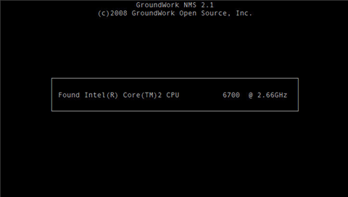
If the minimum resources are not discovered during installation, the administrator will be prompted whether to abort or continue with the installation process. For example, the following screen capture shows that the minimum required disk space was not detected. If this situation is detected, the administrator may choose to either proceed by selecting the "Yes" option, or may choose to abort the installation process by selecting the "No" option. | 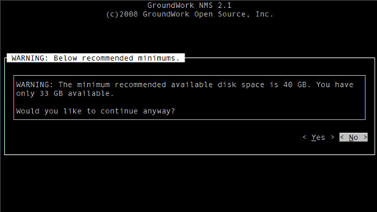
The installer will then check to see if another instance of the installation process is already running. If another instance is detected, the installer will present an advisory message to the administrator and abort the installation, as shown in the screen capture to the right:  If a system crash or other event results in an unclean termination, an old lock file may still be present and prevent reinstallation. In those cases where you know that no other installation is running, you can manually delete the ".lock" file from the installer directory to proceed. | 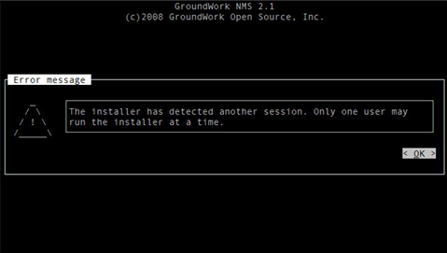
The installer then prompts the administrator to specify whether user connections to the GroundWork Monitor server typically use the server's short hostname or its fully-qualified domain name. This information is necessary to properly configure the Apache web server and is a critical choice.  Specifically, the web browser authentication credentials that are used to access GroundWork Monitor are also used to access the NMS applications. In order for the cookies to be reusable in this manner, however, the GroundWork Monitor server and the GroundWork NMS server must both use the exact same domain name. Therefore, if this option is specified incorrectly, the users will have to re-authenticate whenever they launch an NMS application.  You will want to select the Short Name option if you can type short host names into your browser to access the GroundWork hosts. FQDN should be selected if full domain names are required to access your GroundWork hosts or you are performing a distributed installation.  If the short domain name type is selected, the installer will use the local hostname. If the fully-qualified domain name type is selected, the administrator will be prompted to provide the server's full domain name. | 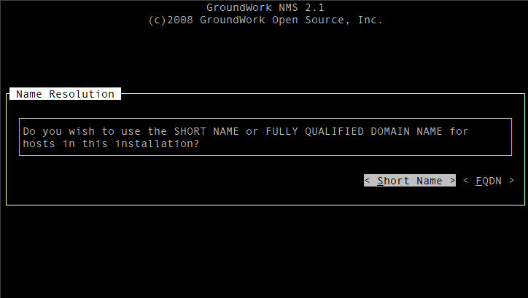  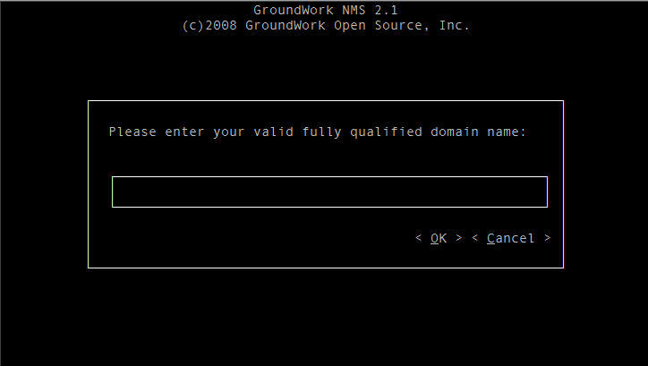
Next, the installation process attempts to determine if a MySQL password has been defined. First the installer checks to see if a system variable called MYSQL_ROOT has been defined, and if so it uses the variable's value as the password for the MySQL root user account for all of the subsequent database modifications. If the MYSQL_ROOT variable has not been defined, the installer prompts the administrator for the MySQL root user's password. If you are presented with the MySQL Password prompt, you may either provide the password to the installer, or you may abort the installation process. This prompt is shown here in the screen capture to the right: | 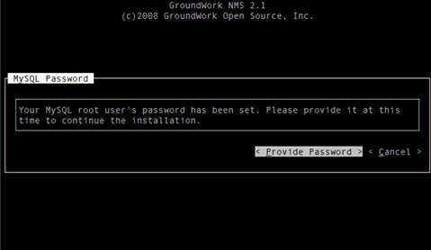
If a previous version of NMS is discovered, the installer asks if the old packages should be upgraded. If the administrator chooses to upgrade the old software, the installer will remove the old packages and install the new packages with no further confirmation.  Note: Upgrades from NMS 5.1.3 and NMS 2.0.x are supported. If you are upgrading from NMS 5.1.3 or earlier versions it is recommended that you contact GroundWork Support to get further instruction, since some of these installations were customized. | 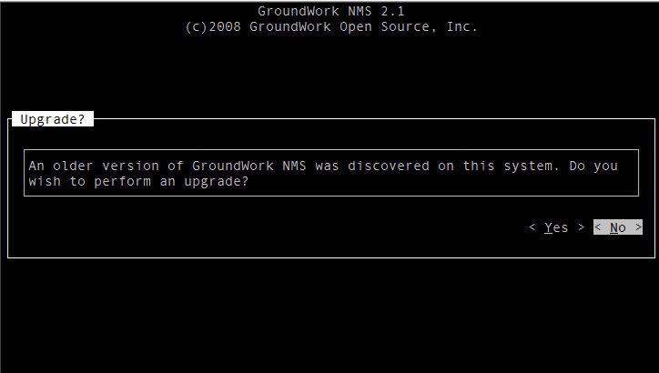
If this is a new install, the installer determines the NMS application components that are available, and presents the administrator with the discovered components. The administrator must confirm that they want the itemized components to be installed. Note that until this point, no system modifications have been made, and this is the last chance for the administrator to abort the installation process with a clean system. The screen capture on the right shows five component modules available for installation, and choosing the "Install" option will cause the component software packages to be installed: | 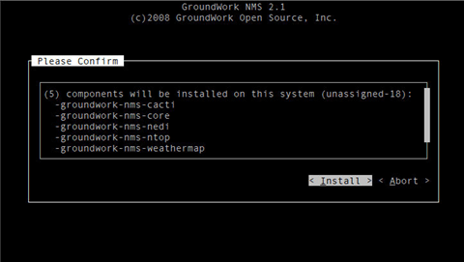
If the administrator chooses to proceed, the installation software will install the component RPMs and also execute some post-installation scripts. During this process, the screen will be updated with status information and a progress bar that shows what is currently happening relative to the entire installation process. The screen capture on the right shows the first part of this process, with the groundwork-nms-core RPM being installed: | 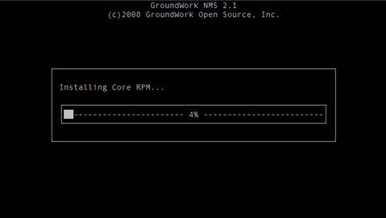
When the installation process completes successfully, a summary screen similar to the following will be presented: | 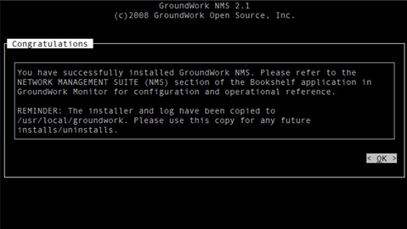
Once GroundWork NMS 2.1 has been successfully installed, running the installer script again will allow the administrator to change the configuration, either by adding additional components or by removing existing ones, using a screen similar to the following.  To modify an existing installation, select the host you want to modify and press ENTER to flag it, and then choose the "Configure Host" option. | 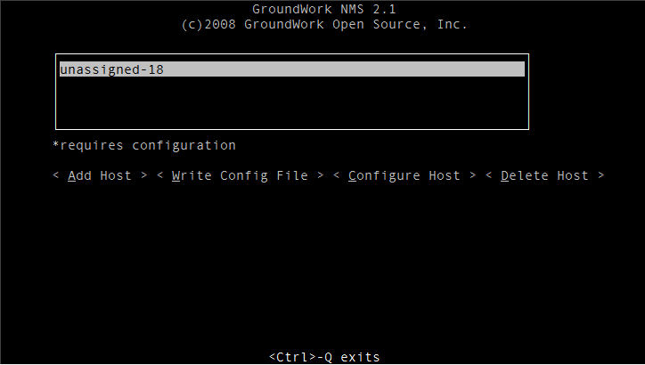
To change the installation status of a specific component, double-click the desired component with your mouse, and then choose the "Execute Changes" option. A prompt will be presented that asks for confirmation. | 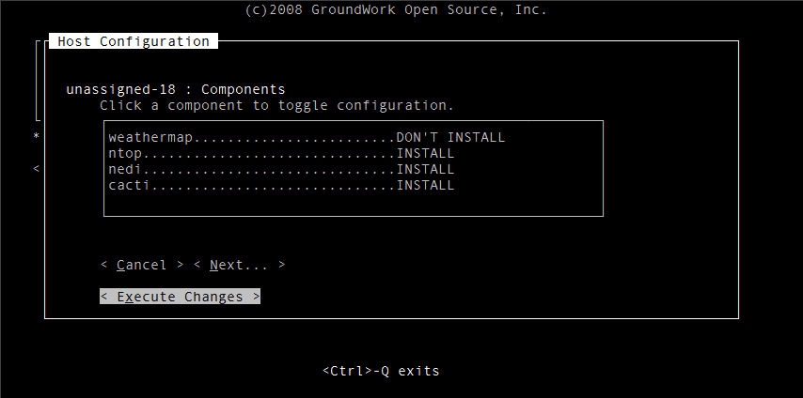

SECTION 3 – DOWNLOAD AND INSTALL PROCESS
Note: A backup is recommended before upgrading GroundWork NMS. Please see Appendix A – Backup in this document before installing GroundWork NMS.
To start the download and install process you will need to log into GroundWork Connect at: http://www.groundworkconnect.com Select the downloads tab and listed under NMS – 2.1 Available Downloads select your appropriate operating system and platform for GroundWork NMS 2.1. Then follow the steps 1 through 5 described below.
Step 1 - Review Distribution Notes
The following documents should be reviewed prior to installation. Select the links to review and continue to Step 2:
- Release Notes - New features in GroundWork NMS 2.1
- Readme - Bug Fixes and Known Issues
- Install Guide – (this document) Important information before you install GroundWork NMS
Step 2 – Download GroundWork NMS Software
Continue by downloading the files containing the NMS 2.1 software. Based on your NMS license your download options will include a complete NMS package or a subset of the NMS components.
- Select the link provided to download NMS.
- After the files have been successfully downloaded, copy them to a working directory.
- Execute the command: tar -xzvf groundwork-nms-*.tar.gz to expand the contents of the archives. This will result in a new subdirectory called groundwork-nms-installer-2.1.0 being created under the current directory that contains the NMS 2.1 installation files and the component packages. The contents of this directory may be relocated to any path, with the only requirements being that the resulting directory must be accessible to the root user account from the GroundWork Monitor server.
Step 3 - Install GroundWork NMS
Use the following steps to install GroundWork NMS 2.1. Refer above to SECTION 2 – AUTOMATED INSTALLER – WHAT TO EXPECT for a walk-through of the installation process.
- Login with root privileges to the GroundWork Monitor server.
- Change the current directory to the directory containing the installation files: (e.g. cd groundwork-nms-installer-2.1.0)
- Start the installer: ./run_install.sh

Step 4 - Verify Installation
There are two methods to determine whether or not the software was correctly installed, both of which should be used.
First, you can open the log file that was created during the installation, and review the information contained within it. Any errors or potential problems that were encountered should be reflected there. You can also point a Web browser to http://hostname:81/ (where "hostname" is the hostname of the GroundWork Monitor server). GroundWork NMS uses a separate instance of the Apache web server to host the component applications, which listens on port 81 of the server. If the Apache server has been started successfully, the banner message "It works!" will be displayed for any direct connection requests, thereby indicating that the Apache server is up and running.
Step 5 – Post Installation Tasks
Once the installation of GroundWork NMS 2.1 has been completed and verified, you must perform some additional tasks in order to expose the component applications to the GroundWork Monitor users.
First, each of the component applications must be assigned to the desired users so that the applications appear in the main drop-down menu for those users. This process is performed by editing the user roles and assigning the Guava object for the application(s) to the desired role(s). For information on configuring user roles, refer to the "Configuring Roles" section of the Administration documentation.
Separately, each application has its own considerations for the initial configuration and ongoing operation of that application, such as changing default settings and managing user accounts. For information on configuring the component applications to suit your environment, refer to the application-specific sections of the "GroundWork NMS" documentation in Bookshelf.
APPENDIX A - BACK UP
This appendix outlines recommended back up procedures for GroundWork Monitor and previous versions of NMS to be completed before upgrading to GroundWork NMS 2.1.
GROUNDWORK MONITOR BACKUP
Custom Changes
It is recommended that a complete backup of /usr/local/groundwork be taken before upgrading. If this is not possible the following should be considered the bare minimum set of files to be preserved.
- Plugins: /usr/local/groundwork/nagios/libexec
- CGI graphs: /usr/local/groundwork/apache2/cgi-bin/graphs
- Eventhandlers: /usr/local/groundwork/nagios/eventhandlers
- SNMPTT configuration: snmptt.conf, snmptt.ini
- Custom syslog filters: syslog.conf, syslog-ng.conf
- Logrotate: logrotate.conf, any changes under /etc/logrotate.d
- Foundation configuration: foundation.properties
- NSCA configuration: nsca.cfg
- Distributed deployment configuration: MonarchDeploy.pm
- The contents of the ‘nagios’ user home directory
- The contents of the ‘nobody’ user home directory
- The last configuration file: /usr/local/groundwork/nagios/etc/config-last.log
- All modified apache configuration files
- The contents of /usr/local/groundwork/etc
- The contents of /usr/local/groundwork/backup
- The contents of /usr/local/groundwork/jobs
RRD Files and Current Nagios Configuration
Back up existing RRD files and your current Nagios configuration. This will create three TAR files in the current directory.
- tar cfz GWMON-xxx-rrd.tar.gz /usr/local/groundwork/rrd
- tar cfz GWMON-xxx-nagios.tar.gz /usr/local/groundwork/nagios/etc
- tar cfz GWMON-xxx-users.tar.gz /usr/local/groundwork/users
MySQL Databases
GroundWork recommends that all MySQL databases be backed up before upgrading. The upgrade procedure will migrate the databases to the latest version of GroundWork Monitor. Create a back up directory (e.g. /usr/local/backup-gwmon/) and enter the following commands to create the back ups:
- Monarch (Configuration)
mysqldump -uroot monarch > /usr/local/backup-gwmon/monarch.sql
- Guava (Framework)
mysqldump -uroot guava > /usr/local/backup-gwmon/guava.sql
- Dashboards (Guava Dashboard Config)
mysqldump -uroot dashboard > /usr/local/backup-gwmon/dashboard.sql
- Foundation (Monitor Data)
mysqldump -uroot GWCollageDB > /usr/local/backup-gwmon/GWCollageDB.sql
- Log Reporting
mysqldump -uroot logreports > /usr/local/backup-gwmon/logreports.sql
GroundWork Configuration Files
- Monarch
Back up the following files and folders before removing GroundWork Monitor and restore after the 5.1.x installation.
tar cfz GWMON-xxx-monarchbackup.tar.gz /usr/local/groundwork/monarch/backup
tar cfz GWMON-xxx-performance_views.tar.gz /usr/local/groundwork/performance/performance_views
- If you have done custom work to these files back up the following:
tar cfz GWMON-xxx-monarchcallout.tar.gz /usr/local/groundwork/monarch/lib/MonarchCallOut.pm
tar cfz GWMON-xxx-monarchexternals.tar.gz /usr/local/groundwork/monarch/lib/MonarchExternals.pm
- If you have configured Apache for secure SSL authentication any HTTPS certificates need to be preserved (the directory of the HTTPS certificates may differ from the example below):
tar cfz ssl-keys.tar.gz /usr/local/groundwork/apache2/conf/ssl.key
- Backup data collected by syslog-ng
tar cfz GWMON-xxx-syslog-ng-data.tar.gz /usr/local/groundwork/var/log/syslog-ng
NMS BACKUP
It is recommended that you back up previous versions of GroundWork NMS before upgrading to NMS 2.1. The following backup procedure will save the populated databases for cacti and nedi, the rrds for cacti, nedi and ntop, the weathermaps created, and any custom settings, graphics, and other files. The rrd files will be found in the 'rrd' or 'rra' directory of the given NMS component.
If upgrading from GroundWork Monitor 5.1.3 backup the following directories:
- /usr/local/groundwork/nedi
- /usr/local/groundwork/cacti
- /usr/local/groundwork/ntop
Backup of MySQL databases
- mysqldump -uroot nedi ><safe_backup_place>my_nedi_backup.sql
- mysqldump -uroot cacti ><safe_backup_place>my_cacti_backup.sql
If upgrading from NMS 2.0 backup the following directories:
- /usr/local/groundwork/nms
- /usr/local/groundwork/enterprise
Backup of MySQL databases
- mysqldump -uroot nedi ><safe_backup_place>my_nedi_backup.sql
- mysqldump -uroot cacti ><safe_backup_place>my_cacti_backup.sql

