## FVC

* **准确度（Accuracy）**: 0.6888
* **宏平均精确度（Macro Precision）**: 0.6754
* **微平均精确度（Micro Precision）**: 0.6888
* **加权精确度（Weighted Precision）**: 0.6809
* **宏平均召回率（Macro Recall）**: 0.5910
* **微平均召回率（Micro Recall）**: 0.6888
* **加权召回率（Weighted Recall）**: 0.6888
* **宏平均F1-score**: 0.6103
* **微平均F1-score**: 0.6888
* **加权F1-score**: 0.6786

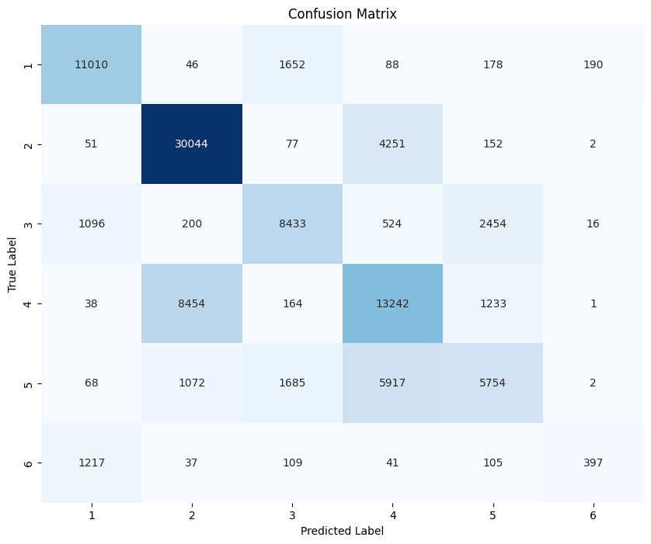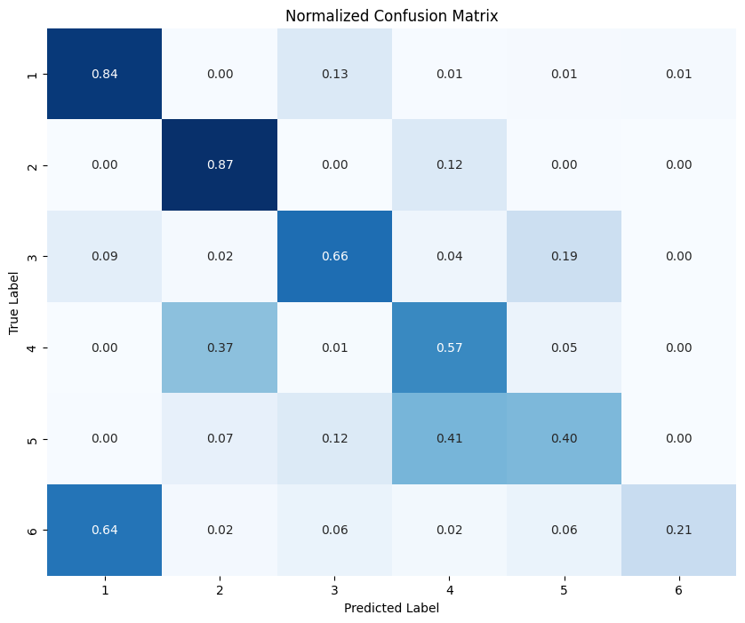

| **类别** | **精确度（Precision）** | **召回率（Recall）** | **F1-score** | **支持度（Support）** |
| --- | --- | --- | --- | --- |
| 1 | 0.82 | 0.84 | 0.83 | 13164 |
| 2 | 0.75 | 0.87 | 0.81 | 34577 |
| 3 | 0.70 | 0.66 | 0.68 | 12723 |
| 4 | 0.55 | 0.57 | 0.56 | 23132 |
| 5 | 0.58 | 0.40 | 0.47 | 14498 |
| 6 | 0.65 | 0.21 | 0.32 | 1906 |

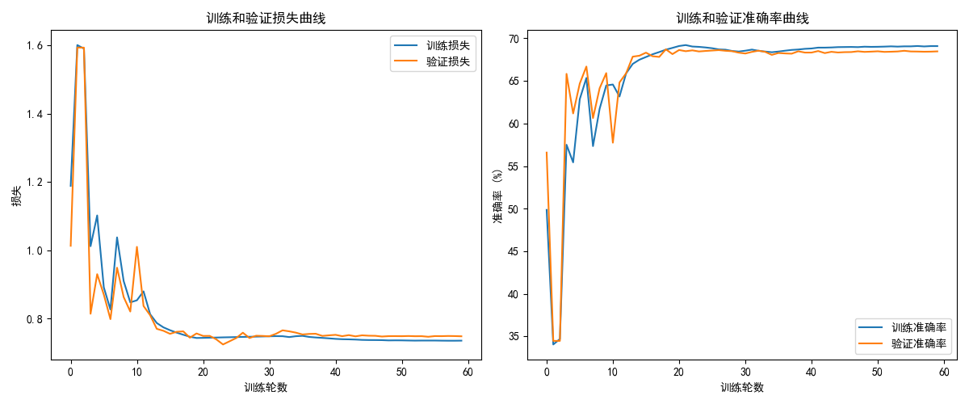

## RSEI

Accuracy: 0.5061

Macro Precision: 0.5284

Micro Precision: 0.5061

Weighted Precision: 0.5045

Macro Recall: 0.5337

Micro Recall: 0.5061

Weighted Recall: 0.5061

Macro F1-score: 0.5304

Micro F1-score: 0.5061

Weighted F1-score: 0.5044

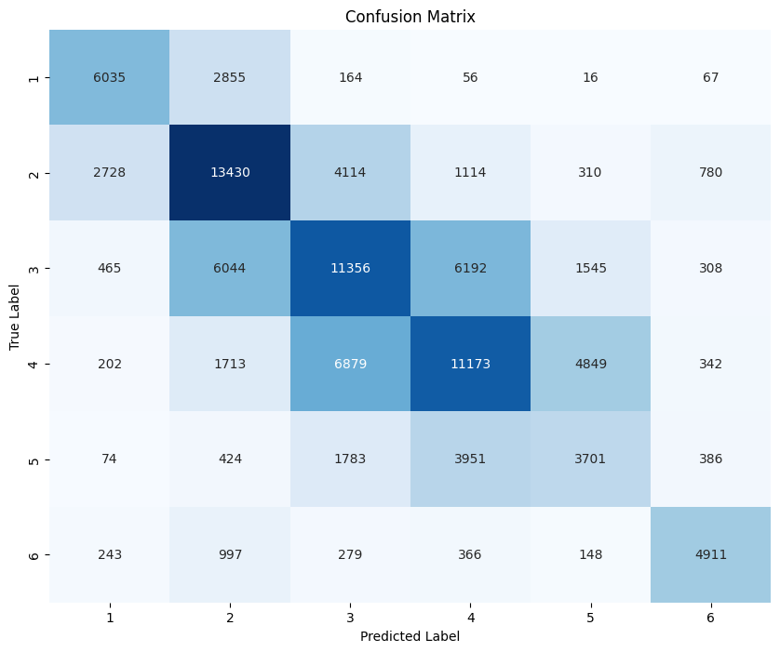

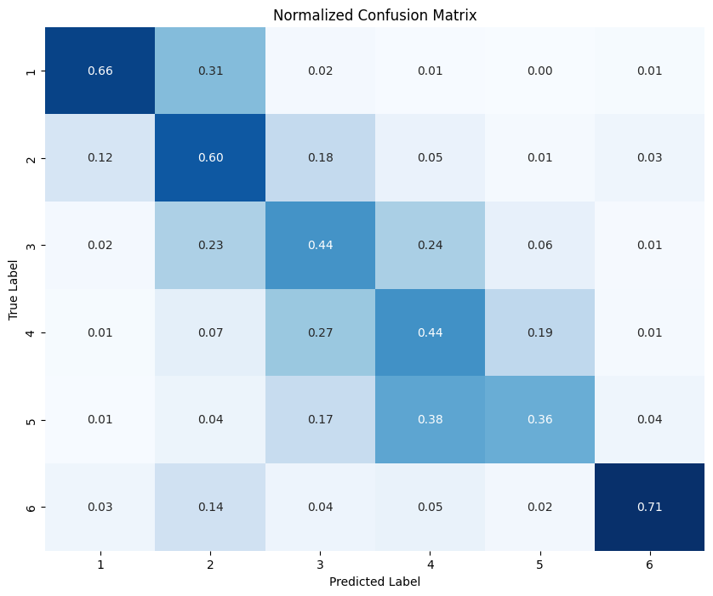

precision recall f1-score support

1 0.62 0.66 0.64 9193

2 0.53 0.60 0.56 22476

3 0.46 0.44 0.45 25910

4 0.49 0.44 0.47 25158

5 0.35 0.36 0.35 10319

6 0.72 0.71 0.71 6944

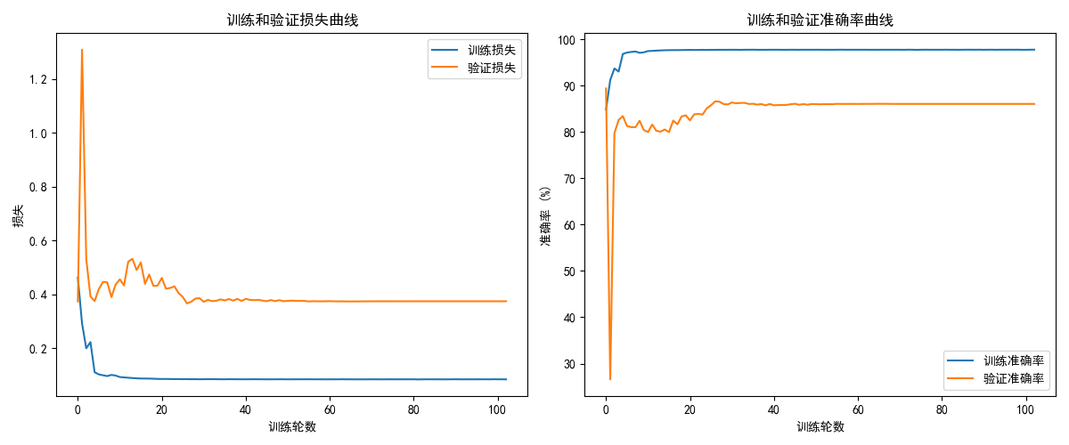

## LULC

Accuracy: 0.9768

Macro Precision: 0.8081

Micro Precision: 0.9768

Weighted Precision: 0.9769

Macro Recall: 0.7997

Micro Recall: 0.9768

Weighted Recall: 0.9768

Macro F1-score: 0.8038

Micro F1-score: 0.9768

Weighted F1-score: 0.9768

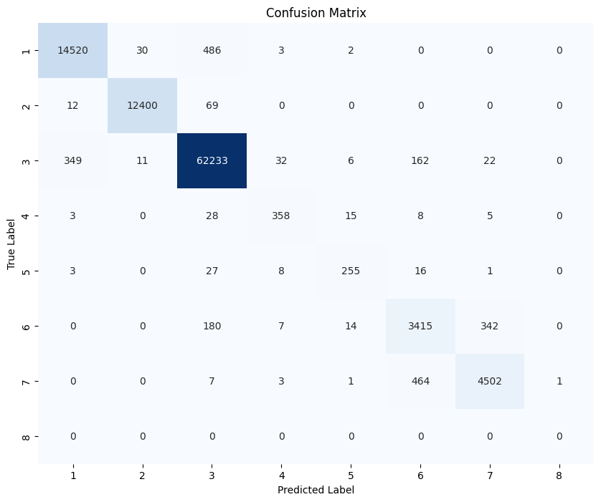

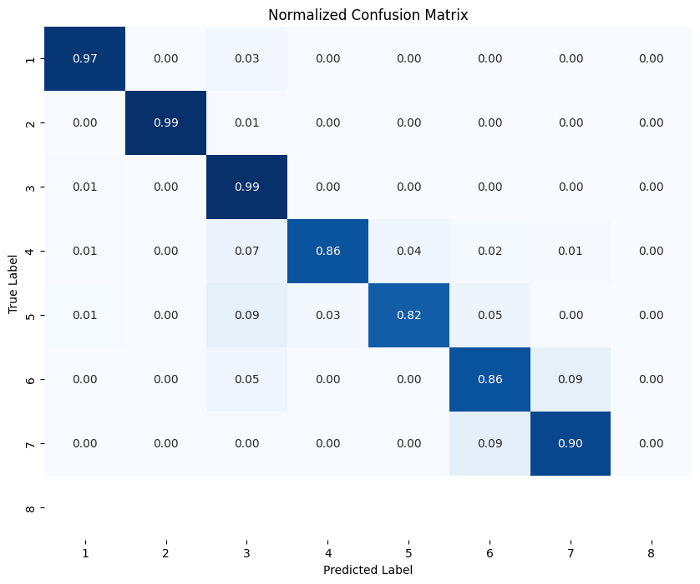

precision recall f1-score support

1 0.98 0.97 0.97 15041

2 1.00 0.99 1.00 12481

3 0.99 0.99 0.99 62815

4 0.87 0.86 0.86 417

5 0.87 0.82 0.85 310

6 0.84 0.86 0.85 3958

7 0.92 0.90 0.91 4978

8 0.00 0.00 0.00 0

