Portal User Manual

2016/08/28

Volvo
目录
1. Summary 2
2. Logining 2
3. Common user system 5
3.1 Home 5
3.2 My Booking 12
4. Business Management System 13
4.1 Police Manage 13
4.2 Booking Manage 14
4.3 Agent Users 15
4.4 User Statistic 16
4.5 Resource Chart 17
5. Root Management System 18
5.1 AD Config 18
5.2 Mail Config 19
5.3 Account Manage 19
5.4 Region Config 21
5.5 Pool Config 23
5.6 Event Logs 25
5.7 Faq Calladmin 25

Summary
This paper mainly introduces the function of the desktop management system and the operation steps. The system consists of 3 subsystems.
- Common user system
- Business management system
- Root management system

Logining

- Open the browser to enter the system address.
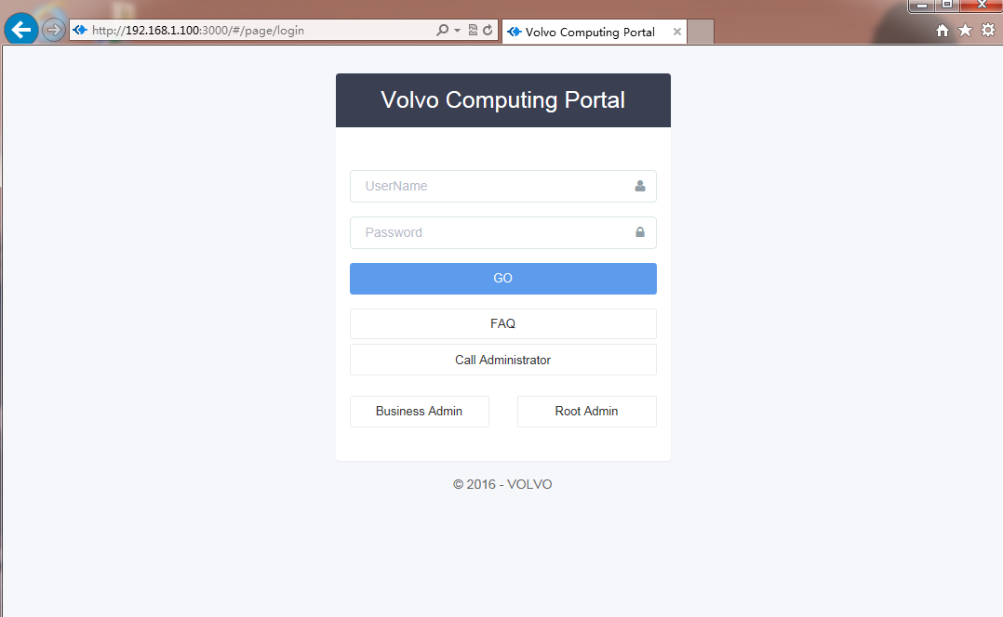
- Enter a user name and password on the login page，Click to login to common user system.
- You can click 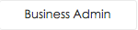 to switch to the business administrator login page. Page as follows:
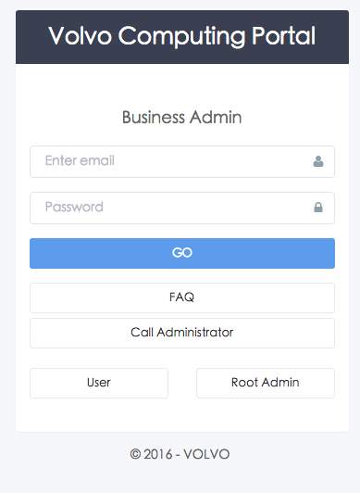
- You can click 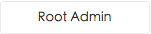 to switch to the root administrator login page. Page as follows:
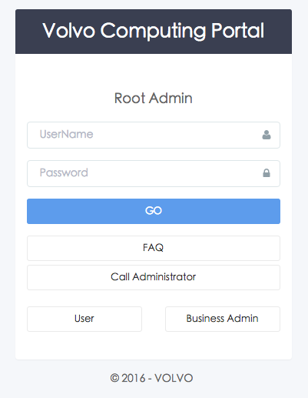
- If you have questions please click 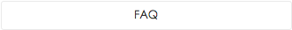 or 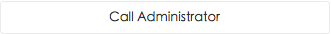 to ask for help.

Common user system
Verify the successful user name and password, and then enter the common user system.

Home

Home page
Page as follows：
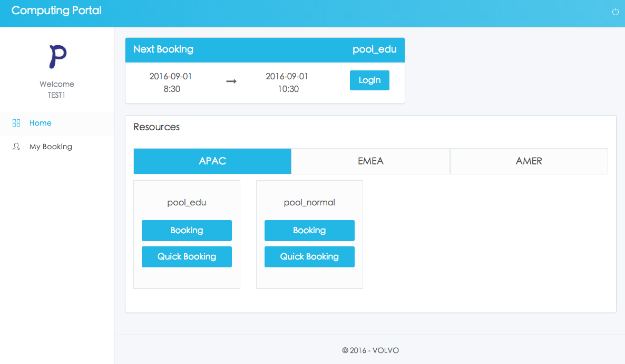
You can click  to exit the system.
- You can click to switch the regions.
- If the current time has booking time. You can click  on the next booking page to login the desktop.
- If the current time has not booking time, then you click on the next booking page, Pop-up warning window.
- If you need other booking time, you can choose the pool, then click  on resources page to booking page.
- If you want to quickly use the desktop, you can choose the pool, then click  on resources page to the quick booking page.

Quick booking page
Page as follows：
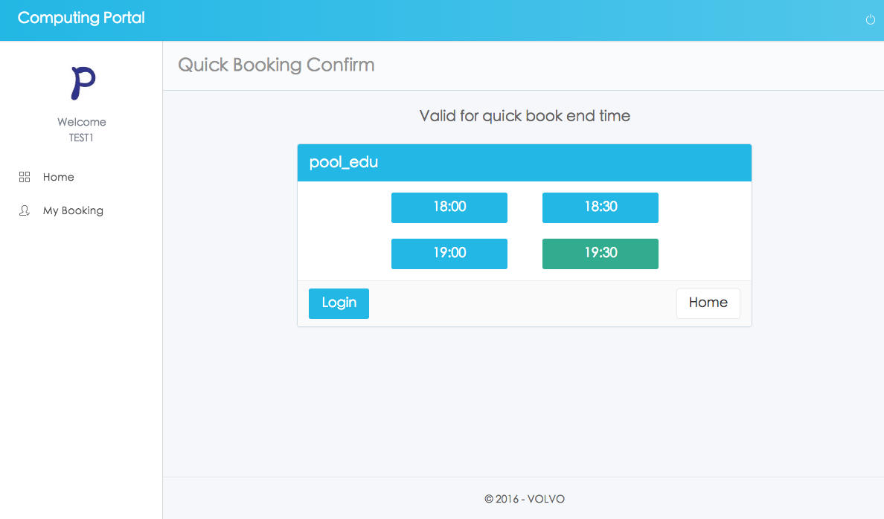
- You can click 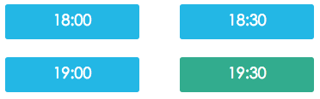to select the end time of this quick booking.
- After select the end time. You can click on this page to login the desktop.
- You can click 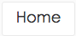 on this page to return to the home page.

Booking page
Page as follows：
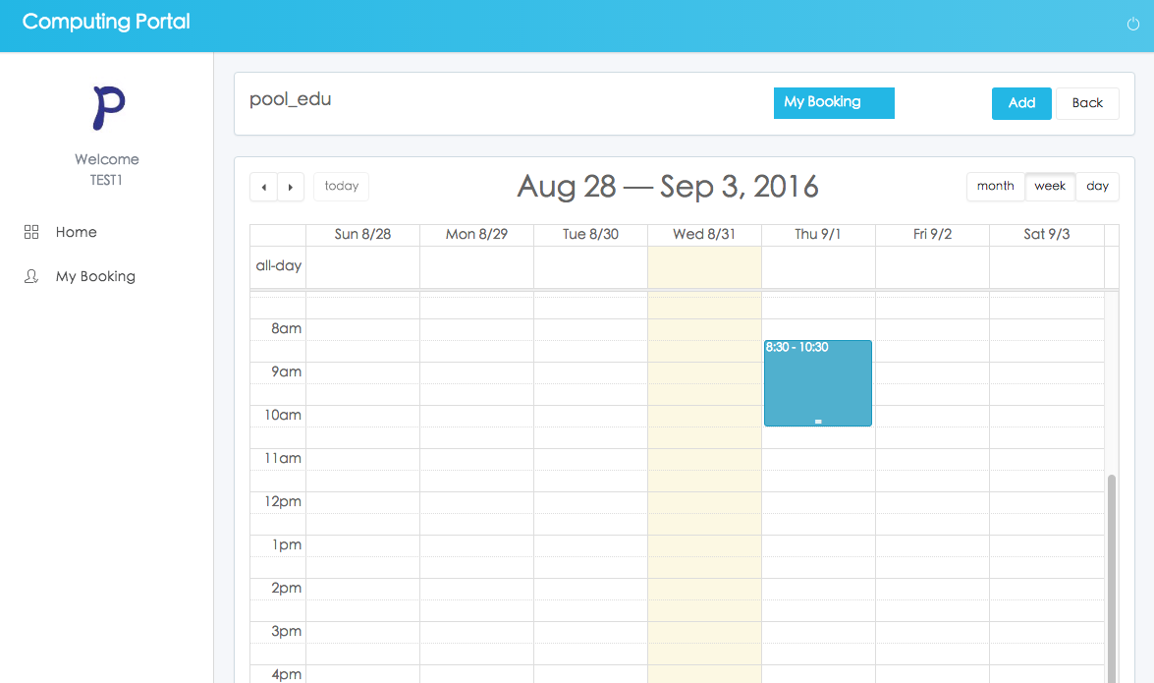
- You can click 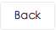 on this page to return to the home page.
- If you need other booking time, you can click  on this page to add new booking information.
Additional page as follows:
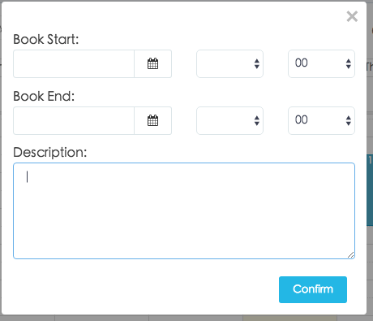
- You can click 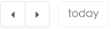 on this page to modify date and time.
- You can click 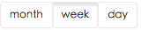 on this page to modify the calendar display mode.
- You can choose the quickly way to add new book. Click the calendar to open the additional page. The start time and end time that you choose on the calendar will display on the additional page.
Additional page as follows:
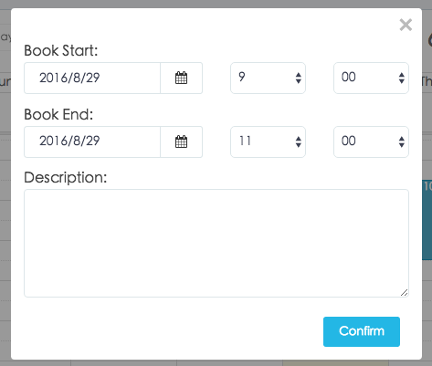
- The booking information on the calendar is allowed to drag .The system save the data immediately after dragging success.
Page as follows:
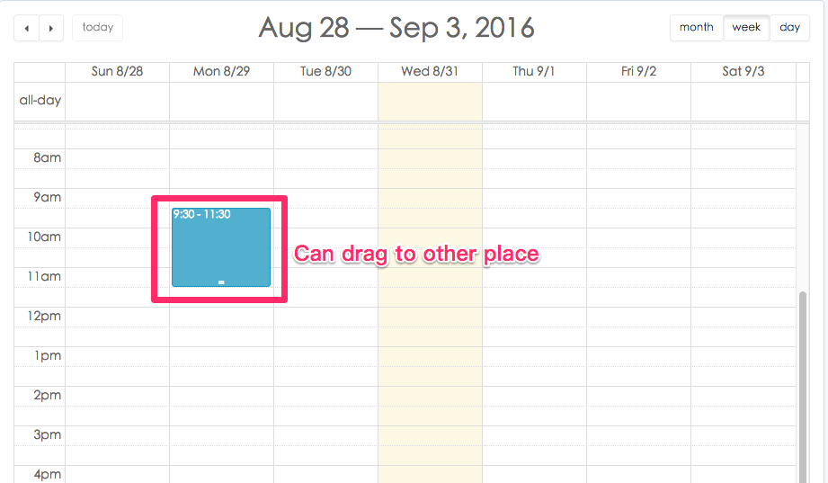
- The booking information on the calendar is allowed to change the size for changing the start time and end time of the booking .The system save the data immediately after changing success.
Page as follows:
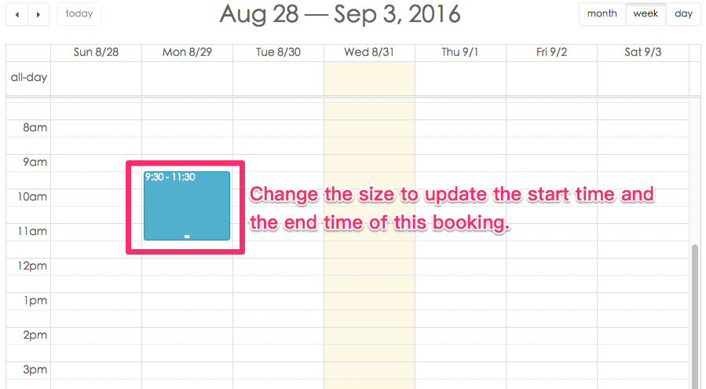
- You can click the booking information on the calendar to choose to delete or update the description.
Page as follows:
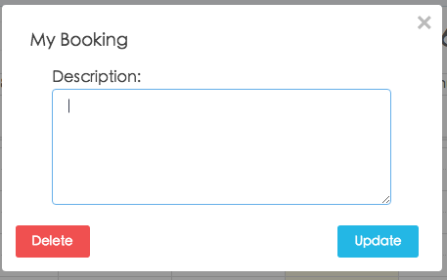

My Booking

MY Booking Page
Page as follows:
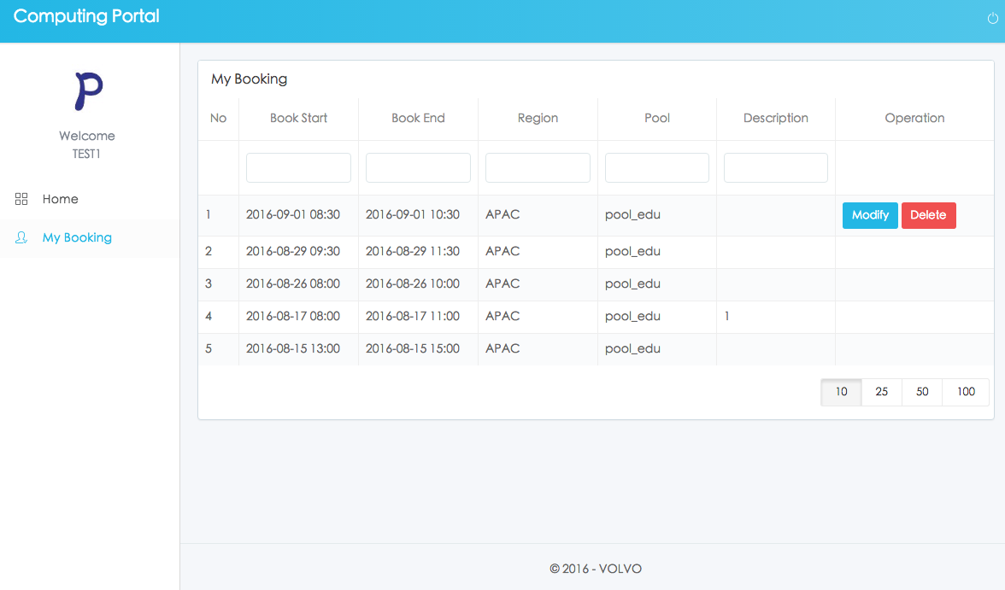
- Expired data and data that have been used can not be edited.
- You can click 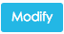 on this page to change the booking information。
Change page as follows:
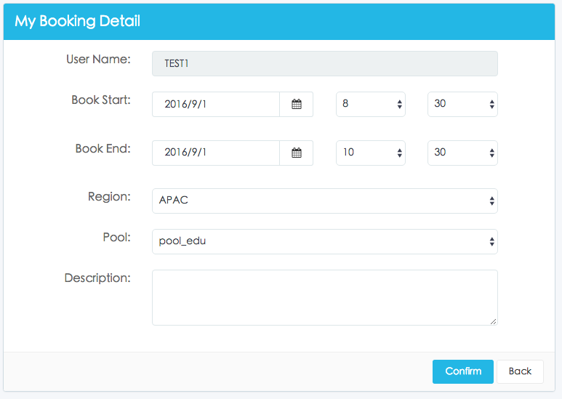
- You can click 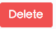 on this page to delete the booking information。
- You can enter the condition to filter the information。
Condition page as follows:
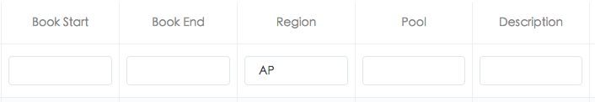

Business Management System
Verify the successful user name and password, and then enter the business management system.

Police Manage
Page as follows：
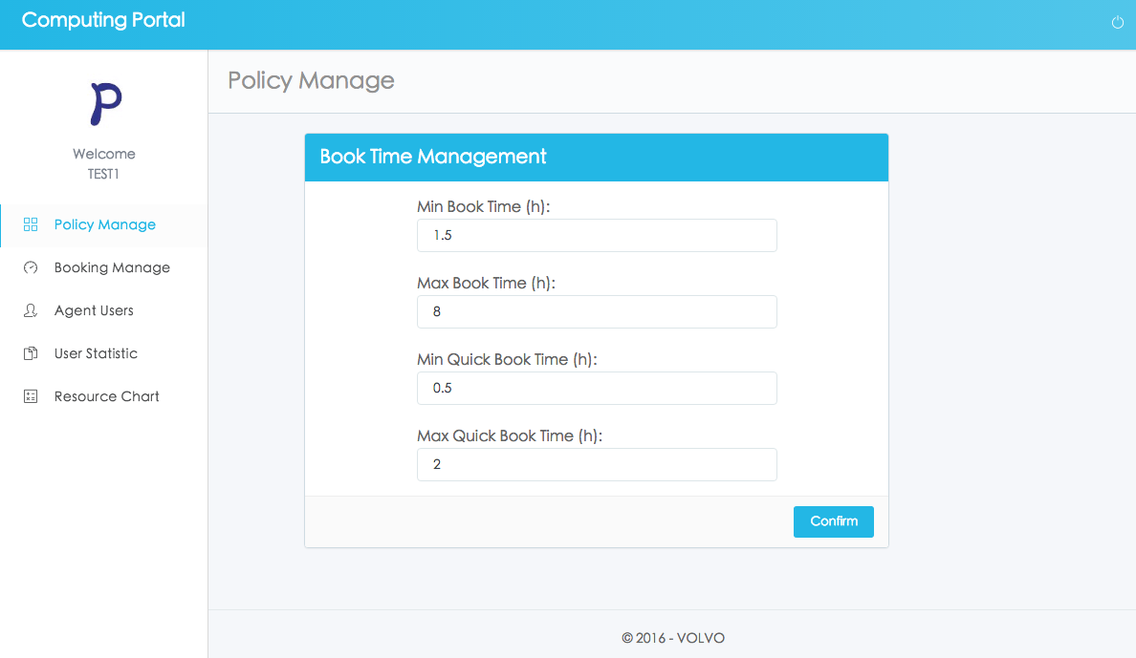
- You can click 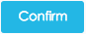 on this page to save the time configuration.

Booking Manage
Page as follows：
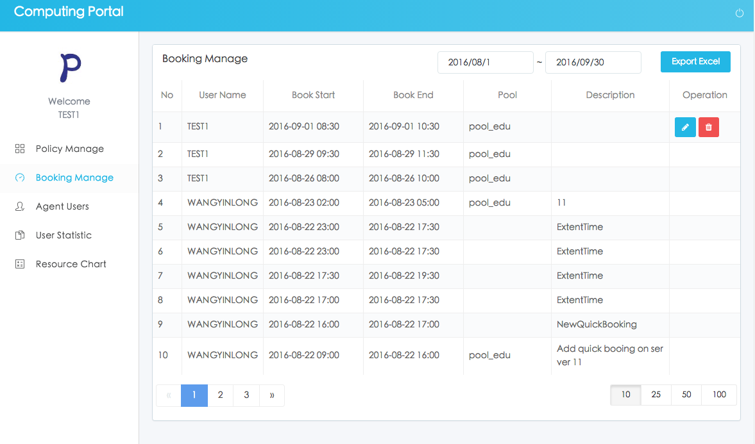
- Expired data and data that have been used can not be edited.
- You can click  on this page to modify the booking information。
Change page as follows:
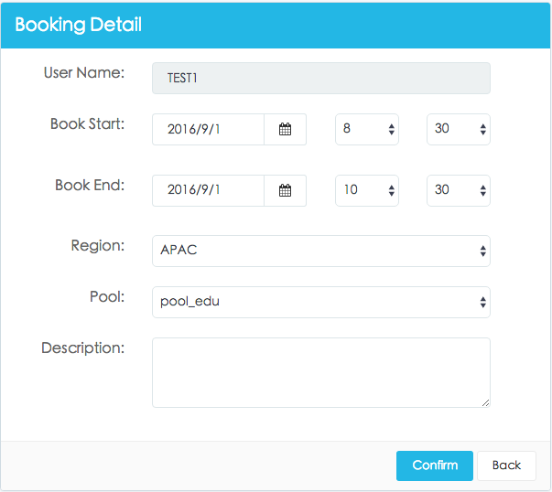
- You can click on this page to delete the booking information。
- You can select time period to filter the information。
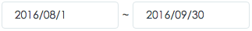
- You can click 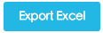 on this page to export the data list of the booking information。

Agent Users
Query the desktop being used.
Page as follows：
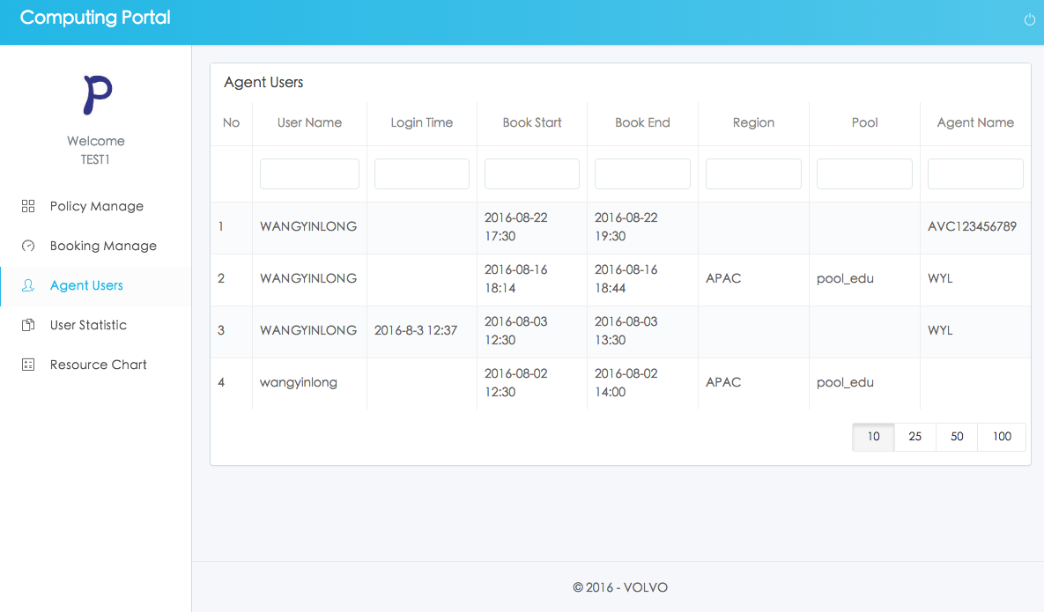
- You can enter the condition to filter the information。
Condition page as follows:
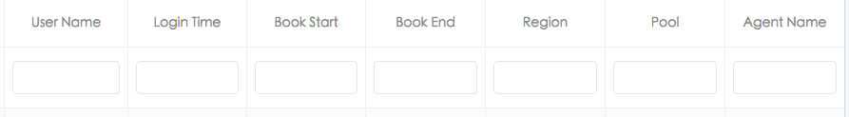

User Statistic
Page as follows：
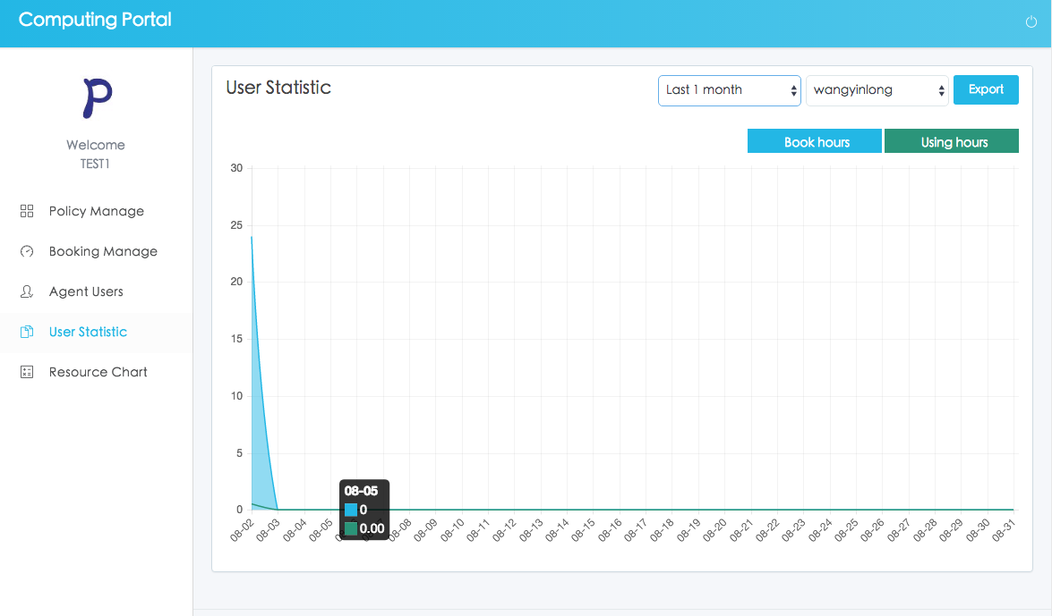
- You can select time period to filter the information.
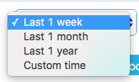
If you select, you can choose the start time and the end time to filter data.
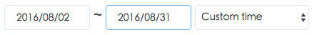
- You can select the user to filter the information.
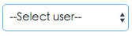
- You can click 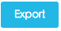 on this page to export the data list of the booking information.

Resource Chart
Page as follows：
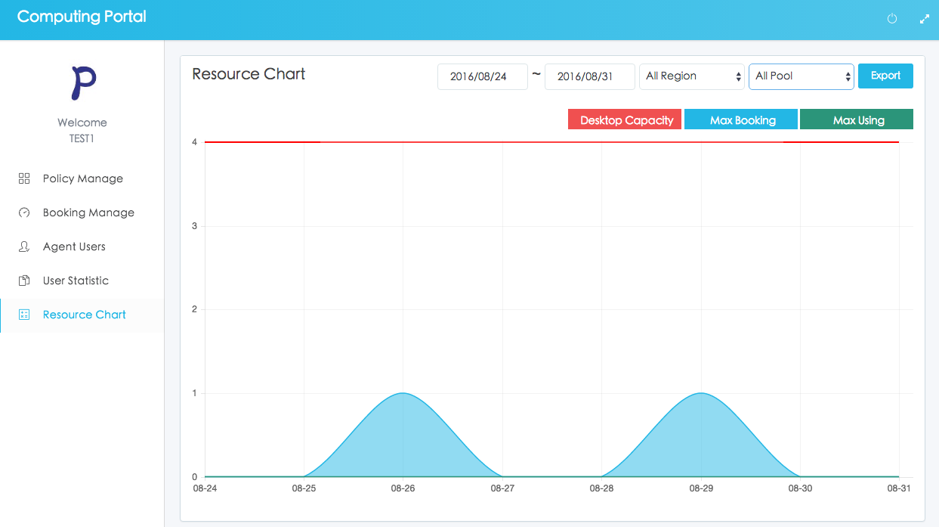
- You can select time period to filter the information.
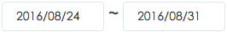
- You can select the region to filter data.
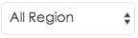
- You can select the pool to filter data.
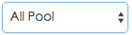
- You can click on this page to export the data list of the booking information.

Root Management System
Verify the successful user name and password, and then enter the root management system.

AD Config
Page as follows：
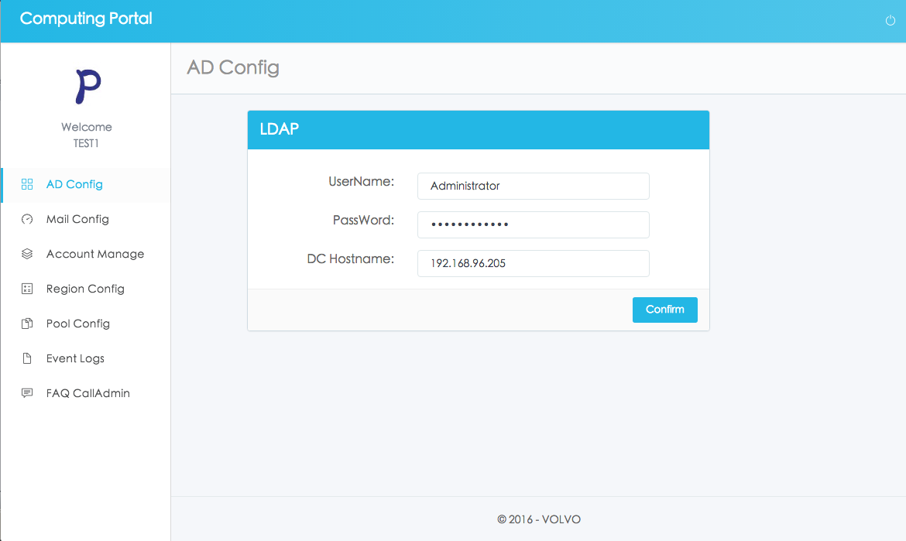
- You can click on this page to save the AD configuration.

Mail Config
Page as follows：
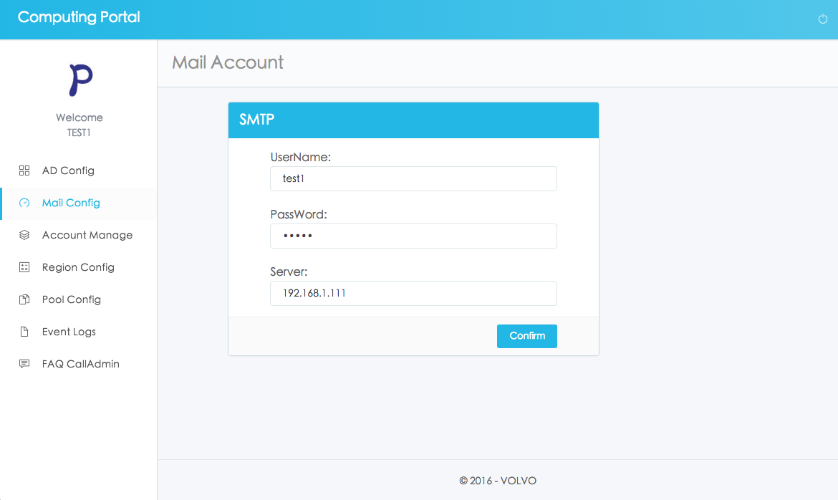
- You can click on this page to save the mail configuration.

Account Manage
Page as follows：
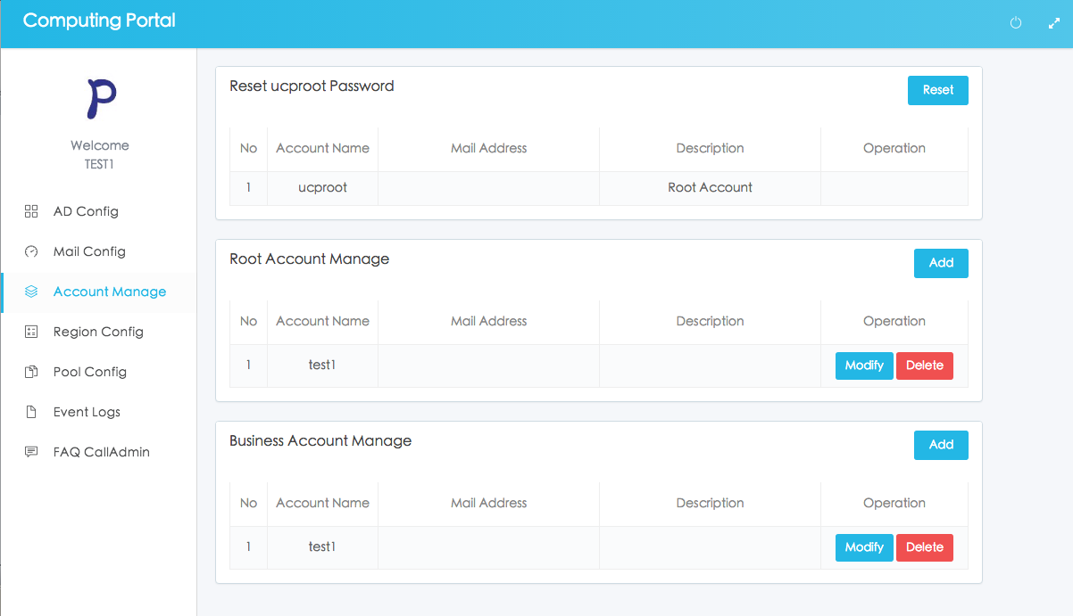
- You can click 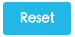 on this page to modify the password of the user ‘ucproot’.
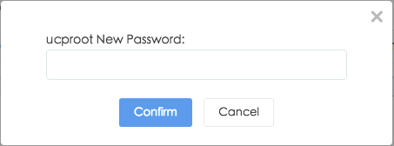
- You can click or  on this root account manage page to add the root right of the user.
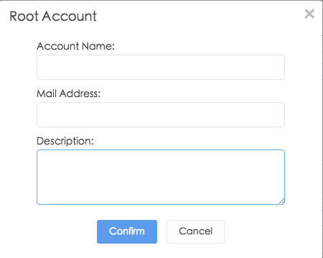
- You can click or on this business account manage page to add the business right of the user.
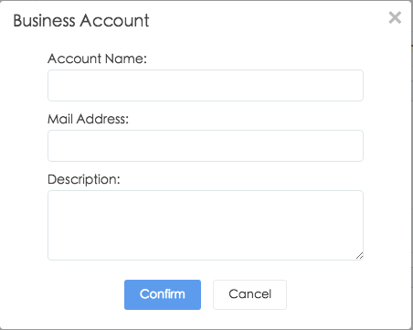
- You can click 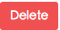 on this page to delete data.

Region Config
Page as follows：
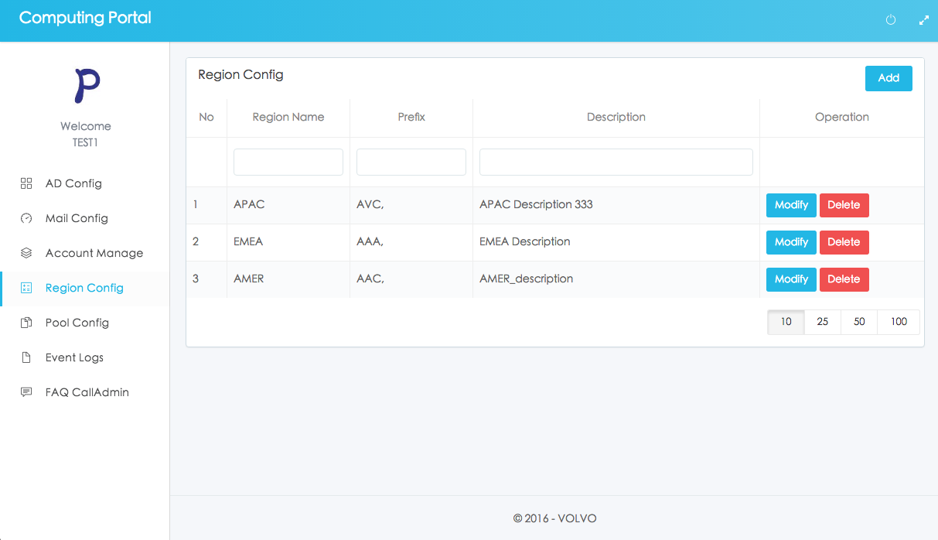
- You can click 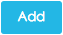or on this page to change the region information。
Region detail page as follows:
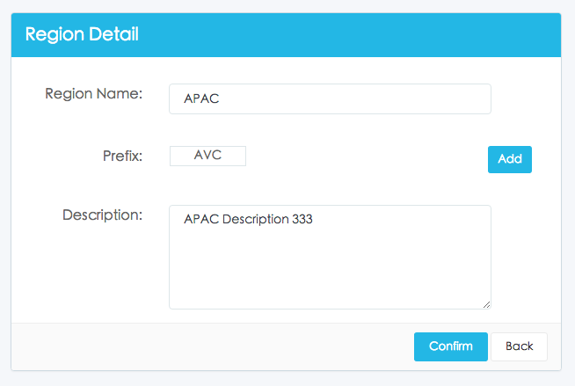
- You can click 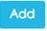 on this page to add the prefix information。
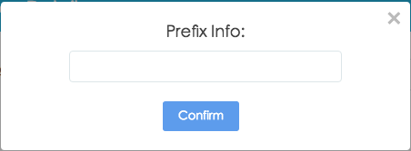
- You can click 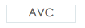 on this page to delete the prefix information。
- You can click on this page to delete the region information。
- You can enter the condition to filter the information。
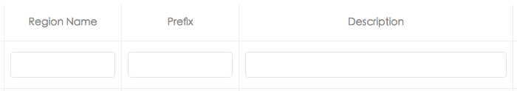

Pool Config
Page as follows：
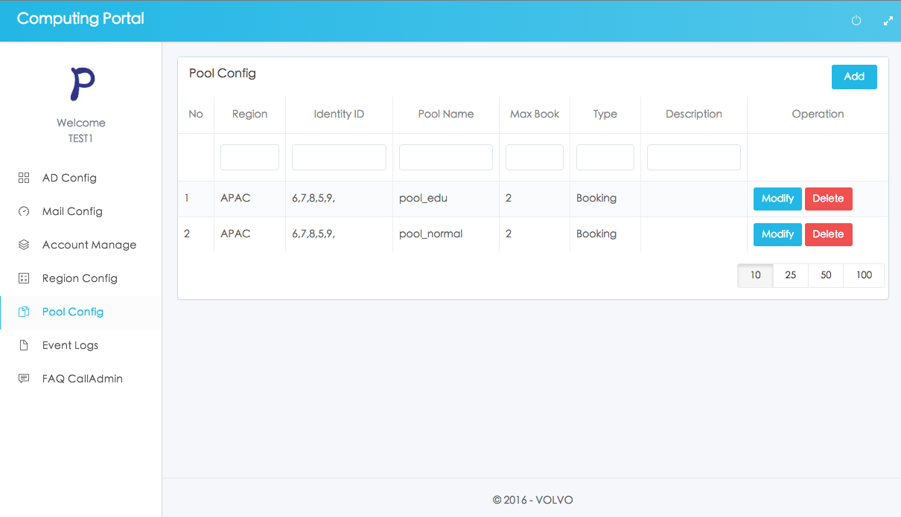
- You can click or on this page to change the pool information。
Region detail page as follows:
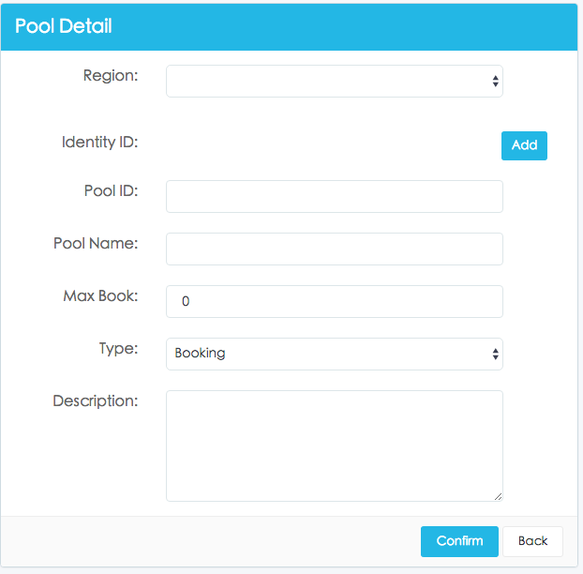
- You can click on this page to add the Identity ID.
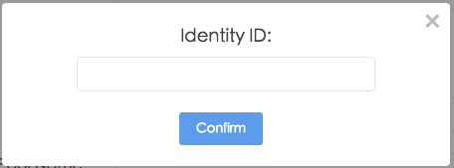
- You can click 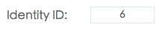 on this page to delete the Identity ID.
- You can click on this page to delete the pool information.
- You can enter the condition to filter the information。
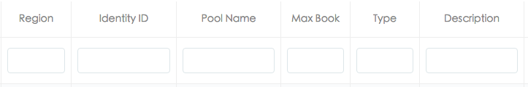

Event Logs
Page as follows：
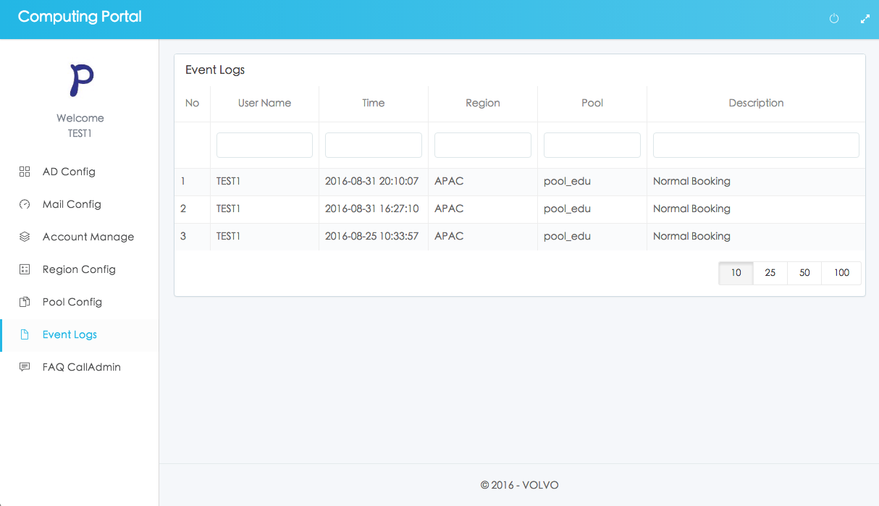
- You can enter the condition to filter the information。
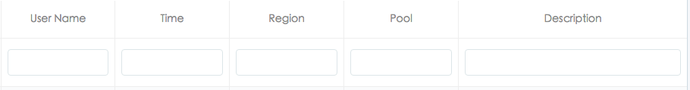

Faq Calladmin
Page as follows：
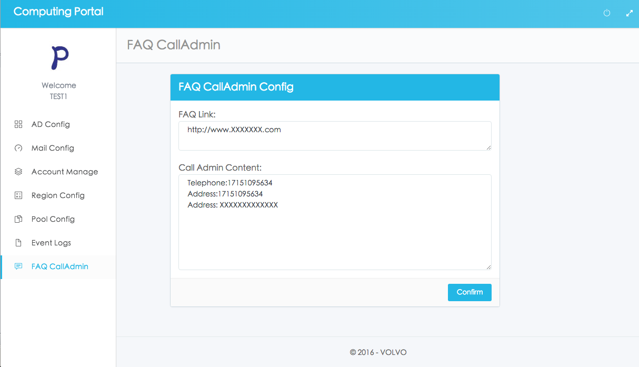
- You can click on this page to save the FAQ and CALLADMIN configuration.

