Portal Technical Structure

2016/09/26

Volvo

Catalog
Catalog 2
1. Overall Design 3
1.1 Operating Environment 3
1.2 Development Environment 3
1.3 Structure 4
2. Module Detail 5
2.1 Computing Portal 5
2.2 Portal Agent 8
2.3 Database 9

Overall Design

Operating Environment
No | Project | Detail
1 | Backstage | Linux, Windows
2 | Foreground | Windows,OSX
3 | Database | SqlServer

Development Environment
No | Project | Detail
1 | Operating System | Windows,OSX
2 | Language | Nodejs、AngularJS、Bootstrap、HTML、CSS、C#
3 | Development Tool | Sublime Text 2
4 | Network | 100M Ethernet

Structure
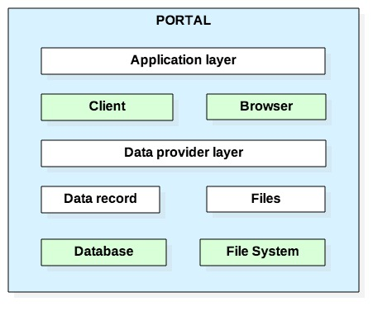
Application layer contains two different applications:
- Background application and data management, Access to the system through the browser.
- Desktop usage restrictions. Install client to manage the using of desktop.
Data provider layer includes two aspects:
- Store operation data through the database
- Export statistics file and report file through the file system.

Module Detail
The system mainly contains the following modules：
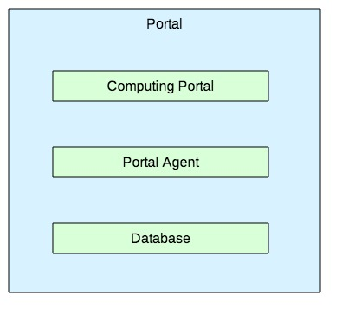

Computing Portal
Business logic as follows:
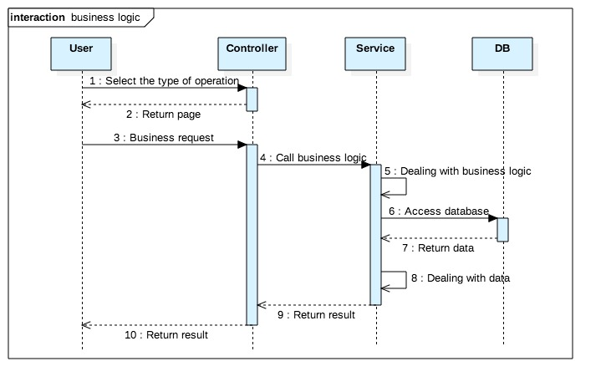
- Controller：Manage user operation , Processing business request，Communication with service.
- Service：Get business request, dealing with business logic, search data from the database, dealing with data.
- DB：Storing data.
This module contains technology and programming language. As follows:
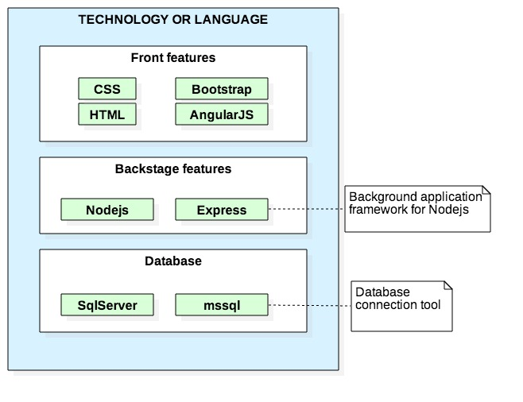
- Front features , Code framework is “MVC” as follows:
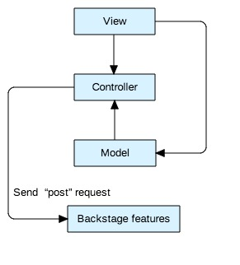
- View: System function page, manage user operation.
- Controller: Get user operations, process business logic and data. Send a “post” request to the backend system.
- Model: Corresponding to the database.
- Backstage features, Code framework as follows:
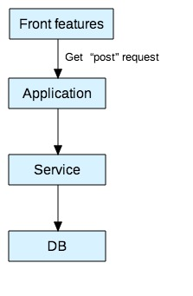
- Application: Gets the “post” request from the front features.
- Service: To complete the actual business logic, including the entity class corresponding to the table of the database, as well as the DAO class to access the database..
- DB: Connect to the database to query the corresponding data.

Portal Agent
The programming language of this module is “C#”
Business logic as follows:
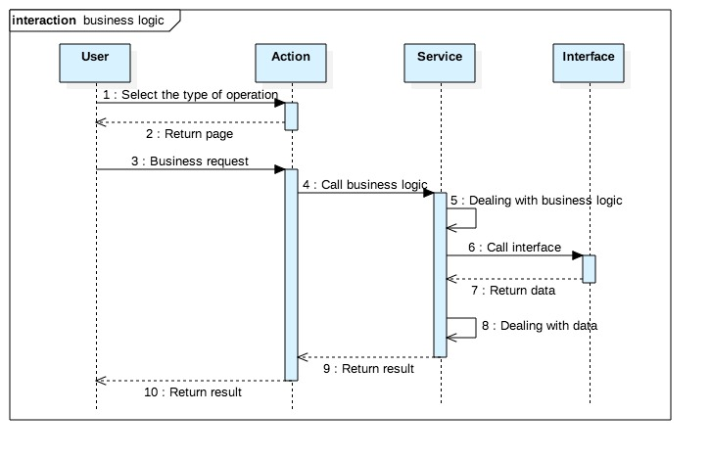
- Action：Manage user operation on client, Processing business request，Communication with service.
- Service：Get business request, dealing with business logic, dealing with data.
- Interface：Call the interface of “Computing Portal” to query data.

Database
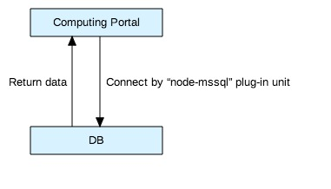
This system uses “SqlServer” to store data and uses the “node-mssql” plug-in unit to connect database and manage the database.

